THE UNIVERSITY OF AZAD JAMMU AND KASHMIR, MUZAFFARABAD
DEPARTMENT OF SOFTWARE ENGINEERING

Name: | Ghazanfar Rasheed
Roll No: | 2025-SET-14
Course: | Programming Fundamentals
Submitted To: | Engr. Zeeshan Rashid
Lab Task no: | 08
Session: | 2025-29
Semester: | 1st

Question # 01:
A customer visits a shopping system where they can choose from three categories of items: Electronics, Clothing, and Groceries. Each category has multiple items with specified prices. The customer selects a category and then select an item with in the category, specifies the quantity they wish to purchase, and the system calculates the total price, applies applicable discounts, and generates an invoice.
Discount Policy:
Purchases below $100: No discount.
Purchases between $100 and $500: 10% discount.
Purchases above $500: 20% discount.
Items & Prices:
The prices for items are predefined:
Electronics: Laptop ($1000), Smartphone ($700), Headphones ($150)
Clothing: Jacket ($120), T-shirt ($40), Jeans ($60)
Groceries: Milk (1 Liter - $2), Bread (1 Loaf - $3), Eggs (1 Dozen - $5)

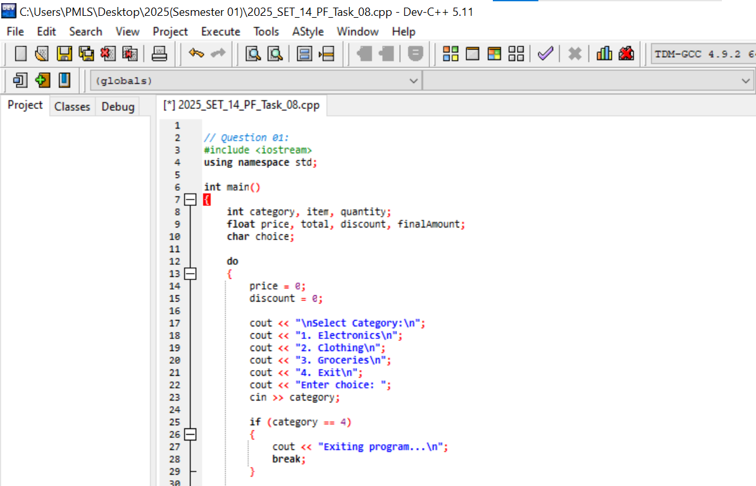
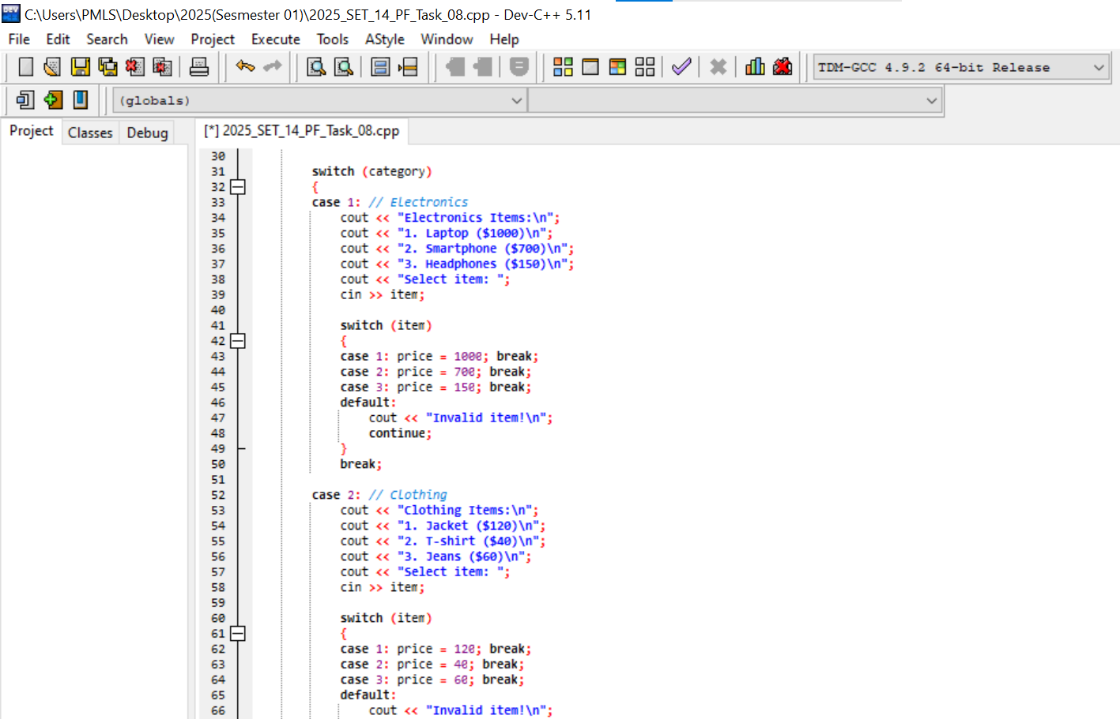
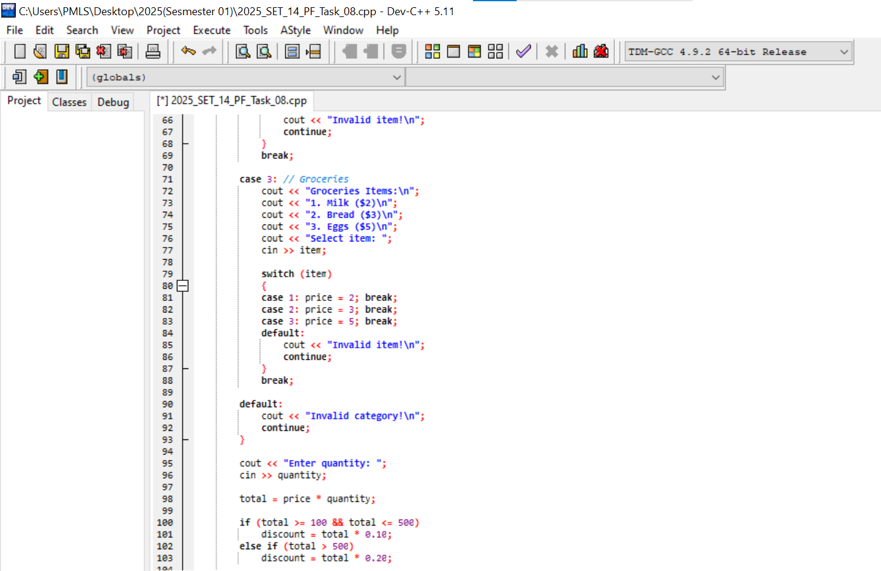
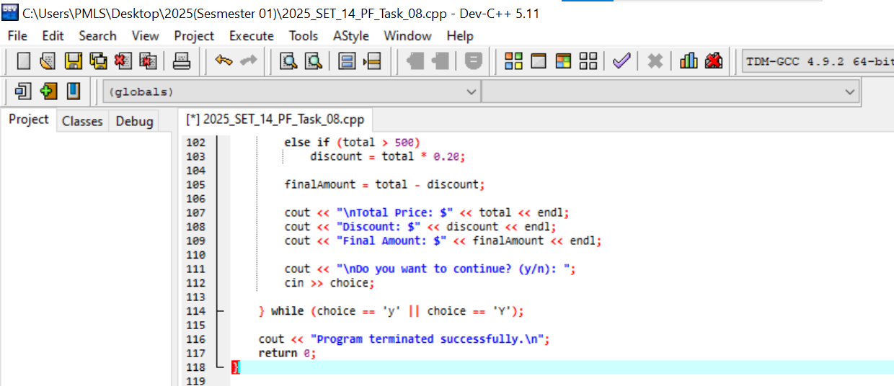
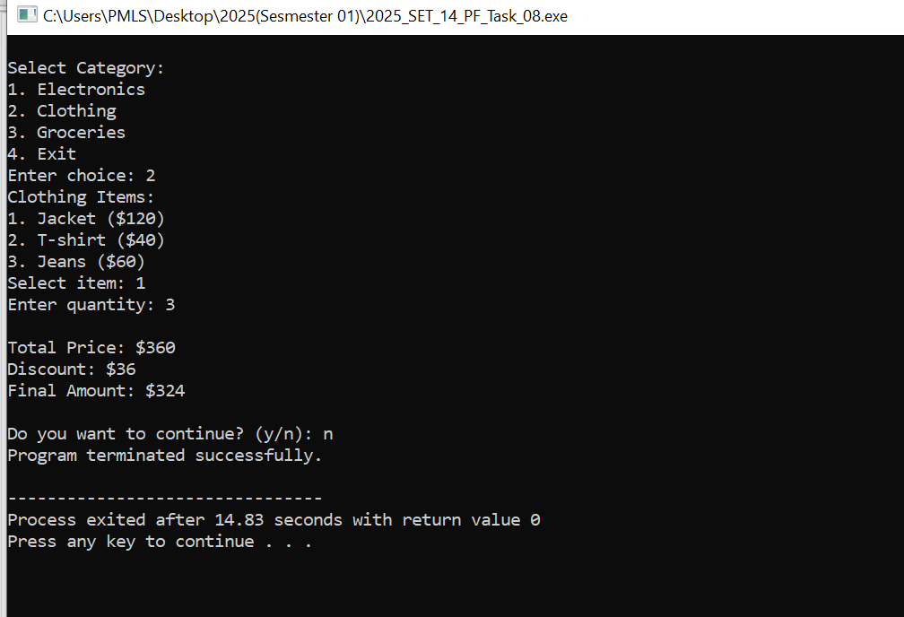

Question # 02:
Write a C++ program that acts as a currency converter. Use a switch statement to let the user choose between converting from USD to PKR,Pound,Euros. Display the converted amount based on the exchange rate and the amount entered by the user.
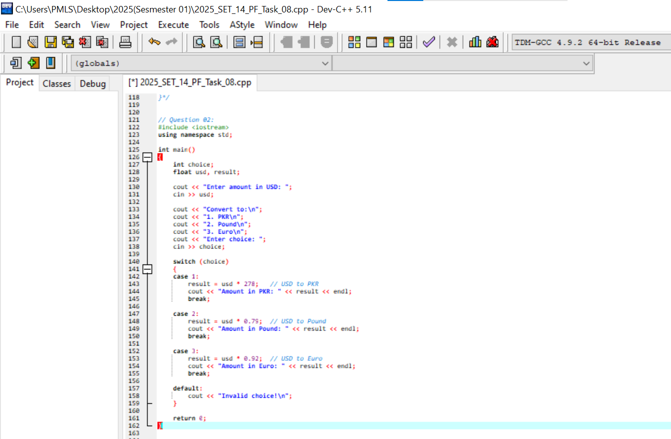
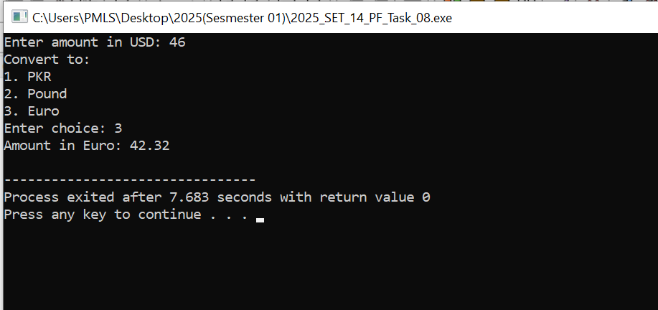

Question # 03:
Write a C++ program that calculates the area of different shapes. Use a switch statement to let the user select a shape (1 for Circle, 2 for Rectangle, 3 for Triangle) and input the necessary dimensions. The program should compute and display the area based on the selected shape.
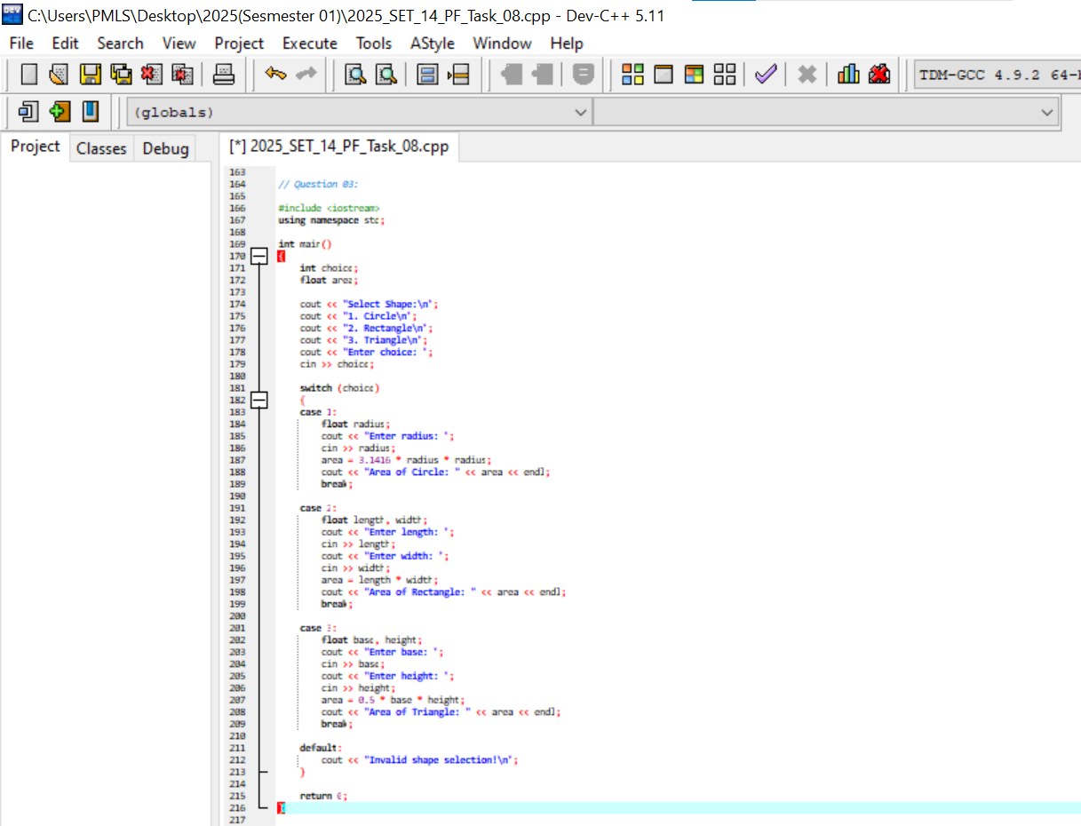
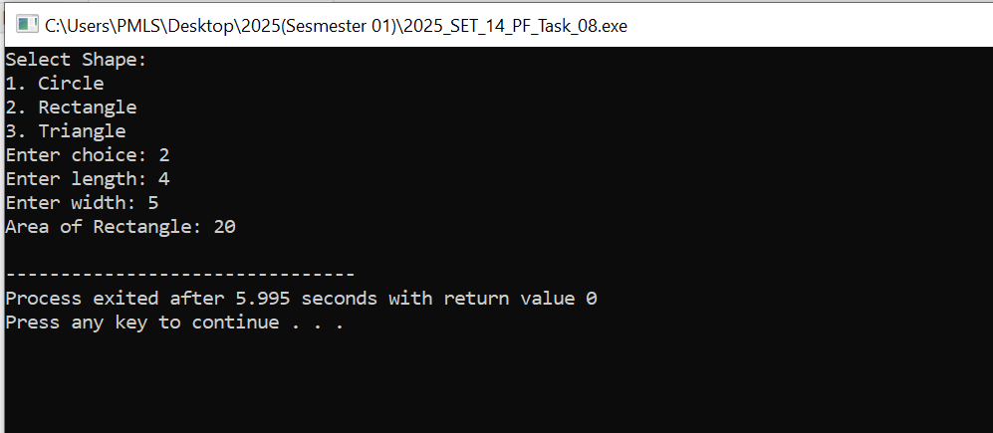
Question # 04:
Write a C++ program that acts as a simple calculator. The program should take two numbers and an operator (+, -, *, /) as inputs and perform the corresponding operation using a switch statement. If an invalid operator is entered, the program should display an appropriate error message.



