THE UNIVERSITY OF AZAD JAMMU AND KASHMIR, MUZAFFARABAD
DEPARTMENT OF SOFTWARE ENGINEERING

Name: | Ghazanfar Rasheed
Roll No: | 2025-SET-14
Course: | Programming Fundamentals
Submitted To: | Engr. Zeeshan Rashid
Lab Task no: | 09
Session: | 2025-29
Semester: | 1st

Lab Objectives
The objective of this lab is to learn how to use loops in C++ to perform repetitive tasks efficiently.
Lab Task of for loop.
1. Write a program to print all numbers from 1 to N, where N is entered by the user.
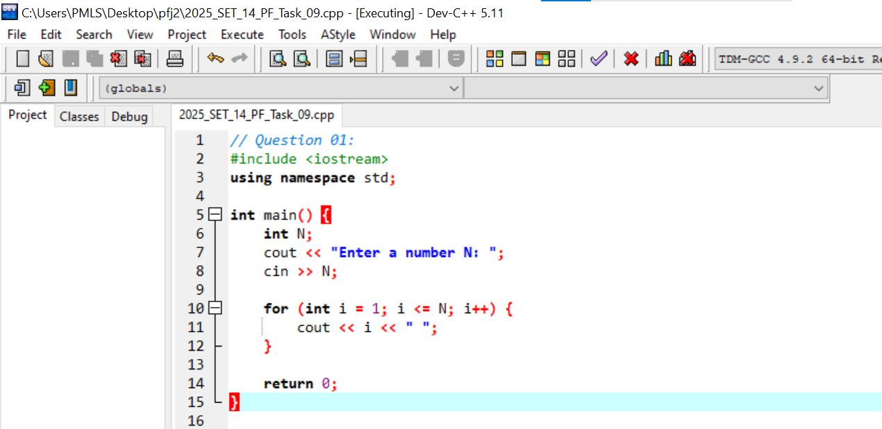
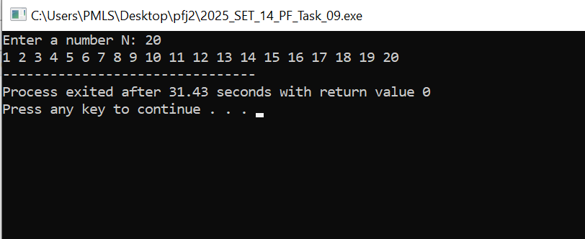

2. Write a program to display the multiplication table of a number entered by the user with limit using for loop.
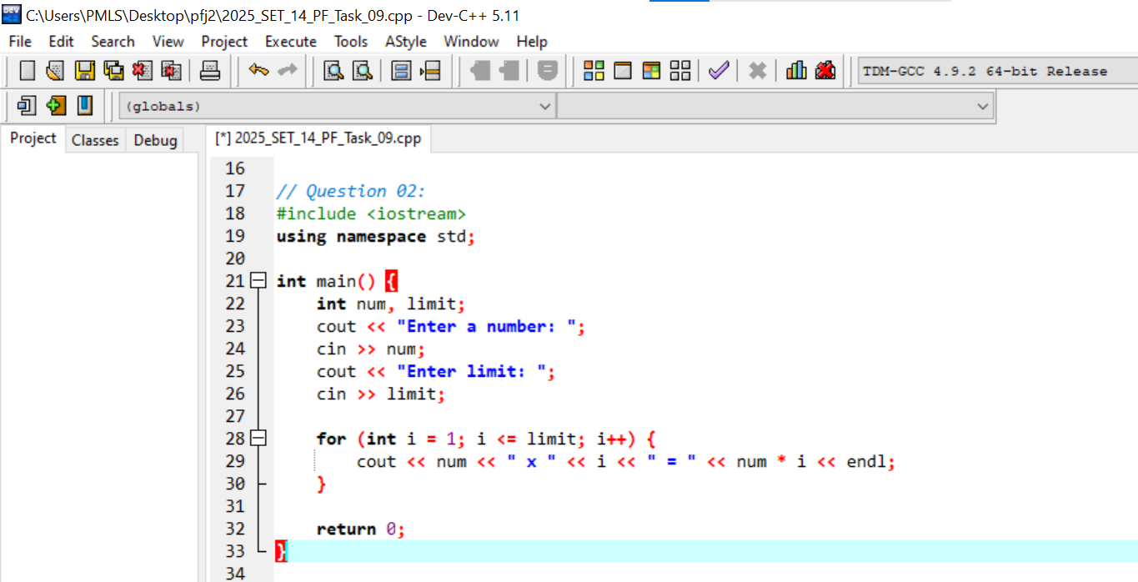
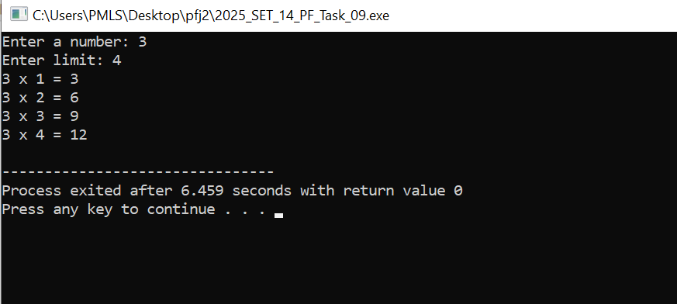

3. Write a program that reads a set of integers and then finds and prints the sum of the even and odd integers.
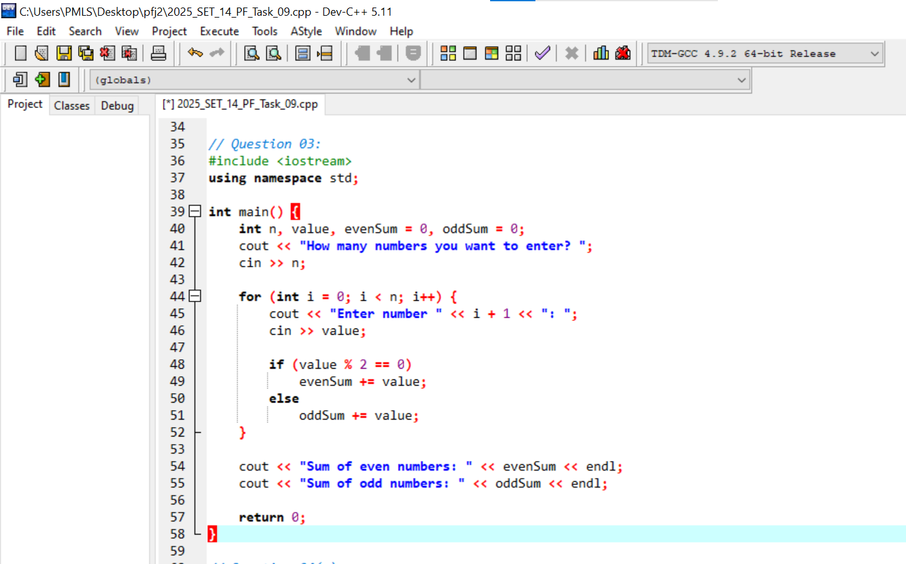
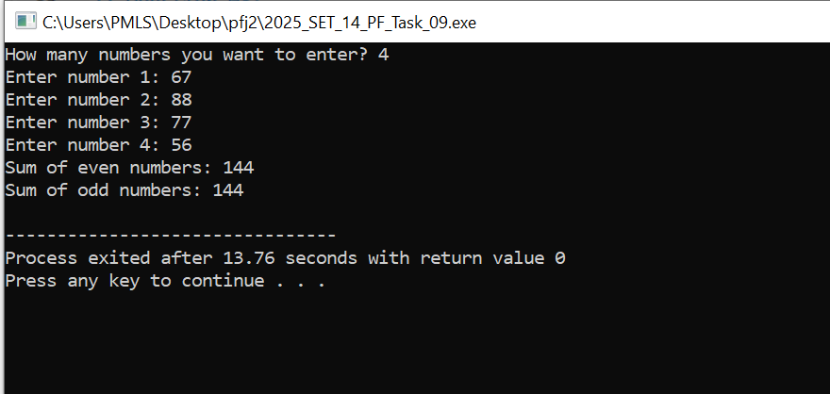
4. The population of town A is less than the population of town B. However, the population of town A is growing faster than the population of town B. Write a program that prompts the user to enter the population and growth rate of each town. The program outputs after how many years the population of town A will be greater than or equal to the population of town B and the populations of both the towns at that time. (A sample input is: Population of town A 5000, the growth rate of town A 4%, population of town B 8000, and growth rate of town B 2%.) (Make choice: use for and also while loop)
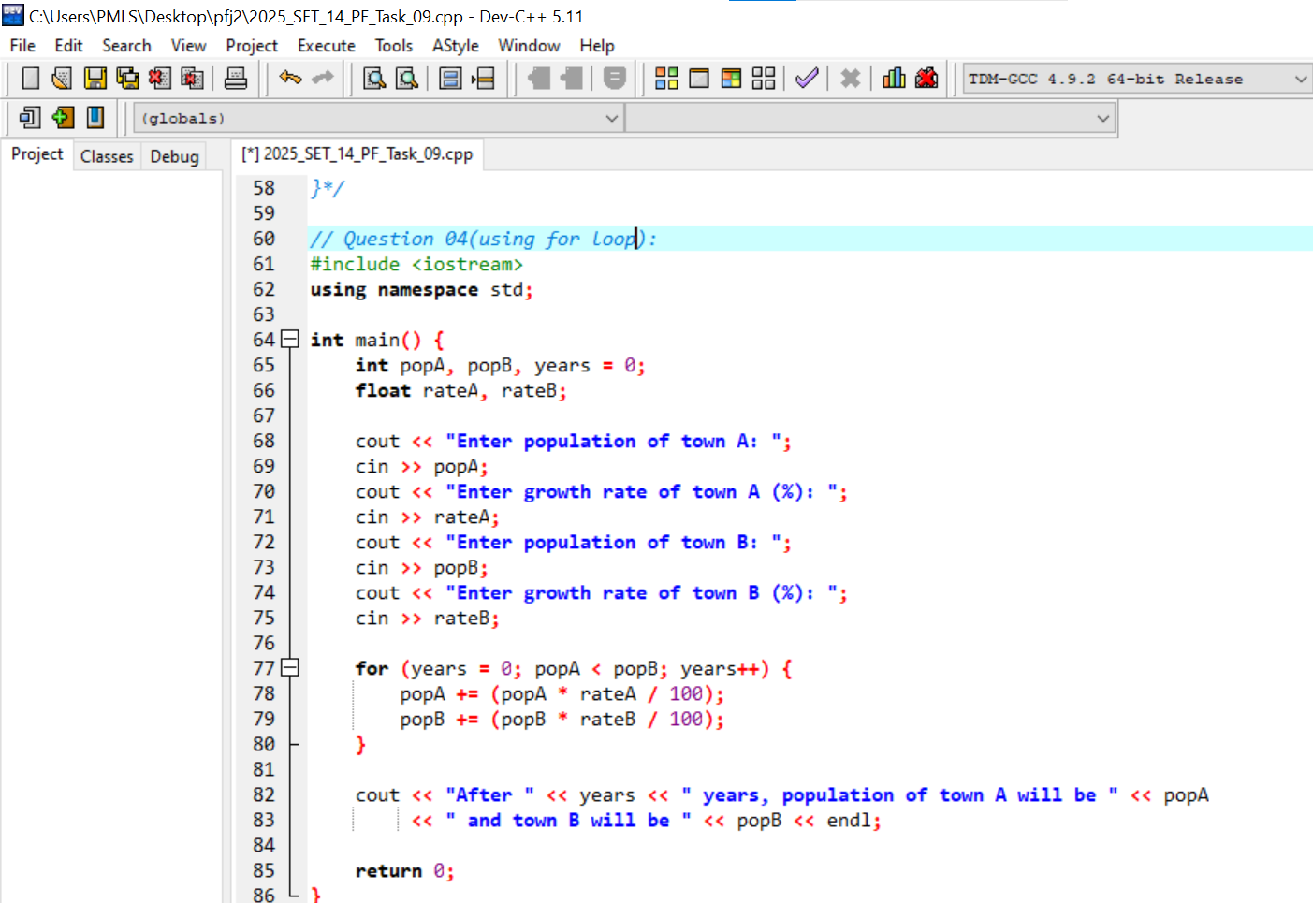
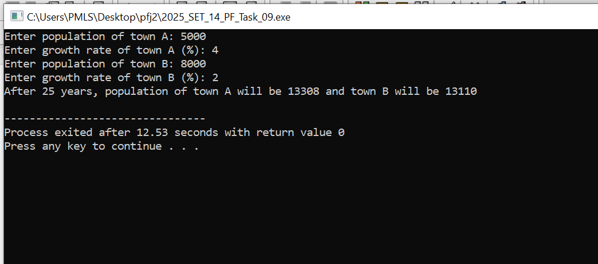
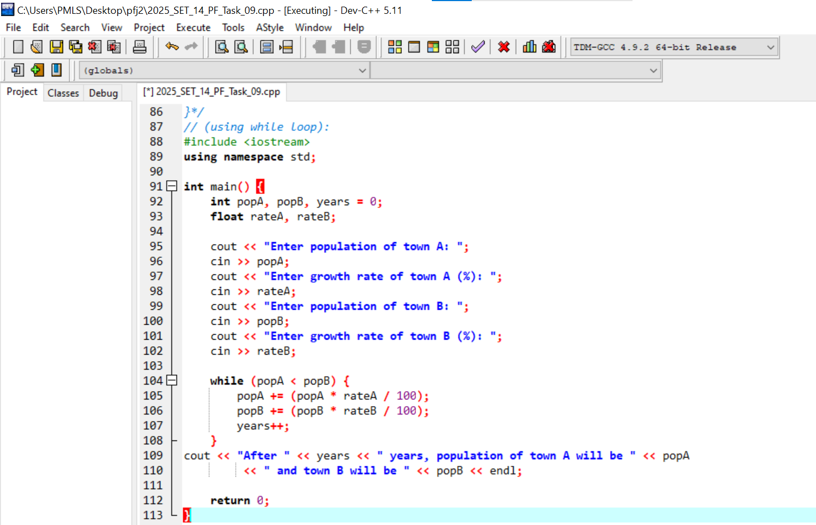
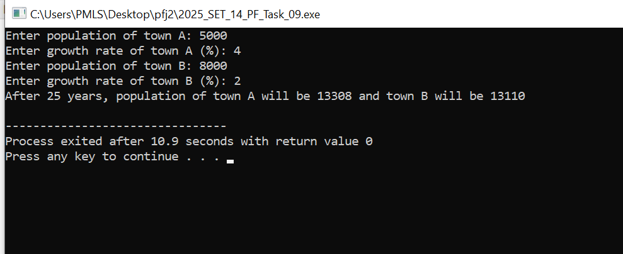
5. A weather station is building a system to record and analyze the daily temperature for a week. Your task is to develop a program that: Prompts the user to enter the temperature for each of the 7 days (Monday to Sunday). Calculates and displays the average temperature of the week. Displays the highest temperature recorded during the week.



