THE UNIVERSITY OF AZAD JAMMU AND KASHMIR, MUZAFFARABAD
DEPARTMENT OF SOFTWARE ENGINEERING

Name: | Ghazanfar Rasheed
Roll No: | 2025-SET-14
Course: | Programming Fundamentals
Submitted To: | Engr. Zeeshan Rashid
Lab Task no: | 10
Session: | 2025-29
Semester: | 1st

Lab Objectives
The objective of this lab is to learn how to use loops in C++ to perform repetitive tasks efficiently.
Lab Task of While loop.
Write a program to display first ten natural number using while loop.
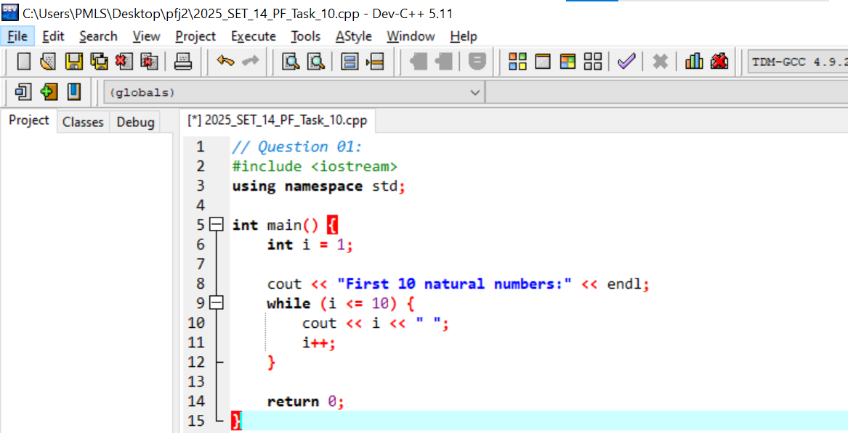
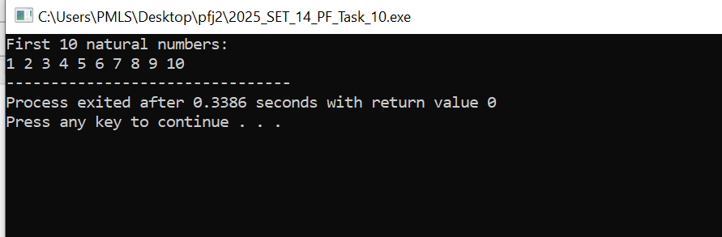

Write a program to display sum of first ten natural number using while loop.
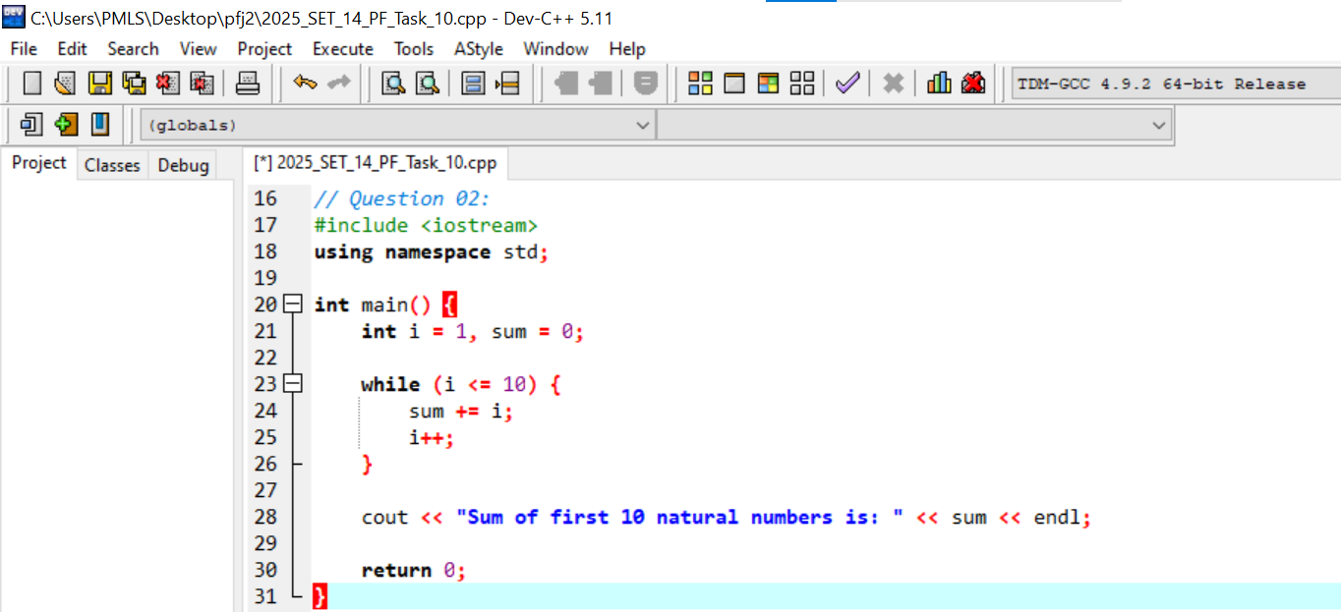
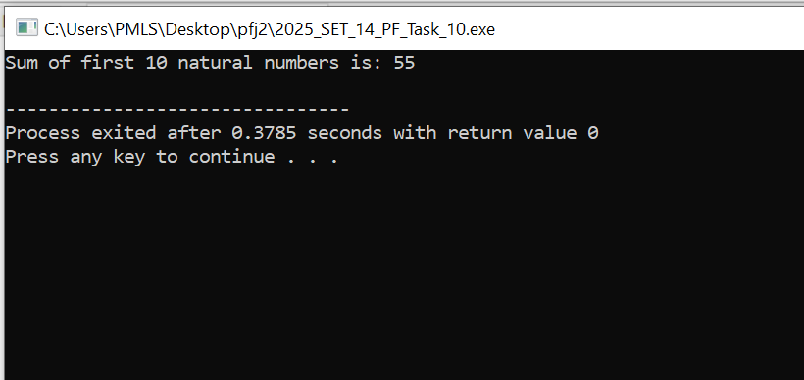

Write a program to display multiplication table of a number entered by user.
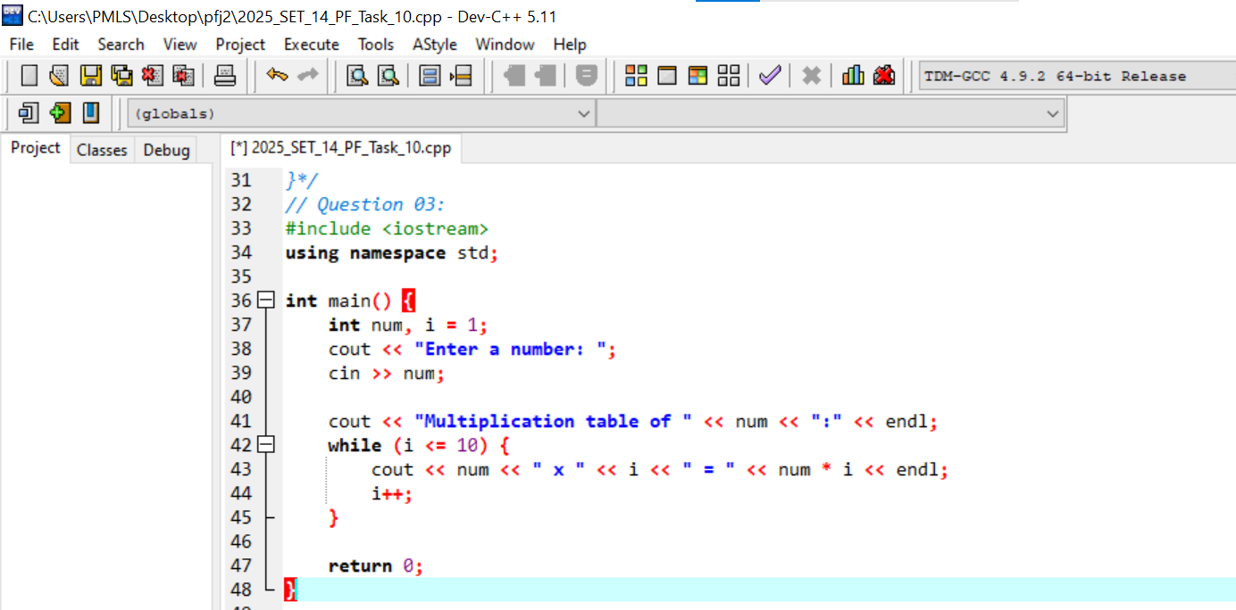
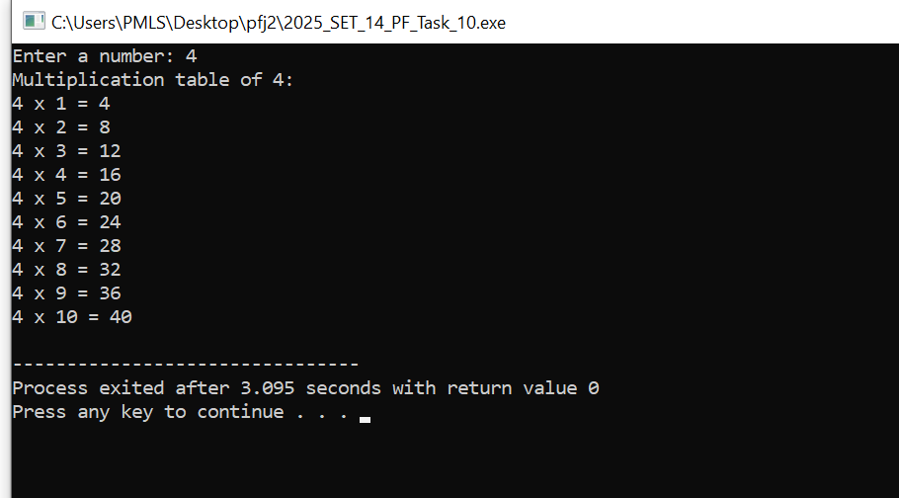

Write a program to find factorial of a number input by user. Hint Factorial n = 1*2*3*4…n
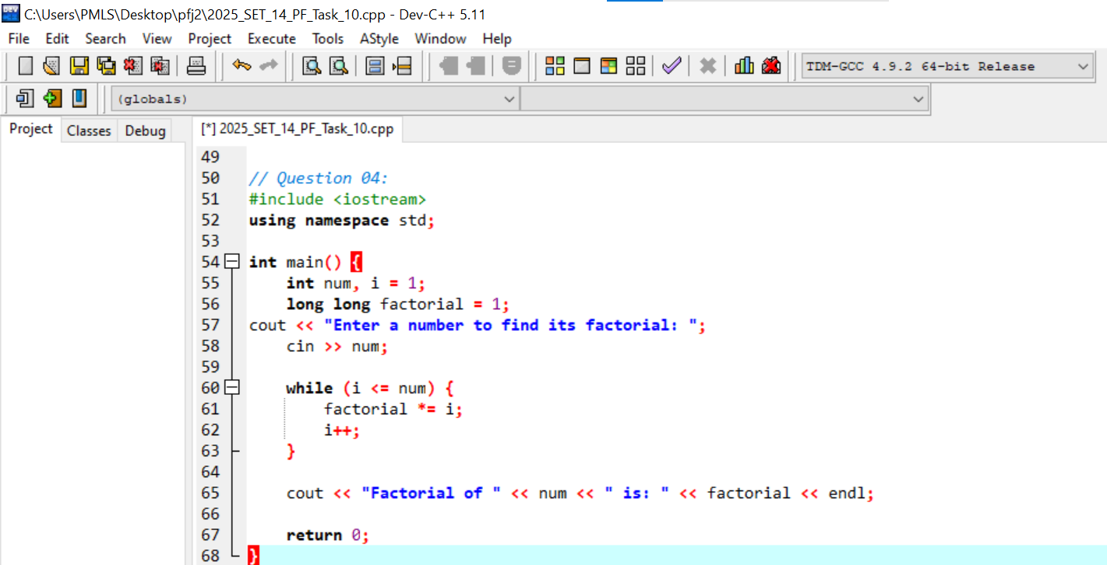
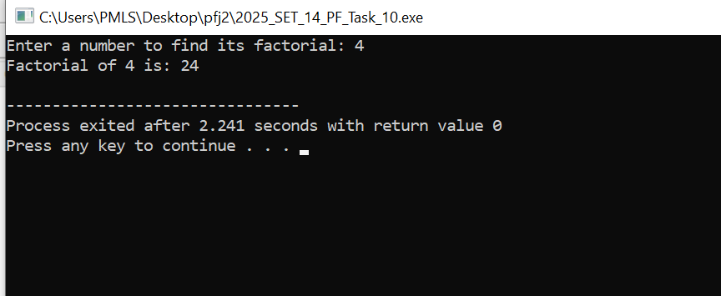

Write a program to find all factors of the number input by user.




