THE UNIVERSITY OF AZAD JAMMU AND KASHMIR, MUZAFFARABAD
DEPARTMENT OF SOFTWARE ENGINEERING

Name: | Ghazanfar Rasheed
Roll No: | 2025-SET-14
Course: | Programming Fundamentals
Submitted To: | Engr. Zeeshan Rashid
Lab Task no: | 11
Session: | 2025-29
Semester: | 1st

Lab Objectives
Lab Task of Array .
- Write C++ program to store and calculate the sum of 5 numbers entered by the user using arrays.
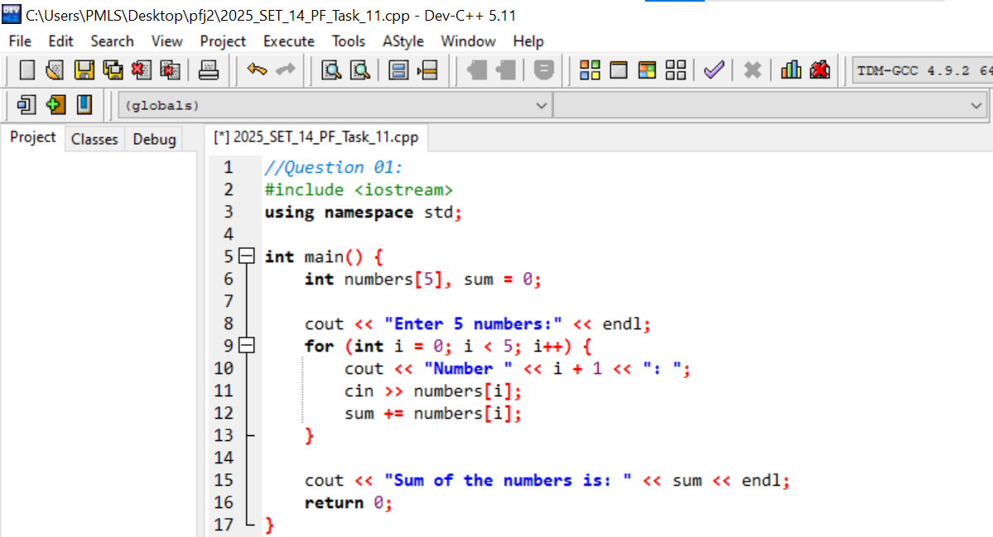
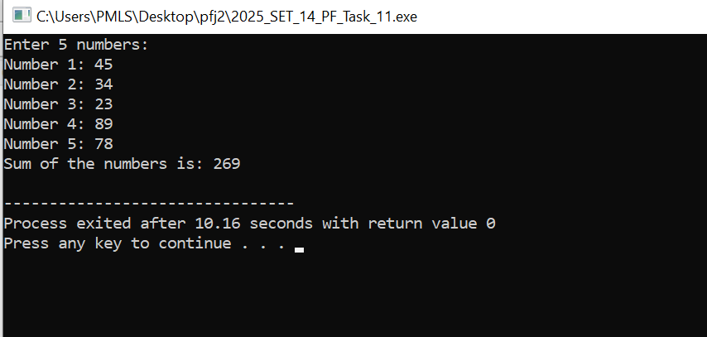

2. Write a program that calculates the average of numbers using arrays with following requirements
• The program should ask user to enter the number of data ( how many number he wants to take average of).
• User should be able to enter the 1-100 numbers .If user enter zero number or more than 100 number .Program should prompt an error message and ask user to enter number again between 1-100.
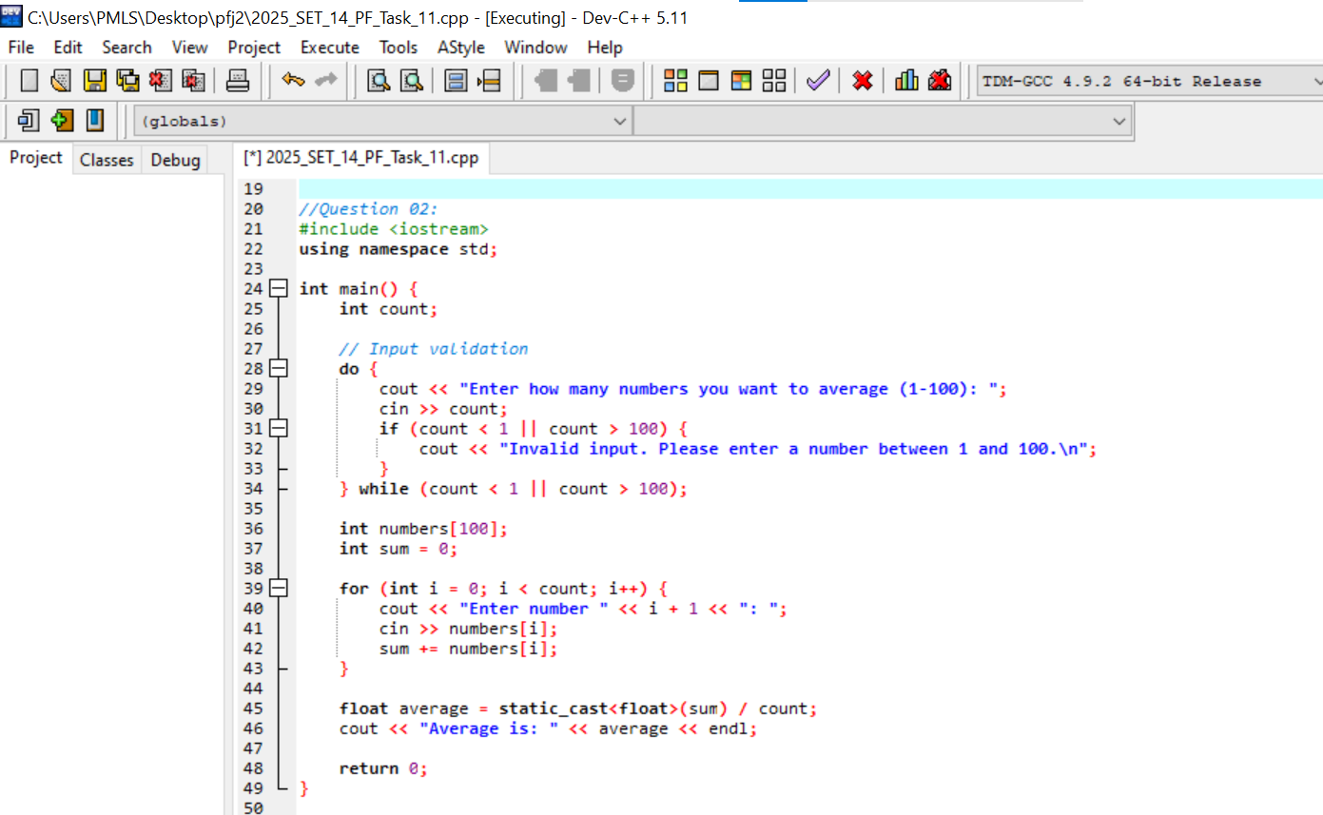
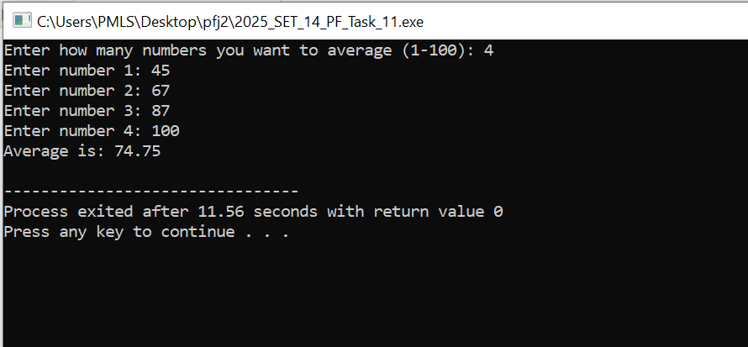
- Write a program to display largest numbers from the array inputted by user.



