THE UNIVERSITY OF AZAD JAMMU AND KASHMIR, MUZAFFARABAD
DEPARTMENT OF SOFTWARE ENGINEERING

Name: | Ghazanfar Rasheed
Roll No: | 2025-SET-14
Course: | Programming Fundamentals
Submitted To: | Engr. Zeeshan Rashid
Lab Task no: | 12
Session: | 2025-29
Semester: | 1st

Lab Task of User defined functions (pass by value)
- A company gives bonuses to employees based on their performance ratings.
If an employee’s rating is:
5 → 20% Bonus
4 → 10% Bonus
3 → 5% Bonus
Below 3 → No Bonus
Write a C++ program that includes:
A function calculateBonus() that accepts salary and rating (pass by value) and calculates the bonus amount.
A function displayBonus() that displays the employee's bonus and final salary after adding the bonus. The main() function should take input from the user and call the functions accordingly.
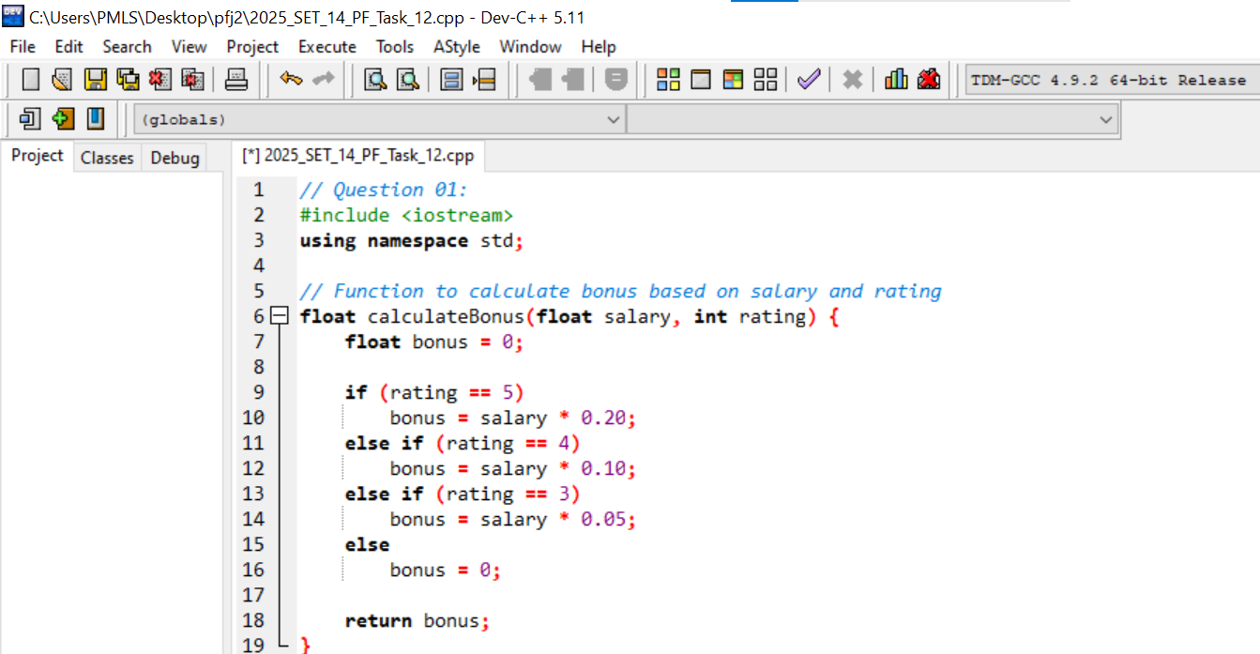
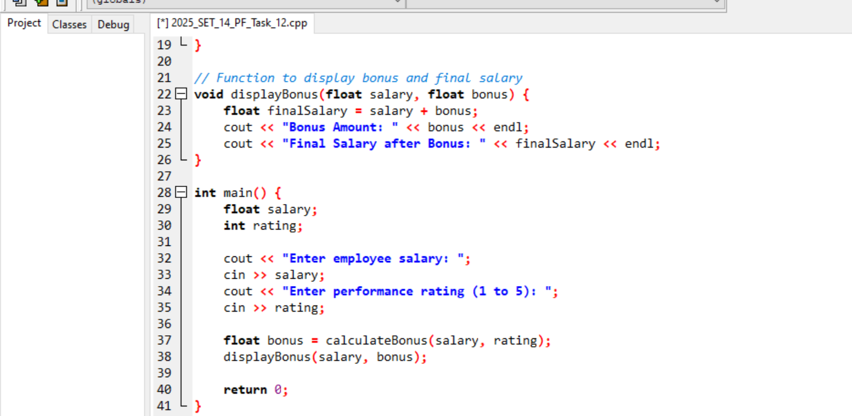
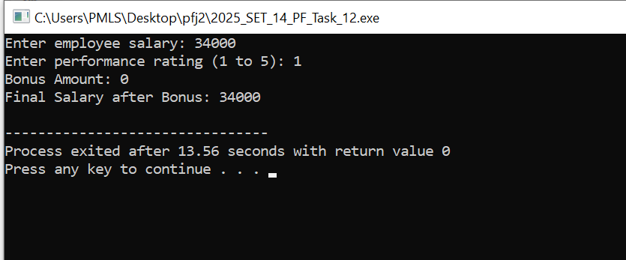
2. Write a C++ program that includes:
1. A function calculatePercentage() that takes 5 subject marks (pass by value) and calculates.
2. A function displayResult() that displays the percentage and grade:
≥90% → "A+"
80-89% → "A"
70-79% → "B"
60-69% → "C"
Below 60% → "Fail





