Dubai Airport Car Rental — Phase 0 Report
Project Foundation & Architecture — Completion Report
Prepared for: Hassan Raza (CEO)
Prepared by: Bliss — Development Team
Project: Dubai Airport Car Rental Platform (website + admin dashboard)
Supabase project: Apex Logistics (renamed for this project)
Date: 24 August 2026

1. Executive Summary
Phase 0 established the technical foundation for the Dubai Airport Car Rental platform: the frontend project scaffold, the complete database schema, security policies, and documentation. No customer-facing booking screens, admin dashboard, or payment integration were built in this phase — that is intentional. Phase 0's job was to get the ground underneath those features right first, so later phases can move quickly without rework.
Following the business model review, the booking workflow was updated and Phase 0 was built directly against the revised rules: booking happens only on the website, WhatsApp is a support channel only, the customer supplies their own driver, and coverage stays Dubai-only. The schema, security policies, and documentation all encode these rules explicitly.
The foundation has been verified end-to-end against a real, live Supabase project (“Apex Logistics”) — not just tested locally. Screenshots of that live verification are included in Section 9.

2. Updated Business Rules — As Implemented
Rule | How it's enforced
Website = Booking | The only booking channel. bookings.booking_channel is constrained at the database level to 'website' — a bad integration cannot silently insert a booking from anywhere else.
WhatsApp = Support Only | No booking tables or flows reference WhatsApp. A complaints table exists to log support/rental-issue conversations that happen over WhatsApp.
Customer Provides Driver | A drivers table captures the driver details the customer submits per booking. There is no company-driver assignment table anywhere in the schema.
Coverage = Dubai Only | The locations table (pickup/drop-off points) has no emirate or country field — multi-region support is out of scope until a future Expand phase.

3. Architecture Selected
Frontend: React 19 + TypeScript + Vite + Tailwind CSS 4 + React Router. Backend: Supabase (PostgreSQL + Auth + Storage), with no separate database introduced. The small set of operations that must never be trusted to the client directly — such as confirming a payment or an admin-only bulk action — are designed to run as Supabase Edge Functions using the service-role key, which never reaches the browser. A placeholder Edge Function (health) is in place to establish that pattern for later phases.
This shape was chosen over standing up a separate Node/Express API because Supabase's Postgres + Row Level Security already covers almost everything the platform needs directly from the client, safely. Introducing a second backend service was judged unnecessary at this stage.

Technology Stack
Layer | Choice
Frontend framework | React 19 + TypeScript
Build tool | Vite 8
Styling | Tailwind CSS 4
Routing | React Router
Database | Supabase PostgreSQL (single database — no other DB introduced)
Auth | Supabase Auth (customers + admin roles)
File storage | Supabase Storage (public vehicle images, private driver documents)
Privileged server logic | Supabase Edge Functions (TypeScript / Deno)

4. Database Schema
13 tables were created, covering every domain area the admin dashboard and customer journey will need. Full column-level detail lives in docs/DATABASE.md inside the project; this is the summary.
Table | Purpose
admin_profiles | Staff/admin accounts and roles (super_admin, staff).
customers | Renters. Supports both signed-in and future guest checkout.
drivers | Customer-supplied driver details, per booking.
vehicle_categories | Economy / Luxury (today's ~35% / ~65% fleet split).
vehicles | The fleet.
vehicle_images | Public vehicle photos.
pricing | List price vs. client price, per vehicle, per rental term.
locations | Pickup/drop-off points — Dubai only.
bookings | The reservation itself; double-booking is blocked at the database level.
booking_status_history | Automatic audit trail of every status change.
payments | Payment records — writable by admins/Edge Functions only.
complaints | Structured record of a WhatsApp support conversation.
audit_logs | Append-only log for sensitive admin-side changes.

5. Security & Access Control
- Row Level Security is enabled on all 13 tables — nothing is readable or writable except through an explicit policy.
- Two credential tiers: a public anon/publishable key for the frontend (safe because RLS still applies), and a service-role key used only inside Edge Functions, never shipped to the browser.
- Driver documents (license, ID) are stored in a private Storage bucket — the uploading customer can write, only admins can read. Vehicle images are the only public bucket.
- A database exclusion constraint prevents two active bookings from overlapping on the same vehicle — verified functionally (Section 9).

6. Verification & Testing Performed
Check | Result
Production build (tsc + vite build) | Clean — 0 errors
Lint (oxlint) | Clean — 0 issues
Dev server startup | HTTP 200 confirmed
Migration applied to a local test Postgres 16 instance | 0 errors — all 13 tables, enums, RLS policies, and storage buckets created
Double-booking guard (functional test) | Confirmed — overlapping booking correctly rejected with a constraint violation
Status-history trigger (functional test) | Confirmed — booking status change logged automatically
RLS enabled on all tables (functional test) | Confirmed
Migration + seed applied to the live Supabase project | Confirmed — see Section 9
Frontend confirmed connected to the live project | Confirmed — see Section 9

7. Files Delivered
44 files, committed to a local git repository and copied into the dubai-airport-rental folder on your Desktop:
- Frontend scaffold — src/ (App shell, Supabase client, typed database types, placeholder booking/admin feature folders)
- supabase/migrations/20260824000000_phase0_foundation.sql — the full schema, RLS policies, and storage bucket setup
- supabase/seed/seed.sql — starter reference data (vehicle categories, airport locations)
- supabase/config.toml and supabase/functions/health/ — Supabase CLI project structure and the Edge Function pattern
- docs/ARCHITECTURE.md, docs/DATABASE.md, docs/SETUP.md — full technical documentation
- .env.example — environment variable template with public vs. server-only variables clearly separated

8. Live Verification
The migration and seed data were applied directly to the live Supabase project (org: GhazanfarGw's Org, project: Apex Logistics) via the Supabase SQL Editor, and the running application was confirmed connected:
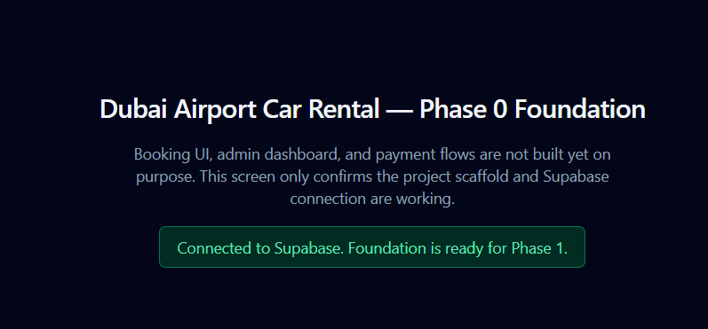

9. What's Ready for Phase 1
The domain schema, security policies, storage buckets, and Edge Function pattern are in place for the next phase to build directly against: the customer booking journey (search → vehicle select → customer/driver details → payment → confirmation), the admin dashboard (fleet, bookings, customers, driver-document review, payments, pricing, complaints, reports), and the WhatsApp support integration.
As instructed, Phase 1 has not been started. This report is the sign-off point — Phase 1 begins on your confirmation.

