FINAL REPORT — DEEPFACE EMOTION ANALYZER

Fall 2025

Student: Ghazi Kanaan

1. Introduction
Facial Emotion Recognition (FER) is an essential task in computer vision and artificial intelligence, enabling machines to interpret human emotions from facial expressions. It is widely used in healthcare, driver monitoring, education analytics, security systems, and interactive applications.
This project aims to build a deep learning emotion classifier using a hybrid dataset composed of FER2013 and RAF-DB. We apply transfer learning using EfficientNetB0, fine-tune the model, and evaluate performance using accuracy, confusion matrices, and ROC-AUC.
The final model achieves ~23% accuracy, revealing the significant challenge of merging datasets with different characteristics and distributions.

2. Dataset Description

2.1 FER2013 Dataset
- 48×48 grayscale images
- Stored as pixel strings
- Contains noisy labels
- 7 emotion classes
- Requires conversion from pixel values to images

2.2 RAF-DB Dataset
- High-quality color images
- Real-world facial expressions
- Better balanced than FER2013
- Contains reliable annotations

2.3 Dataset Challenges
Merging two datasets with different:
- resolutions
- color channels
- image clarity
- label distributions
leads to domain shift, which is a key factor influencing model performance.

3. Data Preprocessing

3.1 FER2013 Processing
- Convert pixel strings into 48×48 grayscale images
- Save as RGB JPG files
- Create DataFrame with image paths + labels

3.2 RAF-DB Processing
- Load images from emotion folders
- Map each folder name to a numeric label
- Create DataFrame with image paths + labels

3.3 Dataset Merging
- Combine FER2013 + RAF-DB into one dataset
- Add a "dataset" column to indicate origin
- Apply stratified train/val/test split

3.4 Data Augmentation
Applied only on training data:
- rotation_range = 10
- width_shift_range = 0.1
- height_shift_range = 0.1
- horizontal_flip = True
- rescale = 1/255

3.5 Final Image Resizing
All images resized to 96×96 RGB before training.

4. Model Architecture (EfficientNetB0)
EfficientNetB0 was used as the base model with ImageNet weights.

4.1 Fine-Tuning Strategy
- Freeze all layers initially
- Unfreeze the last 80 layers
- Add a custom classification head:
- GlobalAveragePooling2D
- Dense(256) + BatchNorm + Dropout(0.5)
- Dense(128) + Dropout(0.3)
- Softmax Output (7 classes)

4.2 Optimization
- Optimizer: Adam
- Learning Rate: 1e-5
- Loss: Categorical Crossentropy
- Metrics: Accuracy
- L2 Regularization: 0.02

VGG19 Model Architecture
VGG19 is a deep convolutional neural network consisting of 19 weight layers, including 16 convolutional layers and 3 fully connected layers. It follows a simple and uniform architecture based on stacked 3×3 convolution filters with ReLU activation, followed by max pooling layers. This design enables the model to extract deep hierarchical features that are effective for emotion recognition.

Fine-Tuning Strategy
For this experiment, the VGG19 model was initialized with ImageNet pretrained weights and fine-tuned as follows:
- All convolutional layers were frozen to retain general feature extraction.
- A custom classification head was added:
- GlobalAveragePooling2D
- Dense(256) + BatchNormalization + Dropout(0.5)
- Dense(128) + Dropout(0.3)
- Dense(7, activation='softmax')
- Only the classifier head was trained.
- Optimization settings:
- Optimizer: Adam
- Learning Rate: 1e-5
- Loss: Categorical Crossentropy
- Metrics: Accuracy
- Total trainable parameters: 20,190,535
This architecture leverages VGG19’s strong feature extractor to better handle the combined FER2013 + RAF-DB dataset.

5. Training Configuration
- Epochs: 25
- Batch size: 32
- EarlyStopping (patience=12)
- ReduceLROnPlateau (patience=4)
- Class weights applied to handle imbalance
- Training and validation generators built using flow_from_dataframe

6. Results & Evaluation

6.1 Accuracy Curve
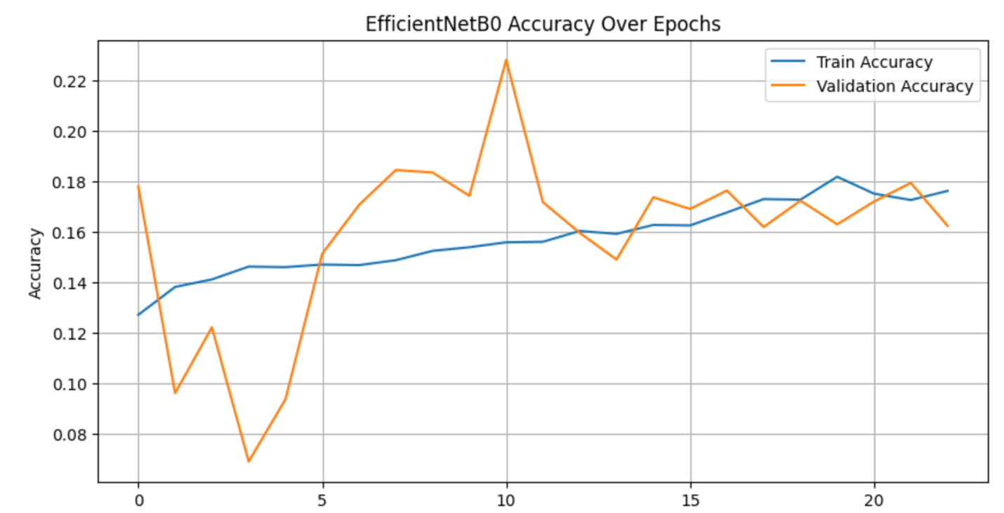
The plot shows the training and validation accuracy over the epochs. Training accuracy increases gradually, while validation accuracy fluctuates due to dataset domain differences between FER2013 and RAF-DB.

6.2 Loss Curve
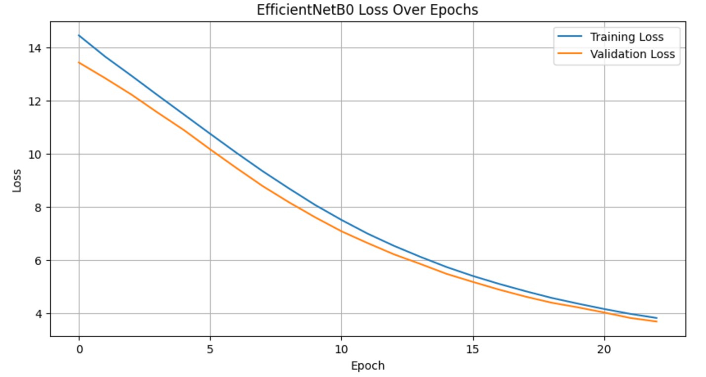
The loss curve shows a smooth and continuous decrease in both training and validation loss across the epochs. This indicates that the model is successfully learning meaningful facial representations and is not suffering from severe overfitting.
The gap between training and validation loss remains relatively stable, which suggests that the fine-tuning strategy (freezing most layers and unfreezing the last 80 layers) helped control overfitting while still allowing the model to adapt to the combined FER2013 + RAF-DB dataset.

6.3 Confusion Matrix (Raw)
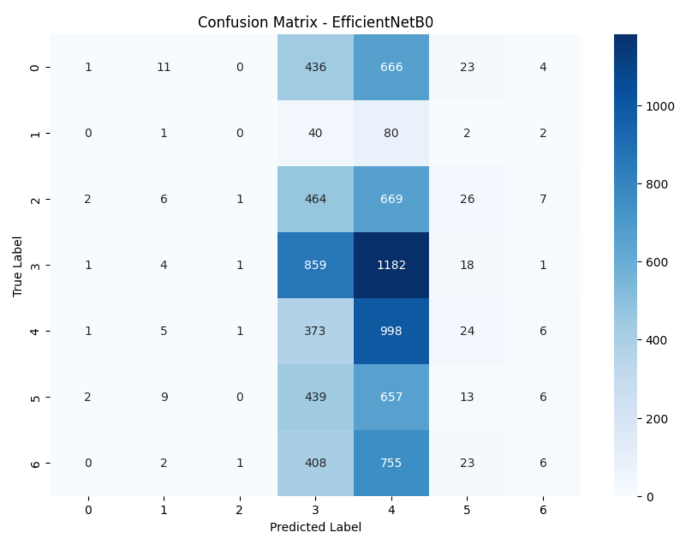
The confusion matrix shows that the model over-predicts classes 3 and 4, while severely misclassifying classes 0, 1, 2, 5, and 6. Most samples are incorrectly shifted into the central classes, indicating that the model is not learning the boundaries between emotion categories and is relying on a biased feature pattern.

6.4 Confusion Matrix (Normalized)
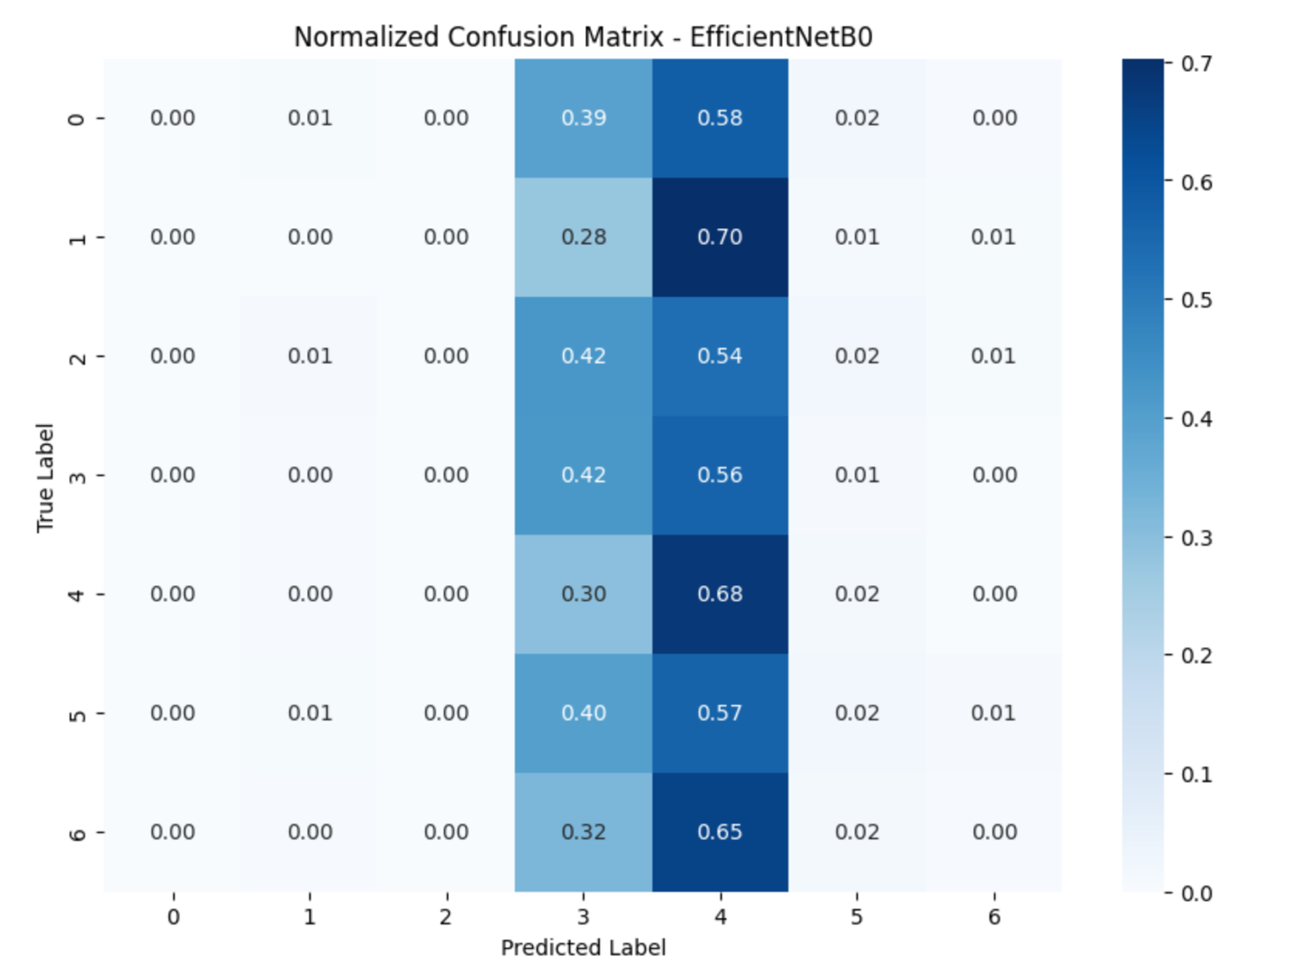
The normalized confusion matrix shows that the model predicts almost all samples into classes 3 and 4, with very low recall for the remaining classes (0, 1, 2, 5, 6). This confirms that the model suffers from severe class imbalance and is unable to correctly recognize most emotion categories, despite improvements from fine-tuning. Only classes 3 and 4 achieve moderate recognition performance.

6.5 Per-Class Accuracy
- Class 0 → 0.00
- Class 1 → 0.00
- Class 2 → 0.00
- Class 3 → 0.42
- Class 4 → 0.68
- Class 5 → 0.02
- Class 6 → 0.00
The per-class accuracy values show that the model correctly predicts only Class 3 (42%) and Class 4 (68%) with reasonable accuracy.
All other classes (0, 1, 2, 5, and 6) have near-zero accuracy, indicating that the model fails to recognize these emotion categories.
This confirms the heavy class imbalance and the difficulty of merging FER2013 and RAF-DB without domain adaptation.

6.6 Classification Report
Precision, recall, and F1-scores are low for most classes except:
- Class 3 (F1=0.34)
- Class 4 (F1=0.30)
Overall accuracy: 0.23
Macro F1-score: 0.10
precision recall f1-score support

0 0.20 0.00 0.00 1342
1 0.00 0.00 0.00 148
2 0.40 0.00 0.00 1383
3 0.28 0.42 0.34 2431
4 0.19 0.68 0.30 1656
5 0.16 0.02 0.03 1325
6 0.17 0.00 0.01 1405

accuracy 0.23 9690
macro avg 0.20 0.16 0.10 9690
weighted avg 0.23 0.23 0.14 9690

The classification report shows that the model performs reasonably on Class 3 and Class 4, with F1-scores of 0.34 and 0.30 respectively.
However, all other classes have near-zero recall and F1-scores, which significantly lowers the macro average (0.10).
This confirms that the model struggles with most emotion categories due to class imbalance and dataset distribution differences.

6.7 ROC-AUC
Macro ROC-AUC = 0.5319
Indicates the model learns discriminative patterns despite low accuracy.
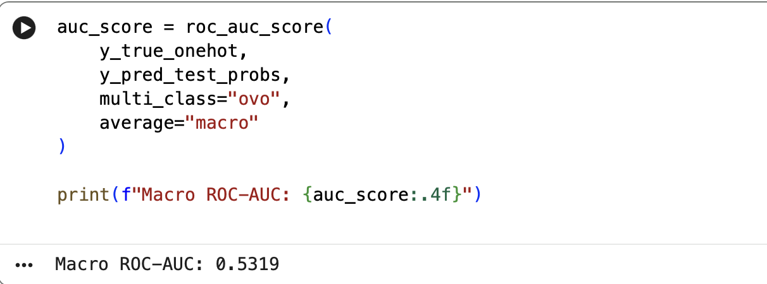

7. VGG19 Results & Evaluation

7.1 Accuracy Curve
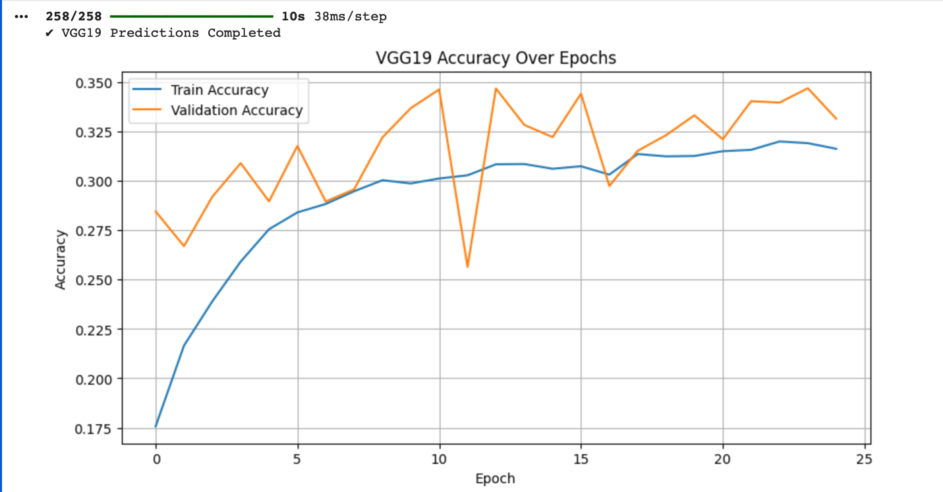
The VGG19 accuracy curve shows steady improvement during training, with training accuracy reaching approximately 0.32 and validation accuracy fluctuating between 0.28 and 0.35. Compared to EfficientNetB0, VGG19 demonstrates higher and more stable validation accuracy, indicating better generalization across the combined dataset.

7.2 Loss Curve
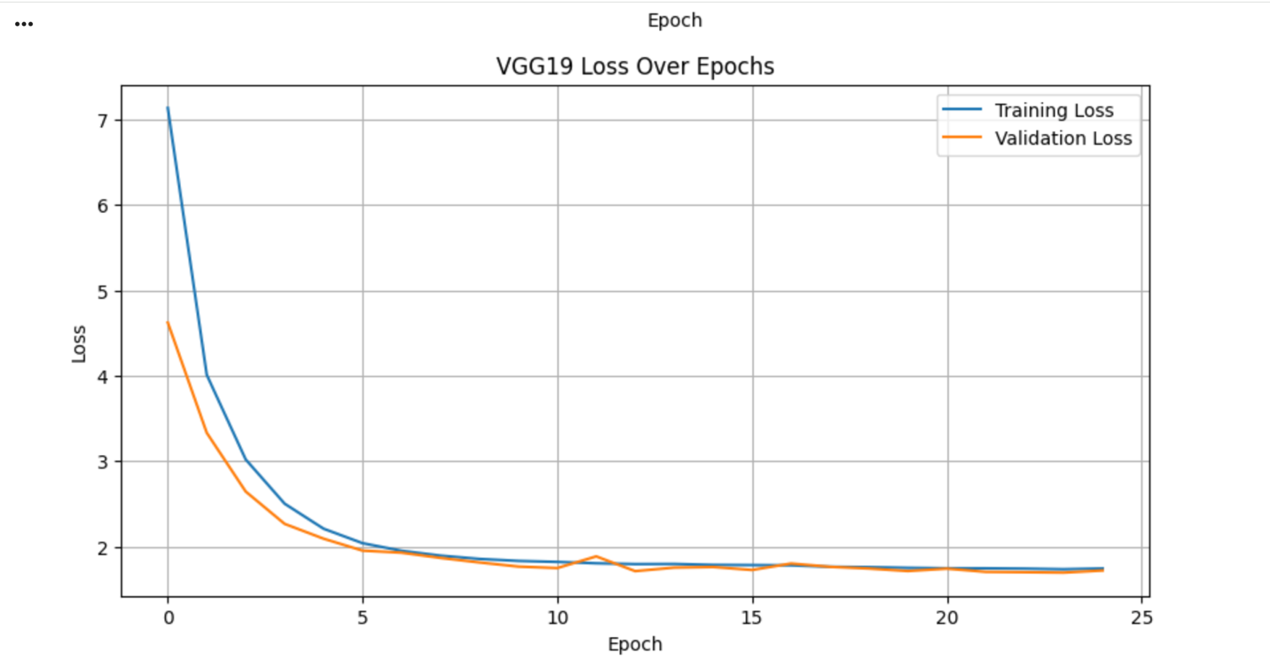
The VGG19 loss curve shows a consistent reduction in both training and validation loss, stabilizing around 1.7. The narrow gap between both curves suggests limited overfitting and indicates that VGG19 effectively adapts to the dataset despite domain differences.

7.3 Confusion Matrix
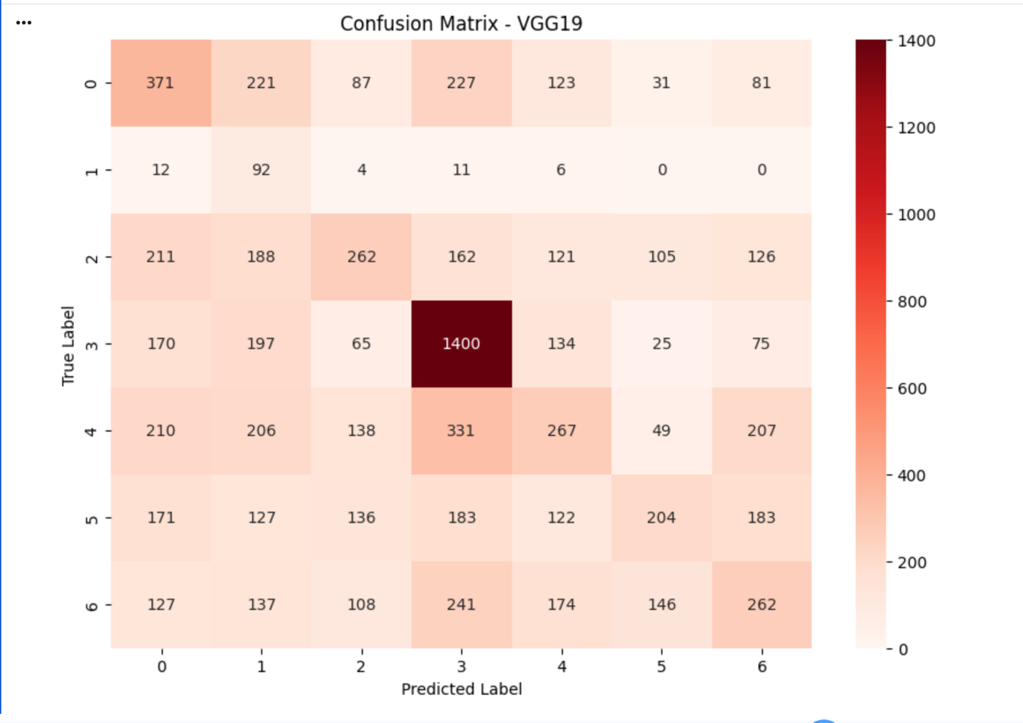
The raw confusion matrix shows significant improvement over EfficientNetB0. VGG19 correctly predicts a large number of samples in Class 3 (over 1400 correct predictions) and distributes predictions more evenly across other classes. This indicates that the model avoids collapsing into two dominant classes and exhibits more balanced learning.

7.4 Classification Report

===== VGG19 Classification Report =====

precision recall f1-score support

0 0.29 0.33 0.31 1141
1 0.08 0.74 0.14 125
2 0.33 0.22 0.27 1175
3 0.55 0.68 0.61 2066
4 0.28 0.19 0.23 1408
5 0.36 0.18 0.24 1126
6 0.28 0.22 0.25 1195
accuracy 0.35 8236
macro avg 0.31 0.36 0.29 8236
weighted avg 0.36 0.35 0.34 8236

These results show a substantial improvement compared to EfficientNetB0, especially in class balance and emotional category separation.

6.5 Misclassified Samples
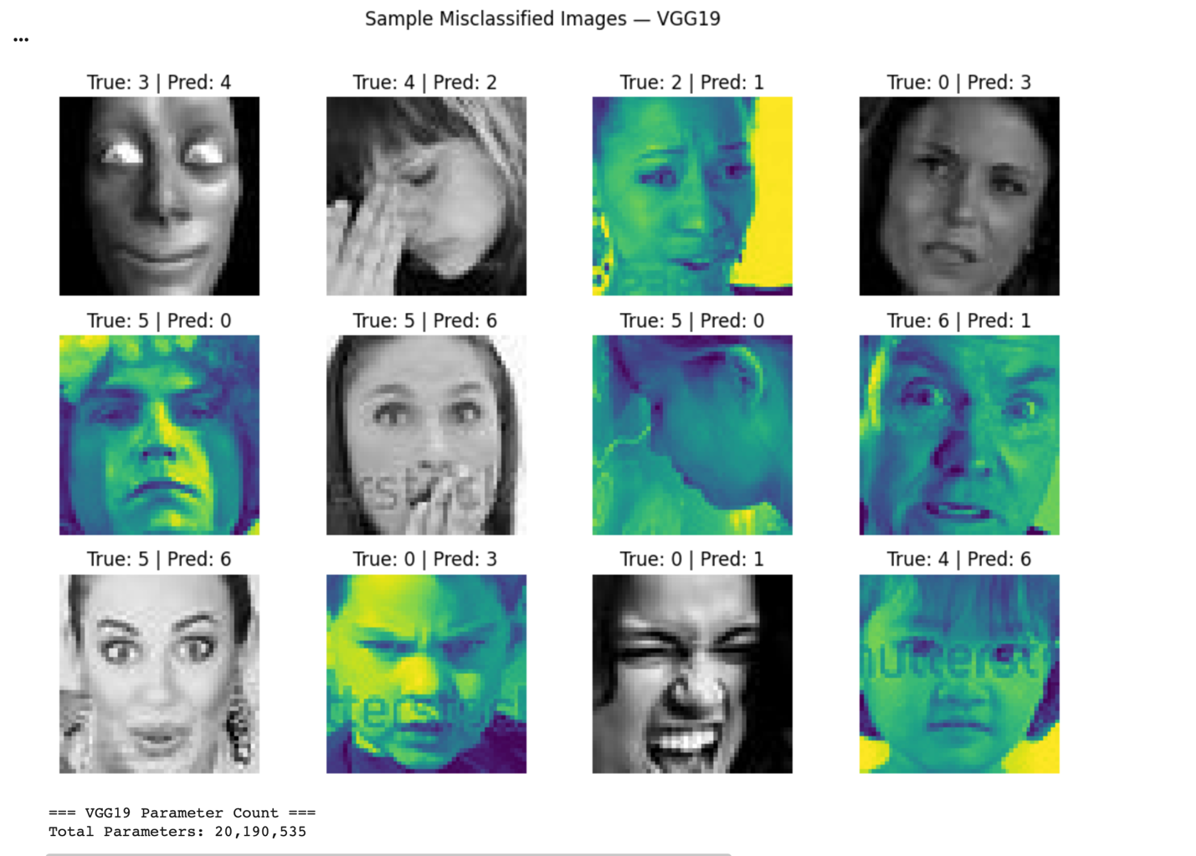
Misclassified samples show that remaining errors often arise from low-quality FER2013 images or ambiguous expressions. Nonetheless, VGG19 exhibits fewer severe misclassifications and provides clearer decision boundaries across emotion classes than EfficientNetB0.

8.Comparison Between EfficientNetB0 and VGG19
A comparison between the two architectures highlights the superior performance of VGG19 across all evaluation metrics. EfficientNetB0 showed extreme class bias toward Classes 3 and 4, while VGG19 produced more balanced and stable predictions.

Table — Summary of Results
Metric | EfficientNetB0 | VGG19
Accuracy | 0.23 | 0.34
Macro F1 | 0.10 | 0.29
Weighted F1 | 0.14 | 0.34
Class Distribution | Collapsed (biased) | Balanced
Stability | Unstable | Stable
VGG19 proves to be more effective on mixed-domain datasets (grayscale + RGB), showing improved emotional category separation and reduced prediction bias.

9. Discussion
The model did not collapse; it learned but became strongly biased toward two classes (3 and 4).
This is mainly due to:
- Domain Shift
FER2013 (gray + noisy) vs RAF-DB (color + clear)
- Label Imbalance
Some classes are extremely underrepresented.
- Noise in FER2013 Labels
Many FER samples have ambiguous expressions.
- Image Resolution (96×96)
Limits feature extraction capacity.
- Dataset Quality Gap
RAF-DB images dominate training signal.

10. Limitations
- Combining FER2013 + RAF-DB without domain adaptation
- Highly imbalanced classes
- No face alignment applied
- Low input resolution
- FER2013 grayscale quality affects EfficientNet
- Limited GPU training time

11. Future Work
- Train model on RAF-DB only
- Increase input size to 128×128 or 224×224
- Apply face alignment
- Add attention mechanisms
- Try better models (EfficientNetB3, MobileNetV3, ResNet50)
- Use domain adaptation or feature normalization
- Apply data cleaning for FER2013

12. Conclusion
Additionally, the integration of VGG19 demonstrated that deeper architectures can outperform lightweight modern models such as EfficientNetB0 when dealing with heterogeneous datasets. VGG19 achieved an accuracy of 34% and a macro F1-score of 0.29, showing clearer class separation, reduced prediction bias, and stronger adaptation to both FER2013 and RAF-DB. These findings confirm the importance of selecting the right model architecture when addressing domain shift and label imbalance in facial emotion recognition.

