# Driver Behavior Analysis

1.INTRODUCTION :

In the field of traffic and transport, road traffic safety, efficiency and environment are major issues. In order to deal with these issues, a creative approach could be to implement suitable advanced driver assistance systems (ADAS). The aim is to support the driver to maintain a safe, efficient and comfortable driving state.

The number of improvements for driver safety has been more than ever yet a significant number of serious accidents still occur all over ther world . those are mostly caused by human mistakes such as typing a text message , speaking someone on the phone , eating and drinking .

So, the control actions that the driver needs to perform are assisted by sensor and computer, the driving behaviors will influence the perception and judgment of the systems.

Classifying human drivers is a very complex task because of the various nuances and peculiarities of human behaviors .

According to current correlative research from home and abroad, the data of driver behavior classifications are divided into two main types:

① the objective experimental data, including vehicles maneuver data (the accelerator, brake pedal, steering wheel, etc.) and motion data (Speed, acceleration, distance headway, headway, etc.).

② the subjective questionnaire data (such as driver behavior questionnaire(DBQ) ).

Driver self-reported investigation as an effective approach to study the driver characteristics has been widely applied on obtaining driver subjective questionnaire data. Especially in the field of psychology and driving traffic accident analysis, driving behavior could be predicted by their preference and subjective assessment of driving style.

2.DESIGN :

A self-reported survey was designed based on the DBQ and some modifications were made to adjust the items for Chinese traffic and driver conditions (e.g. the competitive driving in China is more often than that in other countries, so jumping the queue is taken into account in this self-reported survey).

The questionnaire used in this research included two sections.

1. The driver behavior self-reported survey consisted of 17 items. These questions concerning traffic matters were selected to cover violations of the traffic code, vehicle interaction and the pedestrian-vehicle interaction. Drivers were asked to indicate how often they carried out each of the activities.

(2) Information was also gathered regarding respondents, including gender, age, driving experience, driving time per week, whether the driver occurred in traffic accidents within five years, and so on.

3.data analysis:

Driver self-reported investigation was a common ways to obtain driving psychological, but its disadvantage was that the respondent may not fully understand items in a short time, and this may cause a deviation of statistics results.

4.Driver classification result validation :

Combined with driver accident information, the proportion of the drivers who had a traffic accident within five years in each classification was counted

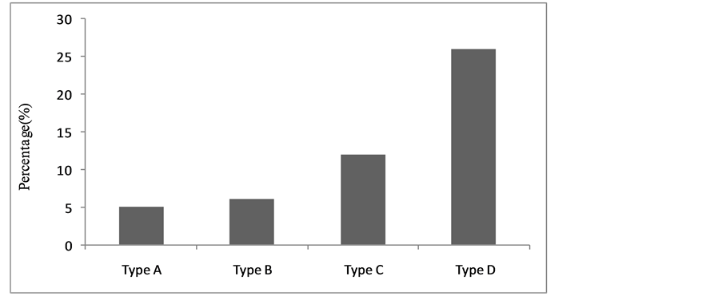

Type A driver (driving style conservative) who had a traffic accident had the lowest percentage, as 5%. The percentages of Type B and Type C were 6% and 12% respectively. However, for Type D driver (driving style aggressive) the proportion was as high as 26%. It showed that there was a correlation between driving style and traffic accident rates. So driver behavior classification in this paper were consistent with actual driving conditions.

5.Gender:

The ratio of driver types in the same gender. For the female driver, Type A and Type B had the more proportion, as 40.4% and 32.6% respectively, but proportion of Type D was only 5.6%. For the male driver, Type D and Type A were shown with higher proportion (30.1%) and lower proportion (21.3%). It is observed that female were more likely than male to careful driving.

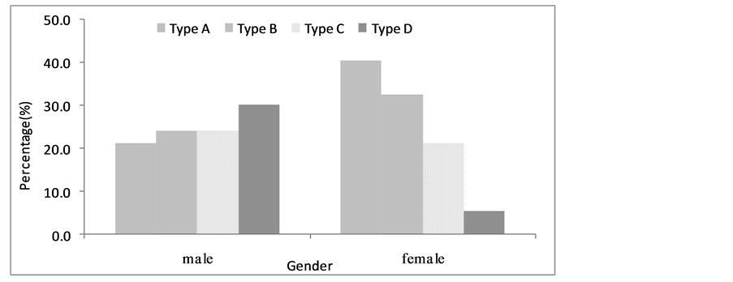

6.Age:

The relationship between age and driver type . The proportion of Type D was 37.8% between 18 - 29 years old, but the proportion of that was only 7% beyond 50 years old. Type A driver of beyond 50 years had the highest proportion, as 50%. We can see that with the increasing of age, the driver has lots of experiences, and driving behavior was careful and moderate.

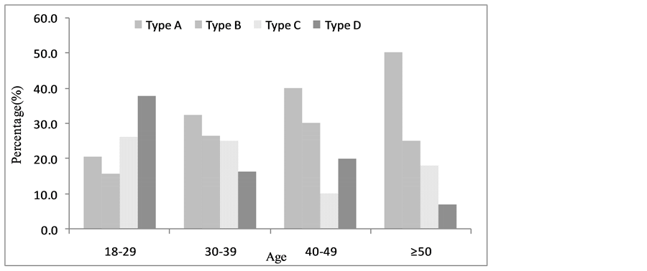

7.driving experience :

The relationship between driving experience and driver type . For drivers with less one years of experience, Type A driver had the highest proportion, which was close to 50%. But the proportion of Type A was only 4.3% for drivers with more ten years of experience. It has shown that with the increase of driving experience, the proportions of Type B, Type C and Type D driver were increased gradually and the proportions of Type A was decreased gradually. To explain such phenomenon, road competitive driving environment

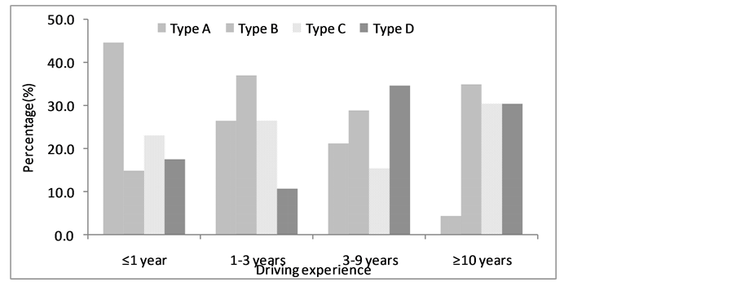

8.driving time per week :

The relationship between driving time per week and driver type. For the driver who has less 5 hours of driving time a week, Type A driver had the highest proportion (36%), and Type D driver had the smallest proportion (15.2%). For the driver who has 5 - 10 hours of driving time a week, Type B and Type C driver had the high proportion, as 33.9% and 30.4% respectively, the proportion of Type D driver was the smallest. For the driver who has 10 - 15 hours of driving time a week, Type B had the high proportion, as 50%. For the driver who has 15 - 20 hours of driving time a week, Type A had the high proportion, as 33.3%. It has shown that differences in driving time per week have no significant effect on driver ratio of each type.

