1. Experiments
  - Dataset Description
We use the PetFinder Pawpularity Score dataset from Kaggle which contains 9912 cat and dog images. Each image is associated with a Pawpularity score in the range [1, 100], derived from normalized page-view statistics. In addition to images, the dataset provides 12 binary metadata attributes describing visual and contextual properties of the image. The brief details of all the input tabular data as well as output Pawpularity is described in Table 1 .
Table 1 Dataset Description
S. No | Field | Type | Values | Description
1 | Subject Focus | Binary | {0,1} | Pet stands out against uncluttered background, not too close / far
2 | Eyes | Binary | {0,1} | Both eyes are facing front or near-front, with at least 1 eye / pupil decently clear.
3 | Face | Binary | {0,1} | clear face, facing front or near-front
4 | Near | Binary | {0,1} | Single pet taking up significant portion of photo (roughly over 50% of photo width or height)
5 | Action | Binary | {0,1} | Pet in the middle of an action (e.g., jumping)
6 | Accessory | Binary | {0,1} | Accompanying physical or digital accessory / prop (i.e. toy, digital sticker), excluding collar and leash.
7 | Group | Binary | {0,1} | More than 1 pet in the photo
8 | Collage | Binary | {0,1} | (with digital photo frame, combination of multiple photos)
9 | Human | Binary | {0,1} | Human in the photo
10 | occlusion | Binary | {0,1} | Specific undesirable objects blocking part of the pet (i.e. human, cage or fence). Note that not all blocking objects are considered occlusion
11 | Info | Binary | {0,1} | Custom-added text or labels (i.e. pet name, description)
12 | Blur | Binary | {0,1} | Noticeably out of focus or noisy, especially for the pet’s eyes and face. For Blur entries, “Eyes” column is always set to 0
13 | Pawpularity | Integer/Discrete numbers | {1,100} | The Pawpularity Score is derived from each pet profile's page view statistics at the listing pages, using an algorithm that normalizes the traffic data across different pages, platforms (web & mobile) and various metrics.

  - Implementation Detail
All the experiments have been conducted on single NVIDIA GeForce RTX 4080 GPU 16GB with RAM 64 GB. EfficientNet is used as the convolutional baseline, and Swin Transformer applied on image data as the transformer-based backbone. All image models are initialized with the pretrained ImageNet weights for vision backbones. Training is performed with Adam optimizers and learning rate scheduler. Tree-based models for metadata including LightGBM and the Support Vector Regressor (SVR) meta-learner are implemented. The experiments till Exp9 as shown in Table 3 are evaluated on Out of Fold (OOF) data using root means squared error (RMSE) by five (5) fold Cross validation without a separate test split due to limited data availability of 9912 records. Each model was trained and evaluated on different folds of the dataset and final RMSE is calculated using all those 5-fold models predictions.
  - Experimental Design
This section introduces a stagewise experimental study to answer the following research question, RQ1: Which combinations of pipeline components contribute most to Pawpularity prediction performance?
To address this question, we conducted a structured stage-wise ablation study by decomposing the Pawpularity prediction pipeline into six stages as shown in Table 2. The goal is to isolate and quantify the contribution of each component by keeping fixed all the other components for single component comparison whenever possible.
Since Transformers are memory intensive, due to their heavier computational requirements , transformer models are trained using a batch size of 12 and optimized with BCE Loss. For a fair backbone comparison in stage 2, EfficientNet‑B4 is also trained under the same conditions, using a batch size of 12 and BCE Loss only. In other experiments for EfficientNet model, optimal hyperparameter of Batch Size 32 and MSE Loss is found and applied across all experiments involving EfficientNet, while Transformers consistently remain at batch size 12 with BCE Loss. For comparisons between experiments, only the component of the stage under investigation is varied, while all other stages are held fixed. For example, when comparing Exp3 and Exp8_1 to evaluate the backbone stage, all other settings remain identical except for the backbone choice. Similarly, when assessing the effect of metadata through early fusion, the backbone (e.g., EfficientNet) is trained under the same batch size and conditions across both experiments to ensure a fair comparison.

  - Pipeline Stages Definitions
The overall pipeline is decomposed into six stages, each with clearly defined options in Table 2.
Table 2 Pipeline Stages Definitions
Stage | Code | Option | Description | What this stage tests
Stage 1  Augment  AndRes | S1-A | 256 + Lite Aug | Resize to 256×256 with light augmentation | Sensitivity to input resolution
 | S1-B | 384+Strong Aug | Resize to 384×384 with strong augmentation | Robustness to visual perturbations
Stage 2  Backbone | B1 | EfficientNetB0 OR EfficientB1 | Lightweight CNN backbone | Performance of small CNN models
 | B2 | EfficientNetB4 | Larger CNN backbone with increased depth and width | Effect of model capacity and scaling in CNN architectures
 | B3 | Swin Transformer | Hierarchical vision transformer with shifted windows | Impact of transformer-based architectures versus CNNs
Stage 3  Metadata | T0 | None | Tabular not included | Image only learning baseline
 | T1 | MLP | Multi-layer perceptron applied to input features | Feature Embedding effect on Fusion
 | T2 | Light GBM | Gradient boosting decision tree model | Effectiveness of tree-based models
Stage 4  Fusion | F0 | None | Single-backbone features used independently (B1, B2, or B3) | Image backbone performance
 | F1 | Early Fusion | Metadata inclusion via early fusion | Benefit of joint Image features and metadata features learning
 | F2 | Late Fusion | Late fusion of independently trained predictors | Ensembling effect of independent metadata and Image backbone model
Stage 5  Head/  Loss | H1 | Single head | Single linear prediction head | Image backbone effect without non linear head
 | H2 | MLP | Multi layer perceptron prediction head | Benefit of added non linearity at output stage
 | Loss | MSE or BCE | Mean Squared Error, Binary Cross Entropy | Sensitivity to loss formulation
 | Metric | RMSE | Root means square error for evaluation | Overall performance
Stage 6  Ensemble | E0 | Single model | Single Model | Single Model Performance
 | E1 | Multi-model ensemble (backbone or CV) | Vision backbone ensemble or Cross Fold ensemble | Collective ensemble models performance
 | E2 | Support Vector Regressor (SVR) | Two-stage model with meta-learner trained on OOF predictions | Effectiveness of learned ensembling for generalization

    - Pipeline Architecture
The overall architecture as shown in Figure 1 takes both image data and metadata as inputs. Image data is processed through vision backbones EfficientNet models or the Swin Transformer, which are fine-tuned on the Pawpularity score to extract meaningful visual representations. On the other hand, metadata is feed into Multi-Layer Perceptron (MLP) for early fusion and a Gradient Boosting Decision Tree (GBDT) model LightGBM for late fusion. In the early fusion strategy, the vision backbones produce embedding rather than prediction scores, while the MLP transforms metadata into a 64-dimensional embedding. These embeddings are concatenated and passed through additional MLP layers for joint training. In the late fusion strategy, the image models and metadata models are trained independently, and their prediction scores are combined using a weighted average. For cross validation ensemble, the predictions are simple average fivefold models while for the SVR meta learner, predictions are directly predicted from both models prediction as input to SVR.
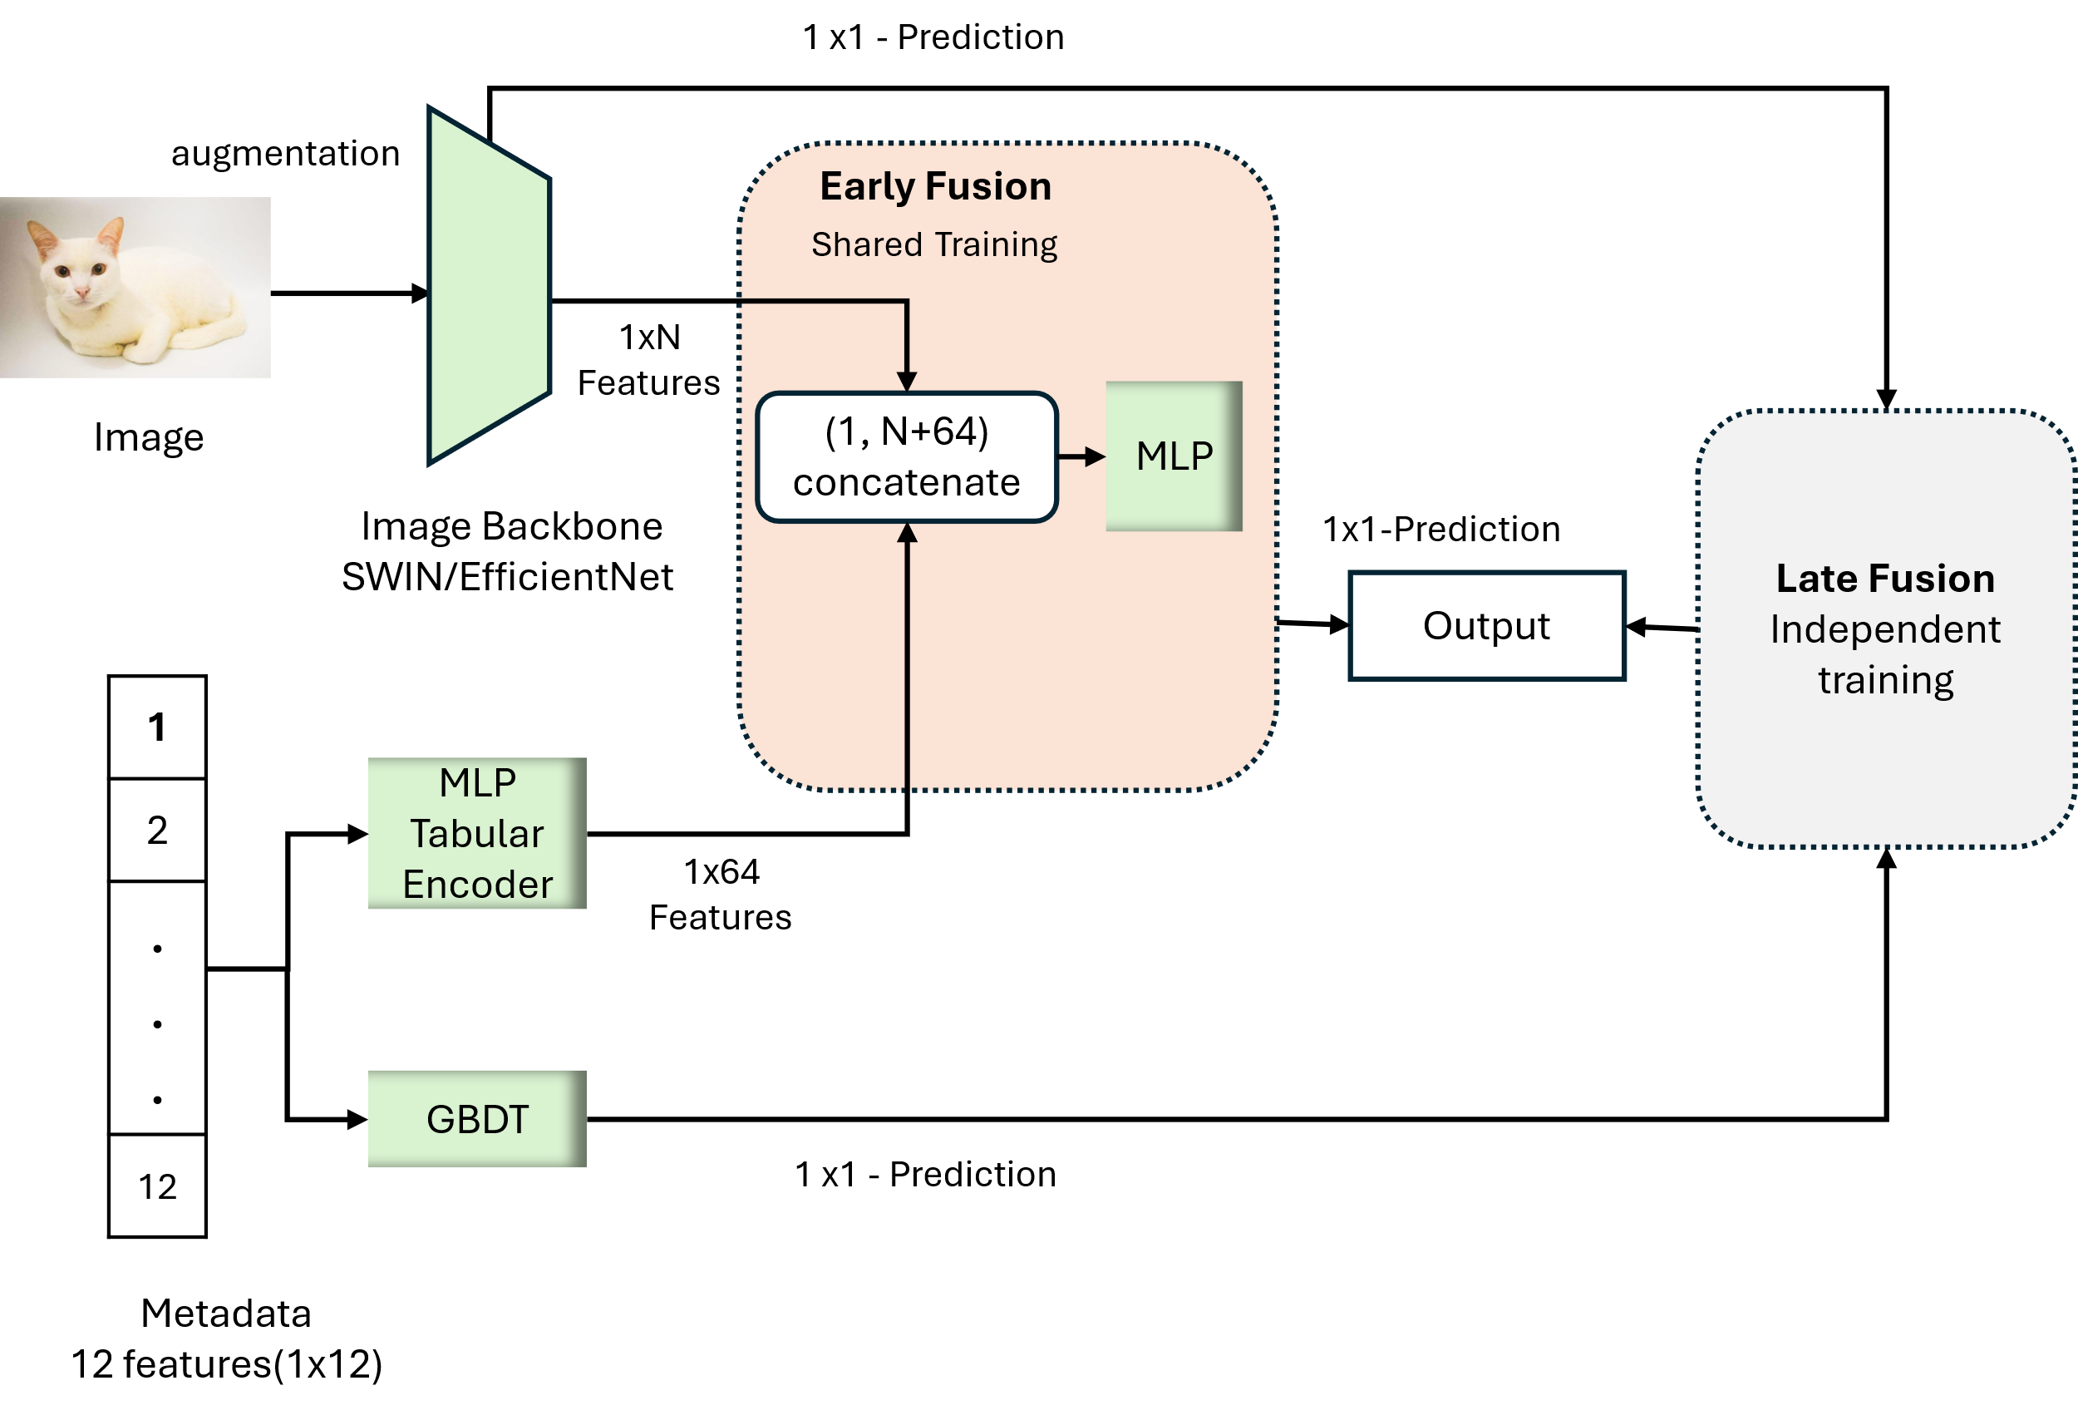
Figure 1 Pipeline

    - Augmentation And Resolution – Stage 1
Dataset augmentation is divided into two categories, light and strong augmentation. For light augmentation, Input Images are randomly flipped horizontally and resized to a fixed resolution. While in the strong augmentation, different variations are added including random Horizontal flipping, rotation, Collor Jittering, Random Affine transformation and random perspective distortions.
    - Backbone – Stage 2
We evaluated convolutional and transformer-based backbones. EfficientNet models are used as CNN based architecture, while SWIN Transformer is picked as transformer-based model.
    - Metadata Fusion – Stage 3 and Stage 4
Metadata is incorporated into the architecture through both early and late fusion strategies. In the early fusion approach, tabular metadata is first processed by a Multi-Layer Perceptron (MLP) and projected into a 64-dimensional embedding. This embedding is then concatenated with the feature representations produced by the Swin Transformer or EfficientNet backbone.

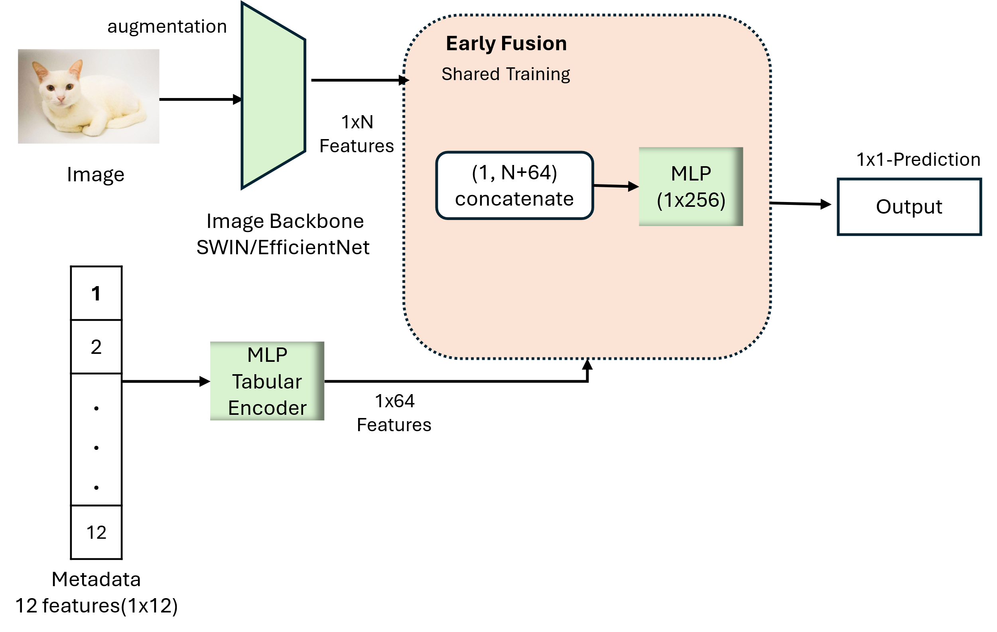  Early Fusion | 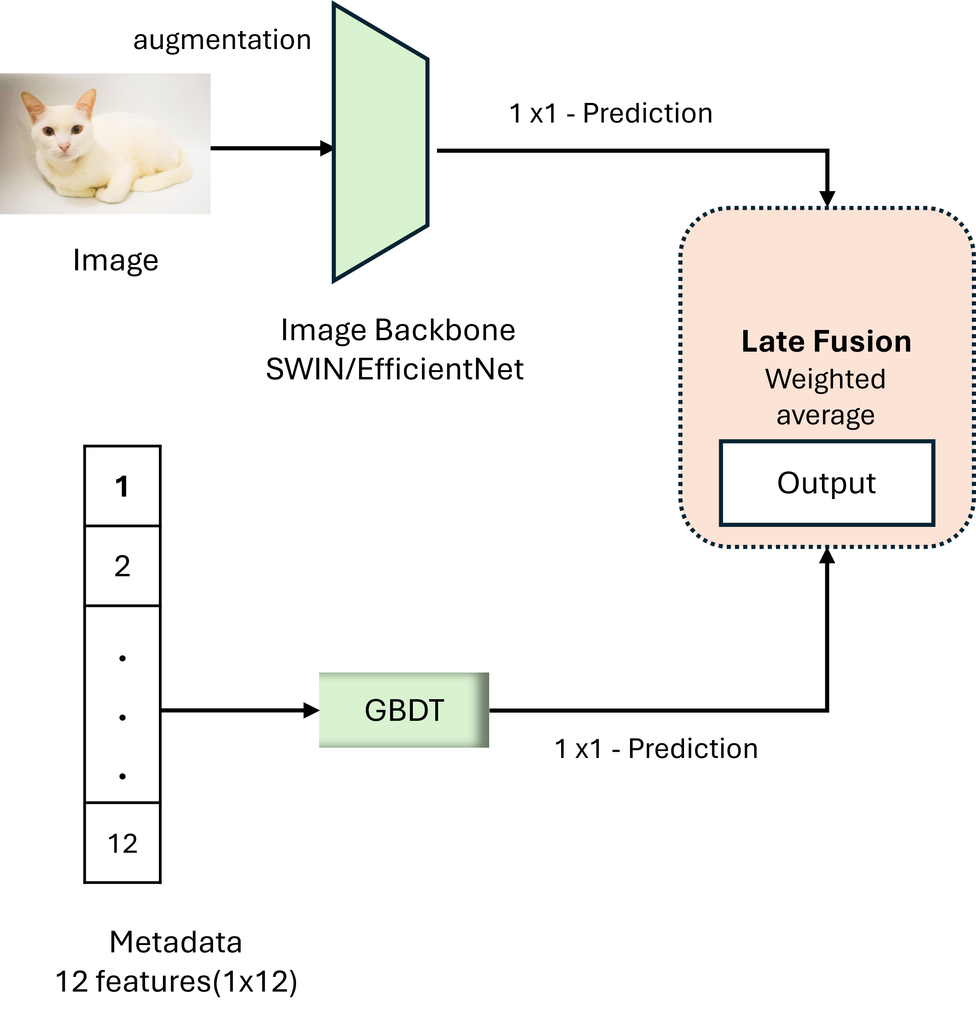  Late Fusion

Figure 2 Early and Late Fusion
For early fusion, The image backbone features are combined with tabular features, allowing the image models to be trained jointly on both visual features and metadata features. For Late Fusion, the both the image model and metadata models are trained independently as shown in Figure 2. Here the metadata is trained with the tree-based model LightGBM while the image models are trained with SWIN Transformer and EfficientNet Model. At the end, predictions can be merged by weighted average, five folds ensemble or meta learner SVR.
    - Loss Change BCE and MSE OR Head– Stage 5
In stage 5 heads, heads and loss are changed and optimized according the CNN backbone and SWIN Transformer.
    - CV Ensemble and Meta Model Learner (Stacked model) – Stage 6
We assessed the single best model out of five folds as well as five models ensemble by average to see the individual as well as collective effect of all folds. Unlike other stages, the data is split to train and test with the ratio of 70% and 30%.
For Meta Model learning, a Swin Transformer model is trained on image data, while a Gradient Boosting Decision Tree (GBDT) model is trained on metadata using 70% of the training set. Five-fold cross-validation is applied, and out-of-fold (OOF) predictions are collected from both models. These OOF predictions are then stacked to form the input for a second-stage Support Vector Regressor (SVR) meta-learner, which is trained to produce the final predictions. During inference, the test data is evaluated by all five-fold-specific models of each backbone. The predictions from the five folds are averaged, resulting in two features swin mean and gbdt mean. SVR is trained on these two models predictions and final output are predicted by SVR.
    - Experiments Configurations
Table 3 provides an explicit mapping between each experiment and its corresponding Stage 1–Stage 6 configuration, ensuring transparency and reproducibility of the ablation logic. For stage 3 Metadata and Stage 4 Fusion are also dependent, so both are combinedly shown in evaluation stage.

Table 3 Experiments Configuration
Exp | Stage 1  Input | Stage 2 Backbone | Stage 3 Metadata | Stage 4 Fusion | Stage 5 Head | Stage 6 Ensemble | Description
Exp0 (code)  RMSE:19.81  Std:0.11 | S1-A | B1 | T1 | F1 | Ridge | E0 | Frozen image embedding + tabular features + Ridge regression
 | Light Augmentation and 256 resolutions | EfficientNetB0  Frozen | MLP | Early Fusion | Ridge | Single Model
Exp1 (code)  RMSE:20.66  Std:0.25 | - | - | T2 | - | - | E0 | Tabular only - LightGBM
 | - | - | Light GBM | - | - | Single Model
Exp2 (code)  RMSE:19.17  Std:0.49 | S1-A | B1 | T0 | - | H1 | E0 | CNN-only baseline
 | Light Augmentation and 256 resolutions | EfficientNetB0 | - | - | Linear Head | Single Model
Exp3 (code)  RMSE:17.71  Std:0.33 | S1-B | B3 | T0 | - | H1 | E0 | SWIN Transformer-only baseline with strong Augmentation
 | Strong Augmentation and 384 resolutions | Swin Transformer | - | - | Linear Head | Single Model
Exp3_1 (code)  RMSE:17.86  Std:0.30 | S1-A | B3 | T0 | - | H1 | E0 | SWIN Transformer-only baseline with light Augmentation
 | Light Augmentation and 256 resolutions | Swin Transformer | - | - | Linear Head | Single Model
Exp3_2  (code)  RMSE:17.92  Std:0.30 | S1-B | B3 | T0 | - | H1, Loss | E0 | SWIN Transformer-only baseline with strong Augmentation and MSE Loss
 | Strong Augmentation and 384 resolutions | Swin Transformer | - | - | Linear Head, MSE Loss | Single Model
Exp4 (code)  RMSE:19.90  Std:0.32 | S1-A | B1 | T1 | F1 | H2 | E0 | EfficientNetB1 and MLP early Fusion
 | Light Augmentation and 256 resolutions | EfficientNetB1 | MLP | Early Fusion | MLP regressor | Single Model
Exp5 (code)  RMSE:17.60  Std:0.16 | S1-B | B3 | T1 | F1 | H2 | E0 | SWIN Baseline and MLP early fusion
 | Strong Augmentation and 384 resolutions | Swin Transformer | MLP | Early Fusion | MLP Regressor | Single Model
Exp6 (code)  RMSE:19.22  Std:0.39 | S1-A | B1 | T2 | F2 | - | E0 | EfficientNetB1 and LightGBM Late Fusion
 | Light Augmentation and 256 resolutions | EfficientNetB1 | Light GBM | Late Fusion | - | Single Model
Exp7 (code)  RMSE:17.64  Std:0.31 | S1-B | B3 | T2 | F2 | – | E0 | Swin Transformer and LightGBM Late Fusion
 | Strong Augmentation and 384 resolutions | Swin Tranformer | Light GBM | Late Fusion | - | E0
Exp8 (code)  RMSE:18.68  Std:0.29 | S1-B | B2 | T0 | F0 | H1 | E0 | High capacity CNN-only and Strong Augmentation
 | Strong Augmentation and 384 resolutions | EfficientNet B4 | - | - | Linear Head | Single Model
Exp8_1 (code)  RMSE:19.06  Std:0.43 | S1-A | B2 | T0 | F0 | H1 | E0 | High Capacity CNN and light augmentation
 | Light Augmentation and 256 resolutions | EfficientNet B4 | - | - | Linear Head | Single Model
Exp8_2  (code)  RMSE:20.60  Std:0.30 | S1-B | B2 | T0 | F0 | H1 | E0 | High capacity CNN-only and Strong Augmentation, BatchSize12, BCELoss
 | Strong Augmentation and 384 resolutions | EfficientNet B4 | - | - | Linear Head | Single Model
Exp9 (code)  RMSE:17.59  Std:0.29 | S1-B | B2 + B3 | T0 | F2 | - | E1 | EfficientNetB4 and SWIN Ensemble
 | Strong Augmentation and 384 resolutions | EfficientNetB4 + SWIN Transformer | - | Late fusion | - | Models Ensemble

To compare the performance of the single best model (selected from 5 folds) with that of the 5‑model ensemble, both approaches must be evaluated on the same records. However, up to Exp9, all reported RMSE values are based on out‑of‑fold (OOF) predictions, where each fold’s records are predicted by a different model trained on the remaining folds.
For this reason, Experiments 5, 10, and 11 in Table 4 were additionally conducted using a 70% training set and a 30% test set. Furthermore, to assess the ensemble’s performance on the test data with a second‑stage meta‑learner, we carried out Experiment 11. Since experiment 5 inference and experiment 11 are evaluated by single model, therefore standard deviation is not applicable without folds and is written with Not Applicable “N/A”.

Table 4 Experiments Configuration (Inclusion of test data)
Exp  (Inference) | Stage 1 (Input) | Stage 2 (Backbone) | Stage 3 (Metadata) | Stage 4 (Fusion) | Stage 5 (Head) | Stage 6 (Ensemble) | Description
Exp5 Inference  (code)  RMSE:17.69  Std:N/A | S1-B | B3 | T1 | F1 | H2 | E0 | SWIN Baseline and MLP early fusion with the best single fold model
 | Strong Augmentation and 384 resolutions | Swin Transformer | MLP | Early Fusion | MLP Regressor | Single Fold best Model
Exp10 (code)  RMSE:17.49  Std: N/A | S1-B | B3 | T1 | F1 | H2 | E1 | SWIN Baseline and MLP early fusion with 5 folds average
 | Strong Augmentation and 384 resolutions | Swin Transformer | MLP | Early Fusion | MLP Regressor | 5 folds average
Exp11 (code)  RMSE:17.61  Std: N/A | S1-B | B3 | T2 | F2 | H1 | E2 | SWIN and LIghtGBM with Support vector Regressor (SVR) as 2nd stage meta learner
 | Strong Augmentation and 386 resolutions | Swin Transformer | LightGBM | Late Fusion | - | Meta Model Stacking (SVR)

2. Results and Ablation
This overviews the stage-wise ablation experiments for the multimodal Pawpularity pipeline. For each stage the table lists, augmentation setting (stage 1), the vision backbone (stage 2), use of tabular metadata (stage 3), fusion type (stage 4), and ensemble configuration (stage 6), together with the mean RMSE and standard deviation over five folds. The ΔRMSE column reports the change in RMSE within each stage when moving from the first to the second configuration. Each stage is analyzed in more detail in the following subsections. As shown in Table 5, all the other components set to fixed except the one in column of Changed Component.

Table 5 Stage Analysis
Stage | Exp | Changed Component | RMSE | Std | ∆RMSE
Stage 1 | Exp8 (code)  (EfficientNetB4) | S1-B  (Strong Augmentation and Resolution) | 18.68 | 0.29 | -0.38
 | Exp8_1 (code)  (EfficientNetB4) | S1-A  Light Augmentation and Resolution | 19.06 | 0.43
 | Exp3 (code)  (Swin Transformer) | S1-B  (Strong Augmentation and Resolution) | 17.71 | 0.33 | -0.14
 | Exp3_1 (code)  (Swin Transformer) | S1-A  Light Augmentation and Resolution | 17.86 | 0.30
Stage 2 | Exp3 (code)  (Swin Transformer)) | B3 | 17.71 | 0.33 | -2.89
 | Exp8_2 (code)  (EfficientNetB4) | B2 | 20.60 | 0.30
 | Exp3 (code)  (Swin Transformer) | B3 and Loss BCE with Batch Size 12 | 17.71 | 0.33 | -0.96
 | Exp8 (code)  (EfficientNetB4) | B2 and Loss MSE with Batch Size 32 (optimized) | 18.68 | 0.29
Stage 3 and Stage 4 | Exp3 (code)  (Swin Transformer) | F0  (No Fusion) | 17.71 | 0.33 | -0.11
 | Exp5 (code)  (Swin Transformer with MetaData) | F1  (Early Fusion) | 17.60 | 0.16
 | Exp3 (code)  (Swin Transformer) | F0  (No Fusion) | 17.71 | 0.33 | -0.07
 | Exp7 (code)  (Swin Transformer with MetaData) | F2  (Late Fusion) | 17.64 | 0.31
 | Exp5 (code)  (Swin Transformer with Metadata) | F1  (Early Fusion) | 17.60 | 0.16 | 0.04
 | Exp7 (code)  (Swin Transformer with MetaData) | F2  (Late Fusion) | 17.64 | 0.31
Stage 5 | Exp3_2 (code)  (Swin Transformer with MSE Loss) | Loss  MSE | 17.92 | 0.30 | 0.21
 | Exp3 (code)  (Swin Transformer) | Loss  BCE | 17.71 | 0.33
Stage 6 | Exp3 (code)  (Swin Transformer) | E0  (Single Model) | 17.71 | 0.33 | -0.11
 | Exp9 (code)  (SWIN+EfficientNetB4) | E1  (Model Level Late Fusion) | 17.59 | 0.29
 | Inference Level for Exp5, Exp10, Exp11 on 30% Test data
 | Exp5 (code)  (Swin Transformer with Metadata at Inference) | E0  (Single Best Fold) | 17.69 | - | -0.19
 | Exp10 (code)  (SWIN Transformer CV Ensemble) | E1  (Fold level average) | 17.49 | -
 | Exp10 (code)  (SWIN Transformer CV Ensemble) | E1  (Fold level average) | 17.49 | - | 0.11
 | Exp11 (code)  (SWIN Transformer CV Ensemble and LightGBM+SVR) | E2  (Meta Model -SVR Stacking) | 17.61 | -

2.1 Augmentation and Resolution - Stage 1
The efficientB4 model RMSE is decreased by 0.38 when high resolution with strong augmentation is applied collectively. However, SWIN is not much affected by the Resolution and Augmentation. This indicates that EfficientNet is CNN-based and resolution sensitive while Swin is patch-based and already models local and global context.

2.2 Backbone - Stage 2
The most impactful component is Backbone change from EfficientNet to Swin model where the RMSE dropped by 2.89 compared to EfficientNet. Swin Outperformed the CNN based model. Even when the EfficientNet is optimized with Batch Size 32 and MSE Loss, the difference 0.96 is still the highest. This suggests that SWIN transformer can see the image as a set of patches and uses multi-head self-attention to capture long-range dependencies whereas EfficientNet relies on local convolutions and pooling, which are less expressive for scene-level images
2.3 Metadata Fusion – Stage 3 and Stage 4
The early metadata infusion and late fusion are analyzed. However, it has not significant effect which shows that the metadata does not have enough signal and contains binary values with very weak correlations with target, so inclusion of metadata does not improve the overall performance and the RMSE is slightly dropped by 0.07 and 0.11 for early and late fusion respectively.
2.4 Loss Change – Stage 5
For Stage 5 (loss formulation), replacing BCE loss with MSE loss on Swin slightly worsens performance and does not improve stability: the Swin model trained with MSE loss (Exp3_2) reaches 17.92 RMSE, compared to 17.71 RMSE with BCE loss in Exp3. This suggests that BCE remains a slightly better-suited loss for Swin on the Pawpularity regression target under the current training setup.
2.5 Image Backbone Late Fusion – Stage 6
Late fusion of EfficientNetB4 and Swin transformers give the negligible RMSE difference of 0.11. Even though they both have different architectures, however this small gain indicates that both backbones share similar error patterns on Pawpularity prediction.
2.6 CV Ensemble and second stage learner (stacked model) - Stage 6
Similarly, the CV ensemble and second-stage SVR meta-learner do not able to consistent improvements over the best single Swin model. Because all image and metadata models exhibit similar high errors in the lowest and highest Pawpularity ranges
2.7 Error Patterns Analysis
From Figure 3, it can be seen that the vision models are producing high errors in the lower and high pawpularity regions Even though the Swin Transformer achieves lower average RMSE than EfficientNet-B4 overall, the bin-wise analysis shows that both backbones still produce their largest errors in the sparsely populated Pawpularity ranges (0–20 and 60–100). The mid-range scores have many training examples, so both models learn stable representations there, whereas the extreme low and high scores regions have less records, leading to underfitting in the tails.
where the number of records is less which makes it difficult to capture enough patterns for high and lower pawpularity animals as shown in Table 6.
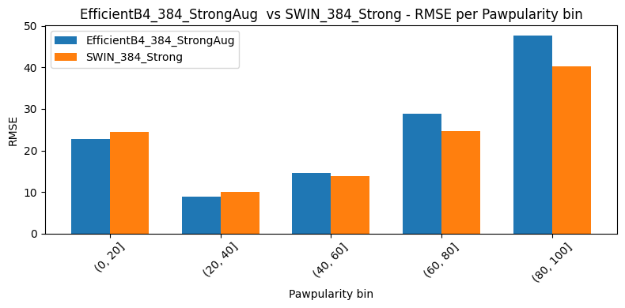
Figure 3 Errors Distribution
Even though the Swin Transformer achieves lower average RMSE than EfficientNet-B4 overall, the bin-wise analysis shows that both backbones still produce their largest errors in the sparsely populated Pawpularity ranges (0–20 and 60–100). The mid-range scores have many training examples, so both models learn stable representations there, whereas the extreme low and high scores regions have less records, leading to underfitting in the tails.
Table 6 Data Distribution and Errors Regions
Bin | Data Count | EffNetB4-RMSE | SWIN RMSE | ∆RMSE
[0,20] | 1417 | 22.81 | 24.49 | 1.68
[20,40] | 5119 | 8.89 | 9.97 | 1.07
[40, 60] | 2088 | 14.52 | 13.58 | -0.66
[60,80] | 727 | 28.76 | 24.57 | -4.18
[80, 100] | 561 | 47.67 | 40.30 | -7.37

Overall Summary of RQ1
Across all experiments, the vision backbone is the most influential component where switching from EfficientNet to Swin gives the largest RMSE reductions in the stage-wise analysis. Under the primary 5-fold OOF protocol (Exp0–Exp9), the lowest RMSE pipeline is Exp9, a model-level ensemble of EfficientNet-B4 and Swin with the lowest OOF RMSE. However, the improvement compared to single SWIN model is not significant. Inclusion of Metadata to swin did not result in high differences but the stability of model is reflected indicating that Metadata is stabilizing the model but cannot capture enough signal due to weak relation with the target. Resolution and augmentation act as secondary contributors, higher resolution with stronger augmentation improves performance, particularly for EfficientNet, but the gains are much smaller than those from changing the backbone.
In additional experiments using a separate 70%, 30% train, test split (Exp5 inference, Exp10, Exp11), Exp10, a Swin + metadata early-fusion CV ensemble, achieves the best test RMSE and shows stable performance across folds, but these results are not directly comparable to the OOF scores (exp0 to exp9) due to different datasets and are therefore treated as reference. To summarize, the experiments show that change of backbone choice (Swin-T) is the dominant factor in Pawpularity prediction, resolution, augmentation offer modest secondary benefits, metadata and fusion strategies are marginal but helps in stabilization under the current setup.

