• '



*wt,en torm is filed.*

CH-250

Proof of Service by Mall

Name of P.1'9on A1ktng for Prottctfon:

Samantha bt!CO-Stewftrt

Name of Per.on to a.R11trtlned:

Bos

Notte. to:s.rv.r

11'c serverm\JS1:

G)

®

©

* & lS .

0f *Fil in court ntlm8 llf1d slrHt llddr9ss:*

Superior court of California, County *of*

_ orover.

* Not be hstechn items(!),@, or @of fom1 CH-I00, *Request for Civil Harassment Restraining Orders.*
  + Mail a copy *o(* all documents checked in@ to the person in@.

© !(Ille server) am 18 yean of age or over and live in or am employed

I

**q dae coanty where** the **mailing** took place. I mailed a copy of all

*,..,F_,_·1n1_ca_se_n_umbe_r:_* ,

Case Number:

**doa1111eats** dtecked below to tbe person in@: 1...C_C_H_-2_4 58_7_1_6_8 .

1. 0 CH-120, *Response to Request for Civil Harassment Restraining Orders*
2. 0 CH-130, *Civil Harassment Restraining Order After Hearing*
3. 0 Other *(specify):* _

@ I placed copies of the documents checked above in a sealed envelope and mailed them as described below:

1. Name of person served: -=-Sa=m=a=-n=th=a'-=B""ri=asc=-=-o S=te w=art -----------------
2. To this address: 350 Bush Street Suite 200

City:San Francisco State: CA Zip: _94_1_0_4 _

1. Mailed on *(date):* -=20::..;;2=-=4-=-8'-'-6=------------
2. Mailed from *(city):_B_url_in_..gt_o_n (state):* Massachusetts

®

**Server's** lnfonnation

Name: _ Address: _

City: State: _ Telephone: _

If you are a registered process server:

Zip: _

County of registration: Registration number: _

0I declare under penalty of perjury under the laws of the State of California that the infonnationabove is true and correct.

Date: 2024-8-6

Bo Shang ►

*Type or print server's name Server to sign here*

* • COl.flCil *al* Califomio, WWW.(X)UrlS *ca (JOV*

StpCember 1, 2022, Oplicnal Form

*al* Civil Proc:e<Ue, § 527.6

Proof of Service by Mail (CLETS) (Civil Harassment Prevention)

CH-250, Page 1 of 1

jNoiielkii'I iiii1 p,fvac:y, please press the Clear

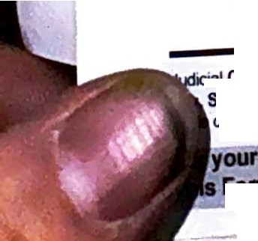

**Folln bullon lftlr** you have prtnllld the form.

p **1h11 form** I Save this form I

'

Clerk stamps dale here *when form is ffled.*

# CH-120

### Re pon to Reque•t for C\vl\ Harassment Reatra\nlng Orders

Use lhla fonn Request (form CH-100)

* R d H *w q,* ivil *Jlarrusme11t*

*R* rtoil'lilt -l2 ) to protect your rights.

* ill <l\1t • take it to the lerk.
* \ vc \i or older-not you-serve the person in G) or l'\, or· y fnai\ with **a** copy of this fom, and any attached

. *H-250,*\>roofofService by Mai\J

, **Seeking** Protection

ll name of person seeki\\g protection *(see form CH-JOO, itemCi)):*

Fill in *court* **name *and*** sli'eet *addr9ss:*

|  |  |  |
| --- | --- | --- |
| Samantha Briasco-Stewart | | Superior Court of **California,** County of |
| Person From Whom Protection Is Sought  a. Your ame: Bo Shang | |
| Your lawyer *(if you have one for this case)*  ame: | State Bar No.: |
| Firm Name: | |

b. Your Address *(If you have a lawyer,* give *your lawyer,s information. Court fills* in case *number when fonn* is *filed.*

I

*/[you do not have a lawyer and want to keep your home address* **\Case Number.**

*private, you may* give *a different mailing address instead. You do not*

CCH-24-587168

*have to* give *telephone, fax, or email.)* .... ......

Address: 10 tkC affertyWay Present your response and any opposition at the

City: Burlington

State: **MA** Zip: 01803 hearing. Write your hearing date, time, and place

Telephone: 781·999-4101 Fax: Email Address: [bo@shang.software](mailto:bo@shang.software)

®

##### O Personal Conduct Orders

a. D I agree to the orders requested.

b. 0 I do not agree to the orders requested.

*(Specify why you disagree in item* @ *on p e 3.)*

from fonn CH-109 item@here:

**Hearing)** Date: Aug 20 24 Time: 8:30am

**Date** Dept.: 505 Room: 505

**Hyou were served with a Temponry Restraining Order, you must obey it util the hearing.** At the hearing, the court may make orders against you that last for up to five years.

c. O I agree to the following orders *(Specify below or in item@ on page 3.)*

#### 0 □ Stay-Away Orders

1. O I agree to the orders requested.
2. {!} I do not agree to the orders requested. *(Specifywhy you disagree in item@ on page 3.)*
3. O I agree to the following orders *(specify below or in item@ on page 3):*

#### □ Additional ProtectedPersons

1. D I agree that the persons listed in item@of form CH-I00 may be protected by the order requested.
2. 00 1 do not agree that the persons listed in item@of form CH-l00 may be protected by the order requeste

. . **COln:il of Ca(lomia.** [www.GOUtts.ca.gov](http://www.GOUtts.ca.gov/)

**Responseto Request for** Civil **Harassment**

CH-120, Pag

**,ludicilll** 1 2023 **Ma,daDly** Form

:;_-:;:§§5276s'111527.9

##### Restraining Orders

**(Civil Harassment Prevention)**



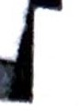

Number:

f

H•24•587168

fc,..Number:

-J

,.,,

*..:.i*

f h

*!]*

© Fftearmt (Gun1)1 FfrNffll **Pertl,** and Ammunition nrearms

tr '"" ft iien't'CI 'flith rnrm ,H-t to, rtlflpJOmr,,*Rnrrrtlnlnl( Ordet*y*,* ou cannot *own* or po.Mal :t m•Y be

**(tHs** flmlnfl r,•m.. or ammanlttoil,1'1' lbthtdt!llOrtnm tttelver9 andfttmd, ind•ny em

ltMd ora,ily t11f'ltttl 11110• Ntttv tor frlnu! (set Peflll Code aeclfon J6 3J).(See ttm *\U of* form

CO•te.)Vo• MUt 8ttl 11> or !MN wftb • ttctnsed gan de1ler, or turn In to • law enfon:emewt **,geaty,** •IIY firti1n1J1 ( **'11ft.**or FirNrm pam it, your immedlat poMH. lon or control within *24* hours or being served **W'itlt rM** Cll-110. on most ftltA tettlpt with the court. You may use *Receipt/or Firearm., and Firearm*

*CR* ) r the rettipt.

. *CT1* I oo not own or htrol any fireann (guns), firearm parts, or ammunition.

b. D I **a** *k* for an xemprion from the firearms prohibition under Code of Civil Procedure section527.9(f) because carrying a firearm is a conditi n of 1uy employment, and my employer is unable *to* reassign me to another position here a fiream, is unnecessary. *(Explain):*

D *Che here if (here is not enough space below for your answer. Put your complete answer on an attached sheet of paper and write "Attachment 6b-Firearms Su"ender Exemption" as a title. Youmay useform*

*MC-025.* Attachment

r

c. 0 I have turned in my fireanns (guns) and fireann parts to the police or sold them to or stored them with a

licensed gun dealer.

A copy of the receipt D is attached. D has already been filed with the court.

0 □ **Possession and** Protection of Animals

1. 0 I agree to the orders requested.
2. 0 I **do not** agree to the orders requested. *(Specify why you disagree in item @on page 3.)*
3. D 1 agree to the following orders *(specify below or in item @on page 3):*

(!) □ **Other Orders**

r' a. 0 J agree to the orders requested.

**ti** b. 0 I do not agree to the orders requested. *(Specify why you disagree in item @on page 3.)*

p c. 0 J agree to the following orders *(specify below or in item @on page 3):*

c**a**

It

**w**

**®**□**Denial**

I did not do anything described in item ® of fonn CH- I00. *(Skip to@ .)*

R... **Jnay** 1, 2023

*,2*

**Response to Request for** Civil **Harassment Restraining Orders**

(Clvll **Haranment Prevention)**

**CH-120, Page** 2 **of4**

CCH-24-587168



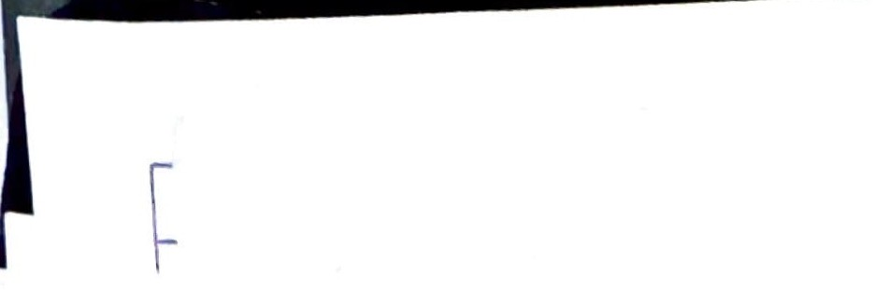



**lc..Number:**

CCH-24-587168

l

*-0*

#### 00 Justification or Excuse

lf l did me or all of the things t11at the person in(D has accusedme of, my actions were justified or excusedfor I

the following reasons *(explain):*

I

00 *Check here if there is not enoughspace below for youranswer. Put your complete answer on an attached sheet* I

*of paper and write "Attachment JO-Justification or Excuse" as a title. You may use form MC-025,* Attachment

e

u ortunatelyI chattedon thisterrible**website** filled withindescribable numbers of criminal yiolations

mm1ttedby streamers and staff, and their fans on socialmedia, plus possible other "white knights" at various 11

organizations or individuals

Fro111111y n,st expelie11ce, tile website called Twlltl, see111edobviouslyofl, like 111ocll diffe,eill hoill llow 11O11nal

□111aIIs usually beat eacl1 ot11e1,IegaIdless of wuIItIy 01 culture. I loweve1, I was du111b eIK>ugl1 to be sucked

!•

into tt:lis oddietion of stupid, ol'ld 11,ot'sonly ffl) fault, beeouse California ete. !'lasno idea!'lo.. to er,for-ee ttleir

-e i gbYsiness tair prastises ast, wt:iist:l inslYdes deGoptiue tactiss,talset:loods, and olher abYsos against wetims ot **fhei•** b11sioess

Continued in Attachment 10 • Justification of Excuse ee

@ 00 **Reasons** I Do Not Agree to the Orders Requested

*Explain your answers to each order requested that youdo not agree with.*

00 *Check here if there is not enough space below for your answer. Put your complete answer on an attached sheet of paper and write "Attachment I I-Reasons I Disagree" as a title. You may use form MC-025,* Attachment

TIiere Is a pobllc Interest 01 11ot a ro, 110 legitir11ate I easo11 lor ti,is st,ea11101I 111et 011'fwiltll, wl1u1n I **happer,ed** te foll ir, lo.e ..it+, btlt ..ould r,e.er abuse.intentienall), like sl'le elaims.116.. e.er I belie.esl'le's adJ,ally beeo stalking me !be othe• way a•o•md witl:1cybe• espiooage o• g•oupcl:lats oolike i.lacko• Google Groups since 2020 and definately sjnce 2023 when I auto-emailed mostof Twitch management and Andy Jassy, and Amazon HR returned an email that I sent to Jassy alleging numerous criminal violations committed by Twitch (only streamers at that time, but given the number of... then employees must be of some character in general I assume)

AJ1yways I believe 011e of l1e1 "wliitek11igl1ts"baited 111e il1to 'calli11g"1101h1Feb 2624 byil1se1ti11g a 01seve,al w11tacts wifb bee name inr my 9'ecb:ook: devk:es Pcevio11slv I bed onty ernaiied bee teasing lnve python code or ped it on Github? She didn't complain of any of that, **and** I didn't even realize she was reading the spam I **was** iMessagingcuz

who wouldn't block that many pages in a scroll? So I assumed any nonnal human would have blocked it, but she sent read recetpts on select times only, seermngly as a message of lol we got u again or something;maybe she aidn t know **ttle** II **picture and enl) eelM ef WNlt her"-.whiteltnights" were deii,g ouch as those ,tho ser,t me te Tauriteri State**

plkoo "bospital" in 5(1Qt24 etc Sbe bas sent n11meco11s read **receipts** oo vari011splatforms **aod a** vecy mean request 1n **appear via** zoom instead, claiming that she'd feel more safe because I seemingly totally ignored the temp RO on Constitutional grounds, giventhe numbers of Twitch users in America and around the world, and that I'd actually head

*w* **SP' Sopeilbi** Coon **tliySeil.... was SIi& altl&Cl** dill Id tnordet het or SOlll&ihltiy **at SF Sopeilm? Its IIWlyS** ltlSUldliy

**,,cheR**I 1alk **19 a weamer** er employee al Tmitsh;aRd lhey'11e almays displayea aR iAhwmaR amewRl et lask of iRlegril'j

Anyway5• by Statute of Cahfom1a C1vn Harassment or CMIStalking, there 1s a requirementcontact tor no legmmate

.-,u,peoe, 8110 eesieell) 1 ,,89 tl'tllli her eul. sh e .. as .. er1tl•fl!Jrl a ef1•m1•11aA1e f!J a11•1 1er11nnrla11atheff:efea ,aA•eusSU!J!Jet·1 s

* nc1 ,. ethical placp to wnrk elc I roean aa:oung to0peno1 v1 e Is a g1Dg un1ess someone ge,s

f0c bee ta 11 . a roar"! ---- --

metti'ng and well there seems to be soooo many white knights attemptingto hann OJ betore he even got

**or: -** murder Samantha at SF Court however OJ is not afraid or in Samantha's case probably like

hasr alleg 1 I wallled *w* !00111 raclIeI 111a11go to court and argue with evidence ptesemed, bat used the

111 a1 caz s ,e

1 U->l

noto *Y*u u. ' . r"iR ead . which meaR& her iRlegrity is "'hat?

*1*

8l'Gt1M of '1eehPg &ao

.,.,...,1.2023

**Response** to Request for Civil Harassment Restraining Orders

CH-120, Page 3of 4

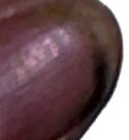(CIYII HaraNment Prevention) *f?§l/lil/tfla*

CCH-24-587168



l th urt to rdet pnynlent of my O Lawyer's fee O Court costs.

e 3m unts T"Cquestcd are:

Ammm1 1wn

_$,

_$

$

_$

$ $-----

□ *Check here ifthere are more items. Put the items and amounts on the attached sheet of paper and write*

*"Attachme,u13-Lawyer's Fees and Costs" for a title. You may use form MC-025,* Attachment

D -Iask the court to deny the request of the person asking for protection that I pay his or her lawyer'sfees and costs.

@ umber of pages attached to this fonn, if any: 100 ish

Date:

►------

*Lawyer's name (if any) Lawyer's signature*

I declai:e under penalty of perjury under the laws of the State of California that the infonnation above and on all attachments is true and correct.

**Date: 2024-8-6**

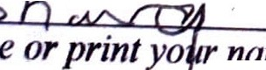

*Typeorprinty<(* ►-- -..,...._ *y-,,o-u,-n-am_e*

Rev• .1nay1, 2023 **Reaponae** to Request for Civil Harassment Restraining Orders

(Civil Harassment Prevention)

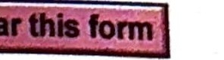or yow pifvacy, plNle .,,_.the Cliii ==:-,-;,, ==- .-----.,.,.""'

CH-120, Page 4 of 4

This F01111 bullanaftlryou have prtnlad the form.. **1h11form**

j Save this form]

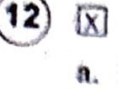

\c... Nurnbtr:

CCH-24-587168

j

No fee for Fillng

n. l rcqu

,

1h t 11 1 l, requircJ to pn th· ,lin lo ' ntitlcd to lit OIin ,

because the person in(!)claims in form CH-JOO

b. •l • 1.i

R'--'qll 1 t '\ 11i ' ourt l· s. *,m,_ , be fileJ separate/ .)*

thnt1 nQ1 t«tuifed \o pny the fili11 fe becnu e I umcli ibl for Ii fee waiver. *(Form FW-001,*

13 0 **La 'FM8 •r,d ·costa**

:TTITLE:



*:* ident Bid,

Ac:e._.:_, n-- .-...

...

**CASE NI.MIER:**

*rrJ..J.*');f') **C0"71** *rt>*

#### MC-025

g Pres; ***ined*** *SJ* ***ri0hts*** ed pro

*!\L TF*

Attachment 1o- Justification or Excuse

Response to CH-120 Civil Restraining Order Request from Petitioner Samantha Briasco-Stewart CCH-24-587168

#### Respondent:BoShang

**Justification:**

Bo Shang, a Twitch user, asserts that the actions alleged by Samantha Briasco-Stewart, which are acknowledged as approximately 95% accurate, are protected under various constitutional rights. These rights safeguard the freedom of expression for millions of Twitch viewers, including critical commentary on the social and economic structure of the Twitch platform.

1. **Freedom of Speech:** Bo Shang's communications on Twitch are protected by the First Amendment of the United States Constitution, which guarantees freedom of speech. His commentary on the nature of Twitch's business model, which he likens to a Ponzi scheme targeting both children and adults, falls under protected speech. This includes expressing concerns about Twitch's algorithms and their potential to foster addictive behaviors.

## **Public Interest:** The respondent believes that his statements are in the public int rest, providing essential insights into the business practices of Twitch. For instance, the critique of Twitch's subscription model and its psychological impact on users is a matter of public concern. Bo Shang's assertion that prominent streamers, such as Pokimane, engaged in legally questionable practices further emphasizes the need for transparency and accountability within the platform.

■

.E:

,t *Bid,*

ICASEHUMBER:

I •••I••.n. C,1. -•• *rrU* -,,ti\ ,.,.,... ,



■---

I 1i ms• rc,rn 2014 to 2019 Pokimane allegedly

*::r*

,

*Sf*

-0 Potctrnane•• Subscription_ er • . d preciation" in tier

*'F* prom sad her ubscribrs"Un yltig:: o practice, communicated to

sub crh:>tion terms. Bo Shengs oDJ .t. *o1*trtese' agreemertts and

Twitchraiseslegitimate questions about the na ure ,

their im' plication for consumer pro·teor10n laws

•

n

**Legel Actions Against TWltch:**

legal cases involving Twitch:

-

Th8 respo

nd0 ·t *r*8 ferences Mo sfgnil1cant

* + In2020, a plaintiff sued Twitch for $25 million,cla!ming_d ma :s related to sex addiction and requesting a gender filter. This cas highlights the psychological and social issues associated with the

•

platform.

* + In 2023, popular streamer Phantomlord won a $15,000 judgment against Twitch over a contractual dispute, despite operating an illicit casino. This case underscores inconsistencies in Twitch's enforcement of its terms of service and legal obligations.

4. **Critical Incidents and Platform Responsibility:** The tragic case of the streamer Reckful, who made violent threats before his untimely death, serves as a stark reminder of the severe mental health issues that can arise within the Twitch community. Bo Shang's critical commentary aims to draw attention to the need for better mental health support and responsible platform management by Twitch.

*In* conclusion, Bo Shang believes that his actions and statements are not only constitutionally protected but also serve a vital public interest by exposing questionable business practices and advocating for the well-being of Twitch users. Therefore, the allegations made by Samantha Briasco-Stewart should be reconsidered in light of these constitutional protections and the broader context of Twitch's operational practices.

#### Respectfully submitted,

Bo$hlang

*==* . •

t Biden Official **Resoonse** to Twitch Complatnl bv Bo Shan•

1---C·CH-242-.'H 7• *Ml*

Attachment 11 - Reasons I Disagree

Response to cH-120 Civil Restraining Order Request from Petitioner Samantha Briasco-Stewart CCH-24-587168

**By Respondent Bo Shang**

# Introduction

This document isa response to the civil restraining order request filed by Samantha Briasco-Stewart against me, Bo Shang, on 08/01/2024. I do not agree with the request andI

believe it is based ona misunderstanding of the nature and purpose of my contact **with**her. I will explain why my contact does not constitute harassment as defined by the Code of CivilProcedure, and why it is justified by the public interest and my personal feelings for

her.

# Why My Contact *Is* Not Harassment

**According** to the Code of Civil Procedure - CCP PART 2. OF CIVIL ACTIONS [307 - **1062.20]**

*TIRE* 7. OTHER PROVISIONAL REMEDIES IN CIVIL ACTIONS (501 - 574] CHAPTER 3.

Jnjunction (525 -534) 527.6. part b clause 3, "harassment" is defined as "untawful *viotenee,* a credible threat of violence, or a knowing and willful course of conduct directed *at* a s cmc *person* that seriously alarms, annoys, or hara$ses the person, and that serves

00 t , ate_P pose," I contend that my contact vvith Samantha Briasco-Stewart does not meet Ulis detmitJon *tor* the following reasons:

* Moryvceorbnatal c-bt W8S- not violent or threstenIng In any way, I never used any physical force m d · 8 use ageinet her. I never threatened to harm her or anyone else. I never

8 8 *any* unwanted sexual *adv*

her privacy I ne d• ances orcomments.I never stalked her or invaded

* + - ver amaged her property or interfered with her work or personal life.

**MC-025** ■----

-

* My contact was not knowing and willful. I did not intend to alarm, nnoy, or h re her. 1 did not know that she would perceive *my* contact as such.I dtd not persistm

contacting her after she expressed her displeasure or asked me to stop.I respected

her boundaries and wishes at all times.

* My contact served a legitimate purpose. I contacted her for two reasons: one, to inform her of the health and legal risks of using and promoting Twitch, a platform that I believe is unlawful, unfair, and fraudulent; and two, to express my genuine love and respect for her, and to propose a relationship that would benefit both of us.

Why My Contact Is Justified

I believe that my contact with Samantha Briasco-Stewart was not only legitimate, but also justified by the public interest and my personal feelings for her. I will explain why in this section.

The Public Interest

Twitch is a platform that allows users to stream and watch live video content, mostly related to gaming and entertainment. It is owned by Amazon and has millions of users worldwide. However, I believe that Twitch is a harmful and illegal product that violates the Business and Professions Code - BPC DIVISION 7. GENERAL BUSINESS REGULATIONS [16000-18001] PART 2. PRESERVATION AND REGULATION OF COMPETITION [16600 - 17365] CHAPTER 5. Enforcement

[17200 - 1721OJ, which prohibits unlawful, unfair, and fraudulent business

practices, as well as similar fraudulently misleading advertisement. I have evidence and arguments to support this claim, which I have shared with Samantha Briasco-Stewart and other relevant parties, such as Twitch's CEO

and Amazon's CEO Andy Jassy. Some of the reasons why I believe Twitch is harmful and illegal are:

* Twitch exploits its users by encouraging addictive and unhealthy behavior, such as excessive gaming, gambling, and spending. It also exposes its users to harmful content, such as violence, sexualization, and misinformation. It does not provide adequate safeguards or warnings to protect its users from these risks.
* Twitch violates its users' rights and privacy by collecting, storing, and sharing their

Jr per nal eta without their consent or knowledge. It also uses deceptive and manipulative techniques to influence its users' behavior and preferences, such as

algorithms. rewards. and recommendations. It does not respect its users' autonomy or dignity.

* Twitch cheats its users by charging them fees and subscriptions for services and features that are not delivered or are defective. It also fails to provide adequate customer support or refunds for its users who encounter problems or complaints. It does not honor its contracts or promises.

As a concerned citizen and a former user of Twitch. I felt compelled to contact Samantha Briasco-Stewart. who is a popular and influential streamer on Twitch, to inform her of these issues and to urge her to stop using and promoting Twitch. I believe that by doing so, I was acting in the public interest and performing a civic duty. I hoped that she would listen to me and join me in exposing and challenging Twitch's malpractices, and that together we could make a positive difference in the world.

My Personal Feelings

Another reason why I contacted Samantha Briasco-Stewart was because I fell in true love and respect for her. I have been following her streams and social media for over a **year.** and I have been deeply impressed by her personality, intelligence, and beauty. I admire her talents, skills, and achievements. I share her interests, values, and goals. I feel a strong connection and compatibility with her. I believe that she is the perfect woman for me, and that she is the perfect woman for any man who also fully respects her no matter what happens, besides any future slim possibility of any future evil behavior.

The respondent knew she was good, and accuse her friends either at Twitch. other software companies, or across the internet such as Discord harassment groups that pop up in hit and run pieces on Medium, or people who create new YouTube accounts with the same string of his name to begin each account name, of committing criminal harassment, criminal stalking, and

U.S. Code Title 18, Section 1030, also known as the Computer Fraud and Abuse Act (CFAA) plus Title 18, U.S. Code, Section 241, "Conspiracy Against Rights."

Under Title 18, U.S. Code, Section 241, it is illegal for two or more individuals to conspire to injure, oppress, threaten, or intimidate any person in the free exercise or enjoyment of any right or privilege secured by the Constitution or laws of the United States.

I contacted her to express my sincere and honest feelings for her, and to propose a relationship that would benefit both of us. I offered her my love, loyalty, and support. I promised her happiness, security, and fulfillment. I suggested that we could be a great couple, and that we could achieve great things together. I did not expect her to accept my proposal right away, but I hoped that she would give me a chance to prove myself and to get to know her better. I did not intend to pressure her or to disrespect her current or past relationships.I respected her choices and preferences at all times.

**Conclusion**

In conclusion, I do not agree with the civil restraining order request filed by Samantha Briasco-Stewart against me, Bo Sheng, on 7/29/2024. I believe that my contact with her does not constitute harassment as defined by the Code of Civil Procedure, and that it is justified by the public interest and my personal feelings for her. I request that the court dismiss the request and allow me to continue to contact her in a respectful and reasonable manner. I also request that the court consider the merits of my arguments and evidence against Twitch, and take appropriate action to protect the public from its harmful and illegal practices. Thank you for your attention and consideration.

##### MC-025

**ATTACHMENT *(Number):*** h.....

_

CASE **NUMBER:**

CCH-242-587168

SHORT TITLE:

President Biden Official Resoonse to Twitch Complaint bv Bo Shang

-

*(This Attachment may be used with any Judicial Council form.)*

Quoting President Biden direct address to Respondnet from June 21 2023: American tech companies, but I complained specifically about Twitch, causes, "form deteriorating mentaJ health and well-being of the erosion of basic rights of Americans and communities worldwide. In particular a handful of large tech companies have prioritized profits over the HEALTH, WELL-BEING and SAFETY, of the PUBLIC; they operate with **MINIMAL** TRANSPARENCY and have evaded accountability for TOO LONG."

*(If theitem that this Attachment concerns Is made under penalty of perjury, all statements in this Atta hment* are *made under penalty of perjury.)*

**Page** of

*(Add pages as required)*

Fann Gd

to,

()pl"""'J U•

ATTACHMENT

*WWW court,nfo* C8 *QOV*

JudotlalCO<IY>ld orna

MC-025(Rcr,J,.liy120CS)

to Judicial Council Form

- ..._,

S'S/24



THE WHITE HOU E



June 21,202

*lxar* Mr. h,ng,

Thank ou for writing to *me.* Whjle rapid technological advancement has helped conn tu and opened up exciting *possibilities* for what the world can be, the rise of tech platfonn has also introduced new and difficult challenges, from deteriorating mental health and welJ-bcing *to the* erosion of basic rights of Americans and communities worldwide. In particular, a handful of large tech companies have prioritized profits over *the* health, well-being, and *safety* of the public; they operate *with minimal* transparency and have evaded accountability for *too* long.

At the heart of American *capitalism* fies a simple idea: open and *fair* competition. The Internet should be no exception. Instead, rapid growth of digital platforms and social media companies has outpaced federal regulations, leading to a massive technology industry controlled by onf y a few big players. Rather than competing for consumers, big tech companies are consuming their competitors, leaving Americans fewer choices for internet pfatfonns, providers, and onfine marketplaces and Jess control over how their personal data is acquired and used.

**We are at** an inflection point and have the opportunity to both bring back much­

.needed *competition* while promoting transparency, accountability, and equity in the technology sector. I was proud to *sign* an Executive Order that crystalized my Administnttion's commitment to help reign in big tech by challenging bad mergers. enforcing antitrust laws, and establishing rules on surveiJlance, data collection, and **consumer** privacy. And I continue to calf on Congress *to* address the power of tech platforms, strengthen privacy *protections,* and ban targeted advertising to our children.

I appreciate your concern about big tech, and I am dedicated to ensuring that the Go ernment continues to put you, the American people, first in everything we do.

Sincerely, *I*

-

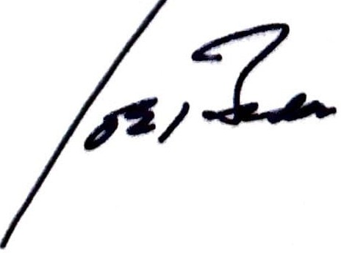

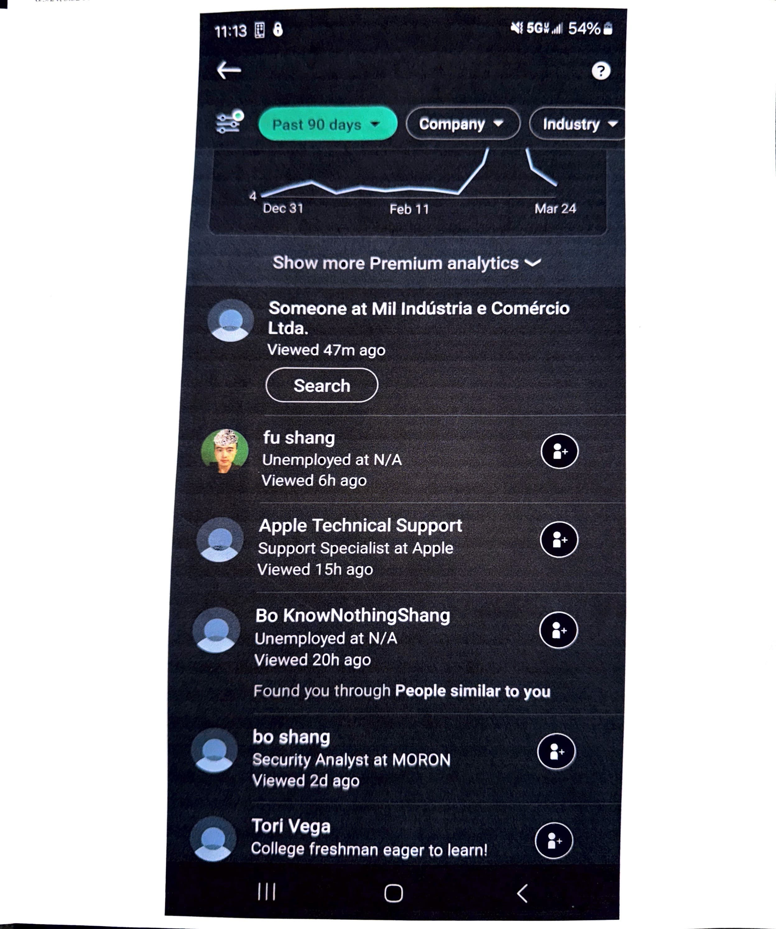

**Subscription Service Terms**

Twitch may offer certain-Ancillary Products and Services in connection with the Twitch Services on a subscription basis with recurring payments **('"Subscription Sefv 1 as** disclosed to you when you subscribe to any Subscription Services. Subscription Services may renew automatically, and you agree that we are authorized to charge you for payment on a recurring basis prior to each renewal. You agree that your Subscription Servtoe will rene-w continuously until you cancel it. Twitch reserves the right to discontinue or modify any subscription fee payment option. If we

isoontinve or mooity a subscription payment option, we will provide notice of such discontinuance or modification by email or through the Twitch advance of the next billing date. If you are signing up under any promotional subscription fee, some additional restrictions may apply.

, rt any, will be provided to you before you sign up for the applicable Subscription Service that is subject to the promotion.



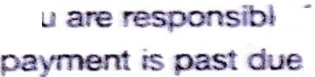**Yo,** le tor all charges incurred under your account. Twitch reserves the right to deactivate Subscription Services to your account if

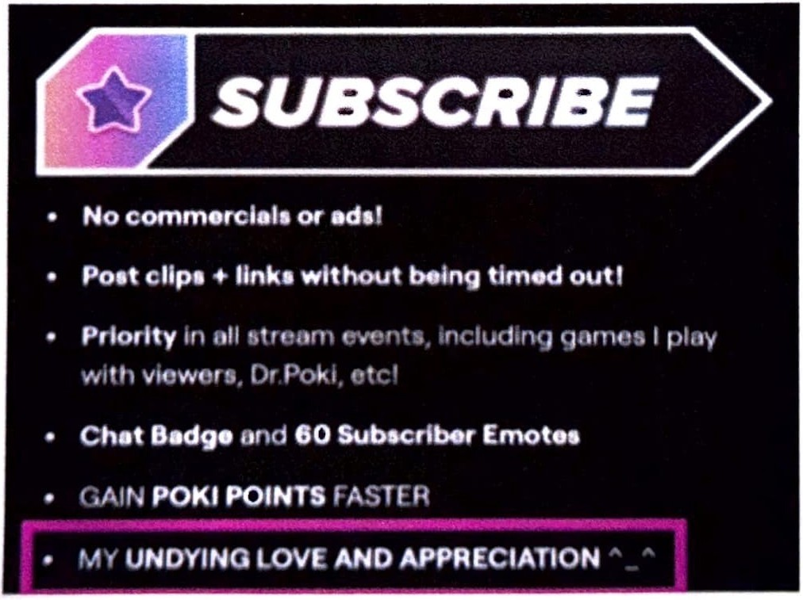. regardless of the dollar amount.

/24,5:51PM imagc_6714419lJl'G

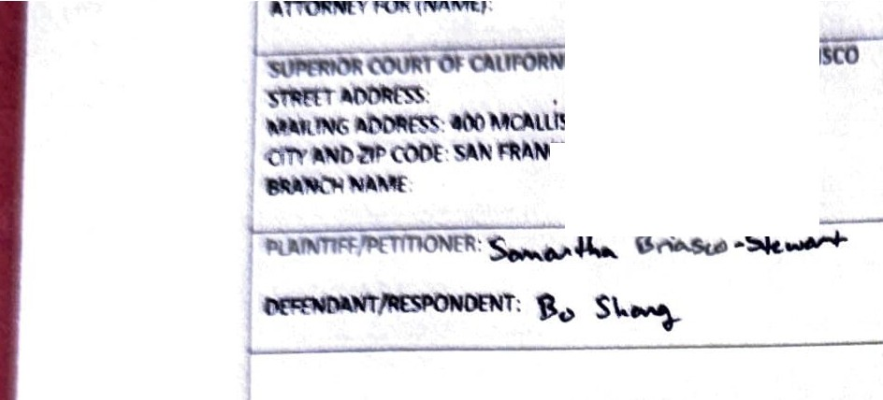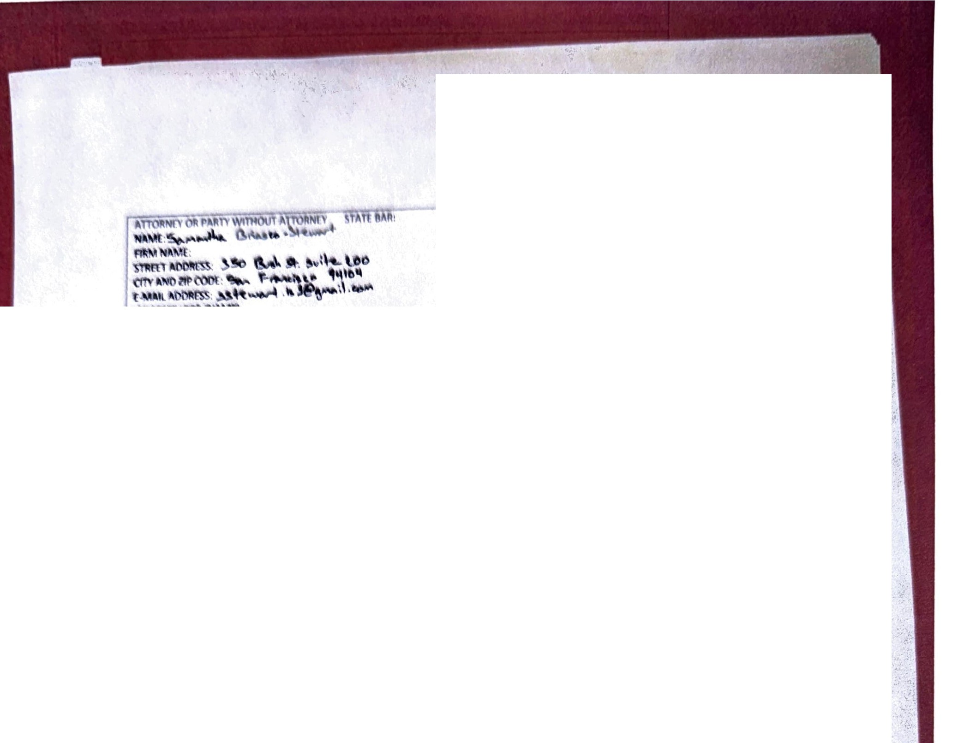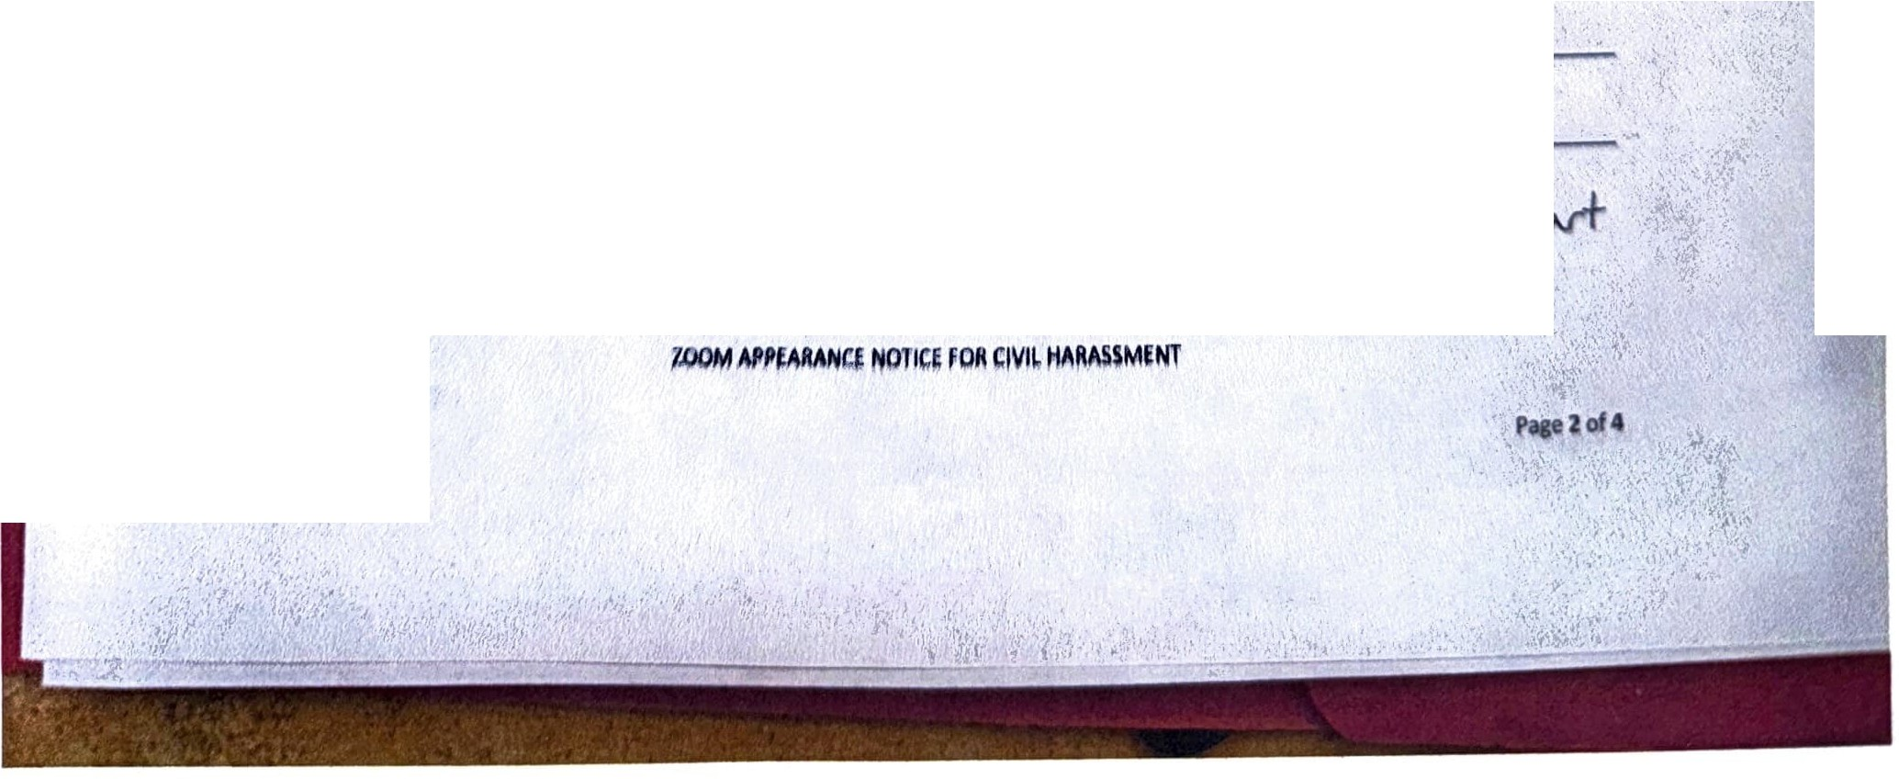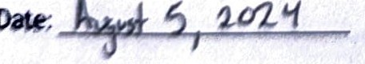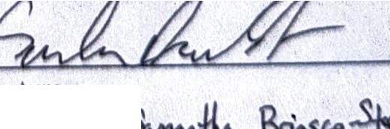

, *I*

|  |  |  |  |
| --- | --- | --- | --- |
|  | |  |  |
| ltimil 5'ffl't, NrnCO.\:A 94ib2 | 103 |  |
|  | |  |
|  | | | CASE NUMBER:c,C..ll- 2.4 1(711,**t** |
| **NOTICE RE: Appearance via** Zoom  (Civil Harassment) | | | Hearing Date: ,-J- *:z..o*• z.o:2'-i Time: ff:U> A..,  Department: 505 |

**hrtyto.a r** by ZOOM (printed name): B -54-.,--.\-

n

**111Yson:** 11., .k4M: M 31...ow" }\...-I- c. a-+ ce,r':- :£-1'- *J(.,..*b

,t:....:...: *,k*  a *.,..r+* w *p.J* ;,.. *r•'-" ,,..J* t-,..+k *:,h-,k* rn sL....1 *f* "- *L.*

.+

*io mo,,*;.,...+.ii ,......b;.,.,.l;.,, £.d, *;;:,* .C-1i-1 " 8!1fcr :£,.,: C"!-: :f. .

viri---1 -

**0R**

D 1 **amnot a** California resident; I reside in the state of _ O.wfort:outside of the State of California. I work in _

Df **hieoutside** *of* the nine *Bay* Area counties (Alameda, Contra Costa, Marin, Napa, San Mateo, San

***f:rancisco, Santa*** Clara, Solano, Sonoma). I live in county.

, **Ml *ma,, ated*** *at* jail/prison and will be incarcerated at the time of the

***COIMthe.lriJJB.***

s11n11turt

Prlnt11d Namei tw

*Sf<N{)J)*

*--li,t-12; ,i*

ps://rnail.google.corn/rnail/u/0/#inbox/FMfcgzQVxtrHdswplWJQNGJnQfKpLzMR?projector=I