1. Running hadoop on your local machine using hadoop
2. Create a python script that hit "https://pokeapi.co/api/v2/ability/" + pokemon_ability_id from ability id 1 - 999
3. Save that ability id into csv per 100 ability id (example : id 1 - 100 on result_1_100.csv, id 101 - 200 on result_101_200.csv and so on) with these columns **id,pokemon_ability_id,effect,language,short_effect** (expected like below picture but with id on the left side of pokemon_ability_id) basically the parsing side is already handled by code that I give on last session.  
   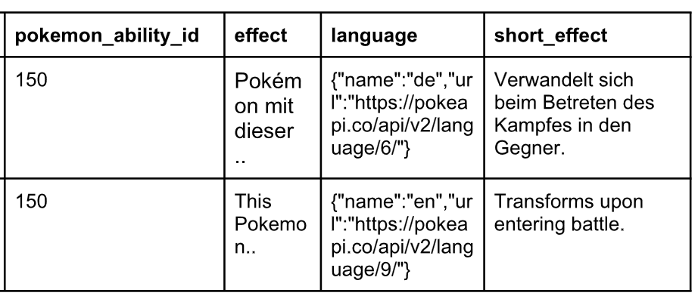
4. Save the csv into hdfs
5. Send the result with the code, explain the code, and screenshot of file above on hdfs and zip it all.
6. Good luck ;)