1. Requirement Gather

Print sum of three numbers.

2. Requirement Analysis

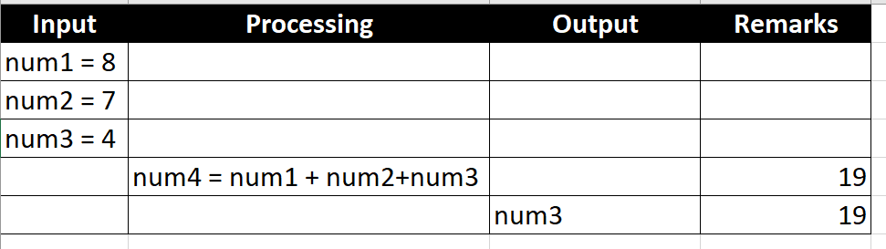

3. Flowchart

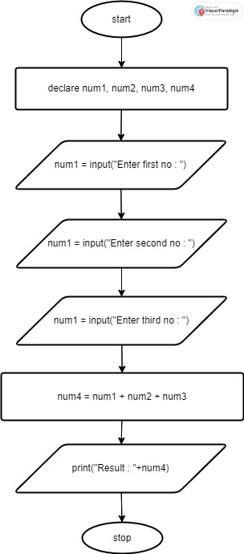

**4. Pseudo code**

**//declare**

1. Declare num1 as integer
2. Declare num2 as integer
3. Declare num3 as integer
4. Declare num4 as integer

**//input**

1. num1 = input(“Enter first no : “)
2. num2 = input(“Enter second no : “)
3. num3 = input(“Enter third no : “)

**//process**

1. num4 = num1 + num2 + num3;

**//output**

1. print(“Sum : “+num4)

**5. Desk-check**

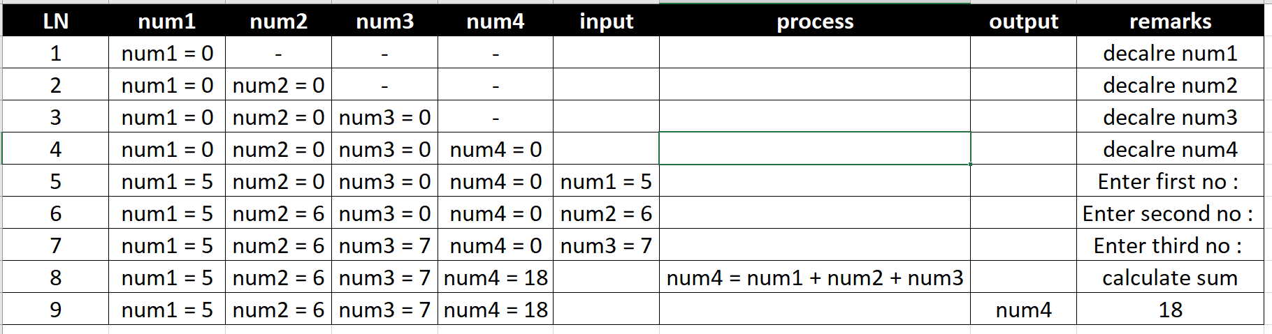

6. Source code (C/C++/C#/**java**/Python)

7. Test case (Output)

Terminal