**Documentatie Laborator #3 PPD**

**Ghimu Lucian Eduard**

**Grupa 233**

1. **Cerinta:**

Problema Implementati o clasa “SortedLinkedList” – lista inlantuita sortata cu elemente de tip real, astfel incat sa fie “thread-safe”.

Operatiile furnizate de clasa sunt:

**- insert(a: Real)** o pre: this=[a(0),…,a(n)] a.i. pentru orice i: 0<i a(i-1) <=a(i)<=a(i+1) o post: a este in lista pe pozitia corespunzatoare: this=[a(0), …a(i), a, a(i+1)…,a(n)] a.i. a(i) <=a<=a(i+1)

**- delete(a: Real)** o pre : exista pos o pozitie valida in lista a.i. lista(pos)= a o post: elementul ‘a’ nu mai este in lista

**- getIterator():**Iterator o pre : lista valida o post: result = it , it in Iterator pe lista Clasa Iterator va fi definita corespunzator cu specificatia clasica a unui iterator (implementeaza interfata IIterator cu operatiile: getNext(); isValid(); getElement()).

Variante Se cere implementarea a doua variante:

1. **sincronizare la nivel de nod** sau portiune din lista,

2. **sincronizare la nivelul intregii liste**. La testarea iteratorului se va folosi intotdeauna sincronizarea intregii liste

1. **Detalii de implementare**

Pentru generalizarea programului am folosit 2 interfete **LinkedList,** pentru lista inlantuita si **Iterator**, pentru iterator.

Fiecare varianta are o implementare propie.

**Pentru sincronizarea la nivel** **de nod,** ma folosesc de **lock** pe fiecare nod. Pentru a efectua o oarecare operatie, e nevoie sa sincronizez 2 lock-uri, unul al nodului current si al 2-lea al nodului successor.

**Pentru sincronizarea la nivel lista,** folosesc `synchronized` din Java, folosind doar lock-ul listei.

Output-ul este scris in 2 fisiere prin intermediul clasei **FileManager**.

Executia efectiva a operatiilor este efectuata de un **Worker**, care primeste ca parametru, operatia pe care sa o efectueze (add, delete sau iterare), de cate ori sa efectueze operatia si lista inlantuita.

Ca sa notific worker-ul de iterare, am folosit sablonul de proiectare **Observer**, worker-ul de iterare este subscriber la restul thread-urilor, care trimit o notificare atunci cand se incheie.

1. **Diagrama de clase simplificata**

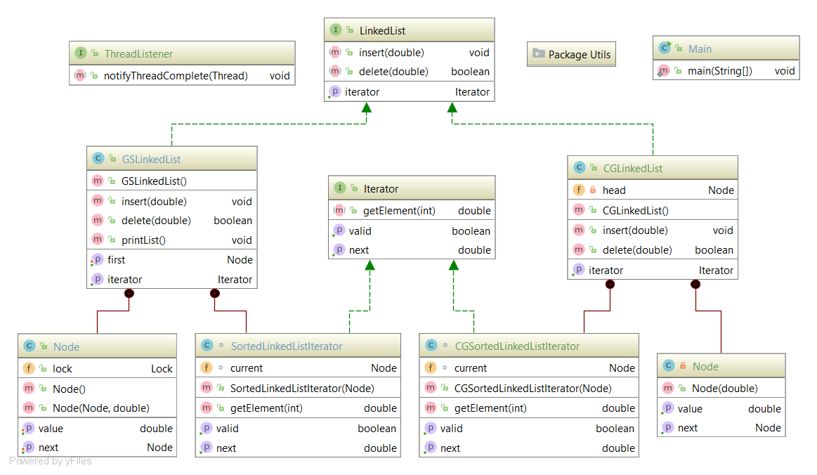

1. **Teste**
   1. **Sincronizare pe nod**

|  |  |  |
| --- | --- | --- |
| Operatii (A, D, I) / nrElemente | Timp (ms) | Corectitudine |
| A(10), A(5), D(7), I | 133 | 100% |
| A(10), A(5), D(7), I | 156 | 100% |
| A(10), A(5), D(7), I | 166 | 100% |
| A(10), A(5), D(7), I | 132 | 96% |
| A(10), A(5), D(7), I | 140 | 100% |
| A(10), A(5), D(7), I | **117** | 100% |
| A(10), A(5), D(7), I | 147 | 100% |
| A(10), A(5), D(7), I | 133 | 100% |
| A(10), A(5), D(7), I | 116 | 100% |
| A(10), A(5), D(7), I | 146 | 100% |
|  |  |  |
| A(100), A(50), D(50), I | 584 | 100% |
| A(100), A(50), D(50), I | 601 | 100% |
| A(100), A(50), D(50), I | 559 | 100% |
| A(100), A(50), D(50), I | 354 | 100% |
| A(100), A(50), D(50), I | 341 | 100% |
| A(100), A(50), D(50), I | 606 | 100% |
| A(100), A(50), D(50), I | **309** | 100% |
| A(100), A(50), D(50), I | 558 | 100% |
| A(100), A(50), D(50), I | 447 | 100% |
| A(100), A(50), D(50), I | 560 | 100% |
|  |  |  |
| A(1000), A(500), D(500), I | **1090** | 100% |
| A(1000), A(500), D(500), I | 4208 | 96% |
| A(1000), A(500), D(500), I | 5110 | 100% |
| A(1000), A(500), D(500), I | 5153 | 100% |
| A(1000), A(500), D(500), I | 4961 | 100% |
| A(1000), A(500), D(500), I | 3854 | 100% |
| A(1000), A(500), D(500), I | 5289 | 100% |
| A(1000), A(500), D(500), I | 5347 | 100% |
| A(1000), A(500), D(500), I | 5053 | 100% |
| A(1000), A(500), D(500), I | 1338 | 100% |

* 1. **. Sincronizare pe lista**

|  |  |  |
| --- | --- | --- |
| Operatii (A, D, I) / nrElemente | Timp (ms) | Corectitudine |
| A(10), A(5), D(7), I | 140 | 100% |
| A(10), A(5), D(7), I | 137 | 100% |
| A(10), A(5), D(7), I | 143 | 100% |
| A(10), A(5), D(7), I | 135 | 100% |
| A(10), A(5), D(7), I | **122** | 100% |
| A(10), A(5), D(7), I | 127 | 100% |
| A(10), A(5), D(7), I | 159 | 100% |
| A(10), A(5), D(7), I | 143 | 100% |
| A(10), A(5), D(7), I | 161 | 100% |
| A(10), A(5), D(7), I | 146 | 100% |
|  |  |  |
| A(100), A(50), D(50), I | 272 | 100% |
| A(100), A(50), D(50), I | 414 | 100% |
| A(100), A(50), D(50), I | **203** | 100% |
| A(100), A(50), D(50), I | 663 | 100% |
| A(100), A(50), D(50), I | 404 | 100% |
| A(100), A(50), D(50), I | 317 | 100% |
| A(100), A(50), D(50), I | 367 | 100% |
| A(100), A(50), D(50), I | 349 | 100% |
| A(100), A(50), D(50), I | 362 | 100% |
| A(100), A(50), D(50), I | 436 | 100% |
|  |  |  |
| A(1000), A(500), D(500), I | 981 | 100% |
| A(1000), A(500), D(500), I | 2767 | 100% |
| A(1000), A(500), D(500), I | 2181 | 100% |
| A(1000), A(500), D(500), I | **744** | 100% |
| A(1000), A(500), D(500), I | 3990 | 100% |
| A(1000), A(500), D(500), I | 1665 | 100% |
| A(1000), A(500), D(500), I | 2868 | 100% |
| A(1000), A(500), D(500), I | 3202 | 100% |
| A(1000), A(500), D(500), I | 892 | 100% |
| A(1000), A(500), D(500), I | 1338 | 100% |

1. **Exemplu fisier log**

00:49:07.527: Thread-0 [OPERATION] [ADD] Value: 0.7012346475135565

00:49:07.526: Thread-3 [OPERATION] [ITERATION] Nr: 0

00:49:07.539: Thread-0 [OPERATION] [ADD] Value: 0.191455758224634

00:49:07.540: Thread-0 [OPERATION] [ADD] Value: 0.837068282341229

00:49:07.540: Thread-0 [OPERATION] [ADD] Value: 0.2598574536584851

00:49:07.541: Thread-3 [OPERATION] [ITERATION] Nr: 1

00:49:07.541: Thread-0 [OPERATION] [ADD] Value: 0.47250778338699095

00:49:07.542: Thread-0 [OPERATION] [ADD] Value: 0.45821963305467395

00:49:07.543: Thread-0 [OPERATION] [ADD] Value: 0.48071534448999775

00:49:07.543: Thread-0 [OPERATION] [ADD] Value: 0.9305784877174298

00:49:07.544: Thread-0 [OPERATION] [ADD] Value: 0.3253686556501909

00:49:07.544: Thread-0 [OPERATION] [ADD] Value: 0.5676706449121441

00:49:07.588: Thread-3 [OPERATION] [ITERATION] Nr: 2

00:49:07.603: Thread-1 [OPERATION] [DELETE] Value: 0.45821963305467395

00:49:07.603: Thread-2 [OPERATION] [ADD] Value: 0.7558703662116745

00:49:07.604: Thread-1 [OPERATION] [DELETE] Value: 0.3253686556501909

00:49:07.604: Thread-2 [OPERATION] [ADD] Value: 0.21151835076876024

00:49:07.605: Thread-2 [OPERATION] [ADD] Value: 0.3845538304917051

00:49:07.605: Thread-1 [OPERATION] [DELETE] Value: 0.2598574536584851

00:49:07.605: Thread-1 [OPERATION] [DELETE] Value: 0.7558703662116745

00:49:07.605: Thread-2 [OPERATION] [ADD] Value: 0.2235513712990005

00:49:07.606: Thread-1 [OPERATION] [DELETE] Value: 0.5676706449121441

00:49:07.606: Thread-2 [OPERATION] [ADD] Value: 0.26197703572069875

00:49:07.607: Thread-1 [OPERATION] [DELETE] Value: 0.47250778338699095

00:49:07.608: Thread-1 [OPERATION] [DELETE] Value: 0.837068282341229

Elapsed time: 133