**HOW IT WORK**

* What you need: to install php :
  + - Link for download: <https://windows.php.net/download>
    - How to install, you can follow the following instructions in the link: https://www.w3resource.com/php/installation/install-php-on-windows.php
* You need firstly to call the commando line „cmd“ as in the screen. But you must be in the directory where the program was saved.

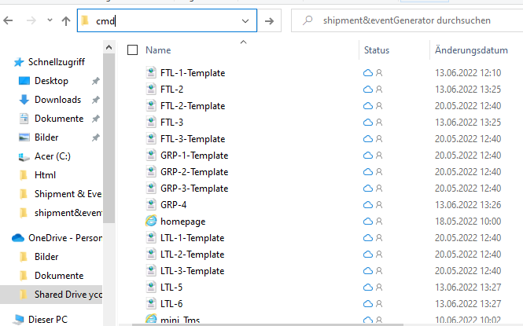

* Please enter "cmd" in the search bar on the far left as in the screen and then just press enter and another window will open directly with the link where you are currently.
* Enter php -S 127.0.0.1:4000 to activate the program as shown in the screen.

Ein Bild, das Text enthält.

* Go to your favorite browser an enter 127.0.0.1:4000/mini_Tms.php or 127.0.0.1:4000/homepage.php