CYPRESS

CYPRESS SEMICONDUCTOR
198 Champion Court
San Jose, CA 95134
Tel: 1-408-943 2600
Web: www.cypress.com
CYPRESS Model
Manual
CYPRESS Model Manual
Version *A
Author: CYPRESS Department: Hardware Systems SEMICONDUCTOR Engineering
Project: CYPRESS Model Manual
Document Cypress Model Manual.docx Name:
Last Changed: 1/13/20
Distribution: General Distribution
Preface: This document covers Verilog model simulation package

This document contains CYPRESS's technical specifications regarding the products described herein. This document may be revised by subsequent versions or modifications due to changes in technical specifications.
Table of Contents
1 Document History 3
2 Overview 4
3 Verilog – Model 4
3.1 Required Files 4
3.1.1 Files for a Simple Verilog Behavioral Simulation 4
3.2 Compiling Model Files 5
3.2.1 Compilation of Verilog Model Files 5
3.3 Simulating Model Files 5
3.3.1 Instantiation Template 5

4 Support ..................................................................................................1 0

Document History

Version/Date | Modification
**: 02/27/2019 | Initial version
*A: 01/13/2020 | Updated AC timing specs.  Fixed the latency issues  Fixed data mismatch at higher frequency  Fixed DPD and HSLEEP Entry Exit issue  Added Partial Refresh  Added Refresh Interval and variable latency feature  Added MPN based AC characteristics selection

Overview
The archive contains, model files for Cypress HyperRam Memory (Figure 1: Downloadable Package Contents).

These models support:

- Verilog behavioral simulation for 64Mb cypress’s HyperRam

- Timing-accurate simulation (including support for interconnect path delays)

- Built-in Timing checks

 | Downloadable Self Extracting File
File  Manual |  | ‐documentation (*.pdf)
Directory Models |  | ‐model code (s27kl0642.v)  ‐test benches (HyperBusTestBench.v)  -controller code (hbram_ctrl.v)

Figure 1: Downloadable Package Contents

The package contains all the necessary preload files, test benches and timing files to get started in your simulation environment.

Verilog – Model

Required Files

Files for a Simple Verilog Behavioral Simulation
The model file s27kl0642.v is located in the model directory. It does not depend on other files and can be run as is in a behavioral Verilog simulation.
Depending upon device MPN requirement, user should enable the respective line, which select the AC timing parameters.
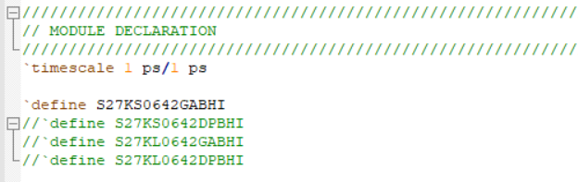
Depending on the file locations and project location, please modify the include file path for file “tasks_simple.v” in “HyperBusTestBench_simple.v”
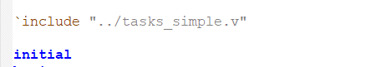

Compiling Model Files

Compilation of Verilog Model Files
The file s27kl0642.v can be compiled as is. No further libraries need to be provided.

Simulating Model Files

Instantiation Template

s27kl0642 DUT (
.DQ7(DQ[7]) ,
.DQ6(DQ[6]) ,
.DQ5(DQ[5]) ,
.DQ4(DQ[4]) ,
.DQ3(DQ[3]) ,
.DQ2(DQ[2]) ,
.DQ1(DQ[1]) ,
.DQ0(DQ[0]) ,
.RWDS(RWDS) ,

.CSNeg(CS) ,
.CK(CK) ,
.CKn() ,
.RESET(dut_reset)
);
4 Support
We appreciate your feedback or suggestions to ensure our models meet your needs. For contacting us, please use cypress forum

