**ADD FILE ASSOCIATION VIA MSI**

**What is MSI?**

**MSI** stands for **Microsoft Installer** also known as **Windows Installer**. It is a **file format** (.msi) used to **install, maintain, and remove software** on Windows.

**Example:** If you download **Firefox.msi**, you're downloading an installer that can install Firefox using the Windows Installer service.

**What is File Association?**

A file association is a **relationship between** a **file type** and a **supporting application**.

In short, File association **associate** (connect) file type to the app which are **capable** of opening the file.

**Example,** a Word document may be associated with Microsoft Word. This means when you double-click a Word document, Microsoft Word will open the file.

**What is Orca?**

Orca is a free **Windows Installer package** editor from Microsoft. **Orca** is a **table editor** for .msi (Microsoft Installer) files. It lets you **view and modify** the internal database tables of an MSI package.

To **Download** Orca(<https://developer.microsoft.com/en-us/windows/downloads/windows-sdk/>)

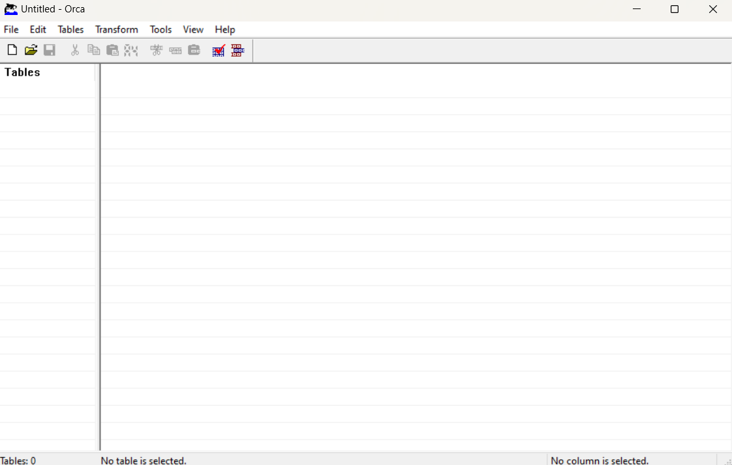**Orca Interface:**

**Requirements:**

* Windows Operating System (Windows 10 or 11)
* Windows SDK (to install the Orca tool)
* Orca Tool (used to edit the MSI file)
* Firefox MSI File (eg: Firefox.msi)
* Notepad (to create a .gha test file)
* To download FirefoxMSI

(<https://www.exemsi.com/downloads/packages/Firefox/Firefox%20Setup%2014.0.1.msi>)

**Goal:**

* This project shows how to change an **MSI installer** to add a **custom file** extension and to open the supported application automatically.
* We used a tool called **Orca** to edit the .msi file (I have used Firefox.msi).
* The goal was to **link files** with the custom extension (eg: .gha) to **open** with the **Firefox** browser (or any other application).
* Now, when we **double-click** a **.gha** file, it will open the **Firefox** automatically.
* This method is useful when we want to control how files open after installing a program.
* It can help IT teams or developers customize software setup easily.

**Steps to Add File Association**

**Step 1:** Download Orca from the link given above or **download** it directly using this link(<https://go.microsoft.com/fwlink/?linkid=2320455>) then open the **winsdksetup**

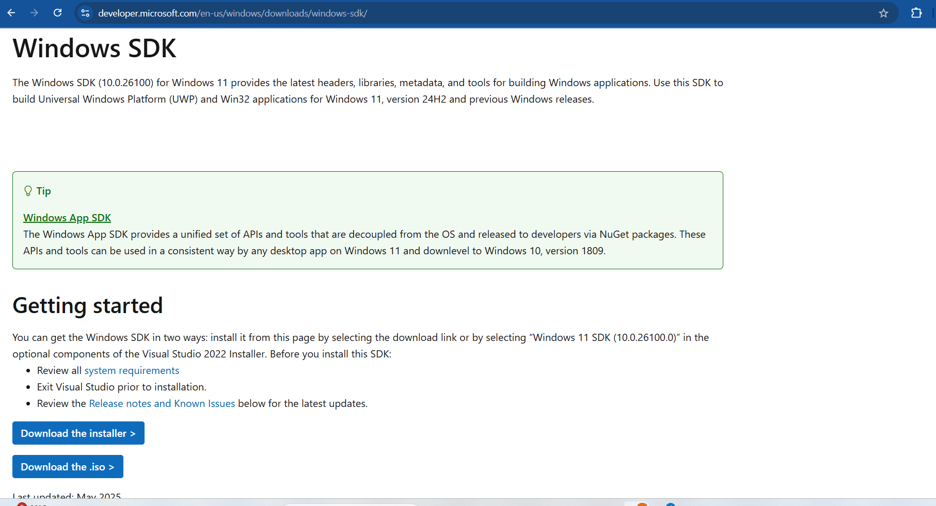



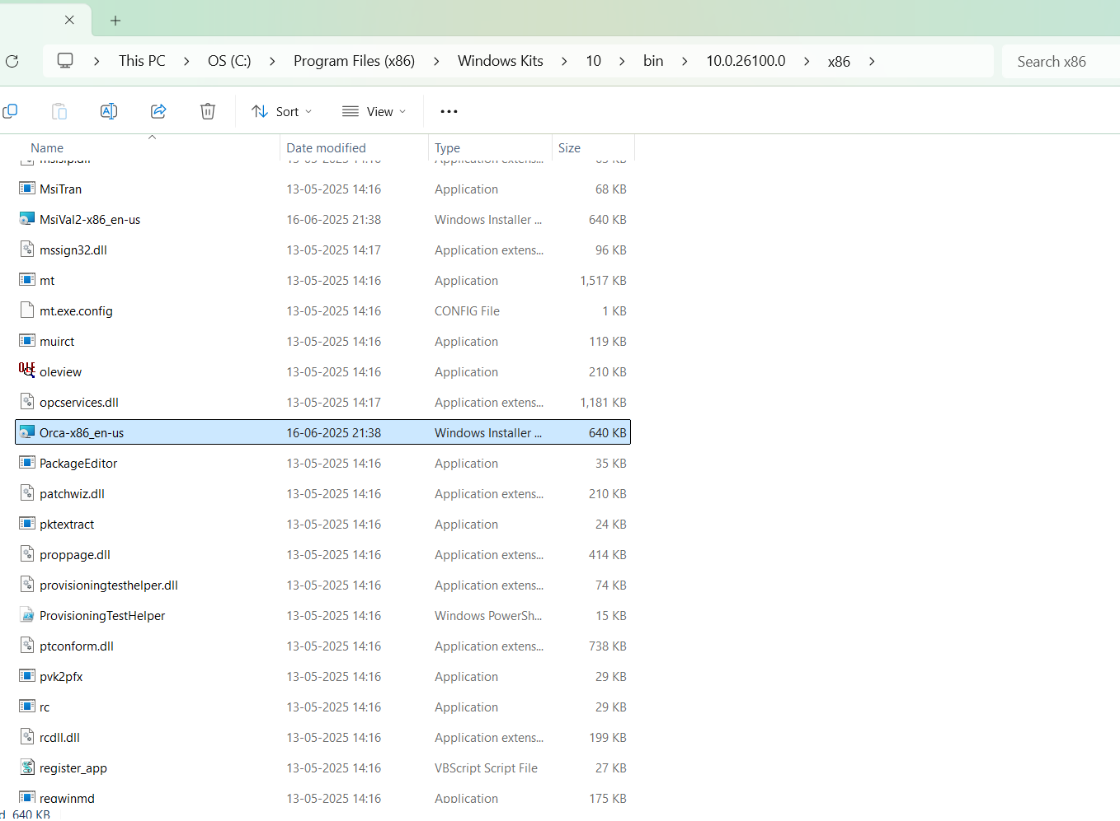**Step 2:** Once the setup is **installated,** then **navigate** to this path **C:\Program Files (x86)\Windows Kits\10\bin\10.0.26100.0\x86 and install the Orca-x86_en-us.msi**

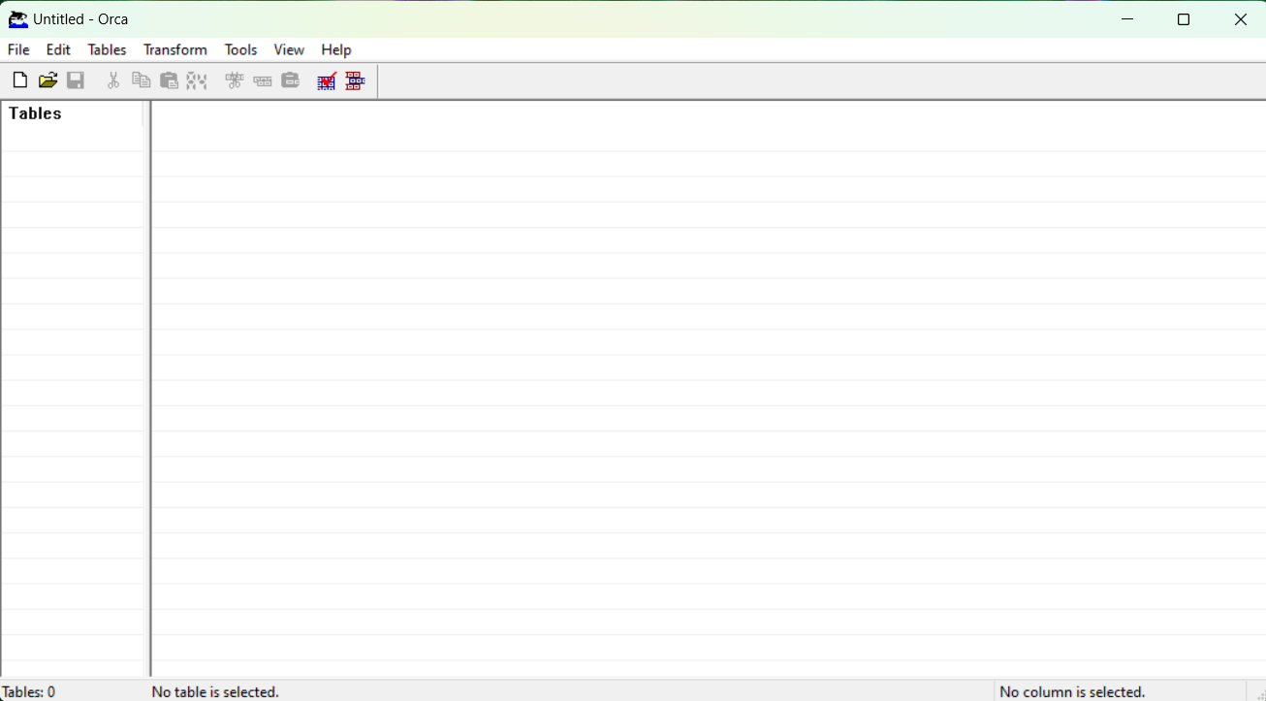**Step 3:** Search Orca in the **Start Menu** and Open **Orca** App

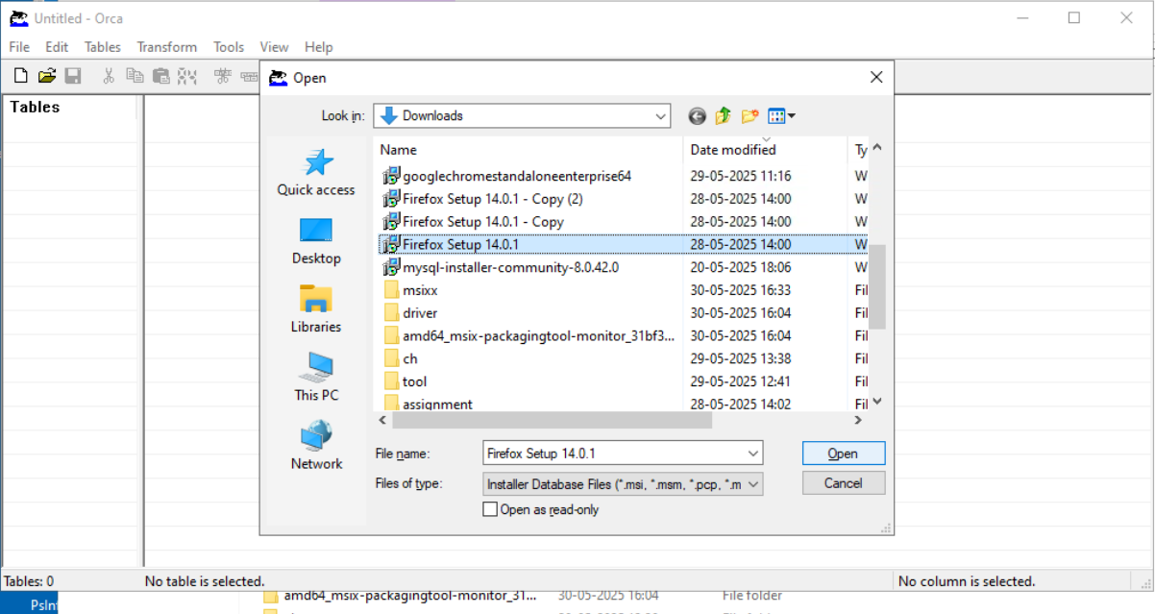**Step 4:** Click on **File** and **Open** the **msi package** which you want to **view or modify.**

**Step 5:** In the **Registry** table on the left side, **manually** **add 3 rows** for each row we will be have to fill **Registry, Root, Key, Value, Component** columnand the **Component** (ex: bz.ProductComponent) will be same for all the 3 rows and **Root** (ex: 0) also

In the first row, Registry column enter the Extfile name and in the Key give the file extension you want (ex: .gha) and set a value (eg:FirefoxHTML.gha)

**First Row**

* Registry: ghaExtFile
* Root: 0 <----same for all 3 rows
* **Key: .gha** <----this is custom extension
* Value: FirefoxHTML.gha
* Component: bz.ProductComponent <----same for all 3 rows

**Second Row**

* Registry: GhaProgID
* Key: FirefoxHTML.gha
* Value: Firefox gha File

**Third Row**

* Registry: GhaCommand
* Key: FirefoxHTML.gha\shell\open\command
* **Value: "C:\Program Files (x86)\Mozilla Firefox\firefox.exe" "%1"**

(%1 represents the file the user double-clicked)

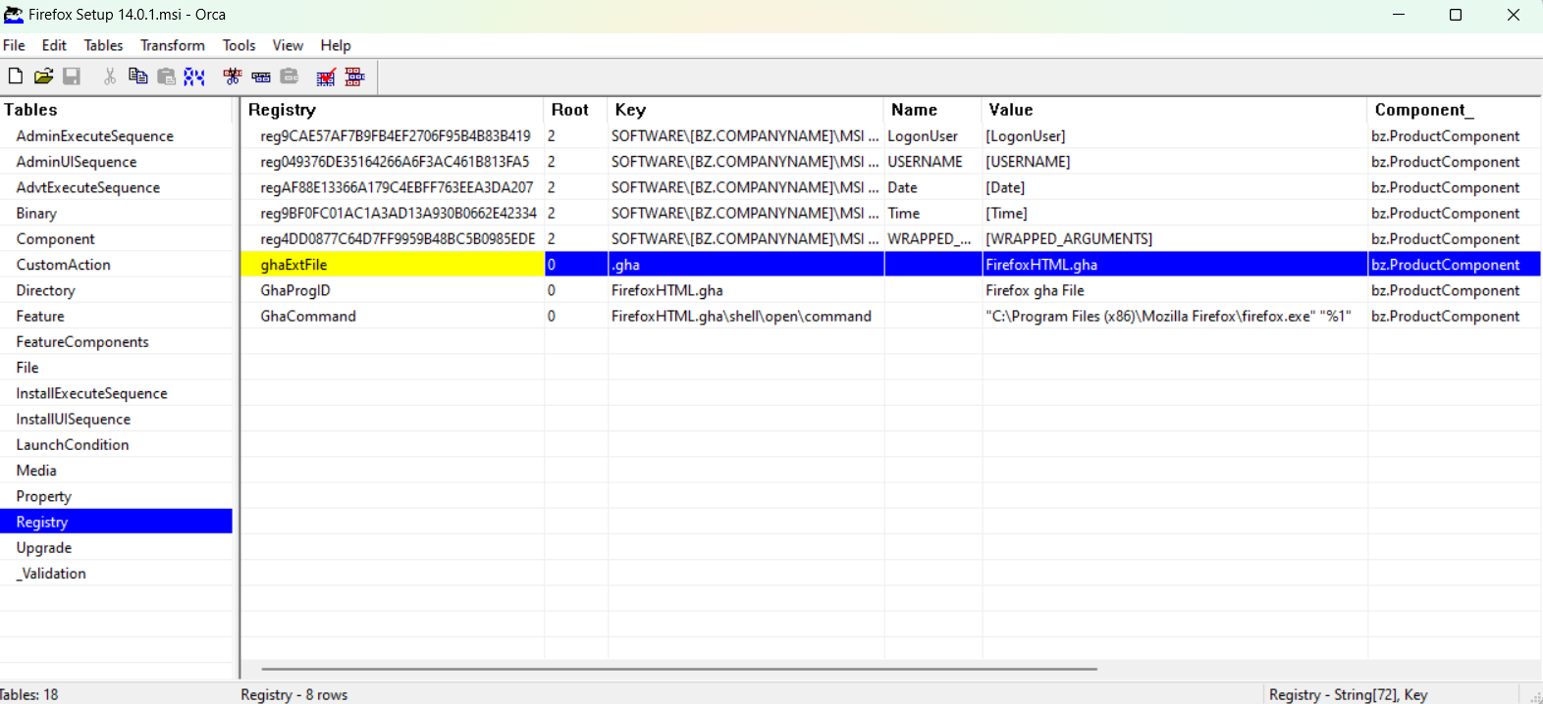**Step 6:** After adding the 3 rows, then in **File** click on **save as** (I have given **fireeeee.msi**) and give a proper name then **close Orca**

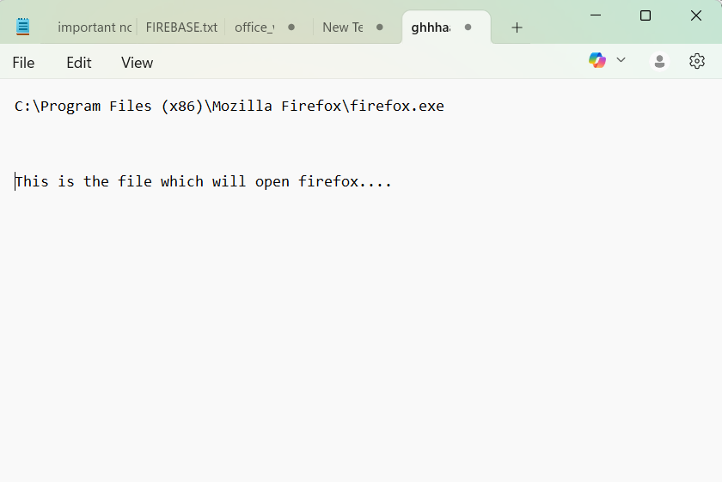**Step 7:** Open **Notepad and** create a new **test file** with your **custom extension (eg: .gha)** and **select All files** as the file type

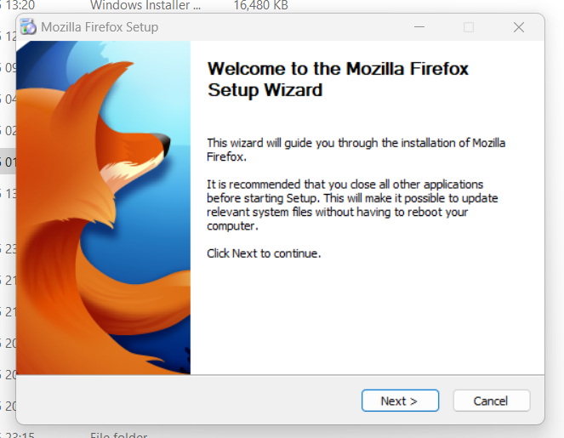**Step 8: Uninstall** the previous MSI if it is already installed (In my case, I had Firefox installed, so I uninstalled it.) then **install** the new MSI that you saved in Step 6 (eg: fireeeeeee.msi the one with file association added).

**Step 9:** **Double click** on the file we create using notepad **(.gha)** it will **open** the **Firefox**

