**Edit Custom Tables in Orca**

**What is MSI?**

MSI (Microsoft Installer) is a Windows installation file format used for installing, maintaining, and removing applications. MSI files contain a database of installation instructions divided into **tables**, which Orca can view and modify.

**What is Orca?**

Orca is a **free MSI editor tool** provided by Microsoft as part of the Windows SDK. It allows users to **View and modify** internal tables of .msi files, **Add custom logic** during installation and **Customize registry** changes, file deletions, environment variables, etc.

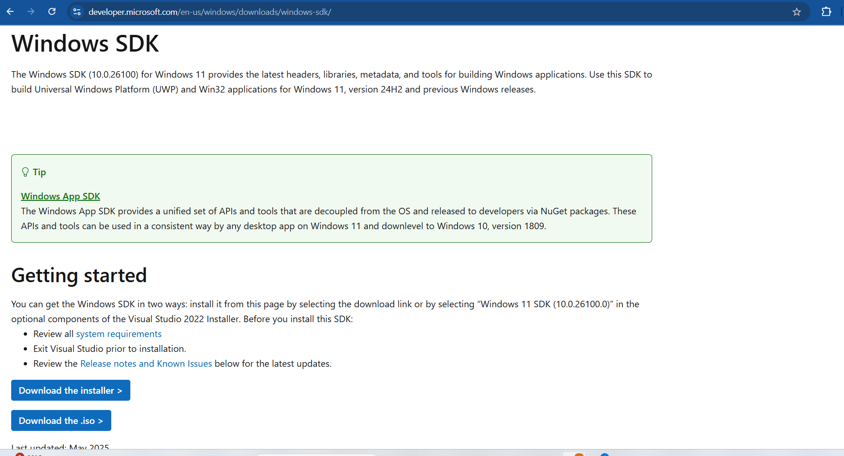To **Download** Orca(<https://developer.microsoft.com/en-us/windows/downloads/windows-sdk/>)

**Goal of This Project**

* To see how we **add and edit custom tables** in an MSI file using **Orca**.
* we will manually add:
  + Environment Table – to set environment variables
  + RemoveFile Table – to delete specific files or folders
  + Registry Table – to add or change Windows Registry entries

**Requirements:**

* Windows Operating System (Windows 10 or 11)
* Orca Tool (installed via Windows SDK)
* An .msi file (Example: Firefox.msi or any other test MSI

**Steps to Edit Custom Tables in Orca**

**Step 1:** Download Orca from the link given above or **download** it directly using this link(<https://go.microsoft.com/fwlink/?linkid=2320455>) then open the **winsdksetup**



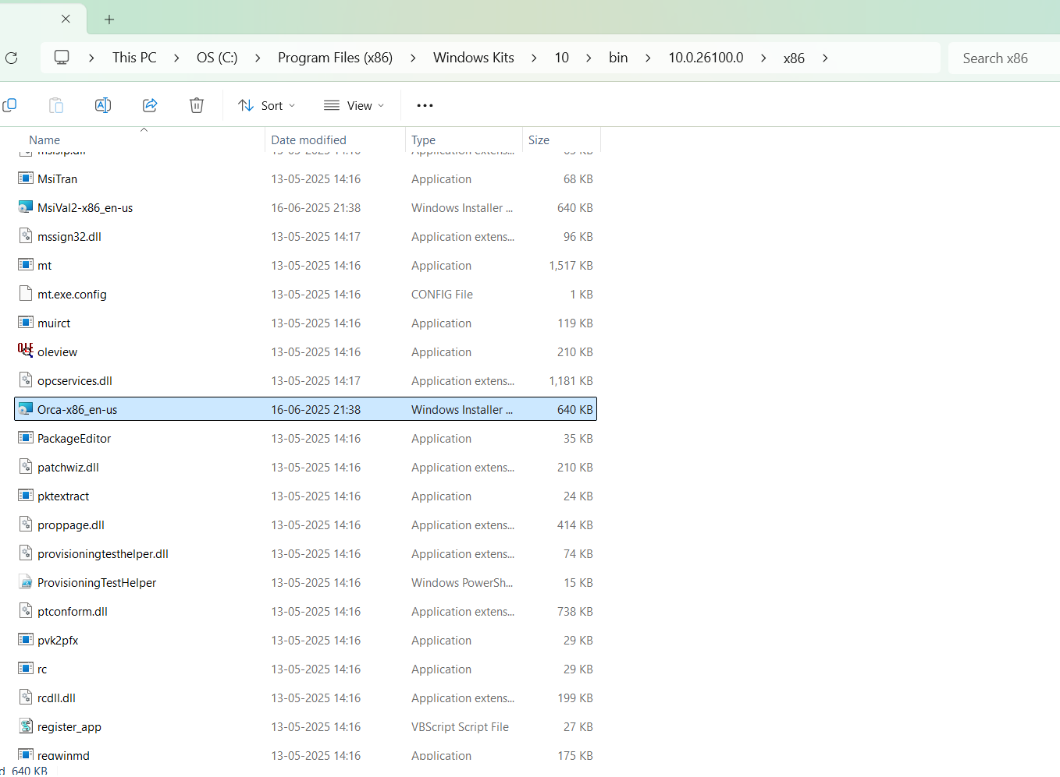**Step 2:** Once the setup is **installated,** then **navigate** to this path **C:\Program Files (x86)\Windows Kits\10\bin\10.0.26100.0\x86 and install the Orca-x86_en-us.msi**

**Step 3:** 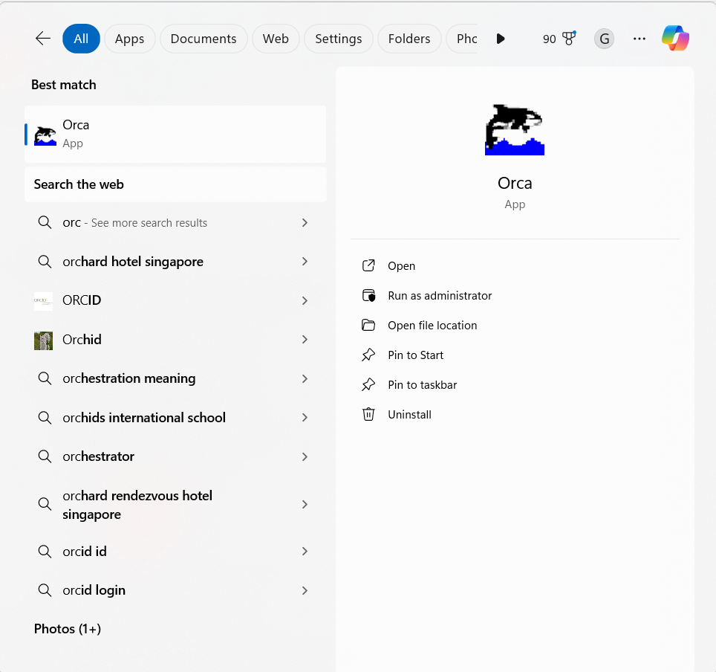Launch Orca from **Start Menu** and **Open Orca**

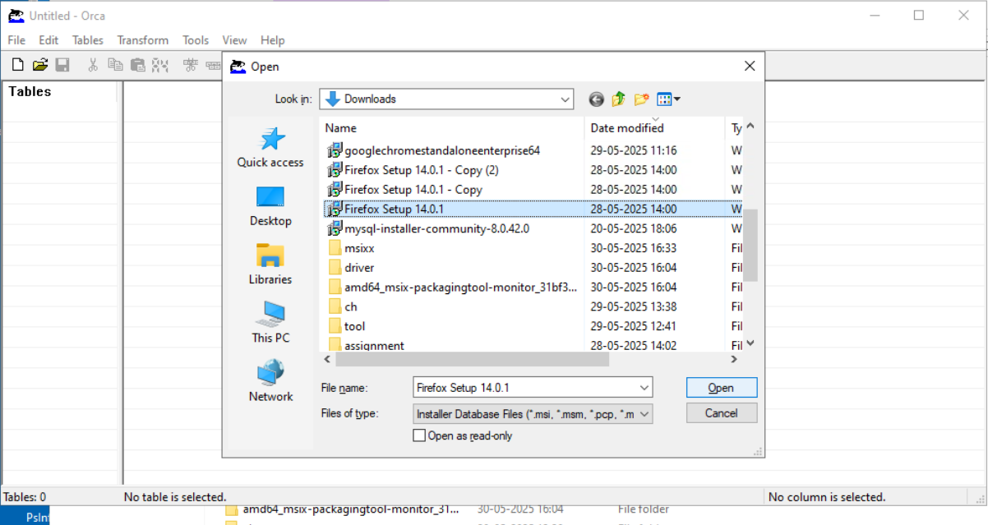**Step 4:** Click on **File** and **Open** choose your MSI file (eg: Firefox.msi)

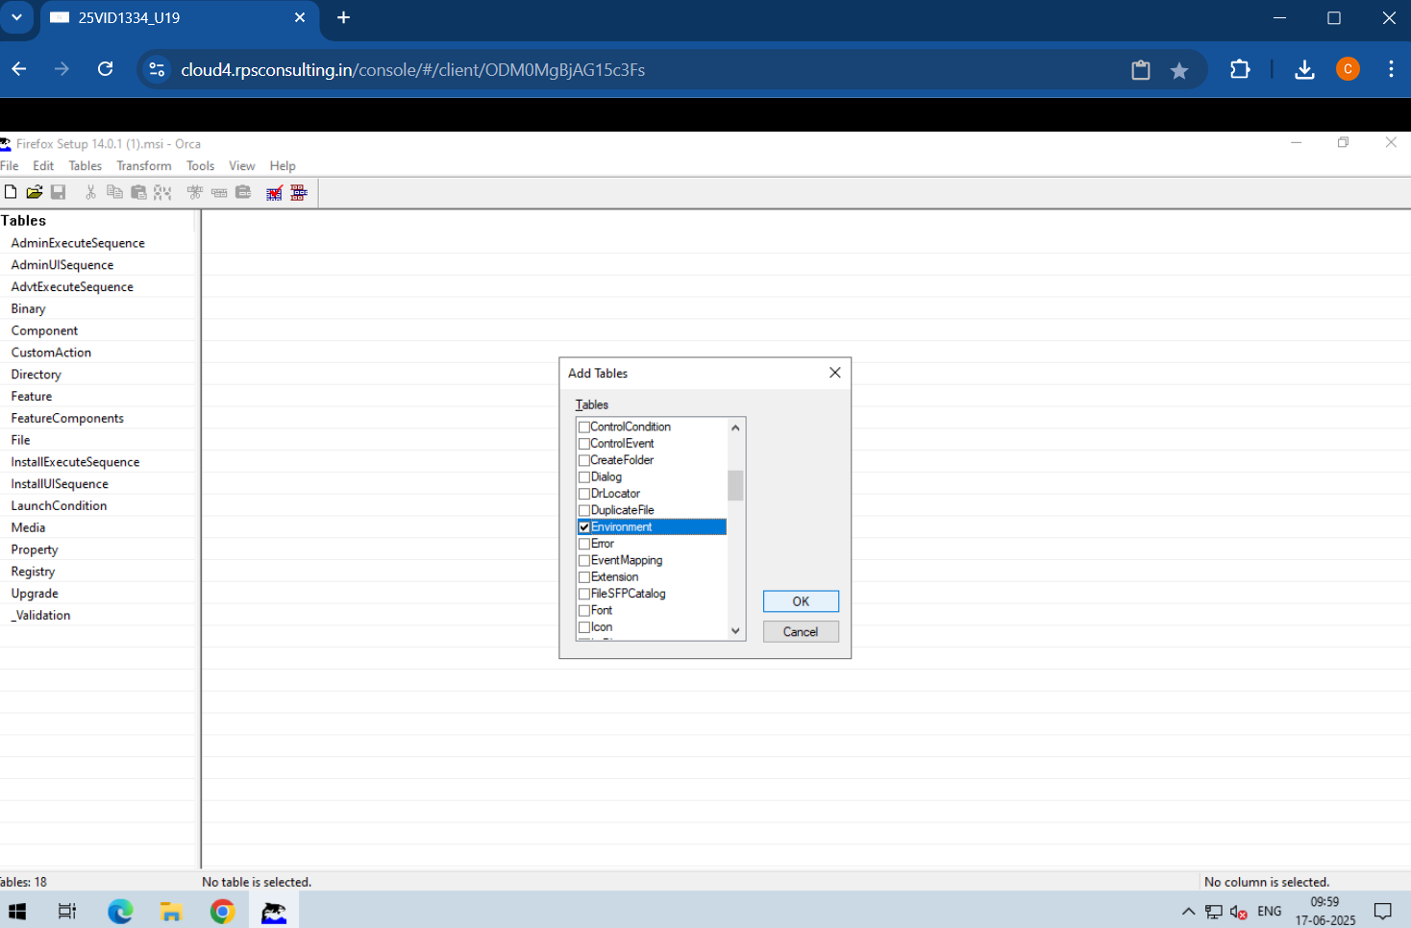**Step 5: Add a Missing Table** Click on **Tables > Add Tables...**Choose the table you want to add Environment.idt, RemoveFile.idt, and Registry.idt. If the table is already present, skip this and directly add rows.

**Step 6: Add Entries to Environment Table**

This table adds environment variables (e.g., PATH, JAVA_HOME,etc)

| **Column** | **Value** |
| --- | --- |
| Environment | AddToPath |
| Name | PATH |
| Value | C:\Program Files (x86)\Mozilla Firefox |
| Component | bz.ProductComponent |
| Action | set |

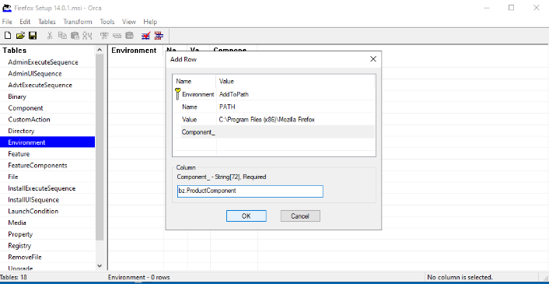**Step 4: Add Entries to RemoveFile Table**

This table removes files/folders on install or uninstall

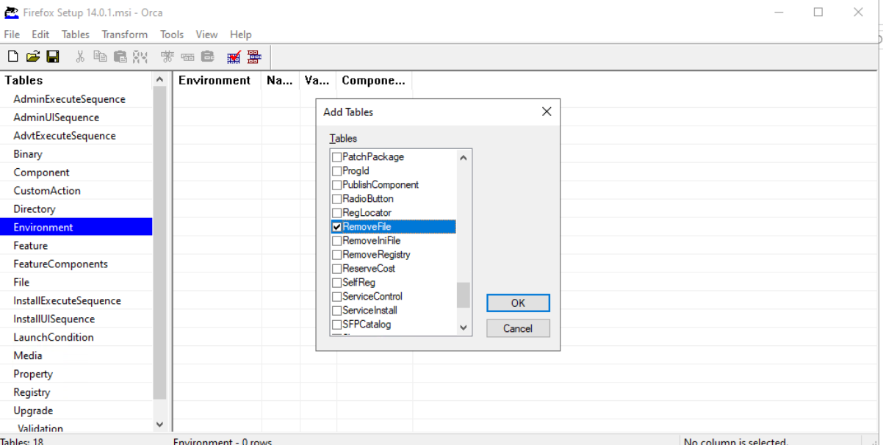

| **Column** | **Value** |
| --- | --- |
| FileKey | DeleteReadme |
| Component | bz.ProductComponent |
| FileName | sample.txt |
| DirProperty | BZ.INSTALLFOLDER |
| InstallMode | 2 (Remove on uninstall only) |

This removes sample.txt from the install directory on uninstallation we have to add the **sample.txt** file in the **C:\Program Files (x86)\Mozilla Firefox** path

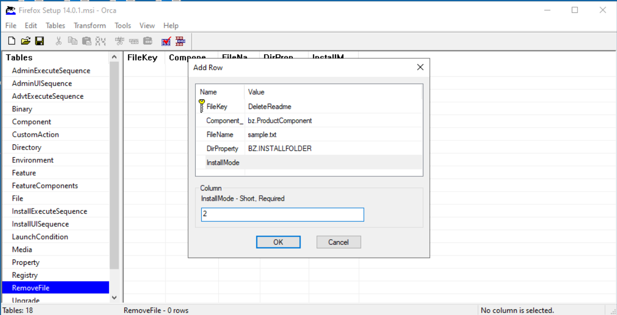

**Step 5: Add Entries to Registry Table**

This table modifies Windows Registry during installation

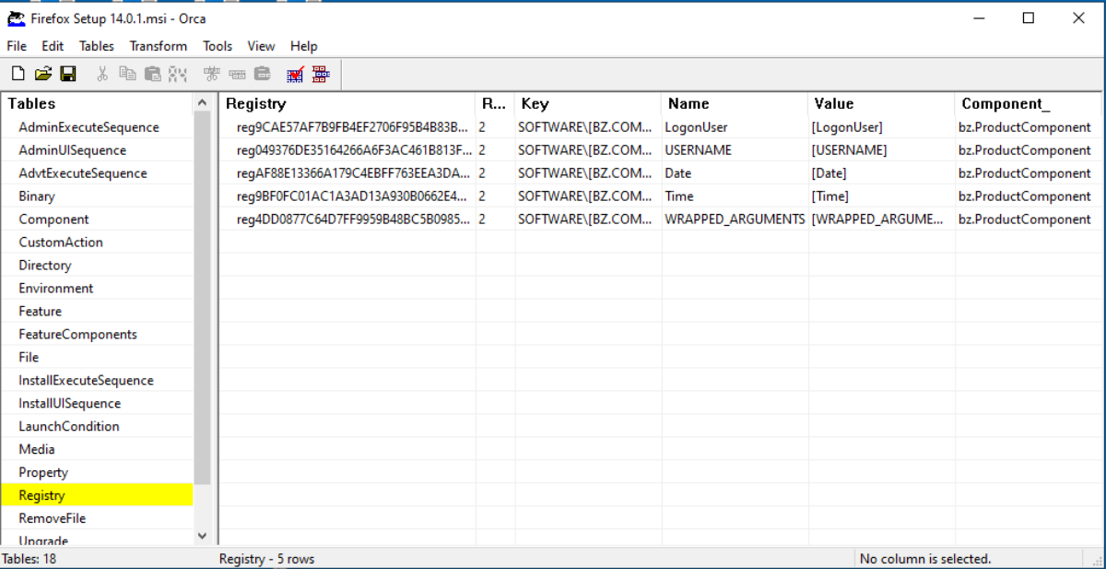

| **Column** | **Value** |
| --- | --- |
| Registry | AddTestRegistry |
| Root | 2 |
| Key | Software\MyTestKey |
| Name | MyVlaue |
| Value | HelloWorld |
| Component | bz.ProductComponent |

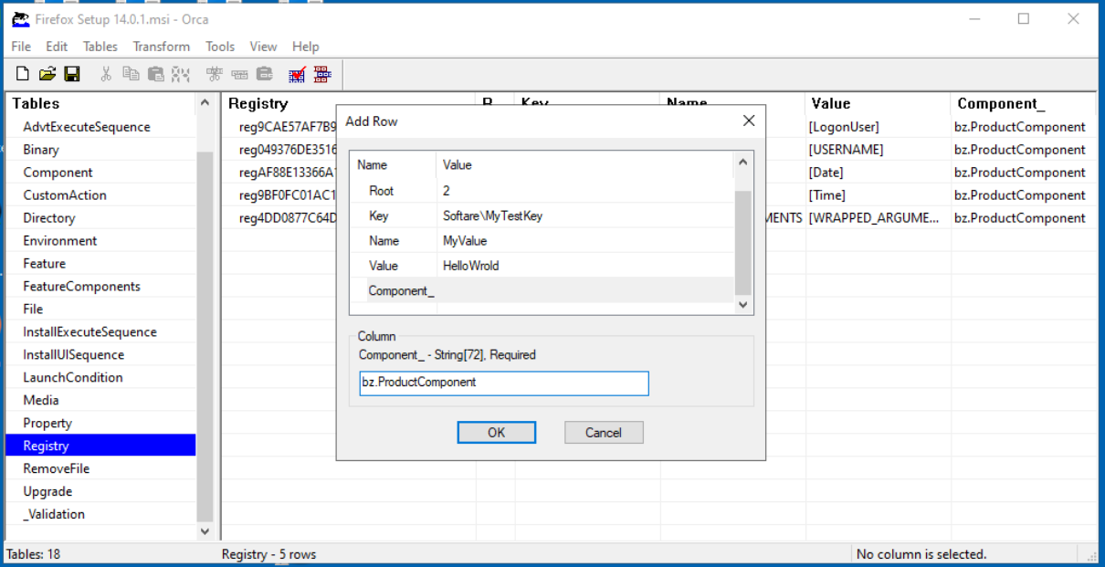

| **Root Number** | | **Hive** |
| --- | --- | --- |
| **0** | **HKEY_CLASSES_ROOT** | |
| **1** | **HKEY_CURRENT_USER** | |
| **2** | **HKEY_LOCAL_MACHINE** | |
| **3** | **HKEY_USERS** | |

**Step 6: Save** the msi click **File > Save As**

* Save your modified MSI with a new name (e.g., Firefox_Custom.msi)

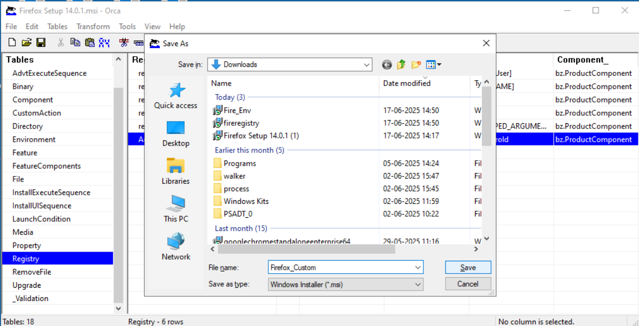

**Step 7:** Then open the **Firefox_Custom.msi** and install it if there exist firefox then **uninstall** the old one and **install** the new modified Firefox_Custom.msi

To Check the Environment variables, Registry Editor and File deletion

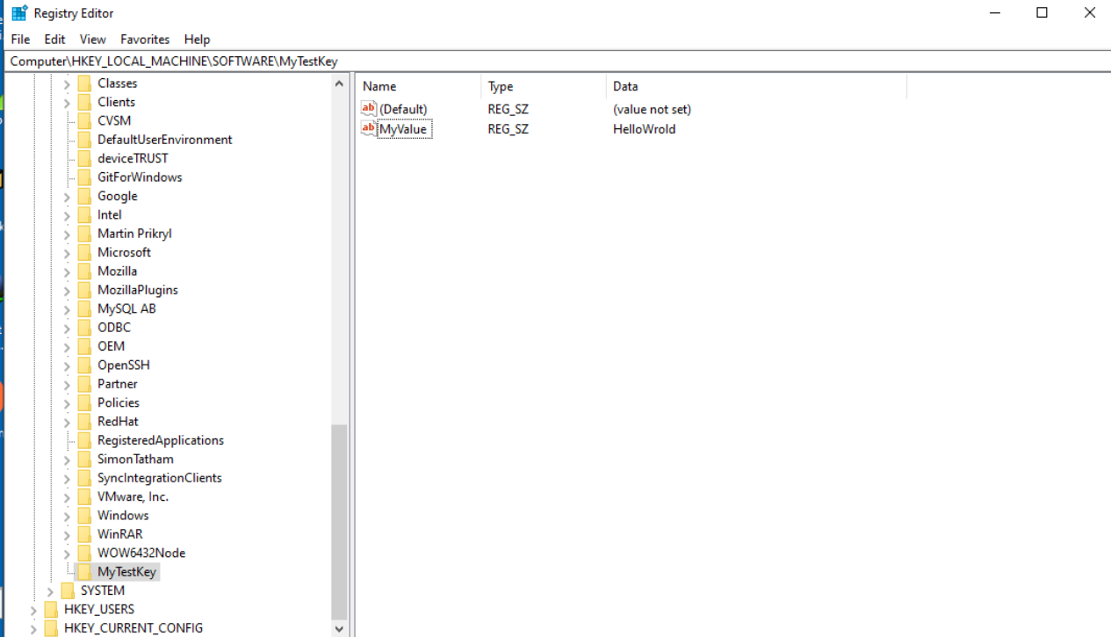**Registry Editor**

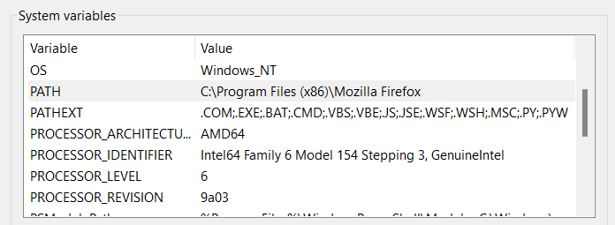**Environment Variable**

**Conclusion**

* Orca allows powerful **customization** of MSI behavior
* By manually editing **Environment**, **RemoveFile**, and **Registry** tables, we can Set environment variables, Clean up unnecessary files, Configure registry entries, etc
* These techniques are **valuable** for software packaging, enterprise deployment, and system integration.