**Intune Application Deployment Process**

To create a .intunewin file compatible with Intune, we will need to use the Microsoft Win32

Content Prep Tool. This tool converts various app installation files (like .msi, .exe) into

the .intunewin format, which is then used for deploying applications to devices managed by

Intune admin center.

**Step 1: - Download the Win32 Content Prep Tool**

Download the Prep Tool from Github (<https://github.com/microsoft/Microsoft-Win32-Content-Prep-Tool>) or form Microsoft official documentation.

**Step 2: - Prepare the app package**

The tool takes your app installation files and convert them to .intunewin package.

After downloading the tool from github we will get **intuneWinAppUtil.exe**

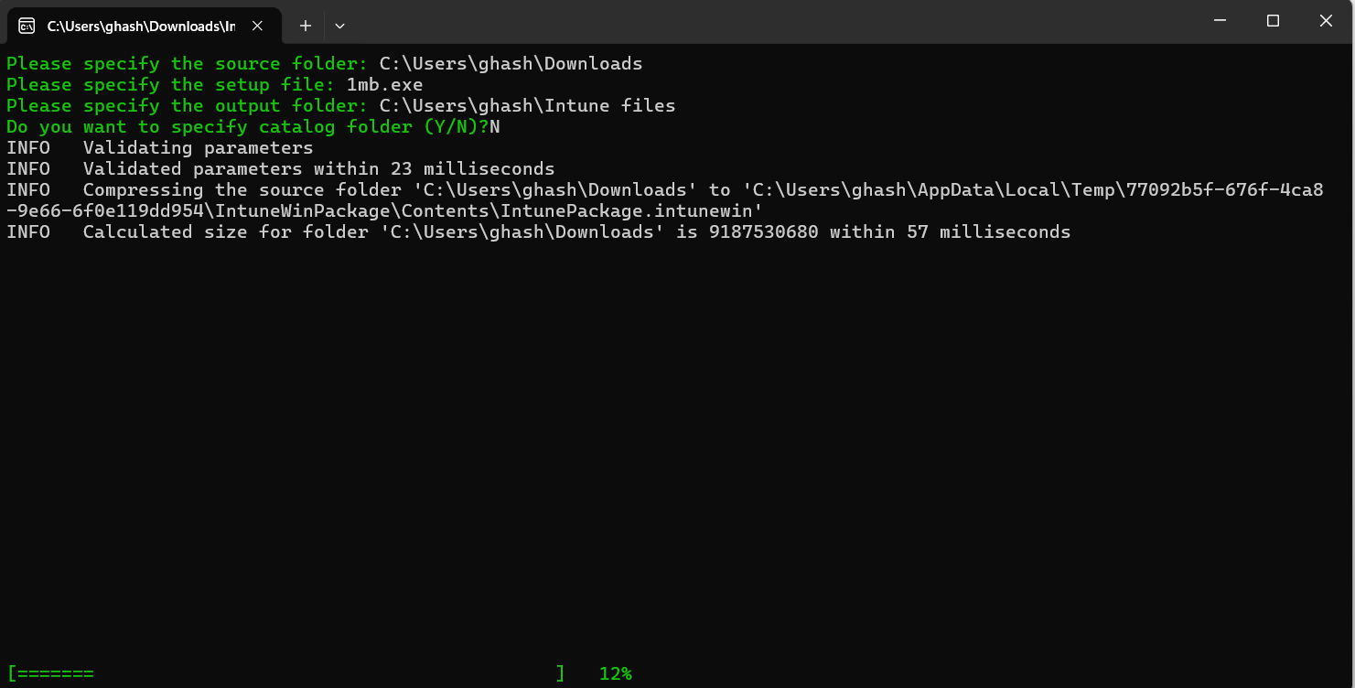[Open **intuneWinAppUtil.exe** it will ask for source folder - where we have files, setup file - name of the file then it will ask for output folder - where we want to store .intunewin then it will ask for catalog folder simply say N.]

**Step 3: -Upload the .intunewin to Intune**

Once the package is created, you can upload it to the Intune admin center to add it as a new app.

**Step 4: - Configure app details**

Provide information like the app’s name, description, privacy policy, and the commands to install and uninstall the app.

**Step 5: -Assign the app to users or groups**

Finally, we will assign the app to the appropriate groups within your organization to ensure it gets deployed to the intended devices.