**Execute, Copy, Install and Active Setup Commands**

**Execute-MSI:**

Executes msiexec.exe to perform the following actions for MSI & MSP files and we can install, uninstall, update,etc as per the parameter -Action.

* Execute-MSI -Action 'Install' -Path 'Adobe_FlashPlayer_11.2.202.233_x64_EN.msi'
* Execute-MSI -Action 'Install' -Path 'Adobe_FlashPlayer_11.2.202.233_x64_EN.msi' -Transform 'Adobe_FlashPlayer_11.2.202.233_x64_EN_01.mst' -Parameters '/QN'
* Execute-MSI -Action 'Uninstall' -Path '{26923b43-4d38-484f-9b9e-de460746276c}'
* Execute-MSI -Action 'Patch' -Path 'Adobe_Reader_11.0.3_EN.msp'
* Execute-MSI -Action Install -Path $AppMSIName -SkipMSIAlreadyInstalledCheck -ContinueOnError $False -LogName "${AppMSIName}_MSI"

**Execute process:**

Execute a process with optional arguments, working directory, window style.

* Execute-Process -Path 'uninstall_flash_player_64bit.exe' -Parameters '/uninstall' -WindowStyle 'Hidden'
* Execute-Process -Path "$dirFiles\Bin\setup.exe" -Parameters '/S' -WindowStyle 'Hidden'
* Execute-Process -Path 'setup.exe' -Parameters '/S' -IgnoreExitCodes '1,2'
* Execute-Process -Path 'setup.exe' -Parameters "-s -f2`"$configToolkitLogDir\$installName.log`""
* Execute-Process -Path 'setup.exe' -Parameters "/s /v`"ALLUSERS=1 /qn /L* `"$configToolkitLogDir\$installName.log`"`""

**ExecuteMSP:**

Reads SummaryInfo targeted product codes in MSP file and determines if the MSP file applies to any installed products

* Execute-MSP -Path 'Adobe_Reader_11.0.3_EN.msp'
* Execute-MSP -Path 'AcroRdr2017Upd1701130143_MUI.msp' -AddParameters 'ALLUSERS=1'

**Copy-File:**

Copy a file or group of files to a destination path.

* Copy-File -Path "$dirSupportFiles\*.*" -Destination "$envTemp\tempfiles"
* Copy-File -Path "$dirSupportFiles\MyApp.ini" -Destination "$envWinDir\MyApp.ini"

**Install-Msupdate:**

Install all Microsoft Updates of type ".exe", ".msu", or ".msp" in a given directory

* Install-MSUpdates -Directory "$dirFiles\MSUpdates"

**Set-ActiveSetup:**

Creates an Active Setup entry in the registry to execute a file for each user upon login.

* Set-ActiveSetup -StubExePath 'C:\Users\Public\Company\ProgramUserConfig.vbs' -Arguments '/Silent' -Description 'Program User Config' -Key 'ProgramUserConfig' -Locale 'en’
* Set-ActiveSetup -StubExePath "$envWinDir\regedit.exe" -Arguments "/S `"%SystemDrive%\Program Files (x86)\PS App Deploy\PSAppDeployHKCUSettings.reg`"" -Description 'PS App Deploy Config' -Key 'PS_App_Deploy_Config' -ContinueOnError $true

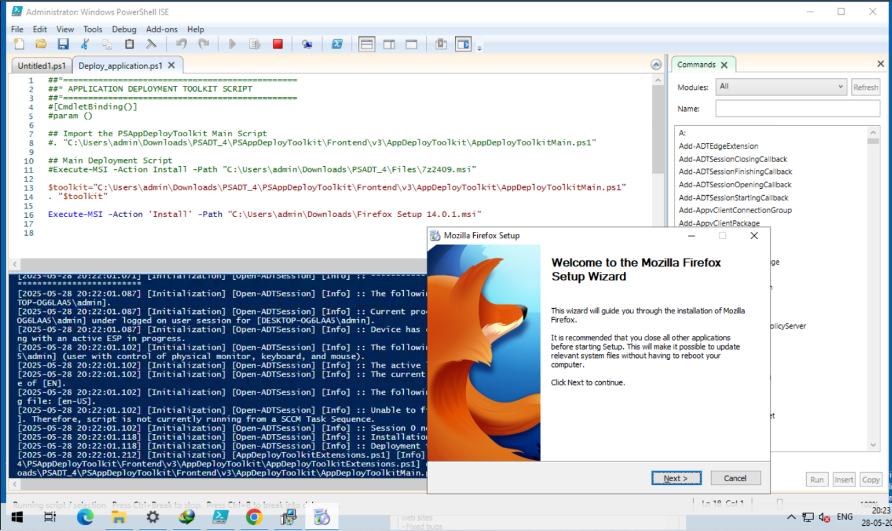

**Execute-MSI Installation and Uninstallation**

In PSAppDeployToolkit, Execute-MSI is a function used for installing, uninstalling, patching, repairing, or performing active setup on MSI and MSP files, or using MSI product codes. For installation, it defaults to using the /i (install) switch of msiexec.exe, while for uninstallation, it uses the /x (uninstall) switch.

**Installation**

**Basic Usage**: Use -Action Install and provide the path to the MSI file.

**Parameters**: we can add or override default parameters to customize the installation process/qn – Silent installation

* /norestart or REBOOT=ReallySuppress – Prevent system restart
* /L*v – Enable verbose logging

**Example:** Execute-MSI -Action Install -Path "C:\path\to\app.msi" -Parameters "/qn REBOOT=ReallySuppress"

**Uninstallation**

**Basic Usage**: Use -Action Uninstall with the MSI path or product code.

**Parameters**: Similar to installation; use /qn for silent uninstall and /L*v for logging

**Example**: Execute-MSI -Action Uninstall -Path "C:\path\to\app.msi" -Parameters "/qn REBOOT=ReallySuppress"

**Important Considerations**

* **Product Code**: You can uninstall using the MSI's product code instead of the file path.
* **Logging**: Use -LogName to specify a custom log file.
* **Pre-flight Checks**: Disable MSI installed check with -SkipMSIAlreadyInstalledCheck.
* **Error Handling**: -ContinueOnError can be used to continue execution on failure.

**Commands For Installation and Uninstallation**

**Installation**

* **Execute-MSI**: Primary cmdlet to install MSI packages.

**Parameters**:

-Action Install: Defines the operation.

-Path: Path to the .msi file.

-DeployMode: Set deployment mode (Silent, Interactive, or NonInteractive).

**Example:**Execute-MSI -Action Install -Path "C:\path\to\your.msi" -DeployMode Silent

**Uninstallation**

* **Uninstall-ADTApplication**: Used for uninstalling apps previously installed using PSAppDeployToolkit.
* **Execute-MSI**: Can also uninstall using the product’s GUID or MSI path.

**Example:**Execute-MSI -Action Uninstall -Path "{GUID of the product}"

**Start-Process with msiexec.exe**: Alternative method to manually run uninstall commands.

**Example**: Start-Process -FilePath "C:\Windows\System32\msiexec.exe" -ArgumentList "/x{GUID of the product} /qn" -Wait

**Other related commands:**

* **Get-RunningProcesses**  
  Checks for running processes that may need to be closed before proceeding with installation or uninstallation.
* **Show-WelcomePrompt**  
  Displays a customizable welcome message to inform or prompt the user before continuing with the deployment.
* **Remove-MSIApplications**  
  Uninstalls specific MSI-based applications from the system.
* **Unblock-ADTAppExecution**  
  Unblocks an application that was previously blocked by the toolkit.
* **Unregister-ADT-Dll**  
  Unregisters a specified DLL file