**Continued Commands …**

**Get-RegistryKey:** Retrieves value names and value data for a specified registry key or optionally, a specific value. If the registry key does not exist or contain any values, the function will return $null by default

Example:

* Get-RegistryKey -Key 'HKLM:SOFTWARE\Microsoft\Windows\CurrentVersion\Uninstall\{1AD147D0-BE0E-3D6C-AC11-64F6DC4163F1}'
* Get-RegistryKey -Key 'HKEY_LOCAL_MACHINE\SOFTWARE\Microsoft\Windows NT\CurrentVersion\Image File Execution Options\iexplore.exe'
* Get-RegistryKey -Key 'HKLM:Software\Wow6432Node\Microsoft\Microsoft SQL Server Compact Edition\v3.5' -Value 'Version'
* Get-RegistryKey -Key 'HKEY_LOCAL_MACHINE\SYSTEM\CurrentControlSet\Control\Session Manager\Environment' -Value 'Path' -DoNotExpandEnvironmentNames

**Set-IniValue:** Opens an INI file and sets the value of the specified section and key.

Example:

* Set-IniValue -FilePath "$envProgramFilesX86\IBM\Notes\notes.ini" -Section 'Notes' -Key 'KeyFileName' -Value 'MyFile.ID'

**Set-ADTIniValue**: This function allows you to set a value within a specified section and key in an INI file.This function takes the path to the INI file, the section, the key, and the value as parameters

Example:

* Set-ADTIniValue -FilePath “c:\Windows\Path\Myini.ini” -Section “Mysection” -Key “Mykey” -Value “myValue”

**Create, Delete, or Modify Registries**

**Create a new key**

* New-Item -Path “HKLM:\Software\Mycompany” -Type Directory -ErrorAction silentlycountinue

**Delete a key**

* Remove-Item-Path “HKLM:\Software\Mycompany” -Recurse -Force -ErrorAction silentlycontinue

**Set a Registry Value**

* Set-Itemproperty -Path “HKLM:\Software\Mycompany\MyKey” -Name “Myvalue” -Value “Mydata”

**Get a registry value**

* Set-Itemproperty -Path “HKLM:\Software\Mycompany\MyKey” -Name “Myvalue”

**Start and Stop Services in PSADT**

**Stop a Service:** Use the Stop-Service cmdlet with the -Name parameter to specify the service name.

* Stop-Service -Name “YourServiceName”

**Start a Service:** Use the Start-Service cmdlet with the -Name parameter to specify the service name.

* Start-Service -Name “YourServiceName”

**Force Stop:** If dependencies are present use the -Force parameter with Stop-Service to stop a service even if it has dependent service

* Stop-Service -Name “YourServiceName” -Force

**Stop with Dependencies:** Use the Stop-ADTServicesAndDependencies function to stop a service and its dependent services.

* Stop-ADTServiceAndDependencies -Name “YourServiceName”

**Start with Dependencies:** Use the Start-ServiceAndDependencies function to start a service and its dependent services

* Start-ADTServiceAndDependencies -Name “YourServiceName”

**Chrome MSI Deploy**

**Step 1: Download the chrome msi**

Link- (<https://chromeenterprise.google/download/?ref=learnintune.net>) while downloading select the MSI as file type

**Step 2: Download the PSADT and place in a random folder (Ex:-ch)**

Link-( <https://github.com/PSAppDeployToolkit/PSAppDeployToolkit/releases>)

**Step 3: Open Invoke-AppDeployToolkit.ps1**

Ex:- C:\Users\admin\Downloads\ch\PSAppDeployToolkit\Frontend\v4\Invoke-AppDeployToolkit

In this file set the AppName, AppVersion, AuthorName, etc and also write

* Execute-MSI -Action “Install” -Path “C:\Users\admin\Downloads\ch\Files\ googlechromestandaloneenterprise64.msi”

**Step 4: Run cmd as an Administrator**

Go to the PSTool where PsExec is present

C:\Users\admin\Downloads\PSTools\PsExec.exe -s cmd.exe

**Step 5: Double tap on the Invoke-AppDeployToolkit.exe**

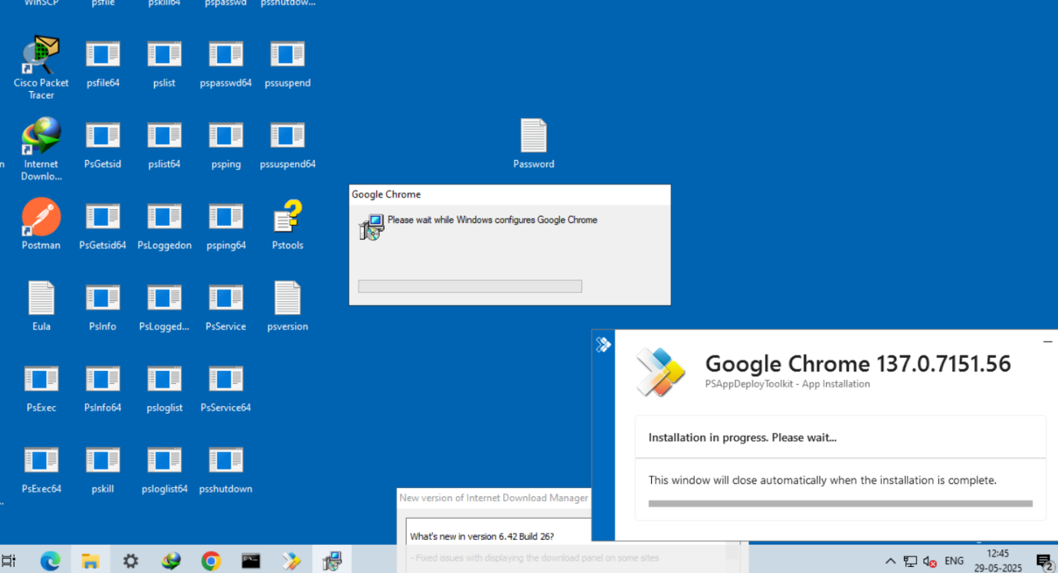

**Step 6: Convert the exe file to intunewin**

Download the Microsoft Content Prep Tool

Link(<https://github.com/microsoft/Microsoft-Win32-Content-Prep-Tool>)

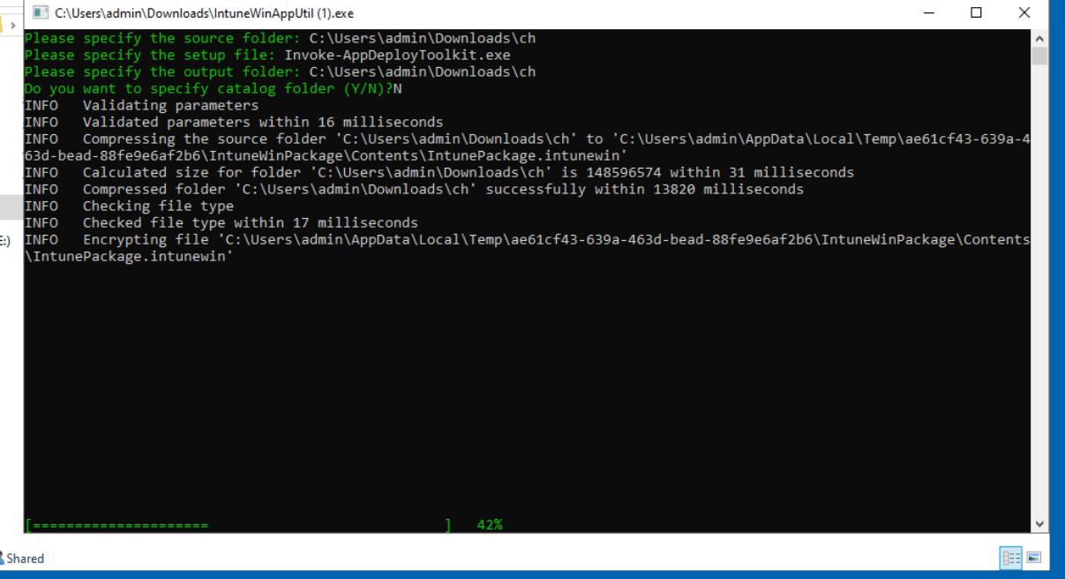

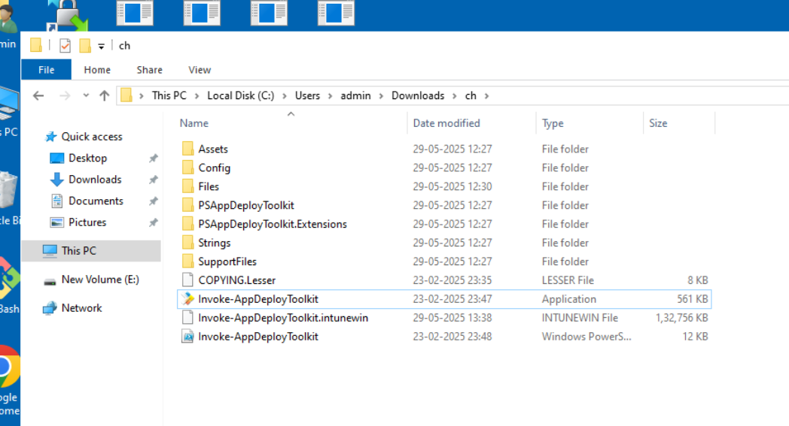

**Step 7: Fill the Form in the Intune**

**Step 8: Deploy it in Intune**