**Steps for Creating Package Using MSIX Packaging Tool**

**Step 1: Download the MSIX Packaging Tool from Microsoft Store then Select Create your app package**

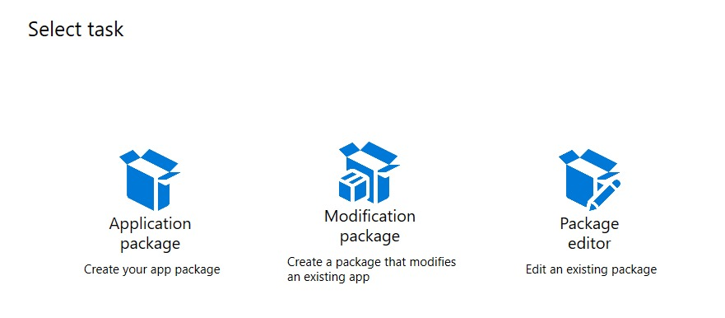

**Step 2: Select Create package on this computer -> Next**

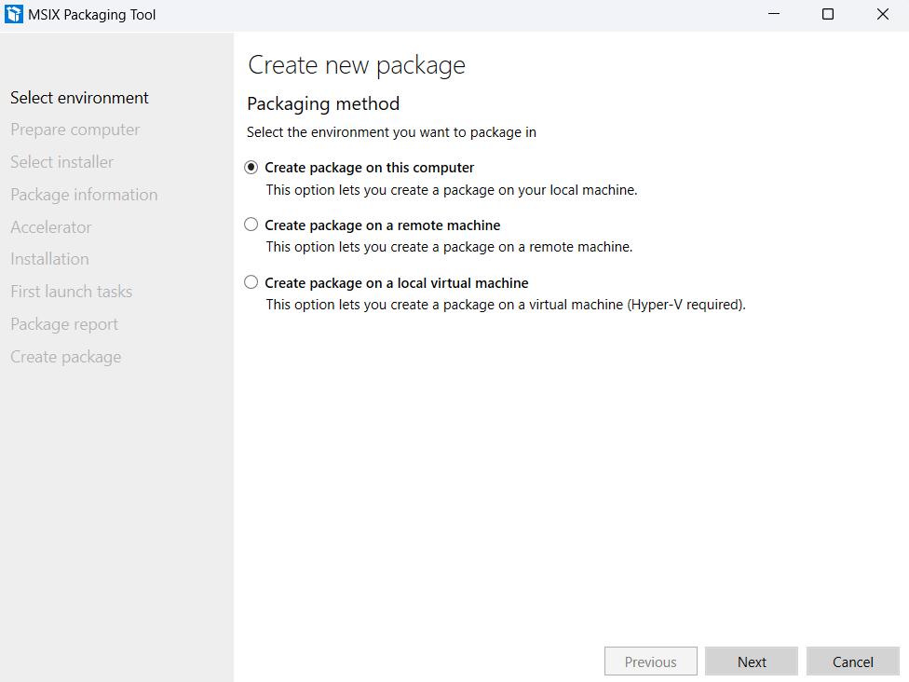

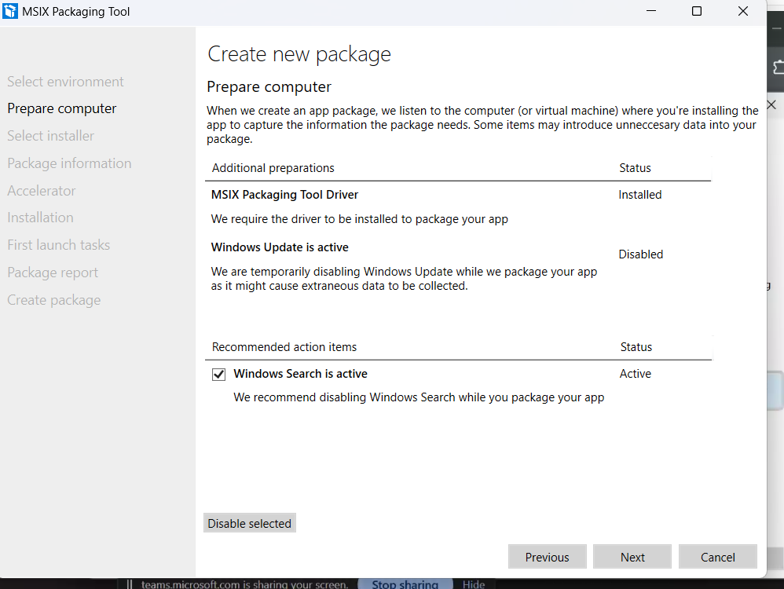**Step 3: In Prepare Computer: It will take some time for checking the driver status once’s its Installed then click on check box -> Next**

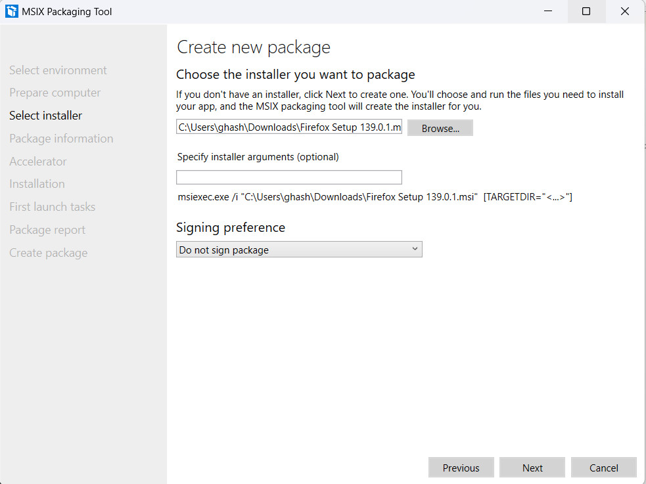**Step 4**: **In** **Select Installer** **->** **Browse** **the .msi file and in** **Signing Preference** **select** **Do not sign package -> Next**

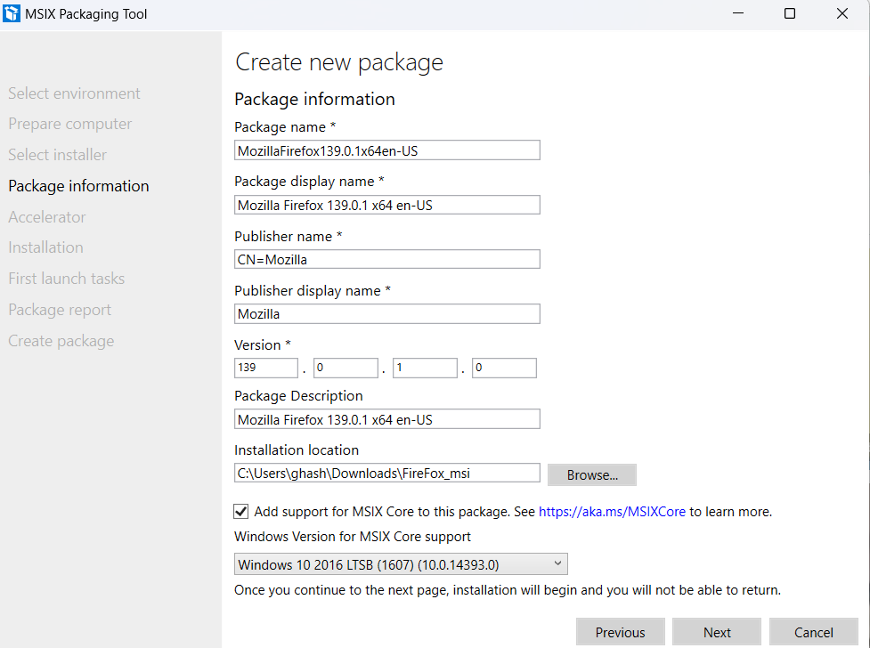**Step 5: In Package information-> in Publisher name* textbox give CN= at the start and then click on the checkbox after that select Windows 10 2016 LTSB from the dropdown-> Next**

**Step 6: In Acceleration -> DO Nothing -> Next**

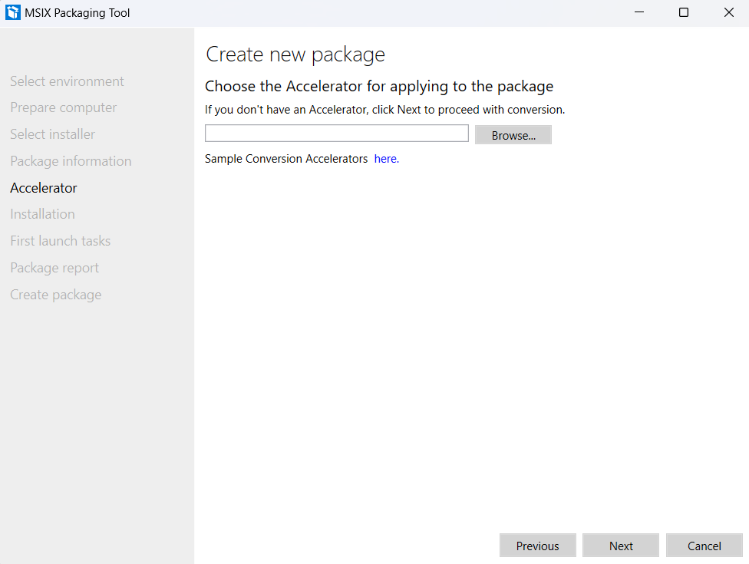

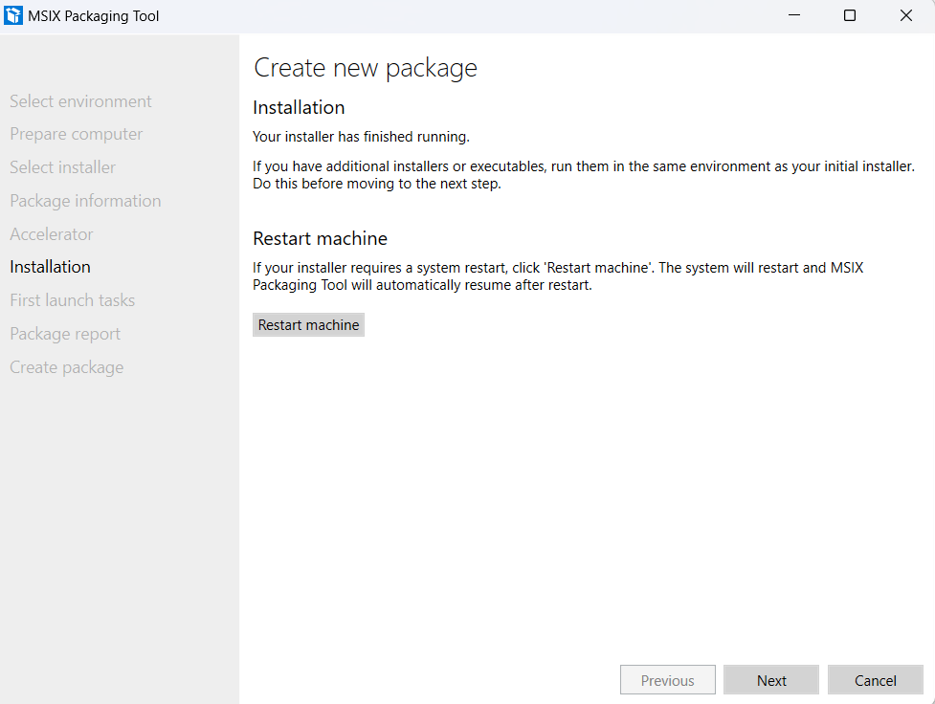**Step 7: In Installation-> Next**

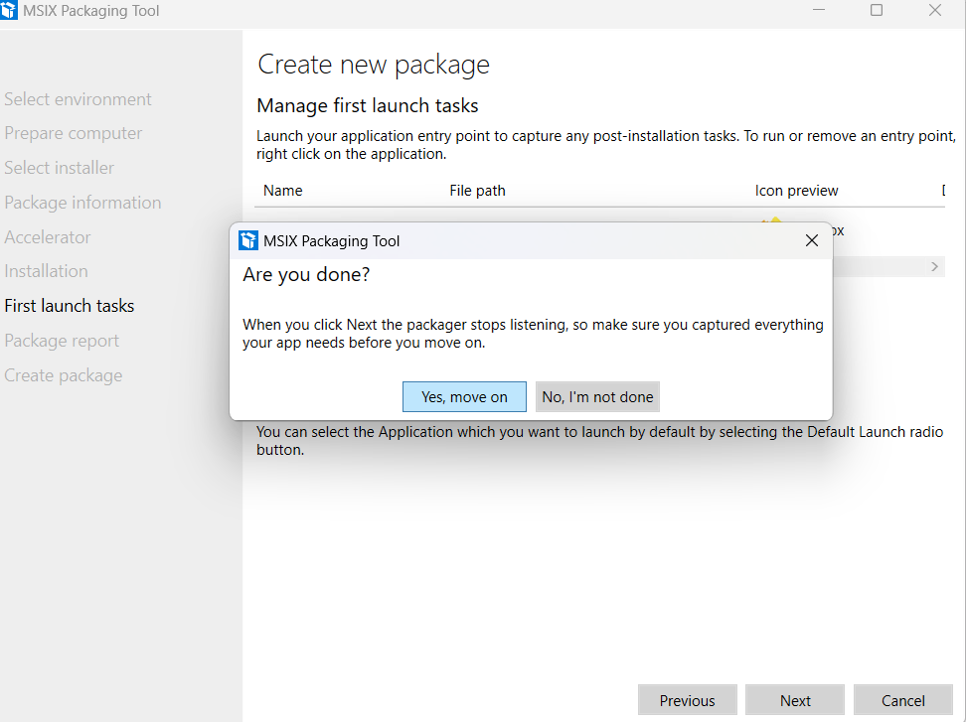**Step 8: In First Launch tasks, click next a Dialog box will appear -> select Yes,move on**

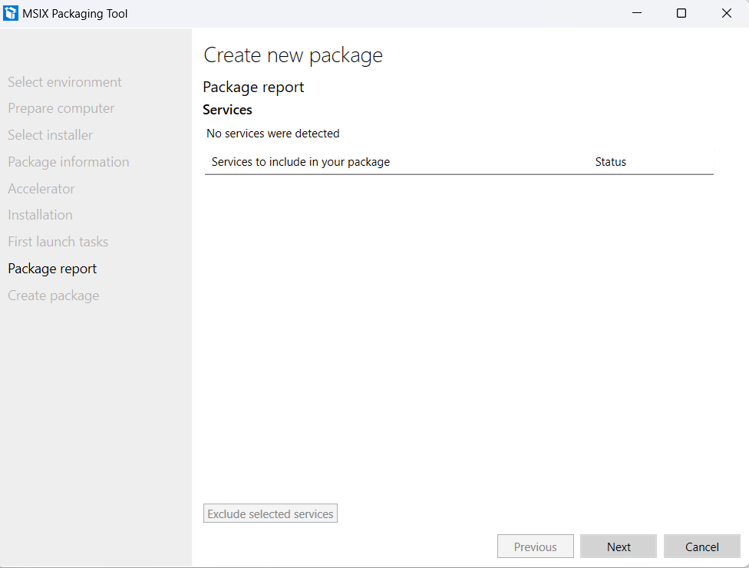**Step 9: In Package report-> Next (Do Nothing)**

**Step 10: In Create Package->Browse where we want to save the MSIX package->Click Create**

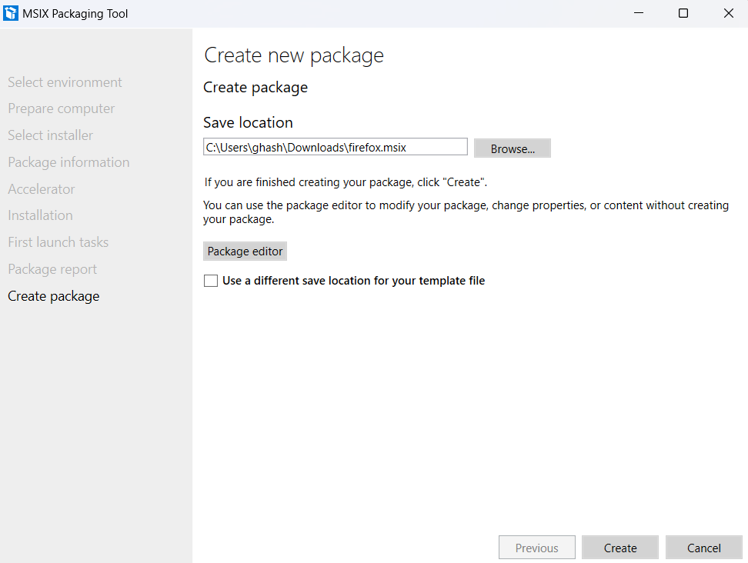

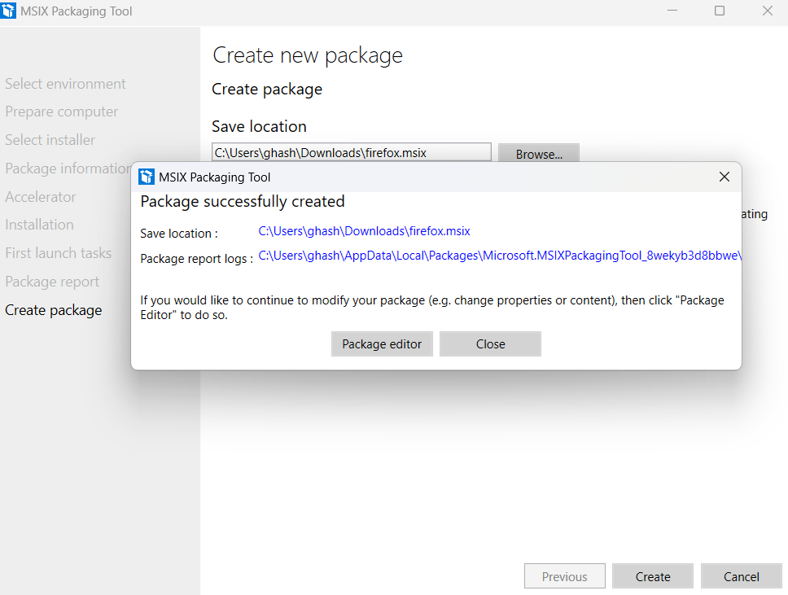**Step 11: After Creating, a Dialog box will appear Package is successfully created-> click on close and check in the save location**

**Step 12: 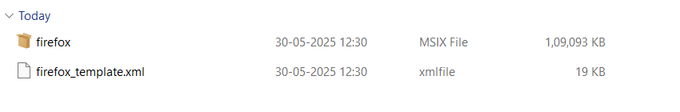The MSIX file and xml file will be present**