1.First, I linked Git to GitHub via username and email.



2.I created an SSH key by writing this code in Visual Studio:

ssh-keygen -t rsa -b 4096 -C "mymail"

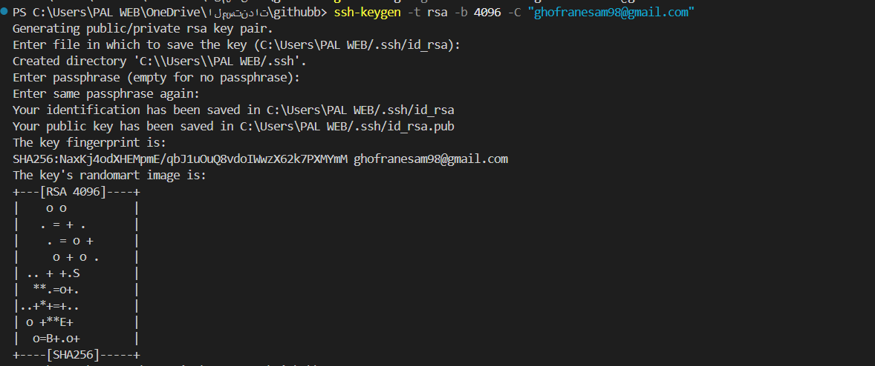

3.Then I ran this command to see what my key was:

cat ~/.ssh/id_rsa.pub



I put it on github and it created an ssh link for me.

4. This command allows us to create a local repository.



5. I wrote the HTML code and then added this code to add the files to the staging area.



6.I then created a commit to add the files written to the local repository and give them an appropriate message.

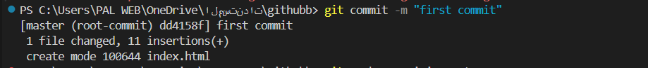

7.I then created a connection between the local repository and the remote repository via an SSH link.



8. Finally I uploaded the files from Local Repository to Remote Repository.

