Java程序设计课程设计

酒店管理系统

学生姓名： | Ghoiss
学 号：
指导教师：
所在学院：
专 业：

1系统简介
酒店管理系统包括用户登录模块、房间管理模块、预订管理模块和客人管理模块，能够实现对房间信息、预订信息和客人信息的添加、修改、删除和查询，确保数据的实时更新。用户通过身份登录后，可以查询到可用房间的基本信息及其价格、状态等详细信息，并能够进行房间预订操作。管理员身份登录后，除了可以查询房间和预订信息外，还可以实现对所有信息的增、删、改、查功能，支持并联查询和模糊查询，方便管理和维护。同时，系统还提供了数据导出功能，允许管理员将房间和预订信息导出为Excel文件，便于数据分析和报告生成。
该酒店管理系统程序利用Java Servlet、JSP、Bootstrap和MySQL数据库实现了各项功能。首先，对系统进行可行性分析，明确需求后进行详细的需求梳理，绘制出系统的基本流程图。接着，进行系统设计，包括功能设计和数据库设计，确保系统的高效性和可扩展性。最后，完成系统的实现和测试，确保各项功能的稳定性和安全性。酒店管理系统的实施大大提高了酒店管理的效率，简化了员工的工作流程，使得房间管理和预订处理更加便捷和安全。

2系统总体设计
2.1 系统的功能模块图。
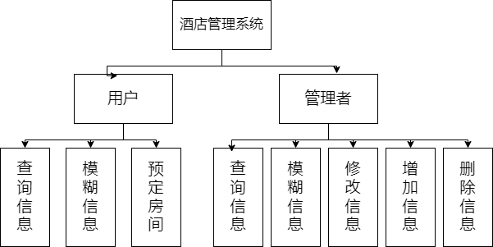

2- 系统的功能模块图

各功能模块简介：
通过用户登录，可以进行查询房间信息、预订房间，实现并模糊查询等功能。
通过管理员登录，可以进行查看、增加、删除、查询预订信息、员工信息、客人信息、房间信息及、模糊查询、poi导出等功能。

3主要业务流程
（1）登录页面（如流程图3-1）
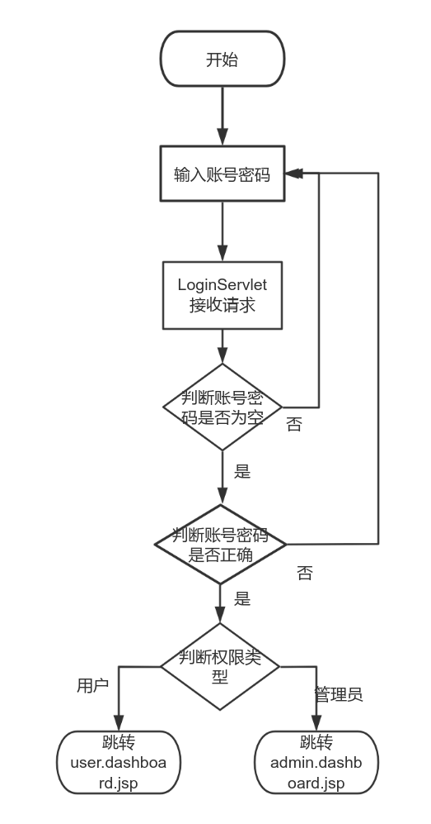
先在登录页面lojin.jsp输入账号密码，通过映射将信息传入类 LoginServlet 中，然后通过调UserService来验证用户的凭据，UserService调用UserDao来查询数据库，与数据库中的进行对比，若为空则跳转到登录页面，不为空则判断是管理员还是用户。管理员跳转管理员页面admin.dashboard.jsp，用户跳转到用户页面user.dashboard.jsp。
3-1 登录流程图
（2）增加信息（如流程图3-2）
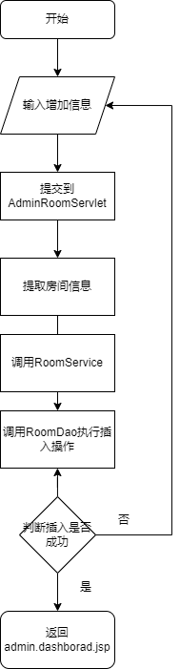
在选择增加功能后，跳转到增加页面form.jsp，在输入要增加的信息后，由AdminRoomServlet处理，调用RoomService来添加房间，调用RoomDao来执行数据库操作，再次查询数据库中结果，并将数据存入列表中，将列表返回到接口中，将数据通过类转发到jsp页面中。

3- 增加信息流程图
（3）删除信息（如流程图3-3）
在选择删除功能后，deleteEmployee被调用确认删除操作，发送DELETE请求到AdminEmployeeServle，AdminEmployeeServlet提取员工ID并调用EmployeeService执行删除操作，EmployeeService 调用 EmployeeDao 执行数据库删除操作，再次查询数据库中结果，并将数据存入列表中，将列表返回到接口中，将数据通过类转发到jsp页面中
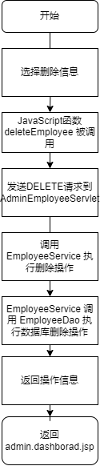
3- 删除信息流程图
（4）修改信息（如流程图3-4）
在选择修改功能后，AdminRoomServlet 接收请求，提取房间信息，在输入要修改的信息后，RoomService 调用 RoomDao 执行插入操作，将房间信息保存到数据库，再次查询数据库中结果，并将数据存入列表中，将列表返回到接口中，将数据通过类转发到jsp页面中。
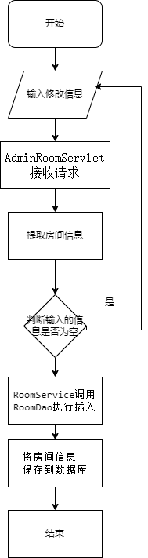
3- 4 修改信息流程图
（5）查询信息（如流程图3-5）
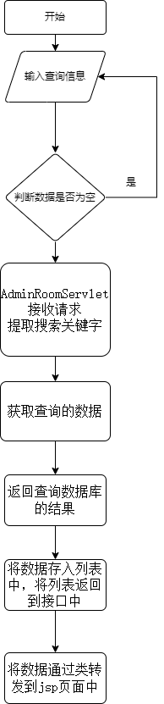
在选择查询功能后，输入搜索关键字并提交表单，AdminRoomServlet 接收请求，提取搜索关键字。RoomService调用RoomDao执行数据库查询，获取匹配的房间信息。返回查询数据库的结果，并将数据存入列表中，将列表返回到接口中，将数据通过类转发到jsp页面中。
3- 5 查询信息流程图
（6）分页功能（如流程图3-6）
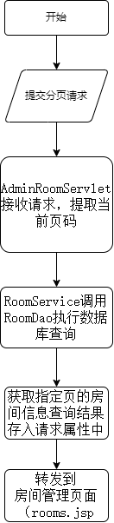
管理员在房间管理页面选择页码并提交请求，AdminRoomServlet接收请求，提取当前页码。RoomService 调用 RoomDao 执行数据库查询，获取指定页的房间信息查询结果存入请求属性中，并转发到房间管理页面（rooms.jsp），显示房间列表和分页控件
3- 7分页功能流程图
4数据库的设计
4.1 概念数据库设计：
（1）房间信息实体E-R图。
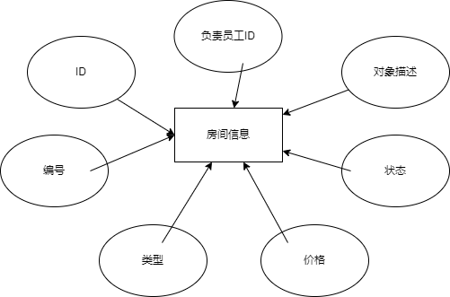
4- -1房间信息实体E-R图
（2）职工信息实体E-R图。
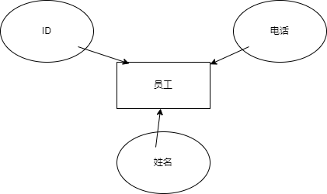
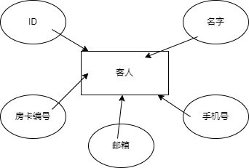
4-1-2员工信息实体E-R图
（3）客人信息实体E-R图。
4-1-3客人信息实体E-R图
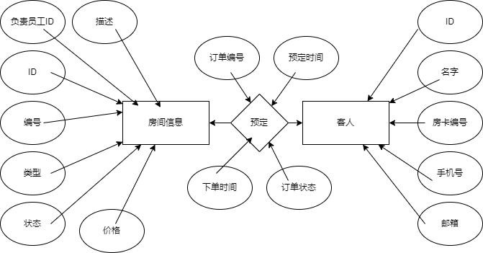
（4）房 间预定联系E-R图。

4-1-4房间预定联系E-R图
4.2 逻辑数据库设计
4.2.1.user表
id | name | password | role | email | phone
5 | admin | pmWkWS | ADMIN | admin@example.com | 13800000000
2 | zxr | b9d487a30398 | USER | 123@qq.com | 1134
3 | tjj | pmWkWSBC | USER | 56891446789548995@547 | +958+
6 | zzp | pmWL = | USER | 3583932764@qq.com | 13603666322
用户信息表用来存放管理员和用户的信息。
4.2.2.employee表
employee_id | name | phone
1 | 王兆祥 | 17735163496
2 | 白超宇 | 15534983485
员工信息表用来存放员工的相关信息。
4.2.3.saleinformation表
id | number | type | price | status | description
1 | 101 | 单人间 | 199.00 | RESERVED | 0xDABE6B5B4
2 | 102 | 单人间 | 199.00 | OCCUPIED | 0xE6A087EE58DABE6B5B4
3 | 201 | 双人间 | 299.00 | AVAILABLE | 0xE8B1AAE58DE58FB0
4 | 202 | 双人间 | 299.00 | MAINTENANCE | 0xE8CE5B8AB3E58FB0
5 | 301 | 豪华套房 | 599.00 | AVAILABLE | 0xE8B1A5AEA288BF
6 | 302 | 豪华套房 | 599.00 | AVAILABLE | 0xE8B1AAE688BF
房间信息表用来存放房间的相关信息。

5系统功能详细实现及效果图
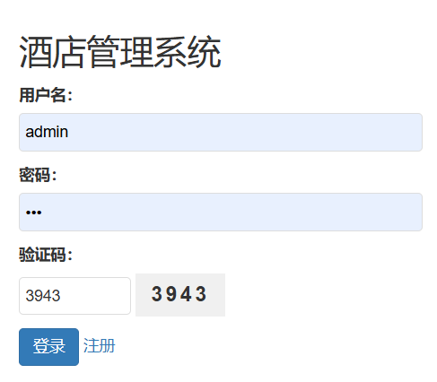
5.1登录页面

用户、管理员自行输入账号和密码进行登录。
5.2用户页面
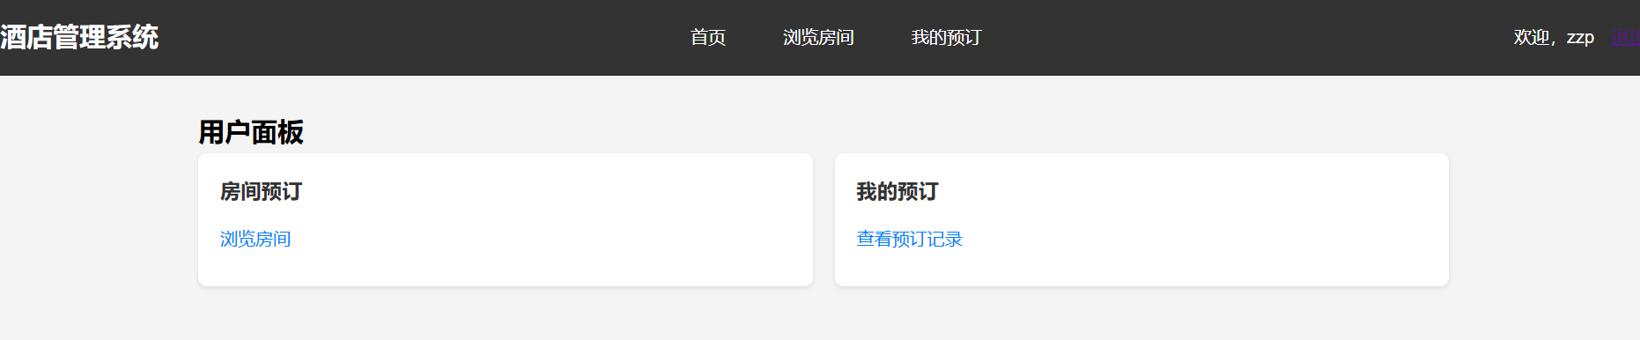
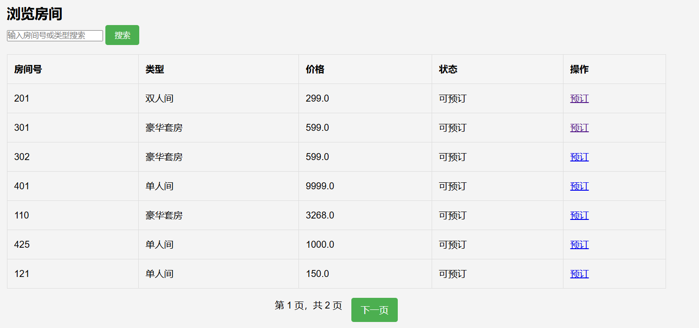

对数据进行了分页，可上下翻页。
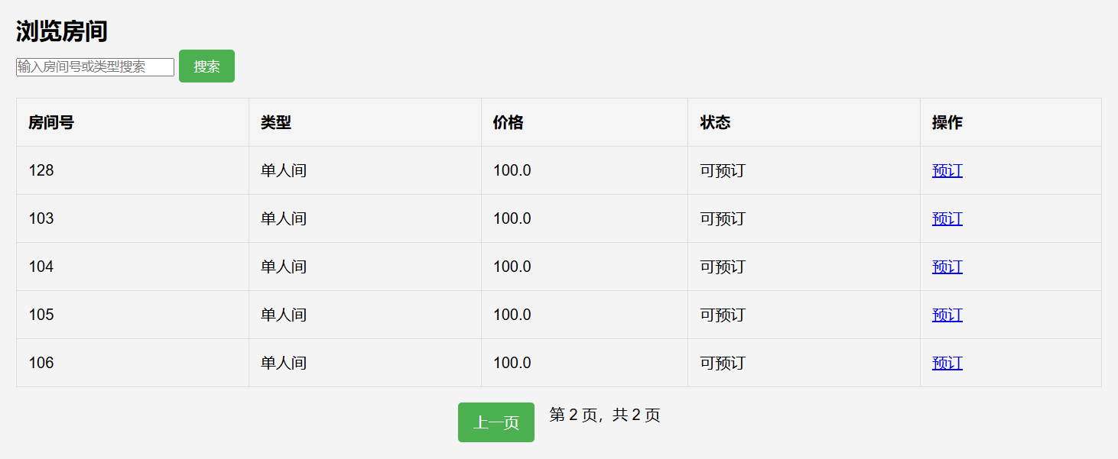

进入用户页面可以对所需的信息进行查询和模糊查询。
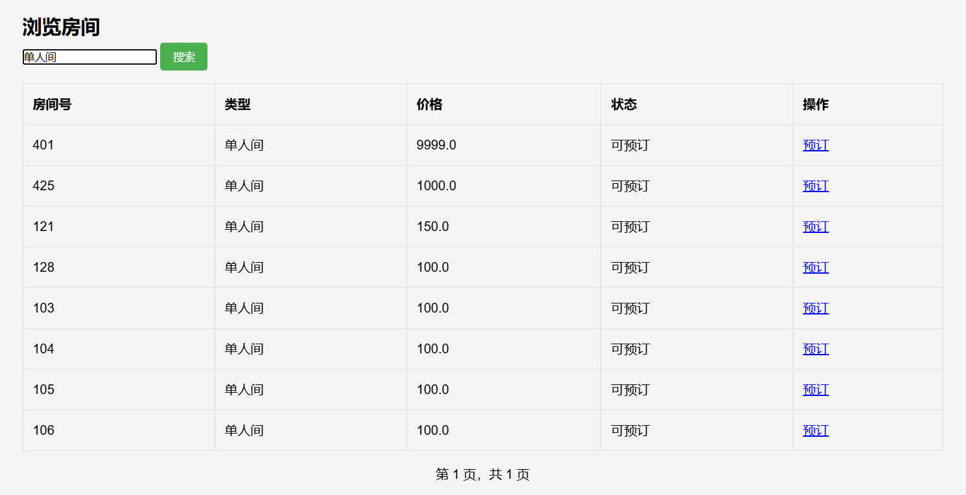

5.3管理员页面

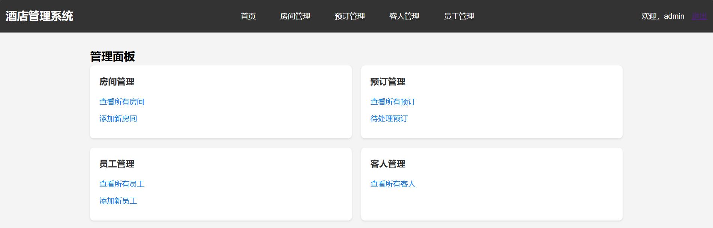

查看房间信息
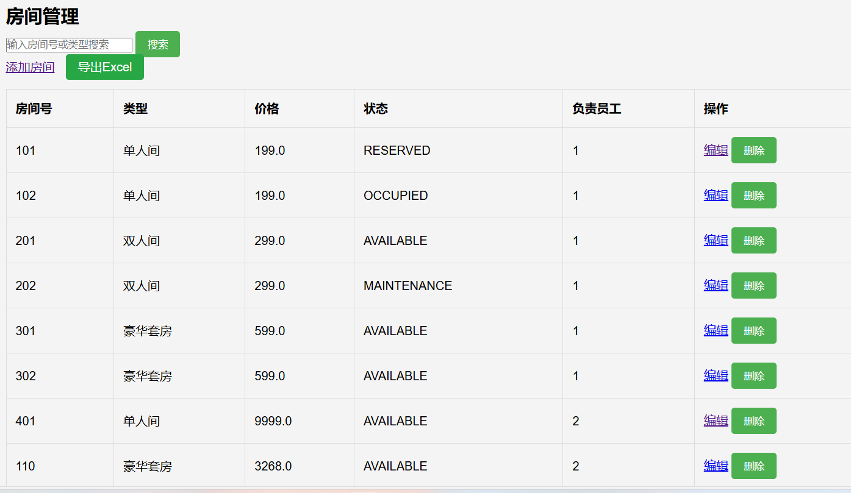

进入管理员页面可以实现对房间信息和员工信息增删改查等功能。
5.3.1增加信息
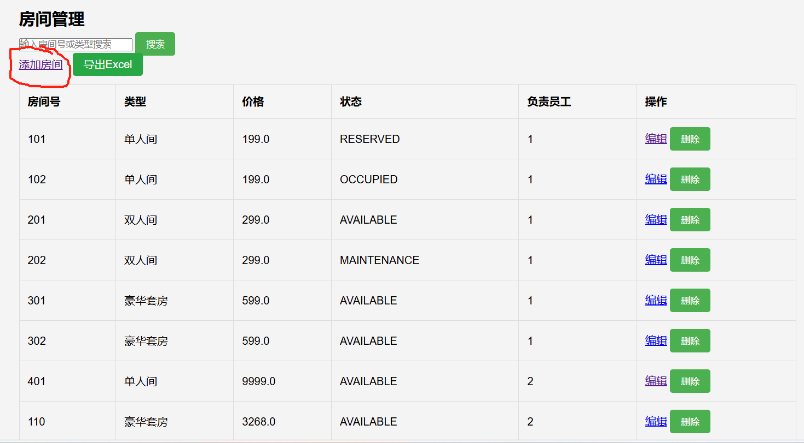

输入房间信息，选择添加。
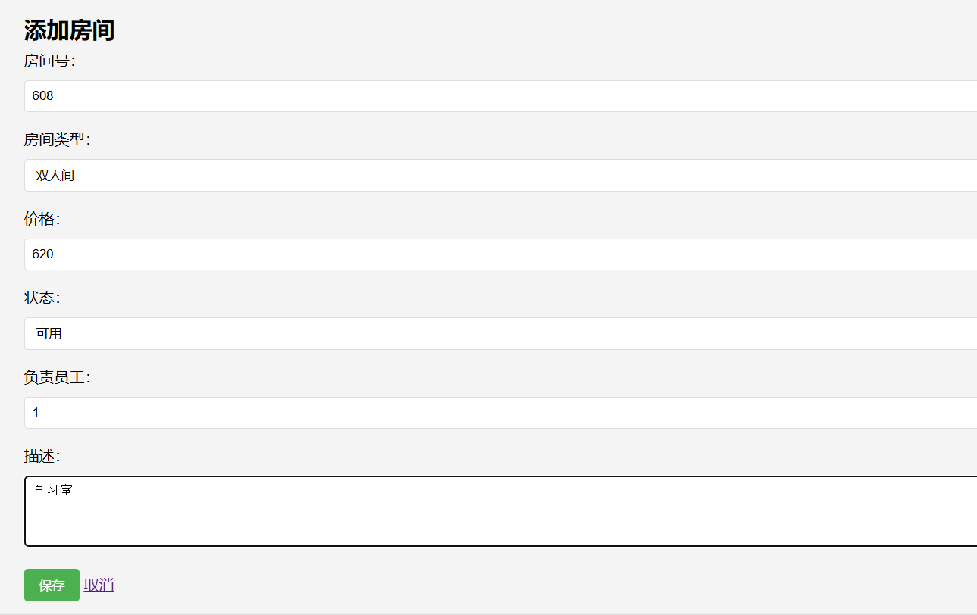

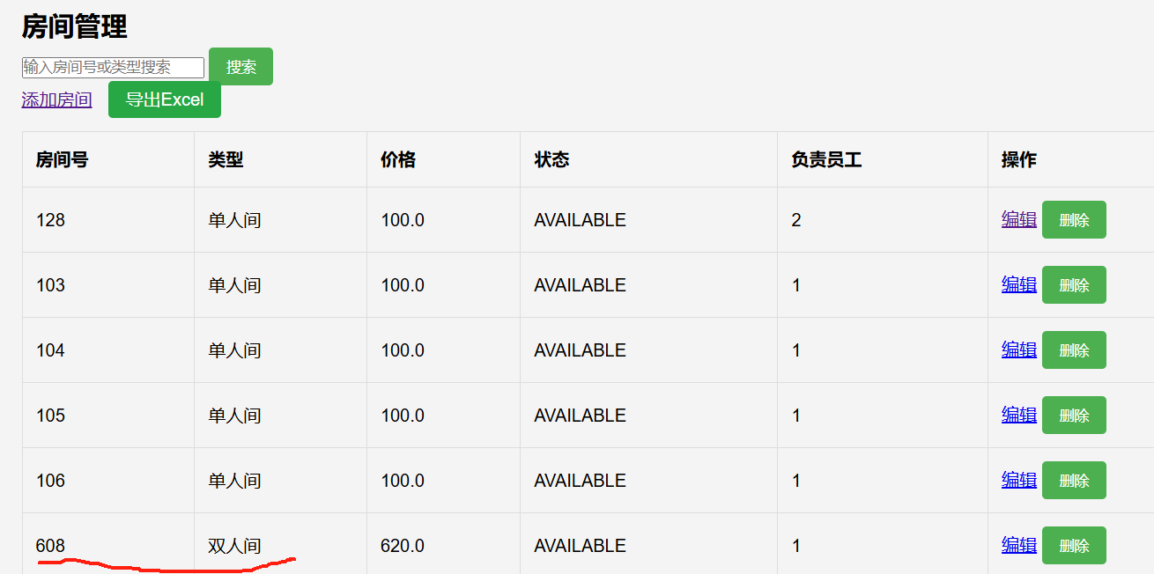

若有信息需要增加可以登陆管理员页面，对需要添加的信息进行添加，添加完成后跳转回房间信息页面，添加完成的信息在最后一页最后一行显示，同样员工信息也可以实现其功能。
5.3.2删除信息
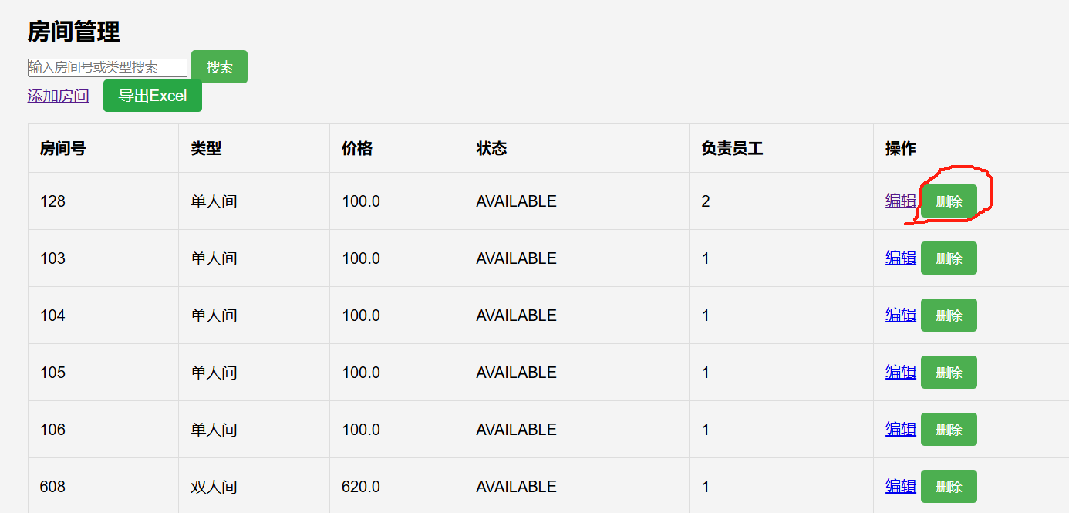

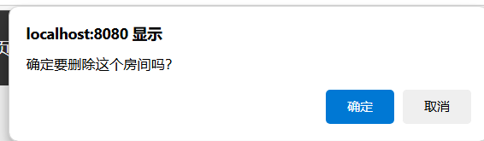

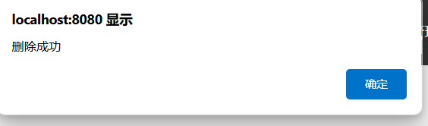

若有信息需要删除，可以登陆管理员页面，直接输入房间编号对其删除，返回房间页面可以查看到信息已被删除。
5.3.3查询信息
若有信息需要查询，可以登陆管理员页面，输入订单编号即可查看关于该订单的全部信息。

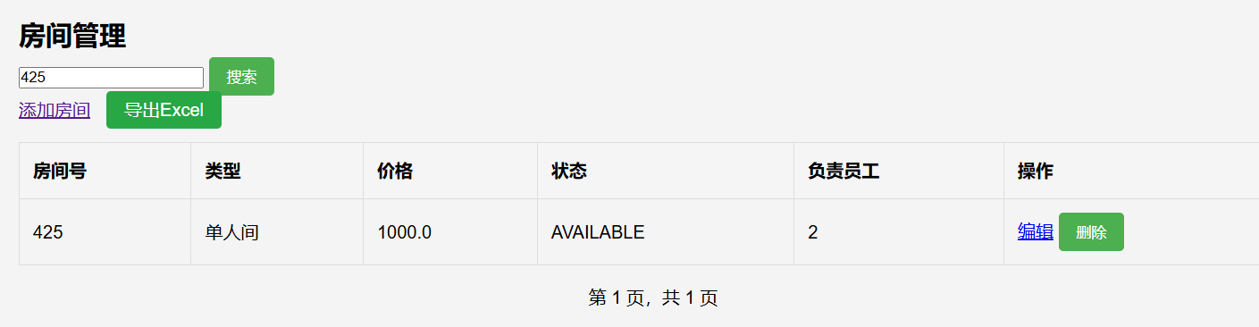

若存在该编号信息，则直接显示在jsp页面上。
若不存在该编号的轿车信息，则显示没有这个车。
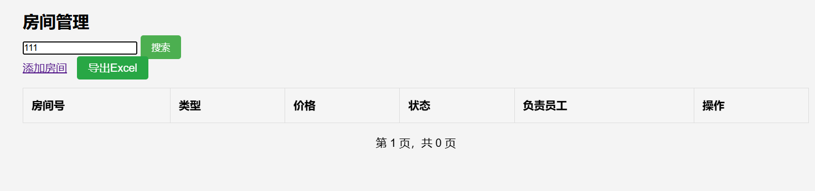

5.3.4模糊查询
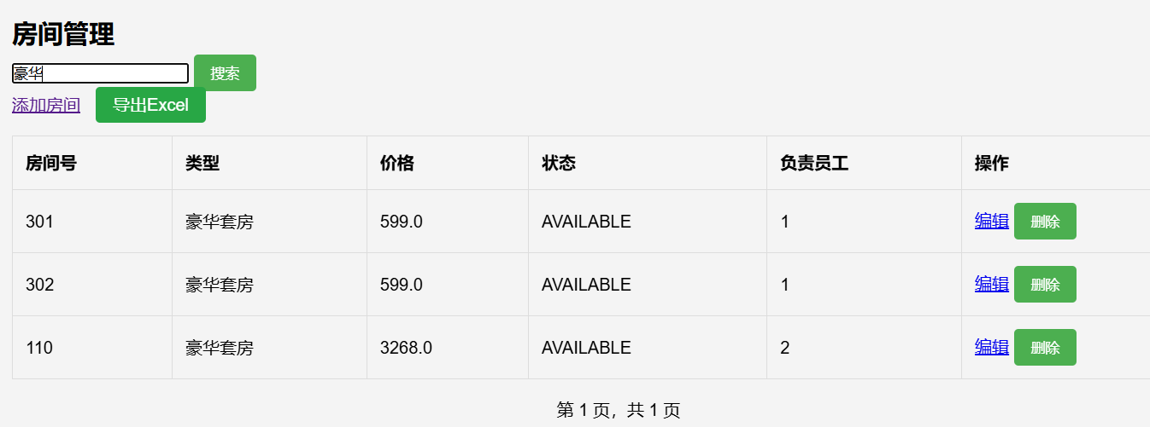

模糊查询查询，当输入豪华字时，则包含豪华字的房间信息将会全部显示出来。
5.3.5poi导出

在房间管理表页面点击导出Excel，生成表格文件，包含当前页面表格的所有信息

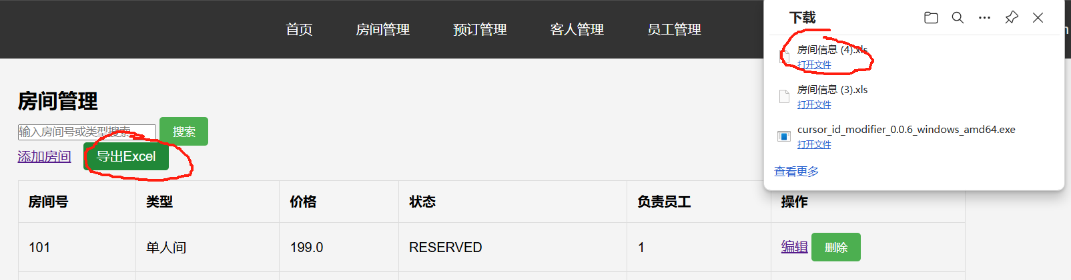

6功能典型代码
ReservationDao:

package lgq.design.jsp.dao;
import lgq.design.jsp.model.Reservation;
import java.sql.ResultSet;
import java.sql.SQLException;
import java.util.List;
public class ReservationDao extends BaseDao<Reservation> {
@Override
protected Reservation mapRow(ResultSet rs) throws SQLException {
Reservation reservation = new Reservation();
reservation.setReservationId(rs.getInt("reservation_id"));
reservation.setGuestId(rs.getInt("guest_id"));
reservation.setRoomId(rs.getInt("room_id"));
reservation.setUserId(rs.getInt("user_id"));
reservation.setCheckInDate(rs.getDate("check_in_date"));
reservation.setCheckOutDate(rs.getDate("check_out_date"));
reservation.setStatus(rs.getString("status"));
reservation.setCreateTime(rs.getTimestamp("create_time"));
return reservation;
}
public List<Reservation> findAll(int offset, int limit) {
String sql = "SELECT * FROM reservations ORDER BY create_time DESC LIMIT ? OFFSET ?";
return query(sql, limit, offset);
}
public List<Reservation> findByUserId(int userId, int offset, int limit) {
String sql = "SELECT * FROM reservations WHERE user_id = ? ORDER BY create_time DESC LIMIT ? OFFSET ?";
return query(sql, userId, limit, offset);
}
public Reservation findById(int reservationId) {
String sql = "SELECT * FROM reservations WHERE reservation_id = ?";
List<Reservation> reservations = query(sql, reservationId);
return reservations.isEmpty() ? null : reservations.get(0);
}
public boolean save(Reservation reservation) {
String sql = "INSERT INTO reservations (guest_id, room_id, user_id, check_in_date, check_out_date, status) " +
"VALUES (?, ?, ?, ?, ?, ?)";
return update(sql,
reservation.getGuestId(),
reservation.getRoomId(),
reservation.getUserId(),
reservation.getCheckInDate(),
reservation.getCheckOutDate(),
reservation.getStatus()
);
}
public boolean update(Reservation reservation) {
String sql = "UPDATE reservations SET guest_id = ?, room_id = ?, check_in_date = ?, " +
"check_out_date = ?, status = ? WHERE reservation_id = ?";
return update(sql,
reservation.getGuestId(),
reservation.getRoomId(),
reservation.getCheckInDate(),
reservation.getCheckOutDate(),
reservation.getStatus(),
reservation.getReservationId()
);
}
public int count() {
return count("SELECT COUNT(*) FROM reservations");
}
public int countByUserId(int userId) {
return count("SELECT COUNT(*) FROM reservations WHERE user_id = ?", userId);
}
public List<Reservation> findBySearch(String keyword, int offset, int limit) {
String sql = "SELECT r.* FROM reservations r " +
"JOIN guests g ON r.guest_id = g.guest_id " +
"WHERE g.name LIKE ? OR g.id_card LIKE ? " +
"ORDER BY r.create_time DESC LIMIT ? OFFSET ?";
String pattern = "%" + keyword + "%";
return query(sql, pattern, pattern, limit, offset);
}
public int countBySearch(String keyword) {
String sql = "SELECT COUNT(*) FROM reservations r " +
"JOIN guests g ON r.guest_id = g.guest_id " +
"WHERE g.name LIKE ? OR g.id_card LIKE ?";
String pattern = "%" + keyword + "%";
return count(sql, pattern, pattern);
}
public boolean delete(int reservationId) {
String sql = "DELETE FROM reservations WHERE reservation_id = ?";
return update(sql, reservationId);
}
}
}

Reservation:

package lgq.design.jsp.model;
import java.sql.Date;
import java.sql.Timestamp;
public class Reservation {
private Integer reservationId;
private Integer guestId;
private Integer roomId;
private Integer userId;
private Date checkInDate;
private Date checkOutDate;
private String status;
private Timestamp createTime;
public Reservation() {}
public Reservation(Integer reservationId, Integer guestId, Integer roomId, Integer userId,
Date checkInDate, Date checkOutDate, String status, Timestamp createTime) {
this.reservationId = reservationId;
this.guestId = guestId;
this.roomId = roomId;
this.userId = userId;
this.checkInDate = checkInDate;
this.checkOutDate = checkOutDate;
this.status = status;
this.createTime = createTime;
}
public Integer getReservationId() {
return reservationId;
}
public void setReservationId(Integer reservationId) {
this.reservationId = reservationId;
}
public Integer getGuestId() {
return guestId;
}
public void setGuestId(Integer guestId) {
this.guestId = guestId;
}
public Integer getRoomId() {
return roomId;
}
public void setRoomId(Integer roomId) {
this.roomId = roomId;
}
public Integer getUserId() {
return userId;
}
public void setUserId(Integer userId) {
this.userId = userId;
}
public Date getCheckInDate() {
return checkInDate;
}
public void setCheckInDate(Date checkInDate) {
this.checkInDate = checkInDate;
}
public Date getCheckOutDate() {
return checkOutDate;
}
public void setCheckOutDate(Date checkOutDate) {
this.checkOutDate = checkOutDate;
}
public String getStatus() {
return status;
}
public void setStatus(String status) {
this.status = status;
}
public Timestamp getCreateTime() {
return createTime;
}
public void setCreateTime(Timestamp createTime) {
this.createTime = createTime;
}
}

Service:

package lgq.design.jsp.model;
import java.math.BigDecimal;
public class Service {
private Integer serviceId;
private String serviceName;
private BigDecimal price;
private String description;
private String status;
public Service() {}
public Service(Integer serviceId, String serviceName, BigDecimal price,
String description, String status) {
this.serviceId = serviceId;
this.serviceName = serviceName;
this.price = price;
this.description = description;
this.status = status;
}
public Integer getServiceId() {
return serviceId;
}
public void setServiceId(Integer serviceId) {
this.serviceId = serviceId;
}
public String getServiceName() {
return serviceName;
}
public void setServiceName(String serviceName) {
this.serviceName = serviceName;
}
public BigDecimal getPrice() {
return price;
}
public void setPrice(BigDecimal price) {
this.price = price;
}
public String getDescription() {
return description;
}
public void setDescription(String description) {
this.description = description;
}
public String getStatus() {
return status;
}
public void setStatus(String status) {
this.status = status;
}
}

ReservationService:
package lgq.design.jsp.service;
import lgq.design.jsp.dao.ReservationDao;
import lgq.design.jsp.model.Reservation;
import lgq.design.jsp.util.PageUtil;
import java.util.List;
public class ReservationService {
private ReservationDao reservationDao = new ReservationDao();
private RoomService roomService = new RoomService();
public PageUtil<Reservation> getAllReservations(int page) {
int pageSize = 10;
int offset = (page - 1) * pageSize;
List<Reservation> reservations = reservationDao.findAll(offset, pageSize);
int totalRecords = reservationDao.count();
PageUtil<Reservation> pageUtil = new PageUtil<>();
pageUtil.setRecords(reservations);
pageUtil.setCurrentPage(page);
pageUtil.setTotalRecords(totalRecords);
return pageUtil;
}
public PageUtil<Reservation> getUserReservations(int userId, int page) {
int pageSize = 10;
int offset = (page - 1) * pageSize;
List<Reservation> reservations = reservationDao.findByUserId(userId, offset, pageSize);
int totalRecords = reservationDao.countByUserId(userId);
PageUtil<Reservation> pageUtil = new PageUtil<>();
pageUtil.setRecords(reservations);
pageUtil.setCurrentPage(page);
pageUtil.setTotalRecords(totalRecords);
return pageUtil;
}
public boolean createReservation(Reservation reservation) {
if (!roomService.updateRoomStatus(reservation.getRoomId(), "RESERVED")) {
return false;
}
return reservationDao.save(reservation);
}
public boolean checkIn(int reservationId) {
Reservation reservation = reservationDao.findById(reservationId);
if (reservation != null) {
reservation.setStatus("CHECKED_IN");
roomService.updateRoomStatus(reservation.getRoomId(), "OCCUPIED");
return reservationDao.update(reservation);
}
return false;
}
public boolean checkOut(int reservationId) {
Reservation reservation = reservationDao.findById(reservationId);
if (reservation != null) {
reservation.setStatus("COMPLETED");
roomService.updateRoomStatus(reservation.getRoomId(), "AVAILABLE");
return reservationDao.update(reservation);
}
return false;
}
public boolean updateReservationStatus(int reservationId, String status) {
Reservation reservation = reservationDao.findById(reservationId);
if (reservation != null) {
reservation.setStatus(status);
return reservationDao.update(reservation);
}
return false;
}
public List<Reservation> getAllReservations() {
return reservationDao.findAll(0, Integer.MAX_VALUE);
}
public boolean deleteReservation(int reservationId) {
Reservation reservation = reservationDao.findById(reservationId);
if (reservation != null) {
if ("PENDING".equals(reservation.getStatus()) ||
"CHECKED_IN".equals(reservation.getStatus())) {
roomService.updateRoomStatus(reservation.getRoomId(), "AVAILABLE");
}
return reservationDao.delete(reservationId);
}
return false;
}
}

SearchService：
package lgq.design.jsp.service;
import lgq.design.jsp.dao.GuestDao;
import lgq.design.jsp.dao.ReservationDao;
import lgq.design.jsp.dao.RoomDao;
import lgq.design.jsp.model.Guest;
import lgq.design.jsp.model.Reservation;
import lgq.design.jsp.model.Room;
import lgq.design.jsp.util.PageUtil;
import java.util.List;
public class SearchService {
private RoomDao roomDao = new RoomDao();
private GuestDao guestDao = new GuestDao();
private ReservationDao reservationDao = new ReservationDao();
public PageUtil<Room> searchRooms(String keyword, int page) {
int pageSize = 10;
int offset = (page - 1) * pageSize;
List<Room> rooms = roomDao.findBySearch(keyword, offset, pageSize);
int totalRecords = roomDao.countBySearch(keyword);
PageUtil<Room> pageUtil = new PageUtil<>();
pageUtil.setRecords(rooms);
pageUtil.setCurrentPage(page);
pageUtil.setTotalRecords(totalRecords);
return pageUtil;
}
public PageUtil<Guest> searchGuests(String keyword, int page) {
int pageSize = 10;
int offset = (page - 1) * pageSize;
List<Guest> guests = guestDao.findBySearch(keyword, offset, pageSize);
int totalRecords = guestDao.countBySearch(keyword);
PageUtil<Guest> pageUtil = new PageUtil<>();
pageUtil.setRecords(guests);
pageUtil.setCurrentPage(page);
pageUtil.setTotalRecords(totalRecords);
return pageUtil;
}
public PageUtil<Reservation> searchReservations(String keyword, int page) {
int pageSize = 10;
int offset = (page - 1) * pageSize;
List<Reservation> reservations = reservationDao.findBySearch(keyword, offset, pageSize);
int totalRecords = reservationDao.countBySearch(keyword);
PageUtil<Reservation> pageUtil = new PageUtil<>();
pageUtil.setRecords(reservations);
pageUtil.setCurrentPage(page);
pageUtil.setTotalRecords(totalRecords);
return pageUtil;
}
}

RegistSevlet:

package lgq.design.jsp.controller;
import lgq.design.jsp.model.User;
import lgq.design.jsp.service.UserService;
import javax.servlet.ServletException;
import javax.servlet.annotation.WebServlet;
import javax.servlet.http.HttpServlet;
import javax.servlet.http.HttpServletRequest;
import javax.servlet.http.HttpServletResponse;
import java.io.IOException;
@WebServlet("/register")
public class RegisterServlet extends HttpServlet {
private UserService userService = new UserService();
@Override
protected void doGet(HttpServletRequest req, HttpServletResponse resp)
throws ServletException, IOException {
req.getRequestDispatcher("/jsp/register.jsp").forward(req, resp);
}
@Override
protected void doPost(HttpServletRequest req, HttpServletResponse resp)
throws ServletException, IOException {
String username = req.getParameter("username");
String password = req.getParameter("password");
String email = req.getParameter("email");
String phone = req.getParameter("phone");
User user = new User();
user.setUsername(username);
user.setPassword(password);
user.setEmail(email);
user.setPhone(phone);
user.setRole("USER"); // 默认注册为普通用户
boolean success = userService.register(user);
if (success) {
resp.sendRedirect(req.getContextPath() + "/login");
} else {
req.setAttribute("error", "注册失败，用户名可能已存在");
req.getRequestDispatcher("/jsp/register.jsp").forward(req, resp);
}
}
}

ReservationServlet:

package lgq.design.jsp.controller;
import lgq.design.jsp.model.Reservation;
import lgq.design.jsp.model.Room;
import lgq.design.jsp.model.User;
import lgq.design.jsp.service.ReservationService;
import lgq.design.jsp.service.RoomService;
import lgq.design.jsp.util.PageUtil;
import javax.servlet.ServletException;
import javax.servlet.annotation.WebServlet;
import javax.servlet.http.HttpServlet;
import javax.servlet.http.HttpServletRequest;
import javax.servlet.http.HttpServletResponse;
import javax.servlet.http.HttpSession;
import java.io.IOException;
import java.sql.Date;
@WebServlet("/user/reservation/*")
public class ReservationServlet extends HttpServlet {
private ReservationService reservationService = new ReservationService();
private RoomService roomService = new RoomService();
@Override
protected void doGet(HttpServletRequest req, HttpServletResponse resp)
throws ServletException, IOException {
String pathInfo = req.getPathInfo();
String roomId = req.getParameter("roomId");
if (roomId != null) {
Room room = roomService.getRoomById(Integer.parseInt(roomId));
if (room != null && "AVAILABLE".equals(room.getStatus())) {
req.setAttribute("room", room);
req.getRequestDispatcher("/jsp/user/reservation.jsp").forward(req, resp);
} else {
resp.sendRedirect(req.getContextPath() + "/user/rooms");
}
} else {
HttpSession session = req.getSession();
User user = (User) session.getAttribute("user");
int page = 1;
try {
page = Integer.parseInt(req.getParameter("page"));
} catch (NumberFormatException e) {
// 使用默认值1
}
PageUtil<Reservation> pageUtil;
if ("ADMIN".equals(user.getRole())) {
pageUtil = reservationService.getAllReservations(page);
req.setAttribute("pageUtil", pageUtil);
req.getRequestDispatcher("/jsp/admin/reservations.jsp").forward(req, resp);
} else {
pageUtil = reservationService.getUserReservations(user.getUserId(), page);
req.setAttribute("pageUtil", pageUtil);
req.getRequestDispatcher("/jsp/user/reservations.jsp").forward(req, resp);
}
}
}
@Override
protected void doPost(HttpServletRequest req, HttpServletResponse resp)
throws ServletException, IOException {
HttpSession session = req.getSession();
User user = (User) session.getAttribute("user");
Reservation reservation = new Reservation();
reservation.setRoomId(Integer.parseInt(req.getParameter("roomId")));
reservation.setUserId(user.getUserId());
reservation.setCheckInDate(Date.valueOf(req.getParameter("checkInDate")));
reservation.setCheckOutDate(Date.valueOf(req.getParameter("checkOutDate")));
reservation.setStatus("PENDING");
if (reservationService.createReservation(reservation)) {
Room room = roomService.getRoomById(reservation.getRoomId());
room.setStatus("RESERVED");
roomService.updateRoom(room);
if ("ADMIN".equals(user.getRole())) {
resp.sendRedirect(req.getContextPath() + "/admin/reservations");
} else {
resp.sendRedirect(req.getContextPath() + "/user/reservations");
}
} else {
req.setAttribute("error", "预订失败，请重试");
doGet(req, resp);
}
}
@Override
protected void doPut(HttpServletRequest req, HttpServletResponse resp)
throws ServletException, IOException {
int reservationId = Integer.parseInt(req.getParameter("reservationId"));
String status = req.getParameter("status");
if (reservationService.updateReservationStatus(reservationId, status)) {
resp.setStatus(HttpServletResponse.SC_OK);
} else {
resp.setStatus(HttpServletResponse.SC_INTERNAL_SERVER_ERROR);
}
}
}

login.jsp:

<%@ page contentType="text/html;charset=UTF-8" language="java" %>
<!-- 新 Bootstrap 核心 CSS 文件 -->
<link href="https://cdn.staticfile.org/twitter-bootstrap/3.3.7/css/bootstrap.min.css" rel="stylesheet">
<!-- jQuery文件。务必在bootstrap.min.js 之前引入 -->
<script src="https://cdn.staticfile.org/jquery/2.1.1/jquery.min.js"></script>
<!-- 最新的 Bootstrap 核心 JavaScript 文件 -->
<script src="https://cdn.staticfile.org/twitter-bootstrap/3.3.7/js/bootstrap.min.js"></script>
<link rel="stylesheet" href="css/lstyle.css">
<link rel="stylesheet" href="css/gstyle.css">
<!DOCTYPE html>
<html>
<head>
<title>登录 - 酒店管理系统</title>
<link rel="stylesheet" href="${pageContext.request.contextPath}/css/style.css">
</head>
<body>
<div class="login-container">
<h2>酒店管理系统</h2>
<form action="${pageContext.request.contextPath}/login" method="post" onsubmit="return validateForm()">
<div class="form-group">
<label for="username">用户名：</label>
<input type="text" id="username" name="username" required>
</div>
<div class="form-group">
<label for="password">密码：</label>
<input type="password" id="password" name="password" required>
</div>
<div class="form-group">
<label for="captchaInput">验证码：</label>
<input type="text" id="captchaInput" name="captchaInput" required style="width: 100px;">
<span id="captcha" onclick="generateCaptcha()"></span>
</div>
<div class="form-group">
<button type="submit" class="btn btn-primary">登录</button>
<a href="${pageContext.request.contextPath}/register" class="register-link">注册</a>
</div>
<% if (request.getAttribute("error") != null) { %>
<div class="error-message">
<%= request.getAttribute("error") %>
</div>
<% } %>
</form>
</div>
<script>
let captchaValue = '';
function generateCaptcha() {
captchaValue = Math.floor(Math.random() * 9000 + 1000).toString();
document.getElementById('captcha').innerText = captchaValue;
}
function validateForm() {
const userInput = document.getElementById('captchaInput').value;
if (userInput !== captchaValue) {
alert('验证码错误，请重新输入！');
generateCaptcha();
document.getElementById('captchaInput').value = '';
return false;
}
return true;
}
window.onload = generateCaptcha;
</script>
</body>
</html>

dashboard.jsp:
<%@ page contentType="text/html;charset=UTF-8" language="java" %>
<!DOCTYPE html>
<html>
<head>
<title>管理面板 - 酒店管理系统</title>
<link rel="stylesheet" href="${pageContext.request.contextPath}/css/style.css">
<style>
.dashboard-menu {
display: grid;
grid-template-columns: repeat(2, 1fr);
gap: 20px;
}
.menu-item {
background: #fff;
padding: 20px;
border-radius: 8px;
box-shadow: 0 2px 4px rgba(0,0,0,0.1);
}
.menu-item h3 {
margin: 0 0 15px 0;
color: #333;
}
.menu-item a {
display: block;
margin: 10px 0;
color: #007bff;
text-decoration: none;
}
.menu-item a:hover {
text-decoration: underline;
}
</style>
</head>
<body>
<div class="container">
<%@ include file="../common/header.jsp" %>
<div class="content">
<h2>管理面板</h2>
<!-- 管理菜单 -->
<div class="dashboard-menu">
<div class="menu-item">
<h3>房间管理</h3>
<a href="${pageContext.request.contextPath}/admin/rooms">查看所有房间</a>
<a href="${pageContext.request.contextPath}/admin/rooms/add">添加新房间</a>
</div>
<div class="menu-item">
<h3>预订管理</h3>
<a href="${pageContext.request.contextPath}/admin/reservations">查看所有预订</a>
<a href="${pageContext.request.contextPath}/admin/reservations?status=PENDING">待处理预订</a>
</div>
<div class="menu-item">
<h3>员工管理</h3>
<a href="${pageContext.request.contextPath}/admin/employees">查看所有员工</a>
<a href="${pageContext.request.contextPath}/admin/employees/add">添加新员工</a>
</div>
<div class="menu-item">
<h3>客人管理</h3>
<a href="${pageContext.request.contextPath}/admin/guests">查看所有客人</a>
</div>
</div>
</div>
<%@ include file="../common/footer.jsp" %>
</div>
</body>
</html>

Reservation.jsp

<%@ page contentType="text/html;charset=UTF-8" language="java" %>
<%@ page import="lgq.design.jsp.model.Reservation" %>
<%@ page import="lgq.design.jsp.util.PageUtil" %>
<!DOCTYPE html>
<html>
<head>
<title>预订管理 - 酒店管理系统</title>
<link rel="stylesheet" href="${pageContext.request.contextPath}/css/style.css">
</head>
<body>
<div class="container">
<%@ include file="../common/header.jsp" %>
<div class="content">
<h2>预订管理</h2>
<div class="search-box">
<form action="${pageContext.request.contextPath}/admin/reservations" method="get">
<input type="text" name="search" placeholder="输入预订信息搜索">
<button type="submit">搜索</button>
</form>
<a href="${pageContext.request.contextPath}/admin/export/reservations" class="btn-export">导出Excel</a>
</div>
<table class="data-table">
<thead>
<tr>
<th>房间号</th>
<th>入住日期</th>
<th>退房日期</th>
<th>状态</th>
<th>操作</th>
</tr>
</thead>
<tbody>
<%
PageUtil<Reservation> pageUtil = (PageUtil<Reservation>)request.getAttribute("pageUtil");
if (pageUtil != null && pageUtil.getRecords() != null) {
for (Reservation reservation : pageUtil.getRecords()) {
%>
<tr>
<td><%= reservation.getRoomId() %></td>
<td><%= reservation.getCheckInDate() %></td>
<td><%= reservation.getCheckOutDate() %></td>
<td><%= reservation.getStatus() %></td>
<td>
<% if ("PENDING".equals(reservation.getStatus())) { %>
<button onclick="handleReservation(<%= reservation.getReservationId() %>, 'checkin')">办理入住</button>
<% } else if ("CHECKED_IN".equals(reservation.getStatus())) { %>
<button onclick="handleReservation(<%= reservation.getReservationId() %>, 'checkout')">办理退房</button>
<% } else if ("CANCELLED".equals(reservation.getStatus())) { %>
<button onclick="handleReservation(<%= reservation.getReservationId() %>, 'cancel')">取消预订</button>
<% } %>
<button onclick="handleReservation(<%= reservation.getReservationId() %>, 'delete')"
class="btn btn-danger">删除预订</button>
</td>
</tr>
<%
}
}
%>
</tbody>
</table>
<!-- 分页 -->
<div class="pagination">
<% if (pageUtil != null) { %>
<% if (pageUtil.getCurrentPage() > 1) { %>
<a href="?page=<%= pageUtil.getCurrentPage() - 1 %>">上一页</a>
<% } %>
<span>第 <%= pageUtil.getCurrentPage() %> 页，共 <%= pageUtil.getTotalPages() %> 页</span>
<% if (pageUtil.getCurrentPage() < pageUtil.getTotalPages()) { %>
<a href="?page=<%= pageUtil.getCurrentPage() + 1 %>">下一页</a>
<% } %>
<% } %>
</div>
</div>
<%@ include file="../common/footer.jsp" %>
</div>
<script>
function handleReservation(reservationId, action) {
let confirmMessage = '';
if (action === 'checkin') confirmMessage = '确定要办理入住吗？';
else if (action === 'checkout') confirmMessage = '确定要办理退房吗？';
else if (action === 'delete') confirmMessage = '确定要删除这条预订记录吗？';
if (confirm(confirmMessage)) {
fetch('${pageContext.request.contextPath}/admin/reservations', {
method: 'POST',
headers: {
'Content-Type': 'application/x-www-form-urlencoded',
},
body: 'action=' + action + '&reservationId=' + reservationId
}).then(response => {
if (response.ok) {
window.location.reload();
} else {
alert('操作失败');
}
});
}
}
</script>
</body>
</html>

7总结
本设计用Java代码和MySQL数据库建立连接，实现房间、员工信息的查询、添加、修改、删除、并联查询、模糊查询、poi导出、分页等功能。
在此次 Java 课程设计的开发进程中，由于我自身在设计知识与专业技术领域的储备尚浅，系统的部分功能不可避免地暴露出一些问题与短板。就界面设计而言，从最初的布局规划阶段起，便因我个人设计能力的局限，与预期的理想效果存在一定差距，诸多细节未能精准把控，整体视觉呈现不尽人意。同时，深入探究系统内部，仍有若干关键问题未解决。
不过，“学然后知不足，教然后知困”，这次课设于我而言，无疑是一场收获满满的成长之旅。通过亲手实践，我不仅深度掌握了 Java 与数据库之间紧密的连接技术，明晰了数据交互的底层逻辑，更在一次次代码调试、问题排查的过程中，显著提升了编程技巧，磨炼出更为敏锐的问题解决能力。这些宝贵的经验积累，都将成为我后续学习与探索的坚实基石，激励我持续奋进，不断完善知识体系，力求在未来打造出更加优质、高效的系统。

