<https://www.kaggle.com/c/rsna-intracranial-hemorrhage-detection/overview/description>

**1.Description**

intracranial hemorrhage, bleeding that occurs inside the cranium, is a serious health problem requiring rapid and often intensive medical treatment. For example, intracranial hemorrhages account for approximately 10% of strokes in the U.S., where stroke is the fifth-leading cause of death. Identifying the location and type of any hemorrhage present is a critical step in treating the patient.

Diagnosis requires an urgent procedure. When a patient shows acute neurological symptoms such as severe headache or loss of consciousness, highly trained specialists review medical images of the patient’s cranium to look for the presence, location and type of hemorrhage. The process is complicated and often time consuming.

In this competition, **your challenge is to build an algorithm to detect acute intracranial hemorrhage and** [**its subtypes**](https://www.kaggle.com/c/rsna-intracranial-hemorrhage-detection/overview/hemorrhage-types)**.**

You’ll develop your solution using a rich image dataset provided by the Radiological Society of North America (RSNA®) in collaboration with members of the American Society of Neuroradiology and MD.ai.

If successful, you’ll help the medical community identify the presence, location and type of hemorrhage in order to quickly and effectively treat affected patients.

Challenge participants may be invited to present their AI models and methodologies during an award ceremony at the RSNA Annual Meeting which will be held in Chicago, Illinois, USA, from December 1-6, 2019.

### Collaborators

Four research institutions provided large volumes of de-identified CT studies that were assembled to create the challenge dataset: Stanford University, Thomas Jefferson University, Unity Health Toronto and Universidade Federal de São Paulo (UNIFESP), The American Society of Neuroradiology ([ASNR](https://www.asnr.org/)) organized a cadre of more than 60 volunteers to label over 25,000 exams for the challenge dataset. ASNR is the world’s leading organization for the future of neuroradiology representing more than 5,300 radiologists, researchers, interventionalists, and imaging scientists. MD.ai provided tooling and support for the data annotation process.

The RSNA is an international society of radiologists, medical physicists and other medical professionals with more than 54,000 members from 146 countries across the globe. They see the potential for AI to assist in detection and classification of hemorrhages in order to prioritize and expedite their clinical work.

[A full set of acknowledgments can be found on this page](https://www.kaggle.com/c/rsna-intracranial-hemorrhage-detection/overview/acknowledgments).

**2.Hemorrhage Types**

Hemorrhage in the head (intracranial hemorrhage) is a relatively common condition that has many causes ranging from trauma, stroke, aneurysm, vascular malformations, high blood pressure, illicit drugs and blood clotting disorders. The neurologic consequences also vary extensively depending upon the size, type of hemorrhage and location ranging from headache to death. The role of the Radiologist is to detect the hemorrhage, characterize the hemorrhage subtype, its size and to determine if the hemorrhage might be jeopardizing critical areas of the brain that might require immediate surgery.

While all acute (i.e. new) hemorrhages appear dense (i.e. white) on computed tomography (CT), the primary imaging features that help Radiologists determine the subtype of hemorrhage are the location, shape and proximity to other structures (see table).

**Intraparenchymal** hemorrhage is blood that is located completely within the brain itself; **intraventricular** or **subarachnoid** hemorrhage is blood that has leaked into the spaces of the brain that normally contain cerebrospinal fluid (the ventricles or subarachnoid cisterns). Extra-axial hemorrhages are blood that collects in the tissue coverings that surround the brain (e.g. **subdural** or **epidural** subtypes). ee figure.) Patients may exhibit more than one type of cerebral hemorrhage, which c may appear on the same image. While small hemorrhages are less morbid than large hemorrhages typically, even a **small hemorrhage** can lead to death because it is an indicator of another type of serious abnormality (e.g. cerebral aneurysm).

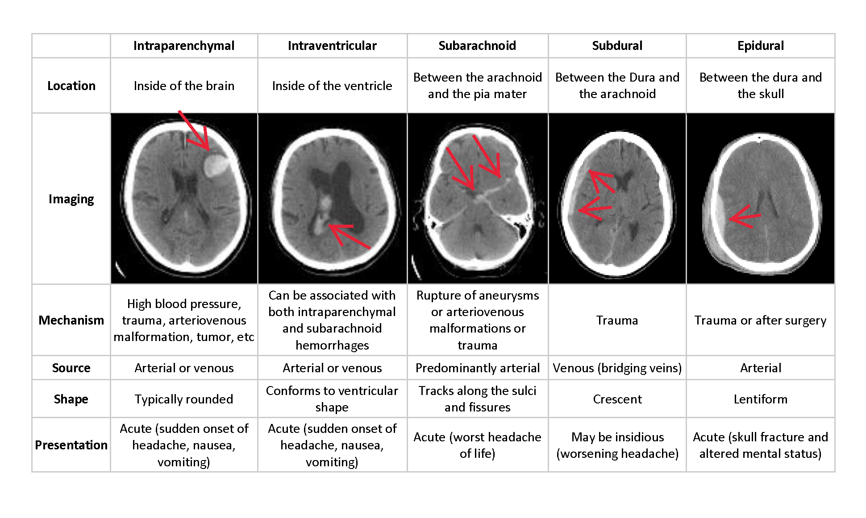

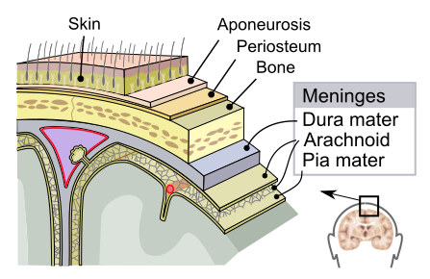

Image credit: By SVG by Mysid, original by SEER Development Team [1], Jmarchn - Vectorized in Inkscape by Mysid, based on work by SEER Development Team, CC BY-SA 3.0, <https://commons.wikimedia.org/w/index.php?curid=10485059>

**3.Evaluation**

Submissions are evaluated using a weighted multi-label logarithmic loss. Each hemorrhage sub-type is its own row for every image, and you are expected to predict a probability for that sub-type of hemorrhage. There is also an any label, which indicates that a hemorrhage of ANY kind exists in the image. The any label is weighted more highly than specific hemorrhage sub-types.

For each image Id, you must submit a set of predicted probabilities (a separate row for each sub-type). We then take the [log loss](https://www.kaggle.com/dansbecker/what-is-log-loss) for each predicted probability versus its true label. Finally, loss is averaged across all samples.

In order to avoid the extremes of the log function, predicted probabilities are replaced with



## Submission File

There will be 6 rows per image Id. The label indicated by a particular row will look like [Image Id]_[Sub-type Name], as follows

There is also a target column, Label, indicating the probability of whether that type of hemorrhage exists in the indicated image.

For each image Id in the test set, you must predict a probability for each of the different possible sub-types. The file should contain a header and have the following format:

Id,Label

1_epidural,0

1_intraparenchymal,0

1_intraventricular,0

1_subarachnoid,0.6

1_subdural,0

1_any,0.9

2_epidural,0

etc.