trasound-dataset-by-using-vgg16-1

January 26, 2026

[1]:
from google.colab import drive drive.mount('/content/drive')

Mounted at /content/drive
[2]:
import os
import numpy as np import random
from PIL import Image, ImageEnhance
from tensorflow.keras.preprocessing.image import load_img
from tensorflow.keras.models import Sequential
from tensorflow.keras.layers import Input, Flatten, Dropout, Dense
from tensorflow.keras.optimizers import Adam from tensorflow.keras.applications import VGG16 from sklearn.utils import shuffle

load dataset
[3]:
dataset_dir='/content/drive/MyDrive/Colab Notebooks/datasets breast cancer/
𝗌breast cancer ultrasound dataset/Dataset_BUSI_with_GT' dataset_paths=[]
dataset_labels=[]
for label in os.listdir(dataset_dir):
for image in os.listdir(os.path.join(dataset_dir,label)): dataset_paths.append(os.path.join(dataset_dir,label,image)) dataset_labels.append(label)
dataset_paths, dataset_labels = shuffle(dataset_paths, dataset_labels) print("Total images:", len(dataset_paths))
print("First 5 paths:", dataset_paths[:5]) print("First 5 labels:", dataset_labels[:5])

Total images: 1592
First 5 paths: ['/content/drive/MyDrive/Colab Notebooks/datasets breast cancer/breast cancer ultrasound dataset/Dataset_BUSI_with_GT/malignant/malignant (190).png', '/content/drive/MyDrive/Colab Notebooks/datasets breast cancer/breast cancer ultrasound dataset/Dataset_BUSI_with_GT/benign/benign (85).png', '/content/drive/MyDrive/Colab Notebooks/datasets breast cancer/breast

[4]:
cancer ultrasound dataset/Dataset_BUSI_with_GT/benign/benign (367).png', '/content/drive/MyDrive/Colab Notebooks/datasets breast cancer/breast cancer ultrasound dataset/Dataset_BUSI_with_GT/normal/normal (127)_mask.png', '/content/drive/MyDrive/Colab Notebooks/datasets breast cancer/breast cancer ultrasound dataset/Dataset_BUSI_with_GT/benign/benign (181)_mask_1.png'] First 5 labels: ['malignant', 'benign', 'benign', 'normal', 'benign']

0 1
from operator import index
import random
import matplotlib.pyplot as plt
#select random indices for 10 images
random_indices = random.sample(range(len(dataset_paths)), 10)
#create a figure to display images in 2 rows fig, axes = plt.subplots(2, 5, figsize=(15, 6)) axes=axes.ravel()
#loop through the selected indices and display
for i, idx in enumerate(random_indices): img_path = dataset_paths[idx]
print(i, idx)
img_path = dataset_paths[idx] img = Image.open(img_path) img = img.resize((224,224))
axes[i].imshow(img, cmap='gray')
axes[i]. set_title(f"Label: {dataset_labels[idx]}") axes[i].axis('off')
plt.tight_layout() plt.show()
1 1066
2 824
3 383
4 1583
5 298
6 864
7 662
8 809
9 582

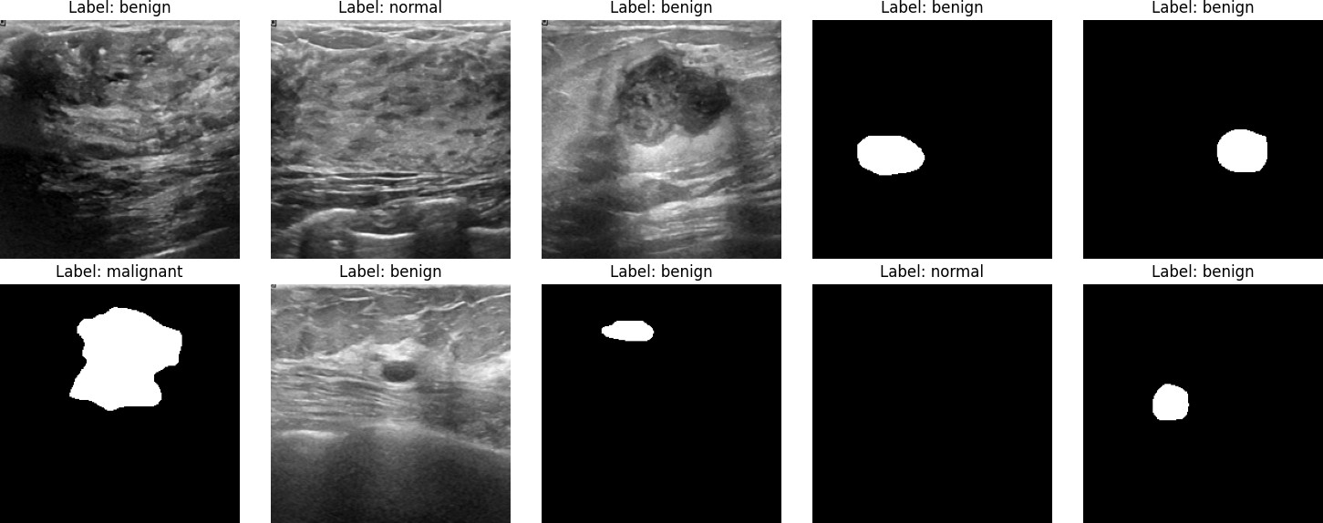

[5]:
# Image Augmentation function
def augment_image(image):
image = Image.fromarray(np.uint8(image))
image = ImageEnhance.Brightness(image).enhance(random.uniform(0.8, 1.2)) #␣
𝗌Random brightness
image = ImageEnhance.Contrast(image).enhance(random.uniform(0.8, 1.2)) #␣
𝗌Random contrast
image = np.array(image) / 255.0 # Normalize pixel values to [0, 1]
return image
# Load images and apply augmentation
def open_images(paths): images = []
for path in paths:
image = load_img(path, target_size=(IMAGE_SIZE, IMAGE_SIZE)) image = augment_image(image)
images.append(image)
return np.array(images)
# Encoding labels (convert label names to integers)
def encode_label(labels):
unique_labels = os.listdir(dataset_dir) # Ensure unique labels are␣
𝗌determined
encoded = [unique_labels.index(label) for label in labels]
return np.array(encoded)
# Data generator for batching
def datagen(paths, labels, batch_size=12, epochs=1):
for _ in range(epochs):
for i in range(0, len(paths), batch_size): batch_paths = paths[i:i + batch_size]

batch_images = open_images(batch_paths) # Open and augment images
batch_labels = labels[i:i + batch_size]
batch_labels = encode_label(batch_labels) # Encode labels
yield batch_images, batch_labels # Yield the batch

[6]:
# Model architecture
IMAGE_SIZE = 224 # Image size (adjust based on your requirements)
base_model = VGG16(input_shape=(IMAGE_SIZE, IMAGE_SIZE, 3), include_top=False,␣
𝗌weights='imagenet')
# Freeze all layers of the VGG16 base model
for layer in base_model.layers: layer.trainable = False

# Set the last few layers of the VGG16 base model to be trainable
base_model.layers[-2].trainable = True base_model.layers[-3].trainable = True base_model.layers[-4].trainable = True

# Build the final model
model = Sequential()
model.add(Input(shape=(IMAGE_SIZE, IMAGE_SIZE, 3))) # Input layer
model.add(base_model) # Add VGG16 base model model.add(Flatten()) # Flatten the output of the base model model.add(Dropout(0.3)) # Dropout layer for regularization
model.add(Dense(224, activation='relu')) # Dense layer with ReLU activation model.add(Dropout(0.2)) # Dropout layer for regularization model.add(Dense(len(os.listdir(dataset_dir)), activation='softmax')) # Output␣
𝗌layer with softmax activation

# Compile the model
model.compile(optimizer=Adam(learning_rate=0.0001), loss='sparse_categorical_crossentropy', metrics=['sparse_categorical_accuracy'])

# Parameters
batch_size = 20
steps = int(len(dataset_paths) / batch_size) # Steps per epoch
epochs = 5
# Train the model
history = model.fit(datagen(dataset_paths, dataset_labels,␣
𝗌batch_size=batch_size, epochs=epochs),
epochs=epochs, steps_per_epoch=steps)
Downloading data from https://storage.googleapis.com/tensorflow/keras- applications/vgg16/vgg16_weights_tf_dim_ordering_tf_kernels_notop.h5

58889256/58889256  0us/step |  |  |  | 0s
Epoch  79/79 |  | 1/5 |  | 1227s | 16s/step -
 | loss: | 0.7558 | - sparse_categorical_accuracy: |  |  | 0.6607
 | Epoch  79/79 | 2/5 | 1211s 15s/step -
 | loss: | 0.2704 | - sparse_categorical_accuracy: |  |  | 0.8999
 | Epoch  79/79 | 3/5 | 1207s 15s/step -
 | loss: | 0.2046 | - sparse_categorical_accuracy: |  |  | 0.9130
 | Epoch  79/79 | 4/5 | 1185s 15s/step -
 | loss: | 0.1594 | - sparse_categorical_accuracy: |  |  | 0.9347
 | Epoch  79/79 | 5/5 | 1187s 15s/step -
 | loss: | 0.0971 | - sparse_categorical_accuracy: |  |  | 0.9654
[7]:
plt.figure(figsize=(8,4)) plt.grid(True)
plt.plot(history.history['sparse_categorical_accuracy'], '.g-', linewidth=2) plt.plot(history.history['loss'], '.r-', linewidth=2)
plt.title('Model Training History') plt.xlabel('epoch')
plt.xticks([x for x in range(epochs)])
plt.legend(['Accuracy', 'Loss'], loc='upper left', bbox_to_anchor=(1, 1)) plt.show()

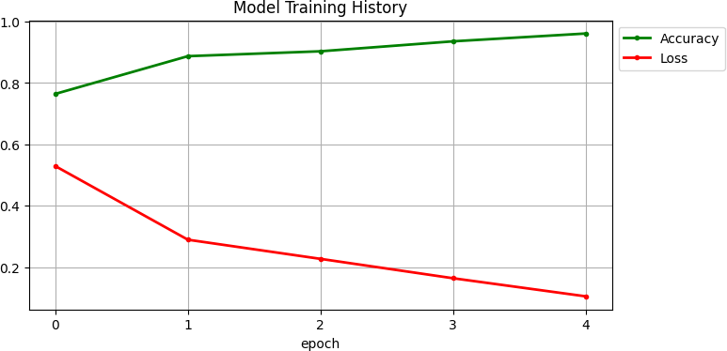

[9]:
# 3. Confusion Matrix
conf_matrix = confusion_matrix(dataset_labels_encoded, np.
𝗌argmax(dataset_predictions, axis=1)) print("Confusion Matrix:") print(conf_matrix)
# Plot the Confusion Matrix
plt.figure(figsize=(8, 6))
sns.heatmap(conf_matrix, annot=True, fmt="d", cmap="Blues", xticklabels=os.
𝗌listdir(dataset_dir), yticklabels=os.listdir(dataset_dir)) plt.title("Confusion Matrix")
plt.xlabel("Predicted Labels") plt.ylabel("True Labels") plt.show()
import matplotlib.pyplot as plt
from sklearn.metrics import classification_report, confusion_matrix, roc_curve,␣
𝗌auc
import seaborn as sns
from sklearn.preprocessing import label_binarize from tensorflow.keras.models import load_model import numpy as np

# 1. Prediction on test data
dataset_images = open_images(dataset_paths) # Load and augment test images
dataset_labels_encoded = encode_label(dataset_labels) # Encode the test labels
# Predict using the trained model
dataset_predictions = model.predict(dataset_images)
# 2. Classification Report
print("Classification Report:") print(classification_report(dataset_labels_encoded, np.
𝗌argmax(dataset_predictions, axis=1)))

50/50 1002s 20s/step Classification Report:
 | precision | recall | f1-score | support
0 | 0.99 | 0.93 | 0.96 | 427
1 | 0.94 | 1.00 | 0.97 | 899
2 | 1.00 | 0.89 | 0.94 | 266
accuracy |  |  | 0.96 | 1592
macro avg | 0.97 | 0.94 | 0.95 | 1592
weighted avg | 0.96 | 0.96 | 0.96 | 1592
[10]:

Confusion | Matrix:
[[397 29 | 1]
[ 4 895 | 0]
[ 0 30 | 236]]
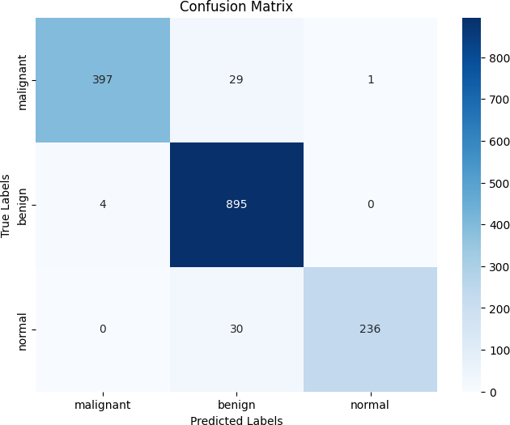

[11]:
# 4. ROC Curve and AUC
# Binarize the dataset labels and predictions for multi-class ROC
dataset_labels_bin = label_binarize(dataset_labels_encoded, classes=np.
𝗌arange(len(os.listdir(dataset_dir))))
dataset_predictions_bin = dataset_predictions # The predicted probabilities␣
𝗌for each class

# Compute ROC curve and ROC AUC for each class
fpr, tpr, roc_auc = {}, {}, {}
for i in range(len(os.listdir(dataset_dir))):
fpr[i], tpr[i], _ = roc_curve(dataset_labels_bin[:, i],␣
𝗌dataset_predictions_bin[:, i]) roc_auc[i] = auc(fpr[i], tpr[i])

# Plot ROC curve
plt.figure(figsize=(10, 8))
for i in range(len(os.listdir(dataset_dir))):
plt.plot(fpr[i], tpr[i], label=f'Class {i} (AUC = {roc_auc[i]:.2f})')
plt.plot([0, 1], [0, 1], linestyle='--', color='gray') # Diagonal line
plt.title("ROC Curve") plt.xlabel("False Positive Rate") plt.ylabel("True Positive Rate") plt.legend(loc="lower right") plt.show()
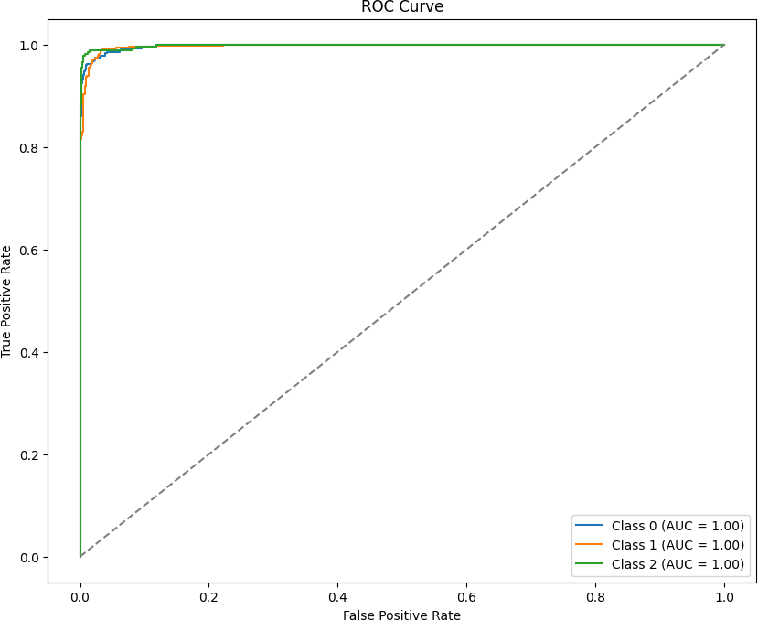

[13]:
# Save the entire model
model.save('model.h5')

WARNING:absl:You are saving your model as an HDF5 file via `model.save()` or
`keras.saving.save_model(model)`. This file format is considered legacy. We

[14]:
recommend using instead the native Keras format, e.g.
`model.save('my_model.keras')` or `keras.saving.save_model(model, 'my_model.keras')`.
from tensorflow.keras.models import load_model
# Load the trained model
model = load_model('model.h5')

[23]:
WARNING:absl:Compiled the loaded model, but the compiled metrics have yet to be built. `model.compile_metrics` will be empty until you train or evaluate the model.
from keras.preprocessing.image import load_img, img_to_array

import numpy as np
import matplotlib.pyplot as plt

#Class labels
class_labels = ['malignant', 'benign', 'normal']

def detect_and_display(img_path, model, image_size=224):
"""
Function to detect cancer and display results.
If no cancer is detected, it displays "No cancer".
Otherwise, it shows the predicted cancer class and confidence. """
try:
# Load and preprocess the image
img = load_img(img_path, target_size=(image_size, image_size)) img_array = img_to_array(img) / 255.0 # Normalize pixel values img_array = np.expand_dims(img_array, axis=0) # Add batch dimension
# Make a prediction
predictions = model.predict(img_array) predicted_class_index = np.argmax(predictions, axis=1)[0] confidence_score = np.max(predictions, axis=1)[0]
# Determine the class
if class_labels[predicted_class_index] == 'normal': result = "No cancer"

else:
result = f"Tumor: {class_labels[predicted_class_index]}"
# Display the image with the prediction plt.imshow(load_img(img_path)) plt.axis('off')
plt.title(f"{result} (Confidence: {confidence_score * 100:.2f}%)")

plt.show()
except Exception as e:
print("Error processing the image:", str(e))
# Example usage
image_path = '/content/drive/MyDrive/Colab Notebooks/datasets breast cancer/
𝗌breast cancer ultrasound dataset/Dataset_BUSI_with_GT/malignant/malignant␣
𝗌(101).png' # Provide the path to your new image
detect_and_display(image_path, model)
1/1 2s 2s/step
