**PORTFOLIO**

ASSIGNMENT OF CSE111

(ORIENTATION TO COMPUTING-1)

**COMPUTER SCIENCE AND ENGINEERING**

Submitted by:

Name: Malay

Registration number: 12321607

Roll No.: 67

Section: K23GD

**Submitted to : Dr. Mir Salim Ul Islam(SIR)**



**LOVELY PROFESSIONAL UNIVERSITY**

**DECLARATION**

I, **Malay Ghosh**, a student of Bachelor of Technology under Computer Science and Engineering discipline at Lovely Professional University, Punjab, hereby declare that all the information furnished in this project report is based on my own work and is genuine

Malay

Registrartion Number: 12321607

|  |  |  |
| --- | --- | --- |
| Platforms for profile creation | Link to student profile | Screenshot |
| ***Figma*** | [@Figma](https://www.figma.com/files/user/1313103393997063664?fuid=1313103393997063664) | 1 |
| ***Quora*** | <https://www.quora.com/profile/Malay-Ghosh-161> | 1 |
| ***Stack overflow*** | <https://stackoverflow.com/users/23032110/malay-ghosh> | 3 |
| ***Hacker Rank*** | <https://www.hackerrank.com/profile/malayghosh2003_1> | 4 |
| ***Hacker Earth*** | <https://www.hackerearth.com/@malayghosh2003.mg> | 5-6 |
| ***Geeks for Geeks*** | <https://auth.geeksforgeeks.org/user/malayghosjn13> | 7 |
| ***LinkedIn*** | [@linkedIn](https://www.linkedin.com/in/malay-ghosh-a2b630215/) |  |
| ***Github*** | <https://github.com/dashboard> | 8 |
| ***CV*** |  | 1 |
| ***MOOCS done*** | [Social_Media_Marketing](C://Users/hp/AppData/Local/Microsoft/Windows/INetCache/IE/68X35WLB/certificate_(2)%5b1%5d.pdf) | 1 |
| ***Technical MOOC Registration*** | [Responsive Web Design](https://www.freecodecamp.org/certification/fcc3da68d4d-89b5-447a-bbc3-78ef2e46f82b/responsive-web-design) | 1 |

1.FIGMA

Profile:

Figma internal profile with project

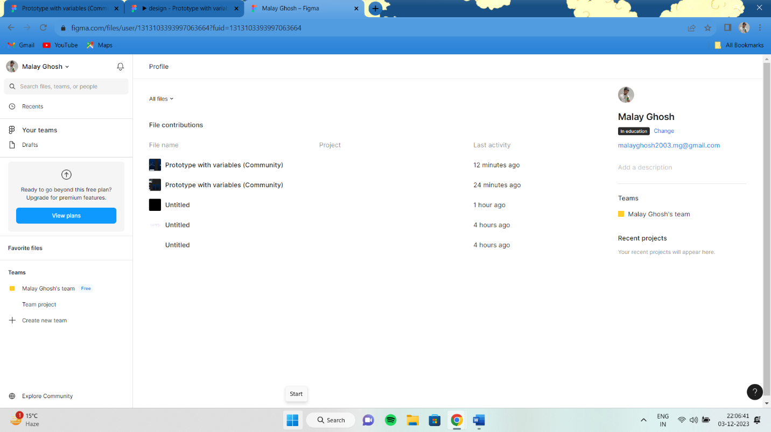

Accomplishment:

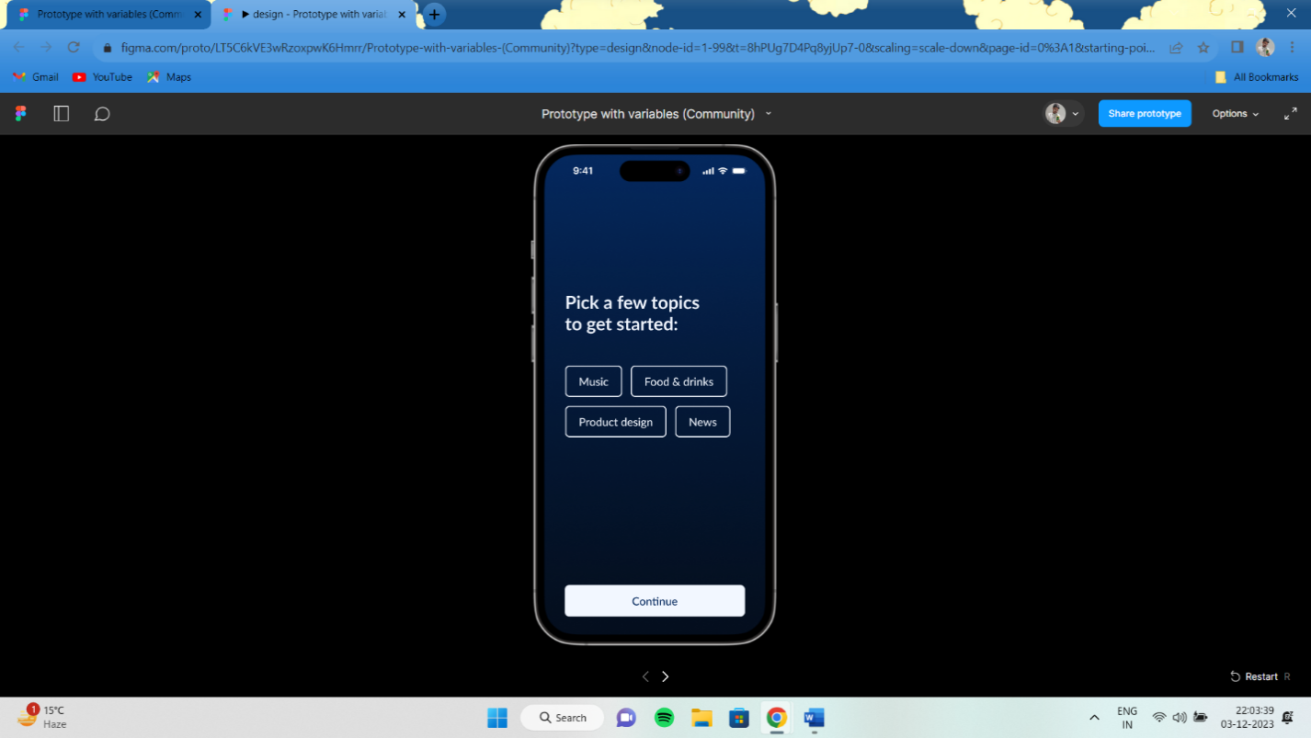

2.QUORA

PROFILE AND ACCOMPLISHMENT:

[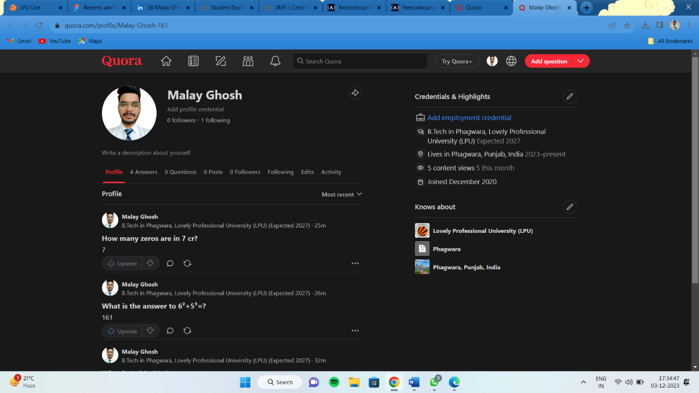](https://www.quora.com/profile/Malay-Ghosh-161)

3.STACKOVERFLOW

PROFILE:

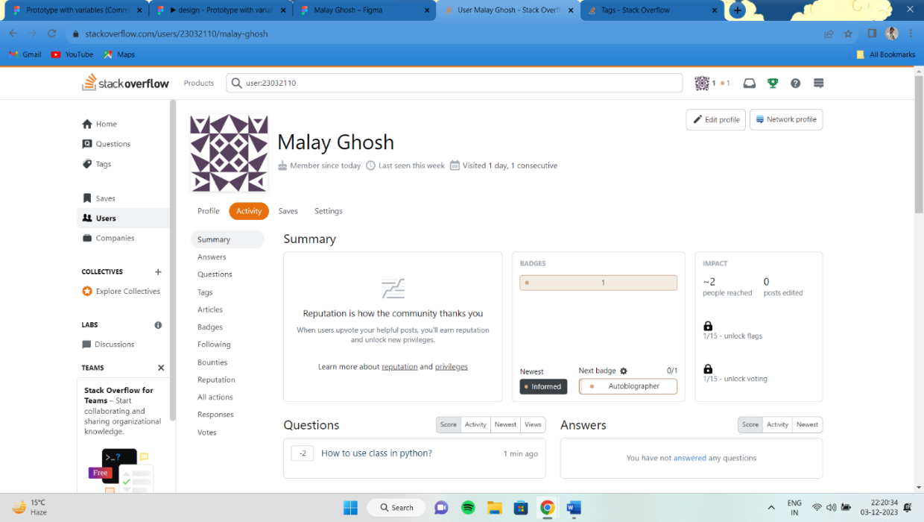

Accomplishment:

Raised a question and got a badge 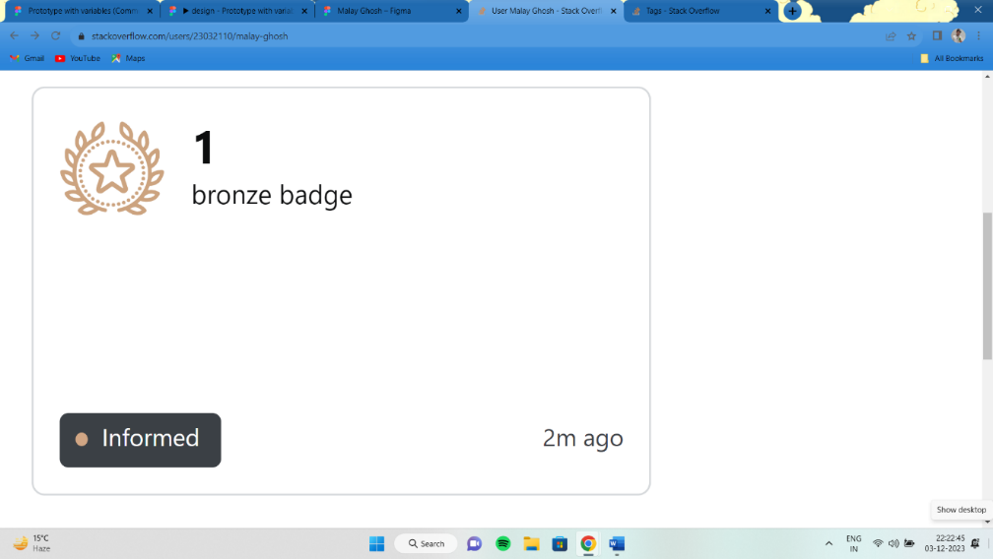

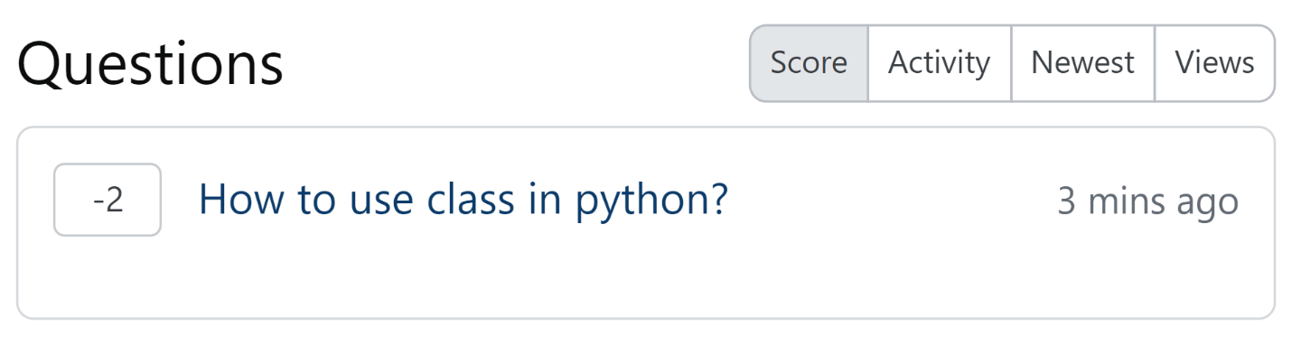

**4.HACKER RANK**

**Profile:**

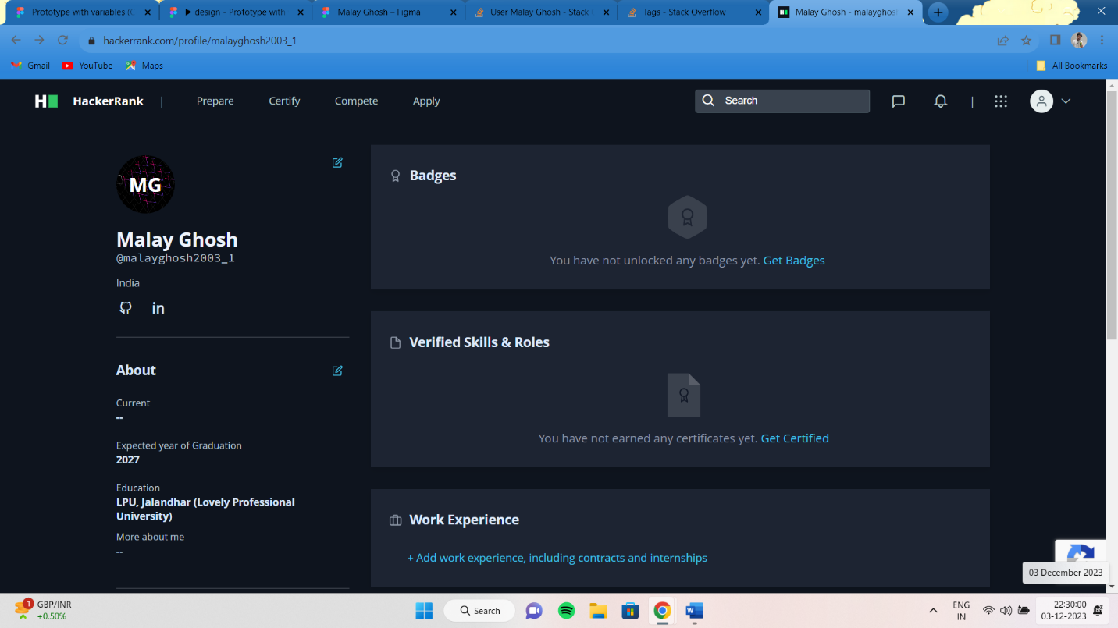

**5.HACKER EARTH**

**Profile:** 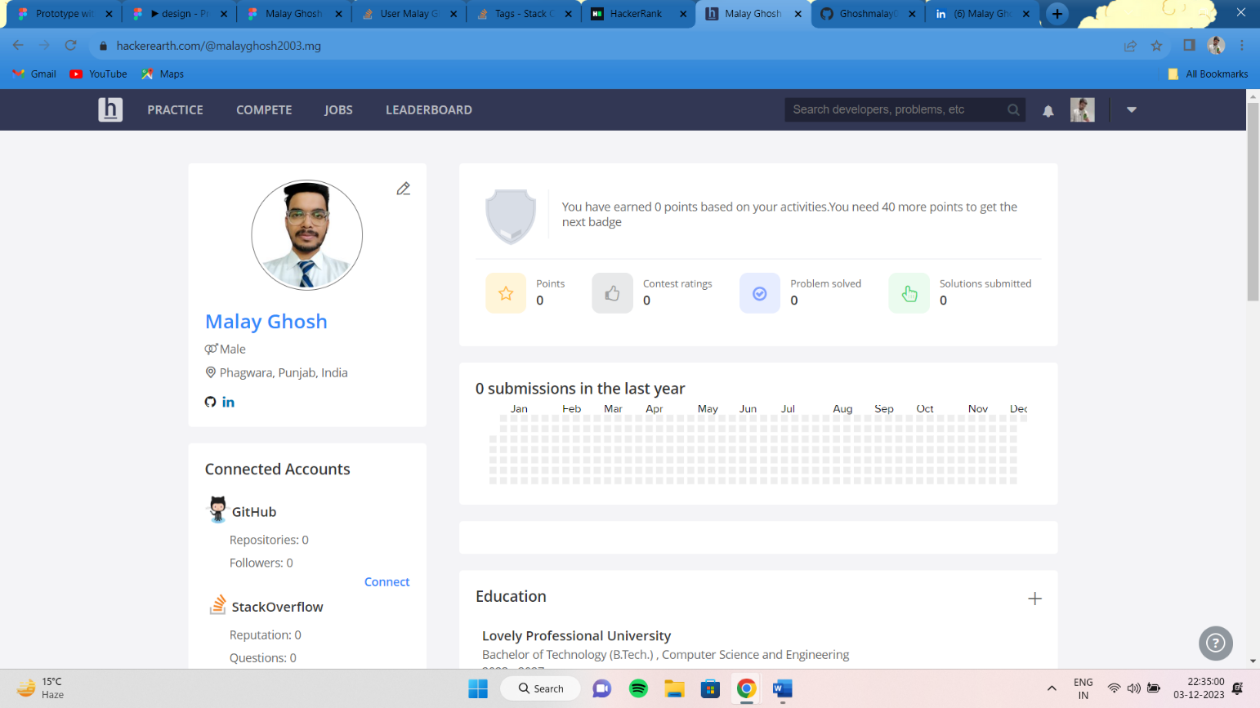

**6. GEEKS FOR GEEKS**

**Profile:**

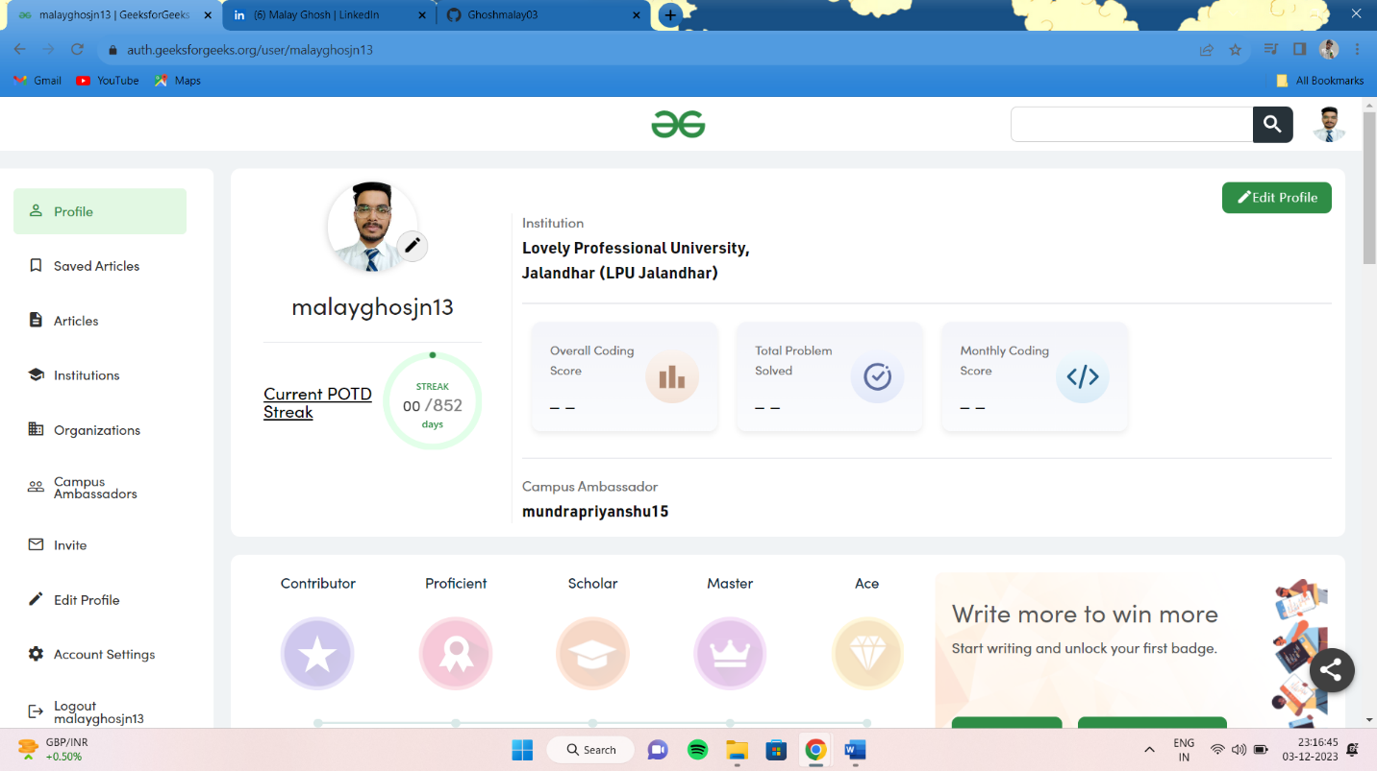

**7. GITHUB**

**Profile:**

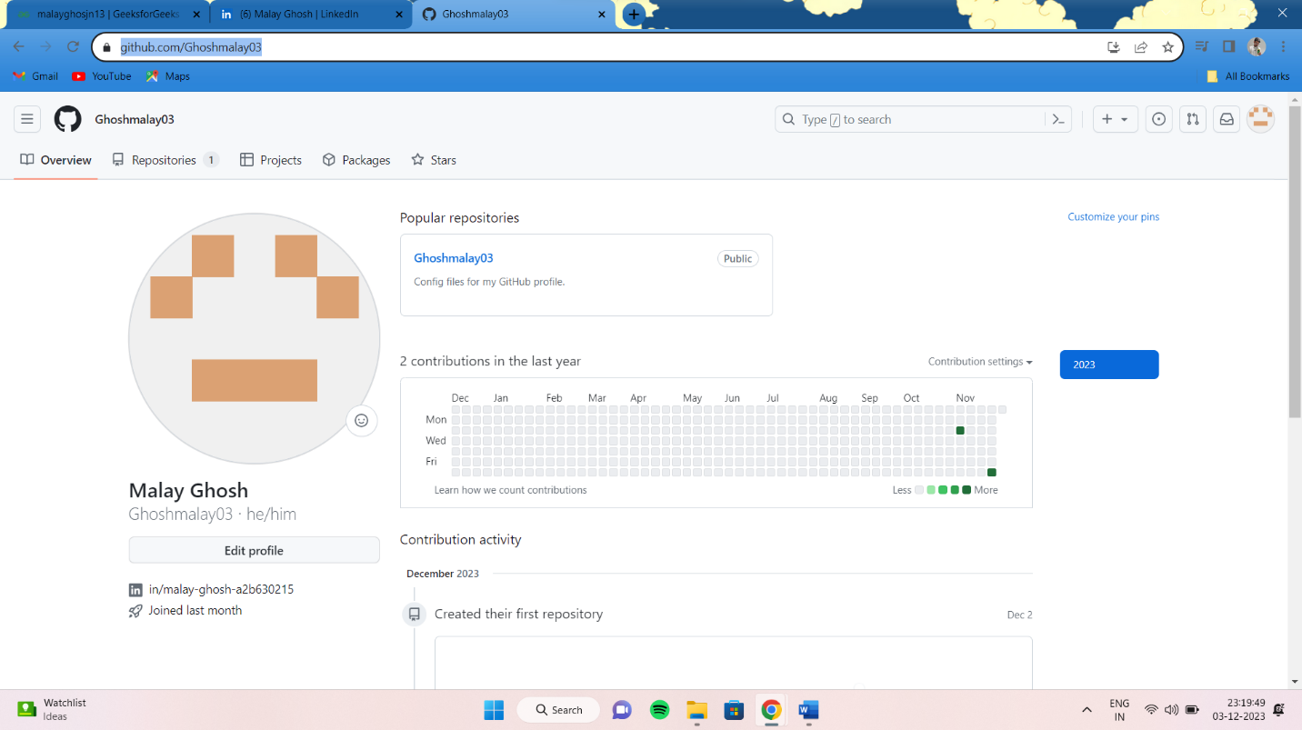

**8. CV**

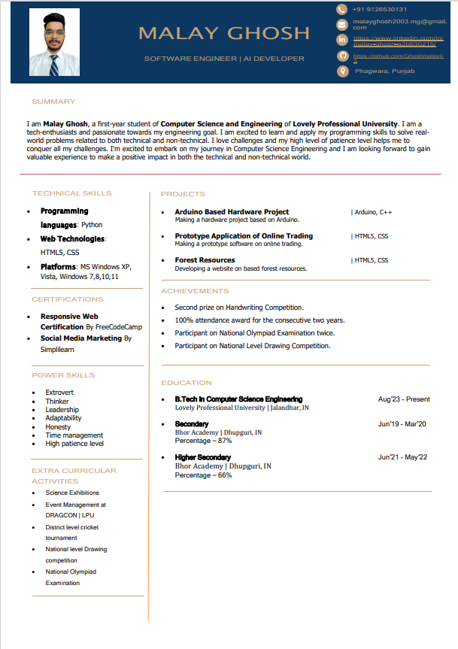

**9. MOOCS completed**

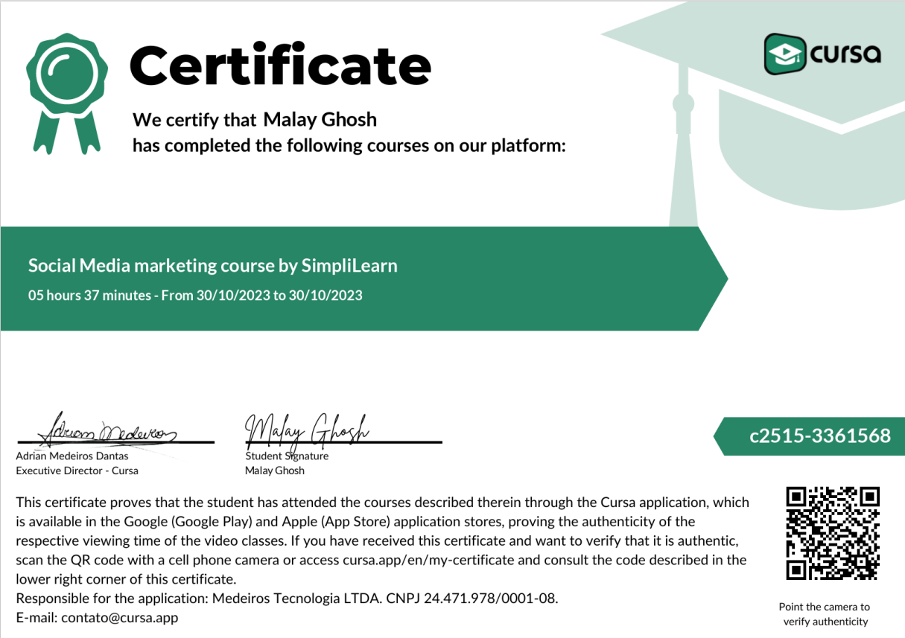

**10. Technical MOOC -**

