
Yarmouk University
Hijjawi Faculty for Engineering Technology
Department of Biomedical Systems Engineering and Informatics

Graduation Project Report

Report Title Font Size 24 Bold

Ghosoun Tyseer AbuDilea 2020978143
Anas AbuDuleh

Semester: First 2020/2021

Date: 10th January 2021

Students' Property Right Declaration and Anti-Plagiarism Statement
We hereby declare that the work in this graduation project at Yarmouk University is our own except for quotations and summaries which have been duly acknowledged. This work has not been accepted for any degree and is not concurrently submitted for award of other degrees. It is the sole property of Yarmouk University and it is protected under the intellectual property right laws and conventions.
We hereby declare that this report is our own work except from properly referenced quotations and contains no plagiarism.
We have read and understood the school's rules on assessment offences, which are available at Yarmouk University Handbook.

Students:
Name: _________________ | Signature: _______________ | Date: __________________
Name: _________________ | Signature: _______________ | Date: __________________
Name: _________________ | Signature: _______________ | Date: __________________
Name: _________________ | Signature: _______________ | Date: __________________

Table of Contents
Students' Property Right Declaration and Anti-Plagiarism Statement i
List of Tables iii
List of Figures iv
Abstract v
Chapter 1: Introduction 1
1.1 Problem statment and motivations behind the project.....................................................
1.2Background..........
1.3Aims and objectives.
1.4How has the problem been solved till now?
1.5 main solution idea
1.6 key technical detail and evaluation of solution.
1.7 A list of contributions with short descriptions
1.8 high-level figure of solution describing the main components of the
system/solution and the basic interactions between them.
1.9Summary of report structure.
Chapter 2: Background 2
2.1 background of the problem(relevant literature research).
2.2 some context about the problem, why it is important and where it is used .
2.3Target market and their needs.
2.4Potential ethical and/or environmental issues.
2.5different approaches currently/previously used to solve the problem
2.6 Technical Background
Chapter 3: Design 3
3.1 Design Overview:
3.1.1 design of project to achieve the solution.
3.1.2 How plan to address the problem statement.
3.1.3 Detailed figure of solution, interaction between the components
,and scenarios of use.
3.2Design Details:
3.2.1Design Specifications
3.2.2 Design Process

    - Legal Aspects
    - Design Constraints
    - Design Standards
    - Design Alternatives
    - Safety Consideration
3.7.8 Design considerations table.
Chapter 4: Implementation 5
4.1 precise description of the methods and tools (hardware, software … etc.)
used to implement solution.
4.1.1 Hardware Environment
4.1.2 Software Libraries and Framework
4.1.3methods used for implementation
4.2infrastructure solution depends on, or is using to accomplish its tasks
4.3 Trade-offs in Design and Implementation
4.4dependencies/assumptions of implementation
Chapter 5: Results and Discussion 6
5.1 results and discussion in detail
5.2strengths and weaknesses of solution/system.
Chapter 6: Economical, Ethic, and Contemporary Issues 7
6.1 Preliminary Cost Estimation and Justification
6.2 Relevant Codes of Ethics and Moral Frameworks
6.2 Ethical Dilemmas and Justification of Proposed Solution
6.4 Relevant Environmental Considerations
6.5 Relevance to Jordan and Region (Social, Cultural, and Political)
6.6 Other Issues and Constraints
Chapter 7: Project Management 8
7.1 Schedule and Time Management
7.2 Resource and Cost Management
7.3 Quality Management
7.4 Risk Management
7.5 Project Procurement

Chapter 8: Conclusion and Future Work 9
8.1 Summary of the main contributions of the work.
8.2 Further Future Work Improving the Proposed System
8.3 Lessons Learned
References 10

List of Tables
Table 1.1 :Report Structure Summary…………………………………………………………………

Table 3.1: Feature Integration Architecture Modes (none / as_node / graph_graph / graph_ae)…….

Table 3.2 : GCN vs. GAT: Key Architectural Differences……………………………………………

Table 3.3 : Comparison of Standard Cross-Validation vs. Hidden Link Recovery Protocol…………

Table 3.4 : Standards and Organizations Relevant to the Project…………………………………

Table 3.5: Design Considerations Matrix with Project Application……………………………….

Table 4.1: Software Libraries and Frameworks Used in Implementation……………………………..

Table 4.2 : Project File Structure – Folders, Files, and Roles……………………………………………

Table 5.1 : Baseline Reproduction Results – LLM and BERT Models (GCN)……………………….

Table 5.2 : GCN vs. GAT Performance Comparison Across All Feature Types……………………….

Table 5.3 : Hidden Link Evaluation Results – evaluation Metrics (GCN vs. GAT)…………………..

Table 5.4 : Hidden Link Evaluation Results – Recovery Rate and Confidence Scores (GCN vs. GAT…

Table 7.1 : Project Timeline – Phase Schedule Across 16 Weeks………………………………

List of Figures
Figure 1.1:Overview of the Drug Repurposing Pipeline vs. Traditional Drug Discovery…………..
Figure 1.2:Evaluation Framewok overview Diagram……………………………………………..
Figure 1.3 :High-Level Architecture of the Proposed Drug Repurposing Framework…………
Figure 2.1Heterogeneous Graph Structure for Drug–Disease Association Prediction in drug repurposing versus drug discovery………………………………………………………………………..

Figure 2.2Message-Passing Mechanism in Graph Neural Networks (GNNs)……………………………

Figure 2.3 : How Chemical structure convert to SMILE and Morgan Fingerprint……………………

Figure 3.1: Detailed System Architecture and Pipeline Overview…………………………………..

Figure 3.2:Diferent usage senarios for the system……………………………………………………
Figure 3.3:Project File Directory Structure…………………………………………………………..

Figure 3.4:Morgan Fingerprint Generation Script (generate_morgan_fp.py)………………………..

Figure 3.5: args.py – Morgan Feature Type Integration………………………………………………

Figure 3.6: Args Configuration for Morgan Fingerprint Settings……………………………………..

Figure 3.7: load_data.py – Morgan Fingerprint Feature Loading …………………………………..

Figure 3.8: ChemBERTa Embedding Generation Script (generate_chemberta_emb.py)………….

Figure 3.9 : args_gat_final.py – ChemBERTa Feature Type Integration…………………………..
Figure 3.10: args.py – Concatenate Type Selection ………………………………………………

Figure 3.11:Architecture Comparision for Concatenatination Types………………………………..

Figure 3.12 :load_data.py – Structural Graph Construction (Top-K Selection)……………………..

Figure 3.13 load_data.py – Structural Graph Node Feature Initialization…………………………

Figure 3.14:load_data.py – LLM Graph Construction………………………………………….

Figure 3.15:load_data.py – Hidden Link Removal from Graph………………………………….

Figure 3.16:model.py – Baseline GCN Encoder Architecture…………………………………
Figure 3.17:HeteroGATLayer Design and Architecture………………………………………………

Figure 3.18:GAT Semantic Attention Mechanism ……………………………………………………

Figure 3.19:GAT Layer Attention – Layer Weights……………………………………………………

Figure 3.20 :GCN Layer Attention Code Implementation…………………………………………….

Figure 3.21:model.py – Bilinear Decoder for Drug–Disease Prediction………………………………..

Figure 3.22:main.py – K-Fold Cross-Validation Data Split…………………………………………..

Figure 3.23:main.py – Test Edge Removal Before Training………………………………………

Figure 3.24:main.py – Feature Generation for Each Fold……………………………………………

Figure 3.25:main.py – Training Epoch Forward Pass…………………………………………………

Figure 3.26:main.py – Store predictions for each fold………………………………………………….

Figure 3.27:main.py –compute overall metrics for all Folds …………………………………………..
Figure 3.28:main_gat_final.py –Training Loop with Early Stopping…………………………………….

Figure 3.29:main_gat_final.py – GAT Training Loop with Validation AUC………………………….

Figure 3.30: main_gat_final.py – Checkpoint Saving on Improvement……………………………….

Figure 3.31:main_gat_final.py – Best Checkpoint Loading After Training………………………….

Figure 3.32:main_gat_final.py – Final Evaluation on Test Mask……………………………………

Figure 3.33:run_hidden_gcn.py – Loading the Full DDA Matrix…………………………………….

Figure 3.34:run_hidden_gcn.py – Hiding Positive Links from Training Graph……………………..

Figure 3.35:run_hidden_gcn.py –Build training data using visible links……………………………

Figure 3.36:run_hidden_gcn.py – K-Fold Training on Visible Links……………………………………

Figure 3.37:run_hidden_gcn.py – Hidden Link Recovery Rate Computation…………………………

Figure 3.38:run_hidden_gcn.py – Reporting results………………………………………………….

Figure 3.39:all_candidates_sorted.py – Drug Candidate Ranking Module…………………………

Figure 4.1: Terminal Command – GCN with LLM Features…………………………………………….

Figure 4.2: Terminal Command – GCN with BERT Features…………………………………………..

Figure 4.3: Terminal Command – GCN with Morgan Fingerprint Features……………………………

Figure 4.4: Terminal Command – GCN with ChemBERTa Features………………………………….

Figure 4.5: Terminal Command – GAT with LLM Features…………………………………………..

Figure 4.6: Terminal Command – GAT with BERT Features………………………………………..

Figure 4.7: Terminal Command – GAT with Morgan Fingerprint Features…………………………..

Figure 4.8: Terminal Command – GAT with ChemBERTa Features…………………………………

Figure 4.9: Terminal Command – Hidden Link Recovery, GCN (ratio=0.10)……………………….

Figure 4.10: Terminal Command – Hidden Link Recovery, GCN (ratio=0.05)……………………….

Figure 4.11: Terminal Command – Hidden Link Recovery, GAT (ratio=0.10)……………………….

Figure 4.12: Terminal Command – Hidden Link Recovery, GAT (ratio=0.05)……………………….

Figure 4.13: Terminal Command –Drug Candidate Ranking………………………………………..

Figure 5.1 : Performance comparison for two LLM embedding generators on four datasets in fivefold cross-validation……………………………………………………………………………………………
Figure 5.2: Ranked Drug–Disease Association Candidates (GCN–LLM Output)……………………..
Figure 8.1: Disease Specificity Index (DSI) Formula for Gene Weighting…………………………….

Abstract
The computational Drug repurposing through the prediction of drug-disease associations, offers significant potential for discovering new theraputic indicators. While modern methods integrate graph neural networks (GNNs) with large language models(LLM) for prediction, further refinement and alternative approaches can enhance prediction performance or provide better ways to evaluate models. In this project, we begin with Baseline, which uses the GCN model with LLM integration to extract high-quality cognitive descriptions of drugs and diseases. We then develop and modify this model, such as replacing the reliance on LLM for drug features with Morgan fingerprinting and ChemBERT, which deal with the molecular and chemical structure of drugs instead of textual descriptions, while leaving disease features unchanged. We also experiment with a different model, the Graph Attention Network (GAT). The second contribution is the development of a new assessment method that involves hiding links, then testing the model's ability to retrieve them, and ranking the results to facilitate the acquisition of candidates for further research or clinical evaluation to provide an assessment of the models' ability to generalize. Morgan's fingerprinting embeddings achieved competitive performance across all measures, indicating their effectiveness and potential for adoption as an alternative to representations based on Language Models (LLM) that require API access or large pre-trained models.
The GAT model also achieved higher recovery results at the level of the hidden link experiment, meaning that this proposed model, which assigns different weights to relationships according to its importance, succeeds in retrieving relationships that were not presented to it better than the original model.

Keywords—Drug repurposing, GNNs, BERT, LLM, Drug-disease association prediction,Heterogeneous graph ,Graph Attention Networks , Morgan ,ChemBERT,SMILES,

Graphical Abstract

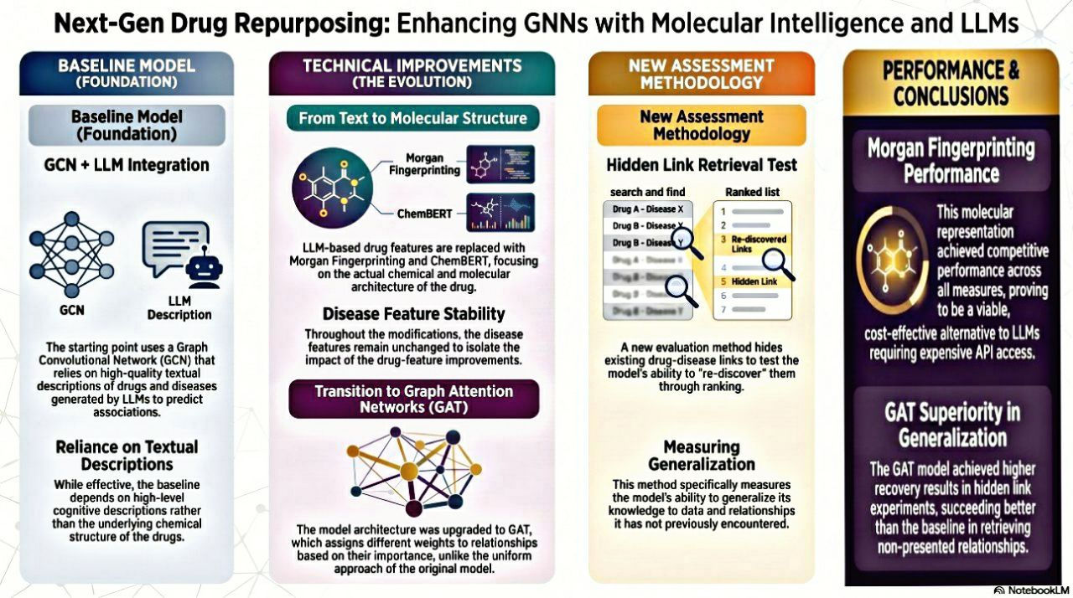

Chapter 1: Introduction

The rapid growth of biomedical data and advances in artificial intelligence have created new opportunities for discovery in several fields, including drug discovery and repurposing. Predicting potential drug-disease associations using computational methods has become a significant research area due to its ability to reduce the time and cost required to identify new therapeutic applications for existing drugs.

This chapter introduces the research problem addressed by this project and discusses the motivations for studying computational methods for drug repurposing. It also presents the project's aims and objectives, provides an overview of available solutions, outlines the proposed methodology, summarizes the key technical aspects and evaluation methodology, and identifies the main contributions and the report's structure.

  - Problem statment and motivations behind the project
In recent years, the field of drug discovery has received increasing attention due to its important role in improving healthcare and addressing complex diseases. However, the traditional process of developing new drugs is considered one of the most complex and resource-intensive processes in modern biomedical science. It requires identifying new therapeutic compounds, verifying their effectiveness and safety, and then passing through all stages of clinical trials until regulatory approval. This process requires significant financial and time investments. Statistics indicate that developing a new drug takes an average of about 13 years and may cost up to 3 billion USD, while failure rates remain high.Therefore, researchers have turned to alternative approaches that aim to accelerate drug development and reduce the associated costs and risks. In this context, computational drug repurposing has emerged as an important and promising alternative approach. It focuses on discovering new therapeutic uses for existing drugs that already have proven safety profiles in humans and are approved and available on the market, instead of developing entirely new chemical compounds. This helps reduce the time and cost required to develop effective treatments.
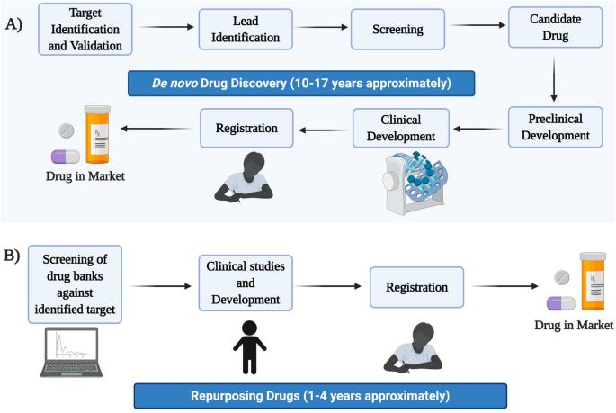
Figure 1.1:Overview of the Drug Repurposing Pipeline vs. Traditional Drug Discovery
The main technical challenge in computational drug repurposing is predicting drug–disease associations. Given a set of known drugs, diseases, and a limited number of confirmed associations between them, the goal is to identify which unknown pairs are likely to represent true therapeutic relationships. This problem is commonly formulated as a link prediction task in a heterogeneous biological network, where drugs and diseases are represented as nodes and known associations are represented as edges. However, the challenge is not only in formulating the problem itself but also in the quality of node representations. The accuracy and richness of the information used to describe each drug and disease are critical factors that determine the model’s ability to generalize and predict new associations.
Many previous approaches, including traditional machine learning methods, matrix factorization techniques, and early graph neural network models, relied on limited similarity measures such as molecular fingerprints, chemical substructures, ontology terms, or network structure. Although these measures provide useful information, they are not sufficient to represent the full biological complexity. They are also affected by data sparsity and incompleteness and cannot effectively utilize the large amount of biomedical knowledge available in scientific literature and databases. As a result, the learned representations are often weak, limiting the model’s ability to generalize beyond the training data.In addition, modern graph neural network models, despite their advances, depend heavily on the quality and structure of the network. Therefore, any missing information or noise in the data directly affects their performance. To address these challenges, this project focuses on improving representation quality by integrating multiple sources of information, including network structure, drug chemical features at different representation levels, and semantic knowledge extracted from biomedical texts using large language models. This integration is performed within a unified deep learning framework based on attention mechanisms, with the goal of improving prediction accuracy, enhancing generalization ability, and providing more reliable and interpretable results, which is highly important in medical applications.
  - Background.
Drug repurposing has contributed to many successful therapeutic discoveries and continues to play an important role in modern biomedical research. The increasing availability of biomedical data has accelerated interest in computational drug repurposing. Large-scale databases now provide comprehensive information about drugs, diseases, molecular structures, biological interactions, and clinical evidence. As a result, researchers increasingly rely on data-driven approaches to analyze these complex relationships and identify potential drug–disease associations that may require further experimental investigation.
Advances in artificial intelligence and data science have also transformed the way biomedical data is analyzed. Computational drug discovery methods have evolved into a fundamental pillar of modern medicine, moving from being supporting tools to becoming a major driver of discovery that can reduce years of laboratory research.
Over time, this field has developed alongside advances in artificial intelligence, progressing from early data-based methods to more advanced approaches capable of identifying complex biological patterns and relationships. This continuous development has established computational drug repurposing as one of the most active research areas at the intersection of biomedical sciences and artificial intelligence.

  - Aims and objectives.
1.3.1Aim
Reproduce, evaluate and enhance the published drug repurposing framework for predicting the association between drugs and diseases. To improve prediction accuracy and scalability

1.3.2objectives

- Reproduce the baseline LLM-DDA framework by executing the publicly available source code on one of the the four benchmark datasets (B, C, F, R) ,spesially Cdataset, to establish a verified reference implementation.

- Validate implementation correctness by comparing reproduced performance metrics (AUC, AUPR, F1-Score, Precision) against the published results to ensure experimental fidelity.

- identify architectural limitations through analysis the baseline model

- Design and implement targeted enhancements to the baseline architecture.

- Evaluate the enhanced framework using the same cross-validation protocol and metrics, for fair comparison.

6.Building a new evaluation framework .

  - How has the problem been solved till now?
Historically, this journey began with traditional machine learning approaches, where the drug–disease association prediction problem was treated as a binary classification task using manually engineered features to represent drugs and diseases. These methods relied on models such as SVM and Random Forest. However, they were limited because they depended heavily on the quality of handcrafted features and could not automatically capture complex relationships.This was followed by matrix factorization methods, where approaches based on analyzing the drug–disease interaction matrix were used to extract latent factors representing the relationships between them. These methods were better at handling missing data, but they still had limited ability to capture complex and nonlinear relationships within biological networks.Later, deep learning techniques emerged, particularly Graph Neural Networks (GNNs), due to their ability to process data as interconnected graphs. In these methods, representations of drugs and diseases are learned directly from the network structure. These approaches achieved better performance because they utilize relationships between nodes. However, they still rely mainly on the graph structure and lack access to the rich information available in medical texts and biological databases.More recently, Large Language Models (LLMs) have emerged in this field. Some studies have started using language-based representations or additional deep learning models and integrating them with Graph Neural Networks (GNNs). The goal of this integration is to bridge the gap between structured numerical data and the deep medical knowledge stored in texts. This is the direction adopted by this project to develop a hybrid and more accurate prediction model.

  - main solution idea
This project is based on the assumption that drug–disease relationships cannot be effectively represented using a single source of information, since biological interactions are naturally multi-level and non-linear. Therefore, the proposed solution is to develop a unified heterogeneous graph learning framework that integrates structural interaction data with rich feature representations derived from multiple biological and semantic sources.The main idea is to start with an existing drug repurposing model as a baseline and then reproduce its results accurately to ensure their validity and consistency. After validating the baseline model, the main contribution of this project is to extend its representation capability through improved feature integration mechanisms and architectural enhancements. Examples include using different embeddings such as ChemBERT and Morgan fingerprints, using a different GAT model instead of GCN, or introducing a new evaluation approach.
A comprehensive comparison is then conducted between the baseline model and the proposed project contributions as a foundation for future additions and improvements.
In summary, the proposed solution is not limited to reproducing an existing framework. Rather, it is an experimental extension that aims to investigate the possibility of introducing meaningful contributions to the field of drug repurposing.

  - key technical detail and evaluation of solution.

1.6.1 Main Technical Details
The proposed solution is based on a hybrid architecture that combines structural representations with biomedical knowledge extracted from textual descriptions. The overall framework consists of the following main stages:
1. Feature Generation
Features are generated in two parts. The first part is related to structural representations, which are generated from known drug similarities (drug_sim), known disease similarities (dis_sim), and known drug–disease associations (drug_dis) available in the dataset.
The second part is related to knowledge extracted from textual descriptions and chemistry, which includes several types of representations such as Morgan Fingerprints, ChemBERT, LLM, and BERT embeddings. These representations are used as node features during training.

2. Heterogeneous Graph Construction
A heterogeneous graph of drugs and diseases is constructed based on the structural representations after applying a Top-K Neighbor Selection strategy (Top 15) to retain only the strongest similarity connections. This process reduces noisy edges and preserves the most informative biological relationships.The representations extracted from textual descriptions are handled differently depending on the training architecture being used.

3. Representation Learning Architecture
To explore different strategies for combining structural and semantic information, I chose graph-ae feature integration architecture for implementation and evaluation.in this architecture , graph is constructed using structural representations, while an autoencoder is used to process the semantic representations.

4. Baseline Model and Proposed Model
Two models are used in the project. Both models can work with all representation types and all architecture types to enable a comprehensive comparison:

1.Baseline Model (GCN): Reproduces the original published framework and is used as the reference model.

2.Proposed Model (GAT): Uses a different type of Graph Neural Network. Its main advantage is that it treats neighboring nodes differently according to their importance through an attention mechanism. This serves as the primary improvement introduced in the project.

5. Layer Integration and Prediction
After learning the representations, a layer attention mechanism combines information from multiple layers of the graph neural network. This allows the model to automatically assign greater importance to more informative representations while reducing the effects of over-smoothing.The final drug and disease representations are then passed to a bilinear decoder, which estimates the probability of association between each drug–disease pair. An activation function converts the prediction scores into probabilities used for ranking and evaluation.

6.2 Evaluation Methodology
To accurately evaluate the performance of the proposed drug–disease association prediction framework, a multi-stage evaluation protocol is adopted to ensure robustness, generalization ability, and fair comparison with the baseline model.

1. K-Fold Cross Validation
The model is evaluated using K-Fold Cross Validation, where the known drug–disease interaction dataset is divided into five subsets. This strategy ensures that the model is evaluated on all available data and reduces the bias introduced by a single train-test split.

2. Evaluation Metrics
Four statistical metrics are used: AUC, AUPR, F1-Score, and Precision.

3. Hidden Link Prediction Evaluation (Edge Masking Strategy)

In addition to standard cross-validation, a specialized evaluation strategy based on interaction masking is introduced. A subset of known drug–disease associations (test edges) is intentionally removed from the heterogeneous graph during training, and the model is trained only on the remaining interactions.
After training, the model is required to predict the hidden associations, and its ability to recover these relationships is measured. This type of evaluation is essential for testing generalization ability and simulating real-world scenarios, where such models are expected to predict associations involving drugs and diseases that were not previously observed during training.

4. Score-Based Ranking Evaluation
This evaluation approach is based on taking the prediction results for previously unknown associations and ranking them according to their scores to identify potential drug repurposing candidates for further investigation.This evaluation supports model assessment because validating the predicted associations through published research increases confidence in the model and strengthens the overall evaluation of its performance.

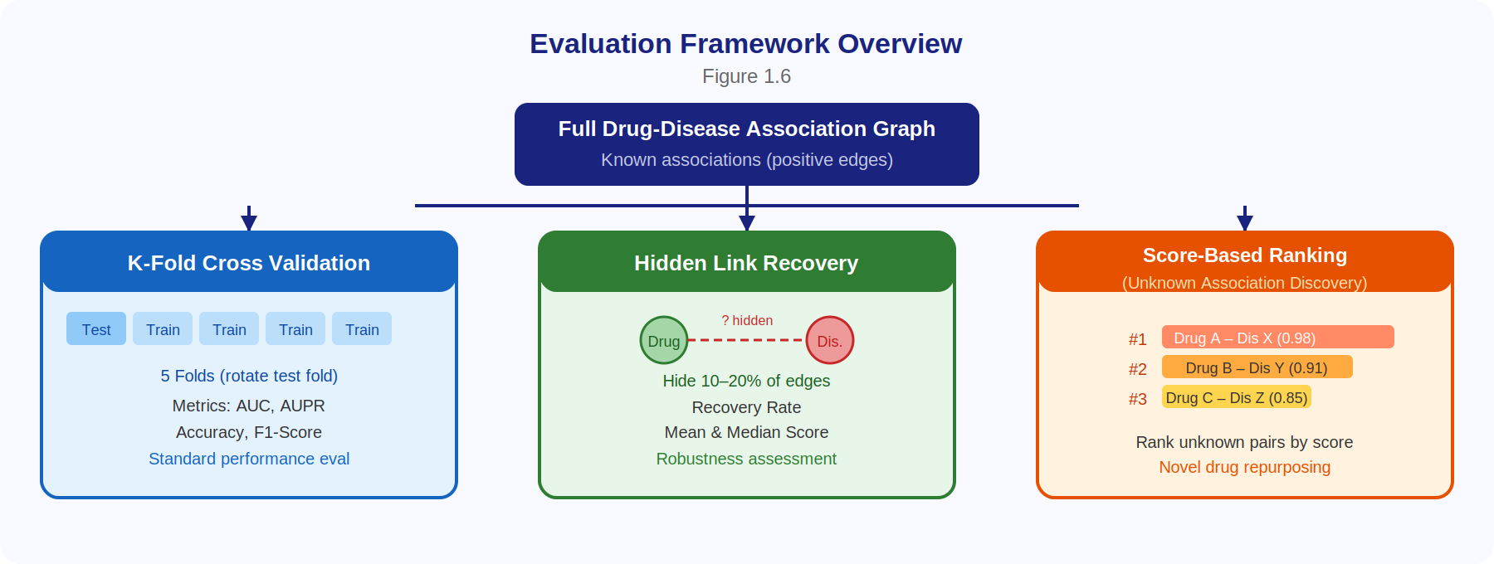
Figure 1.2:Evaluation Framewok overview Diagram
  - A list of contributions with short descriptions
1. Successful Reproduction of the Published Baseline Framework
Successfully reproduced the published baseline framework and verified the reported results to ensure correctness and consistency.
2. Enhanced Drug Representation through Additional Information Sources
Introduced improvements by integrating additional drug representation methods, including Morgan Fingerprints and ChemBERT embeddings, which capture chemical properties of drugs rather than relying only on textual descriptions.
3. Development of a New GAT-Based Model
Developed a new model based on Graph Attention Networks (GAT) as an alternative to the baseline GCN model. The proposed model improves the way importance is assigned to relationships by giving stronger connections higher weights during training instead of treating all relationships equally as in the baseline model.
4. Design of a Comprehensive Evaluation Framework
Designed a two-part evaluation framework. The first part measures the model’s ability to predict new associations that were not seen during training. The second part evaluates the validity of the predicted associations after training by verifying them against evidence from published research.

  - high-level figure of solution describing the main components of the system/solution and the basic interactions between them.

Figure 1.3 illustrates the main components of the system and their interactions. The pipeline flows from left to right through five stages: data input, feature generation, graph construction, GNN model, and evaluation. The feature generation stage is where the new molecular feature types (Morgan FP and ChemBERTa) are introduced as alternatives to the baseline text embeddings. The GNN model stage shows both the baseline GCN and the new GAT encoder as parallel options. The evaluation stage shows the three protocols: standard K-fold CV (baseline), hidden-link recovery (addition), and ranked-candidate scoring (addition).

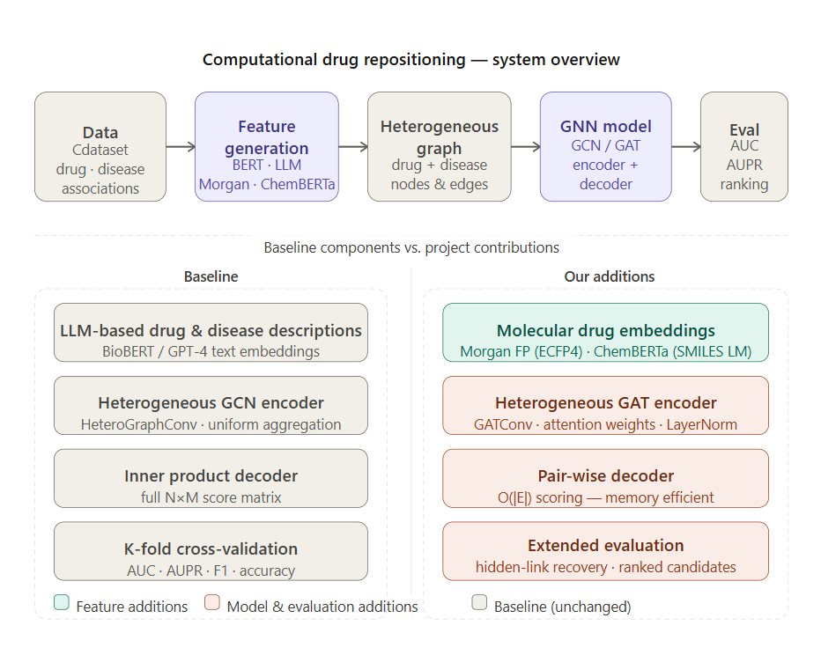
Figure 1.3 :High-Level Architecture of the Proposed Drug Repurposing Framework

The five main stages and their connections are described in detail in Chapter 3 (Design) and Chapter 4 (Implementation). The detailed technical architecture diagram covering all sub-components, code files, and inter-component data flows .

  - Summary of report structure.
This report is organized into eight chapters:
Chapter Name | Description
Chapter 1: Introduction | introduces the problem of drug–disease association prediction and presents the objectives, contributions, proposed solution, and evaluation methodology of the project.
Chapter 2 :Background | provides the necessary background on drug repurposing, discusses the importance of the problem, identifies the target stakeholders, and reviews existing approaches used in the literature.
Chapter 3: Design | presents the design of the proposed framework, including the overall system architecture, design decisions, workflow, constraints, and alternative design considerations.
Chapter 4 :Implementation | describes the implementation details of the project, including the datasets, software tools, libraries, computational environment, and model development process.
Chapter 5 :Results and Discussion | presents the experimental results and provides a detailed discussion and analysis of the obtained performance compared with the baseline framework.
Chapter 6 :Economical, Ethic, and Contemporary Issues | discusses the economic, ethical, environmental, and societal aspects related to the proposed solution and its potential impact.
Chapter 7: Project Management | describes the project management activities, including scheduling, resource allocation, risk management, quality assurance, and project planning.
Chapter 8 :Conclusion and Future Work | summarizes the main findings and contributions of the project, discusses its limitations, and outlines directions for future work.

Table 1.1Report Structure Summary

Chapter 2: Background
  - background of the problem(relevant literature research).
Developing a completely new drug from scratch is one of the most expensive and time-consuming efforts in modern science. On average, bringing a single new drug to the market takes more than a decade of research and testing, with an estimated cost of about 2.6 billion USD [1]. The process starts in the laboratory, where thousands of chemical compounds are screened as potential candidates. Only a small number of promising compounds then enter a long series of preclinical tests, followed by multiple stages of clinical trials on human volunteers, before regulatory authorities can approve them for public use.
Despite these huge investments of time and money, the success rate remains very low. Studies show that fewer than one in ten drug candidates entering clinical trials eventually receive regulatory approval [2]. Most failures happen due to unexpected toxicity, lack of effectiveness in humans, or major manufacturing challenges that only become clear late in the development process, after hundreds of millions of dollars have already been spent. Because of this, the pharmaceutical industry continues to face a constant challenge of finding faster, cheaper, and more reliable ways to deliver effective treatments to patients.
2.1.2 Drug Repurposing
Drug repurposing is one of the most promising solutions to this challenge. Instead of creating new compounds from scratch, drug repurposing asks a simpler question: can an already approved drug, which is used for treating one disease, also be effective for another disease? Since repurposed drugs have already passed important safety and toxicity tests required for human use, the development time can be significantly reduced, and the associated costs can be greatly lowered [3].
2.1.3 Problem Definition: Predicting Drug–Disease Associations
Although the idea of drug repurposing is simple, identifying which existing drugs may be effective against specific diseases is not easy. The human body operates through highly complex networks of biological interactions, and the relationship between a drug molecule and a disease is rarely simple or direct. There are currently thousands of approved drugs and thousands of known diseases, which means the number of possible drug–disease pairs that would require experimental testing is extremely large. Performing laboratory or clinical experiments for each pair is neither practical nor economically feasible.This creates a clear computational challenge: given the huge number of possible drug–disease pairs, can we build a system that intelligently predicts which pairs are likely to represent real therapeutic associations?
Several computational approaches have been proposed in this field. Although these methods are important, they still have clear limitations. They often rely on predefined and manually designed features to represent drugs and diseases, which does not fully reflect the true complexity of biological systems. In addition, similarity measures such as chemical fingerprints, genetic data, or ontology terms only provide a partial view. Most importantly, these models treat drugs and diseases as separate entities, without fully considering the complex relationships between them.
In reality, drugs interact with proteins, proteins are linked to biological pathways, and these pathways influence gene expression, which in turn affects disease conditions. Therefore, modeling these complex relationships requires a more advanced framework that can represent both the entities and their relationships at the same time, not only their individual properties.

  - some context about the problem, why it is important and where it is used .
Computational drug repurposing is not just a technical application of machine learning, but a direct response to deep scientific, economic, and human challenges in healthcare. To understand the motivation behind this field, it is necessary to clarify its multi-dimensional importance, as well as review its real-world applications in biomedical practice.
From a scientific perspective, computational methods contribute to accelerating the transformation of biomedical knowledge into testable therapeutic hypotheses. Instead of relying on intensive manual reading of literature, these methods enable the analysis of large amounts of data and the discovery of hidden patterns and relationships between drugs and diseases. Thus, every computationally predicted link becomes a scientific hypothesis that can be experimentally validated, which reduces the time between discovery and clinical testing.
From an economic perspective, drug repurposing is a more efficient option compared to developing new drugs from scratch, which requires huge financial investments and long time periods, along with high failure rates. In contrast, using already approved drugs allows significant cost reduction, since safety testing stages can be bypassed or shortened, which helps accelerate the development process. This, in turn, increases investment opportunities in therapeutic areas that may not be economically viable under traditional drug development models.
From the human perspective, the importance of drug repurposing appears in meeting the needs of groups that often do not receive enough attention, such as patients with rare or neglected diseases, as well as diseases common in low-income countries, in addition to emerging infectious diseases that require rapid therapeutic response. Although these conditions have a large impact on many patients worldwide, the weak expected economic return limits investment in developing new treatments for them. In this context, drug repurposing provides a more practical and efficient pathway, enabling the development of effective treatments at lower cost and in shorter time, especially given the limitations of traditional approaches, which are slow and expensive, reducing their ability to respond to urgent healthcare needs.
The impact of drug repurposing extends to several fields:
Oncology (cancer):
Computational methods are used to discover drugs that were not originally designed to treat cancer but may have anti-tumor effects, which expands therapeutic options, especially in difficult cases.
Neurological and degenerative diseases:
Such as Alzheimer’s and Parkinson’s, where these diseases are complex and difficult to treat. Drug repurposing provides an alternative approach based on understanding biological mechanisms and selecting drugs that may match them.
Infectious diseases:
These methods enable rapid response to epidemics by identifying existing drugs that can be used against new pathogens, in addition to supporting the treatment of neglected tropical diseases.
Drug repurposing is not limited to finding general treatments, but also extends to supporting the concept of precision and personalized medicine, which aims to tailor treatment for each patient based on their individual characteristics. By integrating genomic and clinical data, computational models can identify patients who are most likely to respond to a specific treatment, improving clinical trial design and increasing their success rates, especially in rare diseases where patient numbers are limited.
Medical history is full of many examples showing that some drugs achieved their greatest effects through uses that were not intended during their development, but were discovered through unexpected observations. These cases highlight an important scientific principle, which is that the biological activity of a drug is often not limited to a single therapeutic context. Although these examples are important in illustrating the concept of drug repurposing, they also reveal the limitations of relying on observation and chance, which pushes toward more structured and systematic computational approaches, forming the foundation of this field.
One of the most prominent examples is thalidomide, which is considered one of the most controversial cases in medical history. It was introduced as a sedative and antiemetic to treat morning sickness in pregnant women, but it was withdrawn from the market after being found to cause severe birth defects, especially in the limbs of fetuses. It was later found that its immunological and anti-angiogenic properties—which were responsible for its harmful effects—could also have therapeutic value in other contexts. Based on this, it was reintroduced under strict control to treat erythema nodosum leprosum, and it later became an effective treatment for multiple myeloma, a type of blood cancer. This case shows that biological properties that may be harmful in one context can become therapeutic benefits in another, which confirms the importance of a deep understanding of drug mechanisms.

  - Target market and their needs.
When we talk about drug repurposing, the benefit is not limited to researchers only, but it also extends to several parties working in the healthcare and pharmaceutical fields. The target market can be divided into four main groups, and each one needs computational tools that help them discover new uses for existing drugs.
First: Pharmaceutical and biotechnology companies
These companies represent the largest part of the market, as they account for more than 57% of the revenues in this field [2]. These companies are interested in repurposing because developing a new drug from scratch is very expensive [1][3]. Therefore, they need intelligent computational tools that help them screen their existing drugs and identify whether they can treat other diseases, which saves billions and reduces the risk of failure in clinical trials [1][4].
Second: Universities and research institutions
These are the ones who develop new ideas and methods, but they often do not have large budgets for laboratory experiments. Therefore, they need open-source tools that can run on regular computers using publicly available data (such as DrugBank and OMIM) to generate new ideas without high costs [3]. This direction is also supported by government funding, as the U.S. National Institutes of Health (NIH) has allocated increasing amounts for this purpose, from 8.2 million dollars in 2022 to expected funding reaching 2.5 billion dollars by 2025 [1].
Third: Contract Research Organizations (CROs)
These organizations conduct clinical trials on behalf of companies, and they are the fastest-growing segment in this field [2]. They need accurate computational models that help them select the best drug candidates for trials, especially in rare diseases that have no approved treatments [3][4][5].
Fourth: Hospitals and doctors
Doctors in hospitals need decision support systems that help them suggest alternative drugs for patients who do not respond to traditional treatments. The U.S. Food and Drug Administration (FDA) facilitates this through a special pathway (called 505(b)(2)), which reduces drug approval time by up to 60% because the drug’s safety is already established [1]. However, doctors still need reliable computational evidence that shows the drug is effective for the new disease before prescribing it.
Common need
All of these groups share the need for fast and accurate computational tools that can integrate information from different sources—such as drug chemical structures, genes, and published research—to predict new drug–disease relationships. This is the main motivation behind developing systems such as LLM-DDA, which combine artificial intelligence and graph neural networks.

  - Potential ethical and/or environmental issues.
When using artificial intelligence in drug repurposing, there are ethical and environmental challenges that must be considered to ensure responsible work and to maintain trust from patients and society.
Data privacy and security
Computational drug discovery systems rely on sensitive health data, chemical structures, and clinical trial results. This data is highly valuable and vulnerable to cyberattacks. Recent statistics show that a large number of institutions leave their sensitive data exposed to AI tools, and AI-related security incidents are continuously increasing, while only a small percentage of pharmaceutical organizations have implemented effective automated protection systems [1]. This creates a direct risk to patient confidentiality and to the intellectual property of research.
Algorithm bias
Artificial intelligence models may be trained on data that is not fully representative of the population. In clinical trials and preclinical studies, historically only limited groups in terms of age, race, and gender are overrepresented, which leads to a lack of diversity in the data. This limitation can produce computational models that give less accurate results for certain population groups, which may reduce the effectiveness of proposed drugs for them or exclude them from suitable treatments [2].
Reliability of large language models
Large language models used to extract biomedical knowledge may produce incorrect yet realistic and specialized information, a phenomenon known as hallucination. In the medical context, such misleading information is dangerous because it may lead to incorrect treatment suggestions or wrong interpretations of diseases. Recent studies show that hallucination rates in medical cases remain high even in the most advanced models, which requires human verification mechanisms and error-detection strategies before making any clinical decision [3][4].
Accountability and responsibility
When a computational system provides an incorrect drug recommendation for a disease, legal responsibility becomes unclear. It is not well defined whether responsibility lies with the system developer, the doctor who followed the recommendation, or the institution that implemented the system. The lack of a clear legal and regulatory framework reduces trust in these tools and complicates their integration into medical practice [5].
Environmental impact
On the negative side, training large artificial intelligence models requires massive energy consumption to power servers and cooling systems, which raises real environmental concerns regarding sustainability [5]. On the positive side, computational methods significantly reduce the need for failed laboratory experiments and animal testing, which lowers chemical waste and reduces the environmental impact of traditional research.

  - different approaches currently/previously used to solve the problem
Over the past two decades, the major development of large-scale biomedical databases, together with advances in computational analysis methods, has helped establish the foundation of a new approach in this field, which is data-driven computational drug repurposing. Instead of relying on observations followed by laboratory and clinical experiments, this approach depends on a comprehensive and systematic analysis of the relationships between drugs and diseases using algorithms capable of discovering patterns and associations that are difficult to notice manually. This field has gone through several stages and developments, where each stage came to address the limitations of the previous stage.
- Machine Learning
In this stage, a predictive model is built based on previously known data about drugs and diseases. Each drug is represented by a set of chemical and physical properties, while diseases are represented by related features such as genetic information or biological indicators.The model then analyzes these features together to try to discover patterns that link drugs and diseases. For example, if some features frequently appear in successful drugs for treating a specific disease, the model learns to consider these features as indicators that help it predict the effectiveness of new drugs for the same disease.
After training, an unknown drug can be input, and the model gives a prediction score that indicates the likelihood that this drug is effective against a certain disease. This method depends heavily on manual feature selection, which requires specialized knowledge in biochemistry. It may also not work well when data is limited or imbalanced, because it often relies on simple relationships and does not fully represent complex biological interactions.
2.Matrix Factorization stage (Matrix Factorization)
This method is based on building a matrix that represents the relationship between drugs and diseases, where each row represents a drug and each column represents a disease. The values inside the matrix indicate a known relationship (a drug treats a disease), no relationship, or an unknown relationship.
The goal here is to “complete” the missing values in this matrix by decomposing it into latent representations. That is, each drug and each disease is transformed into a small vector that represents indirect features that do not appear in the original data, and then these representations are used to estimate the strength of the relationship between any drug and disease.The main idea is that drugs that behave similarly toward certain diseases will have close latent representations, and the same applies to similar diseases.
This method depends greatly on the quality of the data in the matrix. If the data is incomplete or contains noise, the results become less accurate. It also does not directly use external chemical or biological information, but relies only on recorded relationships between drugs and diseases, which makes the biological interpretation of the results limited.
3.Deep Learning
In this stage, neural networks are used that are capable of learning from several types of data at the same time. Instead of relying on manually defined features.This data passes through several layers of the neural network, where it is gradually transformed into more complex numerical representations. In the early layers, simple information is captured, while in the deeper layers more complex relationships are recognized.
In the end, representations are produced for each drug and each disease, and they can be used to predict new relationships between them. These models usually need a large amount of data to work efficiently, and they require high computational resources. In addition, they are considered less interpretable compared to traditional methods, because the decisions they make depend on complex internal operations inside the network that are difficult to trace directly.
4.Graph Neural Networks
Graph Neural Networks (GNNs) are considered a major shift in drug repurposing, where they are used as a powerful computational tool to analyze large biological databases and identify new medical indications for approved drugs. This process is done by formulating the problem as link prediction inside a heterogeneous and complex network, where nodes represent drugs and diseases while edges represent the complex interactions between them. The benefits of using GNNs appear in their strong ability to encode node features and graph structure together, which allows capturing non-linear biological relationships with high accuracy. They have also shown strong success in ranking potential treatments among the top results for many tested diseases, including COVID-19. However, this field faces technical limitations such as dependence on graph structure, so if the data contains missing links or noise (inaccurate data), this negatively affects prediction accuracy. When passing complex features through graph layers, the quality of this information may decrease because the graph focuses only on direct structural links, which may lead to losing deep patterns. In addition, traditional GNNs mainly rely on pairwise similarity features and ignore the large amount of biomedical knowledge available in textual sources.
5.Large Language Models
Large Language Models (LLMs) entered the field of drug repurposing to fill the gap between network data and the large amount of textual biomedical knowledge that traditional models ignored. The idea first started using models like GPT-4 as a direct query tool (DirectPred) through zero-shot or few-shot prompting by directly asking the model about the probability of a relationship between a drug and a disease based on its prior knowledge. However, results showed that direct querying has limitations in accuracy, which led to expanding the idea of using LLMs as a knowledge extractor; where it generates detailed textual descriptions including genes and biological pathways, then converts this text into numerical embeddings. These embeddings enabled models to represent drugs and diseases in a deeper way, combining semantic knowledge extracted from medical literature with the structure of biological networks, leading to a significant improvement in prediction accuracy and discovery of new therapeutic relationships.
  - Technical Background

This section provides an explanation of some of the field-related terms mentioned in the report to give the reader a broader background on the field.

2.6.1 Heterogeneous Graph Concept

A graph is a mathematical structure made up of nodes, which represent entities, and edges, which represent relationships between them. In the context of drug–disease association prediction (DDA), the graph is heterogeneous, meaning that it contains more than one type of node and edge [6]. Basically, the nodes represent drugs and diseases, and in some applications additional nodes may appear such as proteins, genes, and others depending on the nature of the use case. Edges between drug nodes or disease nodes indicate similarity between them. Edges between a drug node and a disease node represent a known therapeutic relationship. The model aims to predict missing edges between drugs and diseases that may indicate a potential therapeutic relationship.

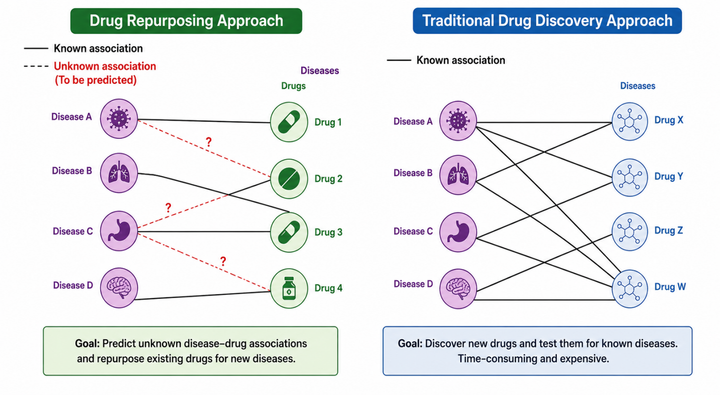
Figure 2.1: Heterogeneous Graph Structure for Drug–Disease Association Prediction in drug repurposing versus drug discovery

2.6.2 Graph Neural Networks (GNNs)

Graph Neural Networks (GNNs) are deep learning models designed to work with graph-structured data. GNNs learn by passing information between connected nodes across multiple stages. Each node in the graph is associated with a set of features, which can be numerical, categorical, or textual. Edges connecting nodes can also contain features such as weights or labels. In each layer of the network, a message-passing process occurs where each node aggregates the representations of its neighboring nodes, combines them with its own representation, and produces an updated representation that reflects its local network context [7]. After several rounds of message passing, each node obtains a final representation that is used in the last layer to produce the results.

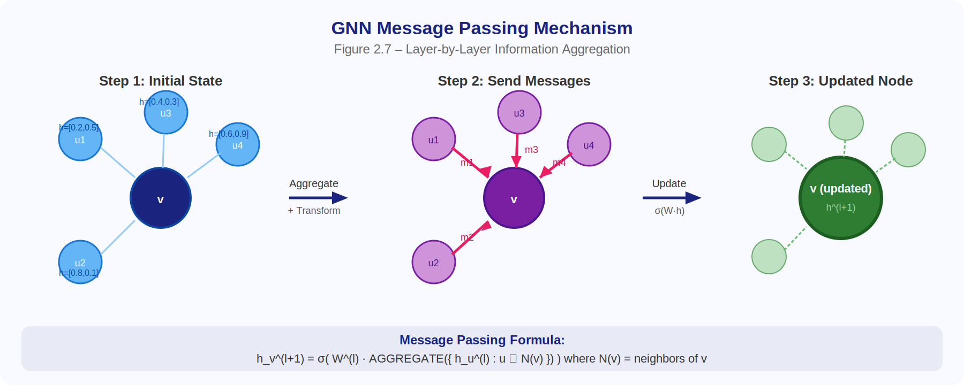

Figure 2.2: Message-Passing Mechanism in Graph Neural Networks (GNNs)

2.6.3Graph Convolutional Networks (GCNs)

Graph Convolutional Networks (GCNs) are a specialized and efficient application of the GNN concept. They are based on an improved version of convolutional neural networks (CNNs) adapted to work directly on graph-structured data that contains nodes and edges by combining node information with information from other connected nodes.From a scientific perspective, GCNs rely on a localized first-order approximation of spectral graph convolutions, a mathematical mechanism that allows the model to generate hidden representations that effectively combine node features and local graph structure at the same time. What makes this approach powerful is its high efficiency and scalability, as its computational complexity increases linearly with the number of edges in the graph. This makes it especially useful in semi-supervised learning tasks, where it excels at inferring unknown node labels by fully leveraging structural connections and available data.

2.6.4 Graph Attention Networks (GATs)

Graph Attention Networks (GATs) are an innovative neural architecture designed to address some limitations of previous models. GATs are mainly based on integrating self-attention mechanisms into graph data processing. While GCNs aggregate neighbor features using fixed or structure-based weights, GAT allows each node to assign different weights to each neighbor dynamically and implicitly.This is done by computing attention coefficients that represent the importance of neighboring node features relative to the target node. This enables the model to focus on the most relevant information within a node’s local neighborhood. To ensure stable learning, GAT uses multiple independent attention heads operating in parallel, and their outputs are then combined to produce the final representation, which improves the model’s expressive power.

2.6.5 Large Language Models (LLMs)

Large Language Models (LLMs) are advanced deep learning models designed to understand and generate human language. They have achieved outstanding performance in tasks such as machine translation, summarization, and question answering [56, 59]. Their strength comes from being trained on massive amounts of textual data (hundreds of gigabytes) collected from books and websites, allowing them to capture complex language patterns and general world knowledge.Unlike older models that processed language word by word in a sequential way—making them slow and limited in understanding long contexts—the Transformer architecture changed this concept through the self-attention mechanism. This allows the model to consider all words in a sentence at once and evaluate their importance relative to each other in parallel. As a result, these models do not only learn rules but also capture patterns and are capable of reasoning.

2.6.6 GPT (Generative Pre-trained Transformers)

GPT (Generative Pre-trained Transformers) represents a core architecture that relies exclusively on the decoder component of Transformers. GPT follows an autoregressive approach, where it predicts the next token based only on previous tokens. This means GPT works in a single direction only (left to right in English), predicting each word based on what came before it.This architecture has evolved significantly from GPT-2 to GPT-4, which supports multimodal inputs (text and images), greatly enhancing its ability for few-shot learning and even zero-shot learning, and enabling complex reasoning tasks. With the increase in parameters from millions to billions in GPT-3 and GPT-4, the model has moved from being a simple text completer to a system capable of solving mathematical problems, understanding images, and learning from very few examples.

2.6.7 Bidirectional Encoder Representations from Transformers(BERT )

BERT (Bidirectional Encoder Representations from Transformers) adopts a bidirectional approach to contextual understanding, processing both previous and next tokens simultaneously to capture deep contextual meaning.BERT is trained using two key strategies: Masked Language Modeling (MLM), where random tokens are hidden and the model learns to predict them from context, and Next Sentence Prediction (NSP), which ensures logical coherence between paragraphs. This design makes BERT highly effective in tasks requiring precise language understanding.

2.6.8 BioBERT

BioBERT is a domain-specific language model specialized in the biomedical field. It is a version of BERT that has been pre-trained and fine-tuned on biomedical texts and data. BioBERT significantly outperforms general-purpose language models in specialized tasks, achieving better results in biomedical question answering.It was developed to improve information extraction and text processing in medicine and life sciences, making it more effective than general models that may not fully understand complex medical terminology with the same level of accuracy.

2.6.9 ChemBERT

ChemBERT is a specialized model designed to handle chemical data. It treats chemical molecules as linguistic text by converting molecular structures into a textual format called SMILES. The model then “reads” and analyzes them in the same way BERT reads human sentences.ChemBERT was systematically trained on a large curated dataset of 77 million SMILES strings from the PubChem database, allowing it to capture complex chemical and molecular patterns. It uses Transformer architecture to predict molecular properties, which is essential in drug discovery and materials science. The model has shown strong efficiency and scalability proportional to the size of the training data.

2.6.10 SMILES

SMILES stands for Simplified Molecular Input Line Entry System. It is a system for representing molecular structures using short text strings. Its goal is to convert chemical structures from geometric forms into a simple linear format that computers can process easily.Each molecule is represented as a sequence of symbols and letters, where letters represent atoms and other symbols describe bonds and branches. Instead of dealing directly with complex molecular structures that look like interconnected graphs of atoms and bonds, SMILES simplifies them into a text-like representation.Once molecules are converted into SMILES format, it becomes possible to use Transformer architectures (such as ChemBERTa) to predict chemical properties.

2.6.11 Morgan Fingerprints

Chemical fingerprints, including Morgan fingerprints as one of the most common types, are the traditional standard method for representing molecules computationally. This technique converts a complex molecular structure into a fixed-length vector or a sequence of binary values (bits).Each bit in this vector represents the presence or absence of a specific structural pattern. The idea is to create a unique “digital fingerprint” that summarizes molecular features, allowing computational systems to compare molecules and predict their properties based on similarity.These fingerprints serve as a baseline that models like ChemBERTa aim to outperform. While fingerprints rely on fixed mathematical rules for feature extraction, ChemBERTa learns these features automatically from SMILES text.

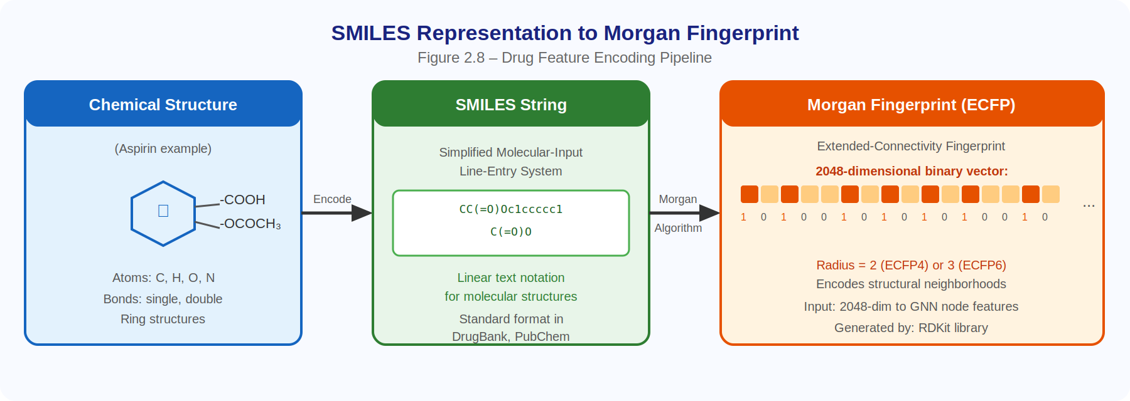
Figure 2.3 : How Chemical structure convert to SMILE and Morgan Fingerprint

2.6.12 Embedding
Embedding (or feature representation) is a mathematical process that converts raw data (such as words, graph nodes, or chemical molecules) into numerical vectors in a continuous space with defined dimensions. The main goal is to encode semantic and structural properties so that similar or related elements are represented by nearby vectors in this space.In graph neural networks, layers compute hidden representations for each node by considering its neighbors. After each layer, the node obtains an updated embedding, which is finally used to compute the association score between drugs and diseases.

2.6.13 Python

Python is a high-level, general-purpose programming language widely used in scientific computing, machine learning, data analysis, and artificial intelligence. It is known for its simple syntax, extensive ecosystem of libraries, and strong support from the research community. These characteristics have made Python the dominant programming language in modern biomedical informatics and drug discovery research.

In this project, Python serves as the primary development environment for implementing all stages of the drug repurposing pipeline. Data preprocessing and manipulation are performed using libraries such as Pandas and NumPy, while graph construction and graph neural network implementation rely on frameworks including PyTorch and PyTorch Geometric. Additional scientific and machine learning libraries are used for model training, evaluation, and result analysis.

The flexibility of Python allows seamless integration of heterogeneous biomedical data, graph-based learning techniques, and language-model-derived molecular representations within a unified computational framework. This capability makes Python particularly suitable for research-oriented applications that require rapid development, reproducibility, and scalability.

Chapter 3: Design
  - Design Overview:
This project is a computational system for drug repurposing, developed as an extension of a previously published baseline system presented in a research paper titled: “Enabling Graph Neural Network-Based Computational Drug Repurposing Using Knowledge Representations Inferred from Large Language Models.”

    - design of project to achieve the solution.
The baseline system proposes integrating a heterogeneous graph neural network with embeddings generated from large language model descriptions of drugs and diseases. The original system encodes prior biological knowledge as a heterogeneous graph and uses text-based embeddings derived from BioBERT or GPT to enrich node features before predicting drug–disease associations.
Our project builds on this foundation and extends it in three directions:
- Adding new molecular-level feature representations for drugs, including Morgan fingerprints and ChemBERTa embeddings derived from SMILES notation.
- Replacing the baseline Graph Convolutional Network (GCN) encoder with a Graph Attention Network (GAT) encoder.
- Introducing two complementary evaluation protocols—hidden link evaluation and ranked candidate scoring—that go beyond the standard K-fold cross-validation used in the baseline system.
The overall system consists of a sequential pipeline of four main stages: data and feature preparation, graph construction, model training, and evaluation. Each stage has clearly defined inputs and outputs, and the design choices are either directly inherited from the baseline system or represent carefully designed and well-documented extensions proposed in this project.
    - How plan to address the problem statement.
The main problem addressed by this project is the limited ability of existing computational drug repurposing systems to fully utilize all available drug information and to evaluate predictions in a way that is meaningful for real-world practical use. Specifically, three key gaps were identified in the baseline system:
1. The representation of drugs in the baseline model relies on ATC codes or LLM-generated textual descriptions. These representations do not include molecular-level structural information, which is a critical factor in how drugs interact with biological targets.
2. The GCN encoder treats all neighboring nodes equally, without distinguishing which neighbors are more informative for a specific drug or disease node.
3. The evaluation protocol (K-fold cross-validation) measures average performance but does not directly test whether the model can recover associations that were not seen during training, nor does it identify unknown associations that are worth experimental follow-up.
To address the first gap, two new types of drug features were introduced. Morgan fingerprints are computed directly from SMILES strings using RDKit, and they capture the cyclic topological structure of the molecule as a fixed-length binary vector. ChemBERTa embeddings, on the other hand, are generated by passing SMILES strings through a pre-trained chemical language model, producing continuous vector representations that encode learned chemical semantics. Both feature types are stored as precomputed embedding files and can be selected at runtime using the --feature_type argument, making them direct alternatives to the existing LLM and BERT-based embeddings in the baseline system.
To address the second gap, the GCN encoder in the baseline model was replaced with a heterogeneous Graph Attention Network (GAT). The GAT computes attention coefficients over each node’s neighborhood, allowing the model to assign higher weights to more relevant neighbors. This is particularly useful in heterogeneous biological graphs, where a drug node may be connected to many diseases, but only some of these connections carry strong predictive signals.
To address the third gap, two evaluation strategies were introduced. The first is hidden link evaluation, where a portion of known positive drug–disease associations is removed from the graph before training. After training, the model is evaluated on whether it assigns high scores to these hidden associations. The second is ranked candidate evaluation, where all drug–disease pairs predicted with high confidence but not present in any known dataset are collected and ranked, producing a prioritized list of potential associations for experimental validation.

    - Detailed figure of solution, interaction between the components ,and scenarios of use.
This section provide a detailed figure of solution, describing the interaction between the components in details and describe different scenarios of how the end users will use solution/system.
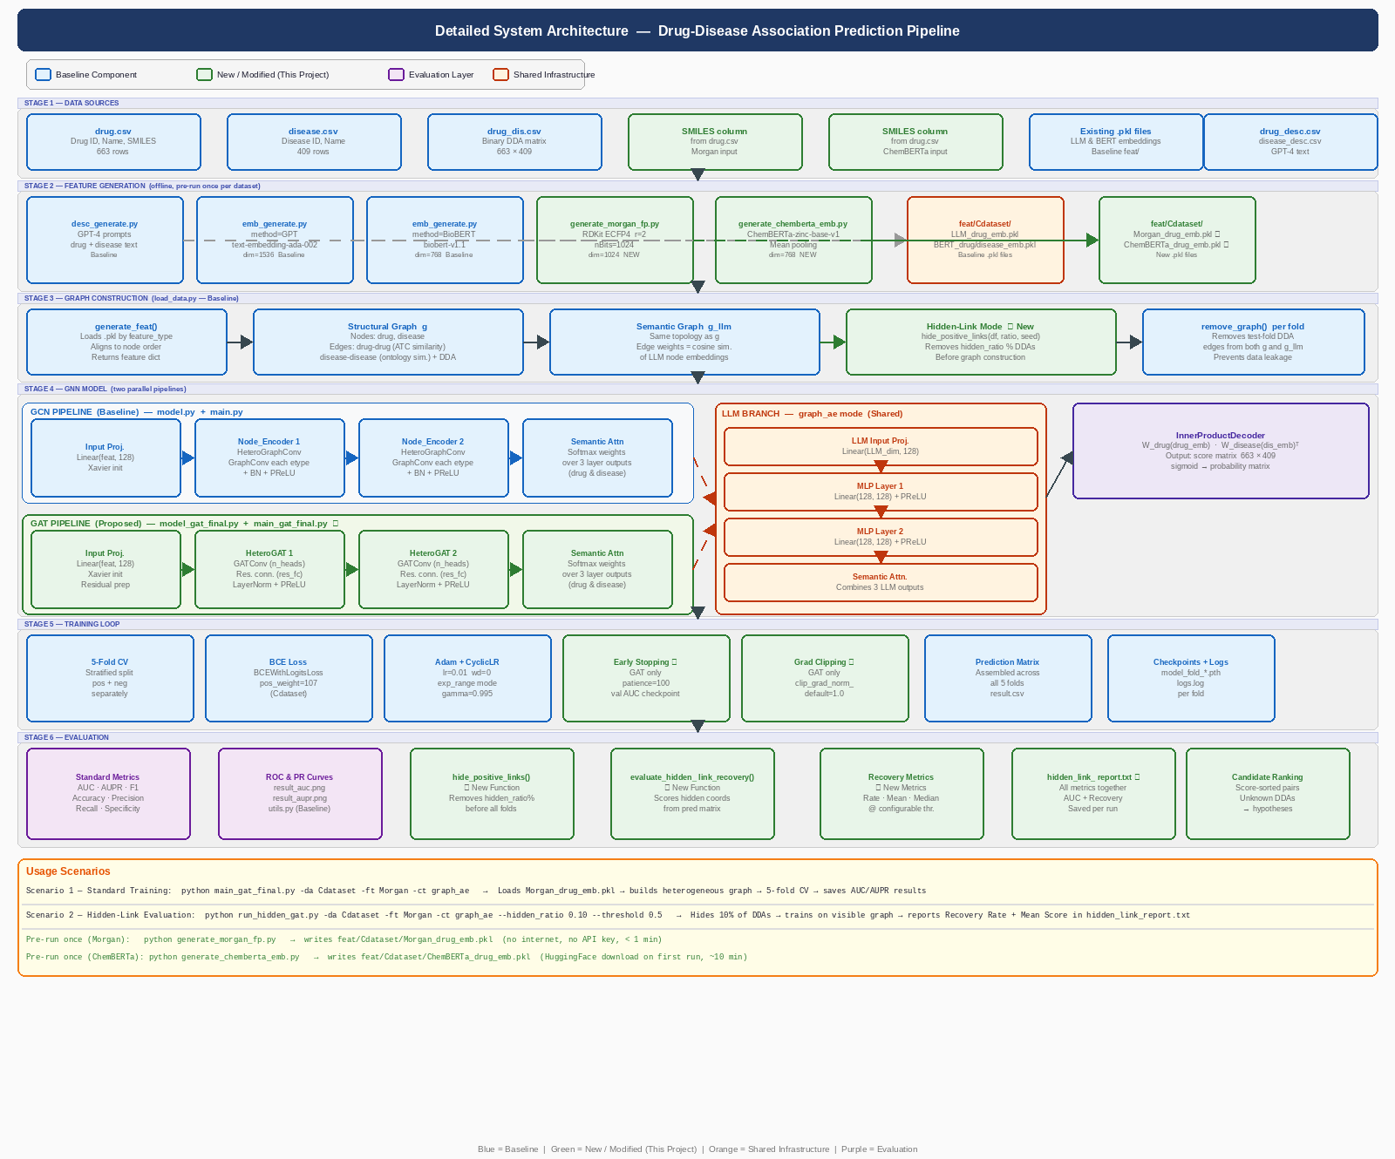
Figure 3.1: Detailed System Architecture and Pipeline Overview

Figure 3.1 illustrates the overall system architecture. The processing pipeline consists of six main sequential stages: data preparation, feature generation, graph construction, model training, evaluation, and output generation.
The data preparation stage involves reading the drug–disease association matrix from the Cdataset dataset, along with drug and disease metadata files. In the hidden link evaluation mode, a configurable percentage of positive associations is removed from the training graph during this stage.
The feature generation stage produces embedded representations for drug and disease nodes. Depending on the selected feature type (BERT, LLM, Morgan, or ChemBERTa), different embedding files are loaded or generated. For Morgan fingerprints and ChemBERTa embeddings, custom preprocessing scripts (generate_morgan_fp.py and generate_chemberta_emb.py) convert SMILES strings into embedding files stored in the feat/ directory. For BERT and LLM features, precomputed embeddings provided by the baseline model are used directly.
The graph construction stage builds a heterogeneous graph in DGL format. Two graphs are maintained: the main heterogeneous graph that captures structural relationships between drugs and diseases, drugs and drugs, and diseases and diseases, and a secondary LLM-based graph that uses cosine similarity between text embeddings to define edges. This dual-graph structure is inherited from the baseline system. When using the graph-ae architecture, which is adopted as the main extension throughout the project, the graph is constructed from structural information, while semantic embeddings are processed through an autoencoder acting as a parallel channel for text-based features. This autoencoder compresses and refines large LLM embeddings to extract the most important biological patterns, ensuring that deep semantic information is preserved and protected from noise or degradation that may occur when directly injected into graph layers. In the final step, a layer-attention mechanism fuses outputs from both the graph channel and the autoencoder channel to produce the final prediction with high accuracy.
Training is performed using a 5-fold cross-validation strategy to ensure stable and reliable results, where the dataset is split into different folds to test the model’s predictive ability across multiple data partitions. The process begins by encoding drug and disease features using GCN layers (or the improved GAT layers), which act as feature extractors that aggregate information from neighboring nodes to understand complex relational structures in the graph.
Next, a layer-wise semantic attention mechanism integrates outputs from different layers. This step allows the model to selectively focus on the most relevant information across multiple network hops, preventing loss of unique node-specific features and improving the quality of the final representation. An inner-product decoder is then used to compute compatibility scores between drug and disease embeddings, converting them into numerical probabilities of therapeutic association.
Finally, model performance is optimized using a weighted cross-entropy loss function. This is essential for addressing the major challenge in biomedical datasets, which is the severe imbalance between known positive associations and unknown or negative samples. This loss function ensures that the model places greater emphasis on correctly identifying true associations, thereby improving predictive accuracy and reducing bias introduced by data imbalance.

Usage Scenarios

1. Training Strategy Scenarios
- Standard Training (Standard CV): Based on the 5-fold cross-validation protocol.
- Hidden Link Evaluation Strategy: Also uses 5-fold cross-validation but first hides a defined ratio of known positive links before training.
2. Model and Architecture Configurations
The system supports 32 different experimental configurations, which result from combinations of the following components after selecting the training strategy:
- Model type: Choice between GCN or GAT
- Embedding types: Four options are available: BioBERT, LLM/GPT-4, Morgan Fingerprints, and ChemBERTa
- Fusion architectures: The system supports four fusion modes:
  - node_feat (direct feature integration)
  - dual_gnn (parallel channels)
  - graph_ae (autoencoder-based semantic channel)
  - none (structure-only model)
3. Terminal-Based Configuration
The system allows direct control of runtime parameters through the command line, enabling precise experimental setups such as:
- Setting number of training epochs (e.g., -ep 5000)
- Adjusting dropout rate (e.g., -dp 0.4)
In the hidden link strategy, additional parameters such as the threshold value and hidden ratio can also be configured. The dataset used in the project can also be replaced with alternative datasets.
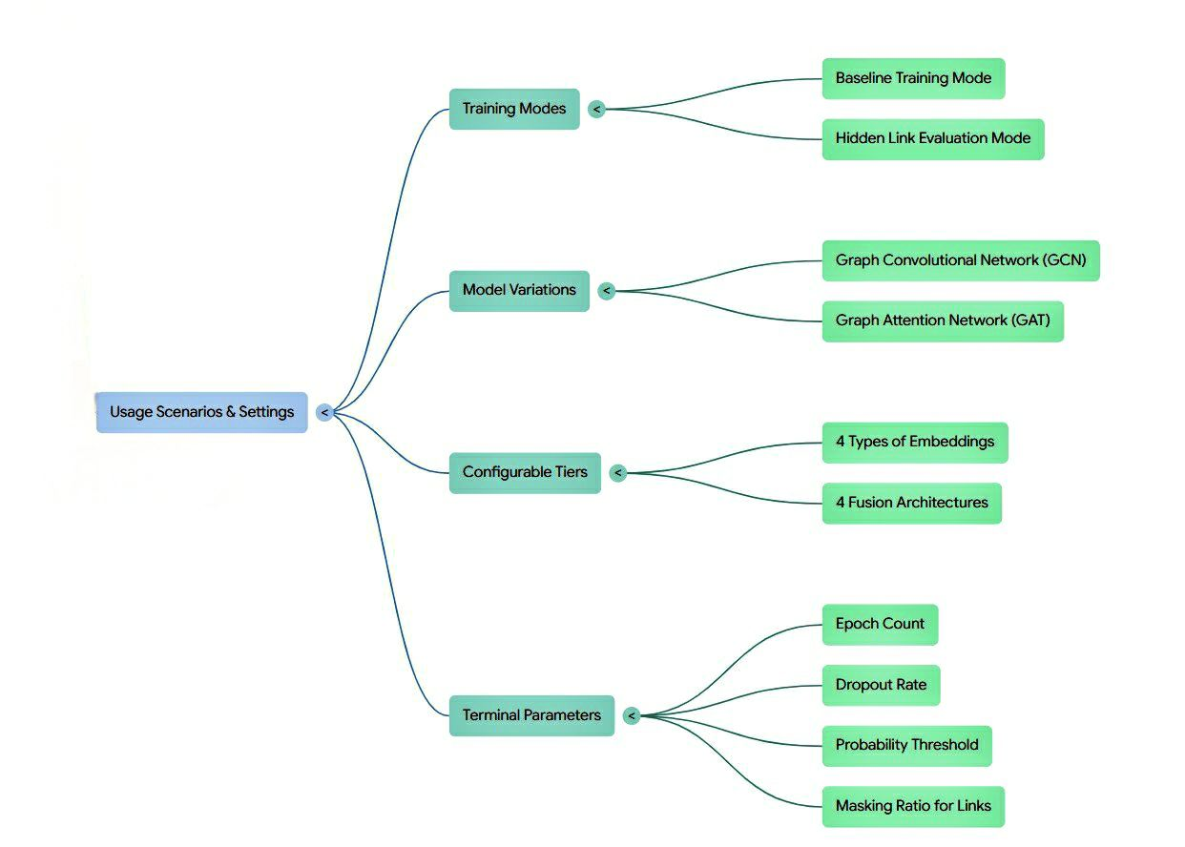
Figure 3.2:Diferent usage senarios for the system

  - Design Details:

    - Design Specifications
The system is a research-grade software pipeline, so the relevant specifications are computational and data-related rather than physical or ergonomic.

The project is organized into four top-level directories:

- codes/ — all Python scripts
- data/ — raw dataset files (Cdataset and others)
- feat/ — precomputed embedding files (.pkl format)
- Result/ — training results

This separation is intentional: embedding files are generated once and reused across all experiments without touching the training code. The result/ directory is created automatically at the start of each training run, with a unique path derived from the experiment configuration.

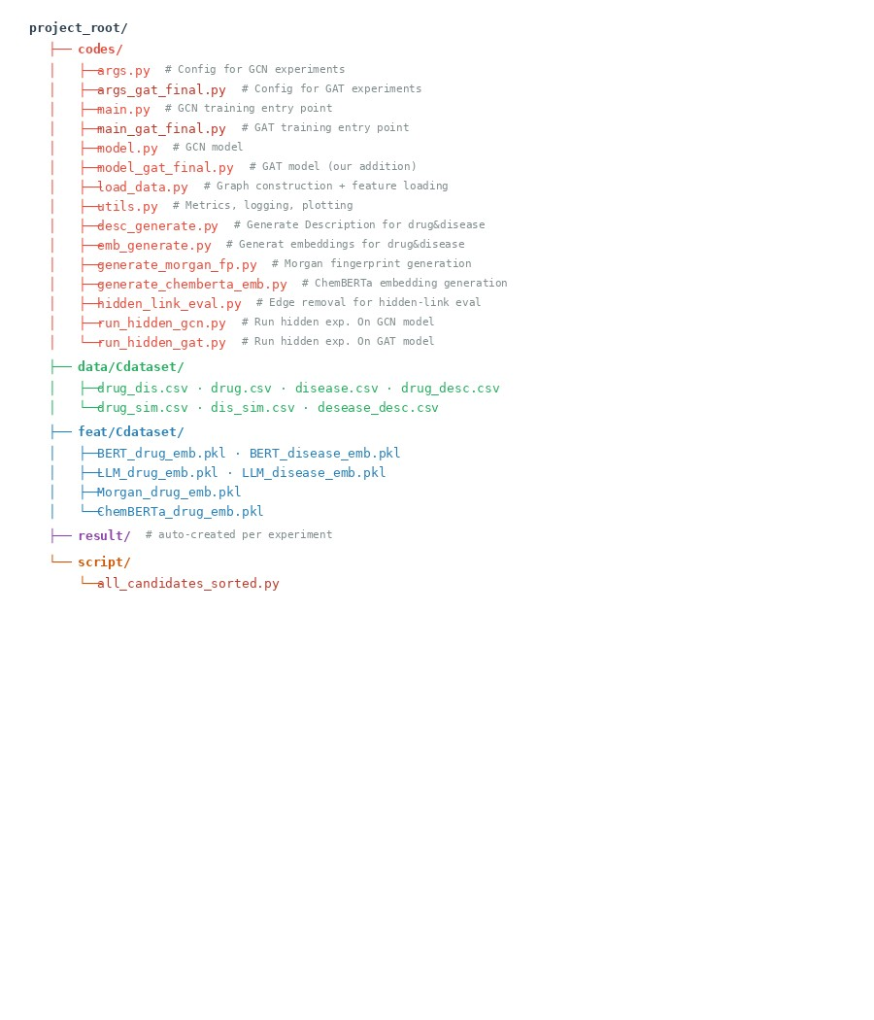
Figure 3.3:Project File Directory Structure
The previous figure3.3 represents the overall and adopted structure of the project files, which must be strictly followed when running any experiment. This is because file names and paths are embedded in the code in one way or another, meaning that any change in the file structure directly affects the experiments and results, and may even cause the system to fail completely during execution, which is something I personally encountered during the development process.
The purpose of this modular structure is not to increase the number of files, but rather to separate tasks and make the project clearer and easier to maintain and track, where each file performs a specific role within the system in a way that complements the other files.

    - Design Process

This section presents the detailed design of each component in the proposed drug-disease association prediction framework. Every component is described within the context of the overall system architecture, explaining its purpose, functionality, and integration points. Where a component extends an existing baseline method, the original approach is referenced and the specific additions are clearly identified.
- Feature Generation and Embedding Layer

The feature generation layer serves as the entry point of the system, converting raw drug and disease data into numerical embeddings that the graph neural network can process. The system supports multiple embedding types, and the selection is controlled through the --feature_type argument in the configuration files (args.py for GCN, args_gat_final.py for GAT).

Baseline Features (Inherited from the Published Framework)
The baseline framework provides two types of text-based embeddings generated from biomedical descriptions:
BERT:Biomedical text embeddings generated from drug and disease textual descriptions
LLM:Semantic embeddings capturing rich biomedical knowledge from LLM-generated paragraphs

How they are used in the system:
Drug descriptions are generated via GPT-4 prompts that request information about chemical structure, pharmacokinetics, toxicity, target proteins, indications, side effects, and clinical usage. Disease descriptions are generated similarly, requesting associated genes, biological pathways, treatment drugs, comorbidities, disease nature, symptoms, types, inheritance patterns, and diagnostic criteria. These descriptions are converted to embeddings using either BioBERT (for BERT features) or OpenAI's ada-002 model (for LLM features). During training, load_data.py loads these .pkl files and injects them as node features into the LLM branch of the heterogeneous graph.

Proposed Extensions: Morgan Fingerprints and ChemBERTa
The project extends the baseline by adding two chemical-structure-based embedding methods that operate directly on SMILES strings rather than generated text descriptions. These additions provide alternative drug representations that capture molecular information at different levels of abstraction.

1. Morgan Fingerprints
Morgan Fingerprints (also known as ECFP - Extended Connectivity Fingerprints) are a traditional computational chemistry method that converts a molecular structure into a fixed-length binary vector. Each bit in the vector indicates the presence or absence of a specific substructure pattern within the molecule.
How it was integrated into the system:
- Generation (generate_morgan_fp.py): Reads the drug.csv file containing SMILES strings for each drug in the dataset. Uses RDKit's AllChem.GetMorganFingerprintAsBitVect() function with radius=2 (equivalent to ECFP4) and 1024 bits. Produces a dictionary mapping each DrugBank ID to its 1024-bit fingerprint vector. Saves the result as feat/Cdataset/Morgan_drug_emb.pkl for reuse across experiments.
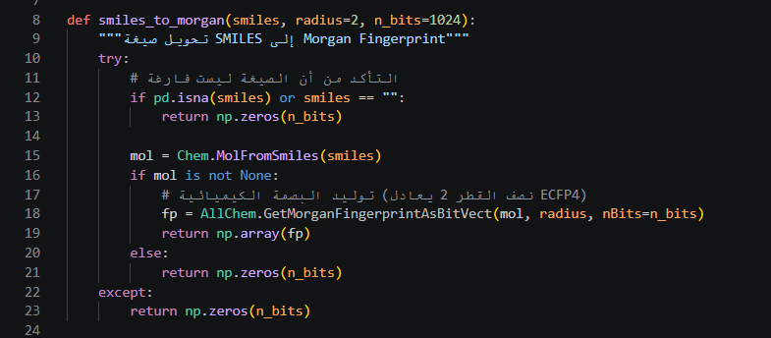
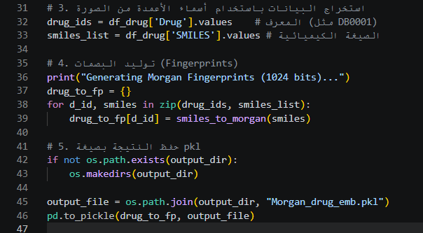
Figure 3.4:Morgan Fingerprint Generation Script (generate_morgan_fp.py)

- System Integration (load_data.py and args.py): args.py adds 'Morgan' to the feature_type choices list. When --feature_type Morgan is selected, args.dr_fingerprint is automatically set to True. In load_data.py, the generate_feat() function checks the args.dr_fingerprint flag. When True, it loads Morgan_drug_emb.pkl and concatenates the 1024-bit fingerprint with the structural similarity features. The drug_in_feats dimension is automatically set to 1024 to match the fingerprint size.

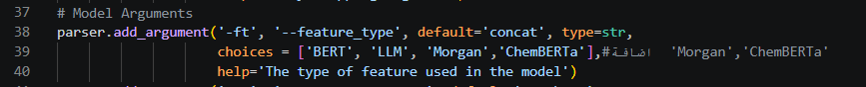
Figure 3.5args.py – Morgan Feature Type Integration

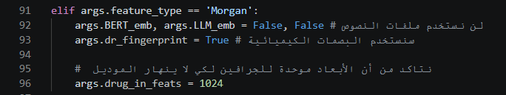
Figure 3.6Args Configuration for Morgan Fingerprint Settings

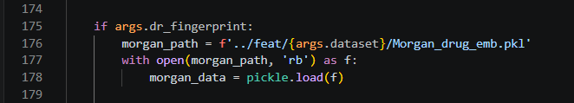
Figure 3.7load_data.py – Morgan Fingerprint Feature Loading
Load-data

- Role in Training: Morgan fingerprints serve as the drug_LLM feature in the dual-branch architecture. They provide a complementary signal to text-based embeddings: while BERT/LLM capture semantic and textual knowledge, Morgan fingerprints capture exact chemical substructure information derived directly from the molecular graph.

2.ChemBERTa Embeddings
ChemBERTa is a Transformer-based language model specifically pre-trained on 77 million SMILES strings from the PubChem database. Unlike Morgan fingerprints which use fixed mathematical rules, ChemBERTa learns chemical representations from data by treating SMILES strings as a language and applying self-attention mechanisms.
How it was integrated into the system:
- Generation (generate_chemberta_emb.py): Uses the HuggingFace model seyonec/ChemBERTa-zinc-base-v1. Tokenizes each SMILES string and passes it through the pre-trained model. Applies mean-pooling over the last hidden state to produce a single 768-dimensional vector per drug molecule. Saves the resulting dictionary as feat/Cdataset/ChemBERTa_drug_emb.pkl.
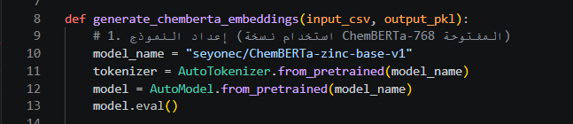
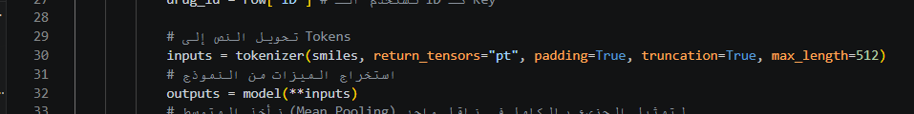
Figure 3.8ChemBERTa Embedding Generation Script (generate_chemberta_emb.py)

- System Integration (load_data.py and args_gat_final.py): args_gat_final.py adds 'ChemBERTa' to the feature_type choices. When selected, args.drug_in_feats is set to 768 to match the ChemBERTa output dimension. load_data.py loads ChemBERTa_drug_emb.pkl and uses these vectors as the drug features in the LLM branch. For diseases, BERT embeddings continue to be used.
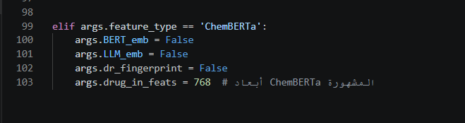
Figure 3.9 :args_gat_final.py – ChemBERTa Feature Type Integration

3. Role in Training: ChemBERTa provides a learned, context-aware chemical representation that captures patterns beyond predefined substructures. It offers a middle ground between the rigid rule-based Morgan fingerprints and the semantic (but potentially noisy) text-based LLM embeddings.
Feature Integration Architecture
The system supports four integration modes controlled by the --concatenate_type argument:

Mode | Description | How Features Are Combined
none | Uses only structural graph features without any LLM integration | Single GNN encoder branch
as_node | Concatenates LLM features directly to structural features as extended node attributes | Single branch with extended feature vectors
graph_graph | Constructs two separate graphs: structural and embedding-based similarity graphs | Two parallel GNN encoders with separate graphs
graph_ae | Uses structural graph for one branch and MLP autoencoder for LLM features on the other | GNN for structure, MLP for semantic features
Table 3.1:Feature Integration Architecture Modes (none / as_node / graph_graph / graph_ae)

Figure 3.10:args.py – Concatenate Type Selection

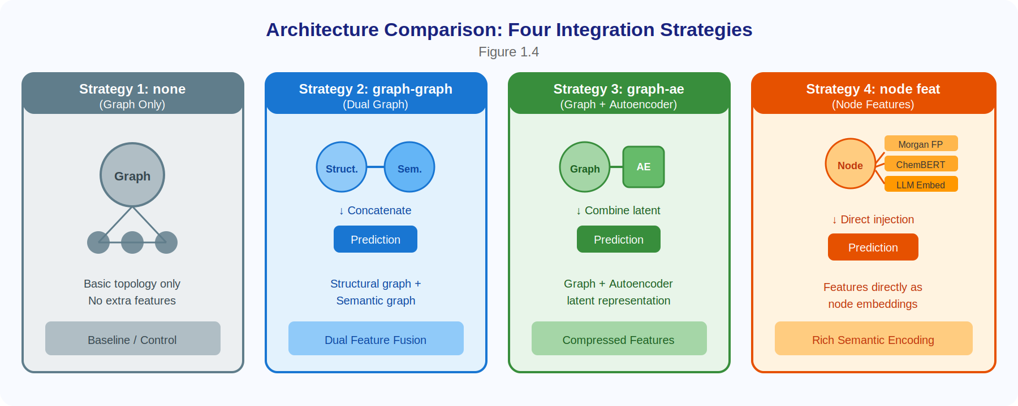
Figure 3.11:Architecture Comparision for Concatenatination Types

However, this project focuses on [graph_ae ] because it is the best architecture according to the baseline results, so we adopted it as our baseline.

2. Graph Construction Layer

1.Structural Graph (g)
The structural graph is built from three data sources provided in the dataset:
- drug_sim.csv: Drug-drug similarity matrix (e.g., Jaccard similarity over chemical structure or ATC codes)
- dis_sim.csv: Disease-disease similarity matrix (e.g., semantic similarity over MeSH or OMIM ontologies)
- drug_dis.csv: Known drug-disease associations (binary matrix)
Top-K Neighbor Selection: For each drug and each disease, only the top-15 most similar neighbors are retained as graph edges. This design decision serves three purposes: (1) reduces graph density and computational cost, (2) filters out weak or noisy similarity connections, and (3) creates a sparse but informative graph structure that focuses on the strongest biological relationships.

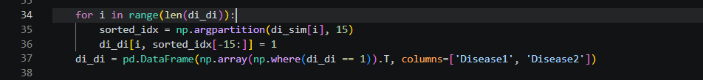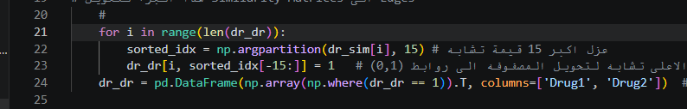
Figure 3.12: load_data.py – Structural Graph Construction (Top-K Selection)

Node Feature Initialization: The initial node features are constructed by horizontally stacking the similarity matrix with a zero matrix. Drug nodes receive [drug_sim | zeros(n_drugs, n_diseases)] and disease nodes receive [zeros(n_diseases, n_drugs) | dis_sim]. This ensures all nodes have the same feature dimension regardless of their type, which is required by the graph neural network layers.

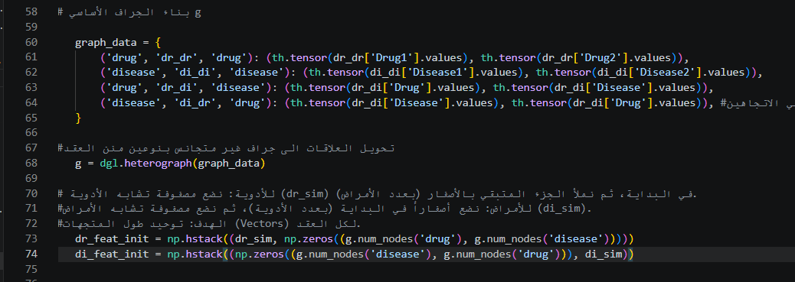
Figure 3.13: load_data.py – Structural Graph Node Feature Initialization

2.LLM Graph (g_llm)
When using BERT, LLM, Morgan, or ChemBERTa features, a second graph g_llm is constructed through the following process: (1) The selected embeddings are loaded for all drugs and diseases. (2) Pairwise cosine similarity is computed between all drug embeddings and between all disease embeddings. (3) Top-15 neighbor selection is applied to create sparse edges based on embedding similarity. (4) The same drug-disease association edges are used to connect the two node types.

Key Point: g_llm contains the same nodes as g but has different edge structures derived from embedding similarity rather than structural similarity. This allows the model to learn from two different views of the same biological network.
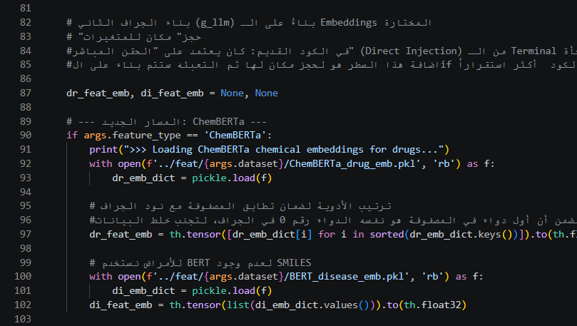
Figure 3.14:load_data.py – LLM Graph Construction
3.Hidden Link Handling
For the hidden link recovery experiment, load_data.py accepts an exclude_dr_di_edges parameter. When provided: the specified drug-disease edges are completely removed from both g and g_llm before training begins. The model cannot use these associations during message passing. This simulates a realistic scenario where some drug-disease relationships are genuinely unknown during the training phase.

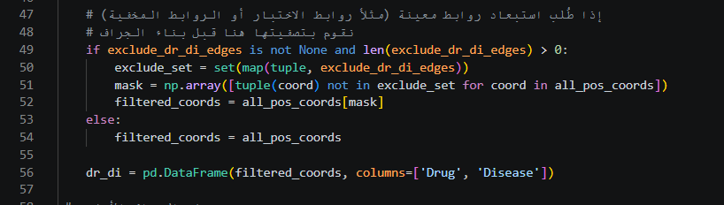
Figure 3.15:load_data.py – Hidden Link Removal from Graph

4. Graph Neural Network Encoder
1.Baseline Encoder: GCN (model.py)
The baseline model uses Graph Convolutional Networks (GCN) implemented through DGL's GraphConv layer:

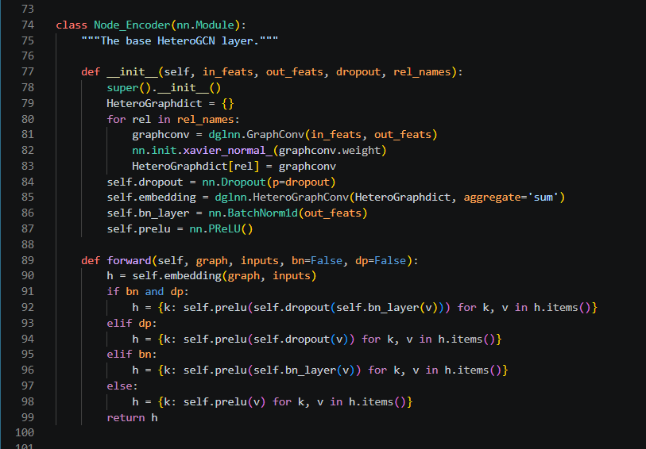
Figure 3.16:model.py – Baseline GCN Encoder Architecture

Architecture in the baseline:
- Two-layer GCN encoder for the structural branch
- Optional two-layer GCN (graph-graph) or MLP for the LLM branch (graph-ae) depending on concatenate_type
- Layer attention mechanism (SemanticAttention) to combine representations from different layers
- InnerProductDecoder for final association score prediction
2.Proposed Encoder: GAT (model_gat_final.py)
The project introduces Graph Attention Networks (GAT) as an alternative to GCN. GAT replaces the uniform aggregation of GCN with a learned attention mechanism that assigns different importance weights to different neighbors.
3. Key Differences: GCN versus GAT

Aspect | GCN (Baseline) | GAT (Proposed)
Neighbor Weighting | Fixed weights based on node degrees | Learned attention coefficients
Mechanism | Spectral graph convolution | Self-attention over local neighborhoods
Computational Complexity | O(|E|) linear in edges | O(|E|) with multi-head attention overhead
Training Stability | Generally more stable | Requires gradient clipping for stability
Parameter Count | Fewer parameters | More parameters due to attention heads
Table 3.2:GCN vs. GAT: Key Architectural Differences
4. GAT Layer Design (HeteroGATLayer)
The custom HeteroGATLayer is designed as follows:
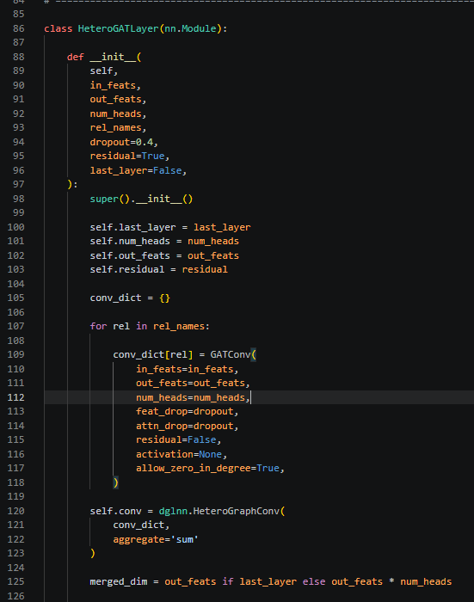
Figure 3.17:HeteroGATLayer Design and Architecture

Why LayerNorm instead of BatchNorm?
Biomedical graphs typically contain only hundreds of nodes. BatchNorm computes statistics across the batch dimension, which becomes unreliable with small graph sizes. LayerNorm normalizes across the feature dimensions independently for each node, making it more suitable for graph-structured data where the number of nodes varies.

Why Residual Connections? Deep GAT models can suffer from over-smoothing, where node representations become increasingly similar as more layers are applied. Residual connections preserve information from earlier layers and help gradients flow more effectively during backpropagation.

Multi-Head Attention: The default configuration uses 2 attention heads (num_heads=2 in args_gat_final.py). Each attention head learns a different set of attention patterns. Outputs are concatenated for intermediate layers or averaged for the final layer.
Attention Mechanism Mathematical Details

The GAT model learns to dynamically assign higher attention weights to neighbors that are more relevant for predicting drug-disease associations.Each drug and disease node starts with features of potentially different dimensions (depending on the feature type). A linear projection layer maps both to a shared hidden dimension (default 128). This is equivalent to the drug_linear and disease_linear layers in the baseline, and serves the same purpose: unifying dimensions before entering the graph encoder.

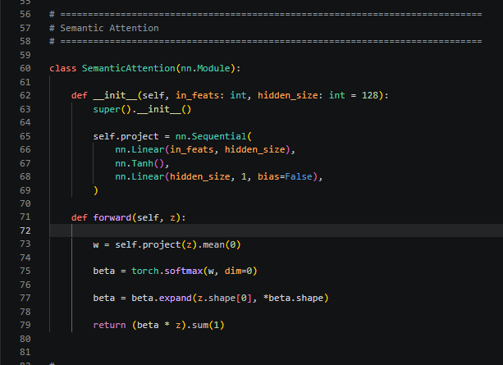
Figure 3.18:GAT Semantic Attention Mechanism
5. Dual-Branch Architecture

Both GCN and GAT models support the same dual-branch design pattern. The structural branch processes graph topology information while the LLM branch processes embedding-based similarity information. After encoding, a Layer Attention mechanism combines representations from all layers of both branches, allowing the model to automatically determine which layer contains the most predictive information.

Layer Attention : Collects embeddings from all layers of both branches (structural and LLM). Uses a learned attention mechanism to compute importance weights for each layer's representation. This allows the model to automatically determine which layer's representation contains the most predictive information for the final task.this layer present in both GCN and GAT models
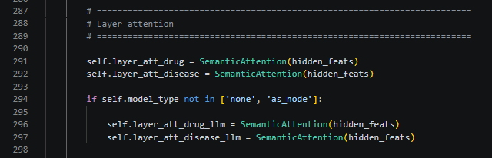
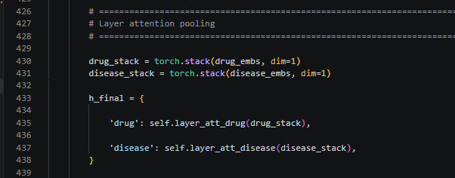
Figure 3.19:GAT Layer Attention – Layer Weights

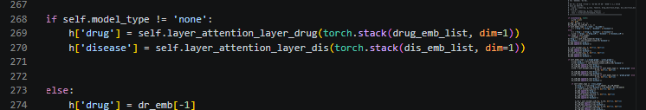
Figure 3.20 :GCN Layer Attention Code Implementation
- Decoder Design
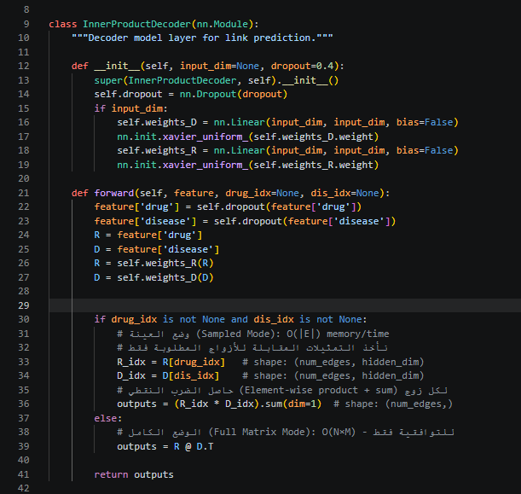
Figure 3.21:model.py – Bilinear Decoder for Drug–Disease Prediction

The implementation of the decoder in the code is based on a Bilinear Inner Product structure, which is the main component responsible for converting latent embeddings into a final prediction matrix for drug–disease associations.
The technical process starts by receiving the final numerical embeddings of drugs and diseases. These embeddings have already gone through multiple update steps and attention mechanisms to ensure that they include both structural and semantic information.
To achieve higher accuracy, the decoder does not simply multiply these embeddings in a basic way. Instead, it uses a trainable intermediate weight matrix (W), whose values are updated during the learning process. This matrix acts as an interaction map that allows the model to estimate the relative importance of each feature in the drug compared to each feature in the disease. This increases the flexibility of predicting complex relationships.
Mathematically, the decoder performs a matrix reconstruction process through matrix multiplication, producing predicted values for all possible interactions, including those missing in the original dataset.
In the final step, the output values are passed through a Sigmoid activation function to compress the results and keep them within a fixed probability range between 0 and 1. The resulting value represents the probability of a true therapeutic association.

7. Training Pipeline Design
1.Baseline Training (main.py)

The baseline training script follows a standard supervised learning protocol with k-fold cross-validation,For each fold in 5-Fold Cross-Validation:
- Split positive and negative pairs into train and test sets

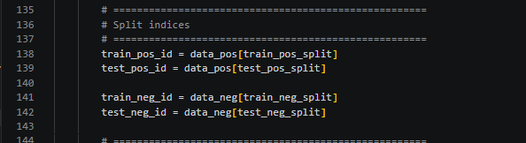
Figure 3.22:main.py – K-Fold Cross-Validation Data Split

- Remove test edges from the graph structure to prevent leakage
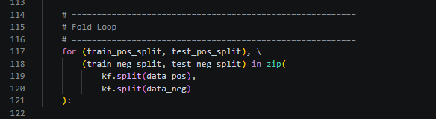
Figure 3.23:main.py – Test Edge Removal Before Training

- Generate node features based on selected embedding type

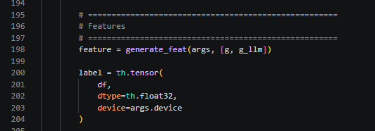-
Figure 3.24:main.py – Feature Generation for Each Fold

- For each training epoch: compute forward pass, calculate BCE loss on training pairs only, perform backpropagation and parameter update, evaluate on test set every 50 epochs
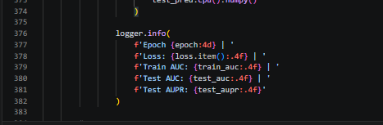
Figure 3.25:main.py – Training Epoch Forward Pass

- Store predictions for this fold

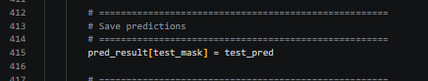
Figure 3.26:main.py – Store predictions for each fold

- After all folds complete, compute overall metrics (AUC, AUPR, F1, etc.)

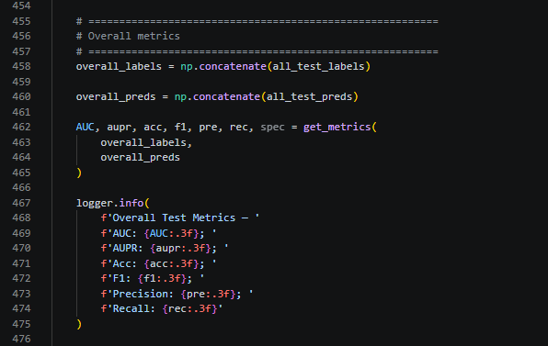
Figure 3.27:main.py –compute overall metrics for all Folds

Loss Function: Binary Cross-Entropy with Logits Loss (BCEWithLogitsLoss) with positive weighting to handle the severe class imbalance (there are far more negative/unknown pairs than known positive associations).
2. GAT Training (main_gat_final.py)
Training Loop Structure:
- train_one_epoch(): perform forward and backward passes on training mask

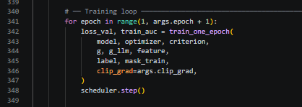
Figure 3.28:main_gat_final.py –Training Loop with Early Stopping

2.evaluate(): compute validation AUC on validation mask
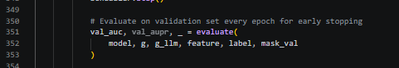
Figure 3.29:main_gat_final.py – GAT Training Loop with Validation AUC

3.If validation AUC improves: save checkpoint, reset patience counter. Else: increment patience counter

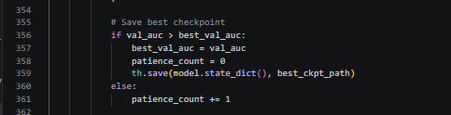
Figure 3.30: main_gat_final.py – Checkpoint Saving on Improvement

4.Every 50 epochs: evaluate on test mask for monitoring purposes

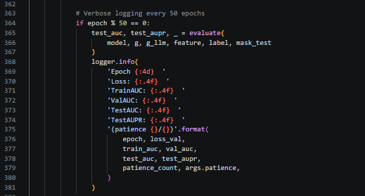
Figure 3.31:main_gat_final.py – Best Checkpoint Loading After Training

5.After training completes: load best checkpoint, evaluate on test mask

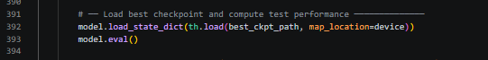
Figure 3.32:main_gat_final.py – Final Evaluation on Test Mask

3.Hidden Link Recovery Training (run_hidden_gcn.py and run_hidden_gat.py)

This is a specialized training protocol specifically designed to evaluate the model's ability to generalize to drug-disease associations that were completely unseen during training:

1.Load the complete DDA matrix from the dataset

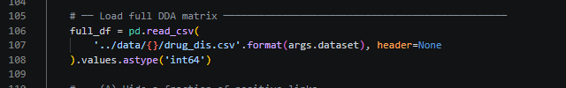
Figure 3.33:run_hidden_gcn.py – Loading the Full DDA Matrix

2.Randomly hide a configurable percentage of positive links (hidden_links)
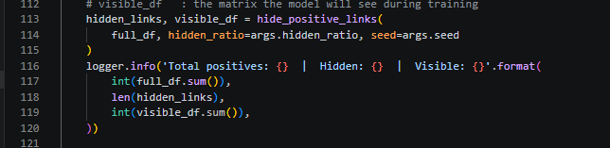
Figure 3.34:run_hidden_gcn.py – Hiding Positive Links from Training Graph

3.Build training data using only the remaining (visible) links
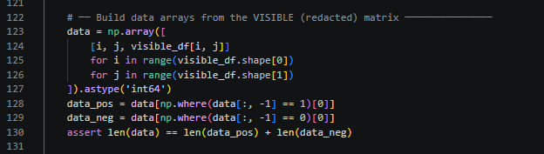
Figure 3.35:run_hidden_gcn.py –Build training data using visible links

4.Run standard k-fold cross-validation on the visible links
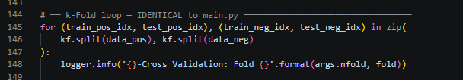
Figure 3.36:run_hidden_gcn.py – K-Fold Training on Visible Links

5.After all folds complete: evaluate the trained model on the hidden links, feed hidden drug-disease pairs through the trained model, compute recovery rate (fraction with score >= threshold), report mean and median scores on hidden links
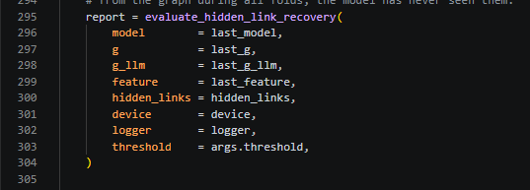
Figure 3.37:run_hidden_gcn.py – Hidden Link Recovery Rate Computation

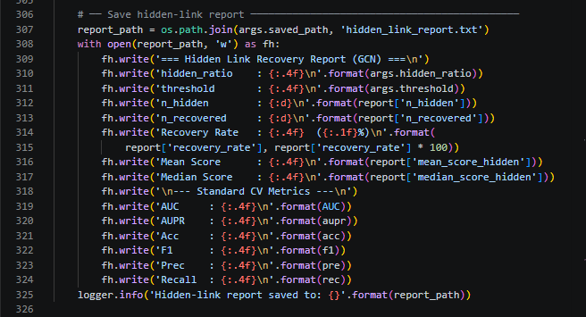
Figure 3.38:run_hidden_gcn.py – Reporting results

Key Design Decisions: Hidden links are completely removed from the graph structure (not merely masked), ensuring the model cannot use them during message passing. A fixed random seed ensures reproducibility across different experimental runs. The hidden ratio is configurable (default 10%) through the --hidden_ratio command-line argument.
Differences from Standard Cross-Validation:
Aspect | Standard Cross-Validation | Hidden Link Recovery
Test set composition | Random split of all positive and negative pairs | Held-out some positive links
Graph during training | Contains all edges except test fold edges | Missing hidden links entirely
Primary evaluation metric | AUC and AUPR on all test pairs | Recovery rate on hidden positive associations
Purpose | Measure overall predictive accuracy | Measure generalization to genuinely unseen associations
Table 3.3Comparison of Standard Cross-Validation vs. Hidden Link Recovery Protocol

4.. Candidate Ranking and Validation Module (all_candidates_sorted.py)
After training completes, the model produces a predicted score for every possible drug-disease pair. The candidate ranking module processes these scores through the following steps:

1.Loads the prediction matrix result.csv for (GCN) or result_gat.csv for (GAT)
2.Filters out all known positive associations (from drug_dis.csv) to focus only on novel predictions
3.Sorts the remaining unknown pairs by predicted score in descending order
4.Saves the ranked list as all_candidates_sorted.csv in the same results directory

Purpose: This module transforms raw model outputs into actionable research leads. The highest-scoring unknown pairs represent the most promising candidates for:
1.Literature validation - checking whether the association has been reported in published biomedical studies;
2. Experimental validation - in-vitro or in-vivo laboratory testing; and
3.Clinical investigation - for drugs that are already approved for other indications.

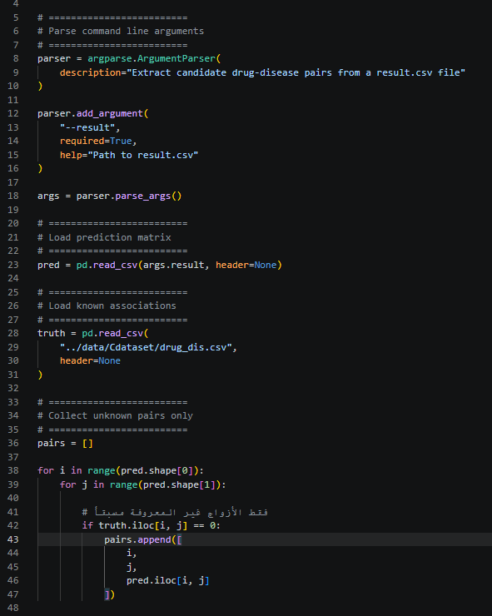
Figure 3.39:all_candidates_sorted.py – Drug Candidate Ranking Module

5.Argument Configuration System
.1 args.py (GCN Configuration)

The baseline configuration file controls the GCN model with the following key parameters: --feature_type selects the embedding type (BERT, LLM, Morgan, or ChemBERTa); --concatenate_type selects the feature integration architecture; --hidden_feats sets the hidden layer dimension (default: 128); --dropout sets the regularization rate (default: 0.4); and --learning_rate, --weight_decay, --epoch control standard training hyperparameters.
2 args_gat_final.py (GAT Configuration)

The GAT configuration file extends the baseline configuration with GAT-specific parameters: --num_heads sets the number of attention heads (default: 2); --clip_grad sets the gradient clipping threshold (default: 1.0); and --leak_safe_mode is an optional flag to recompute similarity matrices per fold for leakage prevention.

Design Rationale: Maintaining separate configuration files allows independent hyperparameter tuning for GCN and GAT models without interference. Both files share the same feature type definitions, ensuring consistent embedding selection across model variants.

    - Legal Aspects
This project is a research-oriented software system developed for academic purposes. All datasets used (Bdataset, Cdataset, Fdataset, and Rdataset) are publicly available from the authors of the original research paper and are used in accordance with the academic usage terms under which they were released.
All software libraries used are open source: PyTorch (BSD License), DGL (Apache 2.0 License), RDKit (BSD License), and HuggingFace Transformers (Apache 2.0 License). The ChemBERTa model weights are publicly available on HuggingFace under a permissive license for research use. The baseline source code, on which this project is built, is publicly available on GitHub (https://github.com/Somewhat120/LLM_DDA/tree/master) without any licensing restrictions that prevent its extension for research purposes.

    - Design Constraints
• Computational resources: Training the model on dataset C for 5000 epochs requires intensive computational resources on the CPU. This limits the number of configurations that can be explored within a realistic project timeframe.
• SMILES availability: Morgan and ChemBERTa embeddings require SMILES strings in the drug data file. Datasets that do not include SMILES (such as Bdataset) cannot use these features without additional data collection.
• Baseline compatibility: The GAT model and hidden link evaluator were designed to remain compatible with existing data formats in load_data.py and utils.py in order to allow direct comparison under identical conditions. This constraint limited the ability to experiment with alternative graph construction methods in order to preserve fair comparisons.
• Evaluation time: Hidden link evaluation requires running a full additional training cycle for each experiment, which doubles the computational cost compared to standard cross-validation.

    - Design Standards

Standard / Organization | Relevance
ISO/IEC 25010 | Software Quality Model
IEEE Software Engineering Standards | Software development practices
ACM Code of Ethics | Ethical use of AI and data
NIST AI Risk Management Framework | Responsible AI development
JSMO | Compliance with national standards in Jordan
Table 3.4Standards and Organizations Relevant to the Project
The proposed system was developed in accordance with internationally recognized standards for software quality and ethics.
The project follows software development principles recommended by the Institute of Electrical and Electronics Engineers (IEEE). These practices were applied throughout the stages of requirements analysis, system design, implementation, testing, and documentation. The structure of the final report and the software development process were organized according to standard software engineering methodologies to ensure consistency and traceability throughout the project lifecycle.
The system design was guided by the ISO/IEC 25010 software quality standard, which defines the main quality characteristics of software products, while the ethical aspects related to artificial intelligence and biomedical data analysis were guided by the ACM Code of Ethics and the National Institute of Standards and Technology (NIST) Artificial Intelligence Risk Management Framework.
By adhering to these standards, the proposed solution maintains academic credibility, software quality, and experimental reproducibility, while also supporting future extensions and further research development.

    - Design Alternatives
Several design decisions were evaluated during the development of this system, with different alternative choices considered for each component:
Morgan fingerprints vs. ECFP6 or MACCS keys:
Morgan fingerprints with a radius of 2 (ECFP4) were selected. A larger radius such as ECFP6 would capture a broader chemical context, but it increases feature sparsity. MACCS keys, on the other hand, are shorter (166 bits) and less expressive. ECFP4 with a 1024-bit representation is the most commonly used configuration in the literature and provides a balanced trade-off between expressiveness and dimensionality.
ChemBERTa vs. MolBERT or other molecular language models:
The ChemBERTa model (seyonec/ChemBERTa-zinc-base-v1) was chosen because it is publicly available on HuggingFace, uses a simple SMILES tokenizer, and produces 768-dimensional embeddings that are compatible with the BioBERT embeddings already used in the baseline system. Alternative models such as MolBERT or MolT5 require different tokenization pipelines and produce embeddings with different dimensionalities, which would require more extensive changes to the model pipeline.
GAT vs. Graph Transformer or HAN:
Graph Attention Network (GAT) was selected as an alternative to GCN because it introduces an attention mechanism over node neighborhoods without changing the overall encoder depth or the heterogeneous graph structure. More complex alternatives such as Graph Transformers or Heterogeneous Attention Networks (HAN) require major architectural changes and extensive hyperparameter tuning, which was beyond the scope of this project.
Hidden link ratio:
By default, 10% of positive edges are hidden. A higher ratio (e.g., 20%) would test more hidden links but would leave less training data, potentially weakening the model and making comparisons with standard cross-validation less reliable. Therefore, 10% was chosen as a conservative baseline setting.
Graph construction strategy:
The graph is constructed by creating edges based on the top 15 similarity scores between drugs and between diseases. This threshold was chosen to avoid graph overcrowding and noise. Increasing this threshold would allow more distant relationships to be captured, but these edges would have lower similarity scores and could introduce noise and excessive graph density, which was a concern also highlighted in the original baseline study.
窗体顶端

    - Safety Consideration
This is a research-based software project with no physical components; therefore, physical safety risks to the development team are not applicable.
From an end-user perspective, the most important safety consideration is that this system is a computational research tool and not a clinical decision-making system. The drug–disease association results produced by the model represent statistical patterns learned from training data and should not be interpreted as medical recommendations. Any association identified by the model as a potential drug repurposing candidate must undergo standard pharmaceutical validation (pre-clinical and clinical trials) before any medical application.
The domain-guided descriptions generated by the large language model (LLM), used in both BERT and LLM feature modes, are based on outputs from GPT-4 and may contain inaccuracies or outdated information. These descriptions are used solely as input features for the model and are not presented to users as factual medical information.

    - Design considerations table.
Design consideration | Project application | Relevant location in report
Performance | Heterogeneous GNNs and semantic embeddings were used to improve the accuracy of drug-disease association prediction. | Ch.1 -1.6.1  Ch.3 -3.2.1 / 3.2.3  Ch.5 -5.1.2 / 5.1.3 / 5.2.1  Ch.8- 8.2
serviceability | Modular architecture allows replacement of datasets, embeddings, and model components. | Ch.3 -3.1 /3.2.1 /3.2.4 /3.2.6  Ch.4 -4.2  Ch.5 -5.2  Ch.7 -7.3.1
Economic | Computational screening reduces the cost of early-stage drug discovery. | Ch.1 -1.1  Ch.2 -2.1.2 /2.2 /2.3  Ch.6 -6.1 /6.5  Ch.7 -7.2
Environmental | Computational prediction reduces laboratory experiments and material consumption. | Ch.6 -6.4
Environmental Sustainability | The software solution can be reused with new datasets without requiring additional physical resources. | Ch.6 -6.4 /6.5
Manufacturability | Not applicable since the project is software-based. | Ch.3 -3.4  Ch.6 -6.1
Ethical | Ethical considerations related to AI predictions and the use of biomedical data are addressed. | Ch.1 -1.3.2  Ch.2 -2.4  Ch.3 -3.5 /3.7  Ch.6 -6.2 /6.3 /6.5
Health and safety | The system supports researchers but does not replace clinical validation or medical decisions. | Ch.3 -3.7  Ch.6 -6.3 /6.5
Social | Accelerating the discovery of treatments and improving patient outcomes. | Ch.1 -1.1  Ch.2 -2.2  Ch.6 -6.5  Ch.8 -8.3
Political | The system relies primarily on publicly available international datasets and has no significant political constraints. | Ch.2 -2.3/2.4  Ch.3 -3.5  Ch.6 -6.5
Table 3.5Design Considerations Matrix with Project Application

Chapter 4: Implementation

This chapter describes how the system designed in Chapter 3 was actually built and run. Where the design chapter focused on what each component does and why it was chosen, this chapter focuses on how it was carried out — the tools and libraries used, the infrastructure the system depends on, the trade-offs encountered during implementation, and the assumptions that the code relies on to function correctly.

  - precise description of the methods and tools (hardware, software … etc.) used to implement solution.
4.1.1 Hardware Environment The implementation and evaluation of the proposed drug repurposing system were carried out using a personal computer. No specialized hardware, laboratory equipment, embedded devices, or external computational platforms were required during the development process. All tasks, including data preprocessing, heterogeneous graph construction, model training, performance evaluation, and result analysis, were executed locally on the personal workstation. Since the project is a software-based research solution, the personal computer provided sufficient computational resources to support all stages of development and experimentation.
4.1.2 Software Libraries and Frameworks
Library / Tool | Version | Purpose & Dependency Notes
Python | 3.8+ | Core language. All scripts are Python 3. f-strings and walrus operators require 3.8+.
PyTorch | 1.12+ | Tensor computation, autograd, model definition, Adam optimizer, BCEWithLogitsLoss, cyclic LR scheduler.
DGL (Deep Graph Library) | 0.9+ | Heterogeneous graph construction (dgl.heterograph), HeteroGraphConv, GATConv, GraphConv, remove_edges, edge_ids.
NumPy | 1.21+ | Array operations, argpartition for top-K neighbor selection, where for mask extraction, KFold splitting support.
Pandas | 1.3+ | Reading CSV files (drug_dis.csv, drug.csv, drug_sim.csv, dis_sim.csv), saving result.csv.
scikit-learn | 0.24+ | KFold, roc_auc_score, average_precision_score, precision_recall_curve, roc_curve.
RDKit | 2022.03+ | Chem.MolFromSmiles, AllChem.GetMorganFingerprintAsBitVect in generate_morgan_fp.py.
HuggingFace Transformers | 4.20+ | AutoTokenizer, AutoModel for ChemBERTa in generate_chemberta_emb.py; BertTokenizer, BertModel for BioBERT in emb_generate.py.
Matplotlib / Seaborn | Any recent | Plotting ROC and PR curves, saving result_auc.png and result_aupr.png.
pickle / pandas.to_pickle | stdlib / pandas | Saving and loading precomputed embedding dictionaries (.pkl files).
OpenAI Python SDK | 0.27+ (baseline) | desc_generate.py and emb_generate.py for offline LLM description and embedding generation. Not required at training time.
tqdm | Any | Progress bars in generate_chemberta_emb.py and DirectPred.py.
Visual Studio Code(VS Code) | 1.124.0 | integrated Development Environment (IDE) used for code development, debugging, script execution, and project management.
Table 4.1:Software Libraries and Frameworks Used in Implementation

    - methods used for implementation
Following the design presented in Chapter 3, the practical implementation of each project component was carried out. The implementation followed a consistent methodology: when a proposed design proved sound in practice it was adopted directly; when a run produced unexpected results or errors that prevented execution, each problem was analysed, investigated, and resolved systematically. This iterative process continued until every component reached its final approved design as documented in Chapter 3.

All features and experiments were executed through the command line in the terminal using the format python main_fileName.py. The -ft argument was used to change the feature type. For all other settings, the default values were kept fixed to ensure stability and fair comparisons. However, these settings can still be modified from the terminal when needed, such as -se 0, -ct graph-ae, and -ep 5000.

- Baseline Model Execution (GCN — Reproducing Reference Results)

Once the environment was configured, the first step was to run the GCN model using the settings reported in the original research paper. This was done to verify that the baseline results could be reproduced and to confirm that the setup was correct before introducing any new contributions.

- LLM
The experiment was run from the terminal using the following command:
Figure 4.1Terminal Command – GCN with LLM Features

Runtime:7 hours and 23 minutes

2.BERT
The experiment was run from the terminal using the following command:
Figure 4.2Terminal Command – GCN with BERT Features

Runtime:3 hours and 21 minutes

2. Adding Features and Contributions — GAT Model
After validating the baseline model, work began on implementing the proposed new feature types, running them, and adjusting them based on the results observed during each execution.

1.Morgan
The experiment was run from the terminal using the following command:
Figure 4.3Terminal Command – GCN with Morgan Fingerprint Features

Runtime:7 hours, 22 minutes

2.ChemBERT
The experiment was run from the terminal using the following command:
Figure 4.4Terminal Command – GCN with ChemBERTa Features

Runtime:5 hours, 2 minutes

3. Second Model (GAT) — All Feature Types

After completing all GCN runs, the work moved to the second proposed model — the Graph Attention Network (GAT). It was executed with each of the four feature types following the same approach used for GCN.

1.LLM
The experiment was run from the terminal using the following command:
Figure 4.5Terminal Command – GAT with LLM Features

Runtime:9 hours, 18 minutes

2.BERT
The experiment was run from the terminal using the following command:
Figure 4.6Terminal Command – GAT with BERT Features
Runtime:8 hours, 32 minutes

3..Morgan
The experiment was run from the terminal using the following command:
Figure 4.7:Terminal Command – GAT with Morgan Fingerprint Features
Runtime:8 hours, 25 minutes

4.ChemBERT
The experiment was run from the terminal using the following command:
Figure 4.8:Terminal Command – GAT with ChemBERTa Features

Runtime:8 hours, 29 minutes

4. Hidden Link Recovery Experiment

This experiment underwent more than one structural redesign throughout the course of the project, which required re-running it from scratch each time. Applying it across all feature types and both models in full would have required considerable additional time beyond the project scope; it would also have complicated the comparison and discussion of results due to the large number of variables involved. Therefore, it was applied and validated on a single feature type — LLM — on both models and try 2 hidden ratio, which was sufficient to demonstrate its operation and verify its correctness.

1. Hidden Link Recovery — GCN with LLM
- hidden ratio= 0.1 (default)

Figure 4.9Terminal Command – Hidden Link Recovery, GCN (ratio=0.10)
Runtime:1 hour, 38 minutes

- hidden ratio= 0.05
Figure 4.10Terminal Command – Hidden Link Recovery, GCN (ratio=0.05)
Runtime:1 hour, 46 minutes

2. Hidden Link Recovery — GAT with LLM
- hidden ratio= 0.1 (default)

Figure 4.11Terminal Command – Hidden Link Recovery, GAT (ratio=0.10)
Runtime:6 hours, 35 minutes

- hidden ratio= 0.05
Figure 4.12Terminal Command – Hidden Link Recovery, GAT (ratio=0.05)
Runtime:7 hours, 25 minutes

5. Drug Candidate Ranking

This contribution extracts and ranks candidate drugs for each disease in descending order of their predicted association scores generated by the model. Unlike the other contributions, this function adds no computational overhead during training, as it operates entirely on already-available prediction outputs and produces a sorted file without any retraining.

It was not applied to every feature type and model combination. Given its clearly defined purpose and the fact that its behaviour does not vary with the feature type used, verifying that it functioned correctly on one representative run was sufficient. The experiment confirmed both its operation and the validity of its output.

The process runs after the experiment is complete, using the path containing the results to be sorted. The known Drug_disease Assosiation has a fixed path in the code because we are working on a single dataset throughout the project. However, the code can be modified to accommodate different dataset relationship files, or later modified to allow manual selection from the terminal, similar to other settings.

Figure 4.13Terminal Command –Drug Candidate Ranking
Runtime: Generating the ranked output file took only a few minutes.

  - t infrastructure solution depends on, or is using to accomplish its tasks
All experiments were conducted on a personal laptop with CPU-only computation. No GPU acceleration was used during development or training. While this increased training time per fold compared to GPU-based execution, it was sufficient for the dataset scale (663 drugs, 409 diseases in Cdataset) and eliminated dependency on external computational resources.
The system is designed to run on standard research workstation machines and does not require any specialized hardware. GPU acceleration is optional and can be enabled by passing the CUDA device index through the --device_id argument. If a GPU is not available, all computations automatically fall back to the CPU through device abstraction in PyTorch.

The following table presents the project structure in more detail, along with an explanation of each component and its purpose.
Folder | File | Role in the project
codes/ — Baseline files
codes/ | args.py | Defines all settings used during training: which dataset to use, which type of features and model, learning rate, number of training rounds, and so on. All experiment settings are controlled from this single file without changing the code.
codes/ | main.py | The main entry point for running experiments with the GCN model. It loads the data, runs 5-fold cross-validation, trains the model, and saves the results and performance metrics.
codes/ | model.py | Contains the GCN-based model architecture. The model takes drug and disease features as input, passes them through graph convolution layers, and outputs a predicted association score for each drug-disease pair.
codes/ | load_data.py | Responsible for loading the dataset files, building the heterogeneous graph (nodes = drugs and diseases; edges = their relationships), and preparing the feature vectors that will be fed into the model.
codes/ | utils.py | A collection of helper functions used throughout the project: computing performance metrics (AUC, AUPR, F1), setting the random seed for reproducibility, logging, and plotting ROC and PR curves.
codes/ | desc_generate.py | Calls the GPT-4 API to automatically generate a structured natural-language description for each drug and disease in the dataset. The descriptions are saved as CSV files and used later to produce text-based embeddings.
codes/ | emb_generate.py | Takes the GPT-4 descriptions produced by desc_generate.py and converts them into numerical vectors (embeddings) using either BioBERT or the OpenAI embedding API. The resulting vectors are saved as .pkl files.
codes/ — Our feature additions
codes/ | generate_morgan_fp.py | Our addition. Reads the SMILES chemical notation of each drug from drug.csv and converts it into a Morgan Fingerprint — a fixed-length binary vector that encodes the drug's molecular structure. Saves the result as Morgan_drug_emb.pkl.
codes/ | generate_chemberta_emb.py | Our addition. Uses a pretrained chemical language model (ChemBERTa) to generate a 768-dimensional embedding for each drug from its SMILES string. Captures learned chemical meaning rather than just structural patterns. Saves the result as ChemBERTa_drug_emb.pkl.
codes/ — Our model and evaluation additions
codes/ | args_gat_final.py | Our addition. Same role as args.py but for GAT experiments. Adds GAT-specific settings such as the number of attention heads and gradient clipping, and includes a label for naming experiment result folders.
codes/ | main_gat_final.py | Our addition. The main entry point for running experiments with the GAT model. Mirrors main.py in structure but uses the GAT architecture.
codes/ | model_gat_final.py | Our addition. Contains the GAT-based model architecture. Unlike the GCN model, it uses attention mechanisms to decide how much importance to give each neighboring node, rather than treating all neighbors equally.
codes/ | hidden_link_eval.py | Our addition. Randomly removes 10% of known drug-disease associations from the dataset before training begins. These removed pairs are used after training to test how well the model can recover associations it has never seen.
codes/ | run_hidden_gcn.py | Our addition. Runs the full hidden-link evaluation experiment using the GCN model. Trains on the modified dataset (with hidden edges removed) and evaluates how well the model scores the withheld associations.
codes/ | run_hidden_gat.py | Our addition. Same as run_hidden_gcn.py but uses the GAT model instead.
data/Cdataset/ — Dataset files
data/Cdataset/ | drug_dis.csv | The main association matrix. Each row is a drug, each column is a disease, and each cell contains 1 (known association) or 0 (no known association). Size: 663 x 409.
data/Cdataset/ | drug.csv | List of all 663 drugs with their DrugBank ID, drug name, and SMILES string. The SMILES column is used by the Morgan and ChemBERTa preprocessing scripts.
data/Cdataset/ | disease.csv | List of all 409 diseases with their OMIM ID and disease name.
data/Cdataset/ | drug_desc.csv | GPT-4 generated text descriptions for each drug, produced by desc_generate.py. Used as input for generating BERT and LLM embeddings.
data/Cdataset/ | disease_desc.csv | GPT-4 generated text descriptions for each disease, produced by desc_generate.py.
data/Cdataset/ | drug_sim.csv | A 663 x 663 matrix of pairwise drug-drug similarity scores based on ATC classification codes. Used to build the drug-drug edges in the graph.
data/Cdataset/ | dis_sim.csv | A 409 x 409 matrix of pairwise disease-disease similarity scores based on disease ontology. Used to build the disease-disease edges in the graph.
feat/Cdataset/ — Precomputed embedding files
feat/Cdataset/ | BERT_drug_emb.pkl | Precomputed BioBERT embeddings for all 663 drugs (768-dimensional vectors). Generated by emb_generate.py from drug descriptions. Loaded at training time when --feature_type BERT is selected.
feat/Cdataset/ | BERT_disease_emb.pkl | Precomputed BioBERT embeddings for all 409 diseases (768-dimensional vectors). Always loaded regardless of which drug feature type is selected, because diseases have no SMILES strings.
feat/Cdataset/ | LLM_drug_emb.pkl | Precomputed GPT embedding vectors for all 663 drugs (1536-dimensional). Generated by emb_generate.py. Loaded when --feature_type LLM is selected.
feat/Cdataset/ | LLM_disease_emb.pkl | Precomputed GPT embedding vectors for all 409 diseases (1536-dimensional). Loaded when --feature_type LLM is selected.
feat/Cdataset/ | Morgan_drug_emb.pkl | Our addition. Precomputed Morgan Fingerprint vectors for all 663 drugs (1024-dimensional binary vectors). Generated by generate_morgan_fp.py. Loaded when --feature_type Morgan is selected.
feat/Cdataset/ | ChemBERTa_drug_emb.pkl | Our addition. Precomputed ChemBERTa embedding vectors for all 663 drugs (768-dimensional). Generated by generate_chemberta_emb.py. Loaded when --feature_type ChemBERTa is selected.
result/ — Experiment outputs (auto-created)
result/ | result.csv | The final prediction matrix output by the model after all folds. Contains a predicted association score for every drug-disease pair. Used for evaluation and for generating the ranked candidate list.
result/ | model_fold_k.pth | Saved model weights for each fold (k = 1 to 5). Allows the trained model to be loaded later without retraining.
result/ | result_auc.png | The ROC curve plot for the overall out-of-fold predictions, showing model performance visually.
result/ | result_aupr.png | The Precision-Recall curve plot for the overall out-of-fold predictions.
result/ | logs.log | A timestamped log file recording training progress: loss, AUC, and AUPR values every 50 epochs across all folds.
scripts/ — Post-processing scripts
scripts/ | all_candidates_sorted.py | Our addition. Reads the final result.csv prediction matrix, filters out all known (labeled) drug-disease associations, and produces a ranked list of the remaining unlabeled pairs sorted by predicted score. This list represents the model's top candidates for new drug repositioning discoveries.
Table 4.2: Project File Structure – Folders, Files, and Roles

4.3 Trade-offs in Design and Implementation

During the design and implementation of the system, several trade-offs were necessary to balance performance, complexity, interpretability, and computational efficiency.

1. model complexity versus interpretability.
More advanced models, such as HAN, provide higher predictive performance, but they are less interpretable and more complex compared to simpler baseline methods . For this project, a balance was chosen to ensure acceptable performance while maintaining a level of interpretability suitable for research analysis and result validation.

2.computational cost versus scalability.
Increasing the complexity of feature extraction improved the quality of predictions; however, it also significantly increased training time and memory consumption.

3. accuracy versus generalization.
While optimizing hyperparameters improved performance on validation data, excessive tuning risked overfitting.

4. Dataset Completeness versus Data Quality
the project implement on known open source dataset like baseline model , the nature of dataset contribute in the result so maybe using different dataset out of provided datasets make different better results

5. implementation speed versus system modularity.
A modular design was adopted to enhance maintainability and future extensibility, even though it required additional initial development effort compared to a more compact but rigid implementation.

4.4 dependencies/assumptions of implementation
- The drug–disease association matrix (drug_dis.csv) contains only two values, 0 and 1, with no missing data. Any value other than 1 is treated as a negative case by the program.

- The file drug.csv contains a column named "Drug" which includes DrugBank identifiers, and another column named "SMILES" which contains SMILES strings. This is required for both generate_morgan_fp.py and load_data.py. If the identifier column name in drug.csv is different, the fingerprint-to-node mapping in generate_feat() will fail without warning or may raise a KeyError.

- The included .pkl files (such as BERT_drug_emb.pkl) contain dictionaries, where index i corresponds to the i-th drug or disease according to the dataset order. For ChemBERTa, dictionary keys are sorted before constructing the feature tensor, so the key order must match the node order in the graph.

- Disease features in the Cdataset are based on ontology-based similarity (dis_sim.csv). SMILES descriptions are not available for diseases and are only used for drugs. Therefore, disease embeddings in Morgan and ChemBERTa settings always rely on precomputed BERT embeddings. This assumes the existence of a BERT_disease_emb.pkl file in the path feat/Cdataset/, regardless of the selected feature type (--feature_type).

Chapter 5: Results and Discussion

This chapter presents the results obtained from running the proposed system on the Cdataset, covering all experimental configurations including the reproduced baseline, the proposed architectural change (GCN to GAT), the newly introduced embedding types (Morgan Fingerprint and ChemBERT), the edge-masking evaluation protocol and drug Candidate Ranking
Results are discussed in the context of the design decisions described in Chapter 3, and comparisons are drawn between each configuration and the baseline to assess the contribution of each proposed addition.

  - results and discussion in detail

5.1.1 Baseline Reproduction

The first step was to reproduce the original baseline as published in the reference paper, using the Graph Autoencoder (graph_ae) architecture with GCN layers and BERT-based embeddings for both drugs and diseases. The experiment was run using 5-fold cross-validation on Cdataset with 5000 epochs, a learning rate of 0.01, dropout of 0.4, and a hidden dimension of 128.

Model | AUC | AUPR | F1 | Precision | Recall | Accuracy
LLM  Original | 0.919 | 0.607 | 0.627 | 0.721 | 0.555 | NA
LLM  Reproduced | 0.897 | 0.559 | 0.590 | 0.657 | 0.535 | 0.993
BERT  Original | NA | NA | NA | NA | NA | NA
BERT  Reproduced | 0.891 | 0.541 | 0.577 | 0.613 | 0.545 | 0.993
Table 5.1Baseline Reproduction Results – LLM and BERT Models (GCN)

The Accuracy value is not reported in the published results of the research paper. Therefore, our approach is not applicable (NA).

The Recall value was not reported in the original model within the published study, so we calculated it indirectly based on the mathematical relationship between the evaluation measures, using the reported values ​​for both Precision and F1-score according to the following equation:
Recall=(Precision * F1)/2(Precision - F1)

The original paper did not provide precise numerical assessment measures for the BERT-based variable. Instead, it presented a graphical comparison of performance between BERT-DDAGNN-AE and LLM-DDAGNN-AE, noting that the differences were small but evident in the graph as shown in Figure 5.x , indicating very similar performance trends. Therefore, a direct numerical comparison of the reproduced BERT model was not possible.

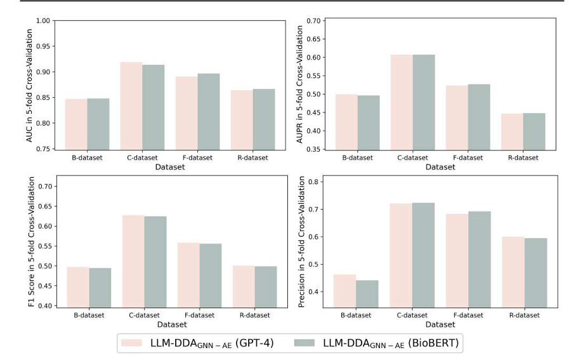
Fig.ure 5.1 : Performance comparison for two LLM embedding generators on four datasets in fivefold cross-validation

Within our reproduced experiments, the LLM-based and BERT-based variants exhibited similar overall behavior, consistent with the qualitative observations reported in the original study.

The reproduced version achieved results reasonably close to those reported in the original LLM-DDAGNN-AE study. While all evaluation metrics were slightly lower, the model still demonstrated strong predictive power, achieving an area under the ROC curve (AUC) of 0.897 and an area under Precision/Recall curve (AUPR) of 0.559. The observed performance differences may be attributed to variations in randomization conditions, software environments, library versions, preprocessing details, cross-validation partitions, and the sensitivity of unbalanced data. Despite these differences, the reproduced model successfully mimics the main predictive behavior reported in the original work, supporting the validity of the implementation.

5.1.2 Comparison Between GCN and GAT Models over all features
To assess the impact of integrating GAT while maintaining the same experimental setup whenever possible, we performed a comprehensive comparison of all available feature types. Table X summarizes the performance of both models across all feature representations.

Feature | Model | AUC | AUPR | F1 | Precision | Recall | Accuracy
BERT
 | GCN | 0.891 | 0.541 | 0.577 | 0.613 | 0.545 | 0.993
 | GAT | 0.9218 | 0.4498 | 0.4795 | 0.5114 | 0.4514 | 0.9909
LLM
 | GCN | 0.897 | 0.559 | 0.590 | 0.657 | 0.657 | 0.559
 | GAT | 0.9279 | 0.4980 | 0.5216 | 0.5222 | 0.5209 | 0.9911
ChemBERT
 | GCN | 0.904 | 0.563 | 0.583 | 0.651 | 0.529 | 0.993
 | GAT | 0.9468 | 0.4490 | 0.4748 | 0.4569 | 0.4941 | 0.9898
Morgan Fingerprint
 | GCN | 0.927 | 0.605 | 0.617 | 0.727 | 0.536 | 0.994
 | GAT | 0.9354 | 0.4749 | 0.4948 | 0.5156 | 0.4755 | 0.9909
Table 5.2 GCN vs. GAT Performance Comparison Across All Feature Types

The experimental results revealed a consistent performance pattern across all feature representations (LLM, BERT, ChemBERTa, and Morgan Fingerprints). The GAT-based model consistently achieved higher AUC scores than both the reproduced GCN model and the original published model. Since AUC evaluates the model’s ability to rank positive associations higher than negative ones across all classification thresholds, this result suggests that the attention mechanism improved the model’s overall discrimination and ranking performance.
However, despite the improvement in AUC, GAT did not consistently outperform GCN in threshold-dependent metrics such as AUPR, F1-Score, Precision, Recall, and Accuracy. This indicates that although GAT produced better probability rankings, these improvements did not fully translate into superior classification performance at the selected decision threshold. Several factors may explain this outcome.
First, the graph structure of the drug–disease association dataset may already be effectively represented by the neighborhood aggregation mechanism used in GCN. In such cases, the adaptive neighbor weighting strategy introduced by GAT may provide only limited additional benefit. Therefore, the simpler aggregation process of GCN may be sufficient to extract the most relevant topological information for this prediction task.
Second, GAT introduces significantly greater architectural complexity than GCN through the use of attention coefficients and multi-head attention mechanisms. While these components increase the expressive power of the model, they also introduce additional trainable parameters and greater sensitivity to hyperparameter selection. This increased complexity may require more extensive hyperparameter optimization to fully benefit from attention-based learning.
To ensure a fair comparison, most training settings were kept identical to those used in the original GCN-based framework. Although this design choice enabled a direct comparison between the two architectures, these hyperparameters were originally developed and reported for GCN rather than GAT. Therefore, the adopted configuration may not represent the optimal operating conditions for the attention-based model. Further tuning of parameters such as the number of attention heads, hidden dimensions, dropout rates, and learning rates may improve GAT performance in future studies.
Furthermore, the training time observations documented in Chapter Four support this interpretation. The GAT model required substantially longer training times than GCN, reflecting its greater computational complexity and larger optimization space. This also suggests that attention-based architectures may require broader hyperparameter exploration before reaching their full predictive potential.
Overall, the results demonstrate that incorporating graph attention mechanisms can improve ranking performance, as shown by the consistently higher AUC values. However, under the experimental conditions adopted in this study, these improvements were not sufficient to consistently surpass the simpler GCN architecture across all evaluation metrics. This highlights the importance of considering dataset characteristics, data properties, network size, link density, feature quality, training settings, and architecture-specific optimization when introducing more advanced graph neural network models.

Among all investigated feature representations, Morgan Fingerprints produced particularly strong and consistent results. The Morgan-based models using the GCN architecture achieved evaluation scores that were very close to those reported in the original study across AUPR, F1-Score, Precision, Recall, and Accuracy, while simultaneously exceeding the published AUC performance.
These findings highlight the strong value of traditional structure-based chemical descriptors for drug–disease association prediction and suggest that complex language-based representations are not always necessary to achieve competitive predictive performance. In this study, chemically derived molecular representations were able to match or even surpass the effectiveness of more sophisticated embedding approaches while maintaining excellent discriminative capability.
The results demonstrate that carefully designed molecular descriptors can remain highly competitive even in the presence of modern deep learning representations. They also suggest that combining traditional chemical descriptors with advanced embedding methods may potentially lead to even better performance, which opens the door for further investigation in future work.
5.1.3 Hidden Link Recovery
To assess the robustness and practicality of the proposed models, hidden links were evaluated at two hiding percentages (5% and 10%) to examine the ability of GCN and GAT to recover missing links and prioritize correct correlations under varying levels of graph incompleteness. The results are summarized in Tables X and Y.

Hidden Links Evaluation · LLM Feature · GCN vs. GAT
Model | Hidden Ratio | AUC | AUPR | F1 | Precision | Recall | Accuracy
GCN | 0.10 | 0.8738 | 0.4252 | 0.4654 | 0.3884 | 0.5805 | 0.9888
 | 0.05 | 0.8890 | 0.5216 | 0.5194 | 0.4498 | 0.6146 | 0.9899
GAT | 0.10 | 0.9301 | 0.3943 | 0.2490 | 0.1506 | 0.7192 | 0.9635
 | 0.05 | 0.9353 | 0.4506 | 0.2667 | 0.1622 | 0.7514 | 0.9634

Table 5.3Hidden Link Evaluation Results – evaluation Metrics (GCN vs. GAT)

Hidden Links Evaluation · LLM Feature · GCN vs. GAT
Model | Hidden  Ratio | Hidden Links  (Positives Removed) | Threshold | Recovered  (score ≥ threshold) | Recovery Rate  @ threshold | Mean Score  (hidden positives) | Median Score  (hidden positives)
GCN | 0.10 | 253 | 0.50 | 153 / 253 | 0.6047 (60.5%) | 0.5860 | 0.8944
 | 0.05 | 127 | 0.50 | 72 / 127 | 0.5669 (56.7%) | 0.5555 | 0.8621
GAT | 0.10 | 253 | 0.50 | 181 / 253 | 0.7154 (71.5%) | 0.6970 | 0.9571
 | 0.05 | 127 | 0.50 | 96 / 127 | 0.7559 (75.56%) | 0.7572 | 0.9885

Table 5.4Hidden Link Evaluation Results – Recovery Rate and Confidence Scores (GCN vs. GAT)
The hidden link evaluation increased graph sparsity by removing a subset of known positive associations. Since GAT relies on attention mechanisms to learn the relative importance of neighboring nodes, the removal of positive links likely reduced the amount of structural information available for attention learning. As a result, GAT showed a larger decline in threshold-dependent metrics compared to GCN, which uses a simpler neighborhood aggregation strategy.
Despite the larger decrease observed in several classification metrics, GAT consistently achieved higher AUC values and recovered a greater proportion of hidden positive links. Furthermore, the higher mean and median scores assigned to the hidden positive associations indicate that GAT ranked true associations more effectively than GCN. These findings suggest that the attention mechanism improved the model’s ability to prioritize biologically relevant drug–disease pairs, even when this advantage was not fully reflected in threshold-dependent metrics.
The results indicate that the attention mechanism enabled GAT to rank biologically relevant associations more effectively, even under conditions of incomplete graph connectivity. Although removing positive links reduced the structural information available for attention learning and negatively affected some classification metrics, GAT remained superior in identifying and recovering missing associations. Since discovering previously unknown drug–disease links is a primary objective of drug repurposing, the improved recovery performance observed in GAT represents an important advantage despite the lower F1-Score and Precision values.
The slightly higher recovery rate observed for GCN at the 10% masking ratio is likely due to differences in the specific positive links selected for removal. Since the hidden links were randomly selected from the available positive associations, variations in link difficulty and graph location may influence recovery performance, resulting in minor fluctuations that do not necessarily follow the masking ratio.
In contrast, GAT exhibited the expected trend, where recovery performance improved as the number of removed links decreased. This behavior suggests that the attention mechanism benefited from the increased availability of neighborhood information, enabling more accurate identification of hidden associations.

5.1.4 Candidate Drug–Disease Association Ranking
After evaluating the model, the final prediction results were used to identify potential new drug–disease associations. Only pairs representing unknown associations (i.e., entries labeled as 0 in the original interaction matrix) were retained. The results were then sorted in descending order.
To ensure traceability and verification, each ranked candidate was reported with the corresponding drug–disease interaction identifiers, allowing direct linkage to the original dataset and facilitating the interpretation of the proposed associations, as shown in the figure.
Higher scores indicate greater confidence in the model’s ability to identify a previously unobserved relationship between a drug and a disease. This ranking process enables prioritization of promising candidates for further biological validation studies, literature review, and experimental investigation.
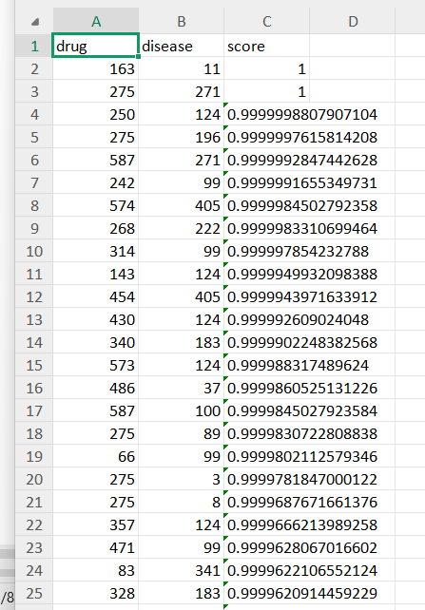
Figure 5.2: Ranked Drug–Disease Association Candidates (GCN–LLM Output)

It is important to note that high predictive scores do not confirm the existence of a true therapeutic relationship. Instead, they indicate that the model assigns a high probability to these pairs based on the available evidence embedded in the graph structure and feature representations. Therefore, the ranked list should be interpreted as a prioritization tool to guide future validation efforts rather than as definitive proof of therapeutic effectiveness.

Chapter 6: Economical, Ethic, and Contemporary Issues
  - Preliminary Cost Estimation and Justification
This project was developed entirely using personal hardware with no additional purchases or licensing fees. The total direct financial cost is zero.All software used is free and open-source: Python, PyTorch, DGL, RDKit, NumPy, Pandas, scikit-learn, and HuggingFace Transformers are all available at no cost. The only component that involves an external service is the OpenAI API, which was used in the baseline's original preprocessing scripts to generate drug and disease text descriptions and their embeddings. However, these files were already precomputed and provided with the baseline's published materials, so no API calls were made during this project.All training and experimentation was performed on a personal laptop using its CPU. No cloud computing, GPU rental, or paid storage was required. The training time per fold is longer on CPU than it would be on a GPU, but this is acceptable for a research project at this scale (663 drugs, 409 diseases).

In terms of justification: the zero-cost development model is appropriate because the project is academic, its dataset is small by machine learning standards, and its purpose is to evaluate research ideas rather than deploy a production system.

  - Relevant Codes of Ethics and Moral Frameworks
Several ethical principles from the ACM Code of Ethics and IEEE Code of Ethics are relevant to this project:
Honesty in reporting: The project is presented as an extension of a published baseline, not an original standalone system. The distinction between baseline components and project additions is clearly documented throughout the report and the codebase.

Transparency about limitations: The system produces predictions that have not been experimentally validated. This is explicitly stated. Predictions from this type of model should only be treated as research leads, not as medical recommendations.

  - Ethical Dilemmas and Justification of Proposed Solution
The main ethical concern in a drug repositioning prediction system is the risk of misuse: someone might treat a model's predicted association as a clinical recommendation and act on it without proper medical validation. This risk exists for any computational drug discovery tool, not just this project.The design of this system does not attempt to mitigate this risk through technical means, because the system is designed for use by researchers and not by patients or clinicians. However, the project is documented in a way that makes its research-only status clear. The output of the model is a ranked list of associations for further investigation, explicitly framed as input to the research process, not an endpoint.

A second concern is the use of LLM-generated content as a feature. GPT-4 descriptions of drugs and diseases may contain inaccuracies. Since these descriptions are used as training inputs (not as user-facing outputs), the concern is that factual errors in the descriptions may introduce noise into the learned embeddings. This is an acknowledged limitation of the baseline design that is inherited by this project. The addition of molecular feature types (Morgan Fingerprints and ChemBERTa) that are derived directly from chemical structure rather than generated text is, in part, a way to provide features that are not subject to this concern.

  - Relevant Environmental Considerations
This project has a minimal environmental footprint. All computations were performed on a personal laptop with no dedicated hardware procurement, no data center usage, and no cloud infrastructure.The most computationally intensive steps — generating ChemBERTa embeddings and BioBERT embeddings — were performed once and the results saved to disk. Subsequent training runs load these files rather than recomputing them, which avoids repeated energy consumption. The GNN training itself is lightweight relative to modern deep learning workloads, since the dataset contains only 663 drugs and 409 diseases.No physical waste was produced. No additional hardware was purchased, and no hardware was disposed of for this project.

  - Relevance to Jordan and Region (Social, Cultural, and Political)
Drug repositioning is particularly relevant in a regional context for several reasons.

Access to medicines: Many diseases that affect populations in Jordan and the broader Middle East are underprioritized in global pharmaceutical R&D because they primarily affect lower-income populations or are geographically localized. Computational drug repositioning offers a lower-cost path to identifying potential treatments for such conditions without requiring full new drug development programs.

Building local AI capability: This project demonstrates that meaningful applied AI research in bioinformatics can be conducted with widely available tools and no specialized infrastructure. This is directly relevant to universities and research groups in Jordan that may not have access to large GPU clusters or commercial research budgets.

Open science: All datasets, code, and pretrained models used in this project are publicly available. This is consistent with the principle that computational research tools should be accessible to researchers in all regions, not just those with access to commercial platforms.

There are no significant political or cultural dimensions specific to this project. It does not involve patient data, clinical trials, or regulatory processes.

  - Other Issues and Constraints
A few practical constraints affected the project that are worth noting:
Dataset scope: Experiments were limited to Cdataset. The benchmark includes four datasets, but running the full experimental comparison across all of them was not feasible within the project timeline.

No experimental validation: The predicted associations have not been validated through wet-lab experiments or clinical evidence review. This is standard for a computational research project at this level, but it means the practical value of the ranked candidate list remains theoretical.

CPU-only training: Training on CPU rather than GPU increases training time per experiment, which limited the number of configurations that could be tested within the available time.

Dependency on precomputed files: The BERT and LLM embedding files provided with the baseline were used as-is. If these files were not available (for example, when applying the system to a new dataset), regenerating them would require either BioBERT infrastructure or OpenAI API access, which involves a cost.

Chapter 7: Project Management
Effective project management is essential for the success of any engineering project. This chapter documents the management framework applied throughout the execution of this project. It includes scheduling and time planning, resource and cost management, quality assurance practices, risk identification and mitigation, and Making all the required tools and data available. The aim of this chapter is to present a clear description of how the project was planned and executed, the level of adherence to the plan, the aspects that required changes, and the lessons learned from this process.The project involves reproducing and evaluating the original LLM-DDA framework, and developing an improved architecture that includes a graph attention network encoder and advanced chemical feature representations (Morgan fingerprints and ChemBERTa embeddings). It also includes designing and implementing an evaluation protocol for predicting hidden links. All of these tasks were completed by a single student over one academic semester, which required careful time management and clear prioritization throughout the work.
  - Schedule and Time Management
The project was planned across a sixteen-week period corresponding to the academic semester. The schedule was organized into ten sequential but partially overlapping phases, structured to ensure that foundational work (literature review, environment setup, baseline reproduction) was completed and validated before more complex development tasks (GAT implementation, feature integration, Hidden Link experiments) were begun. This sequencing was deliberate the correctness of the baseline reproduction was treated as a prerequisite gate before any architectural modification was introduced, ensuring that any subsequent changes in model performance could be due to the project's contributions rather than to setup or data pipeline errors.
Table 7.1 shows the project timeline, specifying each phase and its planned duration within the sixteen-week semester. Shaded cells indicate the weeks during which each phase was active.
Phase / Task | W1 | W2 | W3 | W4 | W5 | W6 | W7 | W8 | W9 | W10 | W11 | W12 | W13 | W14 | W15 | W16
Literature Review & Baseline Analysis | █ | █ | █
Environment Setup & Dependency Config |  | █ | █ | █
Baseline Reproduction & Validation |  |  |  | █ | █ | █
Morgan Fingerprint Integration |  |  |  |  |  | █ | █ | █ | █
ChemBERTa Embedding Integration |  |  |  |  |  |  | █ | █ | █ | █
GAT Architecture Implementation |  |  |  |  |  |  |  | █ | █ | █ | █
Hidden Link Prediction Framework |  |  |  |  |  |  |  |  |  | █ | █ | █ | █
Experimentation & Hyperparameter Tuning |  |  |  |  |  |  |  |  |  |  | █ | █ | █ | █
Results Analysis & Comparison |  |  |  |  |  |  |  |  |  |  |  |  | █ | █ | █
Report Writing & Documentation |  |  |  |  |  |  |  |  |  |  |  |  |  | █ | █ | █

Table 7.1Project Timeline – Phase Schedule Across 16 Weeks

7.1.1 Phase Descriptions and Actual Progress

Weeks 1–3: Literature Review and Baseline Analysis.
The project began with a thorough review of the baseline paper (Gu et al., 2024) and supporting literature on GNN-based DDA prediction, molecular fingerprints, and biomedical language models. The GitHub repository associated with the paper was examined to understand the code architecture before any execution. This phase was completed on schedule and provided the foundation for all subsequent planning decisions.

Weeks 2–4: Environment Setup and Dependency Configuration.
Installing and configuring the software stack (PyTorch, DGL, , RDKit, and associated dependencies) proved more time-consuming than anticipated due to version compatibility conflicts between DGL and PyTorch on the available hardware. This phase required approximately one additional week beyond the initial estimate. The solution involved pinning specific library versions .

Weeks 4-6: Reproducing and validating the original model.
The original LLM-DDA-GNN-AE model was reproduced on Cdataset using the hyperparameters described in the research paper. The numerical results were compared with published results to confirm reproducibility. This validation phase was necessary before proceeding with architectural modifications.

Weeks 6-10: Integrating Morgan and ChemBERTa Embedding.
Morgan Embeddings were calculated for all drug entities and integrated into a drug as node feature. Code was built to generate the embedding, and then modify the project to use it without affecting the other components. ChemBERTa embeddings were also created for all SMILES strings.

Weeks 8-11: Implementing the GAT architecture.
The Node_Encoder class was modified to replace the GraphConv layers with GATConv layers . During the model development phase, a controlled transition from GCN to GAT was performed while maintaining the entire experimental path to ensure fair performance measurement.

Weeks 10-13: Implementing and testing the hidden link prediction framework.
The hidden link prediction protocol was designed and implemented. This protocol involved removing a controlled subset of known drug-disease associations from the training graph and using them as exclusive test samples. During this phase, the concept, its feasibility for the project, and its implementation were studied and tested using two different approaches.

Weeks 13–15: Results Analysis, Comparison.
Performance results from all experimental configurations were collected, tabulated, and analyzed. And make Comparison tables against the baseline .

Weeks 14–16: Report Writing and Documentation.
All project chapters were written and refined in parallel with late-stage experimental work. Code was cleaned, commented, and organized into a reproducible repository structure with a requirements file and execution instructions.

  - Resource and Cost Management

This project was developed entirely using locally available computational resources and publicly accessible datasets. No direct financial expenditure was incurred during the development, training, or evaluation phases of the model.All software dependencies, including PyTorch, DGL, RDKit, and HuggingFace Transformers, are open-source and freely available under permissive licenses. The datasets used for drug–disease association prediction are derived from publicly available biomedical repositories, requiring no licensing fees or subscription costs.

Model training and experimentation were primarily conducted on a personal workstation CPU, with optional use of university-provided GPU infrastructure when required for accelerated training. No commercial cloud computing services or paid APIs were utilized in the final implementation.Therefore, the total financial cost of this project is effectively zero (0 USD), with computational resources being the only required factor for execution.

7.3 Quality Management

Quality management in this project include both the quality of the software implementation and the scientific rigor of the experimental evaluation. The following practices were applied systematically throughout the project to ensure that both dimensions were maintained to a high standard.

7.3.1 Code Quality Practices

Modular Architecture: The codebase was organized into clearly separated modules — model.py (original GCN), model_gat.py (GAT ), train.py, train_gat.py, load_data.py, utils.py, and args.py — with each module having a well-defined responsibility. This separation facilitated independent testing of each component and made it straightforward to compare the behavior of the GAT and GCN variants under identical conditions.

Version Control:Version control was used via Git and GitHub to maintain an organized development workflow. All code updates were regularly pushed to a remote repository to avoid maintaining multiple local copies and to ensure centralized tracking of changes throughout the project.

Reproducibility: A fixed random seed via the set_seed() was used for all experiments. Hyperparameter configurations were logged to file at the start of each training run via the logging infrastructure. All pre-generated embedding files were stored with their corresponding configuration metadata.

Unit Testing: Before adding each new component (such as GAT encoder, Morgan fingerprint features, and embedding modules), basic checks were performed to ensure correct tensor shapes, data types, and valid values. This helped detect and fix dimension mismatch issues early before training.

7.3.2 Scientific Quality Practices

Baseline Validation Before Modification: As noted in Section 7.1, the original baseline was fully reproduced and validated against published result before any architectural modification was introduced.

Consistent Evaluation Protocol: All models — the original baseline, the GAT variant, and all configurations — were evaluated under identical five-fold cross-validation splits, random seeds, and hyperparameter settings . This consistency is essential for valid comparison.

Multiple Metrics: Performance is reported across four complementary metrics (AUC, AUPR, F1-Score, Precision) rather than relying on a single scalar. This multi-metric evaluation is particularly important for highly imbalanced datasets, where AUC alone can be misleadingly optimistic and AUPR provides a more sensitive assessment of prediction quality for the positive class.

Ablation Studies: Ablation experiments were conducted by testing each added component separately (GAT encoder, Morgan fingerprints, and ChemBERTa embeddings) to evaluate its individual contribution to performance. This allowed a clear understanding of the impact of each modification on the final results.

7.4 Risk Management

During the implementation phase, several technical challenges were encountered and addressed throughout the project.

One of the main challenges was reproducing the baseline results reported in the original study. Initial experiments produced noticeably different performance values, which required a detailed review of the source code, preprocessing steps, feature generation pipeline, and training configuration. Through systematic debugging and validation, several implementation issues were identified and corrected, resulting in substantially improved reproducibility.

Another challenge arose during the integration of the proposed GAT-based architecture. Special care was required to ensure that the comparison between the original GCN model and the new GAT model remained fair. To achieve this, only the graph convolution component was replaced while keeping the remaining pipeline unchanged, followed by extensive verification to confirm consistent data flow and model behavior.

Additional issues included tensor dimension mismatches during feature integration and compatibility problems between software dependencies. These issues were resolved through iterative testing, code validation, and environment standardization.

Finally, when evaluating multiple enhancements such as GAT, Morgan fingerprints, and ChemBERTa embeddings, separate experiments were conducted for each modification to isolate its contribution and accurately assess its effect on performance.

Despite these challenges, all issues were successfully resolved, and the final experimental pipeline completed all planned evaluations and validation experiments.

7.5 Project Procurement

The project required several software tools, datasets, and computational resources to support development and experimentation. Since the project was research-oriented, most resources were obtained through publicly available or institutionally provided sources rather than direct procurement .In addition, pretrained language-model embeddings and molecular representations were generated using publicly available models and libraries.

The implementation was carried out using open-source software, including Python, PyTorch, DGL, RDKit, NumPy, Pandas, and Scikit-learn. Source code management was performed using Git and GitHub to maintain version control throughout development.Computational experiments were conducted using personal computing resources . This approach minimized project costs while ensuring sufficient computational capacity for training and evaluation.

Chapter 8: Conclusion and Future Work
  - Summary of the main contributions of the work.
This project successfully achieved its planned objectives, and the main contributions can be summarized as follows:
1. Successful Reproduction and Validation of the Baseline Framework
We successfully reproduced the published LLM-DDA baseline framework on dataset C and verified its reported performance. The obtained results closely matched the original published results, which confirms the correctness and reliability of our experimental setup, data pipeline, and implementation before introducing any modifications.
2. Development and Integration of New Drug Representations
We developed and integrated new drug feature representations. One of these, Morgan fingerprints, achieved results very close to the original model while also showing an improvement in the AUC value.
3. Design and Implementation of an Alternative Model Architecture
We developed a Graph Attention Network (GAT)-based model as an alternative to the baseline Graph Convolutional Network (GCN). Although it has some limitations caused by factors discussed earlier, it still achieved strong performance in certain cases.
4. Design and Validation of a Hidden Link Recovery Evaluation Protocol
This evaluation protocol was successfully applied to both the GCN and GAT models and validated using two different hidden edge ratios (10% and 5%). This contribution provides a more realistic assessment of model generalization compared to standard cross-validation.
5. Implementation of a Candidate Ranking and Validation Module
The module successfully filters known interactions, ranks all unknown drug–disease pairs based on predicted confidence scores, and outputs a prioritized list of candidate associations. This functionality was verified using actual model outputs and confirmed to work correctly without adding any computational overhead during training.
8.2 Further Future Work Improving the Proposed System
During the development phase, the possibility of integrating gene-based disease similarity information was explored as a potential extension to the proposed framework. Early analyses suggested that incorporating gene–disease relationships could enrich disease representations and improve the identification of new drug–disease associations. Initial planning and investigation of this improvement were already started; however, due to the project scope, time limitations, and other priorities, full implementation and evaluation of this component were postponed to future work.
As an additional proposed approach, a gene-based disease similarity measure can be used as an alternative to existing similarity metrics. The motivation behind this extension is to investigate whether gene-based disease similarity can improve the drug repurposing framework. By comparing this approach with the baseline similarity method, the model performance can be evaluated to determine whether gene-based similarity leads to improved prediction accuracy, more reliable results, or higher evaluation scores.
This approach is based on the idea that diseases sharing common genes may also share similar symptoms or responses to drugs. Based on this assumption, genes are used as the foundation for measuring similarity between diseases, allowing a more biologically meaningful representation of disease relationships and helping to identify potential associations between diseases.
Instead of treating all disease-related genes equally, a weighted gene-based disease similarity measure is proposed, where the relative importance of shared genes is taken into account. This produces a more biologically meaningful similarity metric.
As a first step, gene weights are computed based on disease specificity. Since genes do not contribute equally to disease similarity, a Disease Specificity Index (DSI) is assigned to each gene according to the number of diseases it is associated with in the dataset. This weighting scheme allows genes that are highly specific to certain diseases to have a stronger influence on similarity calculations, while genes associated with many diseases contribute less.
Gene–disease associations are first collected from public databases such as DisGeNET. For each gene (gi), the number of associated diseases within the dataset is computed and denoted as Nd, while NT represents the total number of diseases in the study. These values reflect the level of gene prevalence across the analyzed diseases. Based on this, the Disease Specificity Index (DSI) for each gene is computed using the following formulation:

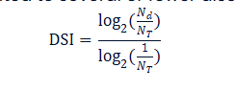
Figure 8.1: Disease Specificity Index (DSI) Formula for Gene Weighting
This formulation assigns higher DSI values to genes associated with fewer diseases, indicating higher disease specificity, and lower values to genes associated with many diseases. The resulting DSI values are normalized between 0 and 1 and later used as gene weights in disease similarity computations.
To compute disease similarity based on gene information, each disease is represented as a gene vector. First, a global gene set G is defined, containing all genes associated with any disease in the dataset. For each disease di, a vector Vdi is constructed, where each element corresponds to a gene in the global gene set. If the gene is associated with the disease, the corresponding element takes a non-zero value representing the importance of that gene; otherwise, it is set to zero.
Formally, the disease vector is defined as:
Vdi = [wi,g1, wi,g2, ..., wi,gn],
where wi,g represents the weight assigned to gene g for disease di according to the Disease Specificity Index (DSI).
When computing similarity between two diseases di and dj, only shared genes are considered in order to avoid artificially lowering similarity due to non-overlapping genes. Let Gdi and Gdj denote the gene sets associated with diseases di and dj respectively. The intersection set Gij represents shared genes between the two diseases. Restricting the computation to shared genes ensures that similarity reflects meaningful biological overlap rather than differences caused by disease-specific genes.
The weighted cosine similarity is defined as follows:
Sim(di, dj) = (Σ_{g∈Gij} w_{i,g} · w_{j,g}) / (√(Σ_{g∈Gij} w_{i,g}²) · √(Σ_{g∈Gij} w_{j,g}²))
where wi,g and wj,g represent gene weights for gene g in each disease, and Gij represents the shared gene set between the two diseases.
Finally, weighted cosine similarity values are computed for all disease pairs in the dataset. The resulting values are organized into a disease similarity matrix S, which is then used as a foundation for downstream analyses such as disease clustering, network construction, and drug repurposing applications.
As an extension to this proposal, an additional metric can be integrated with the disease similarity index (DSI-based similarity).
Within this extended framework, disease similarity is recomputed by considering not only shared genes and their specificity, but also the strength and reliability of gene–disease associations. This is known as the Gene–Disease Association (GDA) score. The Gene–Disease Association (GDA) score represents the confidence level of scientific evidence linking a gene to a disease. This step is crucial for understanding the importance of each gene in different disease contexts and supporting downstream biological analysis.
DisGeNET collects GDA data from multiple sources, including curated expert databases, predicted data from animal models, and automatically extracted literature-based information using text-mining algorithms. These sources vary in reliability; manually curated expert sources are assigned higher weights compared to automatically extracted literature data.
The GDA score for each gene–disease pair is computed by aggregating weighted contributions from each evidence source. This calculation can be summarized using the following equation:
(formula placeholder as in original text)
After obtaining the GDA score for each gene–disease pair, it can be combined with the gene DSI index to produce a final score that reflects both gene specificity and the reliability of its association with the disease.
This final score assigns each gene–disease pair a weight that reflects its importance in the disease context. Genes with higher specificity and stronger scientific evidence have a greater influence when analyzing disease similarity or building biological networks. This gene weighting scheme can then be used to recompute disease similarities and support graph construction, model training, and evaluation.
If incorporating GDA leads to performance improvement, it supports the hypothesis that richer biological context enhances drug repurposing predictions. Otherwise, it suggests that simpler similarity measures may be sufficient and helps avoid unnecessary model complexity.
In this study, all models were evaluated under a fixed and unified hyperparameter setting to ensure a fair and controlled comparison across GCN and GAT architectures under identical experimental conditions. While this approach guarantees consistency and reduces confounding factors, it may limit each model from reaching its optimal performance configuration. Therefore, the reported results reflect performance under standardized settings rather than individually optimized configurations.
As a direction for future work, it would be valuable to perform systematic hyperparameter optimization for each model independently (e.g., learning rate, number of attention heads, hidden dimensions, dropout rate) to evaluate whether GAT-based models benefit more from fine-grained parameter adjustments compared to GCN.

8.3 Lessons Learned
This project provided valuable lessons at the research, technical, and personal levels.
1. Understanding Drug Repurposing
Before this project, I had no background in drug repurposing, and I had to build my understanding from scratch. It took time to study scientific literature to understand why this field is considered a promising alternative to traditional drug development, and how computation can accelerate the discovery of new relationships between existing drugs and diseases. This intensive learning helped me understand the importance of combining domain knowledge with computational methods, and I realized that good solutions do not come only from strong algorithms, but from a deep understanding of the biological problem being solved.
2. Technical Growth
From a technical perspective, the project significantly expanded my knowledge of artificial intelligence and graph-based learning techniques. I gained hands-on experience working with Graph Neural Networks (GNNs), heterogeneous graphs, node embeddings, similarity networks, and feature fusion strategies. In addition, it strengthened my programming skills in Python, allowing me to move from basic coding knowledge to implementing, modifying, debugging, and evaluating complex deep learning models.
3. Importance of Data Quality
I learned practically that data quality is one of the most important factors in the success of any computational model. During development, it became clear that the quality, completeness, and representation of input data directly affect model performance. When I faced issues in reproducing results, I discovered that the problem was not the algorithm itself, but how the raw data was processed, how matrix dimensions were aligned, and how missing values were handled. I realized that advanced models cannot replace a deep understanding of the data, and that one hour of proper data cleaning and validation can save many hours of debugging model errors.
4. Importance of Literature Review Before Implementation
A thorough review of previous studies not only provided a better understanding of existing methods, but also helped identify research gaps and opportunities for meaningful contributions. Reviewing scientific literature before making technical changes provides a broader perspective and better ideas. Research papers are not only for citation, but also a source of inspiration for improvement. This careful reading helped me choose targeted improvements instead of random modifications without clear purpose. This experience showed that successful research often begins with careful analysis of existing work and building upon it rather than starting from scratch.
5. Turning Independent Work into Strength
Working independently on this project was another valuable learning experience. While many graduation projects are done in teams, developing this project individually required full responsibility for all stages, including literature review, understanding the baseline, data preparation, model development, experimentation, error analysis, result evaluation, and report writing. At first, this was a major challenge, but it eventually became one of the most important strengths. This experience strengthened my self-learning ability, project management skills, problem-solving skills, and confidence in handling complex research challenges without relying on a team.
Overall, this project significantly improved my technical expertise and research skills, providing a solid foundation for future work in artificial intelligence, biomedical informatics, and drug discovery research.

References

