

**CSE 344 – ISE 402**

**SOFTWARE ENGINEERING – SYSTEM DESIGN**

**COWPLEX**

**SMART FARM MANAGEMENT SYSTEM**

**Course Instructor** :

Associate Prof. Dr. Mert Özkaya

Dr. Asst. Prof. Eylül Damla Gönül Sezer

**Group 14:**

**ISE :** İdil Defne Akbulut, Gizem Kara, Hafize Naz Yılmaz, İpek Çelebi

**CSE :** Mirhasan Haji Hasanli, Doruk Erinç, Çağlar Metin, Alperen Ali Tunçay, Berk Balkan

**Yeditepe University**

**Istanbul, 2024**

# **Introduction**

## Purpose

This document describes the COWPLEX smart farm management system, highlighting its use to monitor animal health and productivity, support decision-making, and improve farm efficiency. It covers the system's key features, including health monitoring, and milking data analysis, aimed at farmers, veterinarians, and farm managers. The purpose is to showcase how COWPLEX can enhance farm operations and animal welfare.

## Background

The intersection of software engineering and agricultural management has heralded a new era of efficiency and productivity in farming practices. Traditional methods of farm management, heavily reliant on manual labor and empirical knowledge, are being rapidly supplanted by smart farming solutions. These solutions leverage cutting-edge software systems to automate and optimize various aspects of farm management, from animal health monitoring to feed management and milking efficiency.

In recent years, the demand for increased agricultural productivity has risen sharply, driven by global population growth and the consequent need for more food production. However, this demand comes at a time when the agricultural sector faces significant challenges, including limited natural resources, environmental concerns, and the need for sustainable farming practices. Additionally, the complexity of managing modern farms has grown, with a greater emphasis on animal welfare, regulatory compliance, and the economic viability of farming operations.

Smart farm management systems, like the one our project focuses on, are at the forefront of addressing these challenges. By integrating technology into everyday farming operations, these systems provide comprehensive data analysis, real-time monitoring, and decision-making tools. This project, in collaboration with the Department of Industrial Engineering, aims to develop a prototype for such a system, named COWPLEX, designed to enhance farm operations, improve animal welfare, and increase productivity through sophisticated data management and analysis.

The COWPLEX system is envisioned to serve multiple stakeholders within the agricultural sector, including farmers, farm managers, and veterinarians. It aims to offer a suite of functionalities encompassing health monitoring, milking data analysis, feed management, and more, all through a user-friendly interface. The system's development is guided by the principles of user-centric design, scalability, and integration capability with existing farm management infrastructures.

By focusing on these areas, the project aligns with the broader trends in agricultural technology, where the emphasis is on creating sustainable, efficient, and productive farming ecosystems. The collaboration between software engineering and industrial engineering disciplines is crucial in this endeavor, offering a multidisciplinary approach to problem-solving and system development.

This background sets the stage for our project's objective: to design and implement a software solution that not only meets the immediate operational needs of modern farms but also addresses the long-term challenges facing the agricultural industry. Through COWPLEX, we aspire to contribute to the evolution of smart farming practices, showcasing the potential of software engineering to revolutionize traditional sectors.

## Motivation

The agricultural sector stands at a pivotal juncture, facing a trilemma of escalating food demand, finite natural resources, and the imperative for sustainable practices. This scenario is compounded by the challenges of climate change, which exacerbates the unpredictability and volatility in farming outcomes. Traditional farming methods, while rich in historical knowledge and practices, increasingly fall short in addressing these modern complexities. The motivation for our project, COWPLEX, arises from a critical examination of these challenges and the untapped potential of software engineering to provide innovative solutions.

* + 1. **Statement of Problems with the Existing System**

Modern farms operate in an environment where efficiency and data-driven decision-making are not just advantageous but essential. Current systems often rely on disparate tools that lack integration, leading to inefficiencies, data silos, and missed opportunities for optimization. Additionally, there's a significant gap in real-time health monitoring and productivity analysis, which are crucial for proactive farm management. The manual processes prevalent in many aspects of farm management, from feed management to health monitoring, are time-consuming and prone to errors.

* + 1. **The New System**

COWPLEX aims to bridge these gaps by introducing a comprehensive smart farm management solution. The system leverages the latest in software engineering to offer a unified platform that integrates various aspects of farm management. By automating data collection and analysis, providing real-time health and productivity insights, and facilitating seamless decision-making processes, COWPLEX addresses the critical needs of modern agriculture. The features of the new system are designed to solve the identified problems by:

* **Enhancing Efficiency:** Through automation and integration of farm management processes, reducing manual labor and increasing operational efficiency.
* **Improving Animal Welfare:** By real-time health monitoring and alerts, ensuring timely interventions and better health outcomes for livestock.
* **Optimizing Productivity:** With data-driven insights into milking, feeding, and breeding practices, facilitating informed decision-making to boost productivity.
* **Supporting Sustainable Practices:** By enabling precise management of resources and promoting practices that align with sustainability goals.
* **Ensuring Compliance and Traceability:** Through detailed record-keeping and reporting features that ease regulatory compliance and enhance food safety.

The motivation for developing COWPLEX is rooted in the belief that technology can transform agriculture, making it more efficient, sustainable, and resilient. By addressing the current limitations of farm management systems and harnessing the power of software engineering, we aspire to contribute to the advancement of smart farming solutions that can meet the demands of the present without compromising the ability of future generations to meet their own needs.

1. **Functional Requirements for The System**
   1. **Description of the System Functionalities**

* Milking Data Analysis: Integrates with milk machines to accurately measure and record the milking time and quantity, providing insights into productivity and health.
* Manual and Automated Data Entry: Manual data entry for breeding information, parentage, and animal identification, along with automated systems for milk yield and feed intake monitoring.
* Farm Management Console: A dashboard that displays alerts for health issues and facilitating farm-wide management decisions.
* Veterinarian Screen: Allows veterinarians to view animal health data, manage treatments, vaccinations, and perform other health-related procedures efficiently.
* Animal Management Screen: Provides detailed information on individual animals, including health status, lactation data, and movement activities.
* Group Comparison Screen: Enables comparison of data between different animal groups, helping in understanding group performance and making informed management decisions.
* Report Builder Screen: Offers the ability to generate customized reports based on selected criteria, aiding in record-keeping and analysis.
* Farm Settings Screen: Includes options for adding veterinarian information, setting up notifications, and managing animal identification preferences.
* Milking Efficiency Analysis: Integration with milking machines to capture detailed data on milking times and quantities, enabling analysis for efficiency and health assessment.
* Automated Alerts and Notifications: Customizable alert system for health issues, and milking anomalies, sent to users via SMS, email, or in-app notifications for immediate action.
* Detailed Animal Profiles: Creation and management of comprehensive profiles for each animal, including health history, breeding records, and productivity data.
* Interactive Farm Management Dashboard: A central console providing an overview of farm status, including health alerts, and productivity metrics.
* Data-Driven Veterinary Tools: Specialized interfaces for veterinarians to access detailed health data, manage treatment plans, and monitor post-treatment recovery.
* Lactation and Yield Analysis: Tools to analyze lactation cycles and milk yield trends, aiding in nutritional and health management for optimal production.
* Feed Management Integration: Integration with feed management systems to track and optimize feed consumption, nutritional intake, and its effect on health and productivity.
* Genetic and Breeding Analytics: Tools to analyze genetic data and breeding histories, supporting decisions for genetic improvement and herd management strategies.
* Custom Report Generation: Flexible reporting tools that allow users to generate custom reports on health, productivity, breeding, and other metrics for analysis and record-keeping.
* User Access Control: Configurable access levels for different user roles (e.g., farm owner, veterinarians, farm managers) to control the visibility and actions within the system.
* Historical Data Analysis: Storage and retrieval of historical data for long-term health and productivity analysis, trend identification, and decision support.
* Training and Support Resources: Online tutorials, documentation, and customer support services to assist users in maximizing the system's capabilities.
* Integration with External Systems: Capabilities to integrate with existing farm management software, financial systems, and regulatory databases for comprehensive management.
* Compliance and Regulatory Reporting: Features to support compliance with animal welfare standards, environmental regulations, and reporting requirements.
* Security and Data Protection: Ensuring the security of data through encryption, regular security audits, and compliance with data protection regulations.
  1. **Description of the System Users**
* Farmers: Primary users who leverage the system for daily farm operations, making decisions based on the health and productivity data provided.
* Veterinarians: Use the system for accessing health data, scheduling treatments, and monitoring the wellbeing of the animals under their care.
* Farm Managers: Oversee farm operations, utilizing the system's data to optimize productivity, manage resources, and implement strategic decisions.
* Technical Support Staff: Responsible for the maintenance of the system, ensuring that all components function correctly and assisting users with any technical issues.
* Software Developer: Work on developing, updating, and refining the system functionalities, ensuring the system remains cutting-edge and meets user needs.

These functional requirements detail the COWPLEX system's capabilities and the roles of its users in leveraging these functionalities for improved farm management and animal welfare.

# **Non-Functional Requirements**

* Critical Health Alert Response Time:The system must respond to critical health alerts within 2 seconds from data capture.
* System Uptime:The system shall maintain a monthly uptime of 99.9%, excluding scheduled maintenance.
* Data Encryption**:** All sensitive data in transit and at rest must be encrypted using AES-256 or an equivalent standard.
* User Interface Learning Time:The system's user interface should be intuitive, requiring under 1 hour of training for new users to perform basic operations.
* User Load and Data Volume: The system must handle a tenfold increase in user load and data volume without degrading performance.
* Technical Support Availability:24/7 technical support with a maximum response time of 2 hours for critical issues and 24 hours for non-critical issues.
* Legal Compliance:The system must comply with GDPR and relevant local data protection laws for handling and storage of personal and operational data.

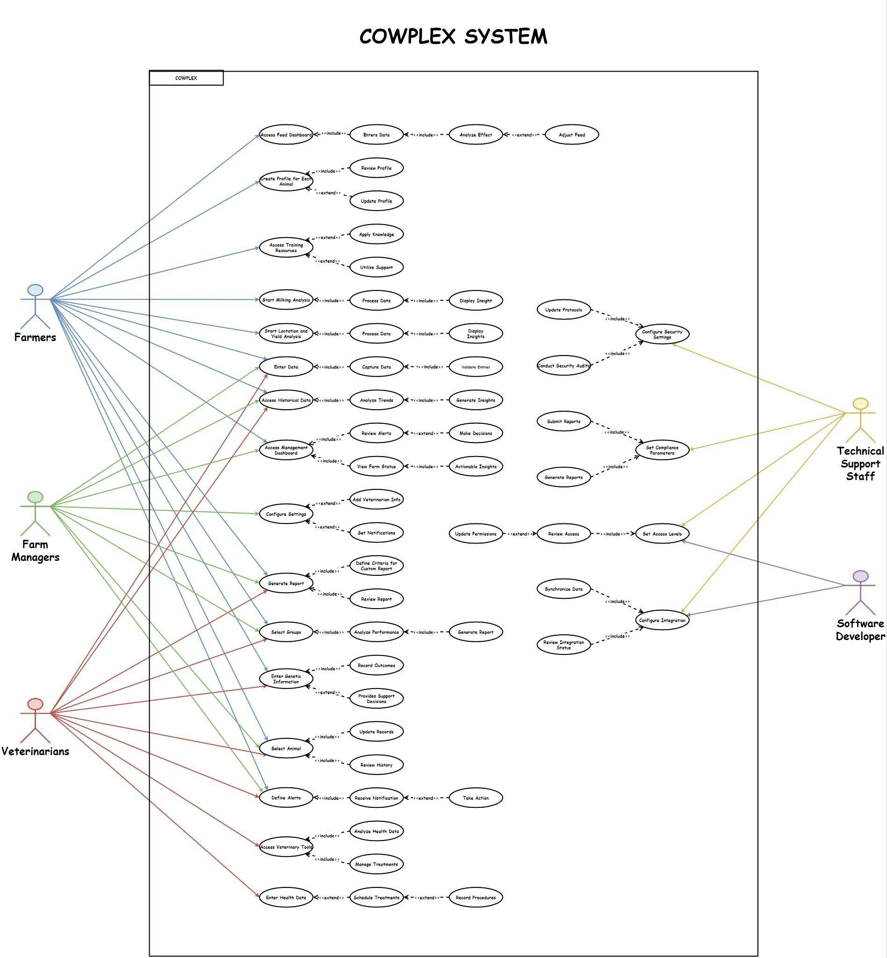

| **USE CASE ID**: UC1 |
| --- |
| **USE CASE**: Cowplex |
| **PRIMARY ACTORS:** Farmers, Farm Managers, Veterinary  **SECONDARY ACTORS:** Technical Support Staff, Software Developer |
| **MAIN FLOW:** **Feed Management Integration**  1. Farmer accesses feed dashboard. 2. Farmer enter consumption information. 3. System analyzes the effect on health and productivity. 4. Recommendations for feed adjustment are provided.  **Detailed Animal Profiles**  1. Farmer creates a comprehensive profile for each animal. 2. Health history, breeding records, and productivity data are updated. 3. User reviews detailed profiles for insights.  **Training and Support Resources**  1. Farmer accesses online tutorials and documentation. 2. Customer support is contacted for assistance. 3. User applies knowledge to maximize system capabilities.   **Milking Data Analysis**   1. Farmer initiates data analysis after milking. 2. System processes milking time and quantity data. 3. System displays productivity and health insights.  **Lactation and Yield Analysis**Farmer initiates lactation and yield analysis.System processes and analyzes lactation cycles and milk yield.Insights on nutritional and health management are displayed.**Data Entry**   1. Farmer/Farm Manager/Veterinary inputs manual data for breeding and identification. 2. System automatically captures milk yield and feed intake. 3. System validates and stores the data.  **Historical Data Analysis**  1. Farmer/Farm Manager/Veterinary accesses stored historical data. 2. System analyzes long-term trends for decision support. 3. Insights based on historical analysis are provided.  **Report Builder Screen**  1. Farmer/Farm Manager/Veterinary defines criteria for the custom report. 2. System generates the report based on selected criteria. 3. User reviews and exports or saves the report.  **Farm Settings Screen**  1. Farm Manager configures farm settings and preferences. 2. Information about veterinarians is added. 3. Farm Manager sets notification preferences.   **Interactive Farm Management Dashboard**  1. Farm Manager accesses the farm management dashboard. 2. System provides an overview of farm status. 3. System displays health and productivity alerts. 4. Dashboard offers insights for immediate actions. 5. Farm Manager makes decisions based on displayed data.  **Custom Report Generation**  1. Farmer/Farm Manager/Veterinary selects parameters for the report. 2. System generates a custom report. 3. Farmer/Farm Manager/Veterinary reviews, exports, or saves the report for decision-making.  **Group Comparison Screen**  1. Farm Manager selects animal groups for comparison. 2. System analyzes and compares group data. 3. System generates a comparative performance report.   **Genetic and Breeding Analytics**   1. System analyzes genetic data and breeding history. 2. Provides decision support for genetic improvement. 3. Outcomes of breeding decisions are recorded.  **Animal Management Screen**  1. Farmer/Farm Manager/Veterinary selects an animal to view detailed information. 2. Health status, lactation data, and movements are updated. 3. Farmer/Farm Manager/Veterinary reviews historical data and trends.  **Automated Alerts and Notifications**  1. Farmer/Farm Manager/Veterinary defines conditions for automated alerts. 2. System sends alerts via SMS, email, or in-app notifications. 3. User takes immediate action based on alerts.  **Data-Driven Veterinary Tools**  1. Veterinarian accesses specialized health data tools. 2. Treatment plans and recovery monitoring are managed. 3. Veterinarian analyzes detailed health data for decisions.  **Veterinarian Screen**  1. Veterinarian accesses animal health data. 2. Veterinarian schedules treatments and vaccinations. 3. Procedures and outcomes are recorded in the system.  **Security and Data Protection**  1. Technical Support Staff configures encryption and security settings. 2. Regular security audits are performed to ensure data integrity and protection. 3. Security protocols are updated in response to audit findings.  **Compliance and Regulatory Reporting**  1. Technical Support Staff sets parameters for compliance with animal welfare and environmental regulations. 2. System automatically generates necessary reports for regulatory bodies. 3. Technical Support Staff reviews and submits compliance reports to regulatory authorities.  **User Access Control**Technical Support Staff/Software Developer sets access levels for different user roles.Access logs are reviewed for security.Permissions are updated based on roles and needs.**Integration with External Systems**  1. Technical Support Staff/Software Developer configures integration with external systems. 2. System synchronizes data with external farm management, financial systems, and regulatory databases. 3. Technical Support Staff/Software Developer reviews the status of integrations and troubleshoots any issues. |
| **POST CONDITION:**   1. The farm consistently applies tailored feed strategies that improve animal health and productivity, with adjustments informed by real-time data analysis. 2. Each animal's health history, breeding records, and productivity data are accurately maintained and readily available for review, facilitating informed decision-making. 3. Farmers have effectively utilized online resources and customer support to maximize the capabilities of the system, leading to better farm management practices. 4. The farm leverages detailed analysis of milking and lactation data to enhance milk yield and quality, with insights guiding nutritional and health management. 5. Manual and automatic data entries, including breeding, identification, milk yield, and feed intake, are accurately captured and validated, ensuring data integrity. 6. Long-term trends from historical data are utilized to support strategic decisions, improving the farm's operational efficiency and productivity over time. 7. Custom reports are generated and used effectively for reviewing farm operations, animal health, and productivity, enabling data-driven decision-making. 8. Farm settings and preferences are customized to meet the farm's unique requirements, enhancing operational efficiency and communication. 9. The farm management dashboard provides actionable insights, health, and productivity alerts, facilitating timely decisions and interventions. 10. Comparative performance reports for different animal groups inform management practices and interventions, leading to optimized group health and productivity. 11. Genetic data and breeding history analysis support strategic decisions for genetic improvement, positively affecting future productivity and health. 12. Detailed animal information is effectively used for managing health, lactation, and movements, with staff actively engaging with the system for daily management tasks. 13. Automated alerts ensure that critical health and operational issues are addressed promptly, reducing the risk of major productivity losses. 14. Veterinarians utilize detailed health data and tools for informed treatment planning and monitoring, improving animal health outcomes. 15. Encryption, security settings, and regular audits protect sensitive data and ensure compliance with data protection regulations. 16. Automated compliance reporting facilitates adherence to animal welfare and environmental regulations, ensuring regulatory compliance. 17. User roles and access levels are managed to safeguard system integrity and data security, with permissions tailored to staff roles and needs. 18. The system's integration with external farm management, financial, and regulatory systems is maintained and optimized, ensuring a cohesive operational ecosystem. |

**Volere Requirements Specification for COWPLEX System**

| **Requirement ID:** 1 | **Requirement Type**: NFR (Performance) |
| --- | --- |
| **Description:** The response time for critical health alerts in the system shall be no more than 2 seconds from the moment the data is captured by the system. | |
| **Rationale:** Quick response times are essential for timely intervention in critical health situations, potentially saving the life of an animal and preventing the spread of diseases within the farm. | |
| **Fit Criteria:** Automated tests that simulate the triggering of health alerts and measure the time taken for the alert to be displayed to the user. | |
| **Priority:** Essential | |

| **Requirement ID:** 2 | **Requirement Type**: NFR (Performance) |
| --- | --- |
| **Description:** The system shall have a monthly uptime of 99.9%, excluding scheduled maintenance periods. | |
| **Rationale:**  High availability is crucial for farm operations to ensure continuous monitoring and management of animal health and productivity, which cannot be compromised. | |
| **Fit Criteria:** Monitoring system uptime over a month and verifying that it meets or exceeds the 99.9% uptime requirement. | |
| **Priority:** Essential | |

| **Requirement ID:** 3 | **Requirement Type**: NFR (Security) |
| --- | --- |
| **Description:** All sensitive data transmitted and stored by the system must be encrypted using AES-256 encryption standard or equivalent. | |
| **Rationale:** To protect the confidentiality and integrity of farm and animal data against unauthorized access and breaches. | |
| **Fit Criteria:** Security audit logs and configuration checks to verify encryption protocols and standards. | |
| **Priority:**  Essential | |

| **Requirement ID:** 4 | **Requirement Type**: NFR (Usability) |
| --- | --- |
| **Description:** The user interface of the system must be intuitive and should not require extensive training for new users, with an average learning time of under 1 hour. | |
| **Rationale:** To ensure that all users, regardless of their technical proficiency, can efficiently use the system without significant downtime or training investment. | |
| **Fit Criteria:** User testing sessions to measure the time taken for new users to perform basic operations within the system. | |
| **Priority:** High | |

| **Requirement ID: 5** | **Requirement Type**: NFR (Scability) |
| --- | --- |
| **Description:**The system must be capable of handling a tenfold increase in user load and data volume without performance degradation. | |
| **Rationale:** To accommodate future growth of the farm operations and the addition of new functionalities without the need for major system overhauls. | |
| **Fit Criteria:** Load testing the system with increasing numbers of simulated users and data until the specified threshold is reached while monitoring performance. | |
| **Priority:** High | |

| **Requirement ID:** 6 | **Requirement Type**: NFR(Maintenance and Support) |
| --- | --- |
| **Description:** The system shall offer 24/7 technical support with a maximum response time of 2 hours for critical issues and 24 hours for non-critical issues. | |
| **Rationale:**  To ensure that any issues encountered by users can be promptly addressed, minimizing disruption to farm operations. | |
| **Fit Criteria:** Review of support ticket logs to verify adherence to the response time SLAs over a defined period. | |
| **Priority:** High | |

| **Requirement ID:** 7 | **Requirement Type**: NFR (Compliance and Regulatory) |
| --- | --- |
| **Description:** The system must comply with GDPR and relevant local data protection laws regarding the handling and storage of personal and operational data. | |
| **Rationale:**To ensure the system adheres to legal requirements for data protection, ensuring user trust and avoiding legal penalties. | |
| **Fit Criteria:** Compliance audit reports demonstrating adherence to GDPR and local data protection regulations. | |
| **Priority:** Essential | |

1. **System Models** 
   1. **Object and Class Models**

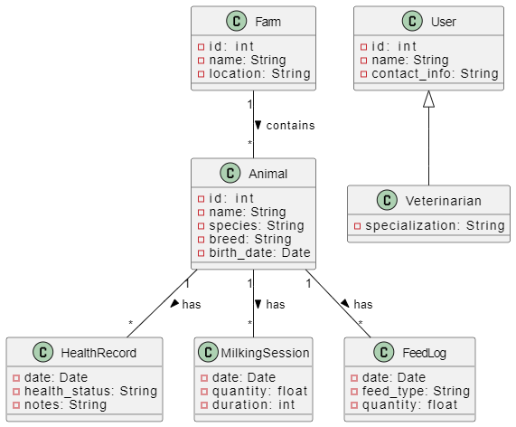

* 1. **User Interface – Screen mock-ups**

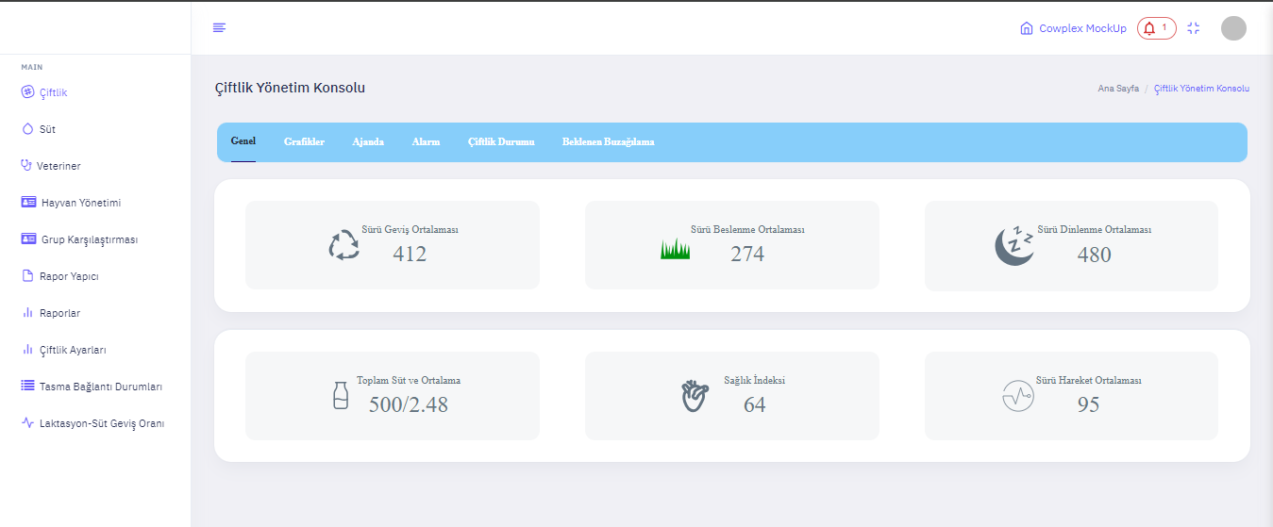

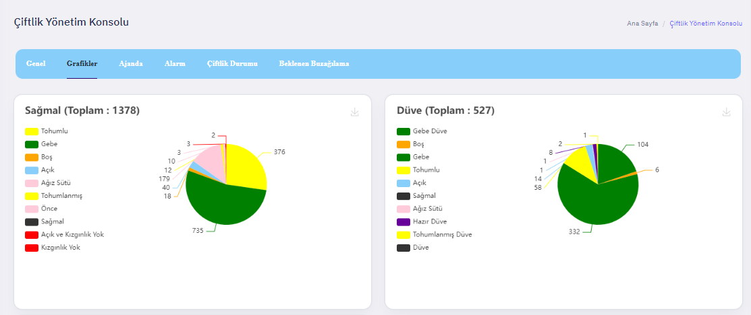

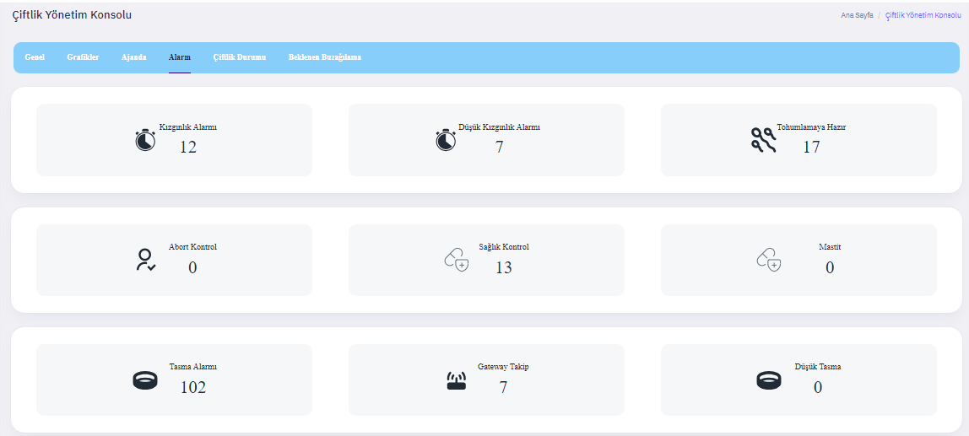

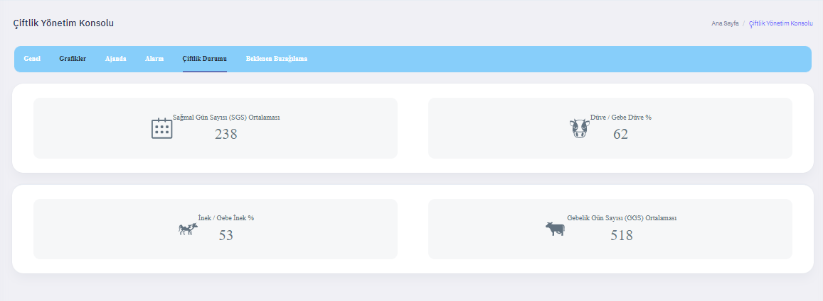

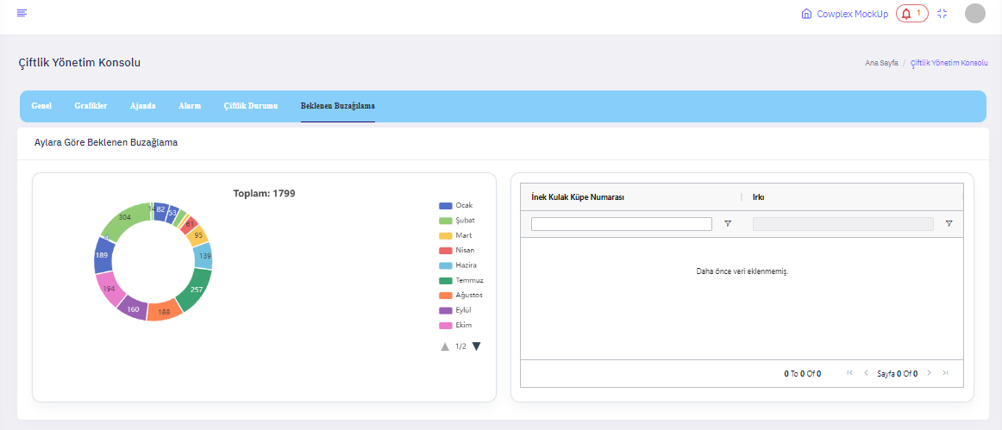

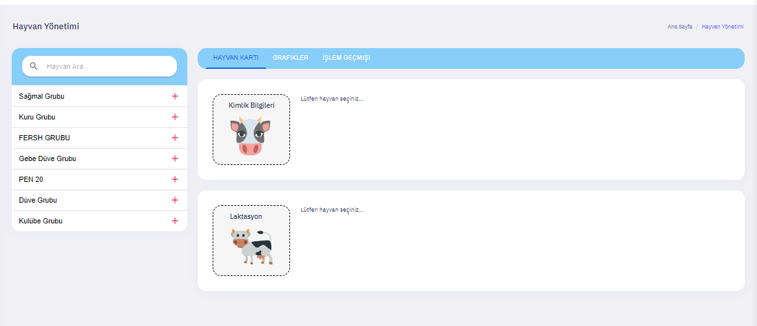

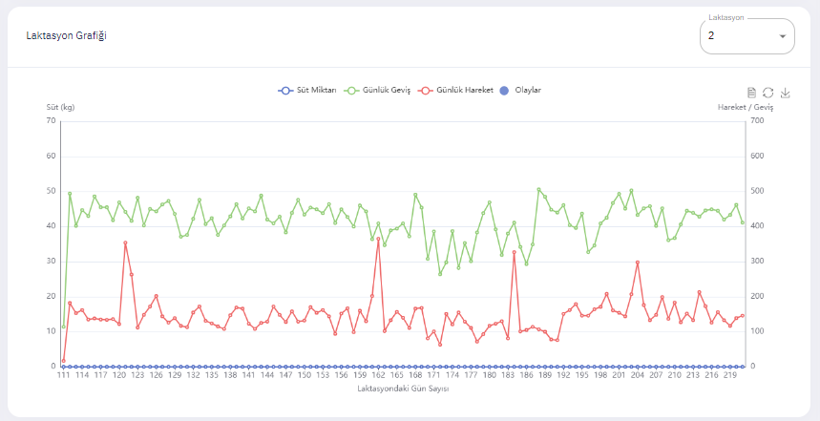

1. **Definitions, Acronyms and Abbreviations**

* **Smart Farm Management System:** A software solution designed to automate and manage the day-to-day operations of a farm, including animal health monitoring, milking data analysis, and feed management, leveraging modern technology to improve efficiency, productivity, and sustainability.
* **Health Monitoring:** The process of continuously tracking and analyzing the health status of farm animals to detect and address potential issues early.
* **Milking Data Analysis:** The collection and examination of data related to the milking process, including volume and time, to optimize milk production and animal health.
* **Feed Management:** The systematic approach to planning and controlling the amount and type of feed given to livestock, aimed at maximizing feed efficiency and nutritional value.
* **IoT:** Internet of Things. Refers to the network of physical objects embedded with sensors, software, and other technologies for the purpose of connecting and exchanging data with other devices and systems over the internet.
* **UML:** Unified Modeling Language. A standardized modeling language used to specify, visualize, construct, and document the artifacts of software systems.
* **API:** Application Programming Interface. A set of rules and specifications that software programs can follow to communicate with each other.
* **GPS:** Global Positioning System. A satellite-based navigation system used to determine the precise location of an object on Earth.
* **RFID:** Radio-Frequency Identification. A technology that uses electromagnetic fields to automatically identify and track tags attached to objects.

Abbreviations

* **DB:** Database. A structured set of data held in a computer, especially one that is accessible in various ways.
* **UI:** User Interface. The means by which the user and a computer system interact, in particular the use of input devices and software.
* **UX:** User Experience. Refers to a person's emotions and attitudes about using a particular product, system, or service.
* **SSL/TLS:** Secure Sockets Layer / Transport Layer Security. Cryptographic protocols designed to provide communications security over a computer network.

1. **Glossary and References**
2. Kumar, Garigipati & Jashuva, Pallikonda. (2021). SMART FARMING MANAGEMENT SYSTEM USING IOT. International Journal of Research in Science and Technology. 11. 10.37648/ijrst.v11i01.002.
3. G. B. N. Rao, K. V. Rao, R. Kamarajugadda, A. A. Reddy and P. P. Rani, "Smart Farming for Agriculture Management Using IOT," 2023 9th International Conference on Advanced Computing and Communication Systems (ICACCS), Coimbatore, India, 2023, pp. 540-544, doi: 10.1109/ICACCS57279.2023.10112839.