仪器准备：示波器、信号源、稳压电源、万用表、频谱仪

准备材料： 高性能洞洞板、面包板、麦克风、小音响
杜邦线 、电阻电容本、高带宽运放 如op095

运放系列：
https://item.taobao.com/item.htm?abbucket=5&detail_redpacket_pop=true&id=560901968411&ltk2=17502140716016wx442f2ndki4iod8comip&ns=1&priceTId=214783cf17502140602222234e19bd&query=%E8%BF%90%E6%94%BE&spm=a21n57.1.hoverItem.11&utparam=%7B%22aplus_abtest%22%3A%22dd9e5cddb4c0faee44e520468943ab52%22%7D&xxc=taobaoSearch

https://item.taobao.com/item.htm?abbucket=5&detail_redpacket_pop=true&id=547982281817&ltk2=1750214143920jyh25l26lwe4b4jlktaeuf&ns=1&priceTId=214783cf17502140602222234e19bd&query=%E8%BF%90%E6%94%BE&spm=a21n57.1.hoverItem.27&utparam=%7B%22aplus_abtest%22%3A%227c1bfa6d63d5bfd18e6cf0a523e0a43c%22%7D&xxc=taobaoSearch

https://item.taobao.com/item.htm?abbucket=5&detail_redpacket_pop=true&id=522624433394&ltk2=1750214214439xesp4t1sp3sx43s4xo9lt&ns=1&priceTId=214783cf17502141656457933e19bd&query=%E8%BF%90%E6%94%BE&spm=a21n57.1.hoverItem.45&utparam=%7B%22aplus_abtest%22%3A%228309f4e09ce266e30f65e27d97821aa8%22%7D&xxc=taobaoSearch

ADDA系列：
主要备用一些带宽50M左右，采样率200M左右的ADC和DAC

https://item.taobao.com/item.htm?id=649701998071&pisk=g9GsRzaadGj6aRFAlRYFOONRPOFjleRzBZaxrqCNk5FOhKnn7j7qkoPjcmibb-Kg_jiIDm1qQfPaHIEUl1UTXo3L9zUfM-h40j_iO01V_hviksN4M3-yaQui7SVv4AjnxySgyzz9gRCv95420yE3fQuiSob1DUkpaZsp5MbAHonY9JU8uSCTDoLQ9rUzM1eA62ELxkFYk1BO96U8WiUYHmBLJPzuDPBOBw3LyrNYDmeAvea0vPFYMbFRPr9_jVTNCcI50ETn7k1AMXapmu31qs4KtPT3qVrB2ecBZRZ-Wk1vqmZrsoZnwHJI-mDtbymXNHNmxxnYlDIp0R0xdDasb3s00f0ZGy01r_3QhlMK6J_AM2Fgc-Djfh6gXAoQEyedlQ4E4k3i6vTcvVnzf5ULLQLSJ-HEs8cwv1N-EVPZHmvPK5gxBWsy4_rWT86fR8fbRu8BRtXcdGISWI1IVY2T-PweRestnRU3Ru8BRtX0By4_YeTCXxf..&spm=a1z10.5-c-s.w4002-24156567526.25.36f7649bJxVsv2
https://item.taobao.com/item.htm?id=776309446656&pisk=gHoxRmameQAcHEnYEx8lsnvgLs9okUD4VjkCj5Vc5bh-9xqGIC7iyRGiadJ4mANt6bVrmKPM31htBxUbhSabN8waBswbhA6TCbqb7qVgi5EtQXpktHxn3xra5BAHxcEeNarbhRw_GdN7nR9uheK5MRqafBAOrGa2vllfG965law7aRe1GPG_NYwaN-w_ffN7PJw1clGs17a7CJbf5lNsF7NzLs__Glt7FJyh5Zws1Y98n7N_frGsFba9676bsG3nRnNu733OfGi8HzToh7Nzwd2bkgD0NGOIA-dUOxNRfGN0JkDnexAAYYqqbXeni3sx9vorw8GBXQEZaVG_BbtFsoungDz-ieOZEoeTRlaRCGM8cSzS4ktCw8uSnViqMOI_3mm3WWzJCGzgVD4IRjBwLYZbCfzEjBS4GAMEY2qpqZZIeVGKWg8rxDKIF6VLIZ9JeN7al8WfBXe2zQ-D38FHHhQN7zJzeWvJeN7al8y8tKpO7NzyU&spm=a1z10.5-c-s.w4002-24156567526.28.7304649bj5PWtj

https://item.taobao.com/item.htm?id=924254840312&ns=1&pisk=gyIZcD6bYlEaosR9SMtqTA7hNoK92nP5SiOXntXDCCAMCstVu_dIcRK_kn52Tsd65hAs0iRhE-n_BPLDg1KMkNOX1I-VH_yQNuZ5BOKvo7N7VVJsaEt-SK0iGXmHnnJiFYx3JOKvmSkImzZPB1p-KL3Dnp2ehKimosmcKXAphKcciCYntLJJmnfDok0HnLgmmcYM-JJ6hmvDIIDHKKpvIKfDmJRHFBADmFfcKbdlItmeFF2AguA3aXuBPQXMTmmred8ipO3j0mr6CFAk-HiDdMJw7QXGjdvYcpjCYUTIh5xhew1ML3rIS3XFo_7lMzgpbtbGMe5T92RC-w6cveMmS9S2_UjM8xoAUH9ciE7La09wfw8PbNextOfW_axOhYP1LU7eypYn3Vx1PTsvrGqZwBTJ31OCZumexEjzxjpHAJSA7j02SppeNJyePdmcggowLa3xkexJLQw6Cq3vSppeNJyEkqLHepR7Cd1..&priceTId=214784b317484822544726594e1ab0&skuId=5967934958418&spm=a21n57.sem.item.7.2edb3903o5uXEw&utparam=%7B%22aplus_abtest%22%3A%2281567b10e6c2afee36a97747552b280a%22%7D&xxc=ad_ztc
fpga系列：
主要备用一写ep4ceXX系列的fpga最小系统板。XX最好要大于15。开放引脚最好不少于40个，如果配备按键和数码管/led灯最好不过了。
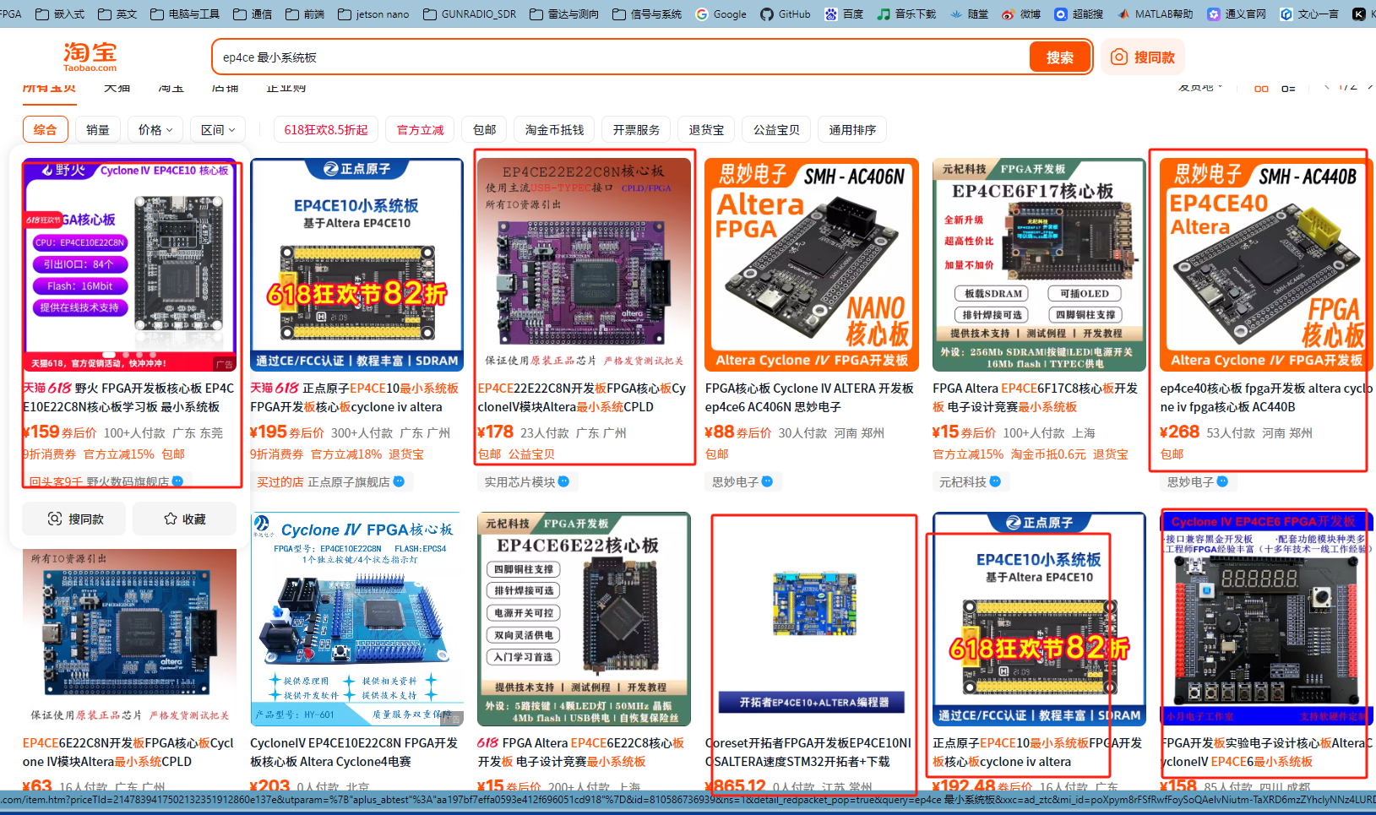
https://item.taobao.com/item.htm?id=793223584506&ns=1&pisk=gdPtcRDgJMjMGfVt-PWHmrRBFR7nM94w9lzWimmMhkELrk_ZnizjljEQmNoglGrYMDa4IAcsmxnbqo30sSVYLIUzu5bZiNla7jlfqgfoMPzZg96tKnF9RvgzRK9jl9cCfwIUugflZyBs7j4CqSD4Jb0trIGjCxOCODu9hhZjhBaIYquXfqO1JwnEon9jhItCO43k5jO6CDMIkqJ6cmg_RpiEljgsCoaCJqmIcbENDDTsmIek9UALD_WJMIFKWAnvimRxbWRoQ0_sYIdxXqDOIPipGINLdnnFzc6y-mliby0T0_RZ1xezoqEO6CZYzWrKRu1vZcaUr8Da1_J4SfmtO5wJlIaK6cMuGAxOv0NaR7lIK__8RWrg7WUDlsg3qDaa1jC5zfhsfX3UiMRsDJwbsAl2fgDalJEKWbszm7VRNyto2qv1Jwp23AgUdZZntRRfC83KqNCv3KkF82nlJwp23v7EJ0bOkKJqLw5..&priceTId=2147836a17502128008456804e1b27&skuId=5583453866752&spm=a21n57.sem.item.13.57d43903y7iBcj&utparam=%7B%22aplus_abtest%22%3A%2283038e7b6a16a310e1b35fe4bf27b358%22%7D&xxc=ad_ztc

https://item.taobao.com/item.htm?id=741263211090&pisk=g_TjbdfVV-2b9G_T1iczPVREhIb6CbuEc519tCU46ZQAB59J6oeYkGFRe1CTHGBZmds6QLj9uZR2FSYWdPzqnmAT5N7tLvuE8IAVSNHFqpRLd-fc613NMP3Ro1SwBP9t8IAcSSwtT33U1gWNmSEOBdQR21ChWPBOBb_RTs_TkGUY28BleNeABGCR21fh6lpTk_QR16zA6iIvw4CGeOQOHGhWwTf1WOh-hW1sctAjgFntKFi43I67WPL5wAXpGRaGwUfbc9AVFv3pPJjfpIB7WxIlDi61EeHrVQvMDK5kC2M5SLx9B198eASD6395GKkQIO8DgF1kGW4pNG6X2EI76PdRoOsMfKMbmtK2FMfR25ghapWJiEKSs8dvLt_AwguKOQI94EjHuYUfJHAVuhpiYubX6nQ54caFd4SQf7s35_6ENbZgjIMbUeW5dOXcD_ff4bG7HhjAZ_6ENbwvjiClGTlSN-KG.&spm=a21xtw.29178619.0.0

stm32f407系列：
最小系统板，板子上配套几个led等和按键更好啥的。
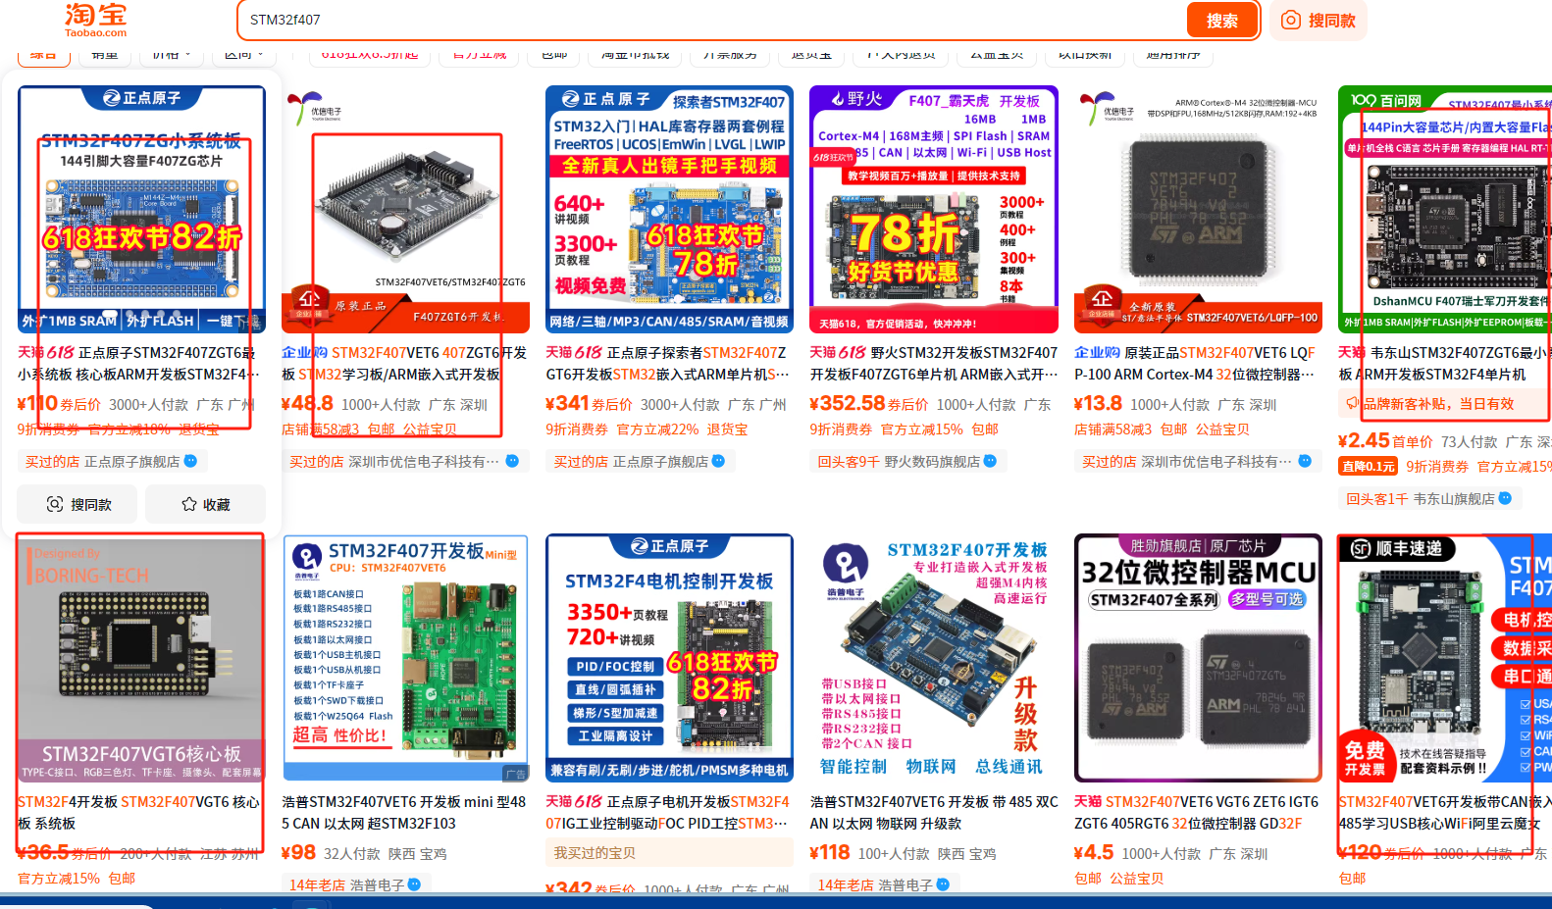

屏幕：
首推迪文屏（3-8寸都可以。）
Stm32f407的开发板如果自带屏幕也行。
竞赛前要学会自己驱动显示器。

