1、程控放大与AGC
https://item.taobao.com/item.htm?abbucket=5&id=746116824194&ltk2=17534873064262y8cav106eq0qviolw7g8&ns=1&spm=a21n57.1.hoverItem.2&utparam=%7B%22aplus_abtest%22%3A%224aff8c29bc883ca459fcbc517b16787c%22%7D&xxc=taobaoSearch
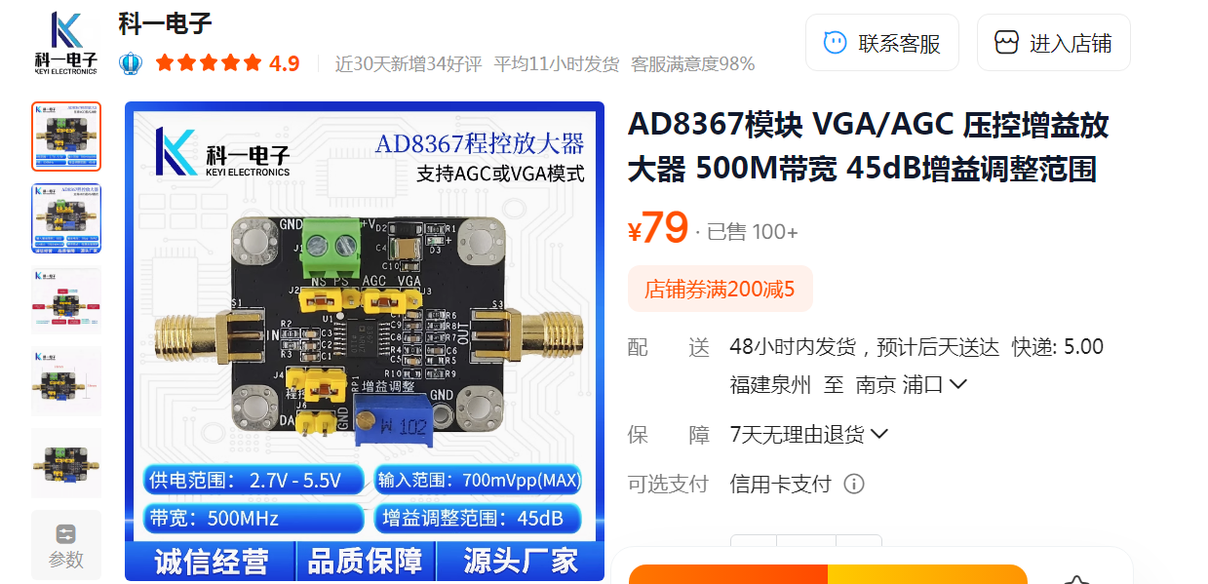
2、高速比较器
https://item.taobao.com/item.htm?abbucket=5&id=786212691421&ltk2=1753487523726t5ky1h7qtvliylhz8am8r&ns=1&priceTId=2147802b17534875042028093e1d3b&spm=a21n57.1.hoverItem.3&utparam=%7B%22aplus_abtest%22%3A%2217c0b873ac4696fde6b3a214915afc7a%22%7D&xxc=taobaoSearch
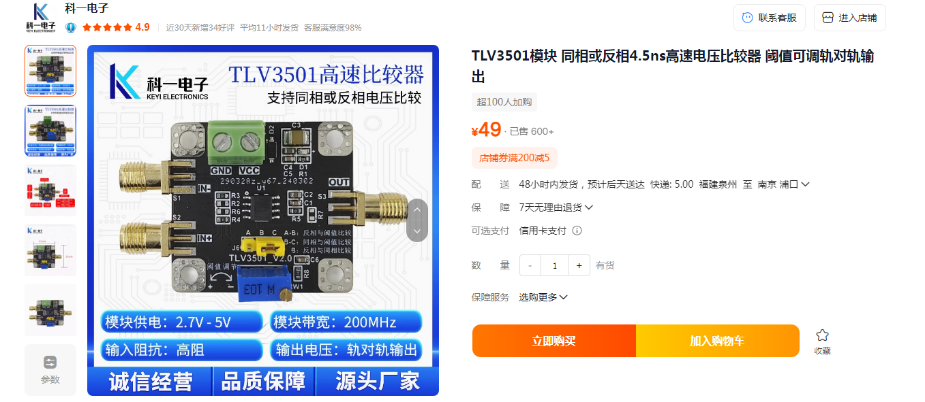
3、运算放大器
https://item.taobao.com/item.htm?abbucket=5&detail_redpacket_pop=true&id=560901968411&ltk2=17502140716016wx442f2ndki4iod8comip&ns=1&priceTId=214783cf17502140602222234e19bd&query=%E8%BF%90%E6%94%BE&spm=a21n57.1.hoverItem.11&utparam=%7B%22aplus_abtest%22%3A%22dd9e5cddb4c0faee44e520468943ab52%22%7D&xxc=taobaoSearch
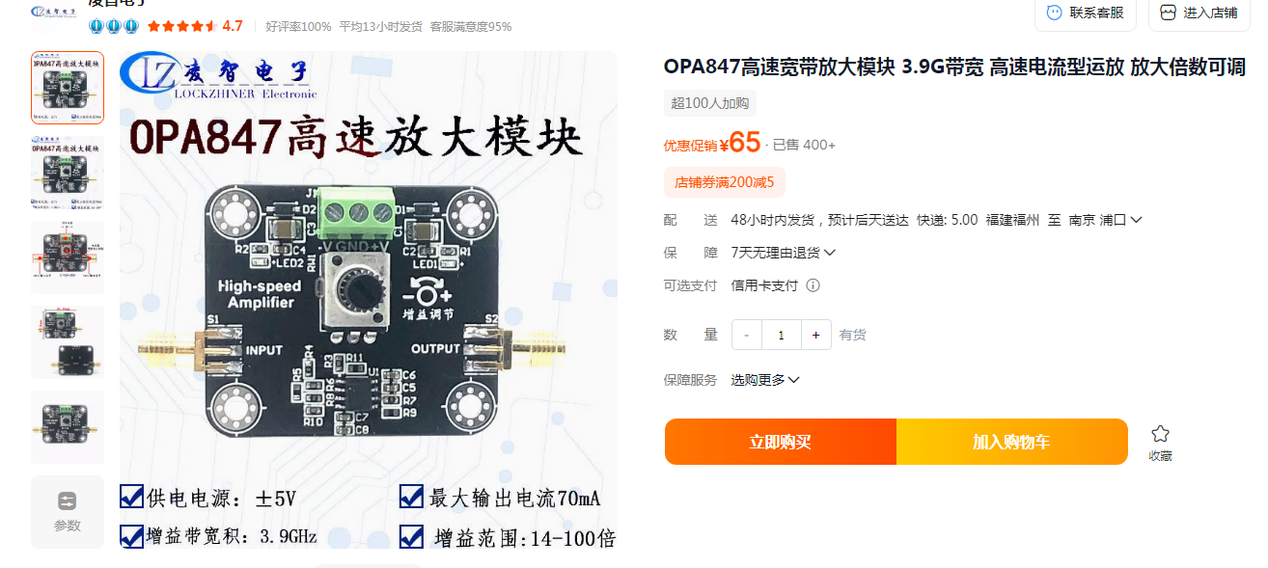
4、DAC模块
https://item.taobao.com/item.htm?id=924254840312&ns=1&pisk=gyIZcD6bYlEaosR9SMtqTA7hNoK92nP5SiOXntXDCCAMCstVu_dIcRK_kn52Tsd65hAs0iRhE-n_BPLDg1KMkNOX1I-VH_yQNuZ5BOKvo7N7VVJsaEt-SK0iGXmHnnJiFYx3JOKvmSkImzZPB1p-KL3Dnp2ehKimosmcKXAphKcciCYntLJJmnfDok0HnLgmmcYM-JJ6hmvDIIDHKKpvIKfDmJRHFBADmFfcKbdlItmeFF2AguA3aXuBPQXMTmmred8ipO3j0mr6CFAk-HiDdMJw7QXGjdvYcpjCYUTIh5xhew1ML3rIS3XFo_7lMzgpbtbGMe5T92RC-w6cveMmS9S2_UjM8xoAUH9ciE7La09wfw8PbNextOfW_axOhYP1LU7eypYn3Vx1PTsvrGqZwBTJ31OCZumexEjzxjpHAJSA7j02SppeNJyePdmcggowLa3xkexJLQw6Cq3vSppeNJyEkqLHepR7Cd1..&priceTId=214784b317484822544726594e1ab0&spm=a21n57.sem.item.7.2edb3903o5uXEw&utparam=%7B%22aplus_abtest%22%3A%2281567b10e6c2afee36a97747552b280a%22%7D&xxc=ad_ztc
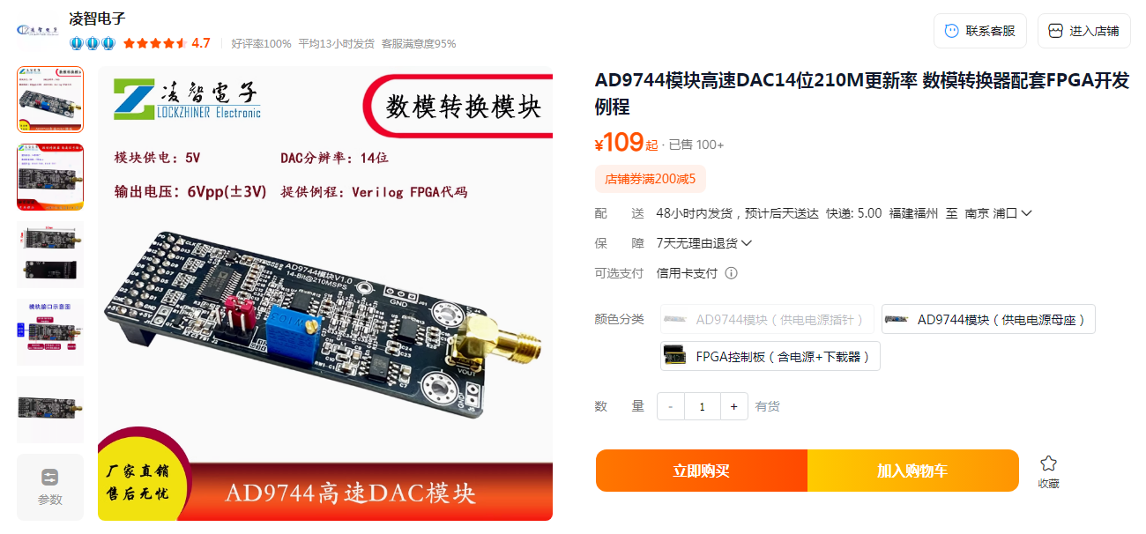
5、FPGA模块
https://item.taobao.com/item.htm?id=741263211090&pisk=g_TjbdfVV-2b9G_T1iczPVREhIb6CbuEc519tCU46ZQAB59J6oeYkGFRe1CTHGBZmds6QLj9uZR2FSYWdPzqnmAT5N7tLvuE8IAVSNHFqpRLd-fc613NMP3Ro1SwBP9t8IAcSSwtT33U1gWNmSEOBdQR21ChWPBOBb_RTs_TkGUY28BleNeABGCR21fh6lpTk_QR16zA6iIvw4CGeOQOHGhWwTf1WOh-hW1sctAjgFntKFi43I67WPL5wAXpGRaGwUfbc9AVFv3pPJjfpIB7WxIlDi61EeHrVQvMDK5kC2M5SLx9B198eASD6395GKkQIO8DgF1kGW4pNG6X2EI76PdRoOsMfKMbmtK2FMfR25ghapWJiEKSs8dvLt_AwguKOQI94EjHuYUfJHAVuhpiYubX6nQ54caFd4SQf7s35_6ENbZgjIMbUeW5dOXcD_ff4bG7HhjAZ_6ENbwvjiClGTlSN-KG.&spm=a21xtw.29178619.0.0
