








Computer Programming (Python)
Experimental Report



Course Name Computer Programming (Python)
Project Name Schedule Management System (SDMS): UI Design and Implementation
Student Name Liu Junjie
Student ID 202583910015
Major Applied Computing
College Nanjing University of Information Science and Technology
Teacher Wu Quan

Date: October 21, 2026

Contents
Abstract 2
Chapter 1 Introduction 4
Chapter 2 Requirements Analysis 7
Chapter 3 Team Division of Work and the Author’s Responsibilities 11
Chapter 4 Overall Design 14
Chapter 5 Detailed Design 26
Chapter 6 UI State Design 35
Chapter 7 Exception Handling and Human-Computer Interaction 40
Chapter 8 Test Plan and Verification 43
Chapter 9 Engineering Implementation and Code Organization 58
Chapter 10 Progress, Issues and Risks 62
Chapter 11 Division of Work and Contribution Statement 65
Appendix A Figure List 67
Appendix B Terms and Abbreviations 69

Abstract
This report is the individual design document of one member of a three-person course project, the Schedule Management System (SDMS). Its author, Junjie Liu, served as the UI owner and the owner of usability verification. The report is built around the design of the graphical interface: requirements analysis, the overall architecture and the position of the UI layer within it, the main-window layout and the detailed design of three core UI components, the UI state model, exception handling and prompt strategy, the test and manual acceptance plans, and the author’s own task breakdown, progress and risk log.
Unlike the other two reports in the team, this document concentrates on how the interface is organised, how users operate it and how the interaction is verified. The architectural layering, the domain model and the complete definition of the service interface are authoritative in the shared team documents docs/design/contracts.md and docs/design/architecture.md. This report only cites their conclusions; it neither sets its own standard nor re-derives them.
All 19 figures in this report (flow charts, diagrams, statistical charts, measured output records and real runtime screenshots) were produced by the author, and their source files and generation methods are traceable.
On the question of how much is actually implemented, this report deliberately states three distinct levels instead of hedging:
- The core logic of the UI layer is in place: the controller, the presenters and their port protocols do not depend on Qt, and are covered by 75 unit tests;
- The availability of the PySide6 and Qt environment has been measured (Section 8.7); the versions measured on Windows are PySide6 6.12.0 / Qt 6.12.0;
- The interface is no longer a set of wireframes: Section 4.5 and Chapter 5 present screenshots of the program actually running (five of them, reproducible with one command, scripts/shoot_ui.py), and 44 acceptance assertions are executed automatically by that script (Section 8.3.1).
At the same time, the state of implementation has to be stated precisely. Persistence has since landed: schedules live in a SQLite database (by default under %LOCALAPPDATA%\sdms\schedules.db) behind infrastructure/sqlite_repository.py, wired at start-up by the composition root in composition.py, so data survives closing and reopening the program. Acceptance item V-14 is therefore exercised end to end by the integration tests instead of on an in-memory stand-in. On Windows the full gate is green: 431 pytest cases, ruff over 74 files, mypy over 50 files, and 44 assertions in the UI acceptance script.

Chapter 1 Introduction
This chapter sets out the project background, the design goals and the terminology conventions, explains the scope and boundaries of this report, and reports the measured development environment, providing a shared context for the chapters that follow.

1.1 Project Background
Schedule management is a frequent need in daily life and study. The course requires a simple graphical schedule management system written in Python that supports adding, viewing, updating and deleting schedules and gives friendly prompts for illegal operations. The task itself is modest in size, but it demands a minimal closed loop across three layers (interface, business and data), which makes it a good single exercise in layered design, event-driven programming, exception handling and teamwork.
The team has three members and works by dividing responsibilities by layer and cross-reviewing each other’s work: one member owns the domain and application layers, one owns persistence and the test foundation, and one owns the interface and usability verification. The author of this report, Junjie Liu, is responsible for the third part.

1.2 Design Goals
The goals of this design can be summarised in four points:
- Functionally usable: all six functional requirements set by the course are implemented in full, so that a user can complete the create, view, update and delete loop without friction.
- Clear responsibilities: the UI layer does only what a UI layer should do. It collects input, displays results and manages interaction state, while business rules and data access belong to the domain layer and the storage layer respectively. This single point determines whether the system is testable and whether three people can work in parallel.
- Verifiable behaviour: every UI behaviour must have a definite way of being verified. Whatever can be covered by automated tests (state evaluation, error mapping, not calling the service when nothing is selected) is written as a unit test; whatever can only be checked by a human (modal dialogs, calendar rendering across months) is written as an acceptance checklist with steps and expected results.
- No crashes on exceptions: every illegal input or failed operation must produce a comprehensible prompt, the program must remain operable, and no raw stack trace may ever reach the user.

1.3 Terms and Conventions
Term | Meaning
Schedule | A single record in the system, made up of four fields (title, date, time and notes) plus a unique identifier
schedule_id | A stable identifier generated by the service layer and stored as text; UI rows bind to this identifier rather than to a row number
UI layer (ui) | The set of modules that own windows, widgets, event wiring and interaction state
Application layer (application) | Owns use-case orchestration (create, query, update, delete) and the service interface
Domain layer (domain) | Owns the business meaning and invariants of a schedule (for example, a title must not be empty once trimmed)
Infrastructure layer (infrastructure) | Owns the persistence implementation, which in this project is a SQLite adapter
Bootstrap | The single place where storage, services and the interface are constructed; owns dependency injection and resource teardown
Contract | The interface agreement shared by the team; once frozen, each layer develops against it in parallel
Empty state | The guiding state presented by the interface when no record exists under the currently filtered date
In this report, F-01 to F-06 are requirement IDs, V-01 to V-16 are manual acceptance step IDs, and P01 to P12 are team task-card IDs; the three sets come from the requirements baseline, the author’s interaction specification and the team work-division plan respectively.

1.4 Scope and Boundaries of This Report
Reading guide. Everything in this volume is the author’s own work: the requirements breakdown, the UI layer design, the state model, the exception handling and the verification plan are all his, and every figure was made by him. Where a chapter depends on material produced with teammates, the shared part is named in Section 11.2 and reproduced only as far as this report needs it. To avoid duplicating the other reports, what this document does and does not cover is stated explicitly here:
Covered here: the understanding and decomposition of the requirements, the position of the UI layer in the overall architecture and its dependency rules, the layout and component design of the interface, the state model, interaction rules, exception prompt strategy, the test and acceptance plans, and the author’s own work log and risks.
Not covered here: SQLite table structures and SQL statements (xhy’s document), and the derivation of domain invariants together with the complete service interface signatures (zch’s document). Wherever such material is relevant, this report cites the conclusion and names its source.

1.5 Development Environment
The interface was developed and accepted on Windows; the measured environment is as follows:
Item | Version / Result
Operating system | Windows 11 (Windows-11-10.0.26200-SP0)
Python | 3.12.14 (interpreter managed by uv)
uv | 0.12.13
GUI framework | PySide6 6.12.0 (Qt 6.12.0), package directory 646.7 MB
Dependency installation | uv sync, 15 packages in total
Tests | uv run pytest -q → 117 passed
Static checks | ruff check passes in full; ruff format --check reports 37 files already formatted
Type checking | mypy src tests → Success: no issues found in 18 source files
Running the interface | uv run python -m schedule_management.ui.app opens the window correctly; all eight assertions in scripts/shoot_ui.py pass
One remark on platform scope is needed, because this point changed once while the report was being written: the target platform has been narrowed to Windows. This was a scheduling decision confirmed by the team during review, and no GUI adaptation is done on the Linux side. The cost is that the question of Qt font-metric differences on Linux is left unanswered: whether the same layout would drift on another platform has not been verified by anyone, and nobody has committed to it. Layout is therefore delegated to the layout managers as far as possible, so that less debt remains if that end is ever taken up (see Section 8.5). The command-line parts (tests, type checking, lint) are platform-independent and can be run by any member on any system.

Chapter 2 Requirements Analysis
This chapter turns the task description given by the course into numbered functional requirements, adds non-functional constraints and scope boundaries, and maps requirements onto design elements, forming the basis for the design and acceptance that follow.

2.1 Original Requirements
The task description contains six requirements:
- User interface: design an intuitive and friendly interface containing a schedule list, a calendar selector and function buttons (add, view, update, delete and so on).
- Adding schedules: users can enter a title, date, time, notes and other information through the interface and save it to the system.
- Viewing schedules: users can pick a date in the interface, see all schedules of that day, and have them displayed in the interface.
- Updating schedules: users can select a schedule and modify each of its fields in the interface.
- Deleting schedules: users can select a schedule and delete it, with the deletion kept safe and accurate.
- Error handling: illegal operations or exceptional situations produce friendly prompts.
Several hints are given as well: the GUI may use libraries such as PyQt or Tkinter; visual quality and user experience should be considered; exceptional situations should be handled; the datetime library may be used for dates and times; a calendar selector may be added to the interface; and data may be organised with lists or dictionaries. The delivery requirements also include one Word design report per member, with at least 20 pages of body text, containing flow charts, diagrams, statistical charts and test screenshots; and they require that “if third-party packages are used, put them in the lib subdirectory under src”. After the technology choice changed to PySide6, that requirement became a compliance item that had to be handled explicitly; see Section 4.4.

2.2 Functional Requirements Breakdown
The requirements above are organised into numbered functional requirements, each with its own acceptance direction, so that testing and acceptance can be checked item by item:
ID | Requirement | Meaning | Acceptance direction
F-01 | Graphical user interface | The main window contains a calendar area, a schedule list and function buttons | All widgets present, today selected by default, month switching works
F-02 | Add schedule | Enter title, date, time and notes, then save | After a successful save the entry appears in the list immediately; on failure the entered content is preserved
F-03 | View schedules | Show all schedules of the selected day | After switching dates the list content and count update together; an empty state is shown when there are no records
F-04 | Update schedule | Select a record and modify its fields | The identifier is unchanged after the update; if the date changed, the list refreshes under the new date
F-05 | Delete schedule | Delete the selected record safely and accurately | There is a confirmation step; a prompt appears when nothing is selected; cancelling changes no data
F-06 | Error handling | Illegal input or exceptional operations produce friendly prompts | The specific cause and a suggested correction are shown; no raw stack trace appears; the program stays operable
Among these, the safety and accuracy of F-05 carry the densest set of interaction rules in this design and are also the easiest to get wrong; Chapters 5 and 6 develop them in detail.

2.3 Non-functional Requirements
Beyond functionality, the following non-functional constraints were agreed for this design:
- Platform and language: implemented in Python 3.12 without changing the scope of the task; the target platform of the GUI is Windows (no Linux adaptation was confirmed during review), and the command-line tools run on any platform.
- UI framework: the GUI uses PySide6 (Qt for Python), with the version pinned by uv.lock to the then-latest stable release. The reason is that native widgets look markedly better than the standard-library Tkinter/ttk, and Qt ships a calendar widget, so details such as month switching, leap years and the first day of the week need no custom drawing. The cost is that dependencies is no longer empty and environment setup gains one uv sync step; see Section 4.4.
- Minimal dependencies: no third-party package beyond PySide6; date and time handling uses the standard datetime library throughout, with no hand-rolled string comparison; persistence uses the standard sqlite3 library, with no ORM.
- Testability: UI-layer logic such as state evaluation, error mapping and input pass-through must be testable without launching a window.
- Maintainability: creation and update share one form implementation so the two code paths cannot drift apart over time; user-facing strings are kept in one place instead of being scattered across callbacks.
- Collaboration rules: no direct pushes to the main branch; development goes through branches plus pull requests; commit messages follow one agreed format.

2.4 Mapping from Requirements to Design Elements
To avoid the situation where a requirement exists in the document but not in the code, the six requirements are mapped below, one by one, onto design elements and verification means:
Requirement | Main design element | Main verification means
F-01 | The top toolbar, calendar grid, list and status bar of the main window | Manual acceptance V-01, V-07
F-02 | The shared form, the date-picker overlay, and the success and failure write branches | Manual acceptance V-02 to V-04, V-15, V-16
F-03 | Per-day query, list refresh, empty state | Manual acceptance V-05, V-06
F-04 | The prefill branch of the shared form, retention of the identifier, and handling of date changes | Manual acceptance V-08, V-09
F-05 | Delete confirmation, the nothing-selected check, and the cancel branch | Manual acceptance V-10 to V-12; unit tests assert the number of service calls
F-06 | Exception classification and prompt mapping, field-level prompts | Manual acceptance V-13; unit tests cover the error mapping

2.5 Scope Definition
The following are explicitly out of scope, so that scope does not creep later: account login and permissions, a network backend and cloud sync, real-time collaborative editing, notifications and push messages, recurring-schedule rules, complex time-zone handling, an ORM framework, and a plugin mechanism. These enhancements will not be considered before the basic closed loop is complete.
Beyond the base requirements, the team agreed to include one engineering enhancement: local persistence with SQLite, so that data survives a restart. The original task does not require this, so whenever it counts towards the deliverable this report labels it an engineering enhancement and never presents it as a course requirement.

Chapter 3 Team Division of Work and the Author’s Responsibilities
This chapter explains why the team divided work by layer rather than by feature, lists the five task cards the author owns, and records the cross-review arrangement and the collaboration conventions, so the reader can attribute each part of the later chapters to its owner.

3.1 Overview of the Three-Person Division
The team divides responsibilities by layer: each member owns one layer and is also responsible for reviewing the adjacent ones.
Member | Role | Primary scope
zch | Team lead / technical owner | Requirement freeze, architecture and contracts, the domain layer, the application layer, the bootstrap entry point, and final integration
ljj (the author) | UI owner / usability verification | UI prototypes and interaction design, the UI-layer implementation, unit tests for the controller and presenters, and GUI acceptance
xhy | Persistence owner / test foundation | The SQLite adapter, storage contract tests, test doubles, and reliability and rollback verification
The reason for dividing by layer rather than by feature is this: dividing by feature (one person doing add, another doing delete) would make everyone touch interface, business and SQL code at the same time, which invites conflicts and makes tests hard to reuse. Dividing by layer keeps each layer’s boundary and its testing means naturally separate: the interface can advance on test doubles independently of the database, which is exactly why this project could finish the interface design before the contract was frozen.

3.2 The Author’s Task Cards
The author owns five task cards in the team plan:
ID | Content | Prerequisite | Delivery branch
P02 | UI sketches and the interaction specification, delivered to docs/figures/ | None; can run in parallel with other tasks | docs/ui-flow
P09 | ui/controller.py, ui/presenters.py and their unit tests | Contract frozen, domain model available (a test double is used first) | feature/schedule-ui
P10 | ui/app.py, ui/schedule_form.py, ui/calendar_view.py | P02 and P09 | feature/schedule-ui
P11 | Joint debugging by all three members (bootstrap entry point and end-to-end flow tests) | Application, storage and UI layers all complete | —
P12 | The individual design report and UI acceptance screenshots | Collected continuously throughout all stages | —
P02 is the only task card without a prerequisite, so it became the first piece of work the author started, and it is also the source of the figures in Chapters 4 to 7.

3.3 Cross-Review Arrangement
The team agreed on cross-review, and review does not transfer responsibility away from the author:
- the author’s pull requests are reviewed by zch, focusing on whether the dependency directions and the use-case wiring are correct;
- xhy verifies how the empty state, illegal input and failed interactions actually behave, following the acceptance steps;
- in return, the author reviews zch’s service interface for whether it is usable for interaction (for example, whether the error types are rich enough for the interface to produce a meaningful prompt).

3.4 Collaboration Conventions
The team has firm rules about how to collaborate, and the author followed them strictly:
- no direct pushes to the main branch, and every change goes through its own branch plus a pull request;
- commit messages follow the “<type>(<scope>): <description>” format, for example docs(ui): add UI sketches and interaction notes;
- pull request descriptions follow one template with five parts: what was done, why it was done, how to verify, screenshots or materials, and caveats;
- after opening a pull request, a suitable reviewer is invited explicitly rather than merely pinged;
- and no commit, push, merge or issue closure is performed without the author’s explicit confirmation.

Chapter 4 Overall Design
Starting from the overall architecture, this chapter describes the layered structure and its dependency rules, the position of the UI layer within it and the breakdown of its internal modules, and then explains the rationale for the technology choice and the overall layout of the interface.

4.1 Architectural Layering and Dependency Rules
The system is a lightweight layered monolith: the domain layer defines what a valid schedule is, the application layer orchestrates the four use cases (create, query, update and delete), and the UI layer and the storage layer act as external adapters to the user and to the database respectively.

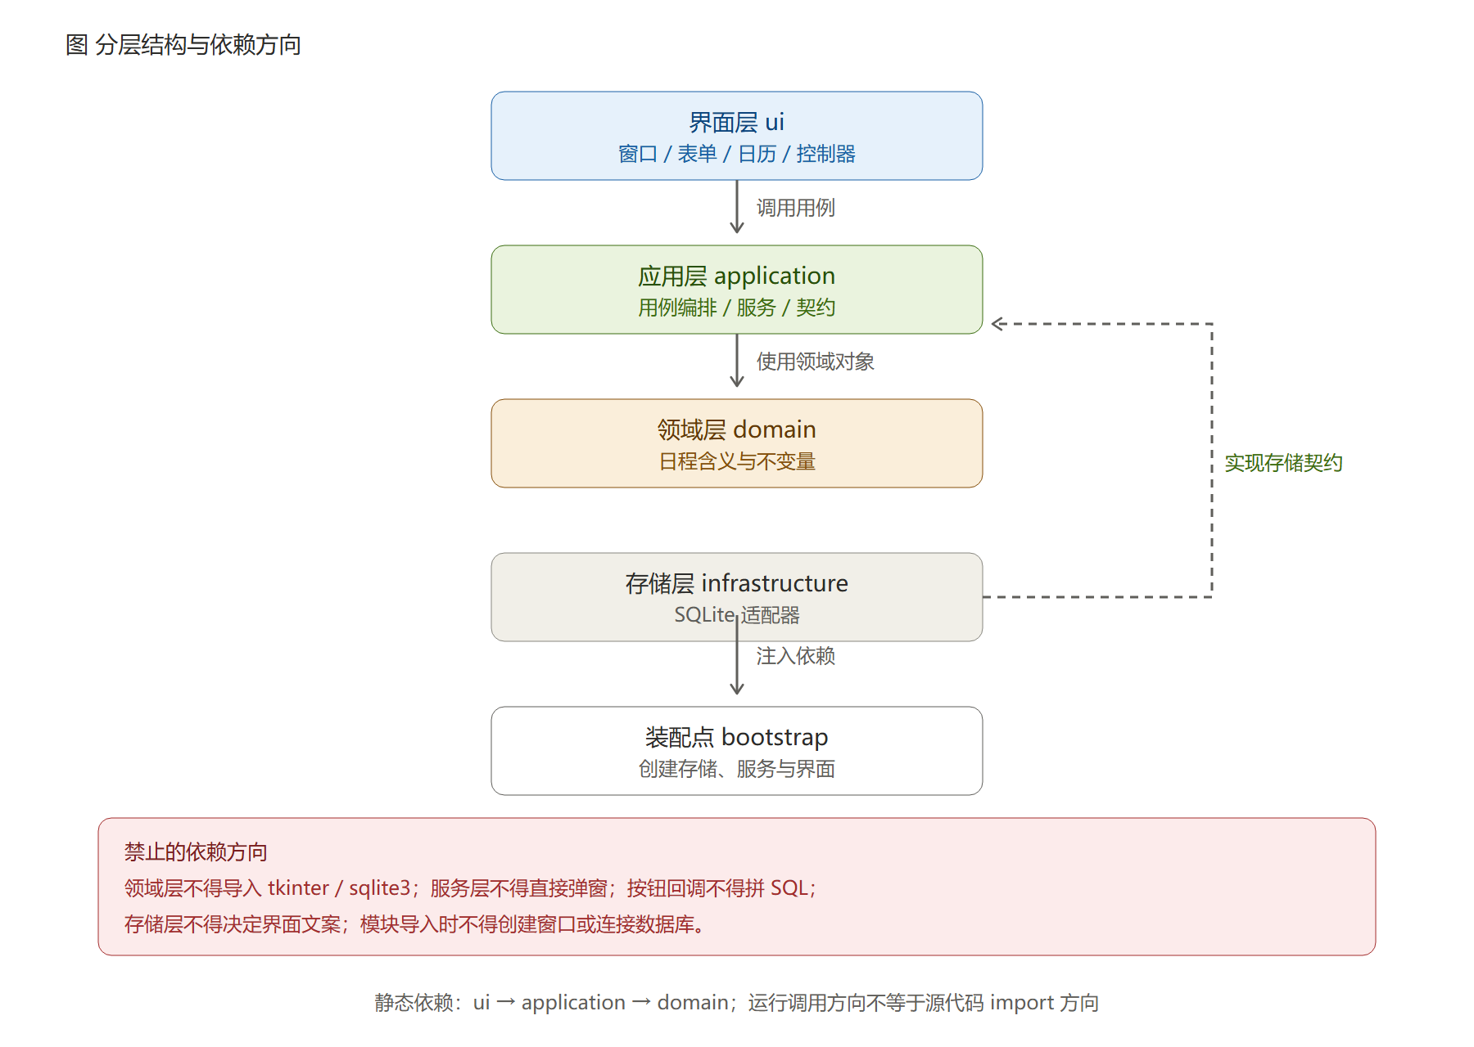
Figure 4-1 Layered structure and dependency direction
Figure 4-1 shows the permitted dependency directions among the four layers: the UI layer calls the use cases of the application layer, the application layer uses domain objects, the storage layer implements the storage contract defined by the application layer, and the bootstrap point creates the concrete objects and injects them. Note that the runtime call direction differs from the import direction of the source code: at runtime the interface calls the service and the service reads and writes data through the injected storage object, whereas in the source code the storage layer depends on the contract interface defined by the application layer, inverting the dependency so that the service layer never needs to know that SQL exists.
Figure 4-1 also lists the dependency directions that are explicitly forbidden. These prohibitions are the substance of the layered design, not a slogan:
- the domain layer must not import PySide6 or sqlite3: business rules should not know that an interface or a database exists;
- the service layer must not raise dialogs itself: prompting is the interface’s job, and the service only raises meaningful error types;
- button callbacks must not assemble SQL: data access may appear only inside the storage adapter;
- the storage layer must not decide interface wording: the database should not care what the user reads;
- importing a module must not create a window or open a database connection, otherwise tests and tools would trigger side effects merely by importing.
Abstraction is introduced in exactly one place: the storage contract. The team agreed that a single ScheduleRepository protocol suffices, with no generic CRUD framework, dependency-injection container or unit of work. Whether to abstract depends on a real need to substitute and to test, not on formal completeness.

4.2 Responsibilities of Each Layer
Layer | Responsible for | Not responsible for
UI layer | Widget layout, event wiring, the date-selection entry point, maintenance of interaction state, and turning backend conclusions into prompts | Deciding business rules, the final say on whether input is valid, and any data access
Application layer | Orchestrating use-case flows, generating stable identifiers, and turning storage results into meaningful errors | Interface wording, concrete SQL
Domain layer | Field semantics and invariant validation of a schedule | Persistence, the interface
Infrastructure layer | Parameterised reads and writes, transaction commit and rollback, exception translation, connection management | Deciding business validity
Bootstrap | Creates storage, services and the interface, injects the dependencies, and owns resource teardown | Carrying business logic

4.3 Breakdown of the UI Layer’s Internal Modules
The UI layer is itself split by responsibility, so that all the logic does not end up in a single window class:

Module | Responsibility | Touches Qt?
app.py | Program entry point: the process’s single QApplication is created only here, together with dependency injection (currently injecting the development stand-in service) | Yes
main_window.py | The QMainWindow itself: the four-part layout, the six buttons in the top toolbar, and the status and selection prompts at the bottom; it is the adapter implementation of MainViewPort | Yes
calendar_view.py | Presents the month grid with QCalendarWidget, handles month switching, spill-over days of adjacent months and leap years, and starts the week on Monday as is customary in China | Yes
date_picker.py | The date-picker overlay used inside the form, a QCalendarWidget internally; it shares the same date-marking painting code as calendar_view.py | Yes
schedule_form.py | The form shared by creation and update, differing only in the window title and whether it is prefilled; the date uses a QLineEdit plus a “Pick” button and performs no date validation at all | Yes
controller.py | Selection-state management, passing interface input to the application layer, and turning errors returned by the backend into prompts. Every interaction rule lives in this layer | No
presenters.py | Display formatting, count wording and the mapping from errors to prompts, all implemented as pure functions | No
view_models.py | The interface’s own data envelopes: list rows, form drafts and the context for opening a form; they contain no widgets and no business rules | No
ports.py | The three port protocols between the interface and the outside world (ScheduleLike, ScheduleServicePort, MainViewPort) | No
The “Touches Qt?” column is not an aside but a first-class constraint: the four lower modules may not touch Qt in a single line, enforced by the 33 AST guards described in Section 8.2. The benefit of this arrangement was cashed in immediately while this report was being written: when the windows were built in P10, not one interaction rule had to change, and only five adapter modules were added.
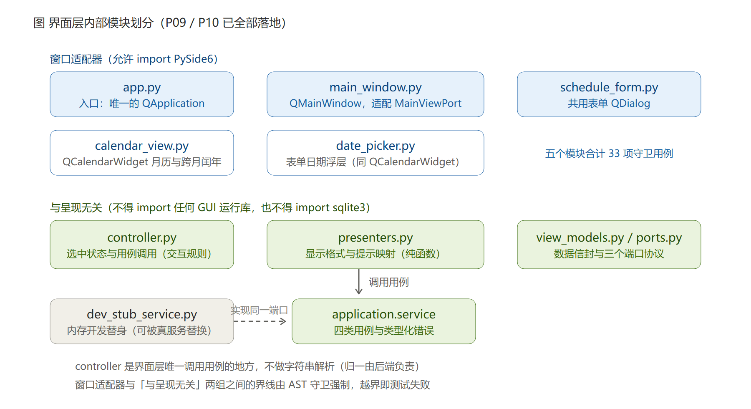
Of the four lower modules, view_models and ports were added during actual coding; see Section 5.5 for why. In Figure 4-2 one dashed line points at tests/fakes.py, indicating that the UI layer’s unit tests use in-memory test doubles instead of real SQLite storage. The significance is that UI development and testing depend neither on the storage layer nor on how complete the contract is: during P09 the test doubles in tests/unit/ui_fakes.py were enough, and P10 went further — src/schedule_management/dev_stub_service.py lets the whole program really open, really operate and really take screenshots with no backend at all.

4.4 Technology Selection and Rationale
UI framework: PySide6 (Qt for Python). This was settled by the team on 14 October 2026: use PySide6 at the then-latest stable version, mainly because native widgets look markedly better than the standard-library Tkinter/ttk, and the task explicitly asks in its hints section that visual quality and user experience be considered, which was given top priority in the choice. The version policy declares PySide6>=6.11.2,<7.0 in pyproject.toml and pins the actual version in uv.lock; when this report was finalised the latest stable release on PyPI was 6.12.0 (released 8 October 2026, requiring Python >=3.10,<3.16, so this project’s 3.12.x lies within the supported range).
PySide6 was chosen over PyQt6 for licensing reasons rather than functional ones: the APIs are essentially the same, but PyQt6 requires a commercial licence outside GPL scenarios, whereas PySide6 is Qt’s official binding and can be used under the LGPL-3.0-only terms.
There are two costs, both stated here: first, dependencies is no longer empty and environment setup gains one uv sync step (about 650 MB the first time, seconds once cached); second, a third-party package is now involved, so where it is submitted has to be handled according to the course requirements (see below). There is a reverse benefit as well: Qt ships QCalendarWidget, so the hand-drawn month grid that had been designed to avoid a third-party dependency is no longer needed, which removes a block of hand-written code and lets the widget guarantee the month-switching, leap-year and week-start edge cases.
Compliance for the third-party package (pending the team lead’s confirmation). The document requirements in Requests/日程管理系统.md state that “if third-party packages are used, put them in the lib subdirectory under src”. After the switch to PySide6 this requirement has a concrete, quantified basis: on this machine the installed package directory occupies 646.7 MB (including the Qt runtime and optional components; the probe script and full output are in Section 8.7), and the binary extensions in it are bound to a platform, so copying a full Qt runtime from one platform into src/lib/ is useless on another and the submission would be too large to upload. This report currently treats it as “put the source, version, licence statement and dependency list under src/lib/, and install for real via uv sync”, with the final arrangement to be unified once the team lead confirms it with the instructor.
It should be noted that every layout, state model and acceptance step described in this document is independent of any particular framework: should Tkinter have to be restored for environment reasons, only the widget names change, while the state model and interaction rules still apply. That is precisely why this material is written as a document rather than buried in code.
Date and time handling: datetime. In memory, datetime.date and datetime.time objects are used uniformly, and the strings seen in the interface exist only at the moment of input or display. The direct benefit is that comparison, sorting and month arithmetic are all guaranteed correct by the standard library, avoiding the boundary errors that hand-written string parsing introduces.
The various ways users write input are parsed uniformly by the backend. The date field offers a calendar overlay for picking and also allows direct typing. For forms such as 2026/10/15 or 2026.10.15 with different separators, the interface does not raise “invalid format”; it passes the raw text to the backend, which performs recognition and normalisation, and only when the backend genuinely cannot recognise it does the interface present the reason given by the backend. Placing this leniency in the backend rather than the interface means the same rules serve the GUI and any other entry point, and there is no inconsistency of the form “the interface blocked it but the backend would have accepted it”, or the reverse.
The date widget is no longer hand-drawn. The earlier plan of generating a date grid with the calendar module and rendering it with ttk rested on the premise dependencies = [], which disappeared once PySide6 was introduced; the main-window calendar and the form overlay now both use Qt’s own QCalendarWidget.
One easily missed detail deserves attention: the date input box is a freely editable QLineEdit, not a QDateEdit. The latter first performs a strict validation against its own display format, rejecting forms such as 2026/10/15 or 15 October before submission, which drags the decision about what is valid back into the UI layer and directly conflicts with the division of responsibilities described in the previous section. A widget choice can affect architecture too, and this is one concrete example in this design.
Persistence: SQLite. It is supported by the standard library, its transaction support is more reliable than hand-written file overwriting, and a single file is easy to carry and back up. The first version targets single-user local use only and makes no claim about multi-user concurrency.

4.5 Overall Layout of the Interface
The main window uses a four-part structure: a top toolbar, a calendar on the left, a list on the right, and a status bar at the bottom.

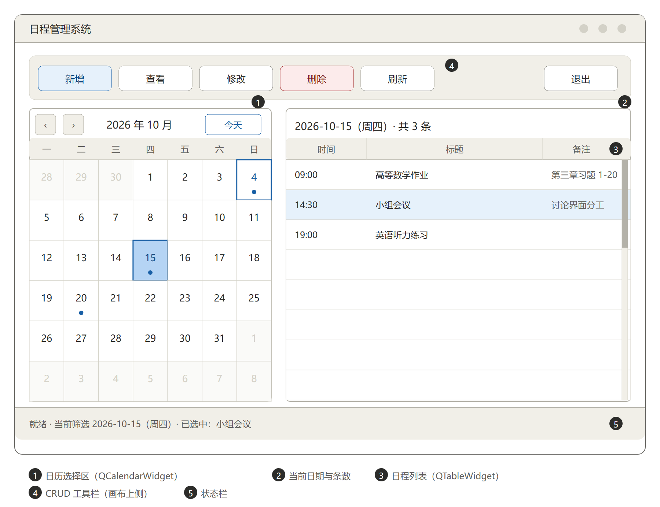
Figure 4-3 Wireframe of the main window
The numbered areas in Figure 4-3 and their responsibilities are as follows:
No. | Area | Widget | Responsibility
1 | Calendar area | QCalendarWidget | Shows the month grid, switches months, returns to today and marks dates that have schedules; the week starts on Monday
2 | Current-date bar | QLabel | Shows the currently filtered date and the number of schedules on that day
3 | Schedule list | QTableWidget | Three columns showing time, title and notes; each row binds the schedule identifier through Qt.UserRole
4 | CRUD toolbar | QToolBar + QPushButton x 6 | Add, view, update, delete, refresh and exit, all placed above the canvas
5 | Status bar | QStatusBar (containing a QLabel) | Shows the result of the most recent operation and the current selection
Four layout constraints run through the rest of the design:
- Operation buttons on top. All six CRUD buttons go into the top toolbar, not at the bottom of the window; the toolbar is the first place a user looks after opening the window, and only a fixed position lets operating habits form. 2. Row identity kept separate from display. The list shows formatted text, but every row must be bound to a schedule identifier. Looking a record up by row number or by title is forbidden: titles may repeat, and row numbers shift with sorting, so neither can serve as an identifier.
- First launch shows the current day. Even when the database is empty there must be a clear empty-state guide, rather than a blank area that makes users suspect the program is broken.
- The calendar must cover adjacent months and leap years. Dates from neighbouring months appear as greyed leading and trailing days and do not participate in the current month’s filtering; both scenarios are mandatory acceptance items.
The wireframe above did not remain a paper idea. After P10 the same layout was written as a real Qt window, and here is how it looks running on Windows 11:

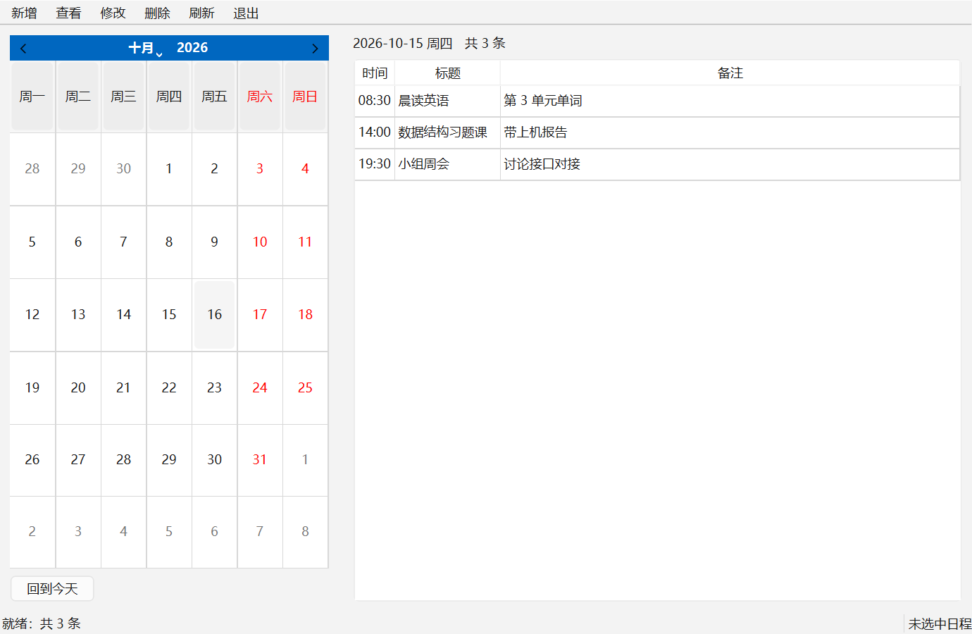
Figure 4-4 The main window actually running (Windows 11, Python 3.12.14, PySide6 / Qt 6.12.0)
Figure 4-4 corresponds to Figure 4-3 area by area: (1) the month grid starts on Monday and today is highlighted; (2) the date bar gives both the weekday and “3 in total”; (3) the three list columns are time, title and notes in that order; (4) the six action buttons sit in the top toolbar; (5) the bottom shows both the result of the most recent operation and the current selection. The three schedules are sample data supplied by the development stand-in service, not real appointments.
Once a row is selected, the selection text at the bottom changes and the relevant buttons are no longer greyed out:

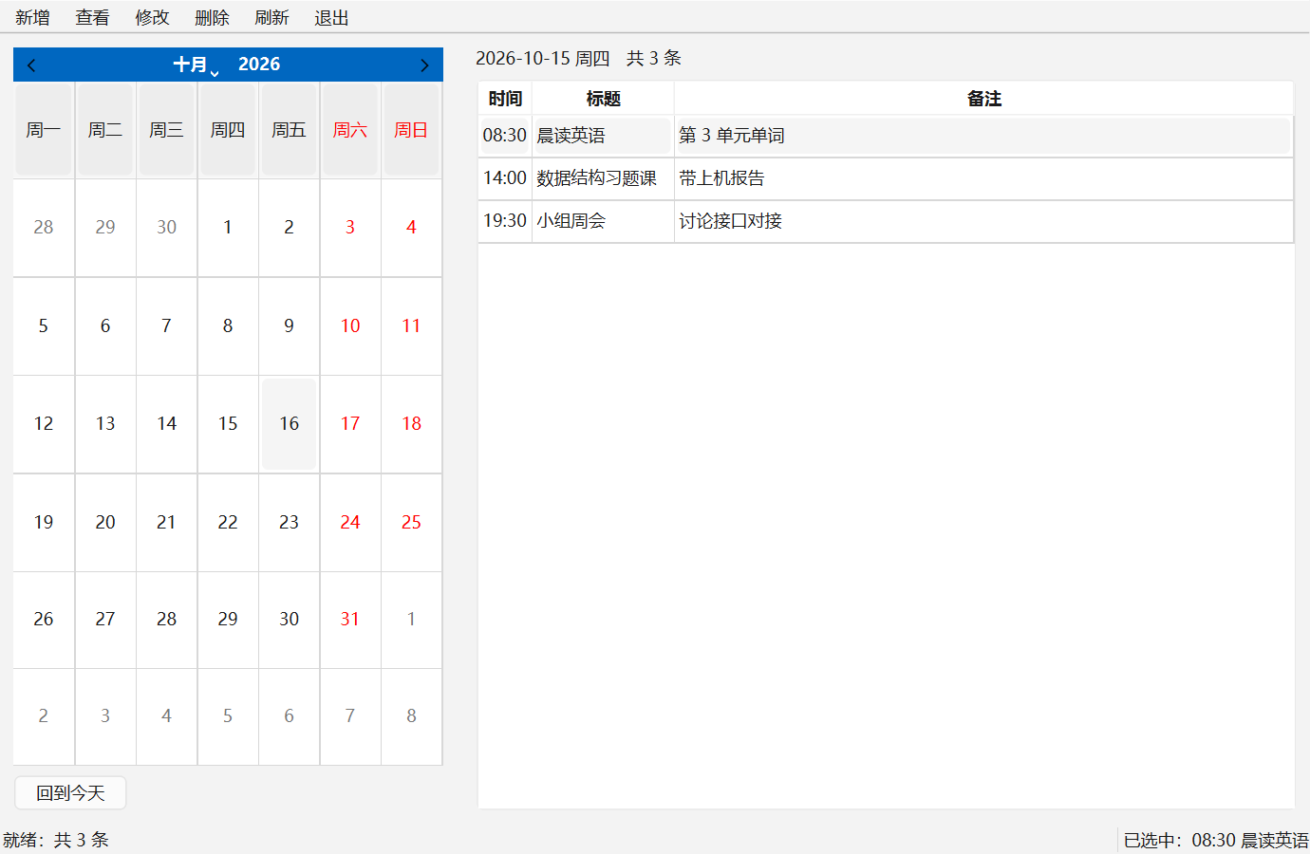
Figure 4-5 Interface state after a schedule is selected
Now the empty state. When there is no schedule on the day, the list area gives explicit guidance instead of staying blank:

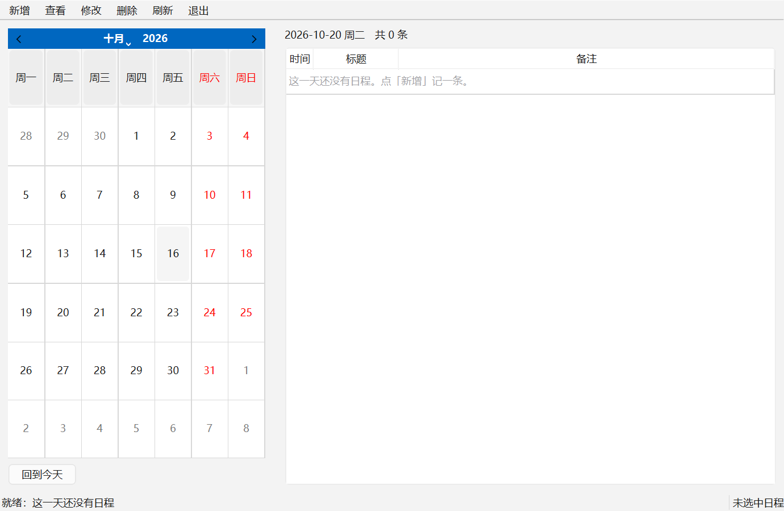
Figure 4-6 The empty state when no schedule exists
The three figures correspond to acceptance items V-01, V-05 and V-06 respectively, and all are reproducible with one command, scripts/shoot_ui.py. One caveat belongs with them: they photograph the interface running on the in-memory stand-in, which proves that the screen and the interaction match the design, but not that data can be stored; the latter is covered by the discussion of V-14 in Chapter 8.

4.6 Target Platform and Front-End Replaceability
This section responds to two sentences from the review: “the Linux side does not need a GUI, so do not adapt it for now”, and “reserve an interface for a CLI or WebUI, keeping the data-processing backend separate from the interacting front end that the user sees”. The first is a scheduling decision, the second an architectural requirement, and the two must not be conflated: deleting the Linux side is a matter of one line, whereas extracting the business logic from the window code is surgery.
Where the seam is. It is the two protocols in ports.py, and nowhere else:
Port | Current desktop implementation | Could later be replaced by
MainViewPort | The QMainWindow in main_window.py | Command-line output plus input() prompts, a web request handler, or even a FakeMainView in tests
ScheduleServicePort | Currently the development stand-in, later the real service in the application layer | Any service that satisfies the same four methods; changing storage does not affect this layer
The eleven methods of MainViewPort (nine one-way outputs plus the two questions, confirm delete and open form) are the entire contract a front end has to honour.
What changing the front end involves. Take a command-line front end as an example (not implemented now; it serves only to test the seam): add an adapter layer implementing MainViewPort plus an entry point, and controller.py, presenters.py, view_models.py, ports.py and all three backend layers stay untouched, while the 108 UI tests in tests/unit/ still run, since they never depended on a window in the first place. The same holds for a web front end.
A testable criterion. This criterion does not rely on subjective impressions, only on which files change: if moving the interaction rules to another front end turns out to require changes in controller.py or presenters.py, the design is judged to be coupled and the seam must be fixed; if only a new MainViewPort implementation has to be added, the seam works. Three hard constraints maintain this property: the “Touches Qt?” column in Section 4.3 together with the AST guards; the rule that the interaction rules of Chapter 5 never mention widget class names; and a one-way dependency direction, with the backend never importing the interface.
What is explicitly not being done now. Neither the command-line front end nor the web front end is implemented: writing them now would produce two half-finished pieces that nobody uses and everybody has to maintain. Only the seam is kept, and the Windows desktop front end is finished first.

Chapter 5 Detailed Design
This chapter explains the responsibilities of the main window’s five areas and the design details of the three core components one by one, then traces the complete call chain of the create and update data flows across the four layers.

5.1 The Main Window and Its Areas
Once the main window is divided into five areas, the coupling between them is confined to well-defined data flows: the calendar area produces the currently filtered date, the list area consumes that date and displays the result, the toolbar produces operation intents, and the status bar summarises the result of the most recent operation. The four interface states (Chapter 6) determine which buttons are available under which conditions.
Construction of the main window follows two rules: widgets are all created in the window construction function and never created on the fly inside an event callback; and callbacks do only three things, namely read the input, hand it to the controller and update the interface with the result, with no business judgement written inside a callback.

5.2 The Calendar Selection Component
The calendar area has three jobs: generate the date grid of the current month, handle month switching and returning to today, and mark which dates have schedules.
The date grid is generated by QCalendarWidget and laid out by week, with adjacent months and leap years guaranteed by the widget. The leading and trailing dates of neighbouring months (for example 28 to 30 September and 1 to 8 November appearing in the October grid) are shown in grey and do not participate in the current month’s filtering: clicking one should be treated as switching to the corresponding month, or the cell should simply not be selectable, a behaviour to be unified when the contract is frozen, but it must never be shown in grey yet handled as a date of this month. One setting must also be made explicitly: Qt starts the week on Sunday by default, which differs from Chinese custom, so setFirstDayOfWeek(Qt.Monday) has to be called, otherwise the same interface would not match the expected screenshots.
Leap years and adjacent months are two faces of the same problem, so acceptance merges them into one step: turn to February 2028 and check that the month shows 29 days, then check that the leading and trailing dates of the neighbouring months are greyed out correctly. Such checks are easily overlooked because during development only the ordinary case of the current month is usually tested.
The calendar must also mark the dates that have schedules. The purpose of the mark is to let users see which days have something planned without clicking through them day by day; it is a usability enhancement, and the wireframe already reserves space for it (the small dot below the date cell).

5.3 The Schedule List Component
The list uses three columns: time, title and notes. For column widths, the time column is fixed and narrow, the title column widest and the notes column medium, balancing information density against readability. Rows are sorted deterministically by time and identifier, so that repeated refreshes on the same date keep a stable order; an unstable order makes users believe the data has been changed.
The deterministic ordering is agreed between the application layer and the storage layer; the interface never sorts on its own, because once the interface and the service each sort, the two rules will diverge sooner or later.
Selection behaviour bears directly on the safety of deletion, so it is described separately: after the user clicks a row, the interface records the schedule identifier bound to that row rather than the row number; when the filtered date changes, the selection is cleared, so that a record selected under the previous date is not mistaken for the current selection.

5.4 The Form Shared by Creation and Update
Creation and update share one form implementation, differing only in the window title and whether the original values are prefilled:

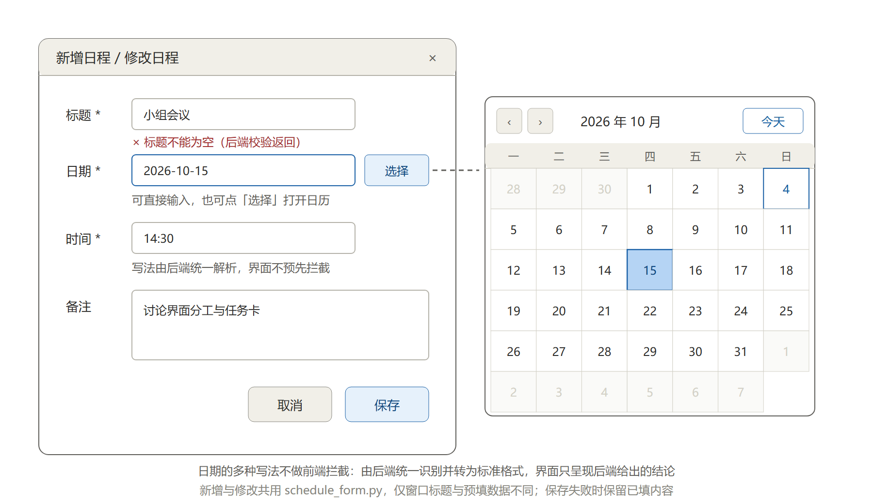
Figure 5-1 Wireframe of the shared create/update form
The form in Figure 5-1 has four fields plus the calendar overlay:
- Title: required.
- Date: required. It can be typed directly, or the Pick button on the right opens a calendar overlay for picking a date; the overlay is a QCalendarWidget like the main-window calendar, and both share the same way of painting date marks. This input is a plain text box rather than a date widget on purpose, so that the many handwritten forms can be passed to the backend unchanged (see Section 4.4). In the illustration the box is focused.
- Time: required, 24-hour clock, minute precision.
- Notes: optional, multi-line.
The field-level prompts in the form present the validation conclusions returned by the backend, not the result of the interface blocking things on its own. Take the title as an example: after the user submits, the service layer finds the title empty and returns a structured error, and the interface marks the field red and shows the reason accordingly. The prompt under the title in the figure carries the label returned by backend validation precisely to make that origin clear: it looks like the familiar front-end red box, but the decision is the backend’s.
Lenient parsing of dates likewise belongs to the backend. When the user types something such as 2026/10/15, the interface does not raise invalid format; it hands the raw text to the backend, which recognises and normalises it to 2026-10-15. Only when the backend genuinely cannot recognise it does the interface present the reason the backend gave. This keeps the parsing rules implemented in one place, shared by the GUI and any other entry point.
At the bottom are two buttons, Cancel and Save. The form’s behaviour is agreed in three points: a successful save closes the form and refreshes the list; a failed save keeps the form and the entered content and only reports the reason; cancelling closes the form without changing any data.
Why one form is mandatory. If creation and update each had their own interface logic, the two sets of code would drift apart as changes accumulated, for example creation validating a non-empty title while update forgot to, or the two handling date formats differently. Such defects are hard to find in testing, because users typically follow only one of the two paths. A shared implementation reduces the difference to a single parameter: whether to prefill, and what the title is.
The real form, once implemented, looks like this:

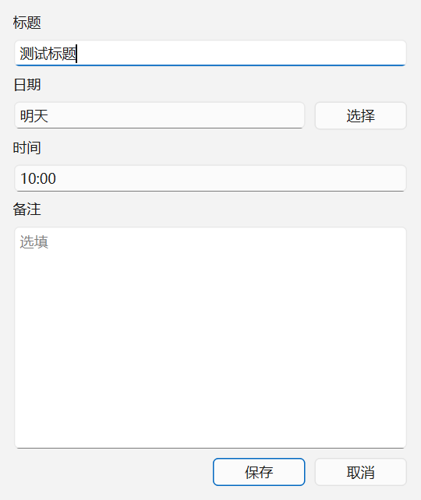
Figure 5-2 The create-schedule form actually running (the date box says tomorrow; the interface does not block it)
What is worth looking at in Figure 5-2 is the word in the date box: “tomorrow”. It demonstrates exactly the point this section argues, namely that the interface performs no date validation at all. A handwritten form the backend cannot recognise either is still accepted and sent, with no “invalid date format” popup; whether it is valid is decided by the backend, and the result is translated by the interface into something a user can read. The Pick button to the right of the date box is the entry point to the calendar overlay; picking a date writes YYYY-MM-DD back into the same text box, and the box remains editable afterwards.

5.5 Controller and Presenters
The controller is the only place in the UI layer that calls application-layer use cases, and the only place that maintains the selection state. It has four jobs:
- read the raw input from the form or the list;
- maintain the selection state and intercept update and delete requests when nothing is selected;
- call application-layer use cases, handing the raw text to the backend for processing;
- turn the error types returned by the backend into prompts the user can understand.
Note the third point: the controller is not responsible for parsing strings into date objects. Which formats are allowed and how they are normalised is a business decision implemented uniformly in the backend. The controller only passes the raw text along and presents the result. This arrangement lets one set of parsing rules serve the GUI and any other possible entry point, and avoids inconsistencies of the form the interface blocked it but the backend would have accepted it.
The presenters are implemented as pure functions wherever possible: formatting a date as YYYY-MM-DD plus the weekday, formatting a count as N in total, and mapping an error type to prompt text and an icon. The advantage of pure functions is that they can be covered by unit tests without creating a single window, which makes the tests fast and stable.
The boundary of responsibility can be stated in one sentence: the backend decides whether input is usable, and the interface presents the conclusion. The interface does not judge whether a title is too long or whether the date may be in the past, because those are business rules; nor does it re-implement format validation, because that would become a second set of rules to maintain. Equally, the domain layer never assumes the interface has already validated: the service must reject illegal data on its own. Both sides' responsibilities are written into the contract, so there is no gap where either both sides validate or neither does.
One boundary deserves special mention: the service layer cannot raise dialogs. So handing exception handling to the backend does not mean the interface stops handling exceptions: the backend decides and raises structured errors, while the interface catches them and translates them into sentences a user can read. Neither side alone suffices; if either is missing, the user either sees a raw stack trace or sees nothing at all.
Status of this round. The four responsibilities above were fully implemented in controller.py and presenters.py on 15 October 2026, with 59 unit tests (see Section 8.2). Two modules mentioned earlier were added during coding, both grown out of real constraints:
- view_models.py: a list row has to carry both the display text and the schedule identifier, and a form has to bring back the previous draft when a failed save is retried. Both need an explicit shape instead of parameters scattered around.
- ports.py: at this point the UI layer could not yet depend on domain classes and application-layer services that had not landed. Declaring with typing.Protocol what the interface needs the other side to look like (structural typing) let the interface be developed and tested against test doubles first, and when the real implementation took over, not a line of controller.py had to change; the type checker proves the fit.
One detail is worth mentioning: the form uses a synchronous model, in which the interface opens the form and returns the draft the user handed back to the controller, which writes it; when the write fails, the draft is pushed back into the form and the form is reopened. Preserving the entered content therefore requires the interface to remember no state of its own, and that behaviour has a corresponding test assertion.

5.6 Data Flow
The complete call chain for creating a schedule is as follows:

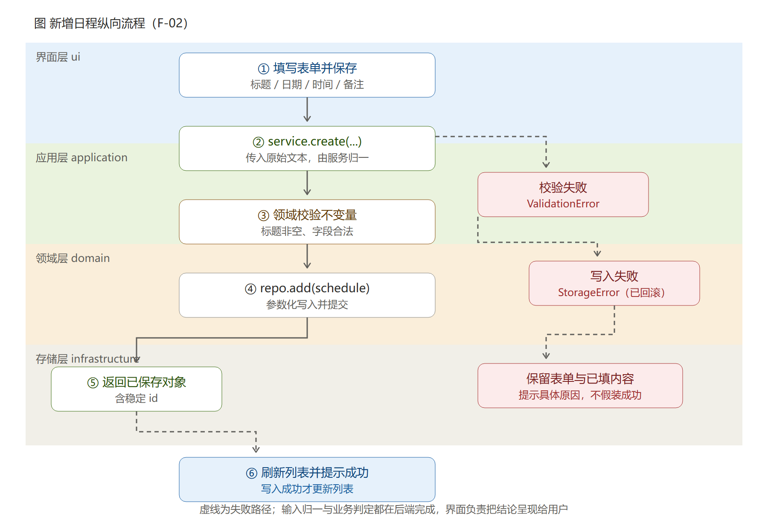
Figure 5-3 Vertical call flow for creating a schedule
Figure 5-3 shows six steps: the user fills in the form and saves; the controller hands the form’s raw text to the service; the service performs backend parsing and domain-rule validation and creates a schedule object with a stable identifier; the service calls the injected storage object to write; the storage adapter writes with parameters and commits, rolling back and translating the exception on error; the service returns the saved object; and the interface refreshes the list and reports success.
The dashed lines in the figure are failure paths, all converging on the same outcome: the form and the entered content are preserved, and the specific reason for the failure is reported. Under no circumstances may the interface pretend a write succeeded when it failed; this is the bottom line on trustworthiness in this design.
Updating a schedule follows a similar flow, with two differences:

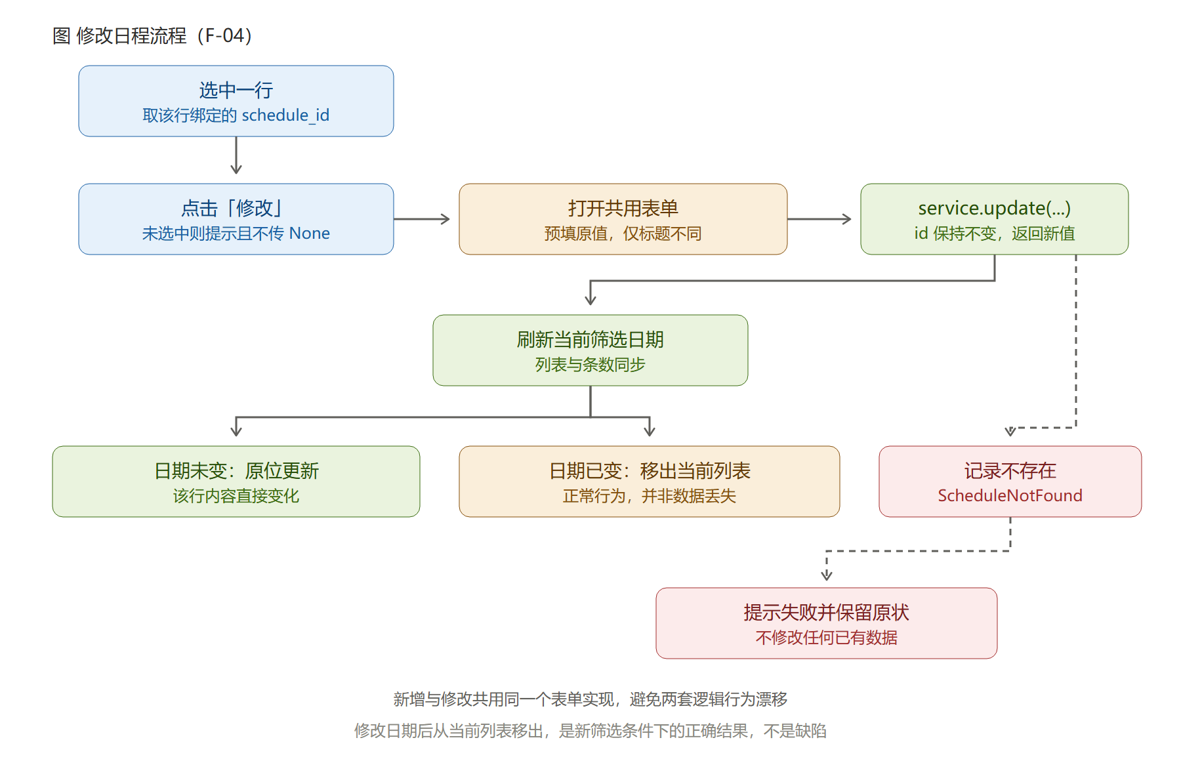
Figure 5-4 The update flow and the handling of a date change
First, an update keeps the schedule identifier unchanged and only modifies the content; second, after a date change the record disappears from the currently filtered date. Figure 5-4 highlights this point: it is not data loss but the correct result under the new filter. Should development treat it as a defect and fix it, the fix would introduce wrong behaviour.

Chapter 6 UI State Design
This chapter abstracts the interface into four main states, gives the transitions between them, and then develops the two paths of the delete operation in detail, since they carry the densest set of interaction rules in this design and are the easiest to implement wrongly.

6.1 The Four Main States
The interface is modelled as four main states plus one cross-cutting error-prompt state:
State | Determined by | Interface behaviour
Idle | No row is selected | The list can be browsed; the update and delete buttons prompt instead of acting
Selected | A row is selected | The row is highlighted, and update and delete are available
Editing | The form is open | The form is modal and the main window waits for its result
Confirming deletion | The delete confirmation box is shown | Waiting for the user to cancel or confirm
Error prompt | The backend reports unrecognised input, failed validation or a failed write | The reason given by the backend is shown and the interface returns to the previous usable state
Modelling nothing selected explicitly as a state rather than an ad-hoc check is an important decision in this design. It makes clicking delete with nothing selected irrelevant to business at the state level, so that in the implementation it is naturally intercepted inside the UI layer.

6.2 State Transitions
The transitions between the four main states are as follows:

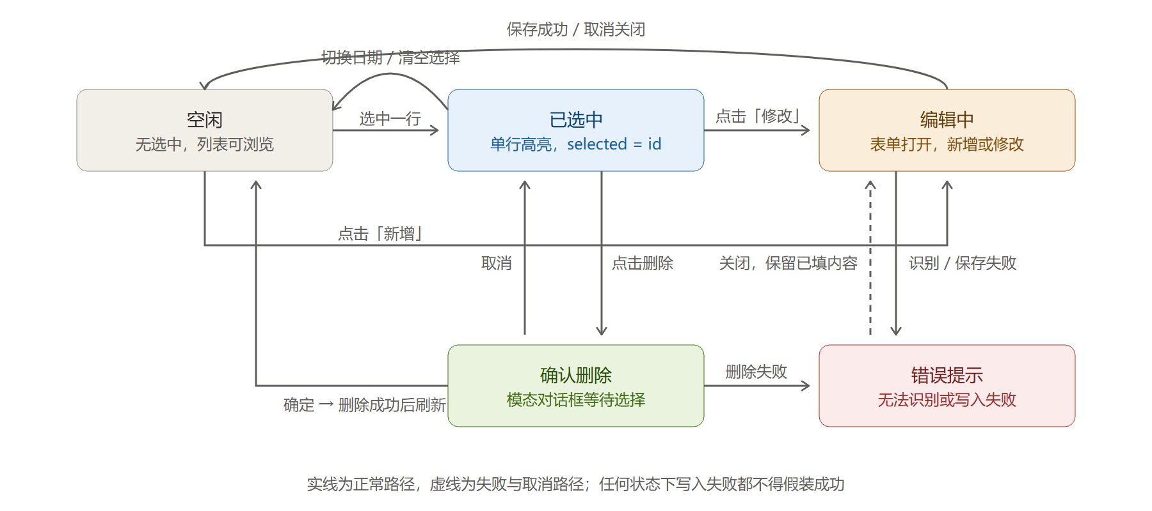
Figure 6-1 Interface state transition diagram
In Figure 6-1 solid lines are normal paths and dashed lines the failure and cancel paths. The key transitions are:
- Idle → Selected: the user clicks a row in the list;
- Selected → Editing: clicking Update opens the form prefilled with the original values;
- Idle or Selected → Editing: clicking Add (adding does not require a prior selection);
- Selected → Confirming deletion: clicking Delete shows the confirmation box;
- Selected → Idle: switching the filtered date or clearing the selection manually;
- Any state → Error prompt: the backend reports unrecognised input, failed validation or a failed write;
- Error prompt → previous state: after the prompt is dismissed, the entered content is preserved in form scenarios.

6.3 The Two Delete Paths
Deletion is the only one of the six requirements that involves both interface state and business validity, and it is the easiest place to get wrong, so two flow charts are given for it.
Path one: clicking delete when no row is selected.

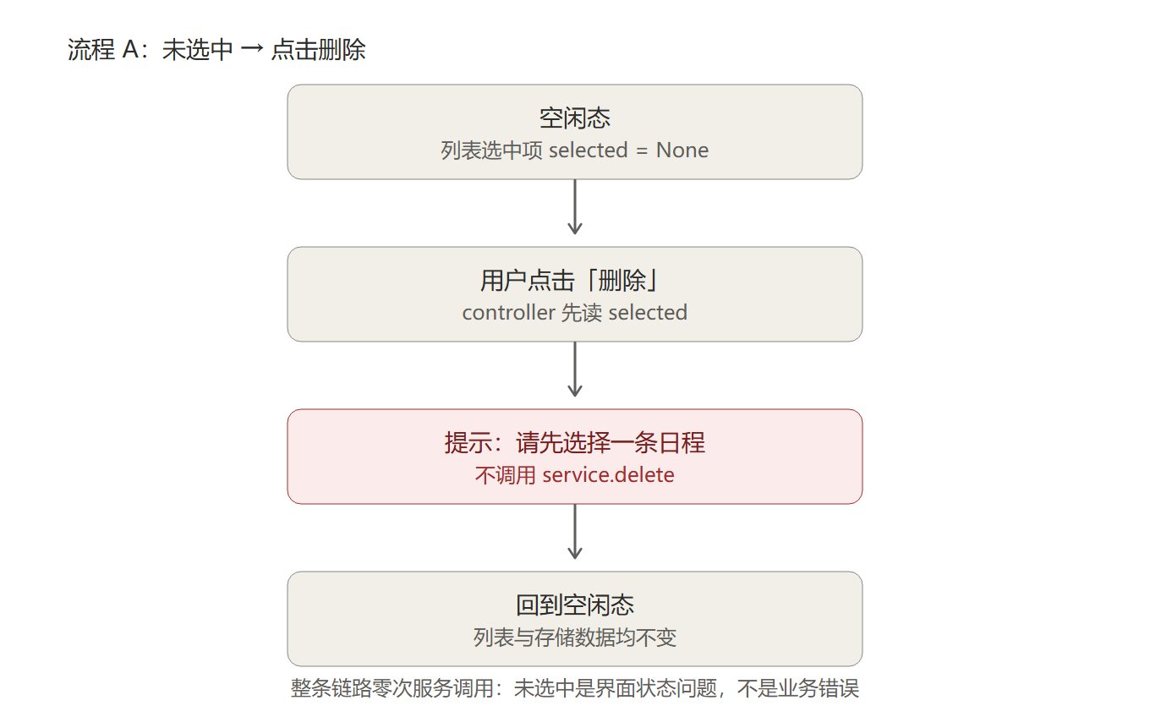
Figure 6-2 State change when delete is clicked with nothing selected
As shown in Figure 6-2, the controller reads the selection state, finds it empty, prompts “Please select a schedule first” and returns. The whole chain makes zero calls to the service. The reason is straightforward: nothing selected is an interface-state matter, not a business error, and should not produce a service query that ends in “record not found”. A unit test can assert this by recording the number of calls on a test double.
Path two: clicking delete with a row selected, then cancelling or confirming in the confirmation box.

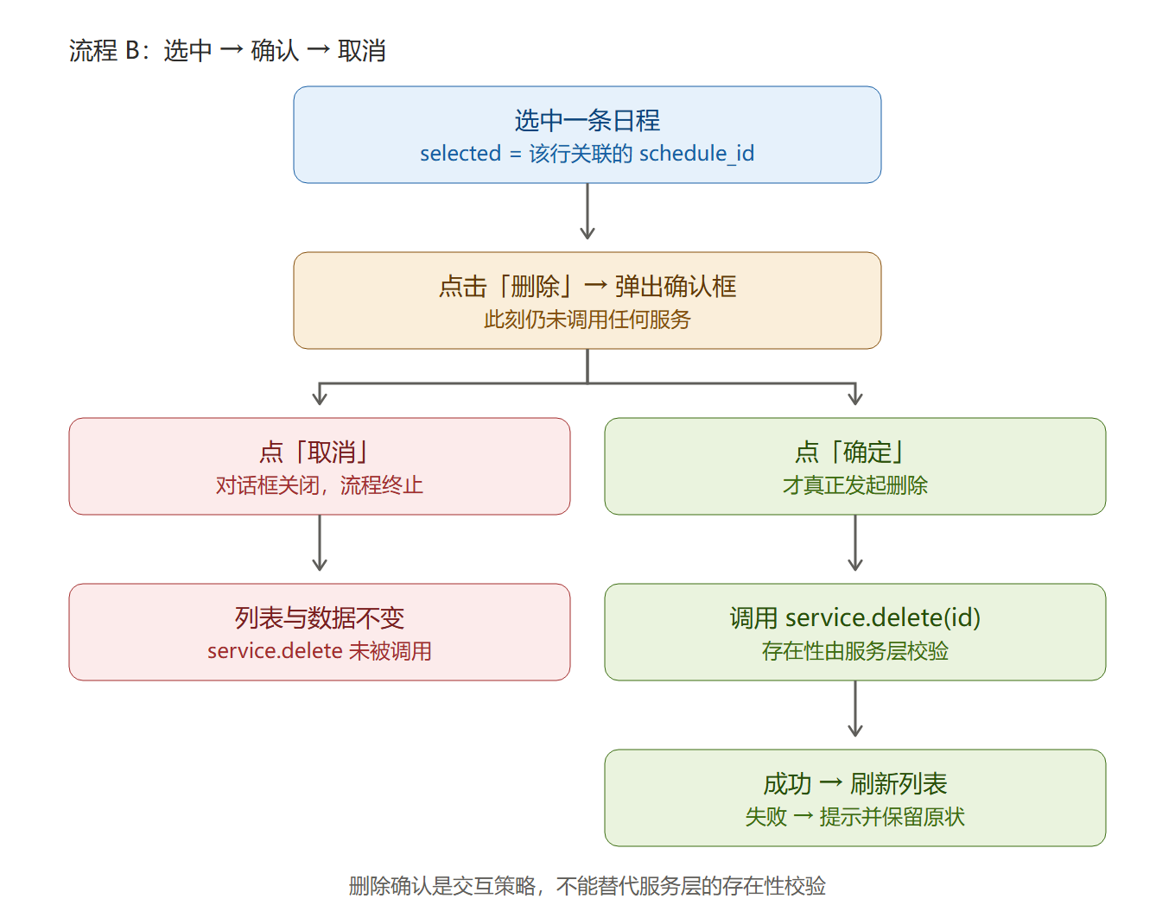
Figure 6-3 The confirm and cancel branches after clicking delete with a selection
As shown in Figure 6-3, the service has not been called when the confirmation box appears; clicking Cancel closes the dialog with the list and the data completely unchanged, again with zero calls to the delete service; only clicking Confirm actually calls the delete service, and whether the record exists is checked by the service layer rather than guessed by the interface.
There is a division of labour here that is easily misunderstood: confirming a deletion is interaction policy, while checking business validity belongs to the service layer. A dialog cannot replace the service layer’s existence check, because the user might delete the same record through another route between the dialog appearing and confirm being clicked (in multi-window or future extension scenarios). So even after the interface has confirmed, the service must still handle a missing record internally and return the result as an error type, which the interface turns into a prompt.

6.4 Correspondence Between States and Implementation
The state model has to land in concrete code locations, otherwise it is only a concept in a document:
State check | Implementation site | Verification
Whether something is selected | The selection-state field of the controller | Unit test: construct the nothing-selected scenario and assert the service is not called
Whether it is editing | The lifetime of the form component | Manual acceptance: the main window is inoperable while the form is open
Whether it is confirming a deletion | The return value of the confirmation box | Manual acceptance V-11: data unchanged after cancelling
The state after an error prompt | Maintained by the controller after it catches the error | Manual acceptance V-03: the entered content is still there after the prompt

Chapter 7 Exception Handling and Human-Computer Interaction
This chapter explains how errors are classified and how they are mapped to prompts, and then sets out the interface behaviour in four scenarios: illegal input, nothing selected, storage exceptions and the empty state.

7.1 Exception Classification and Prompt Mapping
The authority for both state evaluation and error determination is the backend. The UI layer’s job is to catch the structured errors the backend returns and map each to a prompt; for unexpected exceptions it records diagnostic information and shows a generic prompt, neither swallowing them silently nor showing users a raw stack trace.

Error source | Error type | User-visible prompt | Data impact
Input parsing failure | Parse error (returned by the backend) | Field-level prompt, presenting the reason given by the backend | Not written
Domain validation failure | Validation error | The specific rule that was not satisfied is stated | Not written
Storage write failure | Storage error | Generic failure prompt suggesting a retry later | Transaction rolled back, existing data unchanged
Record not found | Record not found error | The prompt says the record may have changed and suggests refreshing before retrying | No modification
Other unexpected exception | Unexpected exception | Generic prompt | Depending on the operation, the interface stays as it was

7.2 Handling Invalid Input
Invalid input is handled on three principles: be specific, be actionable, and preserve the scene:
- Exhaust the leniency first, then report. For fields that allow several written forms, such as dates, the backend first attempts normalisation (recognising 2026/10/15 as 2026-10-15); an error is returned only when recognition genuinely fails. The interface performs no such pre-judgement, so input the backend could have accepted is never blocked in advance.
- The prompt must say what is wrong and what would be right. When the backend returns a reason for failing to recognise something, the interface shows that concrete explanation together with an acceptable example, rather than a vague input error.
- Prompts are field-level and point at the specific input box instead of a single generic dialog. Marking a field red is a visual rendering of the backend’s conclusion; it does not mean the interface has decided anything on its own.
- The entered content is preserved after the prompt, so the user only has to correct the offending field and does not need to refill the whole form.

7.3 Handling No Selection
When the user clicks Update or Delete without having selected a record, the interface prompts “Please select a schedule first” and does not pass an empty value down to the service layer. This rule echoes Section 6.3: an interface-state problem is solved in the interface layer and must not surface in the service layer in the guise of a failed query.

7.4 Handling Storage Exceptions
An exception raised in the storage layer is converted inside the adapter into a storage error, keeping the original cause for diagnostics; the service layer does not swallow it silently but propagates it upward; the UI layer catches it and shows a generic prompt. Nowhere along this chain is an exception swallowed.
Atomicity of writes is guaranteed by the storage layer: every write either completes in full or is rolled back, and a clear-then-write pattern that loses old data when it fails halfway is not allowed. This requirement belongs to the storage layer, but it has one verifiable counterpart on the interface side: after a failed write, the user’s existing data is still fully visible.

7.5 Empty State and First Launch
The empty state is the most easily overlooked part of interface usability. When the selected date holds no schedules, the list area shows “No schedules yet” together with the guide “Click Add to create the first one”, and the date bar shows “0 in total”.
Why the empty state deserves its own design: a blank list cannot distinguish between there really is nothing planned that day and the program has failed. Stating “No schedules yet” explicitly and offering the next step lets users confirm the current state at once and carry on working.

7.6 Three Interface States That Must Be Covered

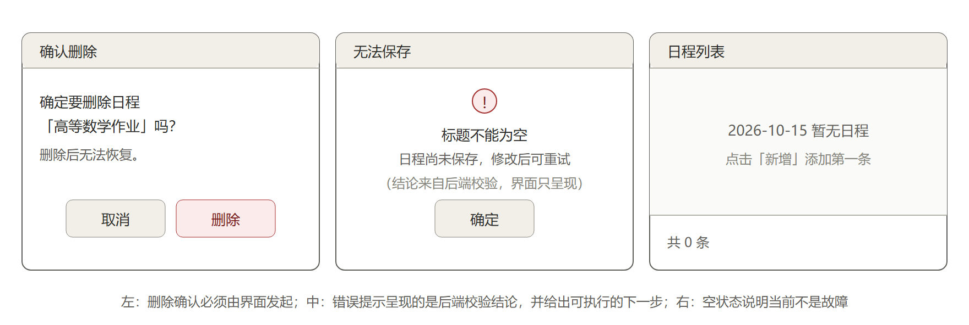
Figure 7-2 Wireframes for the delete confirmation, the error prompt and the empty state
Figure 7-2 places three interface states side by side:
- Left: the delete confirmation. It states plainly which record will be deleted (by title) and notes that deletion cannot be undone. Confirmation is irreversible, so the user must know exactly what is being deleted before clicking.
- Middle: the error prompt. It gives the specific reason and a suggested correction, including the correct format and an example.
- Right: the empty state. It makes clear that nothing is broken and offers the next step.

Chapter 8 Test Plan and Verification
This chapter explains the layered test strategy, presents the UI layer’s unit-test design and the actual distribution of its cases together with the 17 manual acceptance steps, and records the measured results on this machine and the platform differences.

8.1 Test Strategy
Tests are layered, with different means for different layers, so that no single technique is expected to cover everything:
Layer | Testing means | Notes
Domain layer | Unit tests | No dependency on the interface or the database; objects are constructed directly to verify invariants
Application layer | Unit tests plus test doubles | An in-memory storage double verifies use-case flow, input normalisation and error propagation
Storage layer | Contract tests plus integration tests | Shares the same contract tests as the test double; integration tests use a temporary database file
UI layer | Unit tests plus manual acceptance | State judgement and error mapping can be automated; layout, modality and calendar rendering need human eyes
One principle needs emphasis: passing tests does not mean the feature is implemented. The sentence means different things at different stages and the difference must be kept clear:
- At the skeleton stage all nine cases were environment gates (Python version, module importability, package install path) and contained no assertion about business behaviour at all;
- Once the UI layer landed, 108 of the 117 items were real behavioural assertions (interaction rules, error mapping, layering guard, the boundaries of the double service); they proved the logic of this layer correct;
- but a green acceptance list on its own still does not prove that data survives a restart, because most of those items exercise the interface layer. That gap is now closed: the storage layer exists (infrastructure/sqlite_repository.py), composition.py wires the service to it at start-up, and the integration suite in tests/integration/test_service_sqlite.py closes the database and reopens it to check that the records are still there, so V-14 is verified against a real file rather than against an in-memory stand-in.

8.2 UI-Layer Unit Test Design
The UI layer’s unit tests revolve around three targets:
- State judgement: clicking Delete with nothing selected must assert that the service was called zero times; cancelling the confirmation dialog must likewise assert zero calls. These two are the core assertions of the UI layer, and they must be recorded through a test double rather than left to the naked eye noticing that the list did not change.
- Error mapping: given each error type, the produced prompt must match the agreed wording and must not leak technical detail.
- Input pass-through: the interface must hand the raw text the user typed to the service unchanged instead of rejecting it up front. The value of this test is that it locks the boundary of responsibility: if someone later moves validation logic back into the interface, the test makes the forms the backend could accept fail abruptly.
It should be noted that testing input normalisation and validation belongs to the application layer and is not duplicated here. The UI-layer cases verify only two things: whether input is passed through unchanged, and whether results are presented faithfully.
This is where the test double proves its worth: it decouples the UI layer from the database implementation, so UI-layer tests run completely on their own, unaffected by the progress of the storage layer.
The three targets above were turned into 108 actual cases, all passing (together with the 9 environment gates, 117 passed across the whole suite), distributed as follows:
Test file | Cases | Coverage
tests/unit/test_controller.py | 21 | Empty start-up state, switching dates, the six operations, call counts on the two delete paths, retry after a failed write, exception mapping
tests/unit/test_presenters.py | 21 | Date and time formatting, weekday and count wording, selected-item wording, prompt mapping for the three known errors and for unknown errors
tests/unit/test_ui_layering.py | 33 | Layering is checked by parsing the source with an AST: the five presentation-independent modules may not import PySide6, tkinter or sqlite3, while the window adapters may use Qt but still may not touch Tk or SQL; a further meta-assertion requires every ui module to be classified explicitly
tests/unit/test_dev_stub_service.py | 33 | Boundary behaviour of the development double service: empty titles, duplicate titles, deleting a record that does not exist, filtering and sorting by day, and a record leaving the list after being moved to another day
The most representative are the two delete cases, whose assertion target is not the text on screen but the number of calls recorded by the double:
Acceptance item | Test | Assertion
V-10 Delete with nothing selected | test_delete_without_selection_never_calls_service | delete called 0 times, and the prompt goes to the notice area rather than the error area
V-11 Confirmation cancelled | test_delete_cancelled_confirmation_never_calls_service | the confirmation dialog was shown, delete was called 0 times, and not a byte of data changed
V-12 Confirmed delete | test_delete_with_cancel_still_calls_service_once_when_confirmed | delete called exactly once, with the schedule identifier as the argument rather than a title or a row number
V-04 / V-16 Date control pairs | test_create_forwards_raw_date_text_without_parsing, test_create_forwards_unrecognizable_date_text_to_backend | Both 2026/10/15 and tomorrow reach the service unchanged; on failure the backend’s reason is shown and the title is not “Date format is incorrect”
The remaining group (33 cases) is the layering guard. It parses the source into an abstract syntax tree and then judges the import relationships instead of searching the text for keywords: the latter is tripped up by words appearing in comments and docstrings, whereas the former only counts real import statements. What it protects is the bottom line of the constraint in Section 4.3: once controller or presenters import Qt, tests on a machine without a display service fail during collection, and the error message has nothing to do with the business logic. That kind of problem is the most time-consuming to trace, so a machine guard is put in front of it.
After P10 landed, this guard was split into tiers by role:
Category | Modules | May not import
Presentation-independent | __init__, view_models, ports, presenters, controller | PySide6, tkinter, sqlite3
Window adapters | app, main_window, calendar_view, date_picker, schedule_form | tkinter, sqlite3 (PySide6 allowed)
Window code has to import Qt; that is the reason it exists, and a blanket ban would kill it outright. Opening the door left two gaps unopened: window adapters still may not touch Tk (swapping the GUI framework should not affect this place) or sqlite3 (the division-of-labour red line does not get a discount for being front-end code). On top of that sits a meta-assertion: every module in the ui package must appear in one of the tiers above, so a newly added module that forgot to declare itself fails the test outright instead of quietly gaining the freedom to import anything.

8.3 Manual GUI Acceptance Steps
What automation cannot reach is verified by hand. Every record notes the operating system version, the Python version, the PySide6 and Qt versions, the preconditions, the steps taken, the expected result, the actual result and the screenshot path. There are 17 acceptance steps:
No. | Requirement | Steps | Expected result
V-01 | F-01 | Start the program | The window displays normally, today is selected by default, and both the list and the top toolbar are complete
V-02 | F-02 | Fill in every field and save | A success notice appears, the entry shows in the list at once, and the form closes
V-03 | F-02 | Enter only spaces as the title and save | A field-level prompt is given, nothing is written, and the entered content is preserved
V-04 | F-02 | Enter the date as 2026/10/15 and save | The backend normalises it to 2026-10-15 and saves successfully; the interface reports no format error
V-05 | F-03 | Select another day | The list shows only that day’s schedules, and the count matches the title bar
V-06 | F-03 | Select a date with no schedules at all | The empty state and 0 in total are shown, not a blank panel and not an error
V-07 | F-01 | Page across months on the calendar and navigate to February 2028 | Dates of the preceding and following months are greyed out and not treated as part of the current month; February 2028 has 29 days
V-08 | F-04 | Select an entry, click Update and change the title, then save | The list updates and the schedule identifier is unchanged
V-09 | F-04 | Change the date to another day | After saving, the entry leaves the current list and appears under the new date
V-10 | F-05 | Click Delete with no row selected | A prompt asks the user to select a schedule first, the service is not called and the data is unchanged
V-11 | F-05 | Select an entry, click Delete and then click Cancel in the confirmation dialog | The dialog closes and both the list and the data stay exactly as they were
V-12 | F-05 | Select an entry, click Delete and then click OK | The entry disappears and the count drops by one
V-13 | F-06 | Click the buttons rapidly and delete the same entry twice | A comprehensible prompt is given, no raw stack trace appears, and the program remains operable
V-14 | Engineering enhancement | Add several entries, quit the program and start it again | The data is still there, which shows persistence is in effect
V-15 | F-02 | Click the Select button beside the date field to open the calendar popover and pick a day | The popover closes, the date box is refilled with text in the standard format, and editing can continue
V-16 | F-02 | Enter a date that cannot be recognised at all, such as tomorrow, and save | The reason returned by the backend is shown, the entered content is preserved, and the user can correct it and retry
V-17 | Engineering enhancement | Run uv sync on Windows and start the program | PySide6 imports, the main window shows no truncated text, the calendar consistently starts on Monday, and the version numbers are recorded in the screenshot appendix
V-04 and V-16 form a control pair: for the same field, a recognisable form passes straight through and only an unrecognisable one raises an error. Both must be executed before the interface can be shown not to block input up front; running only one of them leaves no way to tell the two very different implementations apart, namely lenient parsing in the backend actually working versus the interface quietly rejecting every non-standard form.
The parts of the other items that became automated assertions are listed in Section 8.2: the success branch of V-01 and V-02 and the service-interaction behaviour of V-04 through V-13 are all covered by unit tests. The leap-year part of V-07 has a semi-automatic fallback: the probe script in Section 8.7 already asserts that February 2028 has 29 days and that they can be selected.

8.3.1 After P10: which acceptance items moved from a human nod to a machine assertion
Once the interface really runs, scripts/shoot_ui.py opens a real window, captures real screen content, and asserts the parts that do not need a human eye. A single command re-runs it, so the interface can be re-verified right after a change instead of a broken screen being discovered the day before the defence. All 8 items currently pass:
Acceptance item | Measured value
V-01 Start-up shows today’s schedules | 3 rows in the list
V-01 Six buttons on the top toolbar | create / view / edit / delete / refresh / quit asserted one by one
V-05 Selecting a row updates the wording | Selected: 08:30 Morning reading in English
V-06 An empty date shows the empty state, not a blank board | No schedules yet. Click Add to record one.
V-06 The empty state shows the count | 2026-10-20 Tuesday 0 in total
V-07 The leap-year date can be constructed | 2028-02-29 passes
V-16 An unrecognisable date leaves the form unchanged | date_text='tomorrow', not blocked by the interface
Three points must be stated alongside, or this patch of green is easily overrated:
- The script must run in a Windows session that has a desktop. On this machine the offscreen platform resolves no Chinese font (QFontDatabase.families() returns 0), so every Chinese glyph captured comes out as a box, and such screenshots have no acceptance value.
- The script runs against the in-memory double service. V-14 therefore cannot pass in this environment: data is lost the moment the program exits, and the item has to wait for the SQLite storage layer before it can be re-tested on real data.
- V-02, V-03, V-08, V-09, V-12 and V-13 need modal dialogs driven or rapid clicks simulated, which the script does not cover, so they are still executed by hand as in the table above; the popover refill in V-15 is the same story, since the script only asserts that the date object can be constructed and never simulates a mouse click on a cell in the popover.
The 17 acceptance steps are distributed over the six functional requirements as follows:

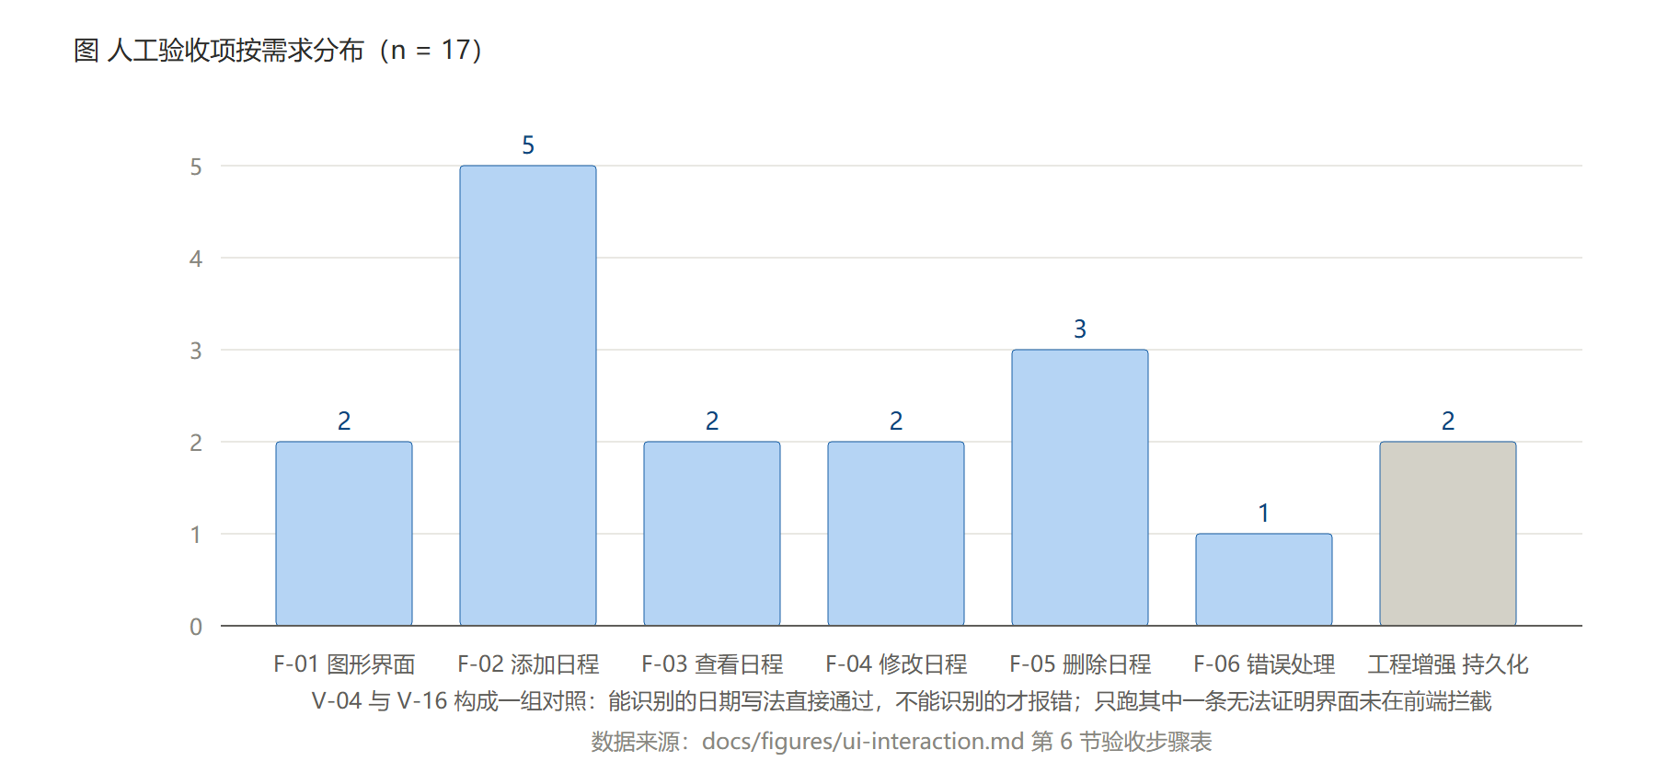
Figure 8-1 Distribution of manual acceptance items by requirement
Figure 8-1 shows that the acceptance steps are not spread evenly: Delete (F-05) and Add (F-02) take three each, because the data changes these two kinds of operation cause are the least reversible and the most expensive to get wrong; Error handling (F-06) has only one step of its own, yet what it verifies is in fact scattered across every other step, since each of them implicitly requires that no raw stack trace appears.

8.4 Environment Verification Results
The engineering gates were executed on the author’s Windows machine, with the following measured results:

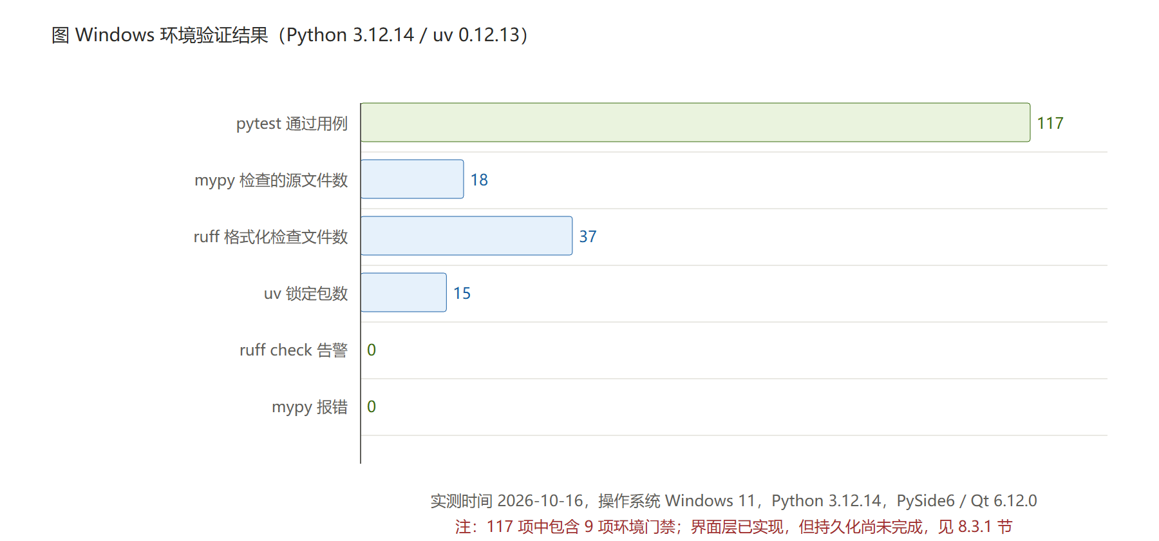
Figure 8-2 Windows environment verification results
The exact command and recorded output for each check:

Check | Command | Result
Dependency sync | uv sync --dev --locked | Succeeded, 15 packages (including the runtime dependency PySide6)
Unit tests | uv run pytest -q | 117 passed
Static check | uv run ruff check . | All checks passed!
Format check | uv run ruff format --check . | 37 files already formatted
Type check | uv run mypy src tests | Success: no issues found in 18 source files
Bytecode compilation | uv run python -m compileall -q src tests | No output, exit code 0
Package import | uv run python -c “import schedule_management” | Points at the source directory, version 0.1.0
Graphics environment | uv run --python 3.12 --with PySide6 python scripts/qt_probe.py | Succeeded: PySide6 6.12.0 / Qt 6.12.0, package directory 646.7 MB, the week start can be set to Monday, 2028-02 has 29 days, and it prints ALL QT PROBES OK (see Section 8.7)
The four numbers in the table above changed three times while this document was being written, each time because a batch of real artefacts landed. They are recorded in chronological order so they can be checked:
Stage | pytest | ruff format | mypy | Corresponding artefacts
Skeleton stage | 9 passed | 19 files | 1 source file | Environment gates only, no business code
After P09 landed | 68 passed | 28 files | 11 source files | Four non-GUI modules plus 59 unit tests
After P10 landed (current) | 117 passed | 37 files | 18 source files | Five Qt window modules, the double service, 33 double-service tests and 33 layering-guard tests
The numbers mean nothing on their own; what they stand for is the code behind them. The last row corresponds to this: the program can really be opened, records can really be added, queried, updated and deleted, and it can be photographed. But the reminder at the foot of the same table still holds, because the data currently lives in memory.
The values above were collected on the same Windows machine (Windows 11, Python 3.12.14); any discrepancy means the working tree is dirty or is not on the same git revision as the commit described here.

8.5 Platform Scope and Acceptance Criteria
After the switch to PySide6, the old Tk 8.6 versus 9.0 version difference no longer exists, since the same wheel is installed and the Qt version is no longer a variable. In the second round of review on GR #5, however, the team lead settled one point: the Linux side needs no graphical interface and will not be adapted for now. This document is therefore revised as follows:
- The target platform is narrowed to Windows. V-17 changes from running once on each of two platforms to running once on Windows, and docs/screenshots/ and its appendix record Windows results only.
- The cost is recorded truthfully. Qt’s font metrics differ between Windows and Linux, so Chinese line height and widget padding differ at the same point size; having verified only one end means the question of whether a switch to Linux would misalign anything currently has no answer, and nobody has promised one. Layout is left to the layout managers to adapt rather than being hard-coded in pixels, precisely so that less debt has to be repaid if that end is ever added.
- A scheduling decision is not an architectural decision. See Section 4.6: precisely because only one end is built, the seam matters more, since adding a CLI or a web front end later would otherwise require digging the business logic out of the window code first.
One further difference in measurement needs aligning within the team: ruff format --check reports 37 files for the author but 17 for the team lead’s Linux baseline. On inspection the number depends on how many Python files the tool scans (it grows as src and tests grow); it is not a difference in formatting rules or behaviour and does not affect the conclusions of the tests or the type check. It was raised in that merge request and will be written into the environment document once the two sides agree.

8.6 Recording Conventions for Screenshots and Materials
Interface screenshots are kept together in docs/screenshots/, and each one is annotated in the body text with the platform and PySide6/Qt version, the preconditions, the steps taken, and the expected and actual results. Test data always uses fictitious schedules (generic examples such as Higher Mathematics Homework or Team Meeting), so personal real arrangements never enter the submitted materials.
That metadata lives in docs/screenshots/README.md rather than being scattered about, so any figure can be re-run and reproduced by following the steps inside. Reproduction is itself part of acceptance: a single uv run python scripts/shoot_ui.py regenerates all five figures (8 checks output, 0 failures), which rules out the situation where the figures in the document show the previous version of the interface.
Screenshot | Related acceptance items | What it shows
main-window.png | V-01, V-02, V-03 | The main window’s first screen: six buttons in the top toolbar, the month calendar starting on Monday on the left, today’s three schedules on the right, and the status and selection hints at the bottom
main-window-selected.png | V-05, V-08 | The state after a row is selected: the row is highlighted, the bottom reads Selected: 08:30 Morning reading in English, and the relevant buttons become enabled
empty-state.png | V-06 | Switched to a date with no schedules: a guidance line and 0 in total instead of a blank grid
form-dialog.png | V-02, V-04, V-15, V-16 | The four fields of the create form, where the date box is an ordinary text box holding tomorrow, which shows the interface does not block input and leaves the judgement to the backend
calendar-leap-2028-02.png | V-07 | February 2028 has 29 days, for the eye to confirm the leap month and the greyed-out days of adjacent months
All five figures are produced by the script and can serve directly as interface evidence in the deliverable. They must, however, be cited together with the three notes in Section 8.3.1: they photograph a screen produced by the in-memory double, which proves the screen and the interactions but not that data survives.

8.7 Measured PySide6 Environment Results
This section answers a question that has to be settled with data rather than expectations: can the chosen GUI framework really run on this machine? The probe script scripts/qt_probe.py is committed alongside this document and can be reproduced:
uv run --python 3.12 --with PySide6 python scripts/qt_probe.py
On Linux without a display service (remote sessions, continuous integration) the offscreen platform must be set first, otherwise QApplication fails outright:
QT_QPA_PLATFORM=offscreen uv run --python 3.12 --with PySide6 python scripts/qt_probe.py
Measured results on this machine (Windows 11, Python 3.12.14):
Probe | Measured value | Which conclusion of this document it supports
PySide6 version | 6.12.0 | The version policy of Section 4.4 holds in practice and there is no need to fall back to Tkinter
Qt runtime version | 6.12.0 | Matches the Python package version, ruling out a mismatch between package and runtime library
Package directory size | 646.7 MB | The quantitative basis for the third-party package compliance work in Section 4.4
Week start set to Monday | In effect (reads back as DayOfWeek.Monday) | The domestic calendar habit described in Section 5.2
February 2028 | 29 days, and 2028-02-29 can be selected | The leap-year branch of V-07, with evidence obtained early instead of waiting for the interface to be finished
QTableWidget | Three columns build correctly | The list component of Section 5.3
QLineEdit | Keeps 2026/10/15 exactly as typed | The measured basis for not using QDateEdit for the date box in Section 4.4
QDateEdit display format | yyyy-MM-dd | As above: it validates strictly against that format before anything else
Two points deserve to be written into the conclusion:
- The leap year and the week start can be settled before the interface is finished. They were verified at the widget level, so the only thing left for manual acceptance is to confirm that the drawn calendar looks as expected. The figure below is the window after actually paging to February 2028:

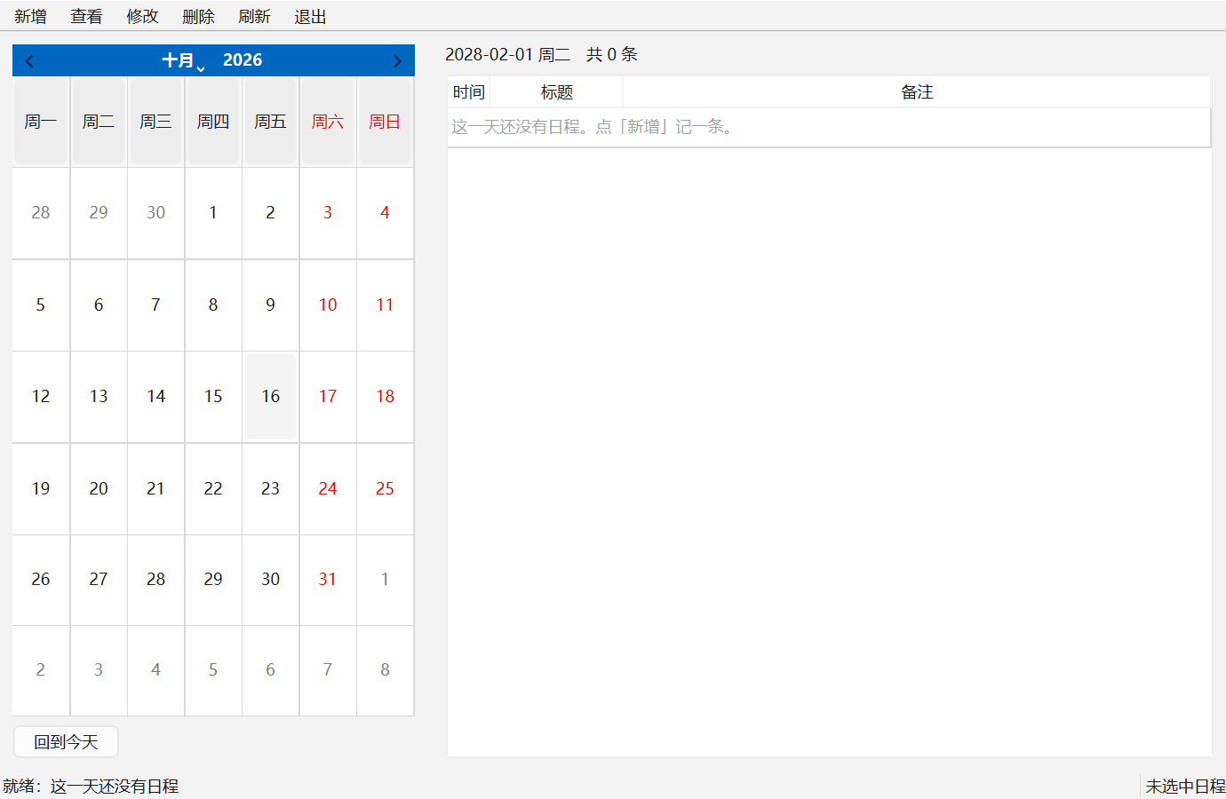
Figure 8-4 The leap-month calendar for February 2028 (the interface as actually run)
In Figure 8-4 the last day of the month is the 29th, the first cell is a Thursday (with Monday as the week start), and the leading days of the previous month are drawn by the Qt widget rather than written by this project, which is exactly the outcome Section 4.4 wanted when it said the date control would no longer be hand-drawn.
- A framework that installs is not necessarily a framework that runs. QApplication fails in an environment without a display service, and that is the real-world origin of the constraint in Section 4.3 that no window may be created at import time. This capability has currently been verified on Windows only; the Linux side is outside what is promised, per the scope statement in Section 8.5.

Chapter 9 Engineering Implementation and Code Organization
This chapter presents the directory organisation of the interface-related files and documents, the dependency management and code quality gates, and lists the two interface conventions that are not yet frozen and therefore block coding.

9.1 Directory Structure
Interface-related files live in the following places (those marked done landed in this round):
src/schedule_management/
ui/
__init__.py (done) package notes and layering conventions
app.py (done) entry point: the single QApplication plus dependency injection
main_window.py (done) main window, the adapter implementation of MainViewPort
controller.py (done) selection state, use-case calls and error-to-prompt mapping: all interaction rules
schedule_form.py (done) shared create and edit form (QDialog)
calendar_view.py (done) QCalendarWidget month calendar starting on Monday
date_picker.py (done) the date selection popover inside the form
presenters.py (done) display formatting and prompt mapping
view_models.py (done) row model, form draft and the context for opening the form
ports.py (done) the three port protocols
dev_stub_service.py (done) in-memory development double service plus seed data
tests/
unit/
test_controller.py (done) controller behaviour and call-count assertions, 21 cases
test_presenters.py (done) pure functions and error mapping, 21 cases
test_ui_layering.py (done) layering guard, 33 cases
test_dev_stub_service.py (done) double-service boundaries, 33 cases
ui_fakes.py (done) test doubles used by the UI layer itself (fake service, fake window)
test_environment.py (done) environment gates, 9 cases
fakes.py in-memory storage double used only by tests (owned by xhy)
scripts/
qt_probe.py (done) PySide6 and Qt environment probe
shoot_ui.py (done) opens a real window, takes screenshots and asserts the automatable parts
The UI layer’s doubles live separately in tests/unit/ui_fakes.py rather than being merged into tests/fakes.py: the latter belongs, by division of labour, to the storage layer’s repository double and is owned by another member. Keeping them apart means adding a UI-layer double never touches a file someone else is editing, so the two of us do not block each other over a single test helper.
Documents and figures:
docs/
figures/ interface sketches and interaction notes (P02 output)
screenshots/ real interface screenshots plus the environment appendix (P10 output, including README.md)
design/ the three members' design documents
The images in docs/screenshots/ are no longer wireframe sketches but the program actually running, which matters for the deliverable: the reviewer looks at the real interface, not at design intent.

9.2 Dependency Management and Packaging
The project manages its environment and dependencies with uv, uses a source layout and is configured as an installable package. uv sync --dev --locked has been confirmed to reproduce the installation on Windows, and the package imports correctly. Development dependencies cover testing, linting and type checking, all pinned through the lock file so behaviour does not drift between machines.

9.3 Code Quality Gates
The following checks run before every commit, and all of them must pass before a merge request is opened:
- dependency lock consistency check;
- code style check and format check;
- bytecode compilation check;
- unit tests;
- type check.
These five tool checks belong to engineering discipline and have nothing to do with whether a business feature is complete; the difference was explained in Section 8.1.

9.4 Interface Conventions Awaiting Freeze
The controller and presenter layer of the interface are written and tested, not because everything was agreed in advance but because whatever was undecided got isolated. Two interface conventions are still awaiting freeze; once frozen, the only things that may need adjusting are the signatures in ports.py and a few calling lines on this side, while the judgement logic inside controller and presenters stays untouched:
- The shape of the service interface signatures: the interface’s port declarations make create and update take raw strings rather than date and time objects, because lenient parsing has been assigned to the backend (see Section 4.4). If the team eventually goes back to parsing in the interface and passing date objects, a few lines in ports.py and controller.py have to follow.
- Error types and the shape of failure returns: whether to raise structured errors carrying the field name, or to return a result-plus-failure-reason object. The interface currently classifies by the three class names in the draft contract (ValidationError, ScheduleNotFound, StorageError); once the real types land, the classification becomes an instance check and neither the tests nor the prompt wording needs rewriting.
What lets the UI layer move forward while the contract is unfrozen is exactly the use-a-double-first path, which takes two forms at two stages:
- The test double of stage P09 (tests/unit/ui_fakes.py): implemented against the port shape, so unit tests of the interface logic run entirely without the storage layer or the contract;
- The development double of stage P10 (src/schedule_management/dev_stub_service.py): the same idea extended from tests into runtime, so the whole program can be opened, operated and photographed with no backend at all.
The benefit of the second point shows up in Chapter 10: it frees interface acceptance from the contract. The cost must be stated too: a double is not a storage layer, and it cannot stand in for persistence (V-14).

Chapter 10 Progress, Issues and Risks
This chapter records the milestones, the current progress, the four identified risks and the next steps. Among them, the unfrozen contract is the only risk that needs someone else to act before it can be removed.

10.1 Milestones
The team divided the project into five milestones:
Milestone | Content
M0 | Design and environment: contract, architecture, interface sketches, storage plan, environment verification
M1 | First vertical slice: the minimal usable path of adding a schedule and querying it by date
M2 | Feature complete: details, update, delete, cancel-delete and every prompt
M3 | Reliability: restart recovery, transaction failure, invalid input, leap year across months, filter consistency
M4 | Delivery: reproduction in a clean environment, screenshots, three documents, team presentation
M1 deliberately consists of one narrow vertical slice, so that the real path from interface to service to database is opened early instead of waiting for every feature to be written before integration begins.

10.2 Current Progress
Task card | Status
P02 Interface sketches and interaction notes | Completed; merge request PR #5 is under review (both rounds of comments have been addressed and folded in)
P01 Contract and architecture document | Not started (the team lead’s task card, still blocking the whole team)
P09 Controller and presenter layer | Completed: four modules plus 59 unit tests, all gates green; the interface shapes still need checking once the contract is frozen
P10 Interface components | Completed: five Qt modules can really be opened, used for create, query, update and delete, and photographed; but with no real storage, persistence (V-14) is not yet verified
P12 Personal document | In progress (this document)
Marking P10 completed requires one qualifier in the same breath: what is complete here is the interface, not the system. Three items have still not landed: the has-schedule marker on the calendar needs a month-level query from the backend; real persistence waits for xhy; the final alignment of interface shapes waits for zch’s contract. Writing these down as known-not-done rather than leaving blanks makes what is still missing visible at a glance.

10.3 Risks and Issues
No. | Issue | Impact | Response
R-01 | The interface contract is not yet frozen | Both P09 and P10 bypassed the blockage with port protocols plus doubles, so the UI layer is no longer waiting; but integration has still not happened, and a double cannot stand in for a real backend | The two interface shapes that need confirming are listed in the design; the interface moves ahead on the double, and once the real service lands only one entry point needs replacing
R-02 | Difference in Qt font metrics between Windows and Linux | The same interface has different line heights and padding on the two platforms, and text may be truncated | Scope has been narrowed: per Section 8.5 and with the team lead’s confirmation, the target platform is Windows and Linux is outside the promise; layout still avoids hard-coded pixels, keeping room to add that end later
R-05 | The course requirement that third-party packages go into src/lib/ | The measured package directory is 646.7 MB and platform-bound, so mishandling it could make the submission impossible | Listed as an item to confirm, with the team lead asking the lecturer; meanwhile handled by a note file plus a dependency list (see Section 4.4)
R-03 | Inconsistent measurement of the environment verification numbers | The environment document could state contradictory figures | Raised in the merge request and to be unified after the team aligns. This document records all three stages of the same numbers (Section 8.4) so there is no argument over which one is right
R-04 | Automated tests may be misread as feature completion | All tests green is taken to mean the system works | Sections 8.1 and 8.3.1 already distinguish the three layers: environment gates, UI-layer behavioural assertions, and persistence verification that does not yet exist. 117 passed does not mean data survives
R-06 | The development double may be mistaken for a real storage layer | Persistence could be wrongly reported as implemented at delivery time | The double carries a prominent note in the source, and only one entry point needs changing to swap it; docs/screenshots/README.md and Section 8.3.1 of this document both state that it cannot verify V-14
R-01 is the most significant risk at present, and the only one that needs someone else to act before it can be removed.

10.4 Next Steps
In order of priority:
- Remove the development double and connect the real backend. This is the most critical step right now: once the application and domain layers land, replace the single build_service() call in ui/app.py with the real service and not one line of the interface or the interaction rules changes. Then re-run every acceptance item of Chapter 8 on real data, above all the V-14 persistence item that could not possibly pass before.
- Drive the contract to a freeze, focusing on two interface shapes: whether create and update take raw strings, and whether failure raises a structured error or returns a result object (see Section 9.4).
- Complete the calendar markers. calendar_view.mark_days() is implemented, but which dates this month have schedules needs a month-level query from the backend (list_days_with_schedules(month) is the suggested shape). Having the interface walk the data itself and bypass the controller would break the seam of Section 4.6, so it is better to leave it blank and connect it once the interface is agreed.
- Ask the team lead to confirm the compliance position on src/lib/ with the lecturer (T-01); this external dependency must be resolved before submission.
- Finish syncing this document with the Word version of the personal design document, and give the team the reproduction steps for docs/screenshots/.

Chapter 11 Division of Work and Contribution Statement
This chapter lists truthfully what the author completed alone, what was done in collaboration with others, and the citation notes, as the basis for recognising contribution and for later checking.

11.1 Parts Completed by the Author
The content of this document and of the corresponding code that the author completed alone:
Item | Notes
Interface sketches and interaction notes | The six interface figures and the interaction notes under docs/figures/, including the 17 manual acceptance steps
Interface flowcharts and diagrams | The layering dependency diagram, the interface module diagram, the create and update flowcharts, the state transition diagram and the error mapping diagram
Statistical charts | The acceptance-item distribution chart, the environment verification chart and the command output record
Interface layer design | Main window layout, calendar component, list component, shared form, and the division of responsibility between controller and presenters
Interface state model | The definition and transition rules of the four main states, and the two delete paths
Exception prompt strategy | Error classification and prompt mapping, field-level prompts and the requirement to preserve entered content
Interface layer core implementation and tests | The four modules controller.py, presenters.py, view_models.py and ports.py under ui/, plus 59 unit tests under tests/unit/ (the most representative being the call-count assertions on the delete paths); to avoid clashing with other people’s files, the doubles were kept separately in tests/unit/ui_fakes.py
PySide6 window implementation (P10) | The five Qt modules app.py, main_window.py, calendar_view.py, date_picker.py and schedule_form.py: a month calendar starting on Monday, six toolbar buttons, a list bound to row identifiers, a shared four-field form, and a date QLineEdit with a calendar popover. The window only adapts the presentation; the interaction rules stay in the controller
Development double service | src/schedule_management/dev_stub_service.py: an in-memory implementation of ScheduleServicePort with seed data, so the interface can be run, accepted and photographed before the backend lands; 33 boundary cases are included and serve as a behavioural reference for the real storage implementation
Interface screenshot script | scripts/shoot_ui.py: opens a real window, screenshots it screen by screen and asserts the acceptance items a machine can judge; all 8 items currently pass, producing the five figures under docs/screenshots/ and the environment appendix
Measured PySide6 environment | The probe script scripts/qt_probe.py, plus the version numbers, package size and widget behaviour measured on Windows (Section 8.7)
Environment verification | A complete set of gate measurements on Windows, covering the PySide6 and Qt versions, the package size and widget behaviour; the Tk version difference found earlier disappeared once Qt was chosen instead
Response to design review | Revised according to the two rounds of review on PR #5. The first round changed four things: the date became a calendar popover that still accepts typing, lenient parsing was assigned to the backend, the CRUD buttons moved above the canvas, and the boundary of exception-handling responsibility was clarified. The second round changed two: the target platform was narrowed to Windows, and Section 4.6 was added on front-end replaceability
This document | Written in full, with all figures produced by the author

11.2 Parts Done in Collaboration with Others
Item | How it was done
Architecture layering and contract | Owned by zch; the author took part in the review from an interaction-usability angle, mainly confirming whether the error types were sufficient to support the interface prompts
Review of the interface sketches | PR #5 was reviewed by zch, who raised three points (date input method, button placement, exception-handling responsibility); the author addressed each one and revised the sketches and interaction notes accordingly
Storage design | Owned by xhy; the author took part in verifying that the list is restored after a restart and that the failure prompts are understandable
Integration | Completed jointly by all three members at P11
Team presentation | The author is responsible for the interaction chapter

11.3 Citation Notes
The requirement text cited here comes from the task description provided by the course; the layered architecture and task-card numbering cite the team’s division-of-work plan; the conclusions confirming the error types and the interaction contract cite the team’s shared contract document. Every figure and table in this document was produced by the author. The environment data are measured on the author’s machine: the engineering gate data were collected on 4 October 2026, with four of them re-collected on 15 October 2026 after the UI layer’s core landed (see Section 8.4); the PySide6 and Qt versions, package size and widget behaviour were measured on 15 October 2026 (Section 8.7). The interface sketches and interaction rules were revised once on 14 October 2026 in response to the PR #5 review, and the UI layer’s core implementation was completed on 15 October 2026.

Appendix A Figure List
No. | Title | Section
Figure 4-1 | Layering and the direction of dependencies | 4.1
Figure 4-2 | Internal module breakdown of the UI layer | 4.3
Figure 4-3 | Wireframe of the schedule management system’s main interface | 4.5
Figure 4-4 | The main window as actually run | 4.5
Figure 4-5 | Interface state after a schedule is selected | 4.5
Figure 4-6 | The empty state when there are no schedules | 4.5
Figure 5-1 | Wireframe of the shared create and edit form | 5.4
Figure 5-2 | The create-schedule form as actually run | 5.4
Figure 5-3 | Vertical call flow when creating a schedule | 5.6
Figure 5-4 | Flow of updating a schedule and handling a date change | 5.6
Figure 6-1 | Interface state transition diagram | 6.2
Figure 6-2 | State change when Delete is clicked with no schedule selected | 6.3
Figure 6-3 | Confirm and cancel branches when Delete is clicked after selecting a schedule | 6.3
Figure 7-1 | Mapping from exceptions to user prompts | 7.1
Figure 7-2 | Wireframes for the delete confirmation, the error prompt and the empty state | 7.6
Figure 8-1 | Distribution of manual acceptance items by requirement | 8.3
Figure 8-2 | Windows environment verification results | 8.4
Figure 8-3 | Environment gate commands and measured output | 8.4
Figure 8-4 | The leap-month calendar for February 2028 (the interface as actually run) | 8.7
Figures 4-4 to 4-6, 5-2 and 8-4, five in all, are real screenshots of the running program; the remaining figures are diagrams or statistical charts produced by the author. The five screenshots can be reproduced with the single command uv run python scripts/shoot_ui.py, and the environment version numbers are recorded in docs/screenshots/README.md.

Appendix B Terms and Abbreviations
Abbreviation | Full form / meaning
SDMS | Schedule Management System
GUI | Graphical User Interface
PySide6 | The official Python binding for Qt (Qt for Python), the interface framework chosen for this project, used under the LGPL-3.0-only terms
Qt | The cross-platform C++ interface framework underneath PySide6, providing widgets such as QCalendarWidget
ttk | The themed widget set for Tk shipped with the Python standard library; it was a candidate for this project but was not adopted
CRUD | The four basic data operations: create, read, update and delete
Contract | The interface agreement document shared by the team; once frozen, every layer develops against it in parallel
Test double | A simplified implementation standing in for a real dependency in tests; in this project, in-memory storage
Empty state | The guiding state the interface shows when the current filter yields no data

