LAB4 – TREES AND FORESTS

- Load the iris dataset, then construct a decision tree model. For the new observation [[ 5, 4, 3, 2]], use your model to predict its class label using both Gini Index and Entropy impurity measures.
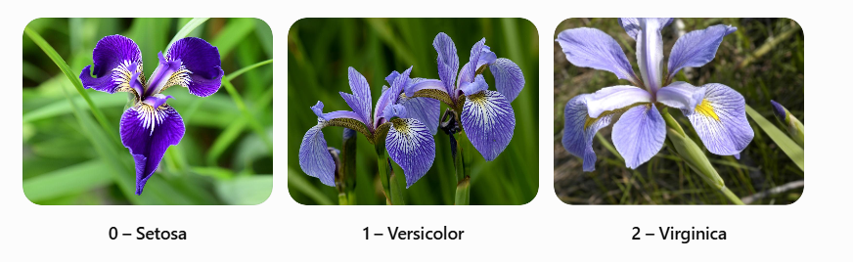
Entropy | 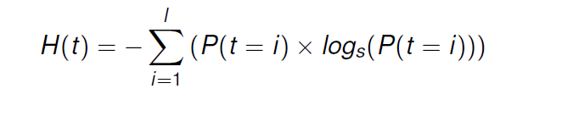
Gini Index | 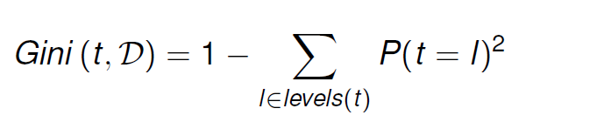

- Find the predicted class probabilities of the observation.
- Visualize the model created by a decision tree learning algorithm.
- Load boston dataset. Using only the first two features (CRIM and ZN), create a decision tree regression model to predict the value for the observation [[0.02, 16]] using both mean squared error (MSE) and mean absolute error (MAE) criteria to reduce variance.

Mean Squared Error (MSE) | 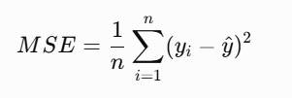
Mean Absolute Error (MAE) | 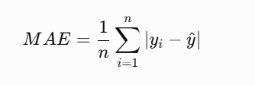

- Train a classification model for iris dataset using a “forest” of randomized decision trees. Predict the class of the observation [[5, 4, 3, 2]] and display the predicted class name. (Load the Iris dataset and train a Random Forest classification model using the RandomForestClassifier algorithm.)
- Load the Boston Housing dataset and train a Random Forest Regressor using only the first two features (CRIM and ZN) and 10 decision trees.
Predict the housing value for the observation [[0.02, 16]].
Display the predictions of all 10 decision trees.
Calculate the average of these 10 predictions.
Compare the calculated average with the final prediction produced by the Random Forest Regressor.
What do you observe? Explain how Random Forest Regression combines the predictions of individual decision trees.

- Plot which features are most important in the random forest model for the iris dataset.
- Train a decision tree or random forest model using a target vector with highly imbalanced classes.

