LAB5 –Nearest Neighbors & Naive Bayes

- Load iris dataset. Find the following observation’s [[ 1, 1, 1, 1]] 2 nearest observations (neighbors).
- Given the below observations, you need to predict their classes based on the class of their 5 neighbors.
new_observations = [[ 0.75, 0.75, 0.75, 0.75],
[ 1, 1, 1, 1]]
- You want to select the best value for k in a k-nearest neighbors classifier.
- The most common type of naive Bayes classifier is the Gaussian naive Bayes, which is suitable for continuous features. In Gaussian naive Bayes, we assume that the likelihood of the feature values, x, given an observation is of class y, follows a normal distribution.
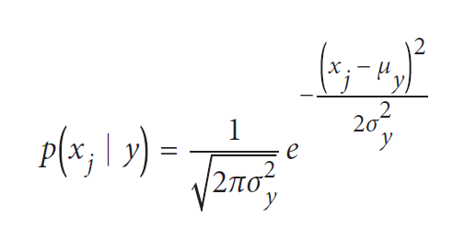
For the new_observation = [[ 4, 4, 4, 0.4]], use the Gaussian naïve Bayes classifier and predict its class label. Calibrate the predicted probabilities from naive Bayes classifiers so they are interpretable.
- One of the interesting aspects of naive Bayes classifiers is that they allow us to assign a prior belief over the respected target classes. We can do this using GaussianNB’s priors parameter, which takes in a list of the probabilities assigned to each class of the target vector (If not specified, the priors are adjusted according to the data.). Use priors=[0.25, 0.25, 0.5] and reconstruct the GaussianNB classifier.
- You have binary feature data and need to train a naive Bayes classifier. Use a Bernoulli naive Bayes classifier.
- Given discrete or count data, you need to train a naive Bayes classifier. Use Multinomial naïve Bayes classifier for the below data.

text_data = np.array(['I love Brazil. Brazil!',
'Brazil is best',
'Germany beats both'])


