
PK FOKAM INSTITUTE OF EXCELLENCE
********
Dignity – Faith – Responsibility
DEPARTMENT OF COMPUTER & MECHANICAL ENGINEERING
Project: Development of a Restaurant Management Web Application
REPORT v1.4
COURSE: INTRODUCTION TO PYTHON PROGRAMMING
THEME: PREPARATION AND RESEARCH FOR THE DEVELOPMENT OF A RESTAURANT WEB APP

Group Members:
- KAMDEM JUDITH
- MVONDO MVONDO ANTHONY
- DJOKO AICHA
- MEP MEKU AUDREY
- IBRAHIM DIALLO

Table of contents
Work Distribution 3
Contribution (Current Report) 4
Introduction 5
Project Objectives 5
Main Objective: 5
Specific objectives: 5
Project Phases 6
Phase 1: Project Initiation (Concept Definition) 6
Phase 2: Requirements Analysis 6
Phase 3: System Analysis 6
Phase 4: System Design 6
Phase 5: Development Environment Setup 7
Phase 6: Backend Development 7
Phase 7: Database Implementation 7
Phase 8: Frontend Development 7
Phase 9: System Integration 7
Phase 10: Testing and Debugging 7
Phase 11: Deployment 7
Phase 12: Documentation and Reporting 8
Phase 13: Maintenance and Improvement 8
System Analysis and Description of the Proposed System 8
Modules: 8
Tools and Technologies 9
Database Overview 9
Project Planning: 10
System Modeling 11
System Implementation 16
Database Implementation 16
Backend Implementation 17
Graphical User Interface Implementation 17
Overviews of our desired Graphical User Interface 19
Current Progress of the Project 19
Difficulties Encountered 23
Solutions Applied 24
Next Steps and Implementation Plan 24
GitHub Repository Link 25
SQL Database File 25

Work Distribution
The project is carried out by a team of four members. Each member has a specific role in the project while contributing to the tasks required at each
Table 1: General role
Member | Role | Matricule Number
Kamdem Matchum Judith Purchelle | Database Analysis, Documentation, Project Coordination | 25S052
Mvondo Mvondo Wilfried Anthony | Backend Development | 25S048
Massado Djoko Aicha | Frontend Development | 26S003
Mep Audrey Larissa | System Integration and Testing | 26S014
Ibrahim Diallo | System Analysis and Implementation Support

Contribution (Current Report)
Since this report covers the first stage of the project, the following tasks were completed collaboratively by the team:
Member | Contribution | Percentage
Kamdem Matchum Judith Purchelle | Analyzed the SQL database structure, studied most of the system models, prepared the project documentation, and designed the PowerPoint presentation containing the desired GUI | 20%
Mvondo Mvondo Wilfried Anthony | Assisted in setting up the Django development environment and project structure and carried out the initial system implementation | 20%
Massado Djoko Aicha | Studied the system requirements, corrected the Use Case Diagram, and participated in the implementation of the welcome page | 20%
Mep Meku Audrey | Helped configure development tools, assisted in project planning, and participated in the analysis of the Class Diagram | 20%
Ibrahim Dialo | Participated in the study of the system models and assisted in project organization | 20%

Table 1.1: Role for stage 1&2

Introduction
The purpose of this project is to design and develop a restaurant management web application that will help restaurants manage their daily operations efficiently. The system will allow restaurant staff to manage customers, orders, reservations, employees, and inventory through a centralized web interface.
The application will be developed using Python and the Django framework, providing a secure and scalable backend environment. A relational database will store restaurant information such as customer data, menu items, orders, and stock.
This project is carried out as a group assignment and will be completed in three stages, each accompanied by a progress report.

Project Objectives
Main Objective: Develop a functional web-based system that simplifies restaurant management tasks.

Specific objectives:
- Design a database system to manage restaurant data
- Develop backend logic using Django
- Create a user-friendly web interface for staff
- Manage restaurant operations: customer info, orders, reservations, employees, inventory
- Ensure the system is organized, efficient, and easy to use

Project Phases
The development of the Restaurant Management Web Application is divided into three main phases.

Phase 1: Project Initiation (Concept Definition)
This is where the idea of the Restaurant Management Web App is born. The main problem is identified: restaurant operations are often slow and disorganized when handled manually. The solution is defined as a digital system that can centralize and simplify restaurant management tasks using a web application.

Phase 2: Requirements Analysis
In this phase, the system requirements are collected and clarified. This includes defining what the system must do, such as managing users, handling orders, displaying menus, and possibly processing billing. User roles (admin, staff, etc.) are identified, along with functional and non-functional requirements.

Phase 3: System Analysis
The system is broken down logically to understand how it will work internally. Workflows such as ordering, menu updates, and user authentication are analyzed. The goal is to clearly understand system behavior before design begins.

Phase 4: System Design
This phase focuses on planning the structure of the system. UML diagrams such as use case, class, sequence, and activity diagrams are created. The database structure and system architecture are also designed. This phase acts as the blueprint of the entire application.

Phase 5: Development Environment Setup
The development tools and environment are prepared. Python is installed, a Django environment is created (using Anaconda or virtual environment), and Django is installed. The project repository is also set up on GitHub, and the initial project structure is created.

Phase 6: Backend Development
The core logic of the system is implemented using Django. This includes creating models, views, and URL routing. Core features like authentication, menu management, and order processing are developed in this phase.

Phase 7: Database Implementation
The database is designed and connected to the backend system. Models are migrated into actual database tables, and relationships between entities (such as users, orders, and menu items) are established and tested.

Phase 8: Frontend Development
The user interface is developed using HTML, CSS, and possibly Bootstrap. Pages such as login, dashboard, menu, and order interfaces are created to allow users to interact with the system.

Phase 9: System Integration
All components of the system are connected together. The frontend is linked with backend logic and database operations. The full workflow of the system is tested to ensure smooth interaction between all modules.

Phase 10: Testing and Debugging
The system is tested to identify and fix errors. This includes checking individual components (unit testing) and the full system (integration testing). Bugs are corrected and performance is improved.

Phase 11: Deployment
The application is prepared for use. It may be run locally or deployed to a web server. Configuration for production use is done if required.

Phase 12: Documentation and Reporting
All project details are documented, including system design, diagrams, implementation steps, and user instructions. This phase ensures the project can be understood and evaluated by others.

Phase 13: Maintenance and Improvement
After initial completion, the system can be improved by adding new features, fixing remaining issues, or optimizing performance based on feedback.

System Analysis and Description of the Proposed System
The proposed system is a restaurant management web application enabling administrators and staff to manage restaurant operations.

Modules:
- Customer Management: Store and track customer information (Currently working on)
- Order Management: Record and manage customer orders
- Reservation Management: Handle table reservations
- Employee Management: Store employee information
- Inventory and Stock Management: Monitor ingredients and stock levels

All modules interact with a central database for organized and accessible information.

Tools and Technologies
Technology | Type | Purpose
Python | Backend programming language | Used to implement the server-side logic of the restaurant management system
Django Framework | Web development framework | Manages database interactions, web pages, authentication, and application security
MySQL | Database Management System (DBMS) | Stores system data such as customers, orders, products, and employee records
GitHub | Version control platform | Used for source code management, version tracking, and project collaboration
HTML | Frontend technology | Provides the structure of the web pages
CSS | Frontend technology | Provides styling and layout for the user interface

Database Overview
The database stores all information required for restaurant operations.
Tables:
- Customers
- Orders
- Reservations
- Employees
- Products/Menu items
- Stock/Inventory
Sample
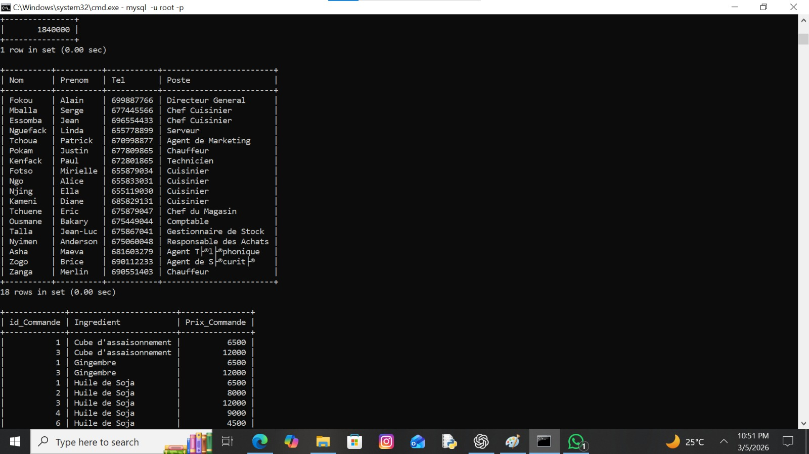
Figure a: Data in the sql file

The design ensures organized, consistent, and retrievable data. The SQL file is included with this report.

Project Planning:
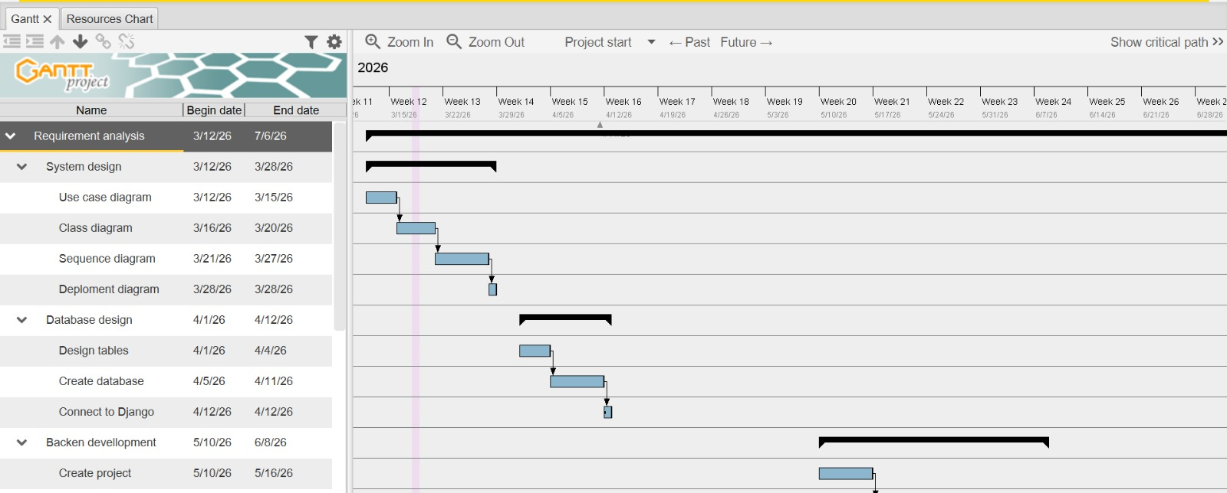
Figure 2: Gantt Chart
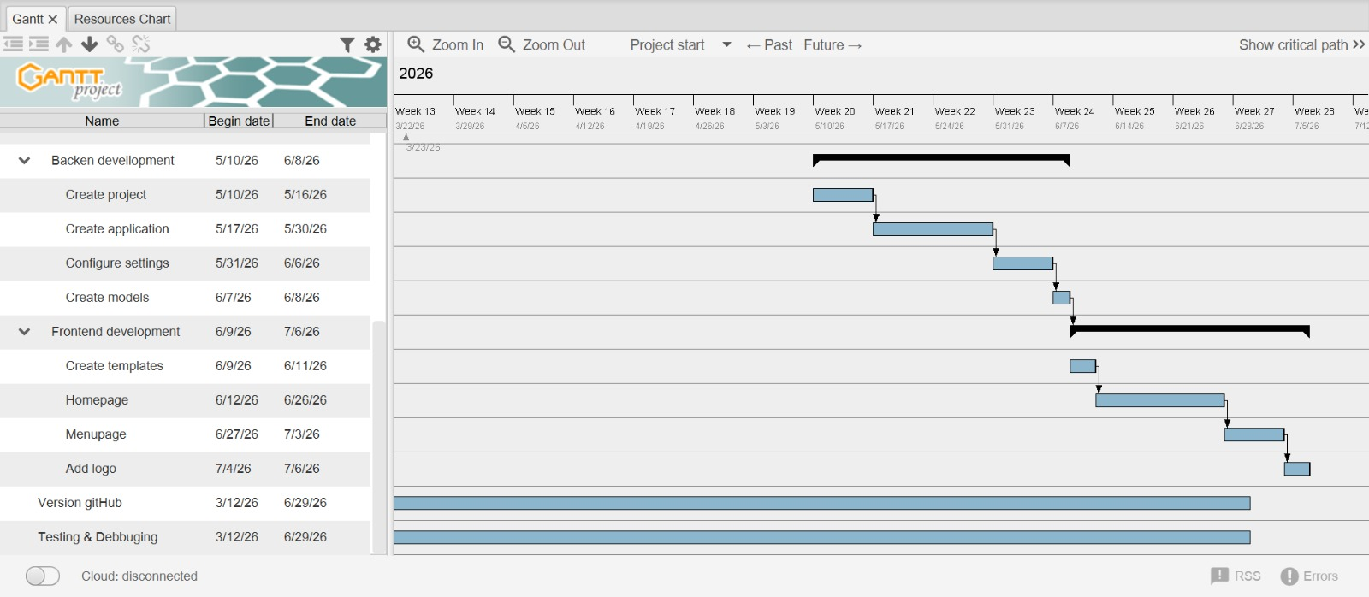
Figure 3: Gantt chart

System Modeling
To better understand the structure and behavior of the system, several UML dagrams were developed.
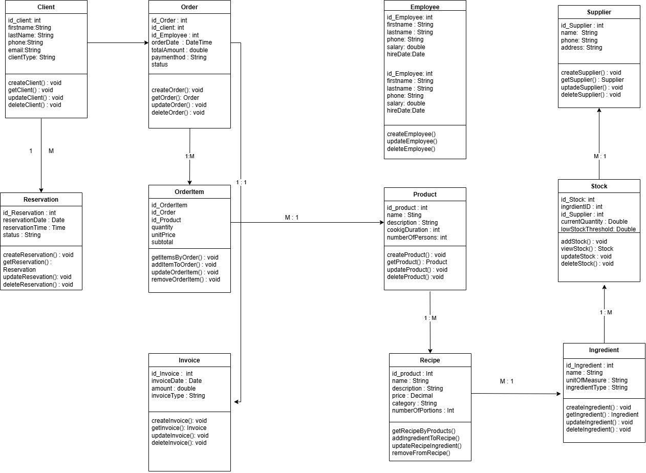
Figure 4: Class model

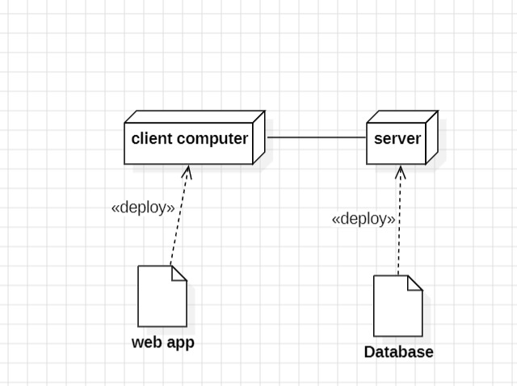
Figure 5: Deployment Diagram

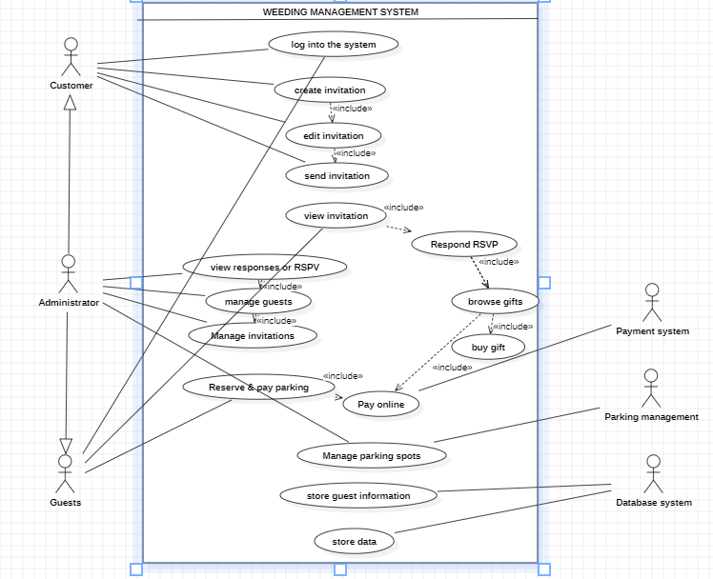
Figure 11: User case diagram
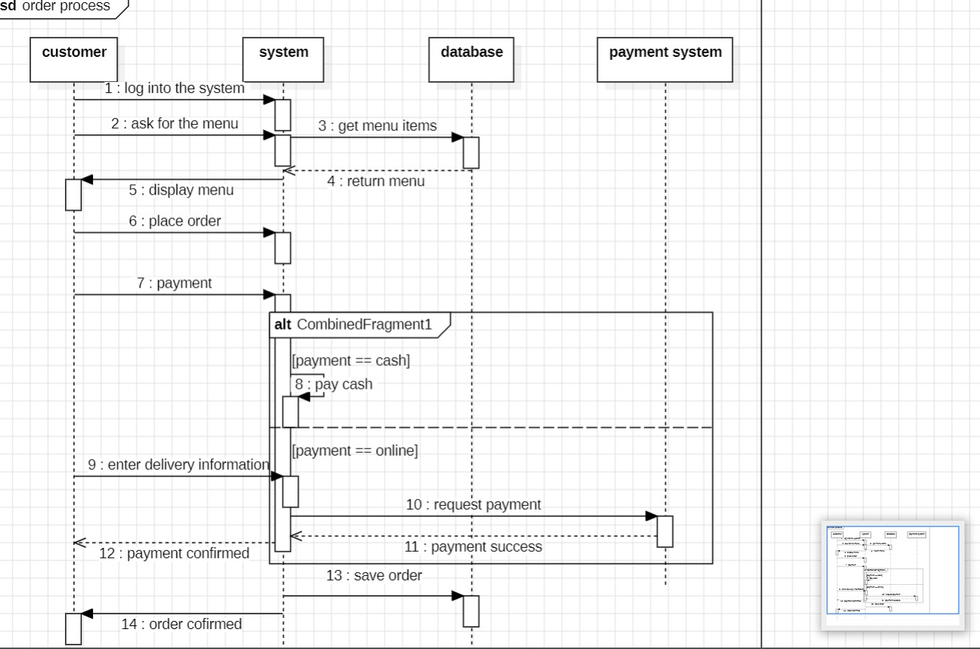
Figure 6: Sequence Diagram

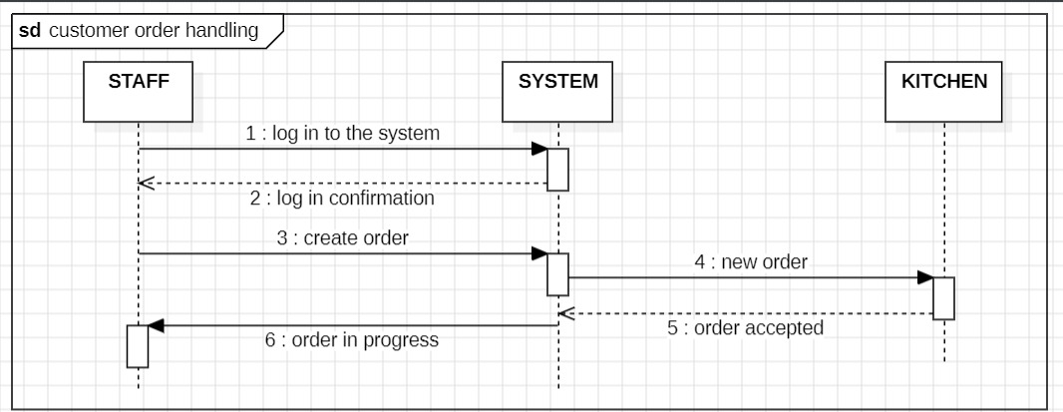
Figure 7: Sequence diagram continuity

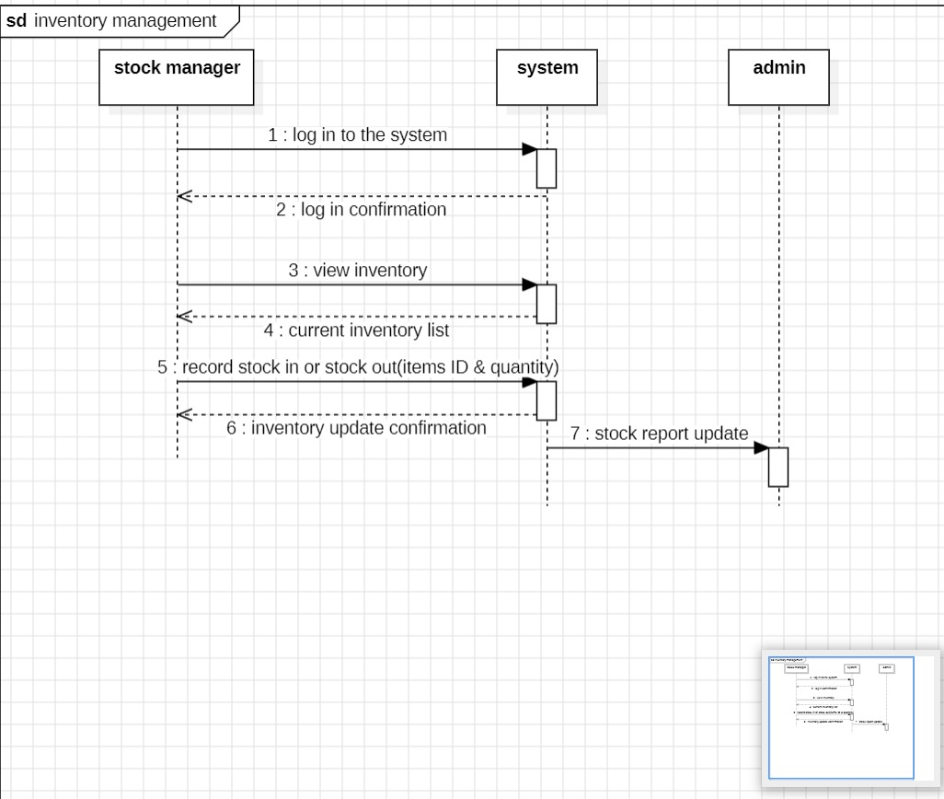
Figure 8: Sequence diagram end

System Implementation
Implementation is the phase where the design of the restaurant management system is transformed into a working application. At this stage, the different modules identified during the analysis and design phases are progressively developed. The objective is to build the backend structure, database, and graphical user interfaces of the system.

Database Implementation
The database was implemented using MySQL based on the class diagram produced during the design phase. The main tables created include:
- Products
- Customers
- Orders
- Reservations
- Employees
- Inventory
The database structure allows the system to store restaurant menu items, customer information, orders, and stock levels.

Backend Implementation
The backend logic is currently being developed using Python and the Django framework. At this stage, CRUD operations (Create, Read, Update, Delete) are being implemented starting with the product management module.
Currently implemented features:
- Add product
- View products
- Modify product
- Delete product

Graphical User Interface Implementation
The graphical user interfaces are being progressively developed starting with the Product Management module. The first interfaces created allow the administrator to add, view, edit and delete products.

Below are screenshots of the first front end implementation results.
Example:
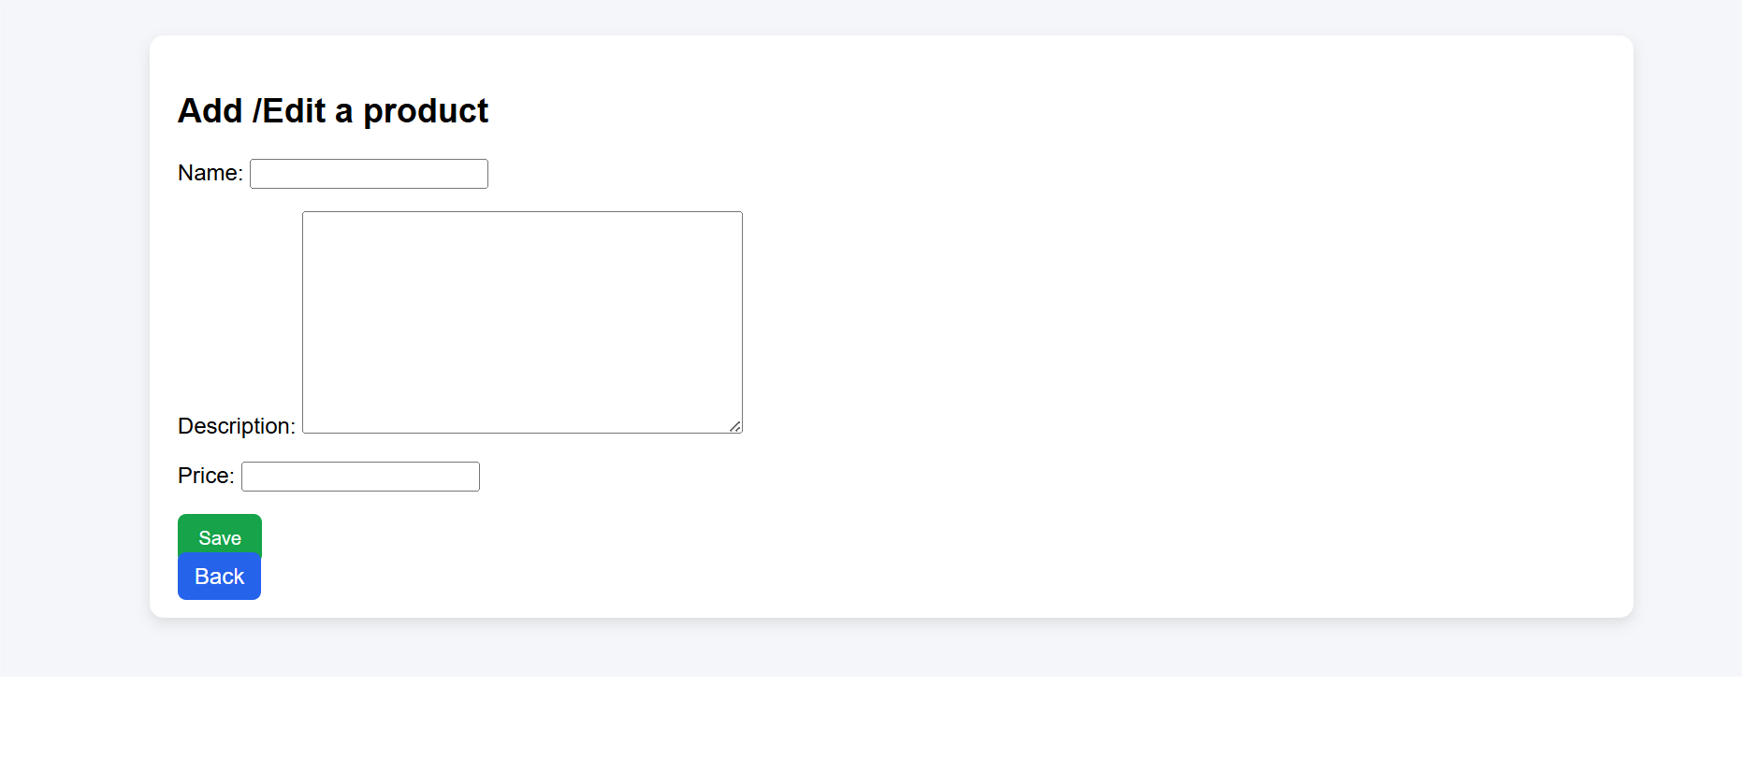
Image 1: Add Product Interface

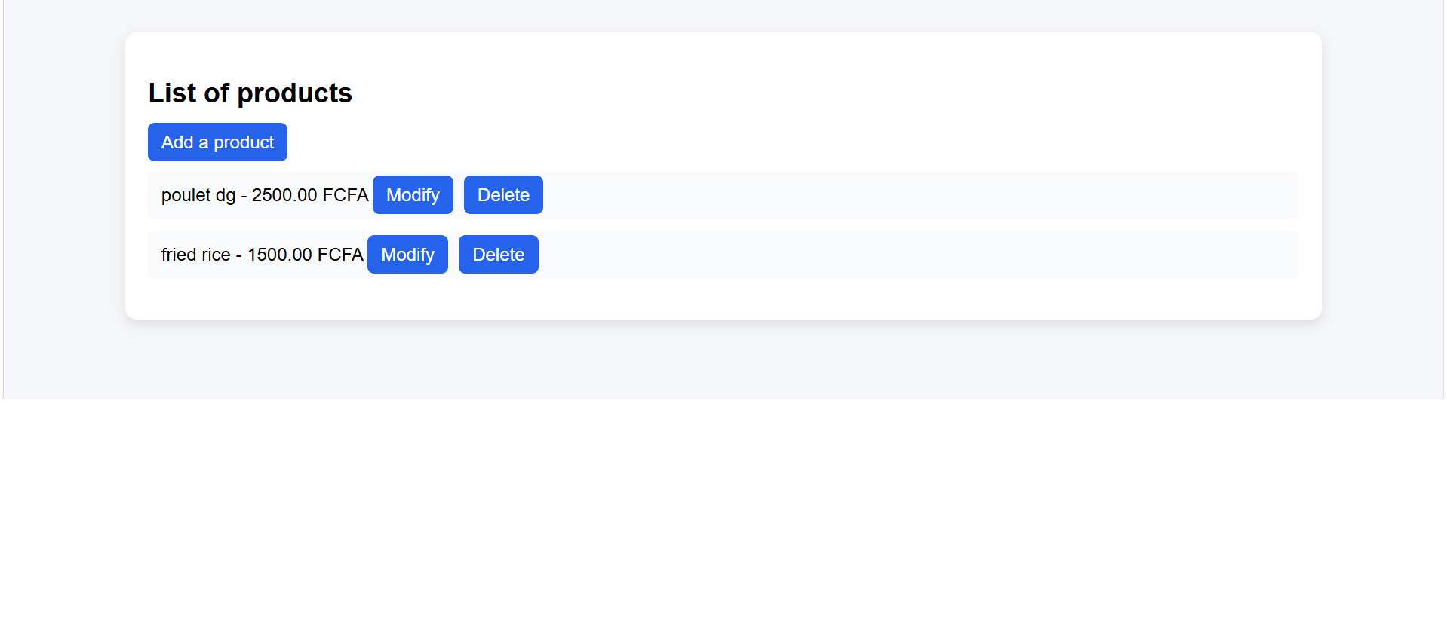
Image 2: Product list interface

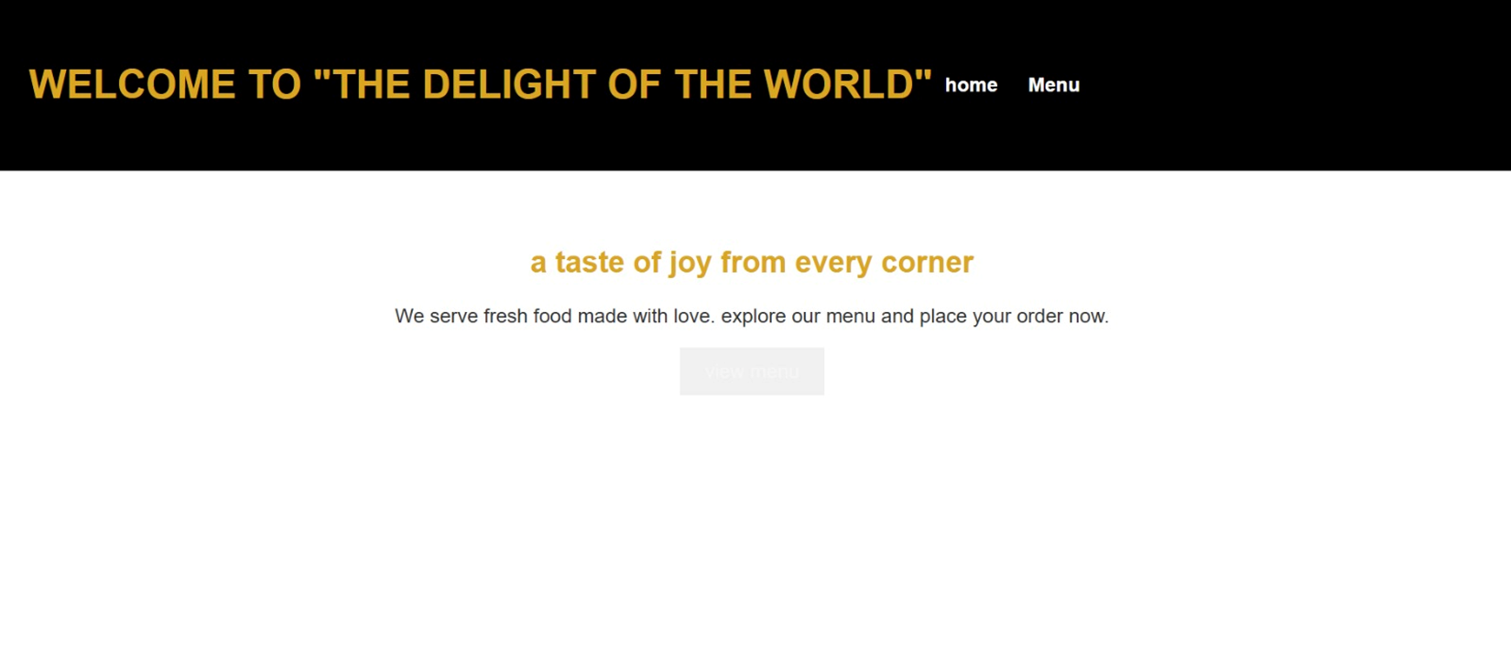
Image 3: Welcome page
This interface allows the administrator to insert new products into the system by providing the name, description, and price.

Overviews of our desired Graphical User Interface
Found in the powerpoint upload in our github repository
Title : GENERAL OVERVIEW OF OUR GRAPICAL USER INTERFACE

Current Progress of the Project
Completed tasks:
- Installed and configured development tools (Python, Django)
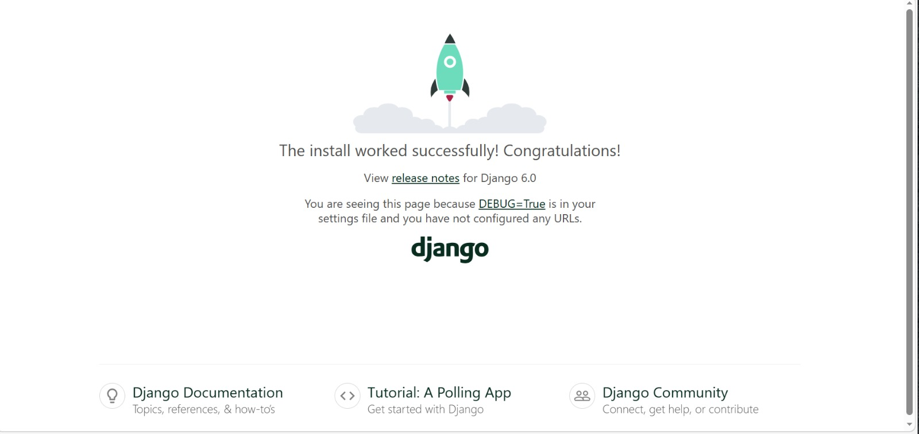
Figure 9: Django complete installation
- Created GitHub repository
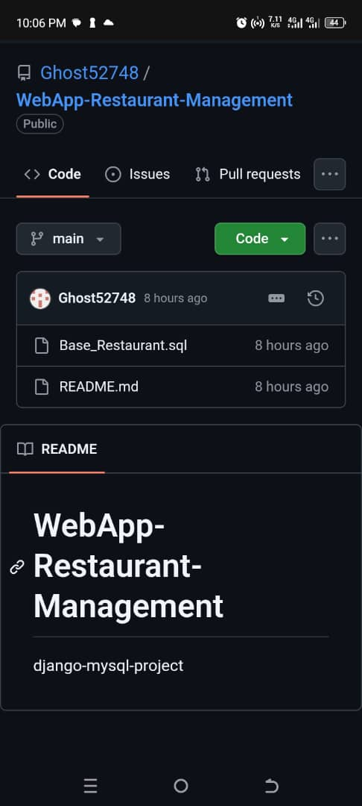
Figure 10: Github repository

- Created Django project structure
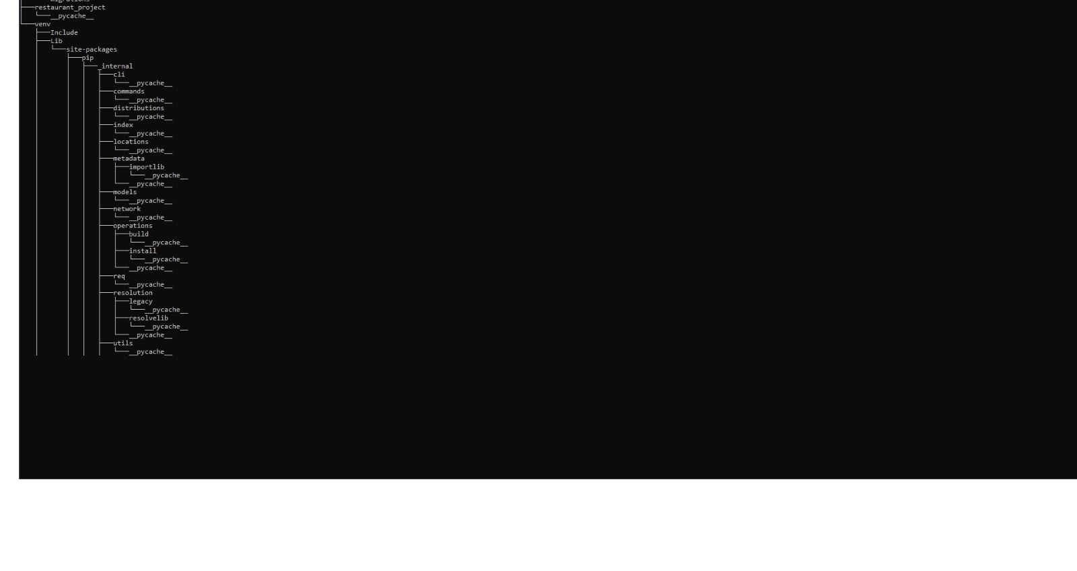
Figure 11: Project structure
- Implemented database models in Django
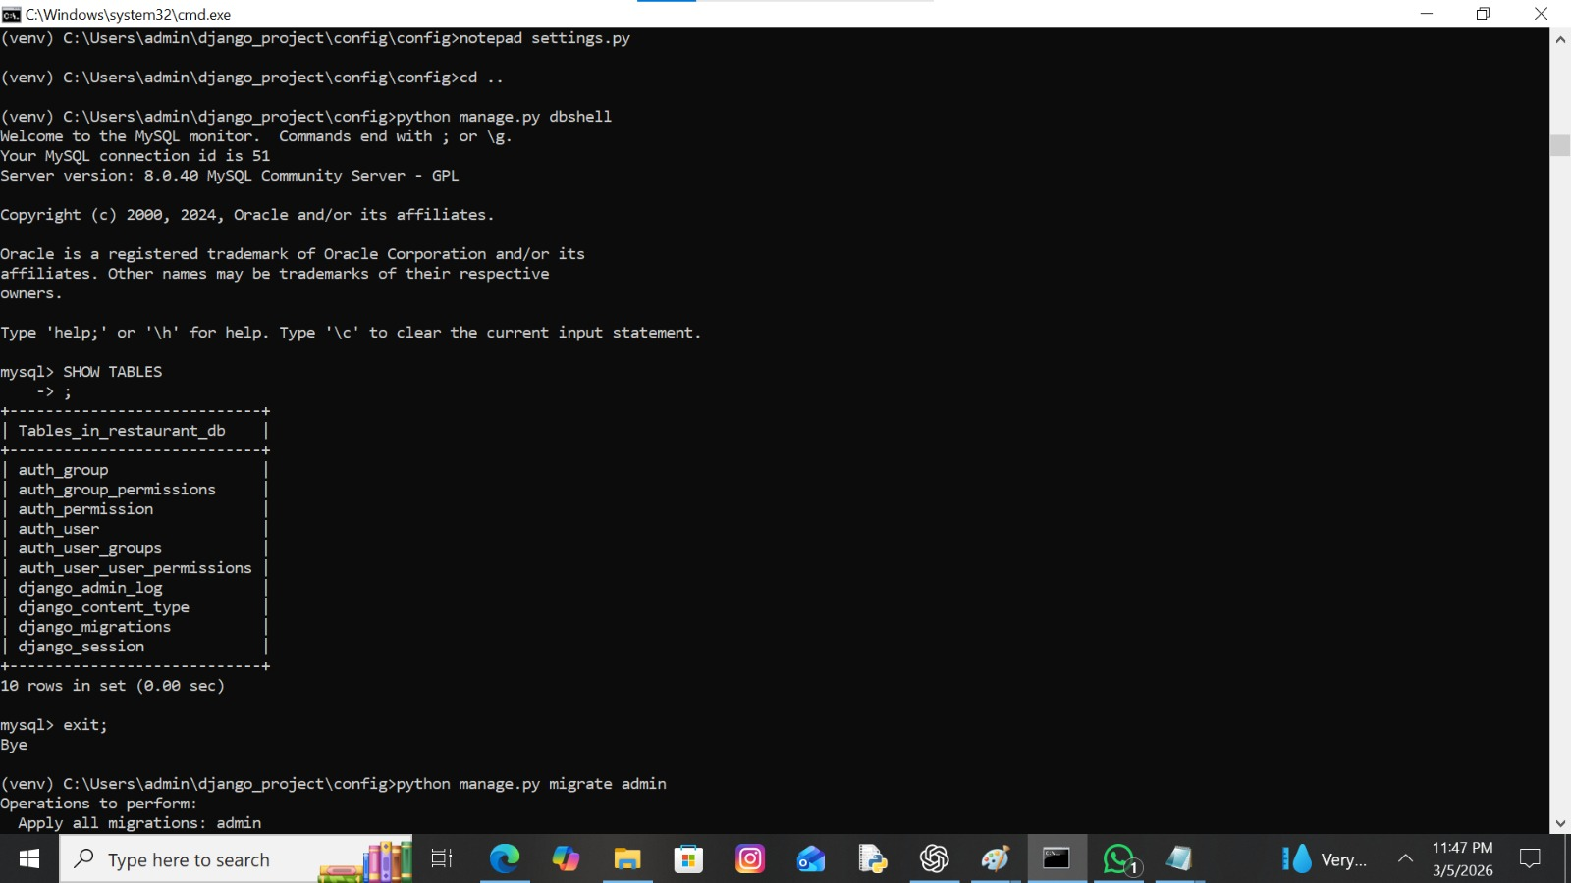
Figure 12:Database models in Django

- Connected Django application to the database
Database link with Django

Figure 13: Database link with Django

- Project plan using gantt chart
- Understanding and representing the management system using models
- Analyze SQL database structure and table relationships
- Study Django framework more deeply
In progress:
- Continuous improvement of system architecture and project plan
- Implementation of the Product management module

Difficulties Encountered
During the first phase of the project, the group encountered several technical and organizational challenges:
• Learning the Django framework for some members who were not previously familiar with it
• Understanding the database structure due to the presence of multiple related tables
• Difficulty understanding and creating UML diagrams such as Class, Use Case, and Sequence diagrams
• Installing and configuring development tools such as Python, Django, StarUML, and GanttProject
• Coordinating tasks and planning work effectively among group members
• Understanding how to properly analyze system requirements before designing the models
· Connecting the Django application to the MySQL database
· Retrieving data from HTML forms caused issues
· Errors occurred during update and delete operations due to mistakes in SQL queries and route configuration.

Solutions Applied
To overcome these challenges, the group adopted the following solutions:
• Members studied Django documentation, watched tutorials, and practiced small examples to improve their understanding of the framework
• The group analyzed the SQL database structure together to better understand relationships between tables and how data flows in the system
• Members researched UML modeling concepts and collaborated to better understand how to design Class, Use Case, and Sequence diagrams
• Members who successfully installed the required tools assisted others in configuring their development environment
• Tasks were clearly divided among members according to roles and competencies to improve efficiency
• Regular communication and group discussions were used to clarify requirements and improve project planning
• SQL queries were reviewed and debugged to ensure that update and delete operations functioned correctly.
• CSS styling was gradually added to improve the interface layout and usability.

Next Steps and Implementation Plan
- Implement core functionalities: orders, customers, reservations
- Connecting all modules to the CSS design
- Implementing customer management
- Implementing order processing
- Developing reservation management
- Improving dashboard interface
- System testing
- Testing and integration of modules

GitHub Repository Link
https://github.com/Ghost52748/WebApp-Restaurant-Management

SQL Database File
The SQL file containing the database structure is included in our Github repository as part of the project submission.
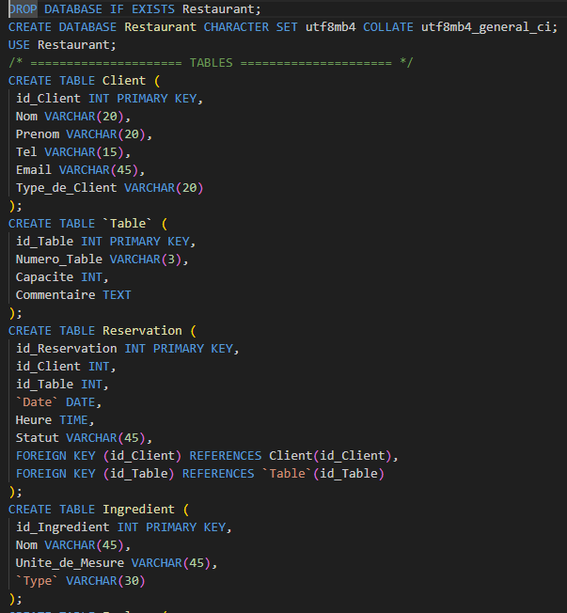
Figure 14: Database file

