
PK FOKAM INSTITUTE OF EXCELLENCE
********
Dignity – Faith – Responsibility
DEPARTMENT OF COMPUTER & MECHANICAL ENGINEERING
Project: Development of a Restaurant Management Web Application
REPORT v1.1
COURSE: INTRODUCTION TO PYTHON PROGRAMMING
THEME: PREPARATION AND RESEARCH FOR THE DEVELOPMENT OF A RESTAURANT WEB APP

Group Members:
- KAMDEM JUDITH
- MVONDO MVONDO ANTHONY
- DJOKO AICHA
- MEP MEKU AUDREY
Table of Contents
1. Work Distribution………………………………………………………3

2. Introduction……………………………………………………………..6

2. Project Objectives……………………………………………………..3
3. Project stages…………………………………………………………..3
4. System Analysis and Description of the Proposed System…………….4
5. Tools and Technologies…………………………………………………5
6. Database Overview……………………………………………………..7
7. Project Planning…………………………………………………………9
8. Current Progress of the Project…………………………………………11
9. Difficulties Encountered……………………………………………….14
10. Solutions Applied…………………………………………………….14
11. Next Steps and Implementation Plan…………………………………16
12. Conclusion……………………………………………………………16
13. GitHub Repository Link……………………………………………...19
14. SQL Database File……………………………………………………19

Work Distribution
The project is carried out by a team of four members. Each member has a specific role in the project while contributing to the tasks required at each
Table 1: General role
Member | Role | Matricule number
Kamdem Matchum Judith Purchelle | Database Analysis, Documentation, Project Coordination | 25S052
Mvondo Mvondo Wilfried Anthony | Backend Developer | 25S048
Massado Djoko Aicha | Frontend Developer | 26S003
Mep Audrey Larissa | System Integration and Testing | 26S014

Contribution During Stage 1 and 2 (Current Report)
Since this report covers the first stage of the project, the following tasks were completed collaboratively by the team:
Member | Contribution | Percentage
Kamdem Matchum Judith Purchelle | Analyzed the SQL database structure, studied and understood most of the system models, and prepared the project documentation and report writing | 25%
Mvondo Mvondo Wilfried Anthony | Assisted in setting up the Django development environment and project structure, and developed the Class Diagram and Gantt Chart | 25%
Massado Djoko Aicha | Participated in studying the system requirements, planned the application interface, and created the Use Case Diagram, Sequence Diagram, and Gantt Chart | 25%
Mep Meku Audrey | Helped configure development tools, assisted in project planning, and participated in the analysis of the Class Diagram | 25%
Table 1.1: Role for stage 1&2

1. Introduction
The purpose of this project is to design and develop a restaurant management web application that will help restaurants manage their daily operations efficiently. The system will allow restaurant staff to manage customers, orders, reservations, employees, and inventory through a centralized web interface.
The application will be developed using Python and the Django framework, providing a secure and scalable backend environment. A relational database will store restaurant information such as customer data, menu items, orders, and stock.
This project is carried out as a group assignment and will be completed in three stages, each accompanied by a progress report.

2. Project Objectives
Main Objective: Develop a functional web-based system that simplifies restaurant management tasks.
Specific objectives:
- Design a database system to manage restaurant data
- Develop backend logic using Django
- Create a user-friendly web interface for staff
- Manage restaurant operations: customer info, orders, reservations, employees, inventory
- Ensure the system is organized, efficient, and easy to use

3. Project Phases
The development of the Restaurant Management Web Application is divided into three main phases.

- Phase 1: Project Preparation and Initial Setup
This phase focuses on understanding the project requirements and preparing the development environment. It includes installing the required tools, creating the Django project structure, analyzing the SQL database, and connecting the application to the database.

- Phase 2: System Development
This phase focuses on building the main functionalities of the application. It includes developing the backend logic using Django, designing the user interface, and implementing the core modules such as customer management, orders, reservations, employees, and inventory.

- Phase 3: System Integration and Testing
This phase focuses on integrating all system components and ensuring that the application works correctly. It includes testing the system, fixing errors, improving performance, and preparing the final version of the application.

4. System Analysis and Description of the Proposed System
The proposed system is a restaurant management web application enabling administrators and staff to manage restaurant operations.

Modules:
- Customer Management: Store and track customer information
- Order Management: Record and manage customer orders
- Reservation Management: Handle table reservations
- Employee Management: Store employee information
- Inventory and Stock Management: Monitor ingredients and stock levels

All modules interact with a central database for organized and accessible information.

5. Tools and Technologies
• Python: Backend programming language
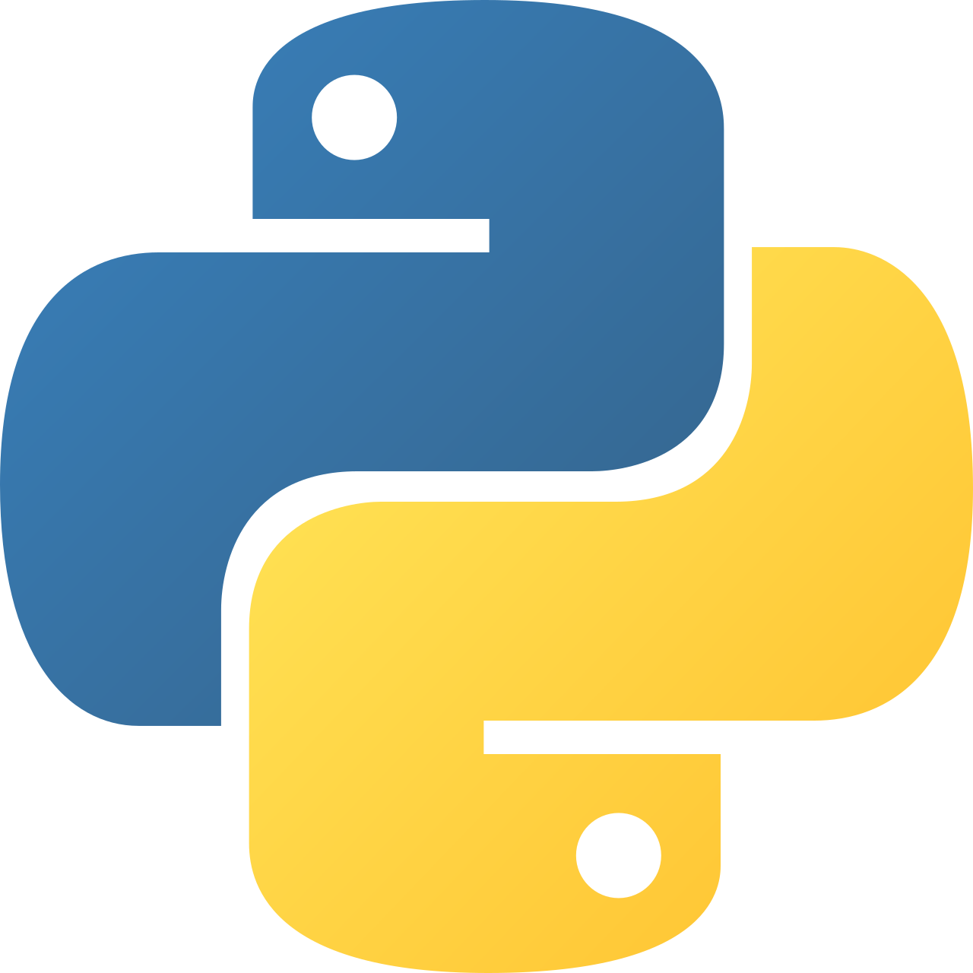
Figure a: Python app
• Django Framework: Handles database, web pages, and security

Figure b: Django app

• MySQL Database: Stores restaurant data
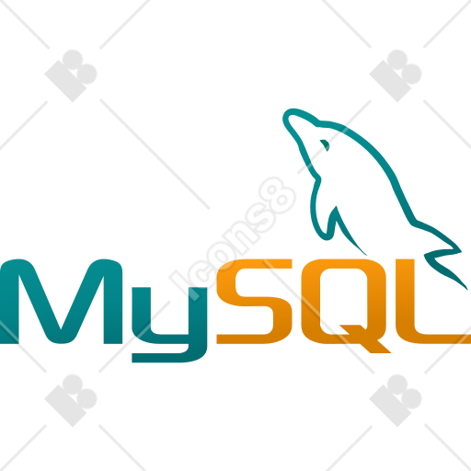
Figure c: Database tool
• GitHub: Version control and collaboration

Figure d: Github
• Web Technologies: HTML, CSS, possibly JavaScript for frontend

Figure e: Html app
6. Database Overview
The database stores all information required for restaurant operations.
Tables:
- Customers
- Orders
- Reservations
- Employees
- Products/Menu items
- Stock/Inventory
Sample
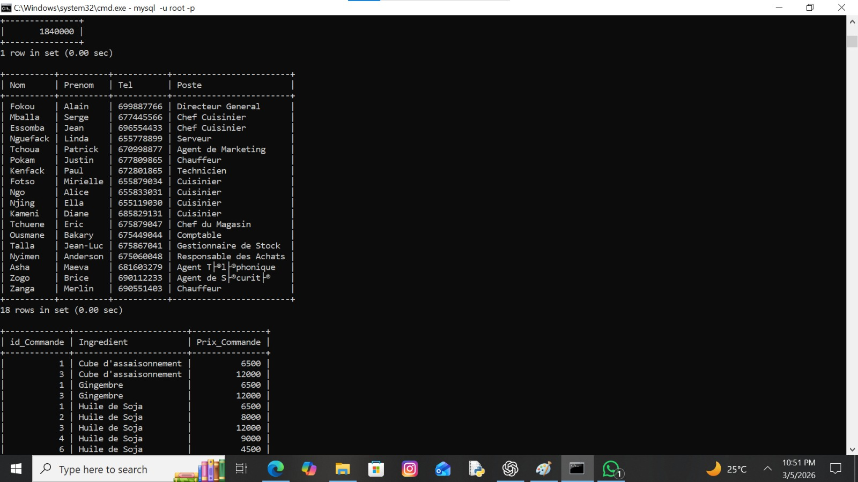
Figure f: Data in the sql file

The design ensures organized, consistent, and retrievable data. The SQL file is included with this report.
7. Project Planning:

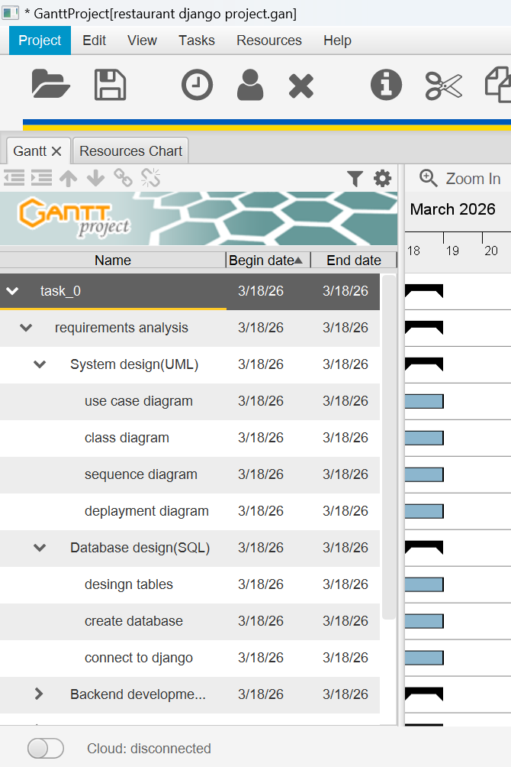

8. System Modeling
To better understand the structure and behavior of the system, several UML diagrams were developed.
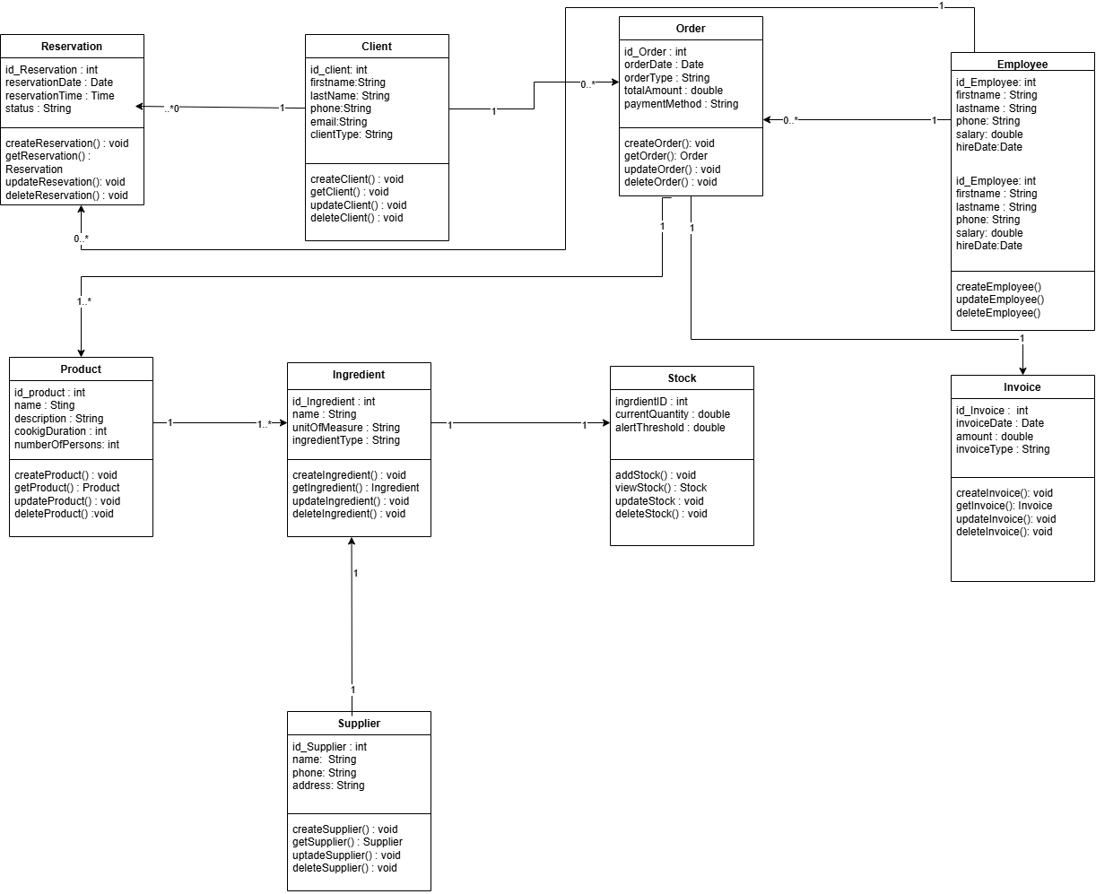
Figure g: Class model

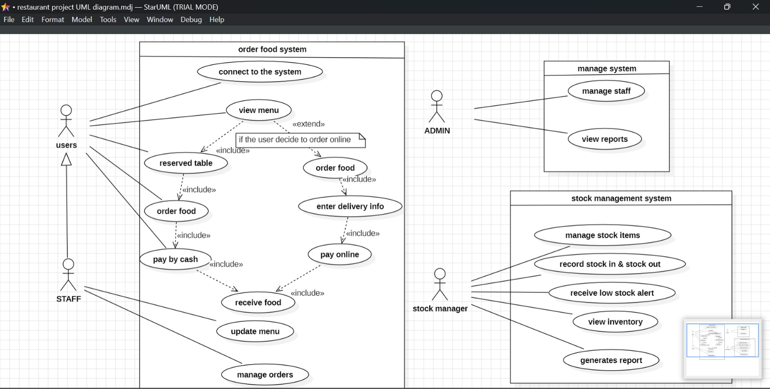
Figure h: User case diagram
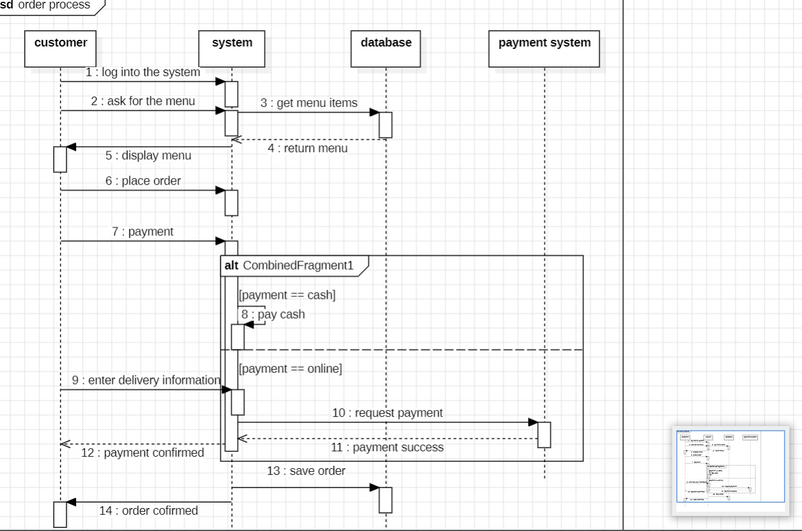
Figure i.1: Sequence Diagram

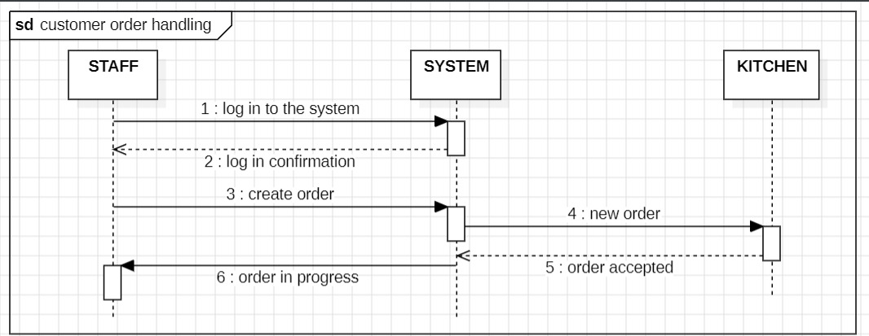
Figure j.: Sequence diagram continuity

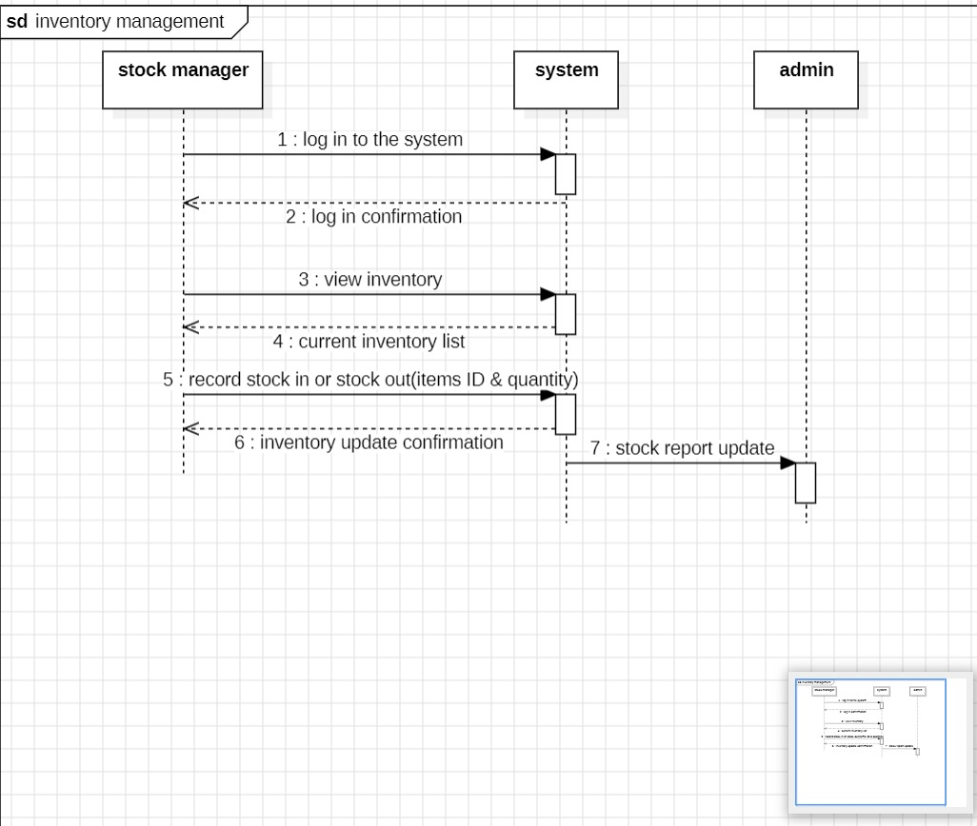
Figure k: Sequence diagram end

9. Current Progress of the Project
Completed tasks:
- Installed and configured development tools (Python, Django)
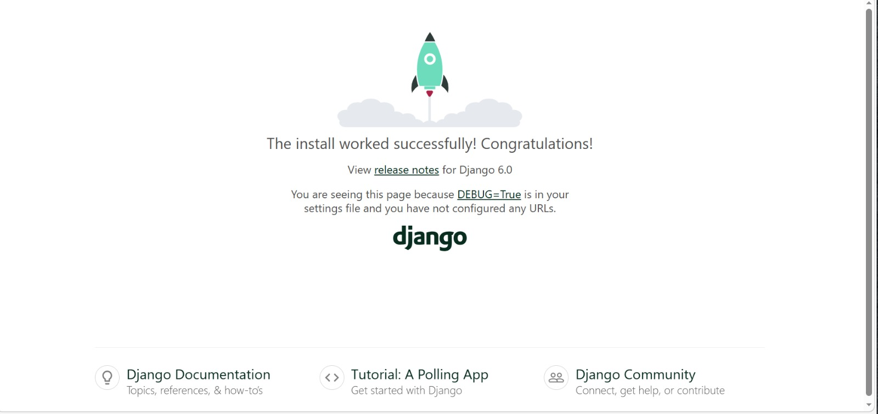
Figure l: Django complete installation
- Created GitHub repository
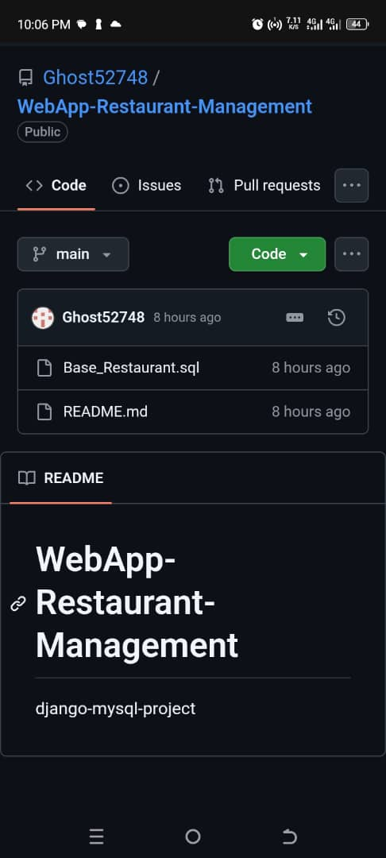
Figure m: Github repository
- Created Django project structure
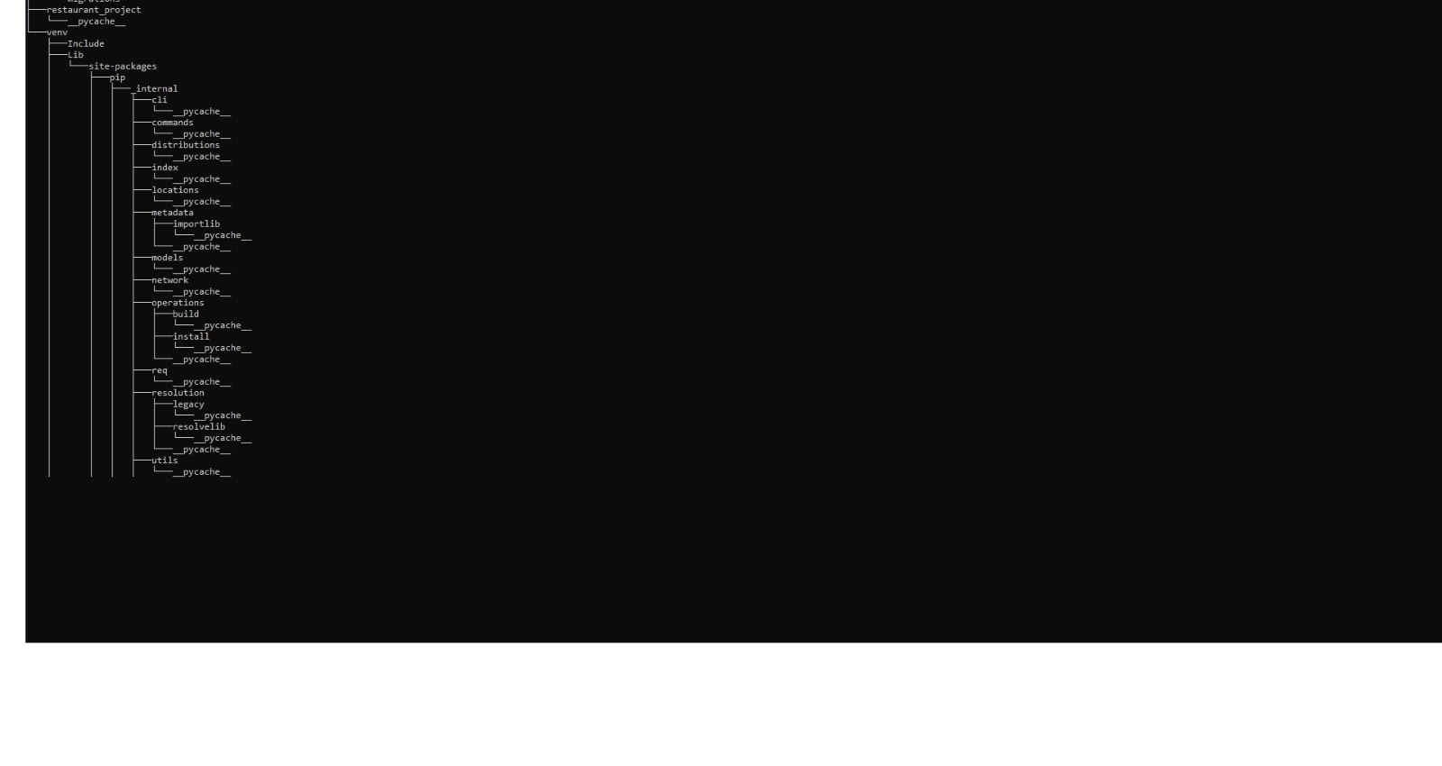
Figure n: Project structure
- Implemented database models in Django
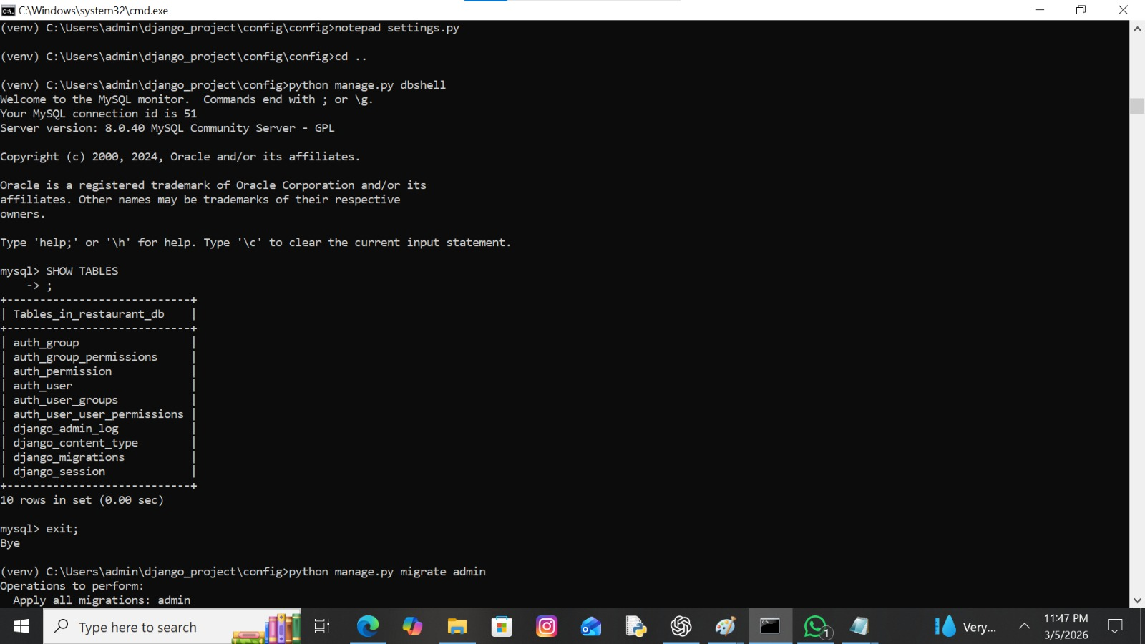
Figure o: Database models in Django
- Connected Django application to the database

Figure p: Database link with Django
- Project plan using gantt chart
- Understanding and representing the management system using models
In progress:
- Study Django framework more deeply
- Analyze SQL database structure and table relationships
- Continuous improvement of system architecture and project plan

10. Difficulties Encountered
During the first phase of the project, the group encountered several technical and organizational challenges:
• Learning the Django framework for some members who were not previously familiar with it
• Understanding the database structure due to the presence of multiple related tables
• Difficulty understanding and creating UML diagrams such as Class, Use Case, and Sequence diagrams
• Installing and configuring development tools such as Python, Django, StarUML, and GanttProject
• Coordinating tasks and planning work effectively among group members
• Understanding how to properly analyze system requirements before designing the models

11. Solutions Applied
To overcome these challenges, the group adopted the following solutions:
• Members studied Django documentation, watched tutorials, and practiced small examples to improve their understanding of the framework
• The group analyzed the SQL database structure together to better understand relationships between tables and how data flows in the system
• Members researched UML modeling concepts and collaborated to better understand how to design Class, Use Case, and Sequence diagrams
• Members who successfully installed the required tools assisted others in configuring their development environment
• Tasks were clearly divided among members according to roles and competencies to improve efficiency
• Regular communication and group discussions were used to clarify requirements and improve project planning

12. Next Steps and Implementation Plan
• Develop backend logic
• Design web interface
• Implement core functionalities: orders, customers, reservations
• Testing and integration of modules

13. Conclusion
Stage 1 focused on environment preparation, initial implementation, and database analysis. Challenges were addressed, workflow organized, and foundation laid for full development.

14. GitHub Repository Link
https://github.com/Ghost52748/WebApp-Restaurant-Management

15. SQL Database File
The SQL file containing the database structure is included in our Github repository as part of the project submission.
