
PROJECT REPORT
CAMPUS NAVIGATION SYSTEM

January 24, 2026
icT UNIVERSITY
MESSASSI YAOUNDE

FACULTY OF INFORMATION AND COMMUNICATION TECHNOLOGIES Fall 2025 FINAL EXAMINATION


Course Code/Course Title | Introduction to Software Engineering/ ICT 2140
Instructor | ENGR.TEKOH PALMA ACHU
Group Number | 5
Project Topic | Campus Indoor Navigation System
Link to GitHub Repository | Ghost590-beep/school-indoor-navigation-system: A web-based indoor school navigation system that provides interactive campus maps and route guidance using Agile (Scrum) methodology.
Group Leader | John Mc Knight Liyou

Group Information
SN | Member’s name | Registration Number | Team Role
1 | John Mc Knight Liyou | ICTU20241639 | Scrum Master
2 | Kole Ebang Ryan | ICTU20251127 | Chief Technology Officer
3 | Ndi Oben Fai | ICTU20241405 | Developer
4 | Ngole Eddy Junior Ndille | ICTU20241435 | Product Owner
5 | Obiegbnaum Odera Philip | ICTU20251151 | Developer

CHAPTER ONE: INTRODUCTION

General Introduction
The ICT University Campus Navigation System is a web-based solution designed to help students, staff, and visitors locate classrooms, offices, and services across multiple floors of the university. It integrates interactive SVG maps, dropdown floor selection, and pathfinding algorithms to provide clear navigation routes. In this project we are going to show you how we implemented thus project form the beginning to the end.

Aim and Objectives
- Aim
The primary aim of this project is to design and implement a smart indoor navigation system for ICT University that simplifies movement within the campus, reduces confusion, and enhances the overall user experience by providing clear, interactive, and efficient guidance.
- Objectives:
  - Provide interactive 2D and 3D maps of all floors and basement.
  - Enable users to select start and destination rooms via dropdowns or search.
  - Enable users to search and find rooms through their room names and highlight through the search bar.
  - Implement shortest path algorithms (BFS) for navigation.
  - Support multi-floor navigation via stairs/elevators.
  - Improve accessibility and reduce confusion for new students and visitors.
  - Ensure accessibility and usability across all possible platforms such as; mobile, computer amongst others.
  - Provide controls such as; rotate, zoom to make navigation easy and more engaging.
Problem Statement
Navigating large academic buildings can be confusing, especially for new students and visitors. Traditional paper maps are static and lack interactivity. This project addresses the problem by offering a digital, interactive, and scalable navigation system that reduces time wasted in finding rooms and improves campus experience.

CHAPTER TWO: LITERATURE REVIEW

Review of Concepts
- Database: Used to store room metadata, floor information, and user preferences.
- API: Enables communication between frontend and backend for room data retrieval.
- SVG Graphics: Provides scalable, interactive maps for each floor.
- Algorithms: BFS (Breadth-First Search) for shortest path navigation.
Software Development Methodologies
- Waterfall: Linear, rigid, less adaptive.
- Agile/Scrum: Iterative, flexible, team-oriented.
Chosen Methodology: Scrum
For the Campus Navigation System, our team adopted Scrum because:
- The project required flexibility: room lists, floor maps, and navigation logic evolved during development.
- The team benefited from clear roles: Scrum Master, Product Owner, and Developers ensured accountability.
- Sprints allowed us to deliver features incrementally (e.g., floor maps first, then dropdowns, then BFS pathfinding).
- Backlog management helped prioritize tasks like UI improvements, multi-floor navigation, and dropdown integration.
- Continuous feedback from peers and supervisors guided refinements and ensured usability.
Related Literature
Previous works on indoor navigation systems highlight the importance of usability, accessibility, and integration with real‑world constraints. Our system builds on these by combining SVG maps with pathfinding algorithms and a user‑friendly interface.

CHAPTER THREE: METHODOLOGY AND MATERIALS

Research Methodology
We adopted Agile Scrum, organizing tasks into sprints, holding regular stand-ups, and using GitHub for collaboration.

System Requirements
- Functional:
  - Load floor maps dynamically.
  - Allow room selection via dropdown/autocomplete.
  - Compute shortest path between rooms.
  - Support multi-floor navigation.
- Non-Functional:
  - Responsive design.
  - Fast performance.
  - Scalability for future expansion.

System Design
- Architecture (HLD):
  - Frontend: HTML, CSS, JavaScript, SVG maps.
  - Backend: GitHub repository, optional database/API integration.
  - Algorithms: BFS for pathfinding.

- UML Diagrams:
The images below show a use case diagram, class diagram and five sequence diagrams for a campus navigation system.

- Use Case: User selects start/end → System computes path → Displays route.
- Class Diagram: Room, Floor, Path, User.
- Sequence Diagrams: At least 5 covering search, navigation, floor switching, path drawing, error handling.

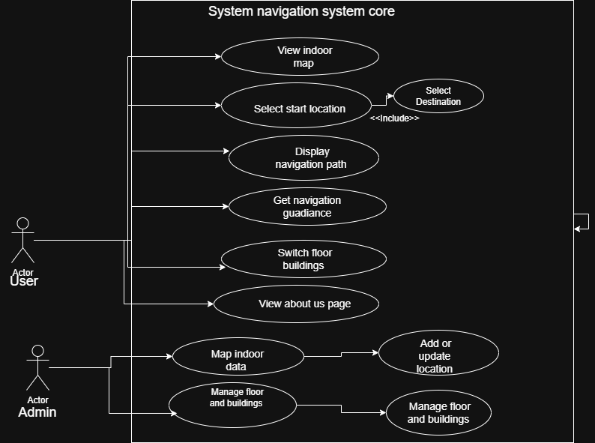
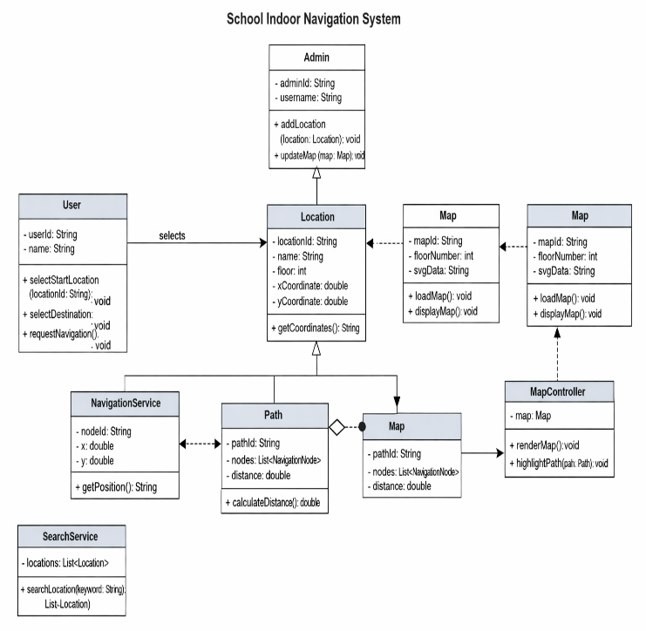

Use case diagram Class Diagram

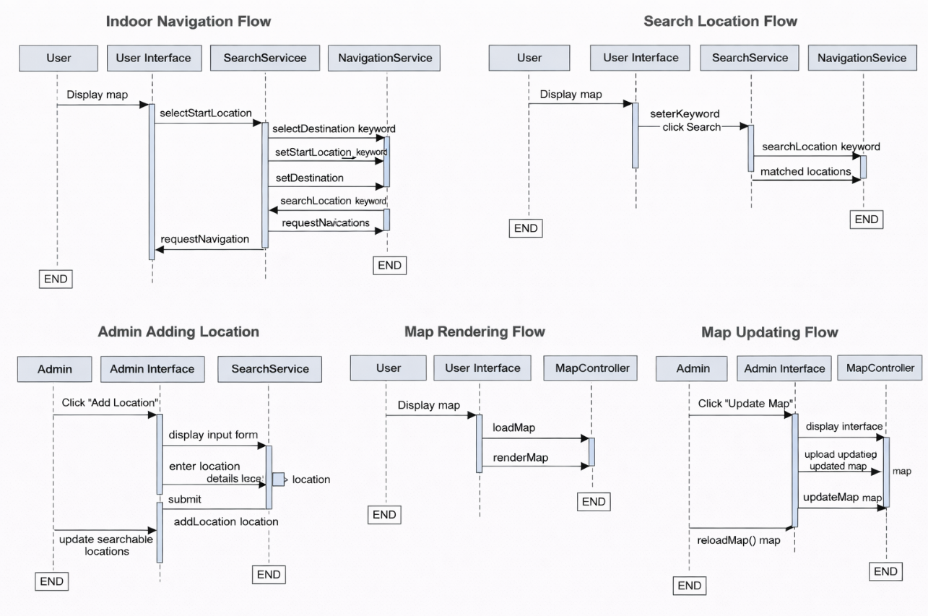
Sequence Diagram

Application of Methodology
- Team Organization: Roles assigned (Scrum Master, Product Owner, Developers).
- Workflow Management: GitHub pull requests, sprint backlog.
- Conflict Resolution: Regular meetings, peer reviews.
- Challenges: SVG quirks, dropdown mismatches, multi-floor path logic.
- Solutions: Modularization, helper functions, iterative debugging.

Requirements Specification
- Product Backlog: Floor maps, dropdowns, BFS, UI controls.
- Sprint Backlog: Implement dropdowns, pathfinding, floor switching.

Test Case Document
- Input: Start = Library, End = Sick Bay → Output: Path drawn across Floor 1.
- Input: Start = Lecture Room 1, End = Dean’s Office → Output: Multi-floor path via stairs.

Proposed Algorithms
- BFS (Breadth-First Search): For shortest path.
- Multi-Floor Path Handling: Detect stairs/elevators, switch floor context.
Materials and Technologies
- HTML/CSS/JS: Frontend.
- SVG: Floor maps.
- GitHub: Version control.
- Agile Scrum Tools: Sprint planning, backlog management.

CHAPTER FOUR: RESULTS AND DISCUSSIONS

Results
- Interactive 2D maps for all floors and basement.
- Dropdowns for room selection (start/end).
- BFS algorithm computes shortest paths.
- Multi-floor navigation supported.

Screenshots
- Floor 1 navigation in 2D map.
The image below shows navigation form the library to the sick bay.
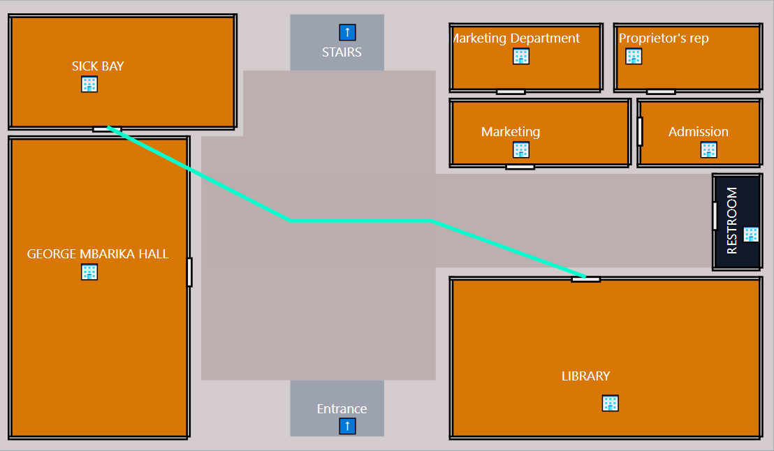
- Multi-floor navigation (Lecture Room 1 → Dean’s Office) in 2D map.
This image below shows the navigation from the lecture room 1 and the dean’s office.

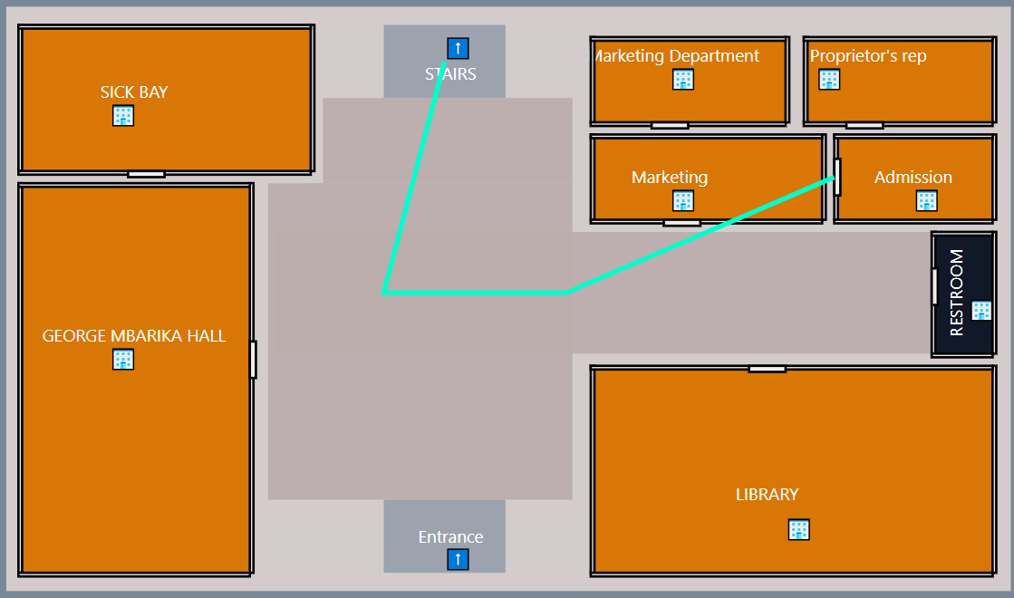
Continues to the next floor as shown in the image below.
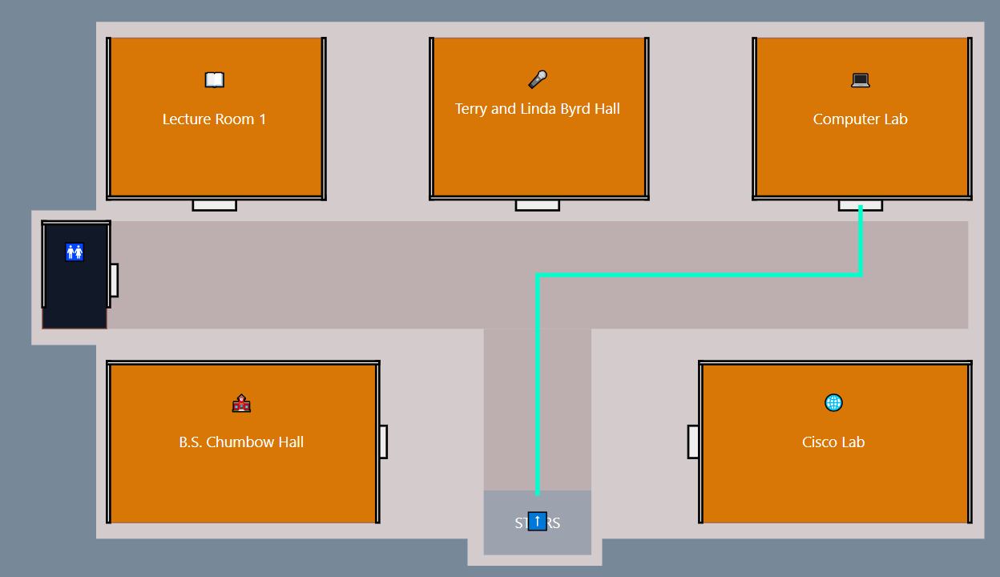
- Floor one navigation in the 3D section.

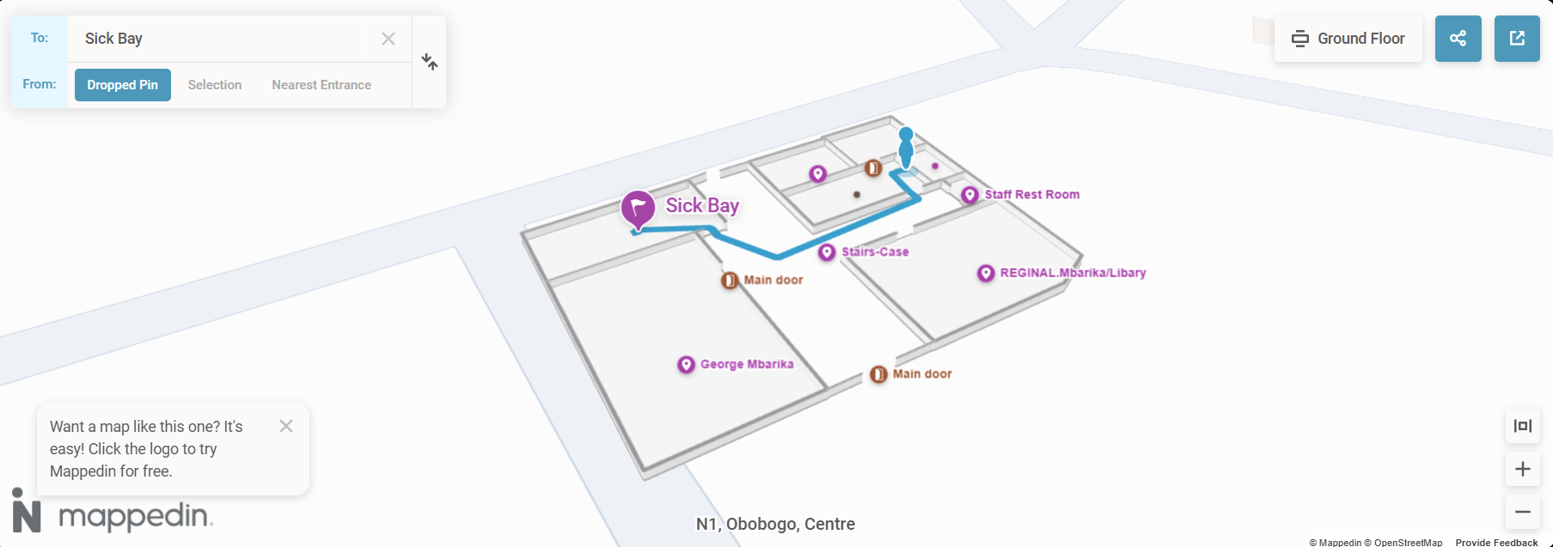

Discussion
The system successfully demonstrates indoor navigation using SVG maps and BFS. Challenges with SVG injection and dropdown mismatches were resolved through modularization and careful debugging.

CHAPTER FIVE: RECOMMENDATIONS AND CONCLUSION
Conclusion
Our team developed a functional indoor navigation system for ICT University. We achieved interactive maps, dropdown room selection, and multi-floor pathfinding. Difficulties included SVG quirks, dropdown mismatches, and multi-floor logic, but these were overcome through teamwork, iterative development and much research.
Recommendations
- Integrate real-time positioning (Wi-Fi/Bluetooth beacons).
- Add accessibility routes (elevator-only paths).
- Expand to mobile app for easier student use.
- Enhance UI with tooltips and icons.
References
Mapbox. (2025). Mapbox Documentation: Maps, Navigation, and Location Services. Retrieved from https://www.mapbox.com → Provides APIs and SDKs for building custom maps and navigation systems, widely used in geospatial applications.
MazeMap. (2025). MazeMap Indoor Navigation for Universities. Retrieved from https://www.mazemap.com → A specialized indoor mapping platform deployed in universities and hospitals, offering detailed floor maps and wayfinding.

