
Group Assignment
Asia Pacific University of Technology & Innovation
Technology Park Malaysia
CT038-3-2-OODJ
Object Oriented Development With Java
NPT1F2411IT
Team Name : Group A11 (E)
Module Lecture : Ishan Shrestha
Hand Out Date : 13th February 2026
Hand In Date : 14th March 2026

Student Name | APU Number
Nabin Raj Joshi | NP070235
Aayush Rimal | NP070079
Aayusha Dhungana | NP070080
Arit Tamrakar | NP070108

Acknowledgement
We would like to take this opportunity to thank our lecturer for all the feedback, guidance and motivation he has given us throughout the project of the development of the Hall Booking Management System. Throughout this module we have been provided with the support needed to learn how to apply object-oriented programming and system designing principles to a real-world application.
This project gave us a real practical experience to work on a system of real-world style for booking, scheduling and organizational actions. During the time of working on the project, it helped us to improve our technical knowledge in Java, swinging graphical user interface and file utilities.
Finally, we would like to thank Asia Pacific University of Technology and Innovation for providing the academic environment, resources and learning support that have helped us carry out this project successfully.

Table of Content
1. Introduction 1
1.1. Background of the Project 1
1.2. Problem Statement 1
1.3. Aim of the Project 2
1.4. Objectives of the Project 2
1.5. Scope of the Project 3
2. System Requirements 4
2.1 Functional Requirements 4
2.2 Non-Functional Requirements. 4
3. Design Solution 6
3.1 Use Case Diagram 6
3.2 Explanation of Use Cases Tables 8
3.3 Class Diagram 20
4. System Implementation 25
4.1 System Architecture Overview 25
4.2 Development Tools and Technologies 25
4.3 Graphical User Interface Design 26
4.4 File Handling Mechanism 26
4.5 Module Overview 27
4.6 Description of Classes 27
4.7 Attribution of Class Relationships. 28
4.8 System Flow / Process Explanation 29
5. Program Output Screenshots 31
5.1 Customer Module 31
5.2 Scheduler Module 35
5.3 Administrator Module 38
5.4 Manager Module 40
6. Application of Object-Oriented Programming Concepts 43
6.1 Encapsulation 43
6.2 Inheritance 43
6.3 Polymorphism 44
6.4 Abstraction 44
6.5 Class and Object Interaction. 45
7. Additional Features 46
8. Implementation 47
8.1 Development Tools and Technologies 47
8.2 System Workflow Implementation 48
8.3 Implementation of Data storage and file processing. 49
9. Limitations of the System 50
10. Conclusion 51
11. References 52
12. Workload Matrix 53
13. Appendix 54

Table of Figure
Figure 1 Use Case Diagram 6
Figure 2 Class Diagram 21
Figure 3 class diagram of customer 22
Figure 4 class diagram for schudular 23
Figure 5 Class diagram of Manager Dashboard 24
Figure 6 Customer Registration Screen 32
Figure 7 Customer Login Screen 33
Figure 8 : Customer Dashboard 33
Figure 9 View Available Halls 34
Figure 10 Book Hall Screen 34
Figure 11 Booking History Screen 35
Figure 12 Raise Issue Screen 36
Figure 13 : Scheduler Login Screen 36
Figure 14 : Scheduler Dashboard 37
Figure 15 Manage Hall Information 37
Figure 16 Set Hall Availability 38
Figure 17 Set Hall Maintenance 38
Figure 18 Administrator Login Screen 39
Figure 19 Administrator Dashboard 39
Figure 20 Manage Scheduler Staff 40
Figure 21 View All Bookings 41
Figure 22 Manager Login Screen 41
Figure 23 Manager Dashboard 42
Figure 24 Sales Report Screen 42
Figure 25 Update Issue Status 43

Lists of Table
Table 1 Customer Registration 9
Table 2 Login 10
Table 3 View Available Hall 10
Table 4 Creating Booking 11
Table 5 Make Payment 12
Table 6 View Receipt 13
Table 7 Cancel Booking 13
Table 8 Raise Issue 14
Table 9 Manage Hall Information 15
Table 10 Set Hall available 16
Table 11 Manage Users 16
Table 12 Manager Schedular Staff 17
Table 13 View all Booking 18
Table 14 View Sales Report 19
Table 15 Manage Issues 19

Abstract
This project involves the designing and development of the Hall Booking Management System for Hall Symphony Inc. The system is being developed as a Java desktop application using the Swing graphical user interface toolkit. The system is designed to manage the booking process of various types of halls, such as Auditoriums, Banquet Halls, and Meeting Rooms, which are used for various events, such as conferences, weddings, and meetings. It is aimed at making the business of dealing with reservations, scheduling and overall management of the hall more efficient within the organization.
The application supports four major user roles namely Customer, Scheduler, Administrator and Manager for which they have specific responsibilities and access to the system. Customers can register, log in, see available halls, make booking, complete payment and issue. Schedulers handle administration of information on halls, availability, and maintenance schedules, and Administrators are responsible for the administration of users and staff. Managers hold themselves accountable for monitoring the performance of the sales and to solve customer issues for effective decision making.
The system was built using object-oriented programming concepts like encapsulation, inheritance, abstraction and polymorphism to obtain a structured and maintainable design. Instead of a database, the entire data is stored in text files using Java file handling APIs i.e java.io, java.nio.file etc. The system design, UML diagrams, system implementation approach, project features, limitations and future improvement recommendations are further discussed in the project report.

Executive Summary
This report is a document on the development of a Hall Booking Management System to be used by Hall Symphony Inc, a company that provide different hall(s) for different types of events. The purpose behind the system is to enhance the booking process, minimize manual work and provide an organized way in handling hall booking and payment, scheduling of halls, maintenance planning, management of staffs and issue tracking.
The system was made as a Java GUI application. Swing was used for the user interface because it offers standard components for developing the application interface in the form of forms, buttons, tables, panels, and dialogs. All records of the system are contained in text files which meets the assignment requirement of NOT using a database. The system was broken down into 4 user roles. Customers use the system to register, book halls, pay, view receipts, book history, and submit issues. Schedulers are concerned with the availability of halls, hall maintenance, and hall information. Administrators control staff and user account control. Managers keep track of the performance of the operations using the sales reports and the management of the issues(Oracle, n.d.).
From a software engineering point of view, the project also shows the application of UML-based design thinking. UML is a standard graphical language which is used to visualize, specify, construct and document software systems and provides both use case diagrams and class diagrams. Models of user interactions and the system structure were created using these diagrams prior to system implementation(Bloch, 2018).
Overall, the project demonstrates the application of the programming language Java and object-oriented programming mechanisms to help solve a practical business problem in a structured and realistic manner.

Introduction

Background of the Project
Many organizations are using digital systems today to manage reservations, scheduling, and customer interactions. Hall Symphony Inc. has halls for events like conference, meetings and weddings. When the booking activities of the bookings are not handled in proper system, the organization can end up with problems like double booking, confusion in the availability of the hall, issue in tracking the money of the customers, lack of coordination among the staff members etc.
A computerized booking solution can help to reduce these problems by centralizing the information and making the system functions more organized. This project has its main focus in the development of a Hall Booking Management System that can assist the company in its day-to-day running hall reservation through a desktop application(Oracle, n.d.).
The system has been developed in Java by using Swing. According to Oracle’s Java tutorials, Swing is defined as a graphical user interface toolkit that provides standard components such as labels, text fields, buttons, tables, and windows.Since the assignment requires for file-based storage, the system uses the text files for the persistence of data. Java also provides file handling in the classic I/O API and the NIO API, which provide ways to create files, open files, read files and write files.

Problem Statement
Manual or poorly structured booking processes may pose a number of issues in a hall rental business. Staff might not have a true picture of hall availability, customers might encounter delays in making reservations and management might not have an effective way of monitoring things and the revenue. Without the proper digital solution, important tasks such as scheduling maintenance, checking bookings and tracking issues can become difficult and time consuming.
The prime issue involved in this project is the absence of an integrated system which will cater to the hall booking activities, staff activities, customer management, and reporting in a more systematic manner.

Aim of the Project
The purpose of this project is to design and develop a Hall Booking Management System which supports the operations of reservation of hall conducted by Hall Symphony Inc. by using a Java-based graphical user interface and a file-based storage mechanism.

Objectives of the Project
The key objectives of the project are:
- To create GUI based application for hall booking and hall management
- to handle four roles of users: Customer, Scheduler, Administrator, and Manager
- to enable the customers to make registration, login, book the halls, make payment and make the issue
- to provide scheduling to manage hall information, availability schedules, maintenance schedules
- to enable the administrator to manage scheduler staff and users
- to enable managers to check the performance of sales and issue handling
- to apply object oriented programming concepts in the system design and implementation
- to store all the data by using the text files as per the assignment requirements

Scope of the Project
The project is restricted to a desktop application implemented using Java Swing. The system includes three categories of hall:
- Auditorium
- Banquet Hall
- Meeting Room
The operating time that has been considered in the system is from 8:00 AM to 6:00 PM. The project does not use a database but the text files. Payment in this system is simulated for the academics and does not link to a real payment gateway. The project is designed to meet the requirements of the coursework as well as illustrate through the working business application the use of object oriented programming. (Bloch, 2018)

System Requirements

Functional Requirements
The Hall Booking Management System is aimed to assist with the working processes of the Hall Symphony Inc. with the help of a digital framework. The system should also offer a secure system of authentication whereby the user can log in with valid credentials and get role-based dashboards. This makes the access to functions of the system controlled and the data on sensitive running of the system secured.
The system will enable the new customers to register with personal and log in details. Once successfully logged in, customers should be allowed to see the available halls, book the ones appropriately chosen by date and time, provide the necessary payment processes and receive the digital receipt. Customers will also be in a position to check on booking history, cancel eligibility bookings, as well as report issues on the service.
Concerning internal operations, the scheduler should be capable of controlling the information about the halls, scheduling availability, and determining maintenance time. Administration users will be in charge of customer account and scheduler staff record and oversee the overall booking transactions. To be able to support the process of decision-making, managerial users will have the ability to see a sales summary and address the problems that come to customers. (Object Management Group, 2017)

Non-Functional Requirements.
Besides functionality, the system has to meet a number of non-functional characteristics of quality. Probably one of these requirements is usability. The interactive interface should be user-friendly and easy to use by users who have limited computer literacy to ensure that the application is user-friendly. The role based dashboards also enhance better user navigation and limits confusion in operations.
The other important requirement is the element of reliability since records about the operations are stored in text files by the system. The program should be able to read and write files properly to eliminate files inconsistency. The modular design of the project, which provides the separation of graphical user interface classes, business service classes and data model classes, supports maintainability. This design technique is in line with the suggested best practices in the creation of object-oriented software that enhances the ability to reuse codes and further increase systems evolution over time
Performance is also put into consideration since the system must be responsive whenever accessing data on booking or producing reports. Simple security measures are implemented by checking of logins and restricted access to system functionality. Though, the application applies file-based storage to store academic needs, these non-functional requirements are a manifestation of well-structured thinking in the design of the software quality. (Object Management Group, n.d.)

Design Solution

Use Case Diagram
The Use Case Diagram will provide the visual description of the interaction of various users with the Hall Booking Management System. UML is a widely used software modeling system visualization and documentation tool which includes use case diagrams as one of its behavioral models.
Four actors are included in the system:
- Customer
- Scheduler
- Administrator
- Manager
Every act has his own functions which are corresponding to his role in the company. Its diagram assists in demonstrating the boundaries of the system, the key interaction of users, as well as the connection between the user and fundamental services.
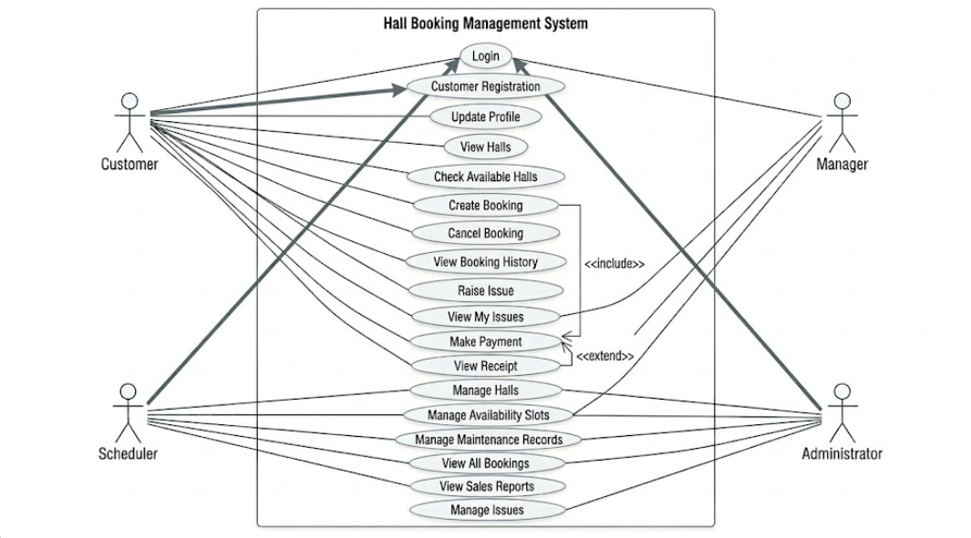
Figure 1 Use Case Diagram

Description of Actors and Principal Use Cases.
Customer
The Customer is the primary outside user of the booking services. The Customer can:
- register an account
- log in
- update profile
- view available halls
- book a hall
- make payment
- view receipt
- view booking history
- cancel booking
- raise issue
These use cases are the regular customer experience of registration up to the after sales services.
Scheduler
Scheduler would be in charge of handling halls. The Scheduler can:
- log in
- manage hall information
- set hall availability
- set hall maintenance
This position is to make sure that the records of halls are always updated and halls are also scheduled accordingly; to be used by customers and to be serviced. (Object Management Group, n.d.)

Administrator
The Administrator is in charge of user and staff administration. The Administrator can:
- log in
- manage scheduler staff
- manage users
- view all bookings
The reason why this role is important is that it contributes to organizational control and oversight.
Manager
The Manager controls business performance and management of issues. The Manager can:
- log in
- view sales report
- view customer issues
- respond to issues
- assign scheduler
- update issue status
The role provides a bigger picture of system activity and quality of operations.

Explanation of Use Cases Tables
This is a very good addition to your project and will definitely improve your report to look similar to a genuine software engineering report. Your current report already has the use case diagram and the general description, so these structured tables added should improve that part of the report.
To give a better picture of the key functional interactions of the Hall Booking Management System, the major use cases are presented in tabular structured form below. A table lists actor, purpose, precondition, normal flow, alternative flow and post-condition for each focused system function.

Table 1 Customer Registration
Item | Description
Use Case Name | Customer Registration
Primary Actor | Customer
Description | This use case lets a new customer login to the system by populating the personally identifiable fields and the login information.
Pre-Condition | The customer has no existing account.
Main Flow | The customer loads the registration form; completes the information and submits it. The system checks the information submitted and writes a new account record to the user file.
Alternative Flow | If an invalid or blank value is entered in any of the fields the system will give an error message asking the user to amend their input.
Pre-Condition | New account for customer is successfully created, the customer can login with that account.
Table 2 Login

Item | Description
Use Case Name | Login
Primary Actor | Customer, Scheduler, Administrator, Manager
Description | This use case enables the registration users to log on to the system by providing correct username and password.
Pre-Condition | The user is expected to have an existing account with the system.
Main Flow | The user enters username and password. The system checks the login, password and role and then shows the right dashboard.
Alternative Flow | If the details are wrong, the system will give an error message and take the user back to the login screen.
Post-Condition | The user is logged in and page is adjusted to an appropriate url.
Table 3 View Available Hall
Item | Description
Use Case Name | View Available Halls
Primary Actor | Customer
Purpose | Enables the customer to browse rooms to book.
Pre-Condition | User is logged in to the system.
Main Flow | The customer opens the hall viewing section. The system reads through halls, availability and maintenance records. It displays all halls that are available.
Alternative Flow | If no hall is available for the requested time or date, the system presents an empty result (no hall available) or display a message.
Post-Condition | The customer has the opportunity to browse available options prior to booking.
Table 4 Creating Booking
Item | Description
Use Case Name | Create Booking
Primary Actor | Customer
Description | This use case enables the customer to book the chosen hall with a valid date and time.
Pre-Condition | The customer has to have the login, and the hall must to be free during valid operating hours.
Main Flow | The customer picks a hall, defines date and time for each booking and indicates he is ready to make the request. The system verifies available halls, possible conflict with maintenance and other business rules and creates the booking.
Alternative Flow | If the hall is not free, the time is not valid or there is maintenance in progress at the time we want to book a time, the booking cannot be made and the screen shows the error.
Post-Condition | A valid booking record is stored in the booking file.
Table 5 Make Payment

Item | Description
Use Case Name | Make Payment
Primary Actor | Customer
Description | This use case enables the customer to pay for a booking.
Pre-Condition | must already be an existing booking.
Main Flow | The system will determines the total value according to halls rate and duration. The customer will agreed to pay for it, and the system will record the transaction.
Unsuccessful Payment | If a payment cannot be made due to incorrect or missing details, an error is returned, and the payment is not saved.
Post-Condition | The information of the payment is stored and the booking continues to receipt generation.
Table 6 View Receipt
Item | Description
Use Case Name | View Receipt
Primary Actor | Customer
Description | This use case is used for presenting or allowing the customer to receive the receipt for a successful payment.
Pre-Condition | There has to be completed payment transactions that exist.
Main Flow | The system retrieves booking and payment information and shows it as receipt.
Additional Path | If there is no matching record, the system will tell us that no receipt can be issued.
Post-Condition | The customer can view the payment summary and booking confirmation.
Table 7 Cancel Booking

Item | Description
Use Case Name | Cancel Booking
Primary Actor | Customer
Description | This is used by the customer to cancel an already made booking.
Pre-Condition | The customer should be logged on and the booking should be obeying to the cancellation rule.
Main Flow | The customer obtains a list of bookings, from the booking history, and requests a cancellation. The booking date is then checked to ensure it is three days away, and the booking is updated.
Alternative Flow | If the booking is made near the event date the cancellation request is not accepted, a message appears explaining the situation.
Post-Condition | The booking status is set to cancelled if the request is valid.
Table 8 Raise Issue

Item | Description
Use Case Name | Raise Issue
Primary Actor | Customer
Description | This use case is used when a customer wishes to lodge a complaint or raise an issue about a booked hall.
Pre-Condition | The customer has logged in and has a booking record.
Main Flow | Enter the issue details and submit. The information related to issue is stored in Issue file.
Alternative Flow | If some of the details that are inputted are missing then a validation message is output to the terminal window and the user is asked to fix the missing information.
Post-Condition | One new Issue record is stored successfully.
Table 9 Manage Hall Information

Item | Description
Use Case Name | Manage Hall Information
Primary Actor | Scheduler
Description | This use case give the scheduler capability of adding, updating or removing halls.
Pre-Condition | The user should be logged in.
Main Flow | The scheduler opens the hall management, adds a new hall, or modifies the existing one then closes the UI and system update the hall file.
Alternative Flow | If the entered hall details are invalid, then the respective error message will be displayed and the update will be rejected.
Post-Condition | Hall details are being entered, amended or deleted.
Table 10 Set Hall available
Item | Description
Use Case Name | Set Hall Availability
Primary Actor | Scheduler
Description | 3.4 This use case is used by scheduler to specify halls available schedule.
Pre-Condition | The hall has to log on to the system. The scheduler has to be logged in.
Main Flow | 1. Scheduler choose the hall and enter the available data and time range, then save this available time slot. 2. The system will save this schedule into the file Scheduling Availability.
Alternative Flow | If the entered time slot is not valid or incomplete then the system will not accept it.
Post-Condition | The availability schedule has been successfully stored.
Table 11 Manage Users

Item | Description
Use Case Name | Manage Users
Primary Actor | Administrator
Description | This use case provides the administrator with the ability to create and edit customer/user records.
Pre-Condition | Admin should be in.
Main Flow | The user enters the user records through administrator in the system, administrator searches the user record or new user, sets the mode as update, block or delete and sets the rest of parameters, then presses update.
Alternative Flow | If the user chosen to log-in does not exist or the user enters the wrong input the system displays error message.
Post-Condition | User records in the user file are correctly changed.
Table 12 Manager Schedular Staff

Item | Description
Use Case Name | Manage Scheduler Staff
Primary Actor | Administrator
Summary | This use case enables the admin to create, update or delete scheduler staff records.
Pre-Condition | The administrator is already logged in.
Main Flow | The administrator defines the scheduler information, chooses the required action and saves it.
Alternative Flow | If the staff details entered are invalid or incomplete, then system terminates and a warning message is displayed.
Post-Condition | Can successfully maintain the Scheduler staff records.
Table 13 View all Booking

Item | Description
Use Case Name | View All Bookings
Primary Actor | Administrator
Description | This use case enables the administrator to view all the booking details stored in the system.
Pre-Condition | The administrator needs to be signed in.
Main Flow | The administrator enters the booking module and retrieves all booking records.
Alternative Flow | If no bookings are found System shows an empty result message.
Post-Condition | The administrator will be able to track general booking activity.
Table 14 View Sales Report

Item | Description
Use Case Name | View Sales Reports
Primary Actor | Manager
Description | This use case logs in the manager to view sales performance based on payment records.
Pre-Condition | The manager must be logged in and payment records must exist.
Main Flow | The manager picks a reporting period. (Indeed, you can choose weekly, monthly, or yearly, etc..) The system works out, then shows you the results.
Alternative Flow | if no payment data is retrieved, the screen will inform that no report is available.
Post-Condition | Vales2 information is shown to the management.
Table 15 Manage Issues

Item | Description
Use Case Name | Manage Issues
Primary Actor | Manager
Description | This use case enables the manager to examine customer issues, assign actions for solving, and change the status of an issue.
Pre-Condition | The manager would be logged in and the issue records would be there.
Main Flow | The manager will launches the issue section, view the details of the issue, change the status, save and exit.
Alternative Flow | If the issue record cannot be found, the relevant error message is provided by the system.
Post-Condition | The post-condition is that pieces of information about the issue are stored, so they can be referred to for later use.
(Oracle, n.d.)

Class Diagram
Class Diagram demonstrates the structural design of the system. Classes, attributes, methods and relationship among various sections of a software are presented using UML class diagrams.
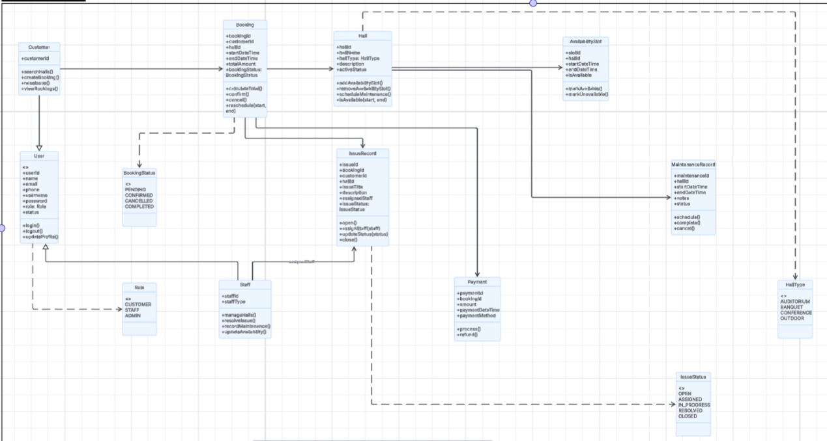
Figure 2 Class Diagram

The key types of the system are presented below.
User
The parent of all types of user within the system is user. It has popular information like:
- userId
- name
- email
- phone
- username
- password
- status
The usual techniques are the behavior based on logins and profile.
Customer
Customer inherits from User. This category relates to customers that utilize the hall booking service. It relates to booking hall functions, reservation history, payment and issue raising functions.
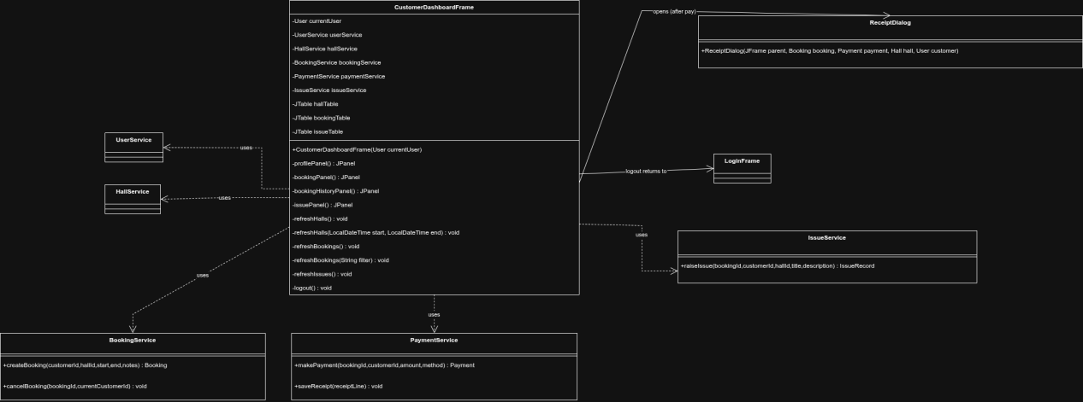
Figure 3 class diagram of customer
Administrator
One of the intermediary classes that can be applied to cluster internal users is staff. It inherits User and serves as a parent to roles of internal staff.
Scheduler
Scheduler is a descendent of Staff. The duties of this class are involved with operations of halls and it involves hall details, hall availability and hall maintenance.
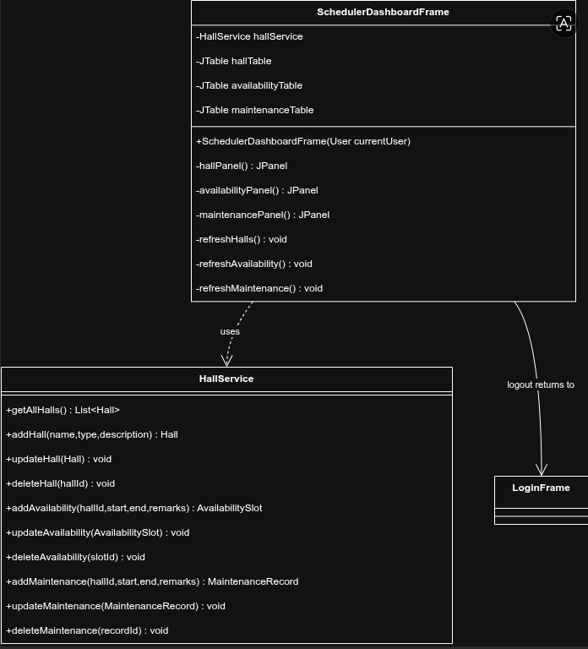
Figure 4 class diagram for schudular
Manager
Manager inherits from Staff. Reporting and issues management are features that are supported by this class.
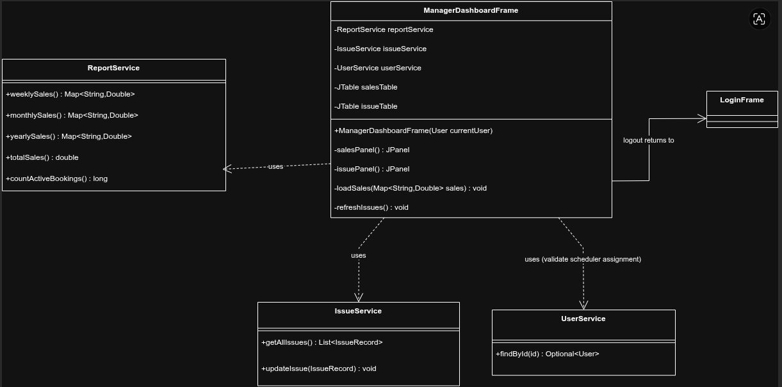
Figure 5 Class diagram of Manager Dashboard
Hall
Hall contains hall-related information like:
- hallId
- hallType
- capacity
- pricePerHour
It is associated with booking and availability as well as maintenance records.
Booking
In booking, reservation data is stored including:
- bookingId
- customerId
- hallId
- bookingDate
- startTime
- endTime
- status
This course is among the most significant courses since it links customers and halls.
Payment
Payment (stores) entry of payment details including:
- paymentId
- bookingId
- amount
- paymentDate
- paymentStatus
It goes with the Booking type.
IssueRecord
Issue Record is where information posted by the customers is stored, i.e. description of the problem, date, staff assigned to it, and status.
Availability Slot
Availability Slot This is a table that contains the date and time interval in which a hall is available at the instance of booking.
Maintenance Record
Maintenance Record is where the maintenance periods are recorded, which prevents the temporary use of the hall. (Oracle, n.d.)

System Implementation

System Architecture Overview
The Hall Booking Management System is layered meaning that it is divided into different functional units. This architectural model enhances better organization of the system and allows the software development to be maintained. The principal layers that were applied in the project are the graphical user interface layer, the service logic layer, the domain model layer, and supporting utility layer.
All the Java Swing based screens include login screens, dash, booking dialogs and reporting views are all found in the graphical user interface layer. Swing offers a list of reusable graphical elements that allow developers to build platform dependent desktops (Oracle, n.d.)The service layer does all the fundamental business processes such as authentication, booking validation, payment calculation, reporting and system initialization. The layer serves as an interface between the user and long-term data storage.

Development Tools and Technologies
Java has been used as a programming language to develop the project. The use of Java was due to its ability to facilitate the use of objects in programming and desktop application building tools. Swing was used to develop the graphical user interface. The documentation of Oracle defines Swing to be under the package of javax.swing used to construct portable window-based interface.
The implementation was led with the help of the UML diagrams. Software engineering is an area of software development where UML is employed to visualize, specify ledger and document software models.
The system is text file based in terms of data persistence. This solution was chosen, as the coursework should store the information in files and not in a relational data bank.

Graphical User Interface Design
The GUI was made straightforward, transparent and role based. Every user is presented with a dashboard that is corresponding to his/her duties. Widely used GUI elements of the system are:
- JFrame
- JPanel
- JButton
- JLabel
- JTextField
- JPasswordField
- JTable
- JOptionPane
Swing offers these re-usable elements in forms, dialog box and data display of a Java application.
The user interface was categorized into registration, login, accessing dashboard, hall management, booking, payment section, issue management, and reporting. Such division enhances usability and guarantees that every module is dedicated to a distinct function. (Oracle, n.d.)

File Handling Mechanism
The system has all records in plain text files. Java has traditional I/O file access and management API as well as NIO and NIO.2 API that has been added recently. According to the file I/O tutorials created by Oracle, Java includes file reading, file writing, file creation, and file opening methods, file path, and metadata work.
The core files in the system are:
- users.txt
- halls.txt
- bookings.txt
- payments.txt
- issues.txt
- availability.txt
- maintenance.txt
The files contain only one type of data. In this design, records are segregated and have easy management. Though, text files are not as efficient as database systems, they can be used in this assignment and in illustrating the concepts of core file handling. (Oracle, n.d.)

Module Overview
The system will be divided into the following modules:
Customer Module
Manages the registration, log in, data about available halls, booking, payment, viewing receipts, booking history, and raising issues.
Scheduler Module
Manages hall information, availability booking, and maintenance booking.
Administrator Module
Manages scheduler staff, user, and booking control.
Manager Module
Manages sales reporting, browsing of issues, responding to issues, assigning issues and maintaining the status of issues.

Description of Classes
The implementation of the system is done through several classes which together depict the hall booking environment. The User class serves as the root class which represents general properties shared by all users like user identification data and authentication data. These properties are passed on to specialized roles like Customer and Staff as an example of minimizing redundancy when an object-oriented software design is built.
Hall class model represents physical hall resource and holds such attribute as the hall category, capacity and hourly price. The Booking class handles the booking operations and links the operation made by the customers with the particular hall resources and time slot.
There exists Financials transactions class which deals with the financial transactions done with payment of booking and helps to generate receipts. The IssueRecord class allows the system to retain customer service feedback on which the system can review the operational issues which can be viewed by management. Other classes like AvailabilitySlot and MaintenanceRecord are done to help make sure that all constraints of scheduling are upheld. This object-oriented hierarchy is based on suggested object-oriented modeling techniques that enhance modularity and maintenance of the application development (Bloch, 2018).

Attribution of Class Relationships.
A number of class relationships are used in the system.
Inheritance Relationship
Inheritance is employed to eliminate repetition of code and depict role based hierarchy. The Java documentation of Oracle defines that inheritance is a process, where one class is based on another one, and it inherits its fields and methods. In this system:
- Customer inherits from User
- Staff inherits from User
- Scheduler extends Staff.
- The Staff is a predecessor to Administrator.
- Manager inherits from Staff
- Association Relationship
- Association is applied in cases when one class is associated with another.
- One Customer can be linked to a number of Bookings.
- One Hall is related to a Booking.
- One Payment is linked with one Booking.
- There can be a Booking that is correlated with an IssueRecord.
- AvailabilitySlot and MaintenanceRecord have a Hall related to it.
Dependency Relationship
Authentication, booking and reporting are just some of the service classes that rely on model classes and file handling classes. This assists in divorcing interface design and system logic.

System Flow / Process Explanation
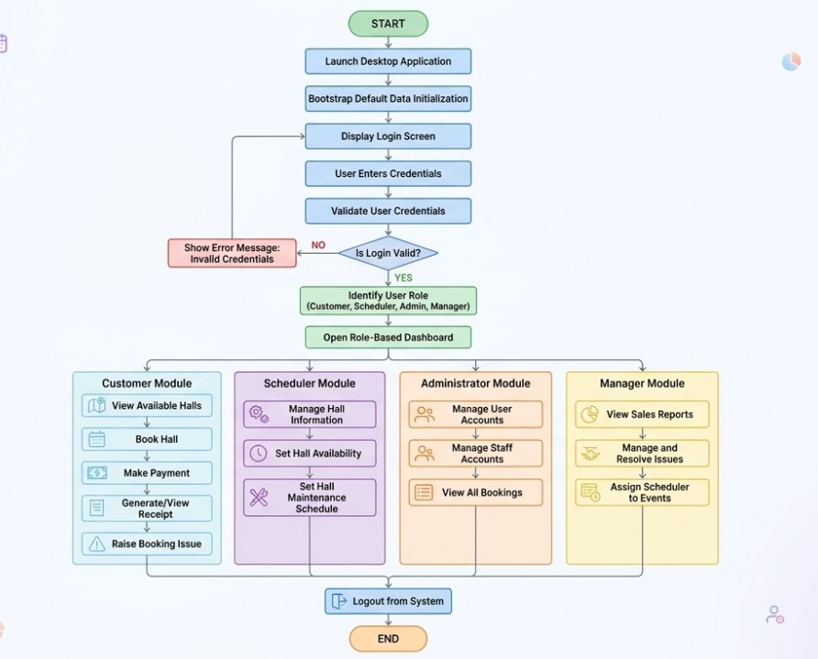
The operation of the Hall Booking Management System (HBMS) begins after the execution of the program. The system first read a file consisting of hall data, user details, a schedule for hall availability, and a maintenance schedule to supply the contextual data. After this initial data pre-loading the user is required to log on the system by providing his user name and password. When this data has been supplied the system compares it to the predetermined data and outputs the user role back to the user. When the role has been identified the system the loads the application‘s interface relative to the role and the user is then able to perform the functions defined for that role. Users include customer and scheduler. Customer can choose a hall (from all available), create a booking, submit a payment, view a receipt, cancel a booking, and report an issue. Scheduler can modify hall info, add time slots for hall availability, and schedule maintenance. Each time the user interacts with the system it records data to storage files of type text so as to maintain data integrity. When the user chooses to log out the system it clears user data and variable values and returns ready for the next user. (Oracle, n.d.)

Program Output Screenshots
Replace the figure labels below with your actual screenshots.

Customer Module
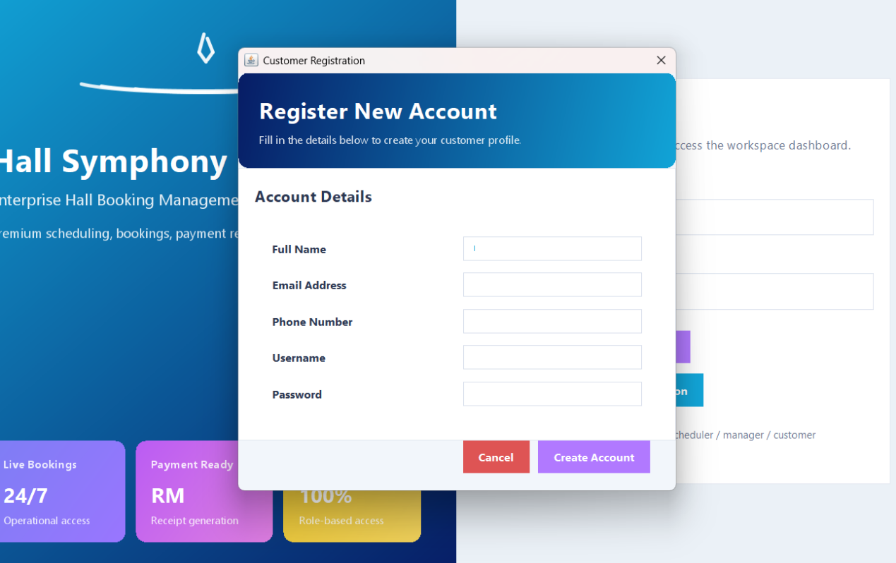
Figure 6 Customer Registration Screen
This screen allows a new customer to create an account in the system. The user enters personal and login details. Validation is applied to ensure that required fields are not empty and that incorrect input is not saved. Once the form is submitted successfully, the system stores the new customer record in users.txt.
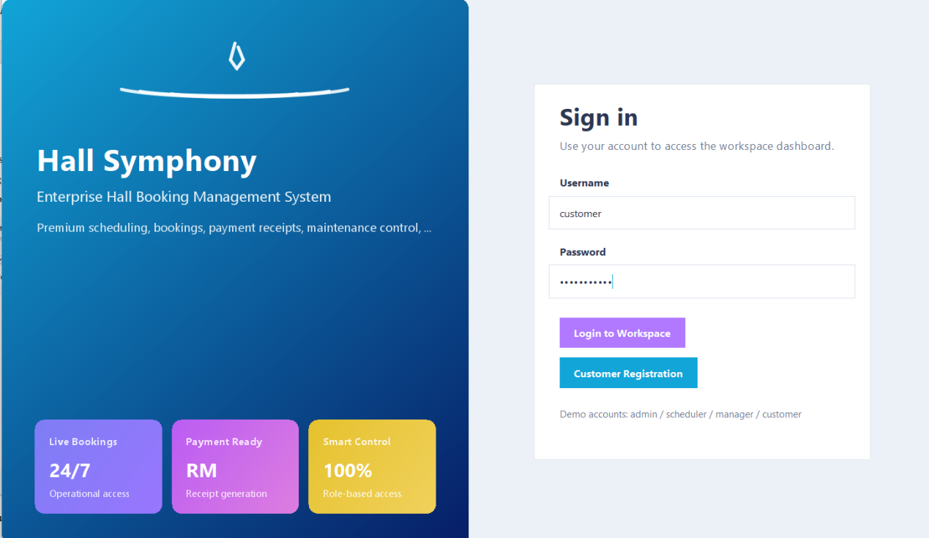
Figure 7 Customer Login Screen
This screen is used by customers to access the system using their username and password. After successful authentication, the customer is redirected to the customer dashboard. This screen is important because it controls secure access to customer functions.
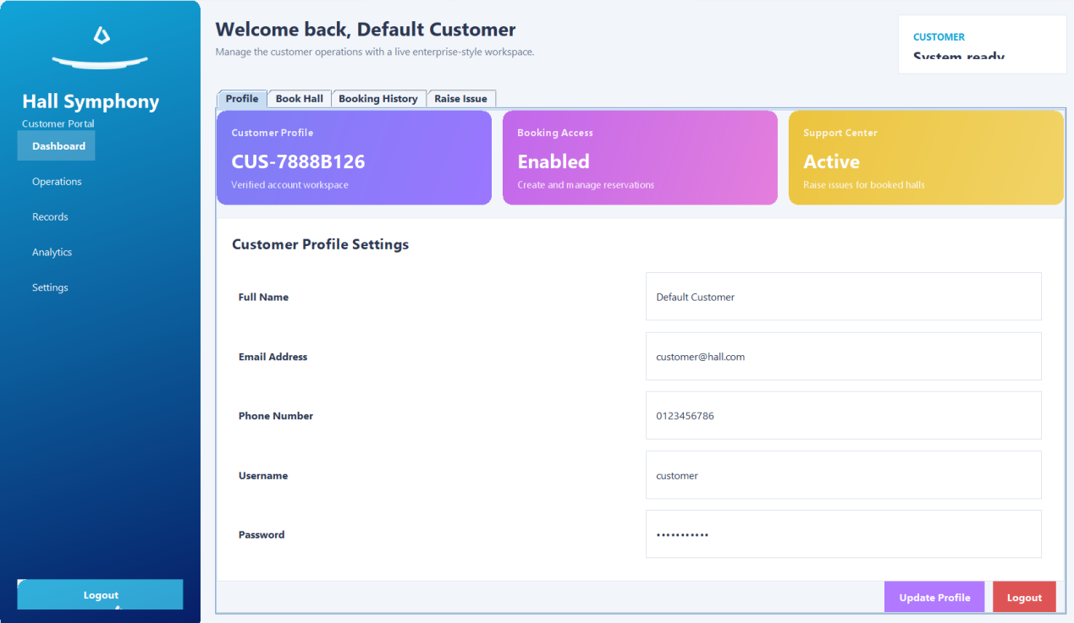
Figure 8 : Customer Dashboard
The customer dashboard acts as the main control panel for customer activities. From this page, the user can access hall viewing, booking, payment, booking history, cancellation, and issue submission. The dashboard helps group all customer services in one place.
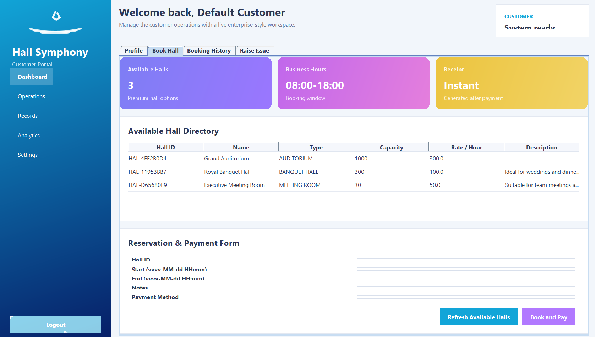
Figure 9 View Available Halls
This screen displays the halls that can currently be reserved. The system checks hall details together with availability schedules and maintenance records before presenting bookable options to the user.
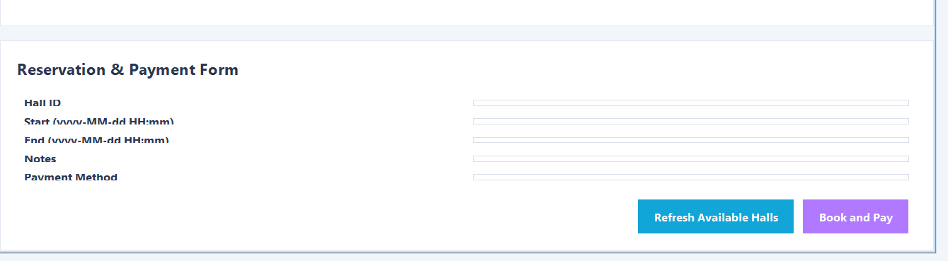
Figure 10 Book Hall Screen
This screen allows the customer to select a hall, choose a date, and provide booking time details. The system performs validation to make sure the selected hall is available, the booking falls within operating hours, and no conflict exists with previous bookings or maintenance periods.
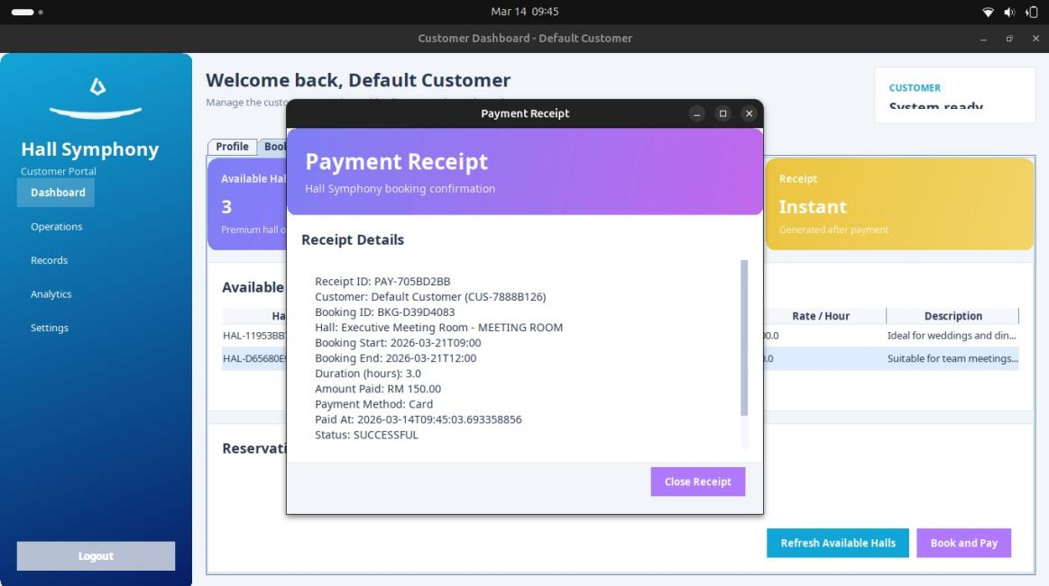
Figure 12 Receipt screen
The receipt screen shows the booking and payment summary after a successful transaction. It typically includes the customer name, hall type, booking date, time range, and total amount paid. This improves transparency and gives the customer proof of payment.
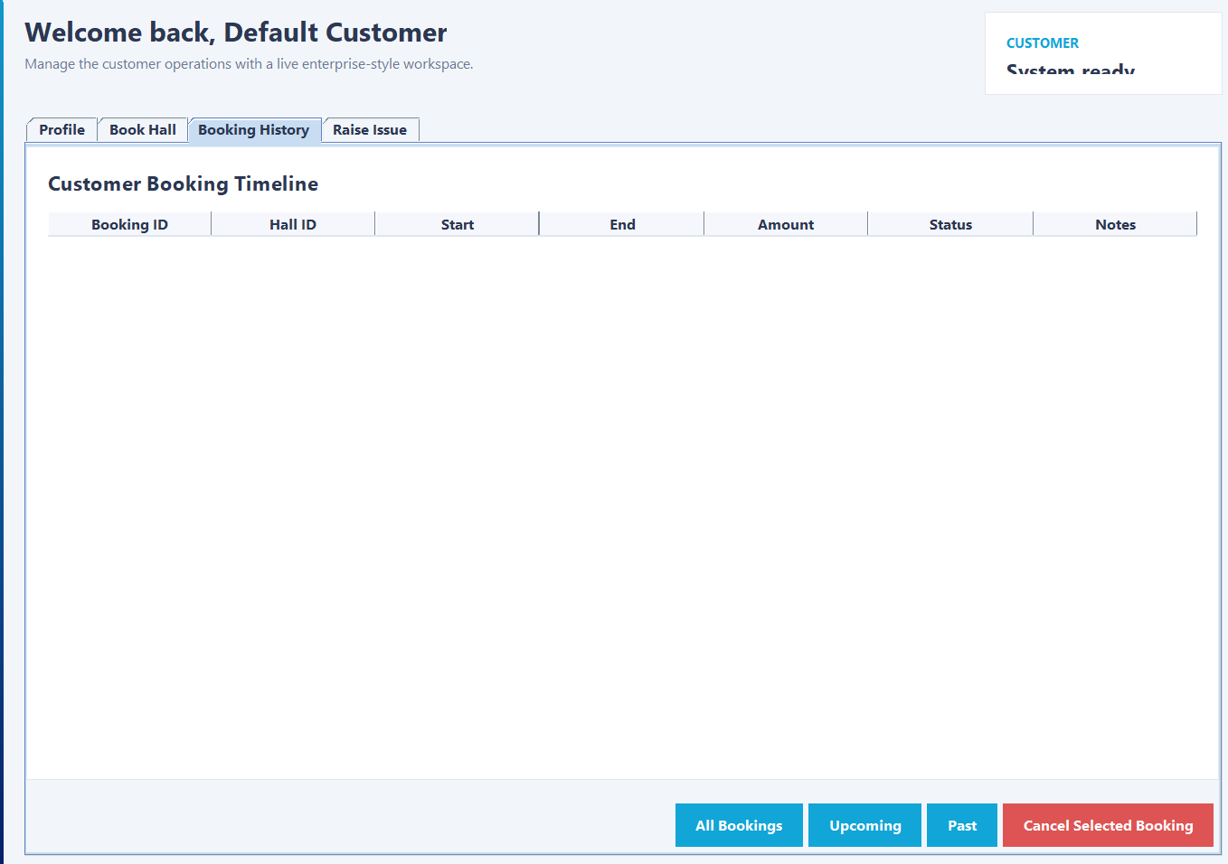
Figure 13 Booking History Screen
This screen displays previous and upcoming bookings created by the customer. It helps the customer review reservation activity and identify which bookings are active, completed, or cancelled.
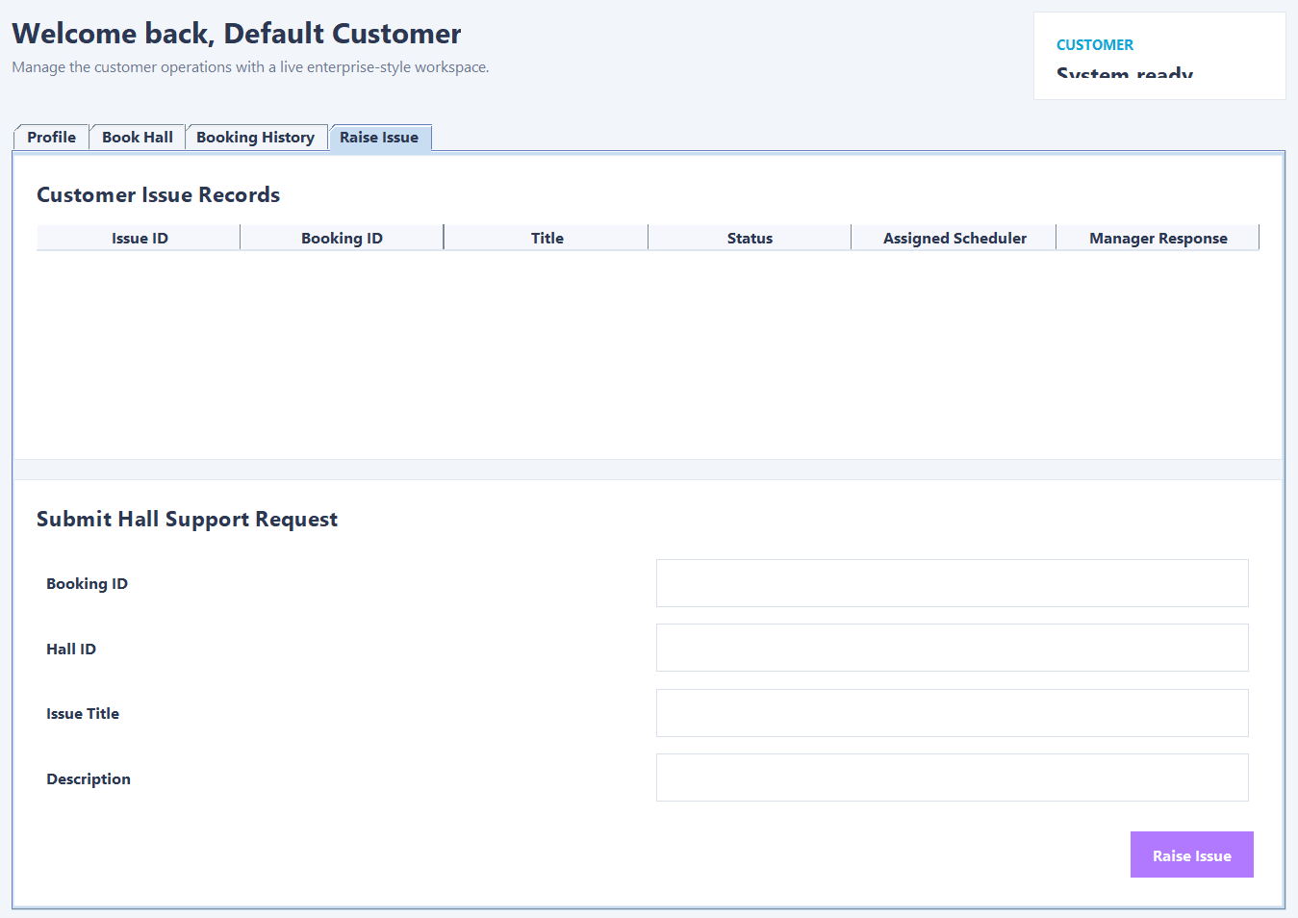
Figure 14 Raise Issue Screen
This screen allows the customer to submit a complaint or issue related to a booked hall. The information entered here is saved and later reviewed by management.

Scheduler Module
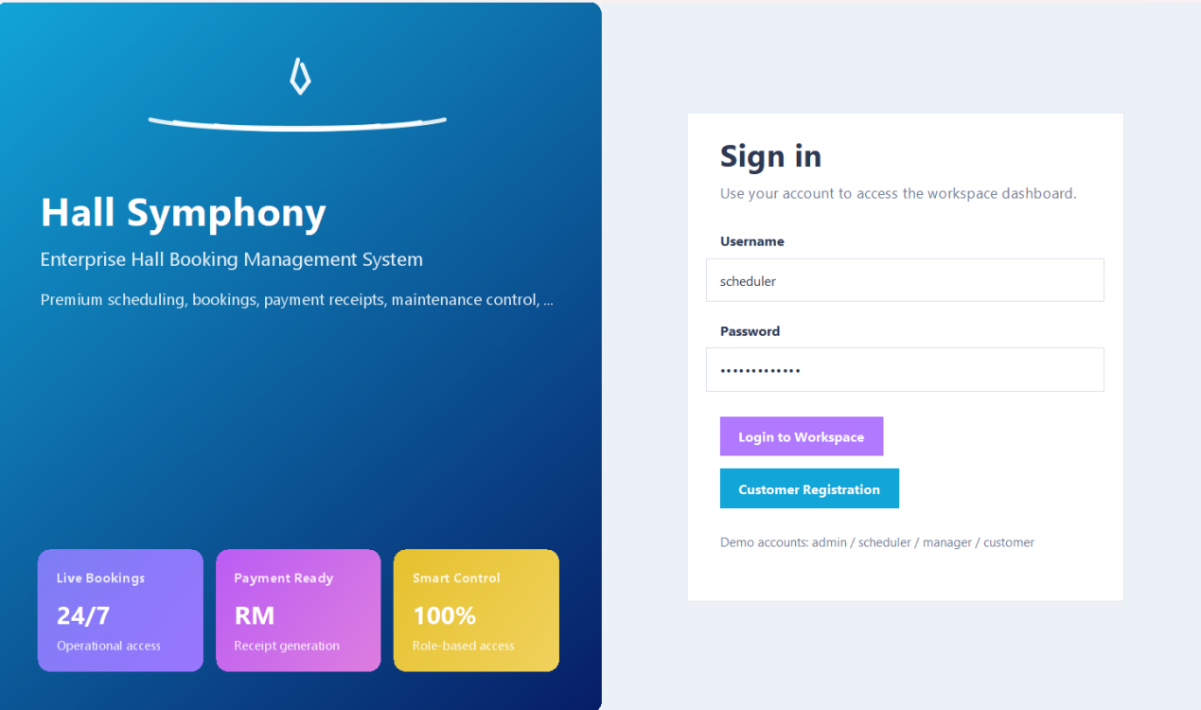
Figure 15 : Scheduler Login Screen
This screen allows scheduler staff to access their operational dashboard.
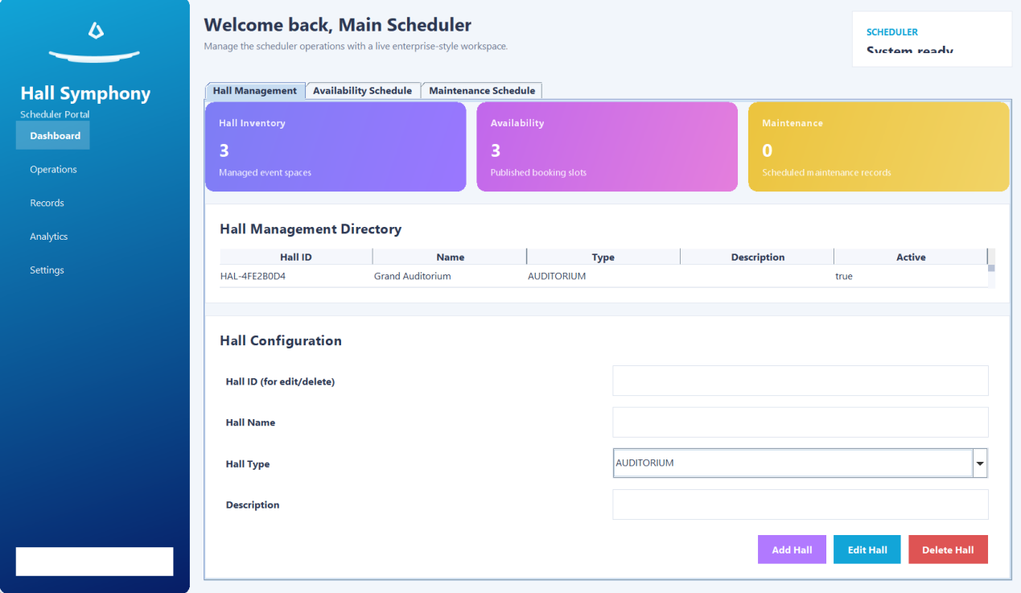
Figure 16 : Scheduler Dashboard
The scheduler dashboard groups all hall-related operational functions. It provides access to hall records, availability scheduling, and maintenance scheduling.
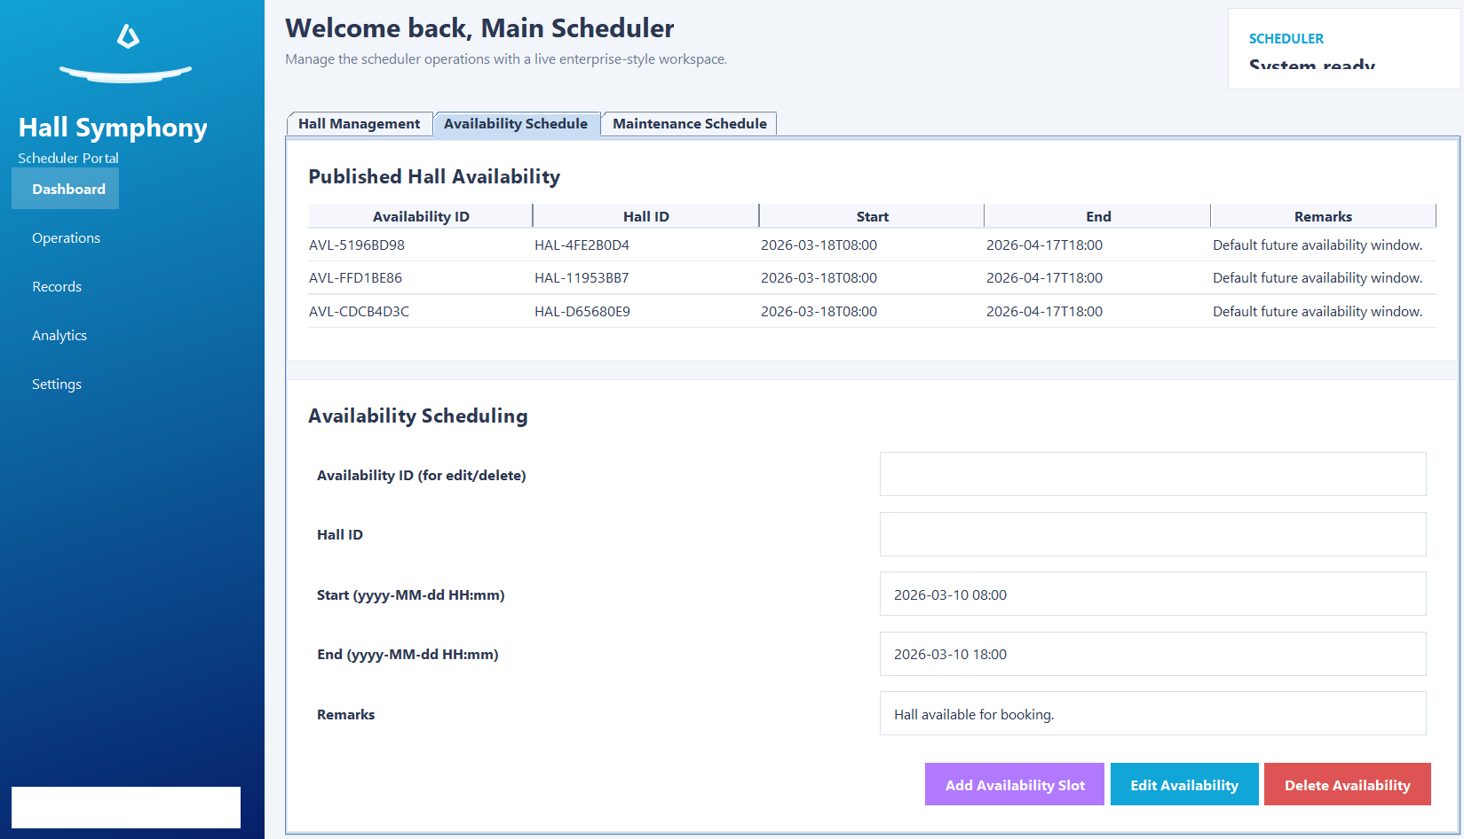
Figure 17 Manage Hall Information
This screen allows the scheduler to add, edit, or remove hall details. Accurate hall information is necessary because the booking and reporting modules depend on this data.
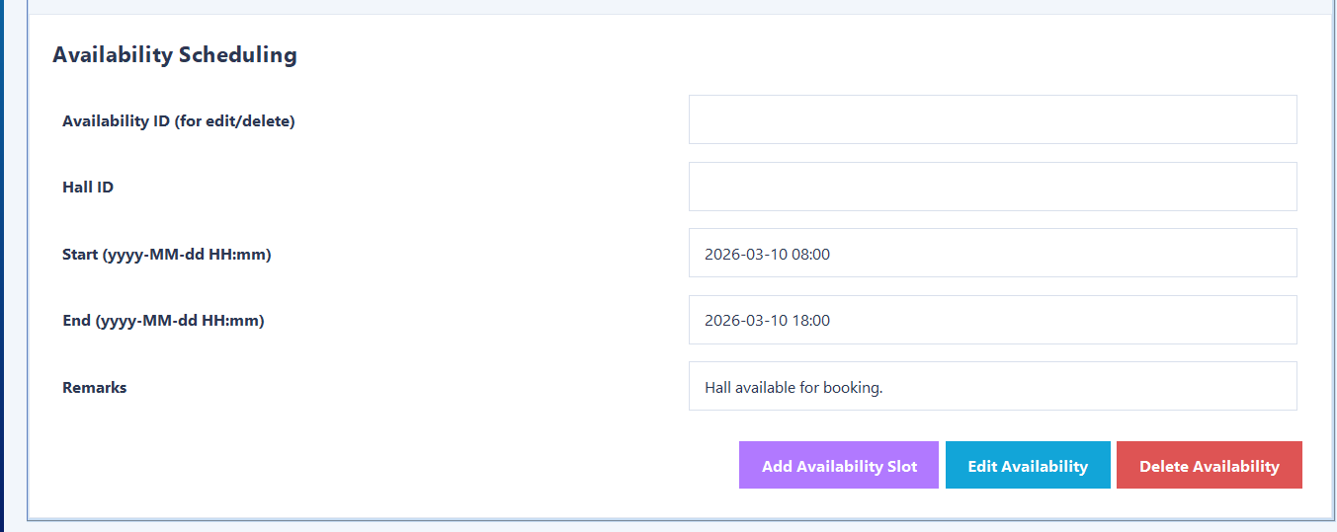
Figure 18 Set Hall Availability
This screen allows the scheduler to define when a hall is available for reservation. These records affect what customers can see and select during booking.
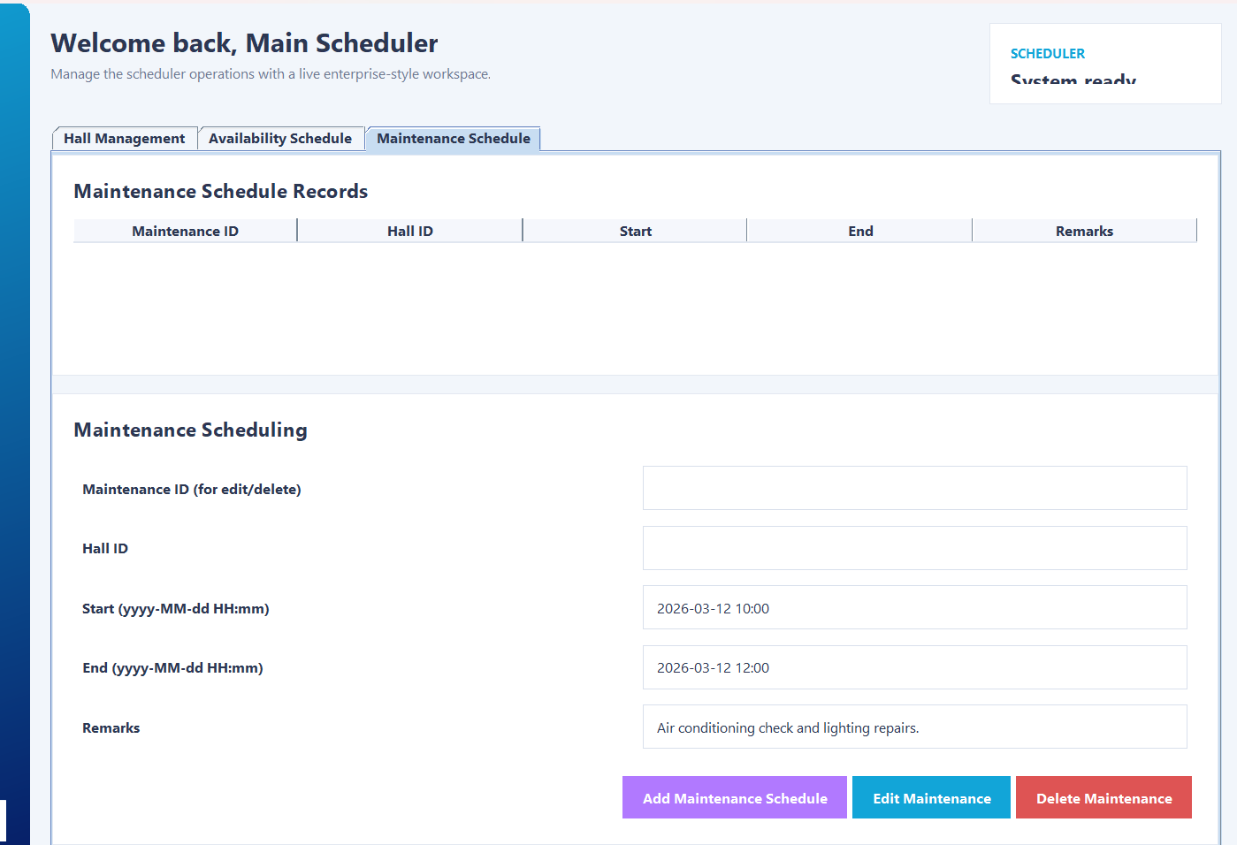
Figure 19 Set Hall Maintenance
This screen is used to schedule maintenance periods. A hall under maintenance cannot be booked during the specified time slot. This feature helps avoid operational conflicts.

Administrator Module
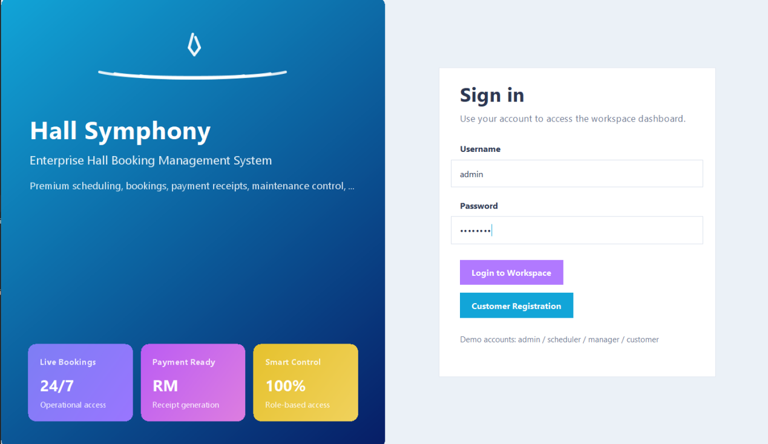
Figure 20 Administrator Login Screen
This screen authenticates the administrator before access is granted to staff and user management functions.
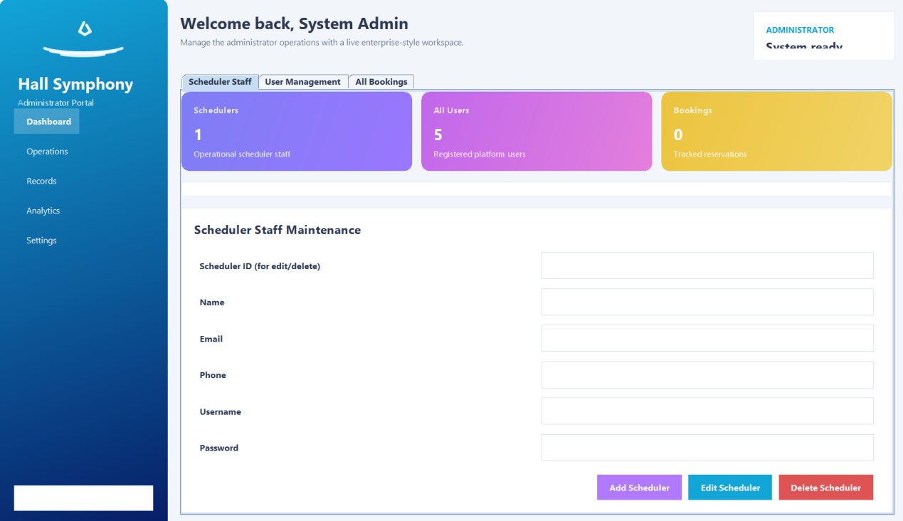
Figure 21 Administrator Dashboard
The administrator dashboard provides a central view of administrative controls. It allows the administrator to manage scheduler staff, users, and bookings.
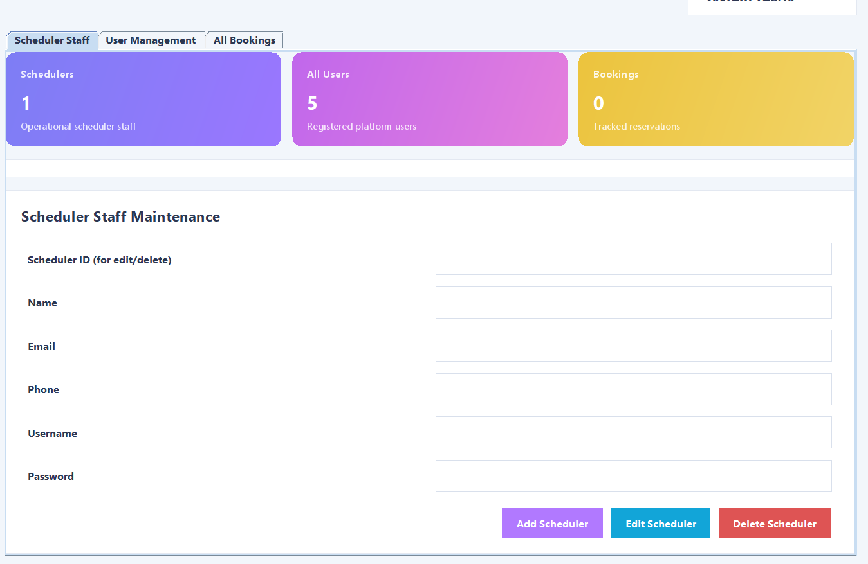
Figure 22 Manage Scheduler Staff
This screen is used to add, edit, or remove scheduler staff records. It helps keep the staff list accurate and updated.
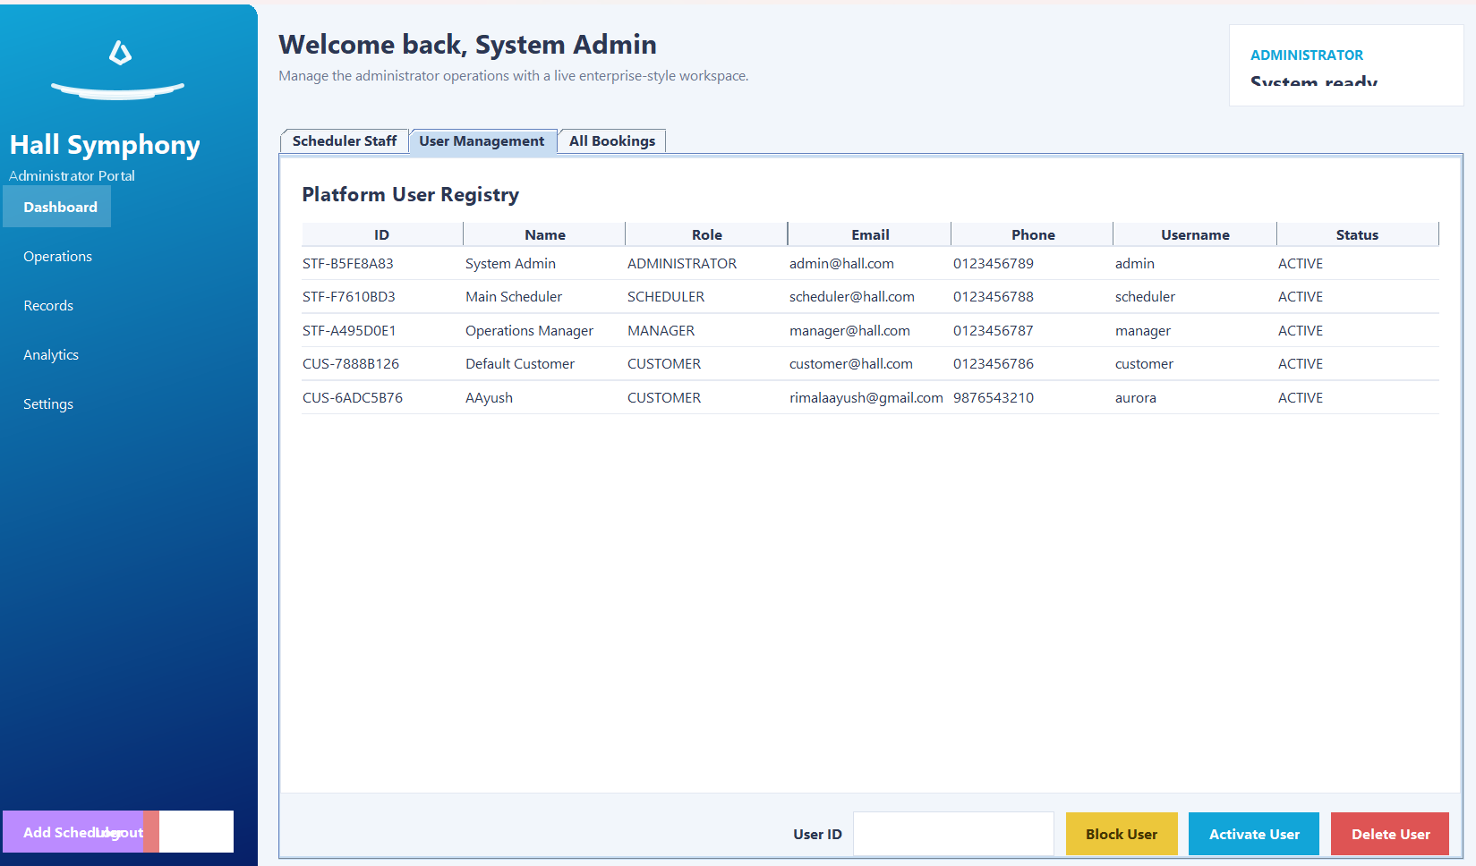
Figure 20: Manage Users
This screen allows the administrator to view and manage customer accounts. Functions may include editing user records, blocking accounts, or deleting records where necessary.
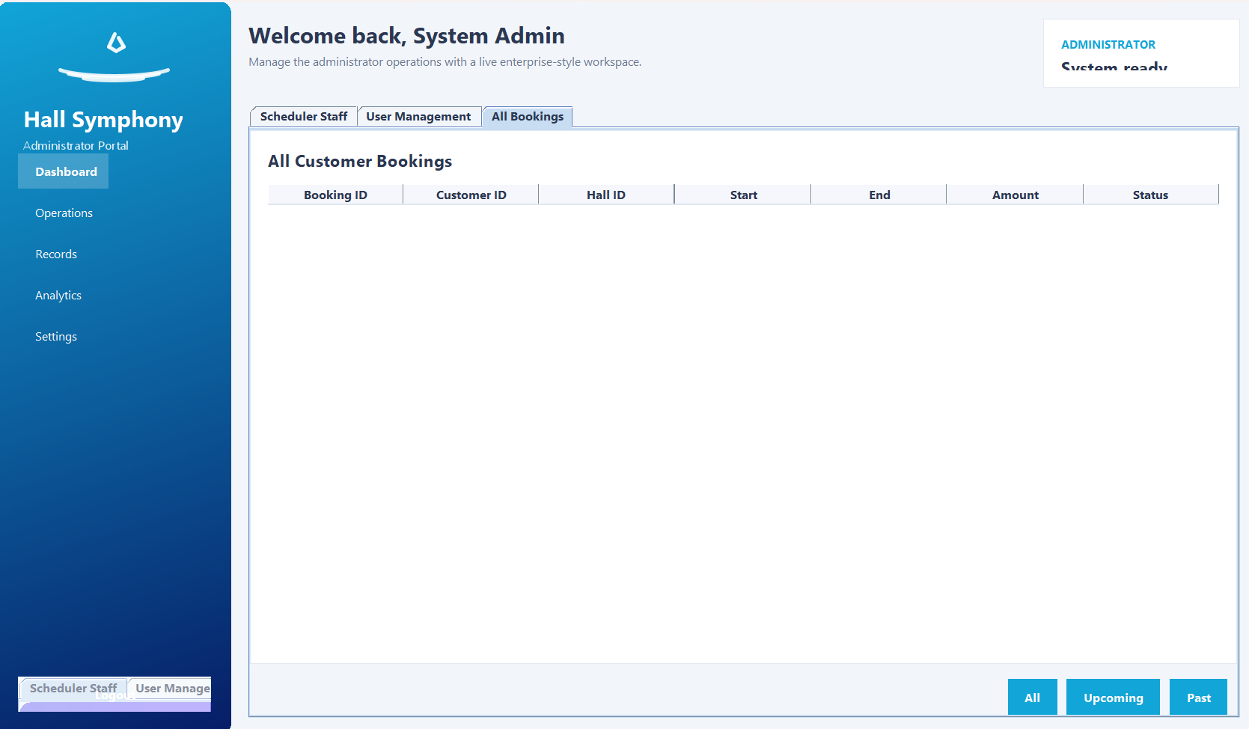
Figure 23 View All Bookings
This screen enables the administrator to review all booking records across the system. It supports monitoring and record control.

Manager Module
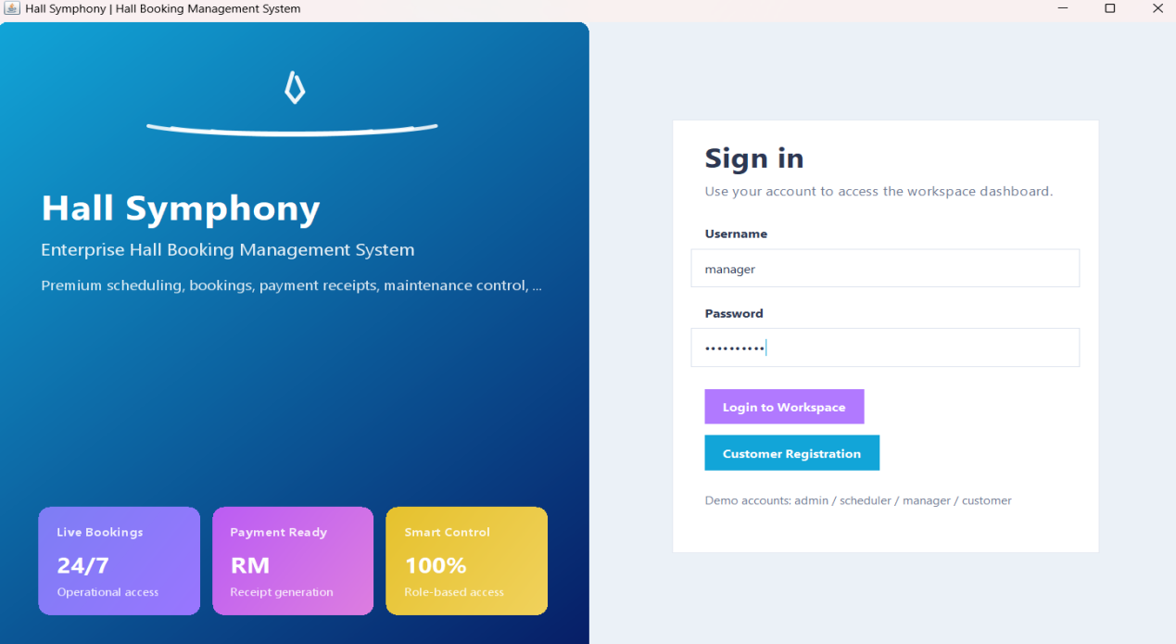
Figure 24 Manager Login Screen
This screen provides secure access to manager-level functions.
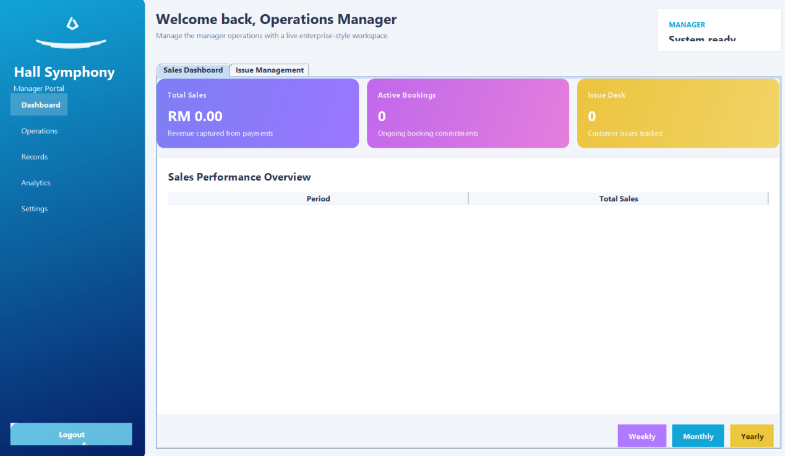
Figure 25 Manager Dashboard
The manager dashboard serves as the main entry point for viewing sales and issue information.
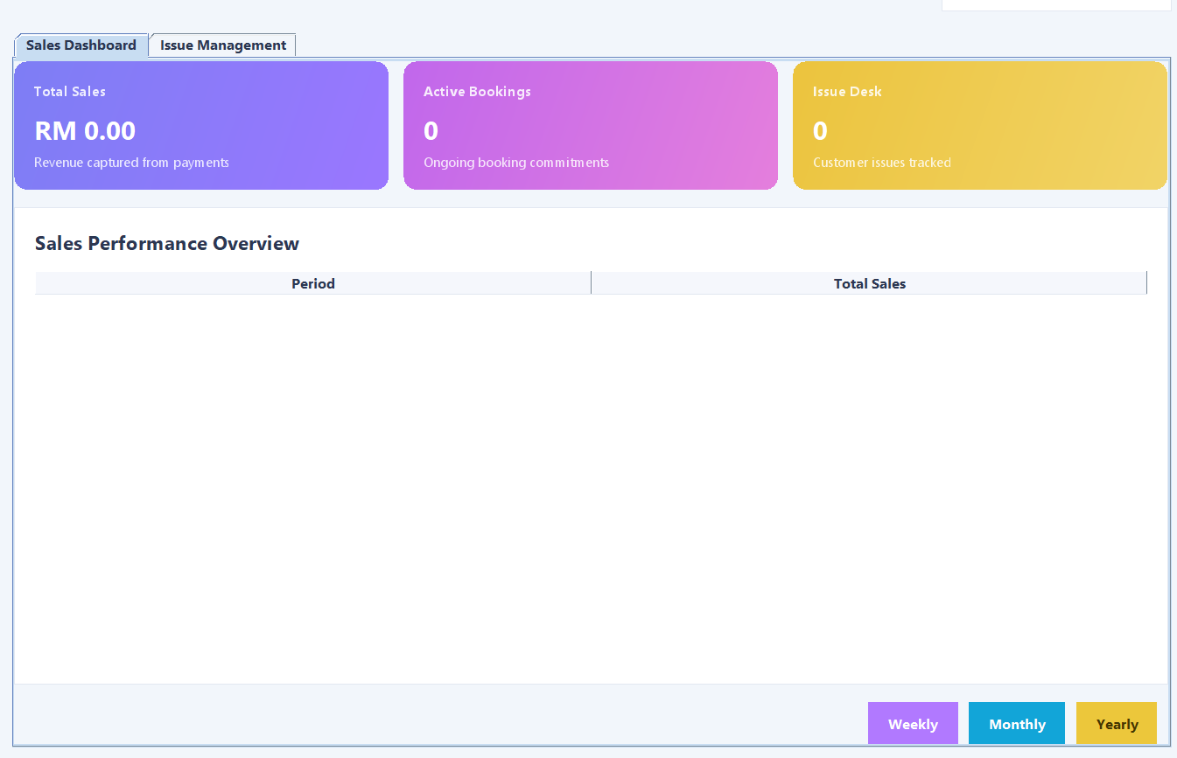
Figure 26 Sales Report Screen
This screen displays revenue information based on booking and payment records. It may include weekly, monthly, and yearly summaries. This function helps management understand business performance.
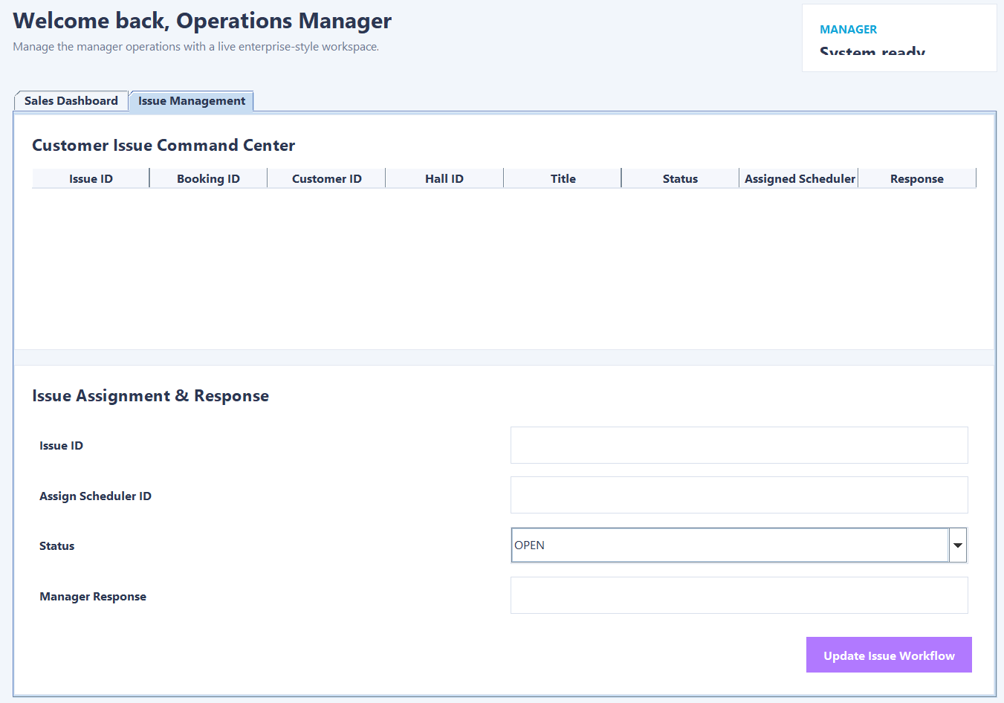
Figure 27 Update Issue Status
This screen allows the manager to change issue statuses such as In Progress, Done, Closed, or Cancelled. This feature supports service monitoring and follow-up.

Application of Object-Oriented Programming Concepts
Object-oriented programming was one of the main foundations of this project. Java is designed around classes and objects, and the project uses these concepts to organize the system into reusable and maintainable parts.

Encapsulation
Encapsulation implies storing data within a class and restricting the access by the methods. Practically, this was implemented by making the class attributes private and revealing this with the help of the getters and setters. This method keeps the delicate information like password, amount of payment, booking and the status of the user.
To illustrate, User, Hall, Booking and Payment are some of the classes with their fields being privately stored. Those that are not directly changed by other classes are not directly approached by methods that are specifically designed to do so. This enhances control and minimizes the accidental alteration.
The system can also be easier to maintain due to encapsulation since in case the validation rules will be modified in future, it will be possible to process them using the class methods without requiring to change the rest of the application.

Inheritance
The concept of OOP is known as inheritance in which one of the classes is based on another and shares its similarities. The Java tutorial of oracle describes the concept of sub-classing where as a subclass inherits both the methods and fields of a super-class.
In this project, there is the user role hierarchy using inheritance:
- Customer extends User
- Staff extends User
- Scheduler extends Staff
- Administrator is an extension of Staff.
- Manager extends Staff
The design helps to avoid duplicated data since all the attributes pertaining to the user like ID, name, email, phone, username and password can be stored in the parent class. Behavior is then acquired by classes of their role. This increases the design and simplifies the expansion. (Oracle, n.d.)

Polymorphism
Polymorphism enables to treat related objects by using a common parent type, but still manages to provide role-specific behavior. The user related operations can be managed in the project with the usual user structures with dashboards and role-based functions acting differently with various roles depending on the role logged in.
Polymorphism also ensures the system is more elastic as a single general mechanism of the login process can result in various outcomes depending on the kind of authorized user. Indicatively, the system determines which dashboard to open as a customer or a scheduler and administrator or a manager after the authentication.
Overridden methods in the code also are a further indication of polymorphism, allowing a child class to give a role-specific implementation.

Abstraction
The concept of abstraction implies the emphasis on fundamental action on concealing internal reality. Abstraction is demonstrated in this project with the isolation between the interface-level code, classes of the model, and service logic. The GUI displays are connected to system operations without the involvement of having to deal directly with file processing details.
As an example, service classes can contain authentication logic, booking checks or file handling. It merely makes a call to the necessary method and gets the output. This makes the code more understandable and prevents the incorporation of all the logic in the GUI layer.
The reason why abstraction is critical is that the project is easier to test, easier to maintain easier to enhance in the future.

Class and Object Interaction.
The project consists of the objects that interact to create the image of the actual booking process. Booking in created by a Customer object. Booking object has a connection with a Hall. On payment, an object Payment is formed. The customer is allowed to establish an IssueRecord in case a problem happens. The Scheduler is in charge of the availability and maintenance records of halls, and the Administrator and Manager are responsible in the work with account and issue records.
This dynamic between objects brings the program nearer to the real world model and that is one of the merits of the object-oriented design..

Additional Features
Besides the main required functions, several supporting features were included to make the system more usable and complete.
First, the project uses separate dashboards for each user role. This helps users focus only on the functions relevant to them and reduces confusion. A role-based interface also improves the professional quality of the system.
Second, the system applies validation on major forms such as registration, login, booking, and payment. This helps reduce invalid entries and protects the consistency of stored data.
Third, the project includes booking history and issue tracking. These features improve the practical value of the system because they support both customer service and internal follow-up.
Fourth, the system records sales information in a way that can be summarized for management reporting. This adds business value beyond simple booking operations.
Finally, the user interface was designed to be more organized and presentable than a basic classroom prototype. A clearer GUI can improve usability and also reflects the practical nature of the project.

Implementation

Development Tools and Technologies
Java Programming Language
The entire Hall Booking Management System has been built on the Java platform. Java was chosen as it is backed up considerably in supporting the concept of object-oriented programming like encapsulation, inheritance, abstraction, and polymorphism. The concepts aid in the system reusability and maintenance (Bloch, 2018).
Java Swing GUI Toolkit
Java Swing was used to provide the graphical user interface of the system. Swing also offers a suite of lightweight code which includes JFrame, JPanel, JButton, JTextField and JTable among others and can be used to create desktop applications with interactive user interfaces (Oracle, n.d.).
java.time API
The system relies on the current structure of the modern package, the java.time, to undertake the operations concerning dates and time. This is significant in paying off business hours, booking length, rules of cancellation and producing periodic sales statement.
Java NIO File Handling
Given that the assignment is not characterised by the possibility of using a database, all information is stored in a form of text files. Java.nio.file package is developed to carry out the file writing, updating, and reading operations in a logical manner (Oracle, n.d.).
Integrated Development Environment (IDE).
An IDE like the IntelliJ IDEA or NetBeans was used to develop the project. The IDE assists in the organization of the project structure, the possibility to debug the errors that happen in the course of the work, and to arrange the various classes effectively.

System Workflow Implementation
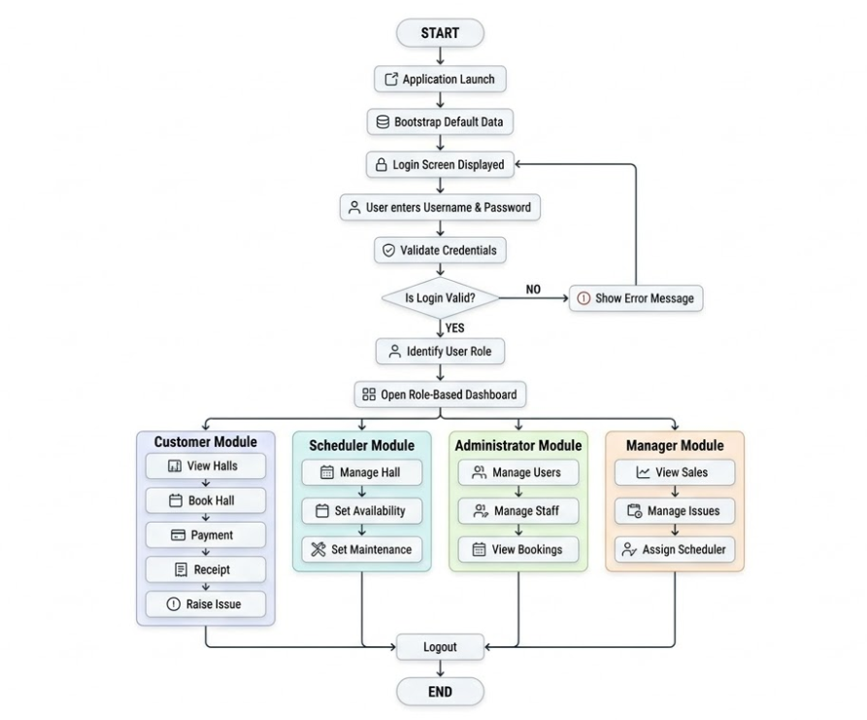
On this Figure demonstrates the working process of the Hall Booking Management System.
This is initiated in the event the application is launched and the system initializes default records using the bootstrap mechanism. This measure is taken towards making sure that fundamental information like the users of a sample, details of the halls and timeframes available have been set up before user interaction begins.

Implementation of Data storage and file processing.
The major data persistence mechanism of this system is plain text files. The system keeps all the operational records in the file system that includes the users, halls, bookings, payments, issues, availability schedules, and the maintenance schedules.
A file handling service is provided that is dedicated to file operations on a low-level basis. This service offers reading of the records, updating of data and adding new records. The system centralizes file operations, thereby decreasing the replication of the code and enhancing the maintainability.
Service classes can be used to interact each functional module with the file layer. E.g. user management service updates the user records, the booking service records the reservations transactions, and payment service records the financial data. validation check is accomplished prior to the data entry into files to avoid the cases of wrong or unfinished data.
The file-based storage is not as scalable as database systems, but in this case, it is adequate to prove the persistent data management of an academic desktop app. It is also useful in visualizing the significance of data organization and software.

Limitations of the System
In spite of the fact that the project is fulfilling the requirements of the main coursework, there is a number of limitations.
- The first weakness is the text files used as opposed to a database. Although illustrated in the assignment, this method is less secure, unscaled, and efficient in comparison to an appropriate database management system.
- The second limitation is that the system lacks live synchronization between a number of users. The project is file-based and thus it does not deal with updates the same way that a multi-user online system would deal.
- The third weakness is that the payment functionality is simulated payment. The system is not linked to actual payment gateway or banking platform.
- There is also a fourth limitation of the absence of built-in notifications. The bookings, cancellations and updates about issues are not followed by email and SMS confirmations to the customers.
- The fifth weakness is that the application is desktop-based, which is constructed using Java Swing. Despite the fact that Swing can be used to develop desktop GUI, it lacks the responsiveness and platform transparency as Web or mobile systems do today. According to Oracle Java tutorials, the Swing tutorials were earlier done using earlier versions of Java but Swing still belongs to the Java desktop platform.
- The sixth weakness is that stronger reporting, user analytic and data centralization options might be needed to support the future business development.

Conclusion
At the conclusion, the Hall Booking Management System has been developed and successfully designed to serve the operations of Hall Symphony Inc. The project offers a logical resolution of hall booking, user management, hall scheduling, payment management, issue tracking and sales reporting.
The system has four user roles, namely, Customer, Scheduler, Administrator and Manager. Every role was given functions that exemplify realistic business roles. Customer module is concerned with booking services. The Scheduler module deals with the availability and maintenance of halls. The Administrator module requires users and staff. Manager module deals with information on handling issues and monitoring of a business.
Technically, the project indicates the application of Java in developing desktop applications, Swing in designing of the GUI and file handling as a persistent storage of data. Java standard packages aid in the creation of a GUI as well as file manipulation and this feature made it an apt component to meet the assignment demands.
Encapsulation, inheritance, polymorphism and abstraction are also the object-oriented concepts evident in the project. The concepts aided in classifying the code into manageable classes and enhanced reusability.
Although the system still has drawbacks, it will offer a solid ground where one can improve it. The project can be further extended to a database backed or web-based solution such as online payment and notification towards the further development. On the whole, the project demonstrates that the combination of software design, object-oriented thinking, and Java programming is possible to effectively and realistically solve a practical business problem.

References
Bloch, J. (2018). Effective Java. Addison-Wesley.
Object Management Group. (2017). Unified Modeling Language (UML), Version 2.5.1. Retrieved from OMG: https://www.omg.org/spec/UML
Object Management Group. (n.d.). Introduction to OMG Specifications. Retrieved from OMG: https://www.omg.org/gettingstarted/specintro.htm
Object Management Group. (n.d.). Unified Modeling Language (UML). Retrieved from OMG: https://www.omg.org/uml/
Oracle. (n.d.). Compiling and Running Swing Programs. Retrieved from Oracle Documentation: https://docs.oracle.com/javase/tutorial/uiswing/start/compile.html
Oracle. (n.d.). Getting Started with Swing. Retrieved from Oracle Documentation: https://docs.oracle.com/javase/tutorial/uiswing/start/index.html
Oracle. (n.d.). Inheritance. Retrieved from Oracle Documentation: https://docs.oracle.com/javase/tutorial/java/IandI/subclasses.html
Oracle. (n.d.). Java I/O, NIO, and NIO.2. Retrieved from Oracle Documentation: https://docs.oracle.com/javase/8/docs/technotes/guides/io/index.html
Oracle. (n.d.). javax.swing Package Summary. Retrieved from Oracle Documentation: https://docs.oracle.com/en/java/javase/11/docs/api/java.desktop/javax/swing/package-summary.html
Oracle. (n.d.). Reading, Writing, and Creating Files. Retrieved from Oracle Documentation: https://docs.oracle.com/javase/tutorial/essential/io/file.html
Oracle. (n.d.). Using Swing Components. Retrieved from Oracle Documentation: https://docs.oracle.com/javase/tutorial/uiswing/components/index.html

Workload Matrix
Student Name | APU Number | Task | Signature
Nabin Raj Joshi | NP070235 | Scheduler module  Hall management  Hall availability schedule  Hall maintenance schedule  Related text files  Aid in the unification of all coding sections. | 
Aayush Rimal | NP070079 | Customer module  Registration and login  Booking  Payment  Receipt  Cancel booking  Raise issue  Related text files | 
Aayush Dhungana | NP070080 | Administrator module  Add/edit/delete staff scheduler.  View users  Block/delete users  View all bookings  Admin screenshots  Write admin part in report | 
Arit Tamrakar | NP070103 | Manager module  Sales dashboard  View/respond to issues  Assign scheduler  Change issue status  Manager screenshots  Write manager part in report  Final report compilation | 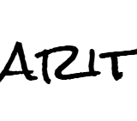

Appendix
Appendix A: Screenshot of users.txt
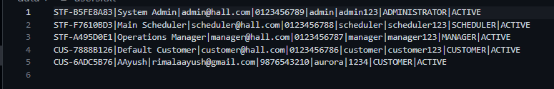Appendix B: Screenshot of halls.txt
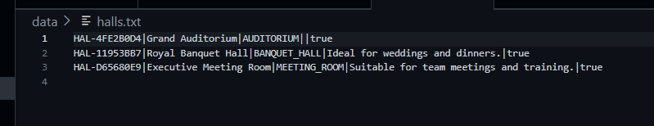
Appendix D: Screenshot of payments.txt
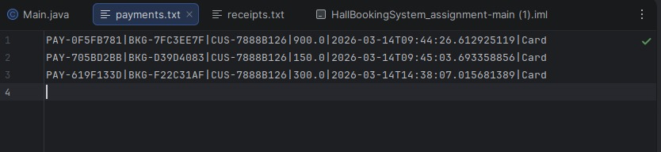
Appendix F: Screenshot of availability.txt
