PENETRATION TESTING REPORT
FOOTPRINTING, NETWORK SCANNING & VULNERABILITY ASSESSMENT

R.M. Naduni Umeda
Cybersecurity Professional | B084 - Networkwalks
08 November 2026

Target: networkwalks.com | scanme.nmap.org
Phases: Reconnaissance | Scanning | Vulnerability Assessment

CONTENTS

- Liability Disclaimer ........................................... 2
- Introduction ...................................................... 2
- Tools Used ........................................................ 3
- Activities Performed ......................................... 3
- Errors Faced & Solutions .................................. 7
- Risk Analysis / Impact ....................................... 8
- Recommendations ........................................... 8
- Conclusion ........................................................ 9
- Evidences Collected ......................................... 9
- Sources & References ...................................... 9

- LIABILITY DISCLAIMER
I have performed these activities only on the systems & devices where I had secured written permission or the devices / systems that I own myself. All these materials are for education and research purpose only. Do not use anything from here to break the law. The instructor, the authors and Networkwalks are not responsible for what you do with this knowledge. Every action you take is your own responsibility. Misuse can lead to criminal charges, heavy fines, loss of your job and a permanent record. In most countries unauthorised access is a crime even when nothing is damaged.

- INTRODUCTION

This report documents my Week 2 work as part of my ongoing internship program at Networkwalks. It covers footprinting the networkwalks.com domain using multiple Kali Linux tools (W2-PM1) and network scanning using Zenmap.
The activities focus on different reconnaissance and information-gathering techniques, from collecting publicly available information about a target, identifying live hosts and services within a network, and understanding the target's public-facing infrastructure.
For each activity, I documented:
• Commands performed
• Results observed
• Screenshots as evidence
• Short explanation of why the information could be relevant from a security perspective

  - Scope & Lab Setup
Scope: This assessment was performed only on the authorized target domain networkwalks.com. No other domain or system was scanned.
Lab Setup: All activities were performed in a controlled lab environment using Kali Linux (Virtual Machine) on my local computer. Tools used were pre-installed Kali tools and Zenmap.
Authorization: Scanning was performed as part of Week 2 coursework for learning purposes, within authorized scope only.

- TOOLS USED
The table below lists each tool used in this report and its purpose.

Tool | Purpose
Kali Linux & Windows | Operating systems used for reconnaissance
WHOIS | Find domain registration details (owner, dates, name servers
WhatWeb | Fingerprint web technologies (server, CMS, plugins, IP)
nslookup | Resolve domain name to IP address using DNS
curl -I | Read HTTP response headers of the website
wafw00f | Detect whether a WAF protects the site
dnsrecon | Enumerate all DNS records (NS, MX, SPF, TXT, SRV)
Zenmap (Nmap GUI) | Scan network to find live hosts, IPs and MAC addresses
- ACTIVITIES PERFORMED
  - Footprinting & Reconnaissance
I performed reconnaissance against the networkwalks.com domain using six Kali Linux tools: WHOIS, WhatWeb, Nslookup, Curl, Wafw00f and DNSRecon. Each tool was used to collect a different type of information about the target.

WHOIS - Domain Registration Details
Command Used: whois networkwalks.com
Result Observed:
WHOIS provided domain registration details including domain name, registrar (GoDaddy), creation date, and name servers. This information helps identify who owns the domain and when it was created.
Why it matters:
An attacker can use owner and expiry information for phishing and domain hijacking attempts.
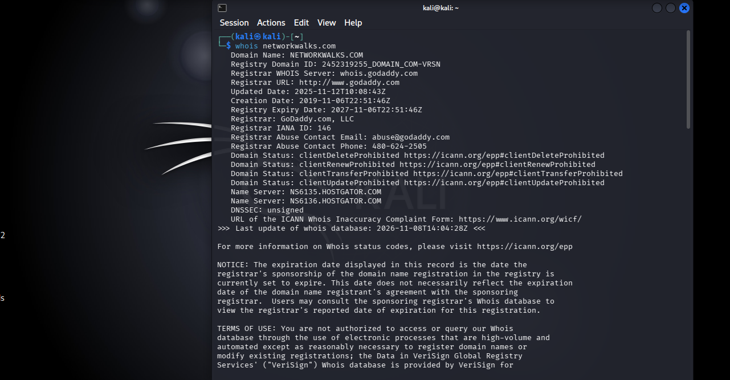 Figure 1: WHOIS lookup for networkwalks.com
WhatWeb - Web Technology Fingerprinting
Command Used: whatweb networkwalks.com
Result Observed:
WhatWeb identified WordPress 7.1.4 and WP Download Manager 3.3.58, along with Apache server and IP address 192.232.216.135.
Why it matters:
Version information helps an attacker search for known vulnerabilities in that specific WordPress version.
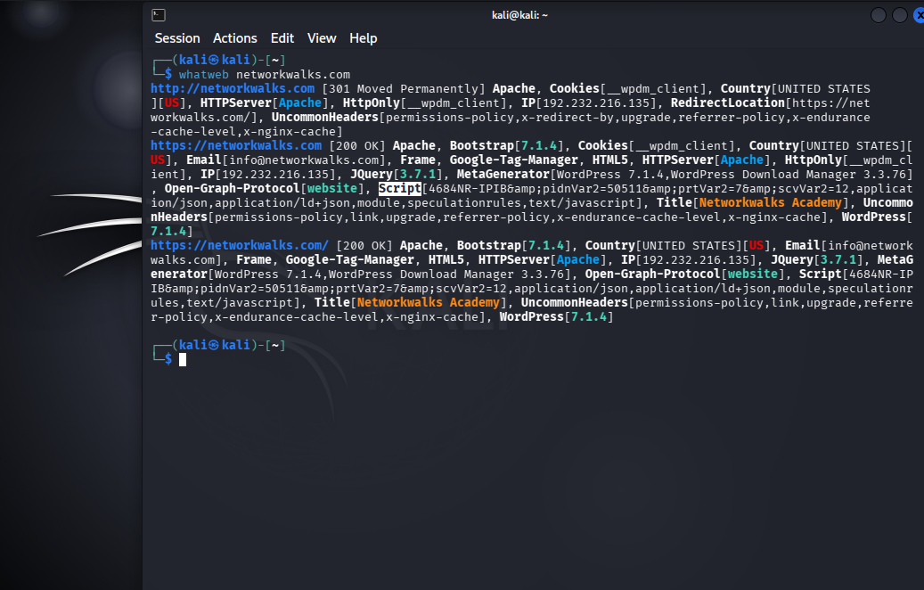
Figure 2: WhatWeb scan for networkwalks.com

Nslookup - Domain to IP Resolution
Command Used: nslookup networkwalks.com
Result Observed:
Nslookup resolved the domain to IP address 192.232.216.135.
Why it matters:
Knowing the server IP allows an attacker to target the server directly for further scanning.
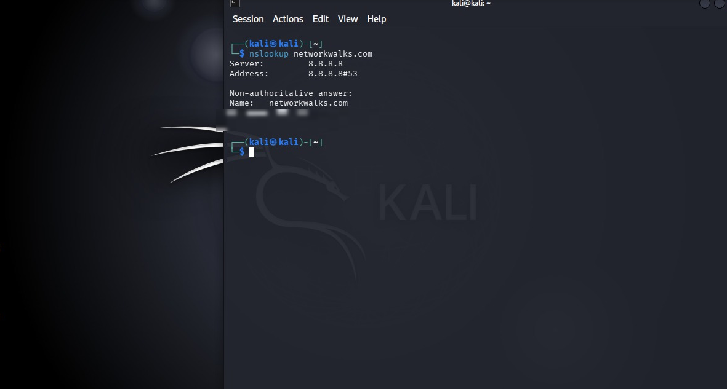
Figure 3: Nslookup result for networkwalks.com

Curl - HTTP Header Inspection
Command Used: curl -I https://networkwalks.com
Result Observed:
Curl with -I option returned HTTP response headers and exposed the WordPress REST API endpoint /wp-json/.
Why it matters:
Headers reveal server and technology information that helps an attacker with further fingerprinting.
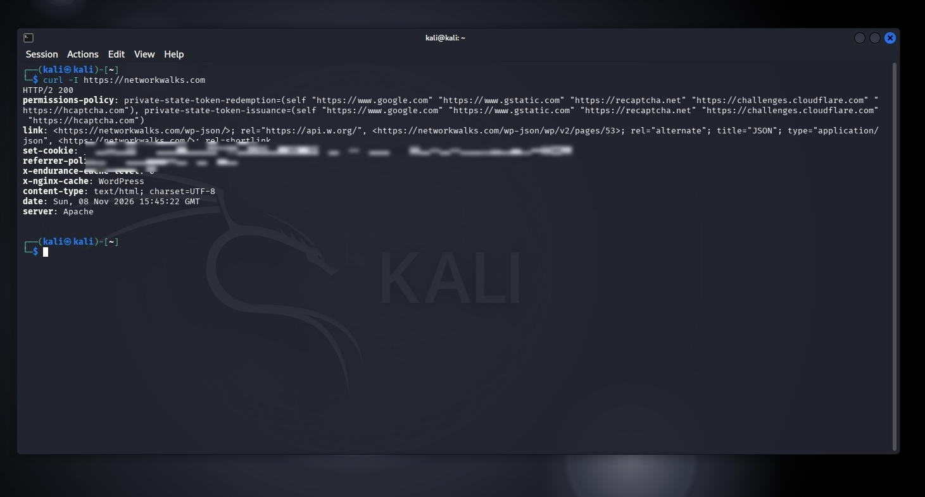
Figure 4: Curl headers for networkwalks.com

Wafw00f - Web Application Firewall Detection
Command Used: wafw00f networkwalks.com
Result Observed:
Wafw00f identified ModSecurity (SpiderLabs) as the Web Application Firewall protecting the website.
Why it matters:
Knowing the WAF type helps an attacker try bypass techniques specific to ModSecurity.
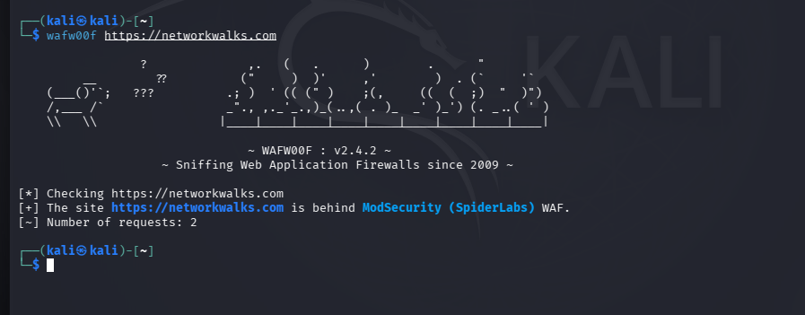
Figure 5: Wafw00f detection for networkwalks.com

DNSRecon - DNS Record Enumeration
Command Used: dnsrecon -d networkwalks.com
Result Observed:
DNSRecon enumerated DNS records including name servers, mail servers, SPF/TXT records, and service records.
Why it matters:
DNS information helps build a broader infrastructure profile for further enumeration.

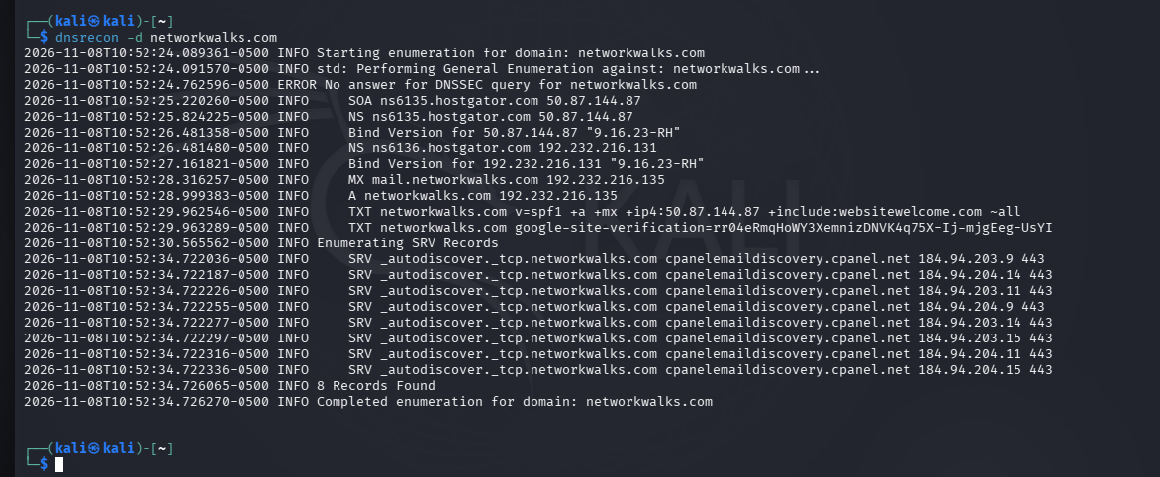
Figure 6: DNSRecon results for networkwalks.com

4.2 Network Scanning with Zenmap
I used Zenmap to perform network scanning. I first used the ip a command in Kali Linux to identify my local IP address and subnet. I then used Zenmap Ping Scan to scan my local network and identify live hosts.
Command Used: ip a
Result Observed:
ip a showed my local IP address as 10.0.0.3 and subnet as 10.0.0.0/24. This confirmed my scan range for Zenmap.
Why it matters:
Knowing my own subnet is required to define the correct scan range in Zenmap.
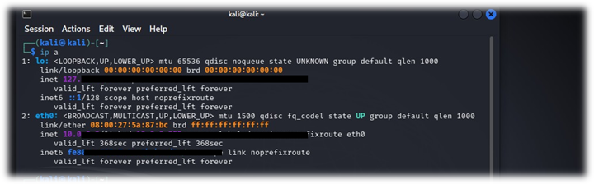
Figure 8: ip a output showing local IP 10.0.0.3

Zenmap - Ping Scan & Topology
Command Used: nmap -sn 10.0.0.0/24 (Zenmap Ping Scan)
Result Observed:
Ping Scan identified live hosts in my local network 10.0.0.0/24 including gateway 10.0.0.1, 10.0.0.2 and my Kali machine 10.0.0.3.
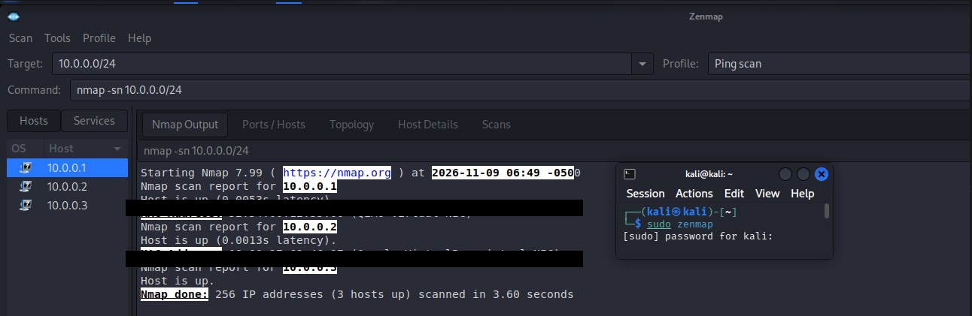
Figure 9: Zenmap Ping Scan - Nmap Output (MAC addresses hidden for privacy)
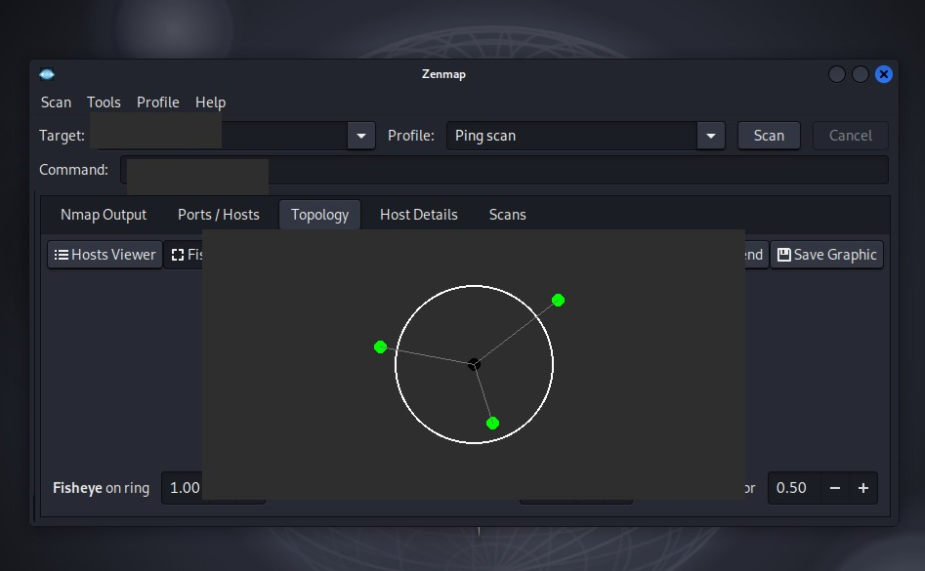
Figure 10: Zenmap Topology view - 3 live hosts in local network (IP addresses blurred for privacy)
Why it matters:
Ping Scan quickly identifies which hosts are live on the local network without scanning all ports. This helps to map the local network before doing a detailed scan.

- RISK ANALYSIS / IMPACT
Based on the information collected, I identified the following potential risks.
 | Risk / Finding | Evidence | Risk Level
1 | Web technology exposed | WhatWeb - WordPress 7.1.4 | Medium
2 | Server IP identifiable | Nslookup - 192.232.216.135 | Low
3 | HTTP info exposed | Curl - /wp-json/ | Low
4 | WAF identifiable | Wafw00f - ModSecurity | Low
5 | DNS info exposed | DNSRecon - NS, MX, TXT | Medium
6 | Multiple live hosts | Zenmap - 3 live hosts | Medium

The risks above are observations from footprinting and scanning, not confirmed vulnerabilities. No exploitation was performed
- RECOMMENDATIONS
Based on the observations from these activities, I recommend the following security improvements:
- Review publicly exposed technology information
Organizations should regularly review what information about their web technologies, CMS and plugins is publicly visible.
2. Keep software updated
WordPress, themes and plugins should be kept updated to reduce the risk from known vulnerabilities.
3. Review HTTP headers
Unnecessary information in HTTP headers should be minimized to avoid revealing server and technology details.
4. Review DNS records regularly
DNS records should be reviewed to ensure no unnecessary or sensitive information is exposed.
5. Keep WAF (ModSecurity) enabled and tuned
The Web Application Firewall should remain enabled and properly configured to block common attacks.
6. Perform regular internal network discovery
Internal networks should be scanned regularly to identify all connected devices.
7. Investigate unknown devices
Any unknown or unauthorized device found on the network should be investigated immediately.
8. Perform security testing only with authorization
All scanning and testing should only be performed with proper authorization and within the approved scope.

- CONCLUSION
During Week 2, I completed footprinting and network scanning. I learned how WHOIS, WhatWeb, Nslookup, Curl, Wafw00f and DNSRecon collect information about a target, and how Zenmap Ping Scan identifies live hosts and network topology. Information gathering is an important part of cybersecurity. All activities were performed within authorized scope.

8. EVIDENCES COLLECTED
All screenshots from WHOIS, Nslookup, WhatWeb, Curl, WafW00f, DNSRecon and Zenmap are included in Sections 4.1 and 4.2 above as Figures 1 to 10. Zenmap Topology was saved in PDF format as required for evidence.

9. SOURCES & REFERENCES
Kali Linux - https://www.kali.org/
Nmap / Zenmap - https://nmap.org/
WHOIS Lookup - https://who.is/
Networkwalks - https://networkwalks.com/

-End-

👤 Author
R.M. Naduni Umeda
Cybersecurity Student B084
LinkedIn: www.linkedin.com/in/naduni-umeda

📌 Project Information
Program Name: Cybersecurity program at Networkwalks | Week: 02 | Repository: GitHub

