Data Description
The data has been retrieved from the opendata forum of the US government https://www.data.gov/ . The data describes the crimes commited in the state of Los Angeles between the years 2010-2015. We have about 1048576 crime records in the data set. The data has even the minute details such as the time of the crime commited and the exact location of the crime scene in the Latitude and Longitude. Other then this the DR number, Date Reported, date of occurance, Area ID, Area Name, Reporting District, Crime Code, Crime Code Description, MO Code, Criminal Age and Sex, Premise description, weapon used are also present in the records.

Data Analysis

1) YEAR 2010-11

- Criminal Sex Ratio
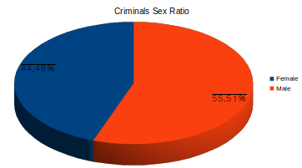

- Case Status & Description
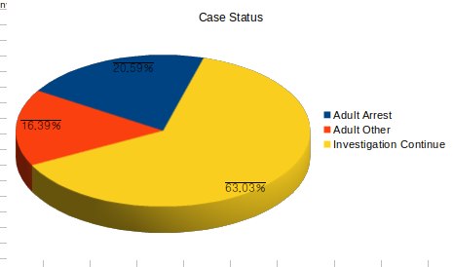

- Age of the criminal
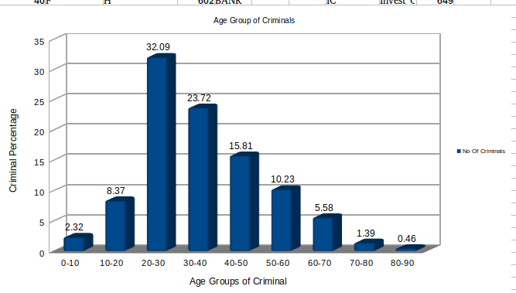

2)YEAR 2012-13

- Criminal Sex Ratio
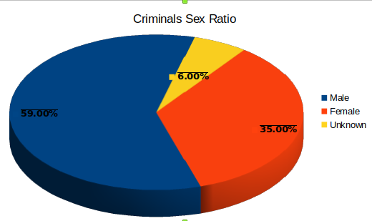

- Crime Status and description

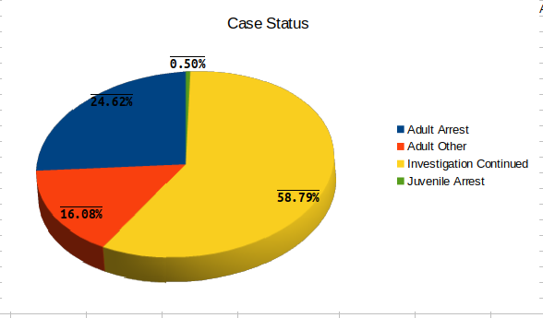

- Age Group of Criminals
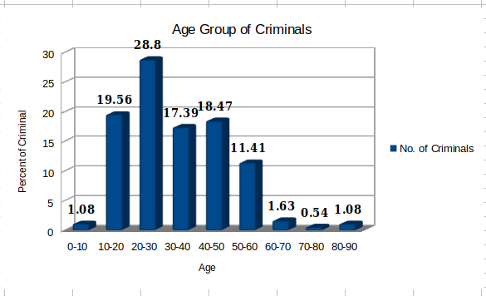

3) YEAR 2014-15

- Criminal Sex Ratio

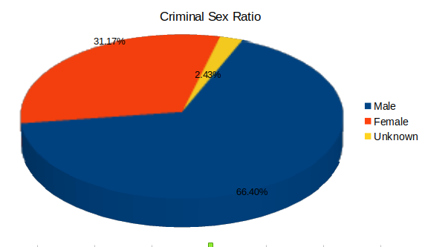

- Case Status & Description – The case description

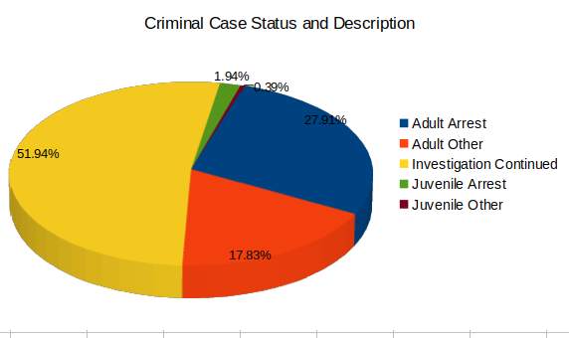

- Age Croup of Criminals
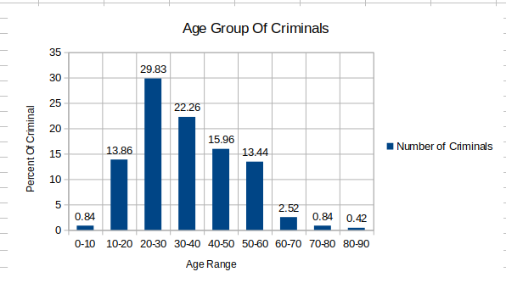

Remaining study to be done
The aim of the project is to ultimately build a UI which will be able to predict the safety factor of a locality. The processing of the data that has been done till date can be used for further sampling. We would follow the same principle used so far to process the remaining data. In the analysis done so far we done it manually but the for retrieving the information we will automate with a simple code that is about complete. We are using this cause the total societies are less but the marked localities within them about 1000. We still have to work on building the interface and also the processed data needs to be uploaded on it as well. The data representation needs to be in sync with the locality selection for the overall safety determination of the locality.

