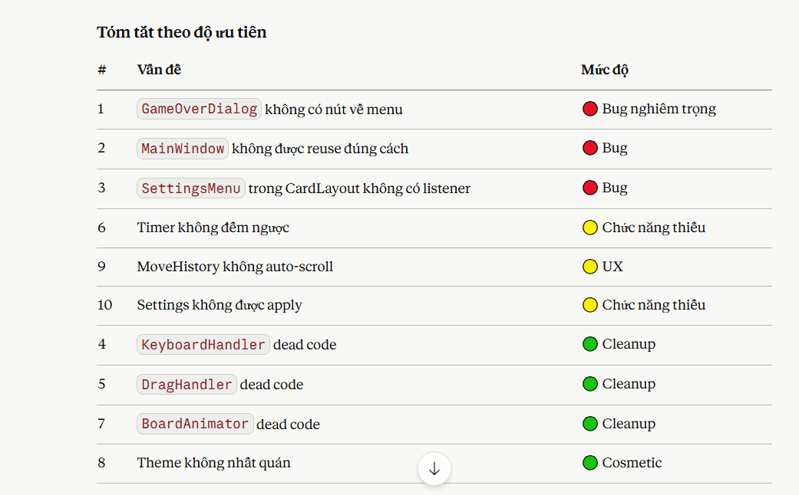
1-2-3-9-6-10 (COMPLETE)

