MPE/AVS War Room

Shellese Hinds;Christian Mclean;Aech King;Andrew Mason;Christopher Jepson
Purdue University Global
IT402 - IT Consulting Skills
Dr. Arnold Webster
November 11, 2025

Contents
Notes & Important Relevant Information 3
APA Citation Reference Statements 3
Q1: Team Role Assignment 5
Q2: Required Scope Modification Plan 5
Q3: Team Member Reflections 7
SWOT Analysis 9
References 10

Notes & Important Relevant Information
This section is used for any metadata pertaining to the SWOT analysis that should not directly be included within the SWOT analysis, including statements of notes, APA references not part of the analysis, etc.

APA Citation Reference Statements
SWOT Analysis Template was created by Google Gemini (2025). Some of the content was also evaluated by Google Gemini. One such example of this was having Gemini create a SWOT analysis of its own and then factoring in what positions a 5-person team would be if addressing a project involving the generated SWOT analysis. This produced some of the titles we assigned to each member. See figure 2 & 3. Please note, figure 2 is not our submitted SWOT analysis.

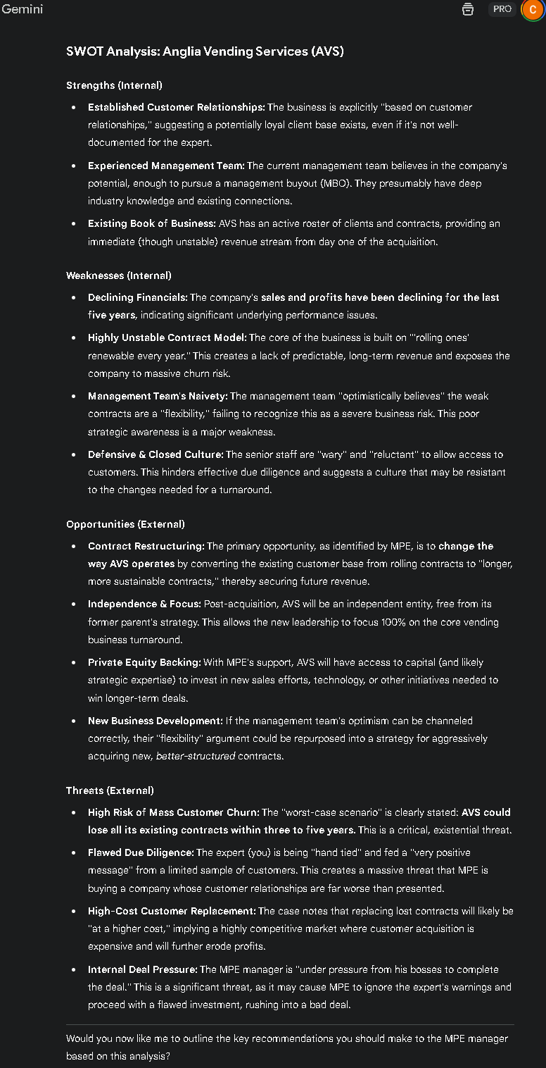
Figure 1

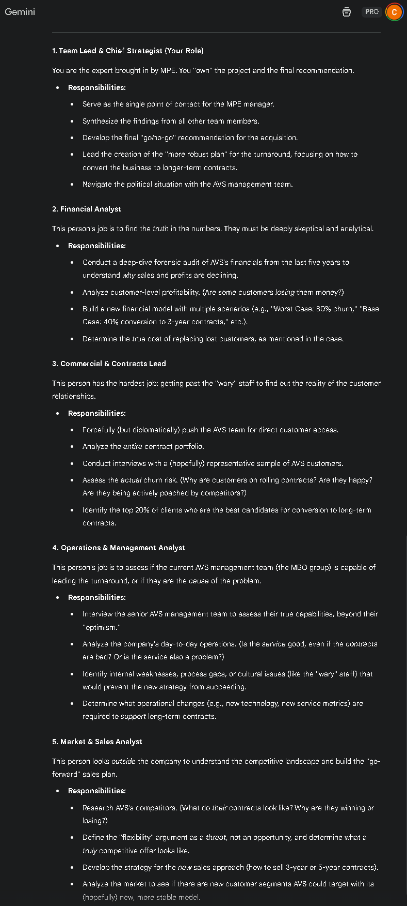
Figure 2

Q1: Team Role Assignment

- Aech King: Operations & Management Analyst (Infostructure Analyst)
- Andrew Mason: Commercial & Contracts Lead (Resource Investigator)
- Christian Mclean: Financial Analyst (Economist)
- Christopher Jepson: Team Lead & Chief Strategist
- Shellese Hinds: Market & Sales Analyst

Q2: Required Scope Modification Plan
This is a project shock and should be treated accordingly. We need to refer to the aims of the project and re-evaluate the resource implications. We were brought in initially to consult on the current business plan and its failings. However, we cannot gain insight into their customer relationships since they'd been 'briefed' before we spoke to them, and we've learned about the short-term contract issue. The team proposes that we shift focus from customer insight and relationships to internal structure issues. The fact we were only allowed to learn positive things about AVS, but their sales and profits have been declining tells us there is something going on that is causing these customers to lose trust. Since we can't speak with them, looking inward is now the best first step.
The scope of the project has changed and is no longer an analysis of an established plan but rather to create a new, feasible business model. Our team will introduce an organized scope management plan based on the professional principles of market research:
- Formal Scope Change Agreement: Identify the new goals with MPE and AVS management now and sign them formally. This shifts our deliverable towards a go/no-go evaluation to a strategic turn-around plan.
- Transit Research and Competitive Analysis: Because no reliable investigation can be conducted on consumers we will start with the available resources and competitive analysis, as the U.S. Small Business Administration (SBA) suggests, we should learn and know other businesses involved in competition with our potential consumers (United States Small Business Administration, 2024). This includes:
- Competitive Benchmarking: Comparing the terms of the contract, the cost, and services provided by the key competitors of AVS to determine the standards in the market and determine the possible competitive advantage.
- Economic Indicators and Trade Statistics: It is examined based on free government data of consumer spending, employment, and industry trends to determine the market size, demand, and other economic indicators impacting the vending business (Small Business Administration, 2024).
- Internal Sales Data Analysis: Mining AVS own sales data to determine the measurable patterns in the customer churn and the contract-renewal rate which may be used to point at the problems without biased customer feedback.
- Revised Deliverables: Our end-product will be a Strategic Restructuring Plan which will entail a new, supported sales and marketing plan, a new financial plan and an operational overhaul plan.

Q3: Team Member Reflections
A big part of this would be shifting the focus of AVS away from their current customer relationships. While it is important to keep AVS’s customers happy, and it’s great that they have a small few with such a great impression of AVS, clearly it is not working to retain or gain additional customers. We need to discuss with them other ways to build trust with customers that aren't communications focused, such as addressing the contracting issue to build confidence in our ability to provide services. The customers need to be happy with products and services, not just relations, if AVS wants to grow.
We will apply data-driven techniques to transform the relationship-based attitude of the AVS management to be more value-based..
- Reframing based on Competitive Analysis: We will utilize the data of the competitive benchmarking to demonstrate that good relationships would not be a specific or lasting strategy. The market research will help us to change their identity and make sure and enhance their business idea (United States Small Business Administration, 2024), transforming it not to be the most trustworthy, data-driven office refreshment solution provider. This reframing is strategic and explains why longer and more stable contracts are necessary.
- Movement Off Anecdotes to Data: We will show an examination of market saturation and internal sales trends to illustrate that although there are some anecdotes to the positive results among some clients, the market data show a downward trend. This factual method is not as confrontational, and it demonstrates that the market is not seeking only good relationships.
- Establish credibility in Performance: We will push to prove that there is indeed trust through performance, that we should have reliable services with a selection of products that ought to be chosen based on data We can show how to enhance customer satisfaction and that our operations are best ensured by longer-term contract. This enables AVS to be more scalable and less susceptible to competition.

SWOT Analysis
INTERNAL FACTORS (Positive) |  | INTERNAL FACTORS (Negative)
### STRENGTHS |  | ### WEAKNESSES
Established, trusting customer relationships |  | Reliance on short-term contracts creating high risk
Experienced management team with industry knowledge |  | Limited access to unbiased customer feedback
Solid infrastructure from parent company Anglia Food Services |  | Declining sales indicating underlying performance issues
Credibility due to AFS backing |  | Vulnerability to losing contracts without replacements
EXTERNAL FACTORS (Positive) |  | EXTERNAL FACTORS (Negative)
### OPPORTUNITIES |  | ### THREATS
Operational independence and agile decision-making |  | High competition leading to aggressive bidding
Longer term fixed contracts (5+ years) |  | Failure to secure new business at sufficient volume
Restructuring to pursue more niche markets |  | Economic pressure on clients
Investments in technology, marketing, or acquisitions |  | Damage to customer relationships during transitional periods

References
Google. (2025, November 7). Gemini [Multi Large Language Model]. Retrieved from 2.5 Pro.: https://gemini.google.com/app
United States Small Business Administration. (2024, November 13). Competitive analysis and market research. Retrieved from Market research and competitive analysis.: https://www.sba.gov/business-guide/plan-your-business/market-research-competitive-analysis

