Mobile Warehouse Operations Application for North Music Warehouse

Client Company
North Music Warehouse
124 Symphony Lane
Raleigh, NC 27603

Consulting Firm
Pulse IT Consulting
8901 Innovation Drive, Suite 220
Charlotte, NC 28262

This document was prepared by
Christian Mclean
christianmclean@student.purdueglobal.edu (mailto: christianmclean@student.purdueglobal.edu)
December 9, 2025

Executive Summary
North Music Warehouse employees currently lose significant productive time walking back and forth to the main office to retrieve printed sales orders and update shipment status. This inefficiency directly affects order fulfillment speed and labor costs across multiple warehouse buildings. Pulse IT Consulting recommends the design and deployment of a secure, native mobile application (iOS & Android) that gives warehouse staff real-time access to the existing sales database, barcode/QR scanning capability, inventory lookup by location, picking list generation, and instant status updates for packing and shipping. The solution will reduce order-processing time by an estimated 40–60 %, eliminate paper-based errors, and provide management with live visibility into warehouse operations. Total project cost is $158,116 with an aggressive 20-week timeline and full go-live targeted for May 2026.

Objectives
• Deliver a secure mobile application allowing warehouse staff to view, pick, and update orders without returning to the main office.
• Achieve ≥99.9 % uptime and real-time synchronization with the existing sales database.
• Reduce average order fulfillment time by at least 40 % within 90 days of go-live.
• Provide management dashboards showing live warehouse activity and bottleneck alerts.
• Ensure the solution is usable by non-technical staff with minimal training (≤2 hours per employee).

Strategies/Methods
The project will follow an Agile/Scrum methodology with two-week sprints to allow rapid feedback from North Music Warehouse stakeholders. Phase 1 (Weeks 1–4) consists of requirements refinement, UI/UX wireframing, and selection of the final technology stack React Native for cross-platform mobile development, Node.js/API layer, and Microsoft SQL Server integration via secure RESTful services. Phase 2 (Weeks 5–14) covers development, barcode integration using ZXing library, offline capability with local SQLite caching, and role-based security. Phase 3 (Weeks 15–18) includes rigorous QA testing in the actual warehouse environment using real devices, performance load testing, and security penetration testing. Phase 4 (Weeks 19–20) covers user acceptance testing, training rollout, and production deployment with a parallel run of the old paper process for one week. All code will be managed in Git with continuous integration pipeline ensures immediate build and unit test feedback. Pulse will host a staging environment for client review after every sprint.

Human Resources
Name | Role | Responsibility
Christian Mclean | Project Manager / Lead Consultant | Overall project delivery, client communication
Marcus Chen | Senior React Native Developer | Mobile app development & barcode integration
Priya Patel | Backend Developer / DBA | API development, database integration & security
Alex Rivera | UI/UX Designer & QA Lead | Wireframes, usability testing, test automation
Taylor Brooks | Warehouse Process Specialist | Requirements, UAT, end-user training

Schedule
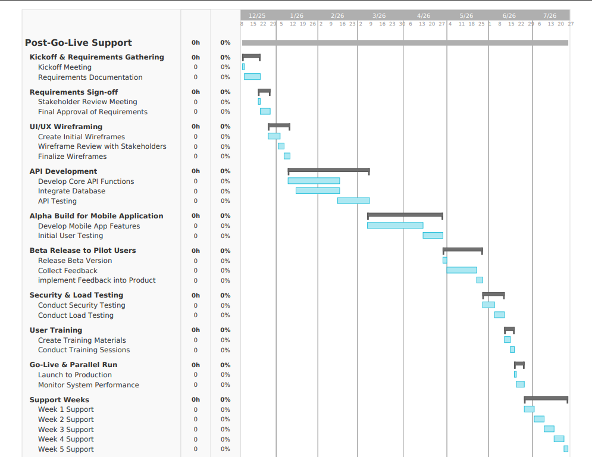

Costs Hardware / Objects
Item | Cost per Unit | Qty | Total | Source
Apple iPad 10.9" (for testing) | $449 | 3 | $1,347 | apple.com
Zebra TC21 rugged scanners | $685 | 15 | $10,275 | zebra.com
Wi-Fi 6 access points upgrade | $899 | 6 | $5,394 | cdw.com
 |  |  | $17,016
Services
Cloud hosting (Azure App Service + SQL) – $800/month × 6 months (includes dev/staging/prod) = $4,800
Labor
Name | Rate | Est. Hours | Total
Christian Mclean | $140/hr | 180 | $25,200
Marcus Chen | $125/hr | 320 | $40,000
Priya Patel | $120/hr | 280 | $33,600
Alex Rivera | $110/hr | 220 | $24,200
Taylor Brooks | $95/hr | 140 | $13,300
 |  |  | $136,300
Total Project Cost: $158,116

Methods of Communication
Primary communication will occur through a dedicated Microsoft Teams channel for instant messaging and file sharing. Weekly status updates every Monday. Bi-weekly 30-minute video calls will be scheduled for sprint reviews and immediate issue resolution. Formal written progress reports will be delivered via PDF every two weeks. Critical issues will trigger immediate phone calls followed by email confirmation. All project documentation, wireframes, and builds will be accessible 24/7 through a secure SharePoint site provided to North Music Warehouse stakeholders.
Approvals
Christian Mclean____Christian Mclean____ Date: December 9, 2025
Client________________________________________ Date: ____________
Appendix
Mobile Wire Frames:
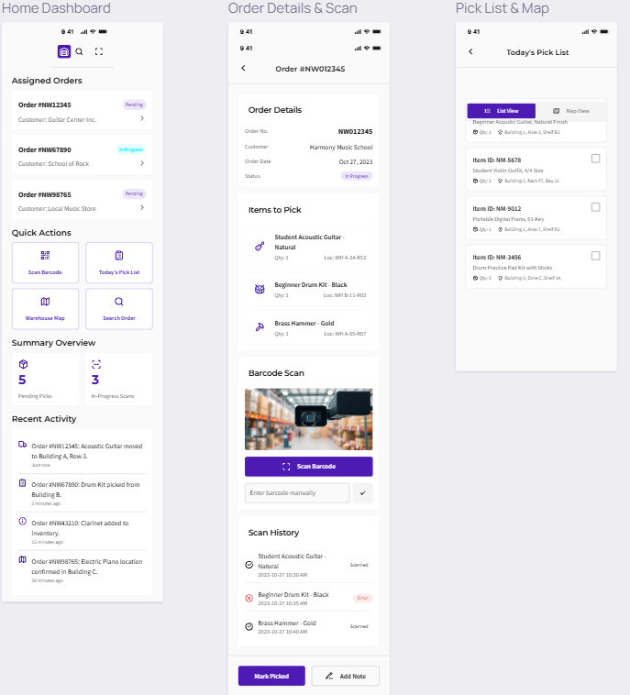

Flow Chart:
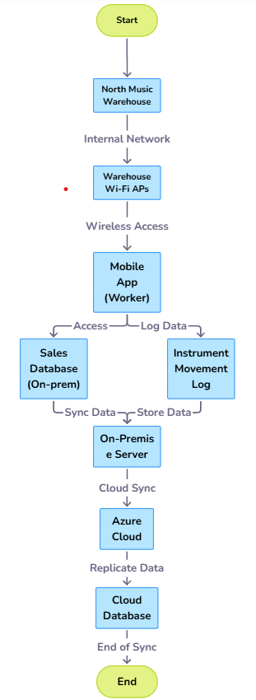
ER Diagram
