Christian Mclean
IT 460 Professor Theodore Witt
Analyzing Amazon.com for Functional and Nonfunctional Requirements

Amazon is the number one site for purchasing in the world as such they have a massive footprint. That means that there site must do a ton of different thing to support the amount of traffic that it gets and must do it in a user friendly and convenient way so that more people flock to it.
Part 1: Functional Requirements
Process-Oriented Functional Requirement: Order Placement
The Amazon website must support a streamlined order placement process to enable users to purchase products efficiently. After all if you don’t have customers, you don’t have a business and people like simple functionality so that they can get exactly what they want in a reasonable time. I will now provide three example of this.
Example 1: Users can add items to their cart from product pages and proceed to check out with a single click, as seen with the "Add to Cart" or “Buy Now” button on a products listing. This single click functionality is truly efficient way to shop pictured here. 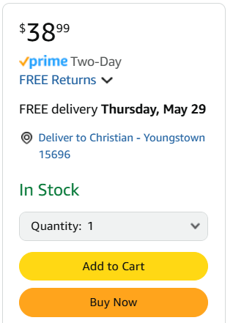

Example 2: The system allows users to select shipping options, such as same-day delivery, during checkout. Allowing flexibility in pricing and allows the customer to determine how urgently they need the product like I will have pictured below. I am a prime member, so all options are free for me but I believe if you are not the prices change based on a few differing factors.
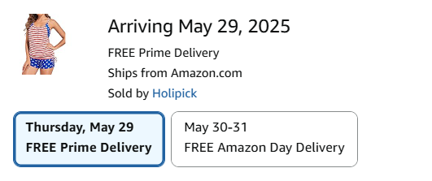

Example 3: Users can save multiple payment methods like bank cards, credit card, Amazon Pay and etc for quick order completion. This allows for more simplicity and also creates a kind of impulse buying situation (less to think about less to question a purchase as necessary or not) for the customer so that it not only helps the customer but the company. I won’t be providing a picture of that for obvious reasons.

Information-Oriented Functional Requirement: Product Descriptions
The Amazon system must manage detailed product information to inform user purchasing decisions. I know especially for bigger purchases like TVs, laptops, things I am going to have for years I want as much information as I could possibly stomach so that I can pick the best option for my price range and needs. Next, I will show some examples.
Example 1: Each product page includes specifications, such as a smart watches’ storage capacity and color options. Again, knowing about the capabilities of the product is a huge determining factor for many people. Like pictured below. 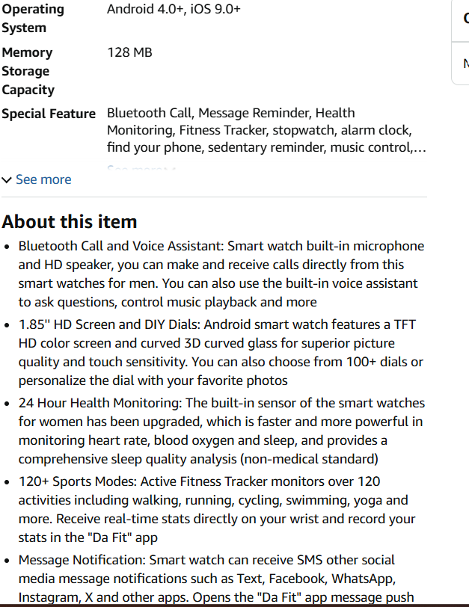

Example 2: Customer reviews and ratings, like a 4.5-star average for a blender, are displayed to guide buyers. Though I don’t take this part to seriously as the variability of people’s abilities and use case can vary so widely. Personally, I have found great success using things all over the spectrum of ratings. But I know people that go by reviews religiously. 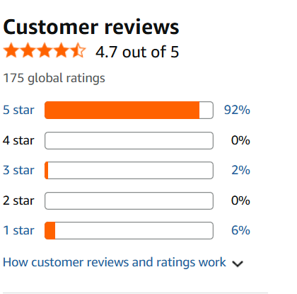

Example 3: The system provides “Frequently Bought Together” suggestions, such as pairing a laptop with a case. This is an excellent addition to the site. Last year I bought a 3D printer and because of this tab I was able to get all the additional things to make it work well once it came. Not only does this show care for customers this inherently inflates sales as tie in purchasing is great for the company. 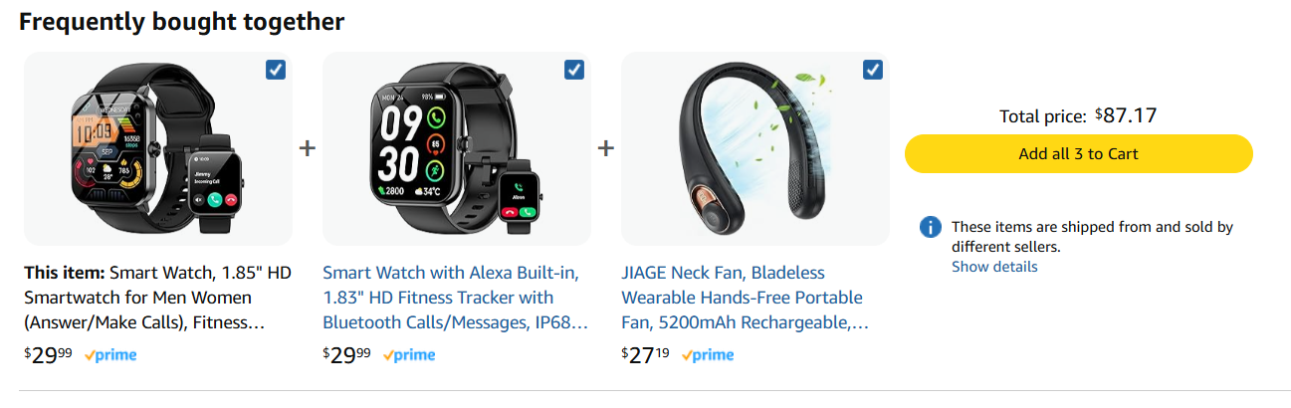

Additional Functional Requirement 1: Recommendation Algorithms
This requirement relates to personalized product recommendations to enhance user experience and drive sales. It is an amazing function pointing out things we may not realize we need as customers. “If you constantly buy this thing or like this thing you may enjoy this.
Example 1: The homepage displays “Recommended for You” items based on a user’s browsing history, like suggesting headphones after viewing electronics. This gives customers a good place to start get them to jump down a rabbit hole and spend more time on their website. I know it gets my wife everytime. 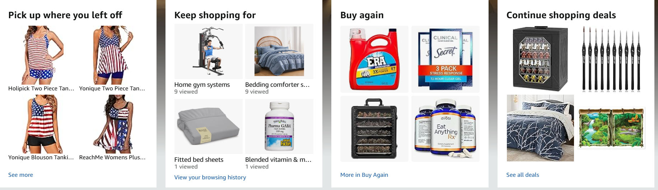

Example 2: The system offers “Customers Who Bought This Also Bought” suggestions, such as books related to a purchased novel. Like this I just bought my son some books for his graduation. I was looking for Man’s Search for Meaning but had forgotten about Meditations so this function actually helped me very recently. 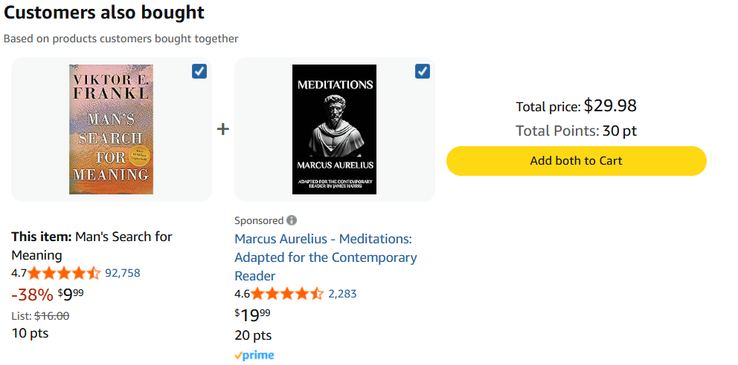

Example 3: Push notifications recommend products based on past purchases, like fitness gear after buying running shoes. This can keep your customer coming back to try to find new good deals on things they need or want.

Additional Functional Requirement 2: User Account Management
This requirement involves managing user accounts to provide a personalized and secure shopping experience. If a customer doesn’t trust you and feel engaged many will move on and try to find a new company to replace you.
Example 1: Users can create and edit profiles, updating details like email or phone number in the “Your Account” section. This makes sure they can have a history of purchases and other things so that way if you have a recurring order like my wife swears by Era detergent however no one around us carries it. You can create repeat customers with loyalty. 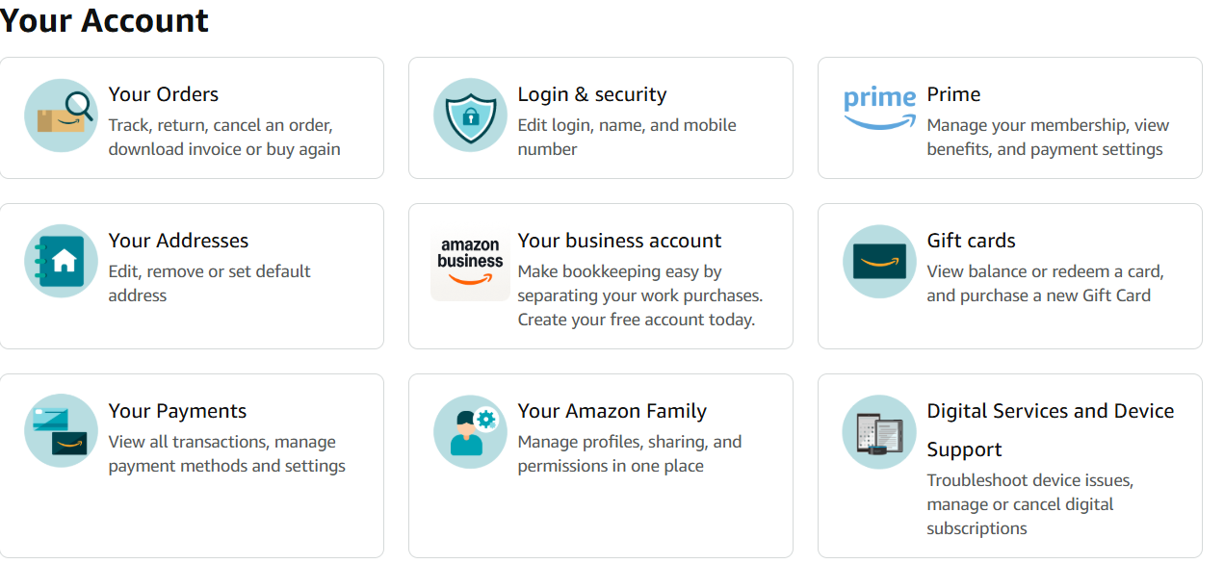

Example 2: The system allows users to track orders, view delivery status, and request returns from their account dashboard. Again, another book I recently ordered but show how you could track it and in the same dashboard after it is delivered you can return it as well. 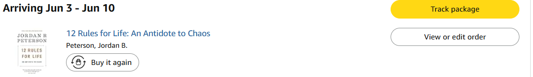

Example 3: Users can manage subscriptions, such as Amazon Prime, with options to renew or cancel memberships as seen here.
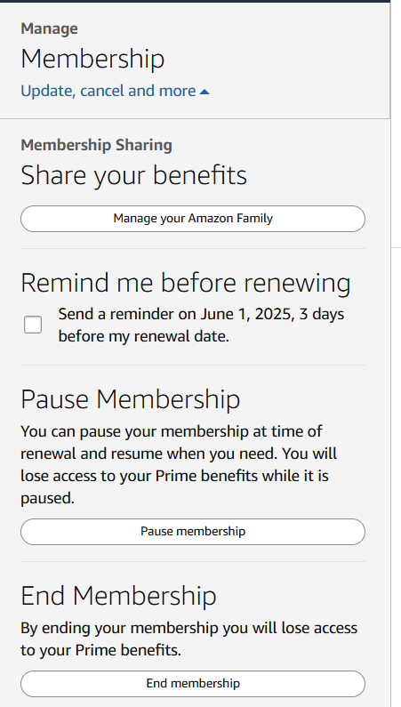
Part 2: Nonfunctional Requirements
Operational
Example 1: The Amazon system must maintain 99.9% uptime to ensure constant availability for global users. Any downtime is lost sales and confidence in the hyper competitive retail field that means company’s like Walmart are right there nipping at their heals.

Example 2: The system must implement automated backup procedures to recover data in case of server failures. The amount of storage space required for this is likely so massive it is hard to visualize just how many resources they must assign to this task.

Performance
Example 1: Web pages must be loaded within 2 seconds to provide seamless user experiences. In the world we live in, people are way to used to having anything at their fingertips in an instant.

Example 2: The system must support millions of concurrent users during peak events like Prime Day without slowdowns. Lost sales at peak times are killer to any companies especially when you have timed events.

Security
Example 1: The system must use end-to-end encryption for all payment transactions to protect user financial data. Not only is this smart, it is legally required by law. Amazon, given the traffic it receives it has to be one of the most secure sites in the world.

Cultural/Political
Example 1: The system must comply with GDPR for European users, ensuring transparent data privacy practices and consent options. Given that this company is global it has a massive footprint and has a ton of cultural pull. Though it also must make sure it is following all applicable laws and regulations in every area it operates which can vary wildly. Laws in China are vastly different then in America.

Part 3: Documenting Your Work
I hope that my other pictures throughout this assignment will be enough but if it is not I have a few more. 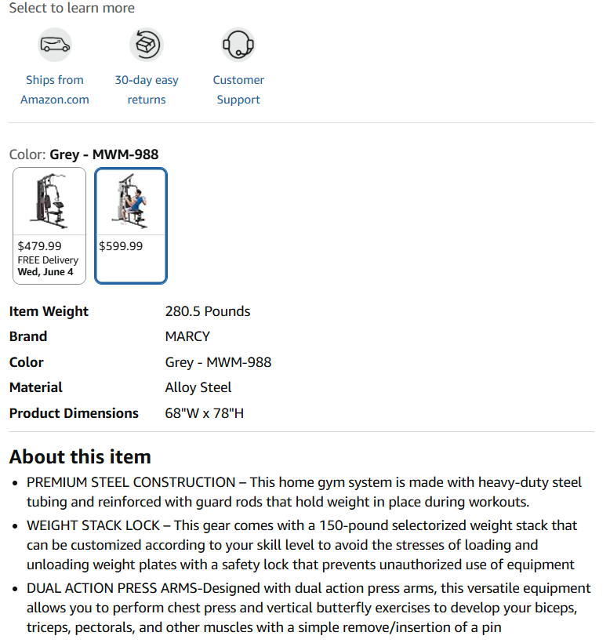 
I explored Amazon.com by navigating its homepage, product pages, and user account sections to identify functional requirements. I tested the order placement process by adding items to the cart and reviewing checkout options, noting features like shipping selections. Product pages revealed detailed descriptions and recommendation algorithms, while the “Your Account” section highlighted user management tools. These observations, combined with interactions like browsing reviews and tracking orders, informed the selection of requirements, ensuring they reflect real user tasks and system capabilities. Overall, this site is a masterpiece of efficiency and consumerism and makes sense why they are leaders in the field of retail and hopefully for them will continue to be that way as they expand their offerings and market share.

References
Amazon. (n.d.). Amazon.com. Retrieved May 27, 2025, from https://www.amazon.com
Wiegers, K., & Beatty, J. (2013). Software requirements (3rd ed.). Microsoft Press.

