Christian Mclean
IT350 unit 6 Professor Jason Litz
Security Implementation

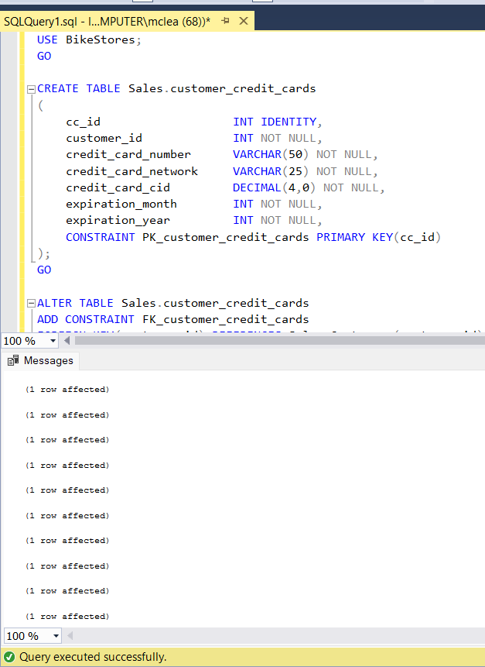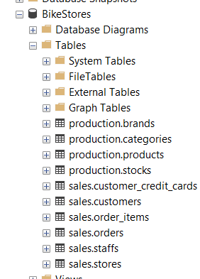
Provide a brief overview of what occurs in the table creation script. What constraints are imposed on the Sales.Customer_Credit_Cards table?
The table is basically their to define a structure to store customer credit card information linked to sales or customer data. The constaraints used where a primary key, unique, and a foreign key constraint.
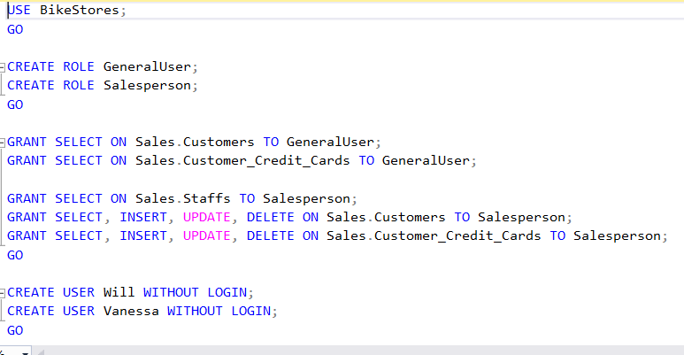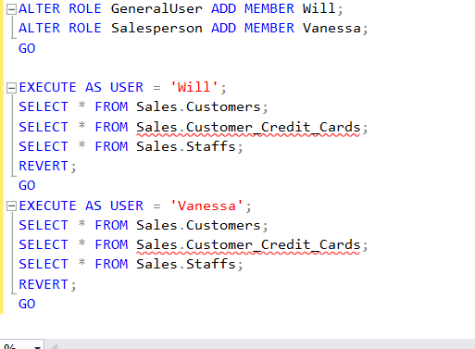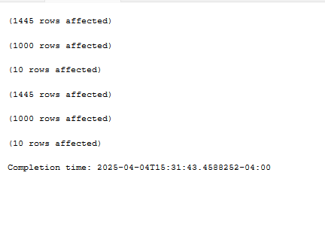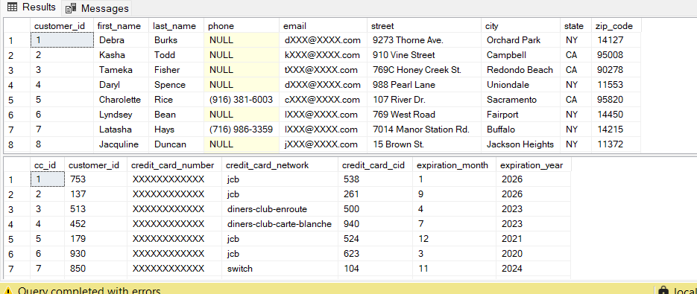
Describe the applied roles/permissions contained in the text file. What can the applicable users do in the BikeStores database? Did any query errors occur? If yes, why?
Will can read the Sales.customer and credit card tables however he can not modify anything. Vanessa can modify those two tables as well veiw intobut not modify sales.staffs charts. The original query was giving me errors that I had with permissions and I had to make sure we we had the table I modified and corrected any issues we had and it fixed it.
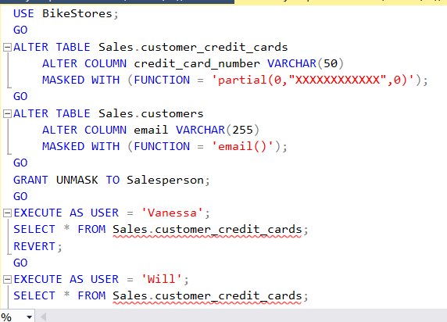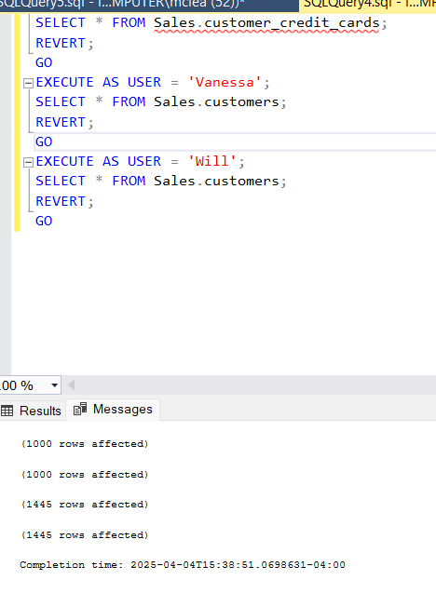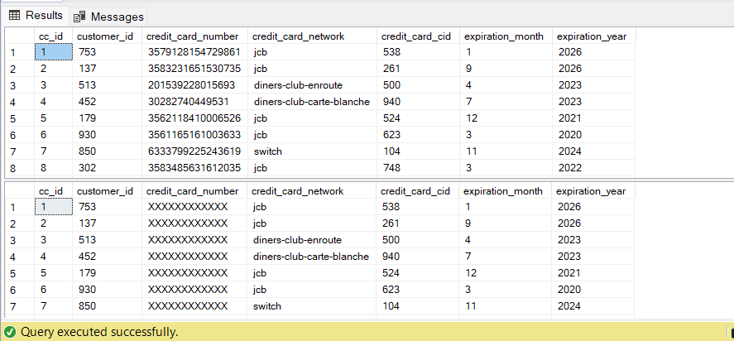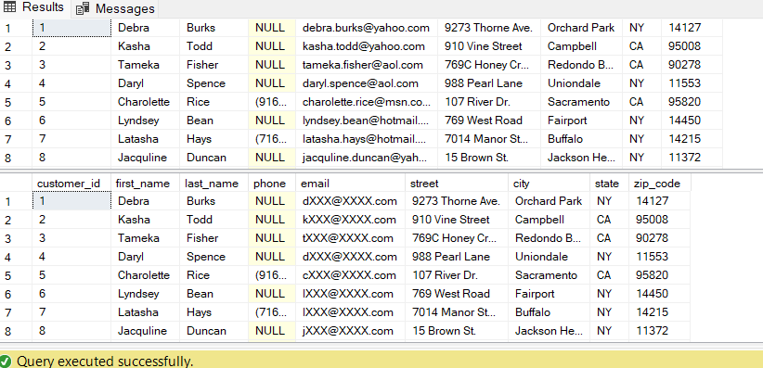
Discuss what transpires with each command/statement.
Each execute affected atleast 1000 rows the alter table to credit cards to varchar50 and applies data masking partially you may see a credit card number with x’s instead of numbers. The next alter changed email to varchar255 to store longer emails though I have never seen one anywhere near that length it also applies dynamic data masking so that something like chrismclean@yahoo.com might show up like cxxxxxx@xxxxx.com to non privaledged users. All the executes basically reveals what you can see from either perspective of the charts you are trying to view in some of them will doesn’t have unmasking privalieges so you’ll see them masked.
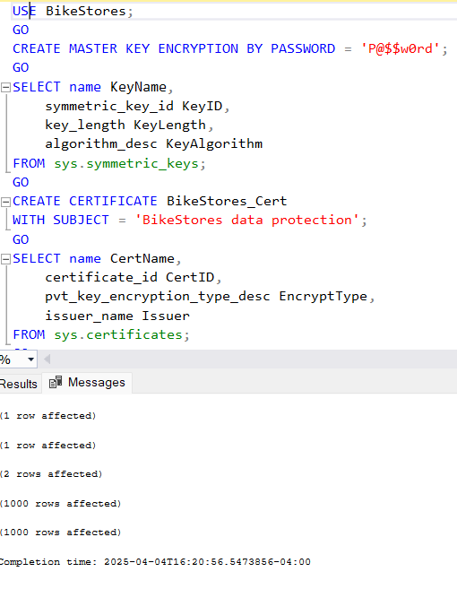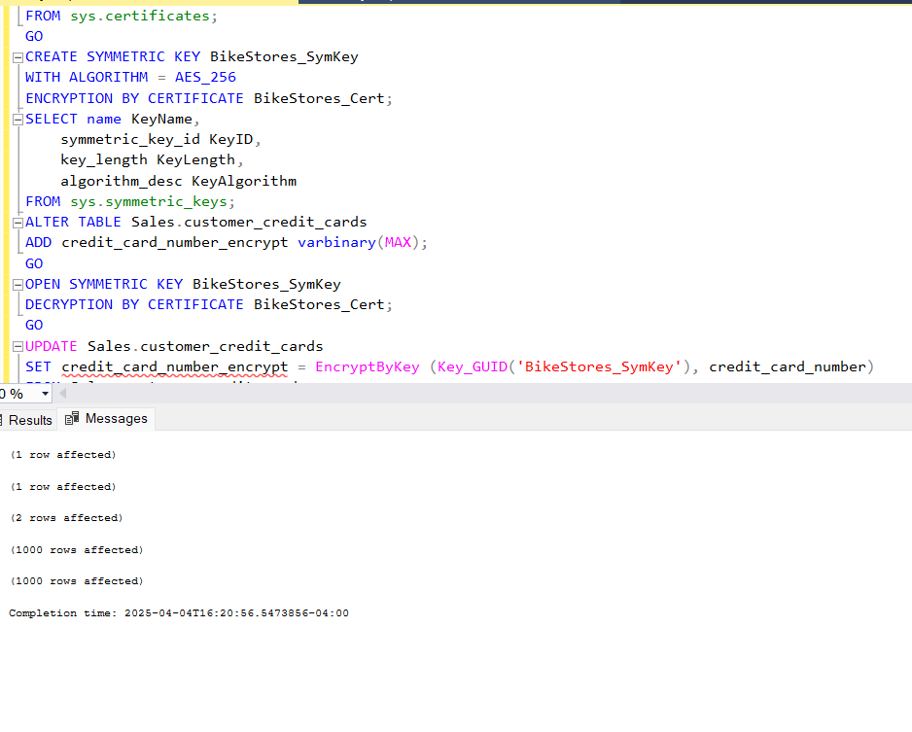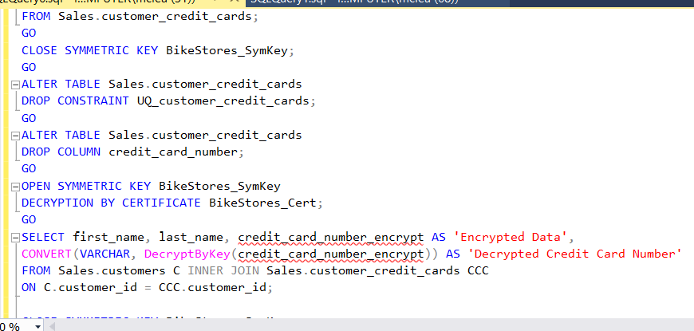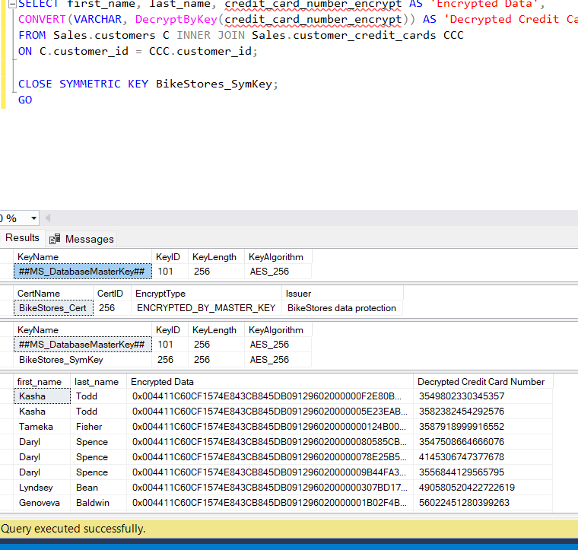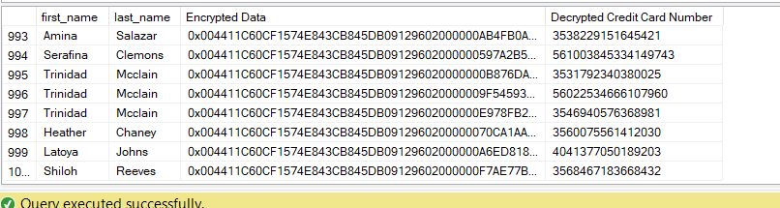
Discuss what transpires with each command/statement. What is the difference between symmetric and asymmetric keys? What are the challenges associated with each encryption key type?
The first create creates a master key root encryption for the database stored in symmetric_keys. The second command queries the symmetric_keys catalog view to display details of symmetric keys, including the newly created DMK. The next command creates a certificate named BikeStores_Cert with the subject BikeStores data protection. This certificate includes a public/private key pair, encrypted by the DMK it helps secure the symmetric_keys. The next command queries the sys.certificates view to display certificate details. The next create adds a symmetric key to symmetric_keys for encrypting/decrypting data, protected by the certificate’s private key. The next one Now shows two rows, the DMK and BikeStores_SymKey. The next open makes the key available for encryption/decryption in the current session. The next update makes sure each credit card number is encrypted into a varbinary value, replacing plaintext with ciphertext. The next close statement enhances security by limiting key exposure. The next alter statement drops a unique constraint which may remove a constraint that might prevent dropping the credit_card_number column. The next alter removes plaintext credit card data, leaving only the encrypted. The next open statement enables decryption in the next query. The next select statement shows both encrypted and decrypted data for users with key access. The final close statement secures the key after use.
The differences between symmetric and asymmetric keys are easily defined. Generally, symmetric keys are faster, only have one key, and the best use case is for bulk data whereas asymmetric keys are slower, have key pair, and are best used for securing keys and small data transfers. The challenges for symmetric keys are key distribution, security, and scalability. Basically, it is hard to manage one key per data set in complex systems, as well as relying on a single key with no inherent encryption/decryption roles. The challenges for asymmetric keys are performance, key management, and revocation. Basically, the slower nature makes it not well used for large data sets and managing public private key pairs and certificates can be complex. For symmetric you want to encrypt by certificate with asymmetric you can try to limit scope, caching, and hybrid encryption.

References
OWASP. (2021). SQL injection. OWASP Foundation. https://owasp.org/www-community/attacks/SQL_Injection
Microsoft. (2023c). sp_executesql (Transact-SQL). Microsoft Learn. https://learn.microsoft.com/en-us/sql/relational-databases/system-stored-procedures/sp-executesql-transact-sql

