Christian Mclean
IT 350 Professor Jason Litz
Testing a Stored Procedure With Security Flaws

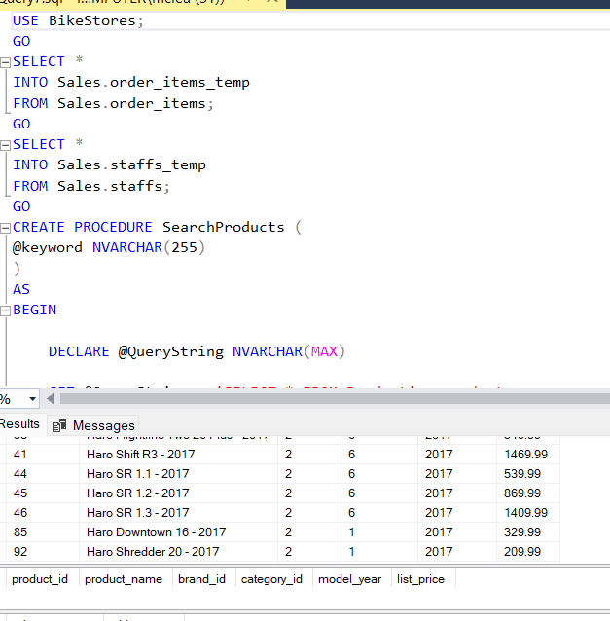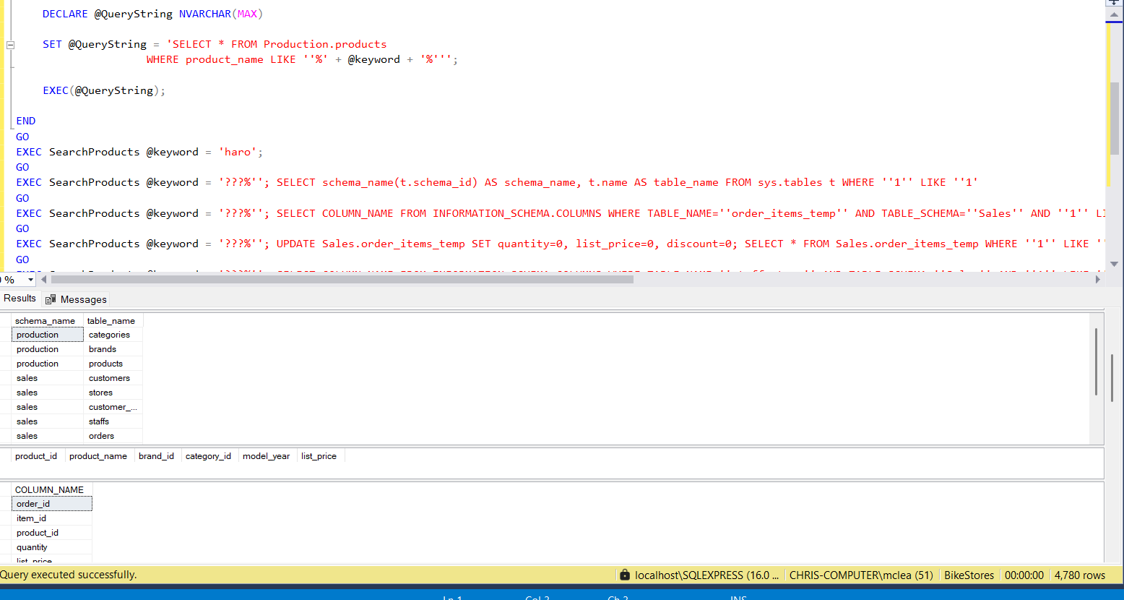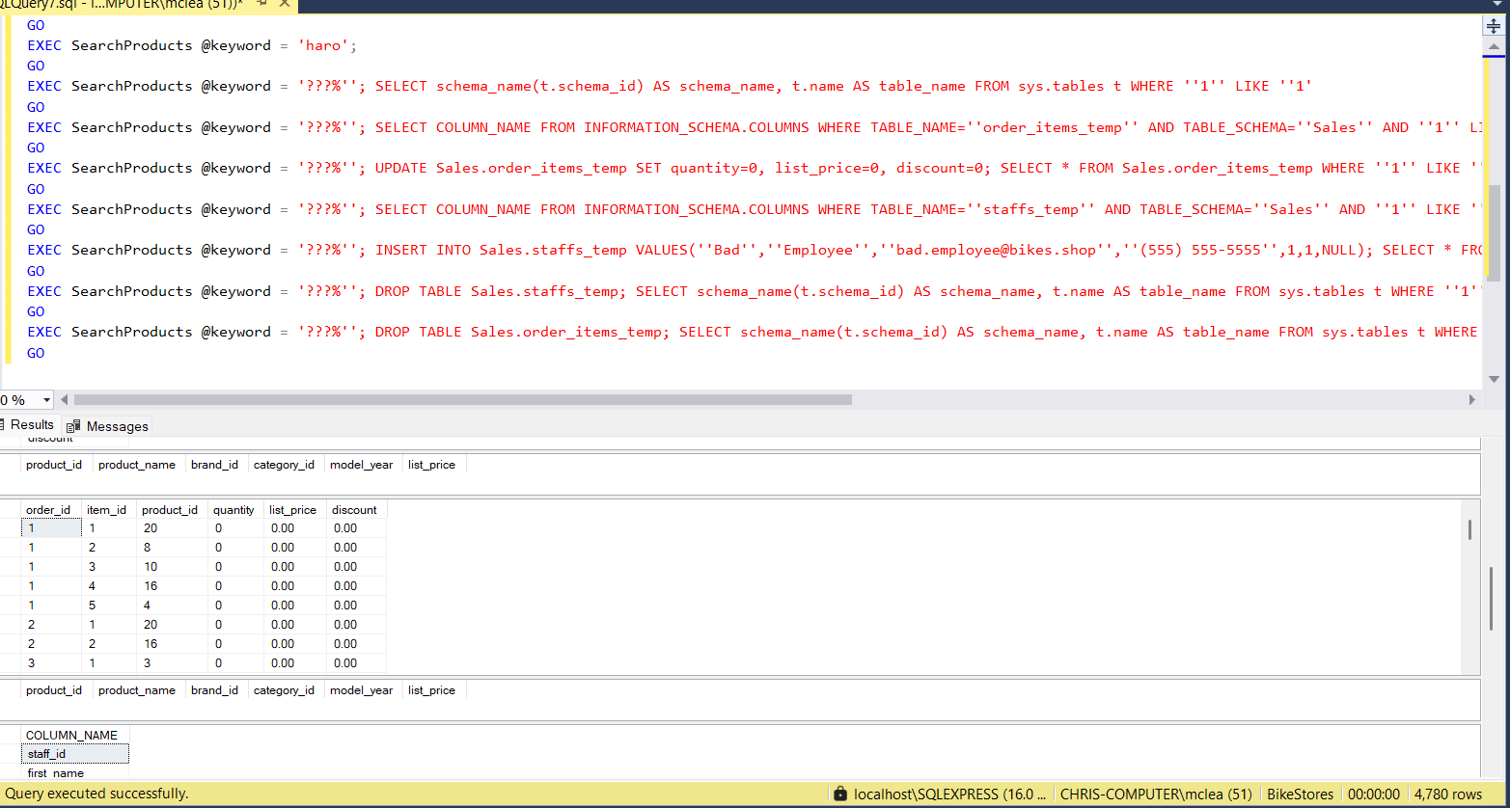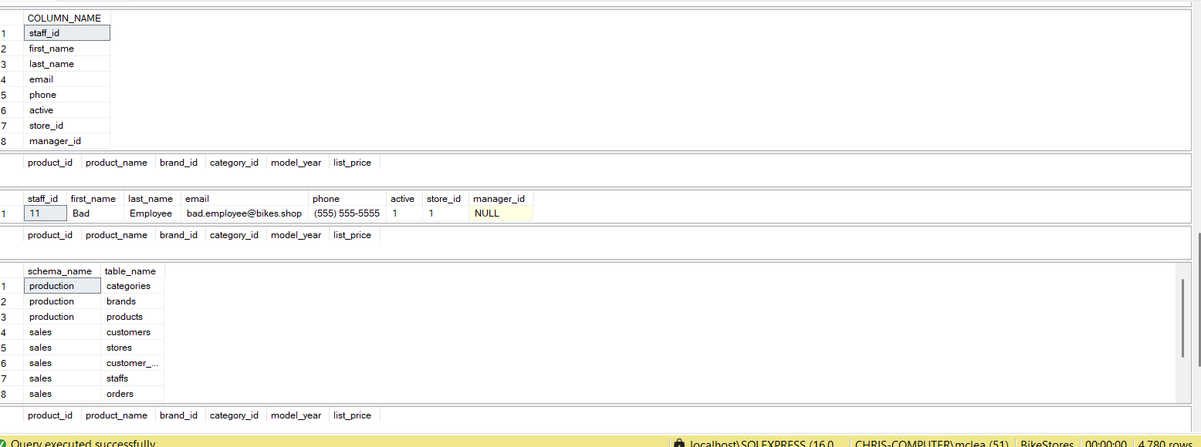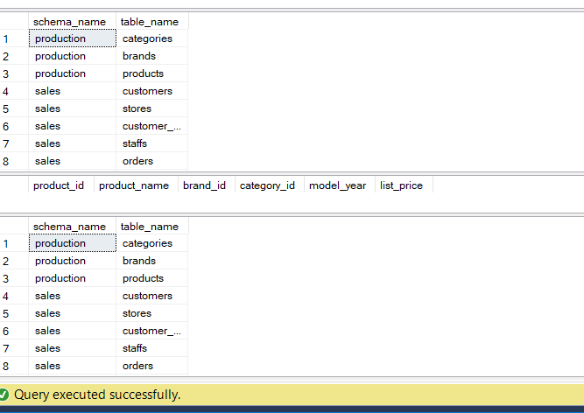
After executing these statements, explain why the SearchProducts stored procedure is problematic. Did any unauthorized data modifications occur? Did data corruption occur? Were any tables improperly dropped from the database?
Searchproducts is problematic it’s vulnerable to SQL injection in that any user or application calling this procedure with untrusted input can execute arbitrary SQL, bypassing permissions if the procedure runs with elevated privileges. Giving an open attack surface. Yes unauthorized data modification did occur particularly in steps 7 modified data and 9 created a fake staff record but they did only effect temp tables. Did data coruption occur no real clear evidence of it. While the The data is altered but not corrupted in the technical sense. If Sales.order_items_temp had constraints that weren’t copied from Sales.order_items, Step 7 might violate logical integrity, but this isn’t corruption technically. Also yes tables were dropped in steps 10 and 11 but only the temp tables were dropped.
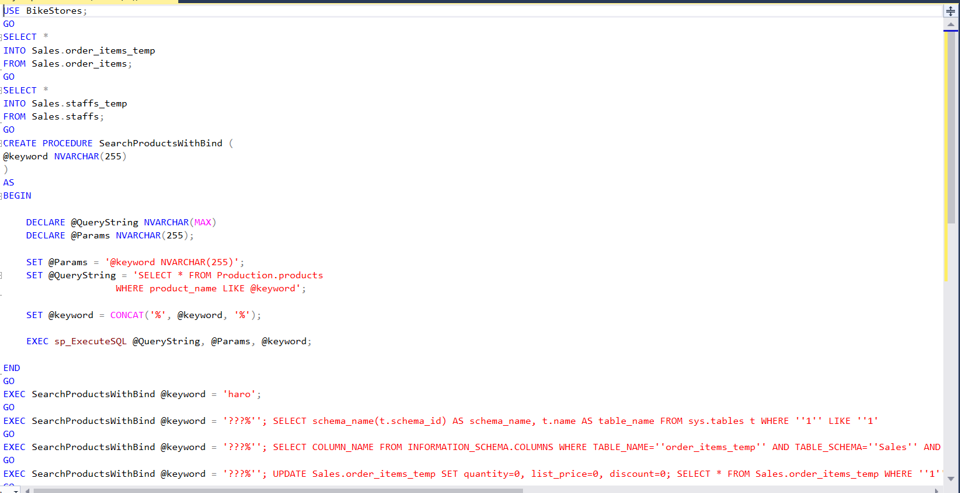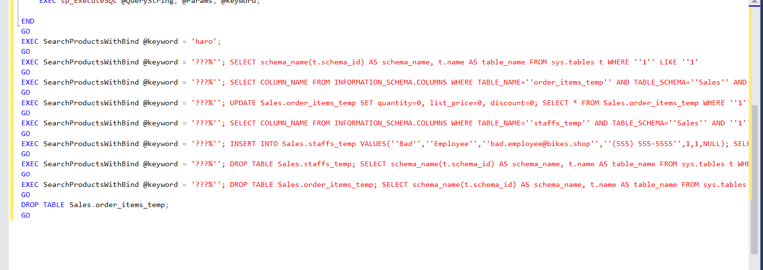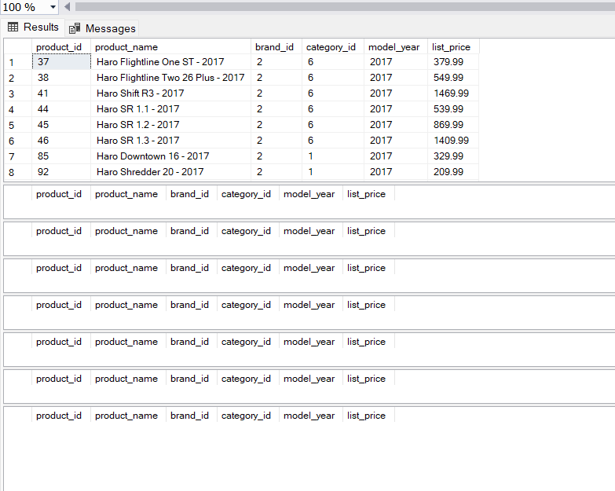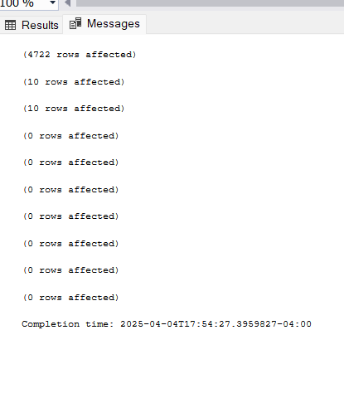
After executing these statements, explain whether the SearchProductsWithBind stored procedure has solved the security issues uncovered in Part 1. If the security issues have been resolved, explain how it was accomplished. Perform research and briefly describe the binding parameter concept. Below is a table contrasting the use of “execute” versus “execute sp_executesql” in Microsoft SQL Server.
Yes the security issues should be resolved SearchProductsWithBind, the new procedure uses parameterized dynamic SQL with sp_executesql, binding @keyword as a parameter rather than embedding it directly into the query string (Microsoft, 2023c). This prevents the database engine from interpreting the input as executable code.

Aspect | EXECUTE (EXEC) | EXECUTE sp_executesql
Syntax | EXEC('string')  concatenates and executes a string. | EXEC sp_executesql @query, @params, @param1, ...  uses parameters.
Parameter Support | No native parameterization; input is part of the string. | Supports parameterized queries with bound variables.
SQL Injection Risk | High; unsanitized input can alter the query (OWASP, 2021). | Low; parameters are treated as data, not code (Microsoft, 2023c).
Performance | No query plan reuse; recompiles each time (Microsoft, 2023c). | Reuses query plans, improving efficiency for repeated calls.
Use Case | Simple, one-off dynamic SQL without user input. | Secure, reusable dynamic SQL with user input.
Example | EXEC('SELECT * WHERE name = ''' + @name + '''') | EXEC sp_executesql N'SELECT * WHERE name = @name', N'@name NVARCHAR(50)', @name

References
OWASP. (2021). SQL injection. OWASP Foundation. https://owasp.org/www-community/attacks/SQL_Injection
Microsoft. (2023c). sp_executesql (Transact-SQL). Microsoft Learn. https://learn.microsoft.com/en-us/sql/relational-databases/system-stored-procedures/sp-executesql-transact-sql

