Problem 1: Establish a database view called TotalBikesSoldView that lists each bike name and associated total quantity sold. Then query the view to show the top ten bikes sold. Present the output in descending order based on total bikes sold. Used Claude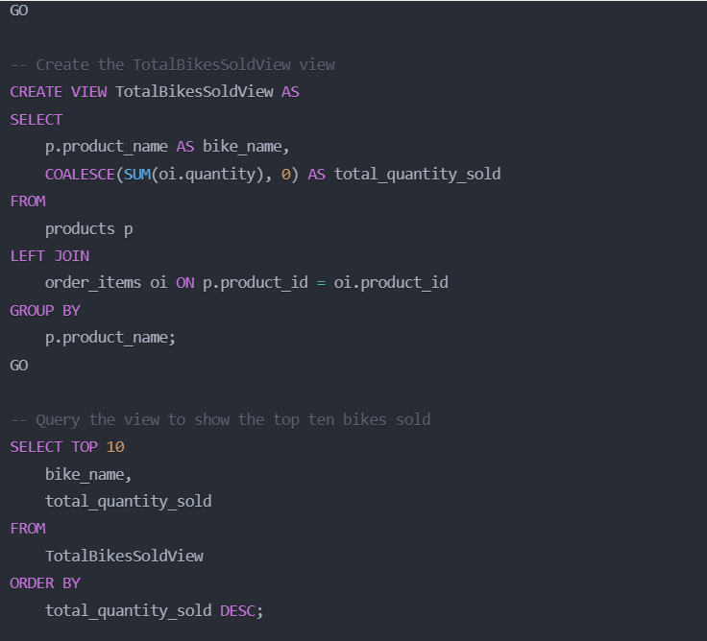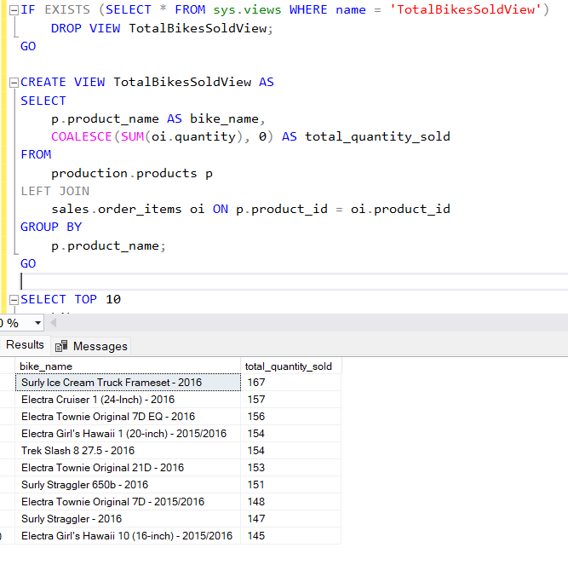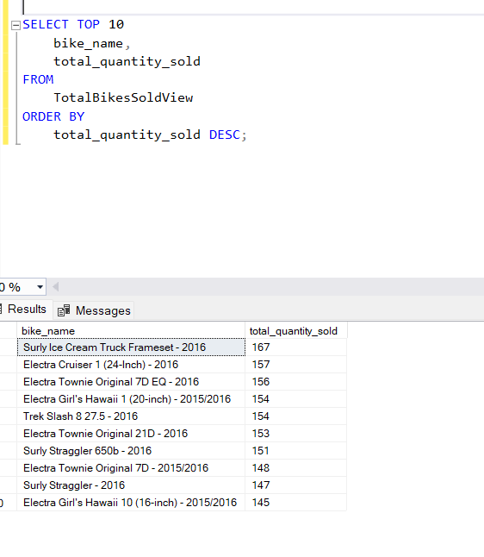
Problem 2: Establish a database view called MaximumBrandBikePriceView that lists each bike brand and associated maximum bike price. Then query the view and present the output in ascending order based on the bike brand name. Used Claude
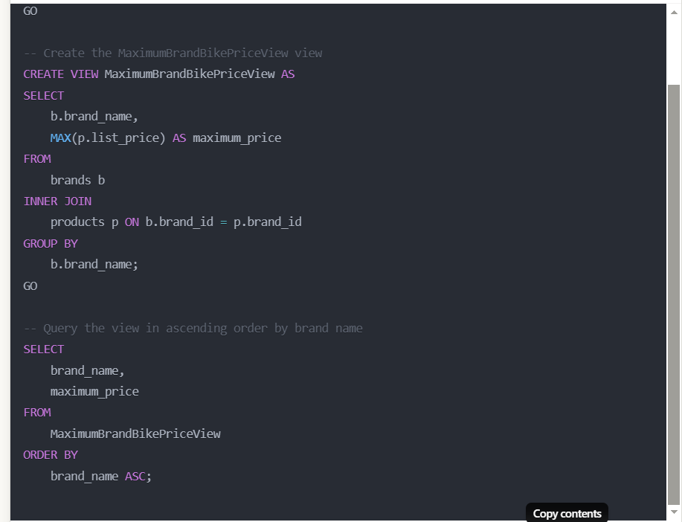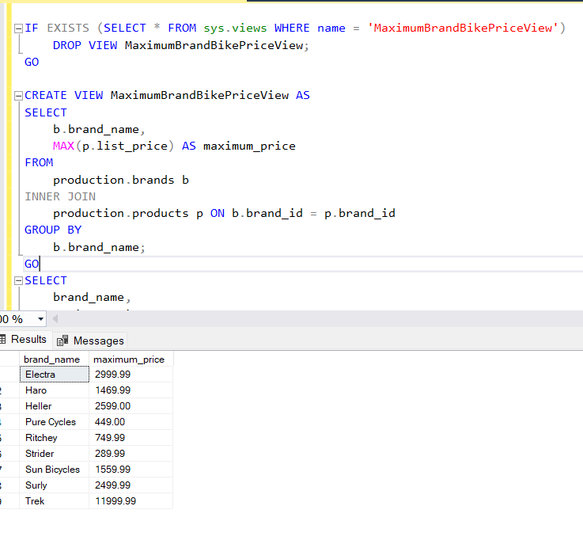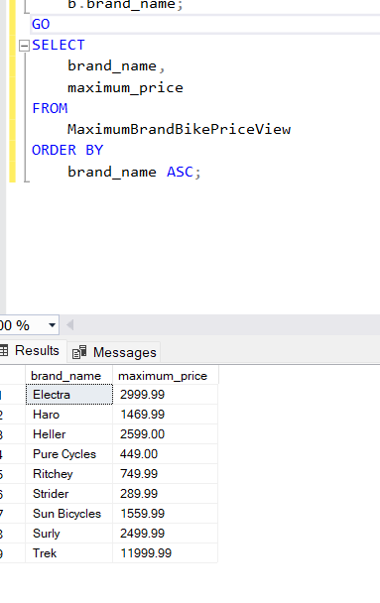
Problem 3: Establish a database view called AverageBrandBikePriceView that lists each bike brand name and associated average bike list price and list price standard deviation. Then query the view and present the output in ascending order based on the bike brand name.
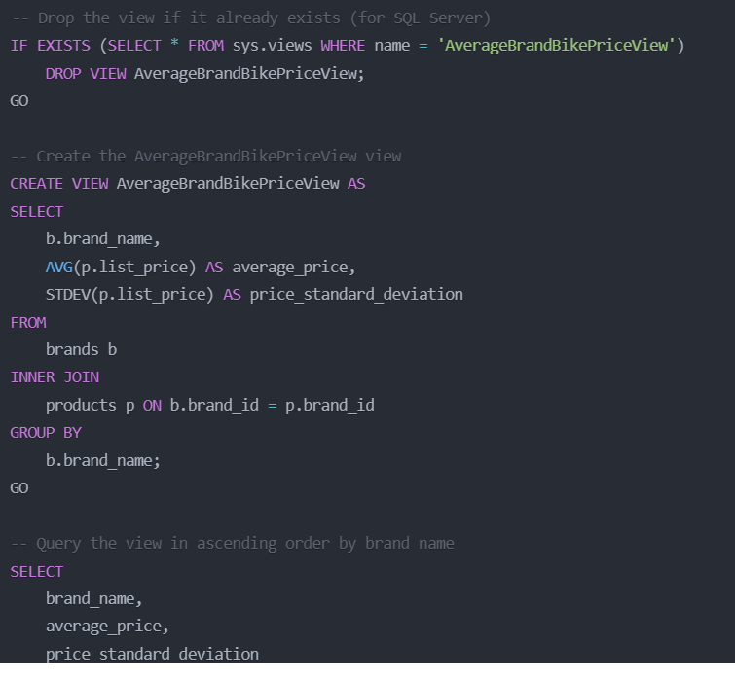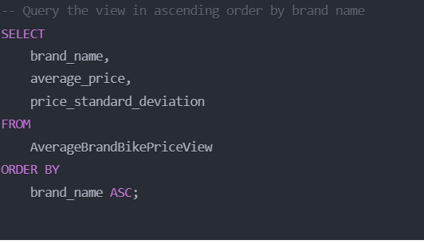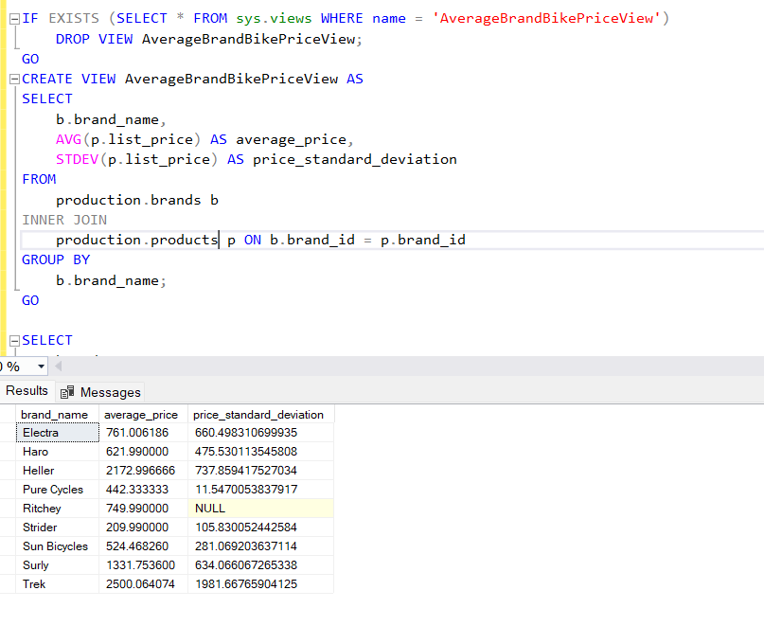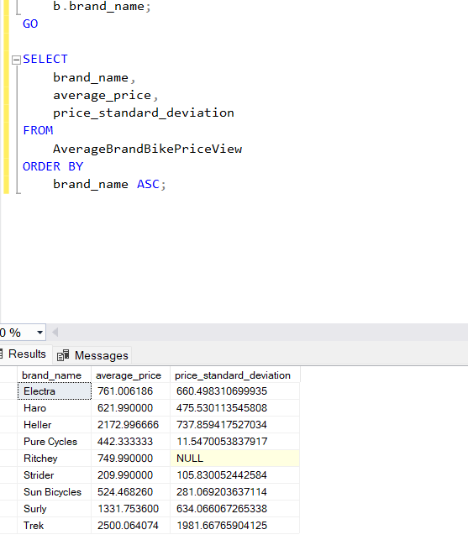
Problem 4: Establish a database view called NumberOfCustomersPerStateView that lists the number of customers in each state. The view needs to show the state name along with the customer amount. Then query the view and present the output in ascending order based on state. 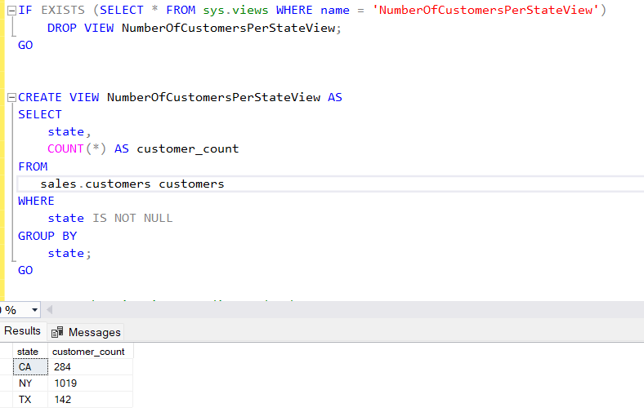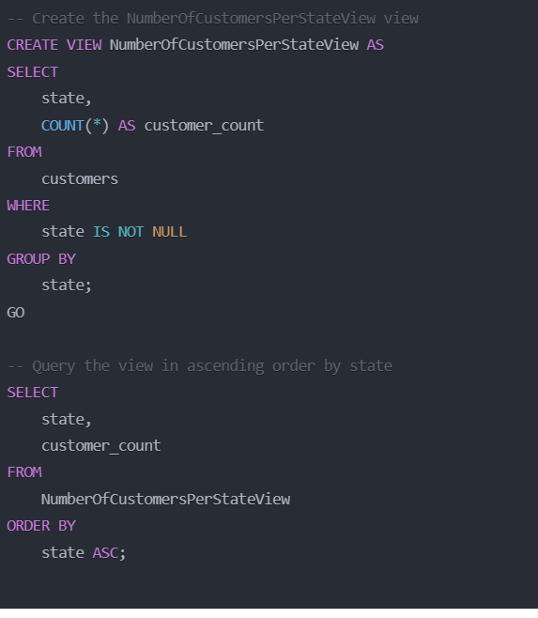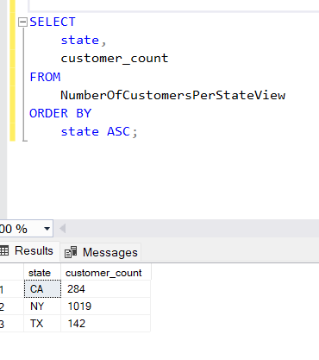
Problem 5: Establish a database view called TotalBikesSoldPerStateView that shows the cumulative bike sales per state. The view needs to show the state name along with the bike sales quantity. Then query the view and present the output in ascending order based on state. 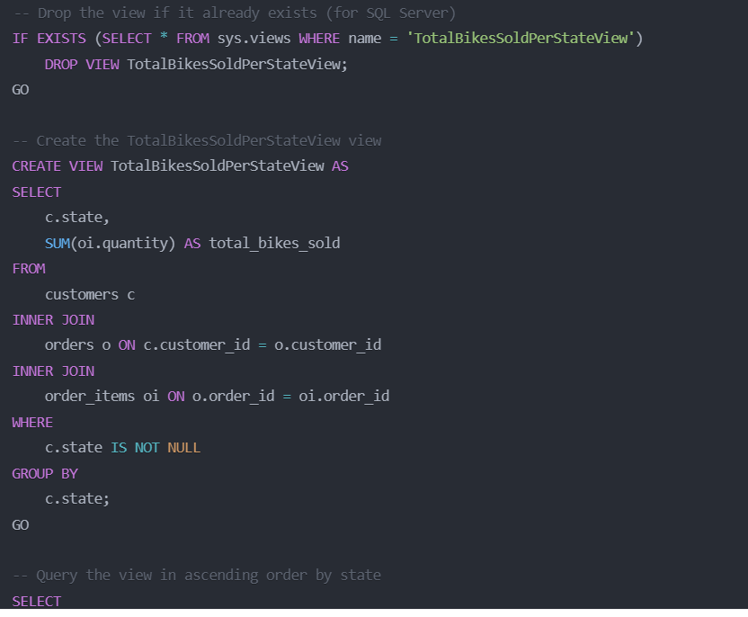 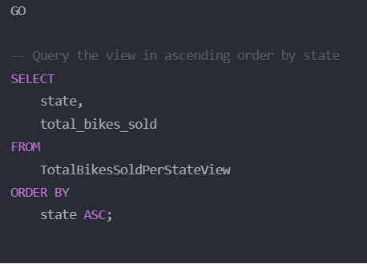 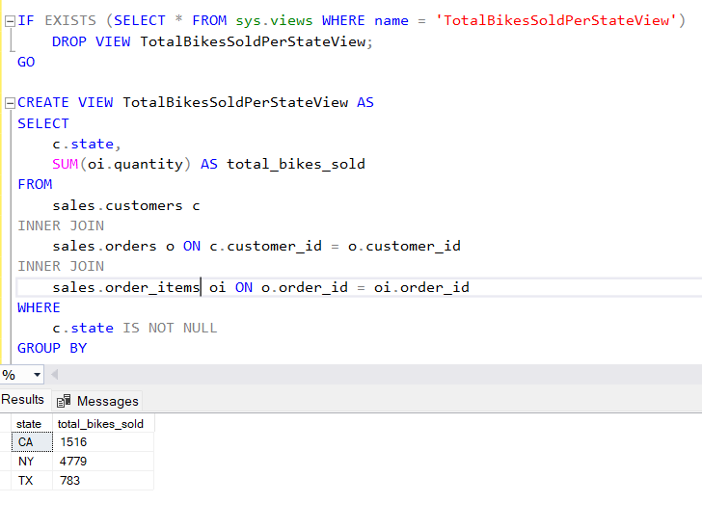 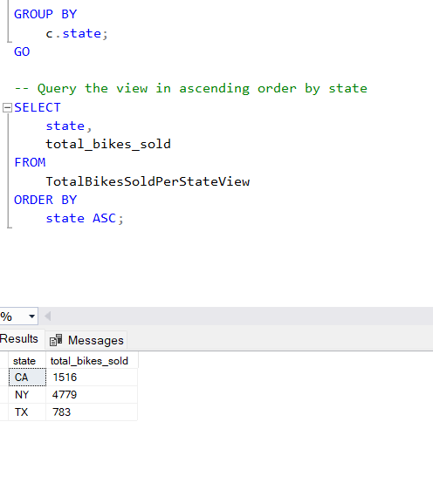
Problem 6: Create a stored procedure that lists the stock quantity at each store for a specified bike brand. The output must show the store name and stock quantity value. The results need to be presented in ascending order based on the store name. The skeleton of the stored procedure is provided below. Used perplexity
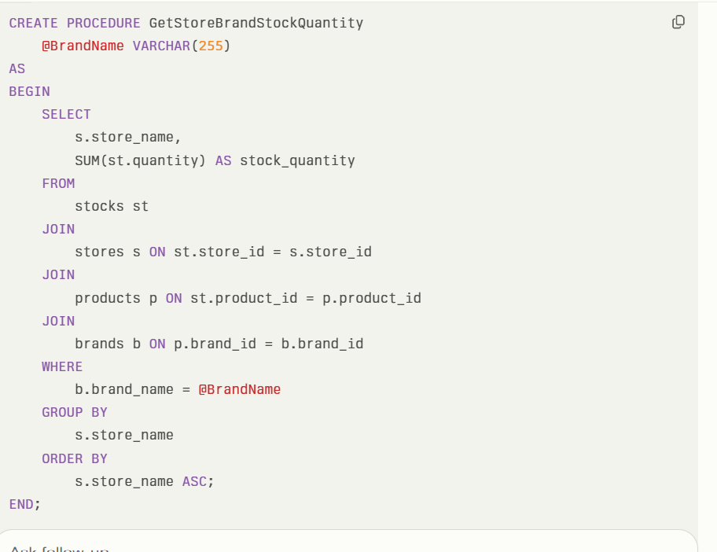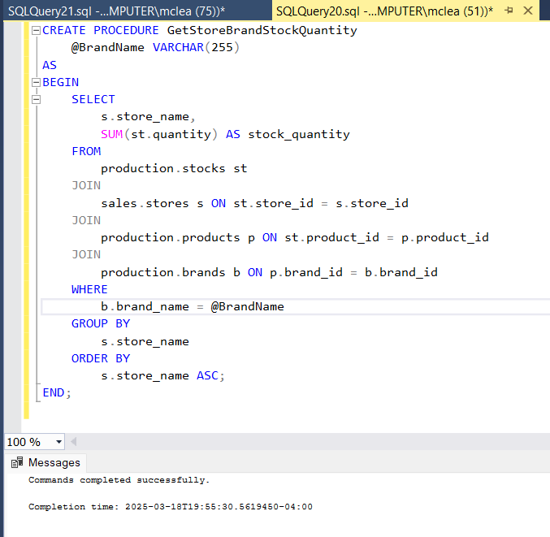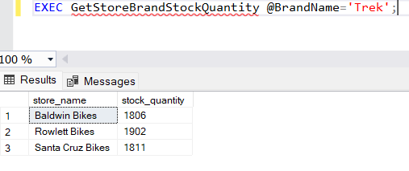
Problem 7: Create a stored procedure that lists the average, standard deviation, maximum, and minimum list prices for a specified bike brand. The output must show the brand name along with the aggregated results. The results need to be presented in ascending order based on the store name. The skeleton of the stored procedure is provided below.
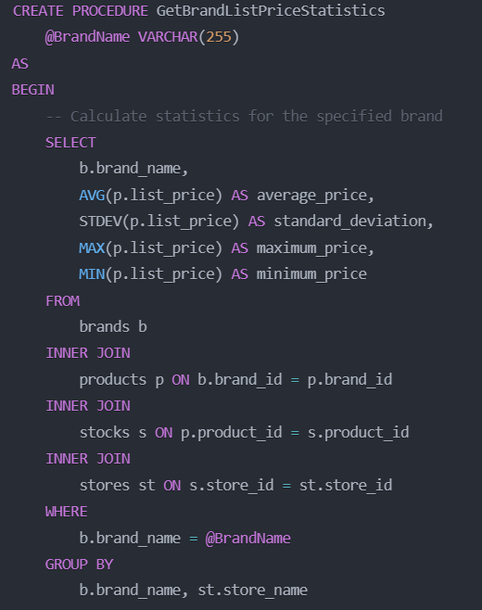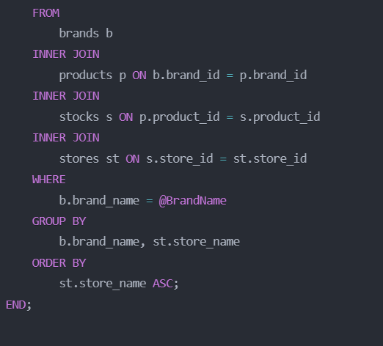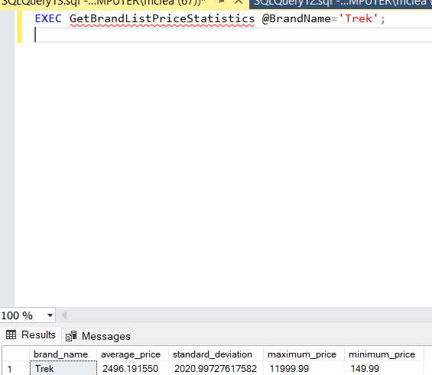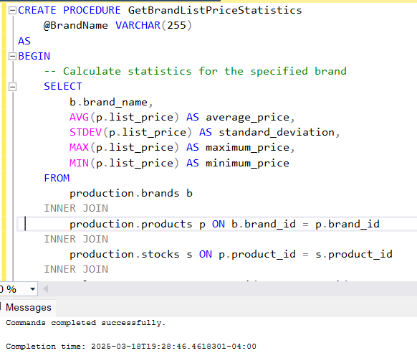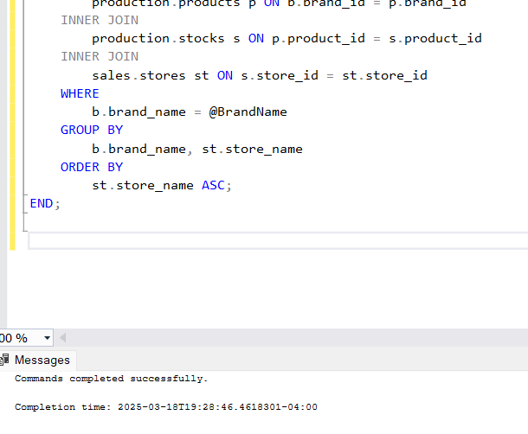
Create a stored procedure that lists the bike categories with minimum list prices below a specified value. The output must show the bike category and associated minimum list price. The results need to be presented in ascending order based on the bike category. The skeleton of the stored procedure is provided below. (Hint: The HAVING clause needs to be used.)
CREATE PROCEDURE GetBikeCategoriesWithMinPriceBelowValue
@Price DECIMAL(10,2)
AS used perplexity 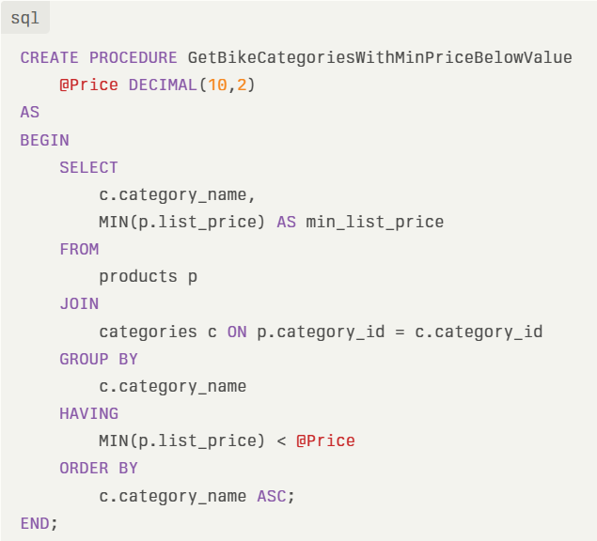 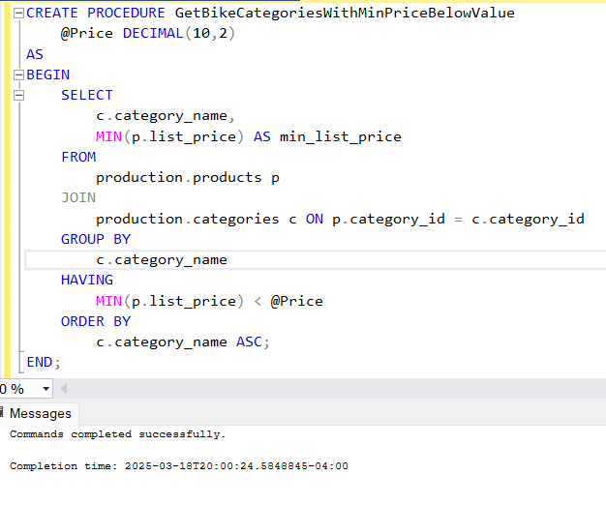 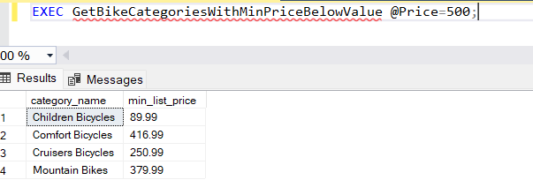
Problem 9: Create a stored procedure that lists the stock quantity for each bike category at a specified store. The output must show the bike category and stock quantity value. The results need to be presented in ascending order based on the bike category. The skeleton of the stored procedure is provided below.
CREATE PROCEDURE GetCategoryStockQuantityForStore
@StoreName VARCHAR(255)
AS
<REPLACE WITH YOUR SQL CODE> 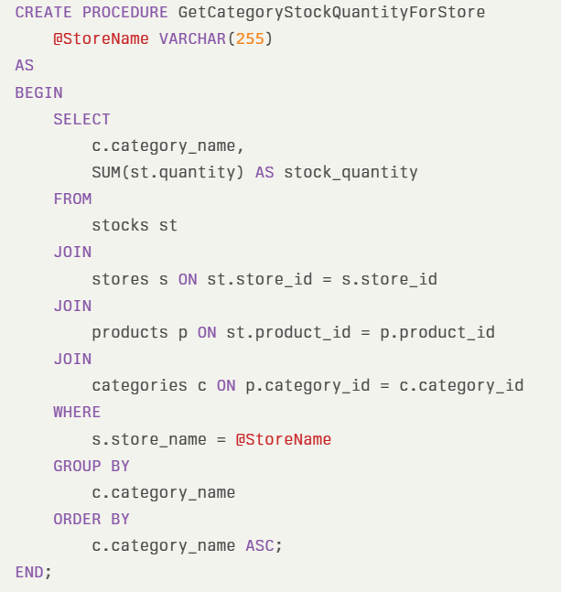 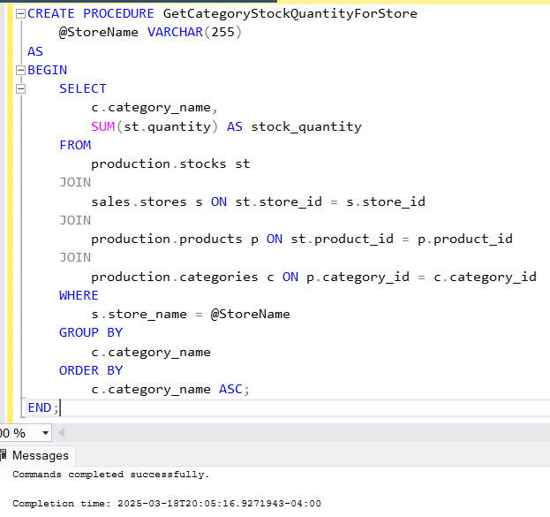 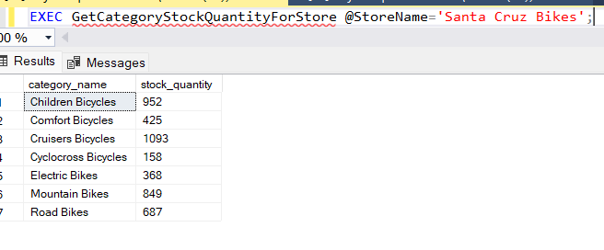
Problem 10: Create a stored procedure that presents the sales discount average and standard deviation for bike brands at or above a specified discount value. The output must show the brand names in alphabetical order along with the associated statistics. The skeleton of the stored procedure is provided below. (Hint: The HAVING clause needs to be used.)
CREATE PROCEDURE GetBrandAverageSalesDiscountAboveValue
@Discount DECIMAL(4,2)
AS
<REPLACE WITH YOUR SQL CODE>used Grok
