Christian Mclean
It 350 Professor Jason Litz
Generating Database Reports

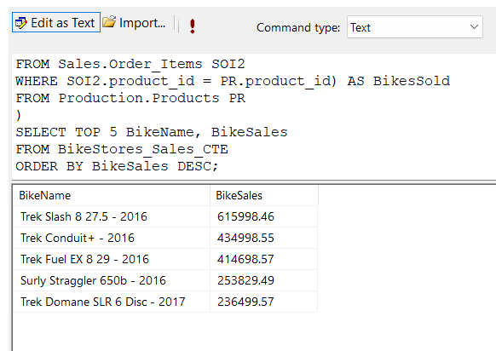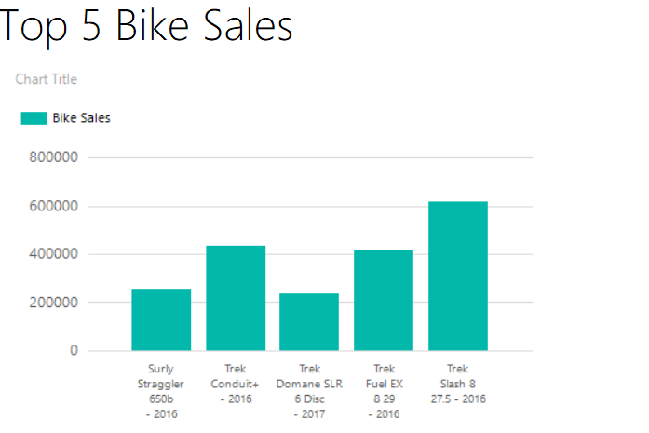
Describe how the query contained in the common table expression (CTE) works?
BikeStores Sales creates a temporary result set with three columns: BikeName, BikeSales, and BikesSold. BikeName, this is the product_name from the production, products table. BikeSales, this is calculated as the sum of quantity x list_price for each product, retrieved via a subquery from the Sales.Order_Items table. This represents the total revenue for each bike model. BikesSold, this is calculated as the sum of quantity for each product, retrieved via another subquery from the Sales.Order_Items table. This represents the total units sold for each bike model. The outer query selects the top 5 bike models (BikeName and BikeSales) from the CTE, ordered by BikeSales in descending order, to show the highest revenue-generating bikes.

Are Correlated or Uncorrelated Subqueries Leveraged?
The query uses correlated subqueries.
Are the Query Results Filtered? If Yes, How Are the Results Filtered?
Yes, the results are filtered. The TOP 5 clause in the outer query limits the output to the top 5 bike models with the highest BikeSales. The ORDER BY BikeSales DESC ensures that only the bikes with the highest sales revenue are selected.
Are Table Joins Used in the Query? If Yes, What Tables Are Linked Together?
No
Are Aggregate Functions Leveraged in the Query? If Yes, Describe the Results and Grouping Parameters
Yes, SUM(Sales) is likely used to calculate the total sales for each bike model. The query seeks the total sales amount for each bike model that is in the top 5 for the company. The GROUP BY BikeModel clause groups the sales data by bike model, so the SUM aggregates all sales for each unique model.
Top 5 bike sales shows the sales figures for the top 5 bike models for the company. The x-axis lists the bike models, and the y-axis represents sales though the unit isn’t specified, it’s likely a monetary value or unit count, ranging up to 800,000. The bike models and their approximate sales are Trek Slash 8 275-2016, 600,000 Trek Fuel EX 8 29-2016, 500,000, Trek Conduct+ -2017 400,000, Trek Domane SLR 6 Disc-2016 300,000, Surly Straggler 650b-2016 200,000
Some assertions we can make based on the table. The Trek Slash 8 275-2016 is the best-selling bike model, with sales around 600,000, significantly higher than the others. Trek Dominance: Four out of the top five bikes are Trek models, indicating that Trek is a dominant brand in this dataset. Sales drop progressively from the top model to the fifth, with the lowest seller having about one-third the sales of the top model. The Trek Slash 8 and Fuel EX 8, both from 2016, are the most popular, suggesting that 2016 Trek models may have been particularly well-received or heavily marketed. The Surly Straggler 650b-2016 is the only non-Trek bike in the top 5, but its sales are the lowest, indicating it’s less competitive in this dataset.
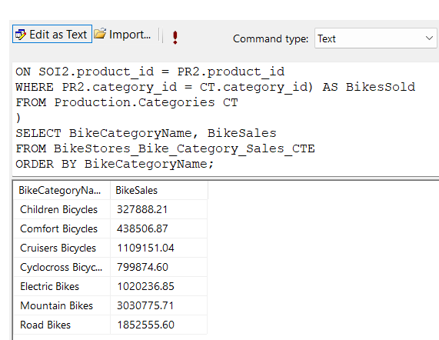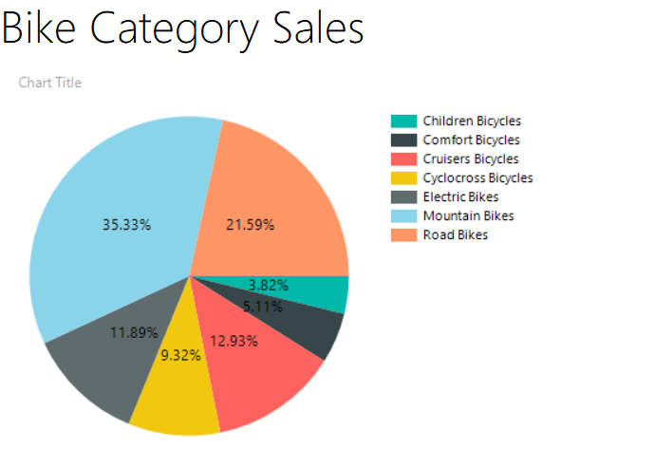
BikeStores Bike Category Sales creates a temporary result set with three columns: BikeCategoryName, BikeSales, and BikesSold. BikeCategoryName, is the category name from the Production.Categories table, representing the bike category. BikeSales is calculated as the sum of quantity x list_price for each category, retrieved via a subquery from the Sales.Order_Items table joined with Production.Products. This represents the total revenue for each bike category. BikesSold is calculated as the sum of quantity for each category, retrieved via another subquery from the Sales.Order_Items table joined with Production.Products. This represents the total units sold for each bike category.
Are Correlated or Uncorrelated Subqueries Leveraged?
Yes, the query uses correlated subqueries.
Are the Query Results Filtered? If Yes, How Are the Results Filtered?
No filtering is applied in the outer query.
Are Table Joins Used in the Query? If Yes, What Tables Are Linked Together?
Yes, joins are used within the subqueries. Inner join Sales.Order_Items and Production.Products.
Are Aggregate Functions Leveraged in the Query? If Yes, Describe the Results and Grouping Parameters
Yes, aggregate functions are used. SUM to calculate the total revenue and number of units sold. The subqueries implicitly group by category_id because they calculate aggregates for each category from the outer query. However, there’s no explicit GROUP BY clause in the subqueries since they return a single scalar value per category.
Examine the generated pie chart report. What information can be drawn from this report? What assertions can be made from this report?
Bike Category Sales shows the distribution of sales across different bike categories, with the following percentages, mountain bikes 35.33%, road bikes 21.59%, comfort bikes 12.93%, children bicycles 11.89%, cyclocross bikes 9.32%, cruisers bikes 5.11%, electric bikes 3.82%. The chart reflects the BikeSales column from the query, which is the total revenue for each bike category.
The chart shows the proportion of total sales attributed to each bike category, with percentages summing up to 100%. The percentages represent the share of total revenue, not the absolute sales figures, as the query calculates BikeSales as revenue and the pie chart displays relative proportions. The chart includes seven bike categories, which aligns with the query selecting all categories from Production.Categories.
Some assertions that we can make are mountain bikes lead with 35.33% of total sales revenue, making them the most revenue-generating category in the BikeStores dataset. Road bikes are the second-highest category at 21.59%, contributing significantly but less than Mountain Bikes. Electric bikes and cruisers bikes have the smallest shares of revenue, indicating they are the least popular or least revenue-generating categories. Comfort bikes, Children Bicycles, and Cyclocross Bikes fall in the middle, each contributing a moderate share of revenue. Mountain bikes and road bikes together account for 56.92% of total sales, showing a concentration of revenue in these categories. Mountain and road bikes may be more popular or higher-priced, while Electric and Cruisers Bikes may have lower demand, lower prices, or fewer units sold may be able to shift production or come up with a marketing plan to increase sales or knowledge on the lower in demand bikes.
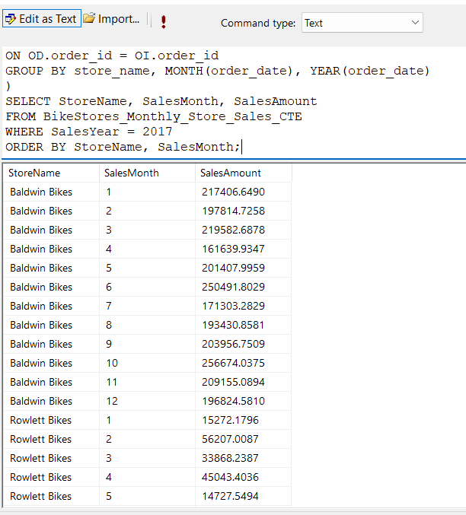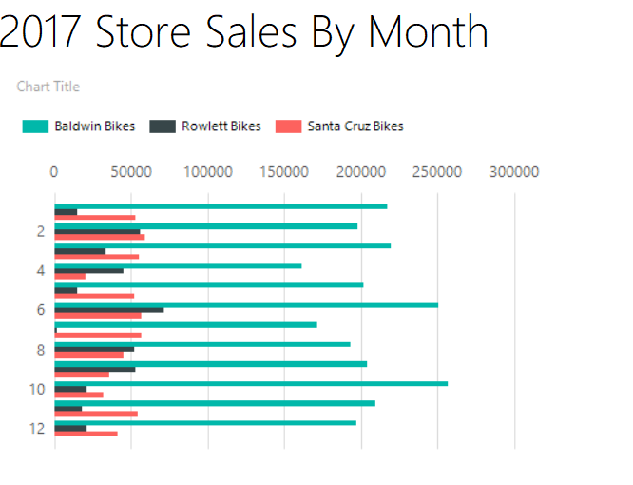
Describe how the query contained in the common table expression (CTE) works.
The CTE named BikeStores Monthly Store Sales creates a temporary result set with four columns Store Name, Sales Month, Sales Year, and Sales Amount. Store Name is the store_name from the Sales.Stores table, representing the name of the store. Sales Month is derived using the Month function, extracting the month from the order_date in the Sales.Orders table. Sales Year is derived using the YEAR function, extracting the year from the order_date. Sales Amount is calculated as SUM, representing the total revenue for each store per month, adjusted for discounts. The data comes from the Sales.Order_Items table.
Are Correlated or Uncorrelated Subqueries Leveraged?
No
Are the Query Results Filtered? If Yes, How Are the Results Filtered?
Yes, the results are filtered for the year 2017.
Are Table Joins Used in the Query? If Yes, What Tables Are Linked Together?
Yes, inner joins are used in the CTE. Sales.Orders, Sales.Stores, and Sales.Order_Items are joined.
Are Aggregate Functions Leveraged in the Query? If Yes, Describe the Results and Grouping Parameters
Yes, an aggregate function is used. SUM is used for total sales amounts. GROUP BY is used for store name, month, and year groups.
Examine the generated bar chart report. What information can be drawn from this report? What assertions can be made from this report?
2017 Store Sales by Month shows monthly sales for three stores Baldwin Bikes, Rowlett Bikes, and Santa Cruz Bikes in 2017. The y-axis represents the months, and the x-axis represents the sales amount. Baldwin Bikes consistently has the highest sales each month, ranging from around 150,000 to 250,000. Santa Cruz Bikes has the second-highest sales, ranging from around 50,000 to 100,000. Rowlett Bikes has the lowest sales, ranging from around 25,000 to 50,000.
Some assertions that can be made Baldwin Bikes is the top-performing store in 2017, with sales significantly higher than the other two stores every month. Its sales are often 2–3 times higher than Santa Cruz Bikes and 4–5 times higher than Rowlett Bikes. Santa Cruz Bikes consistently outperforms Rowlett Bikes in terms of sales, typically doubling Rowlett’s sales each month. There are no major seasonal fluctuations in sales for any store. Sales remain relatively consistent across the year, with minor variations. The disparity in sales between stores is significant. You can see which store need strategic improvement, which stores are doing well and which need help.
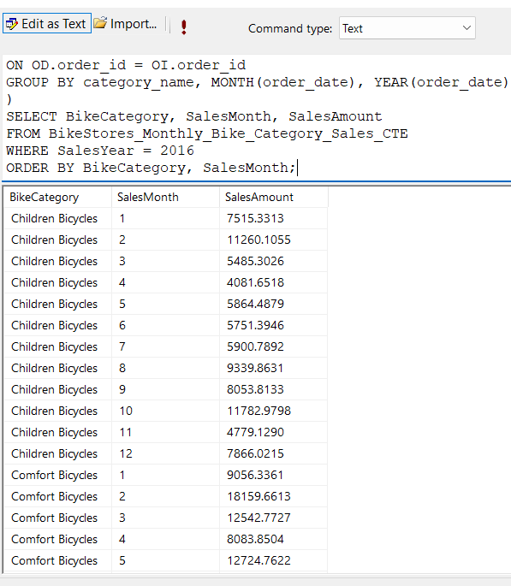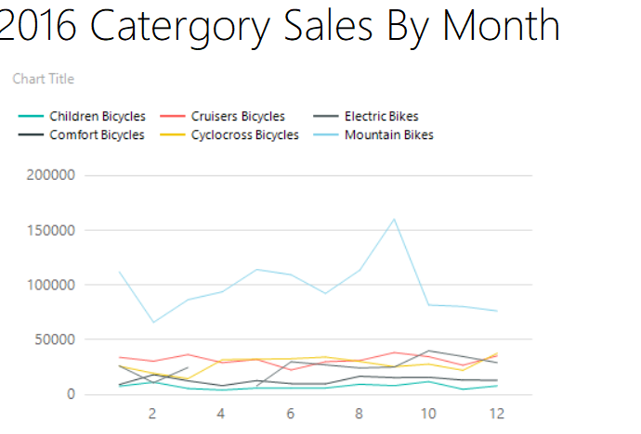
Describe how the query contained in the common table expression (CTE) works.
BikeStores Monthly Bike Category Sales creates a temporary result set with four columns: BikeCategory, SalesMonth, SalesYear, and SalesAmount. Bike Category is the category_name from the Production.Categories table, representing the bike category. Sales Month is derived using the month function, extracting the month from the order_date in the Sales.Orders table. Sales Year is derived using the YEAR function, extracting the year from the order_date. Sales Amount is calculated as SUM, representing the total revenue for each bike category per month, adjusted for discounts. The data comes from the Sales.Order_Items table.
Are Correlated or Uncorrelated Subqueries Leveraged?
No
Are the Query Results Filtered? If Yes, How Are the Results Filtered?
Yes, the results are filtered for sales year 2016.
Are Table Joins Used in the Query? If Yes, What Tables Are Linked Together?
Yes, inner joins are used. Sales.Orders, Sales.Order_Items, Production.Products, Production.Categories.
Are Aggregate Functions Leveraged in the Query? If Yes, Describe the Results and Grouping Parameters
Yes, an aggregate function SUM is used for revenue for each bike type per month and year. This chart is grouped by category_name, month, year.
Examine the generated line chart report. What information can be drawn from this report? What assertions can be made from this report?
2016 Category Sales By Month shows monthly sales for six bike categories in 2016. The x-axis represents the months, and the y-axis represents the sales amount. The chart shows the sales amount for each bike category across all 12 months of 2016. Mountain bikes are consistently has the highest sales, peaking around 150,000 in July and generally staying above 50,000. Children Bicycles, Comfort Bikes, Cruisers Bicycles, Cyclocross Bikes, and Electric Bikes have much lower sales, generally ranging between 0 and 50,000.
Some assertions we can make mountain bikes are the top-performing category in 2016, with sales far exceeding other categories every month. Their peak sales in July are at least three times higher than the peak of any other category. Electric bikes and comfort bikes consistently have the lowest sales, rarely exceeding 20,000, indicating lower demand or lower average prices in these categories. Mountain bikes show a clear seasonal pattern, with sales peaking in the summer and dipping in the winter. This aligns with typical outdoor activity trends, as mountain biking is likely more popular in warmer months. Categories like children’s bicycles, cruisers bicycles, and cyclocross bikes show more stable sales throughout the year, with no significant seasonal peaks. Cyclocross Bikes show a slight increase toward the end of the year, possibly due to seasonal events.
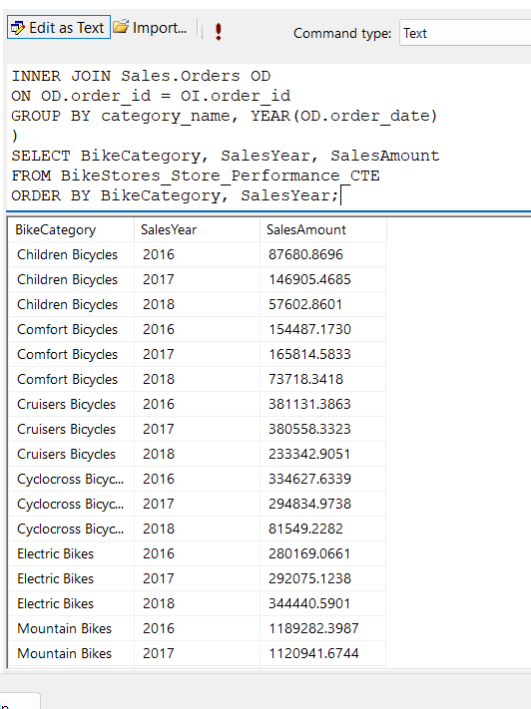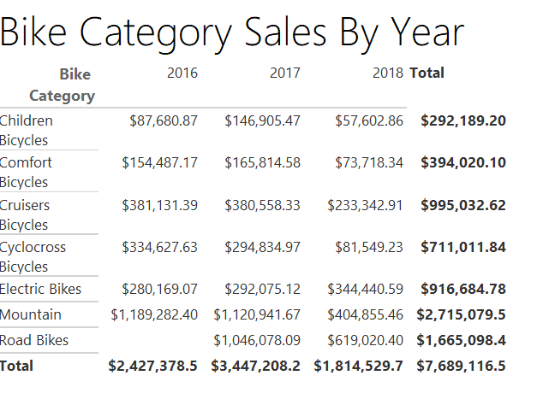
Describe how the query contained in the common table expression (CTE) works.
BikeStores Store Performance creates a temporary result set with three columns: BikeCategory, SalesYear, and SalesAmount. Bike Category is the category_name from the Production.Categories table, representing the bike category. Sales Year is derived using the YEAR function, extracting the year from the order_date in the Sales.Orders table. Sales Amount is calculated as SUM, representing the total revenue for each bike category per year, adjusted for discounts. The data comes from the Sales.Order_Items table.
Are Correlated or Uncorrelated Subqueries Leveraged?
No
Are the Query Results Filtered? If Yes, How Are the Results Filtered?
No
Are Table Joins Used in the Query? If Yes, What Tables Are Linked Together?
Yes, inner joins are used again. Production.Categories, Production.Products, Sales.Order_Items, and Sales.Orders.
Are Aggregate Functions Leveraged in the Query? If Yes, Describe the Results and Grouping Parameters.
Yes, an aggregate function is used again, it is SUM for finding the revenue for each bike category per year. Grouped by category_name, YEAR.
Examine the generated tabular report. What information can be drawn from this report? What assertions can be made from this report?
The table shows the sales amount for each bike category across 2016, 2017, and 2018, with a total for each category. Which were 2016 $2,427,378.50, 2017 $3,447,208.20, 2018 $1,814,529.70 for an overall total of $7,689,116.50. Some assertions that we can make are road bikes are the top-performing category overall, with total sales of $7,689,116.50, contributing significantly to the overall revenue. Their sales peaked in 2017 at $3,447,208.20, which matches the total sales for that year, indicating Road Bikes were the primary driver of 2017’s performance. Sales peaked in 2017 at $3,447,208.20, largely due to road bikes. Other categories like children bicycles and electric bikes also saw increases from 2016 to 2017. Sales dropped significantly in 2018 to $1,814,529.70, a decrease of 47% from 2017. Categories like comfort bikes, cyclocross bikes, and mountain bikes saw sharp declines. The business should continue to prioritize road bikes, as they are the primary revenue driver, especially after their 2017 peak. The consistent growth in electric bikes suggests a rising market trend, and the business might invest more in this category.

