Christian Mclean
IT350 Professor Jason Litz
Assignment unit 2

Problem 1: Create a stored procedure that lists the staff's last name, first name, and email address from all the company stores. The output needs to be in alphabetical order based on the last name then by the first name. The skeleton of the stored procedure is provided below.
CREATE PROCEDURE GetCompanyStaffList
AS
<REPLACE WITH YOUR SQL CODE> used perplexity 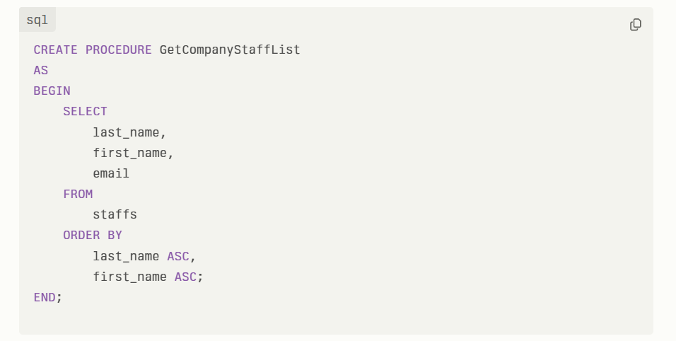 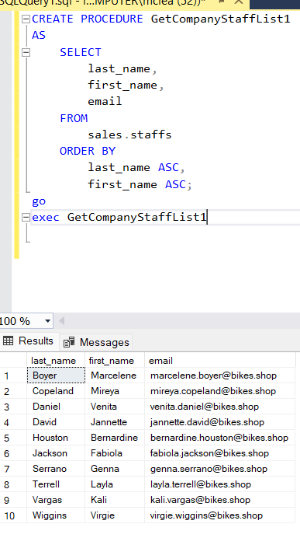

Problem 2: Create a stored procedure that lists the customers from a specified zip code. The skeleton of the stored procedure is provided below.
CREATE PROCEDURE GetCustomersByZipCode
@ZipCode VARCHAR(5)
AS
<REPLACE WITH YOUR SQL CODE> used perplexity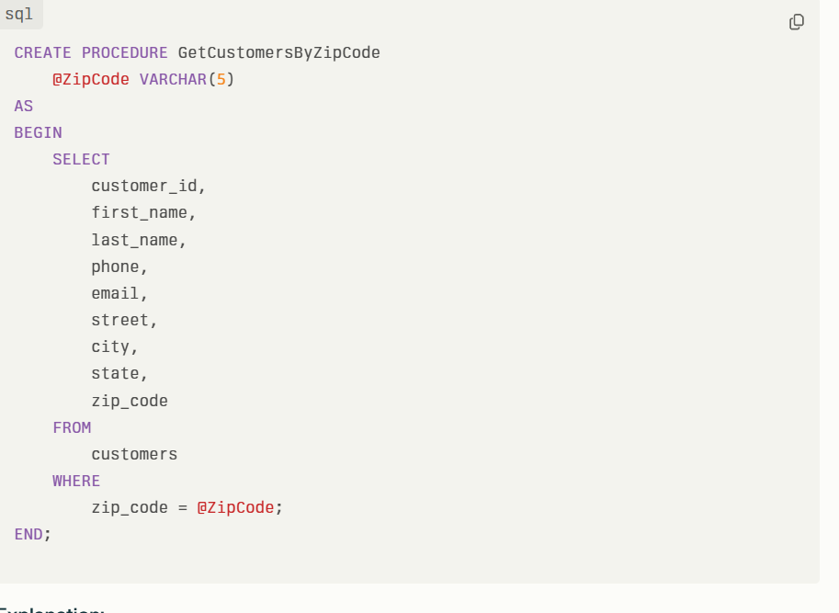
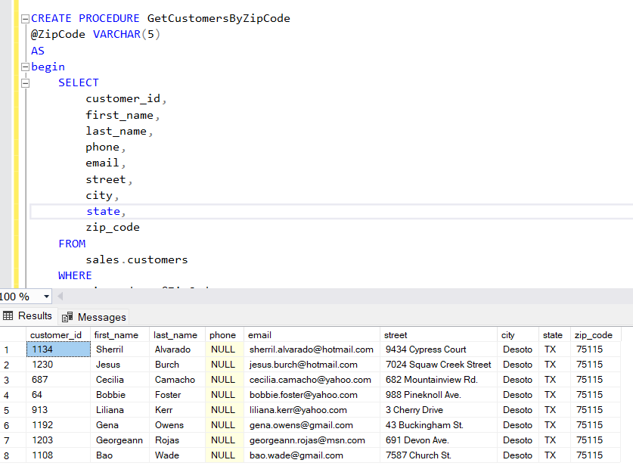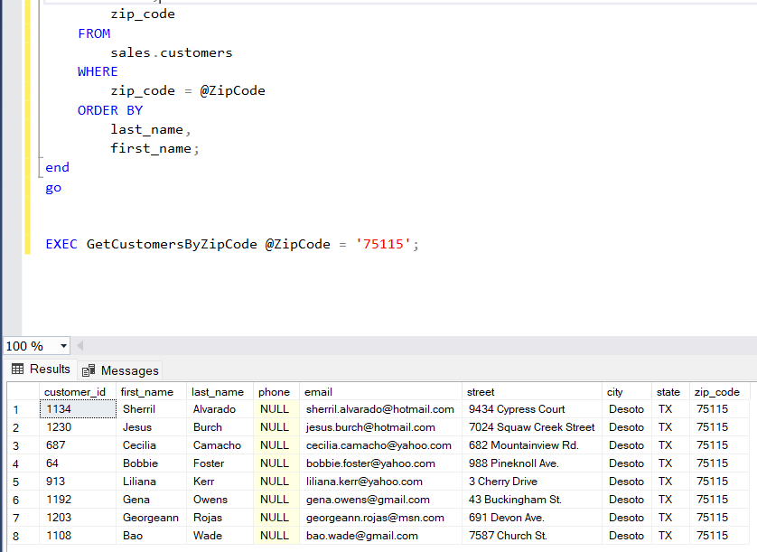
Problem 3: Create a stored procedure that lists mountain bikes for a specified brand. The output must show the bike name, model year, and list price. The results need to be presented in alphabetical order based on the bike name. The skeleton of the stored procedure is provided below.
CREATE PROCEDURE GetMountainBikesByBrand
@Brand VARCHAR(255)
AS
<REPLACE WITH YOUR SQL CODE>used perplexity 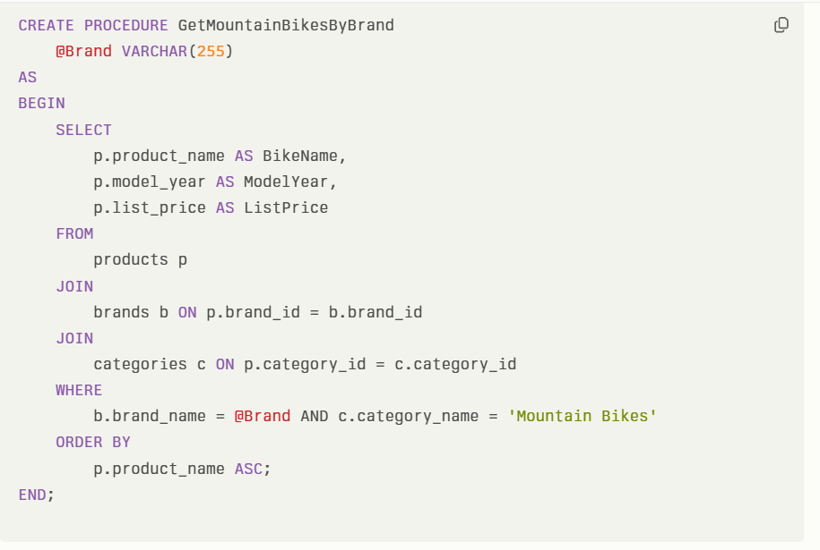 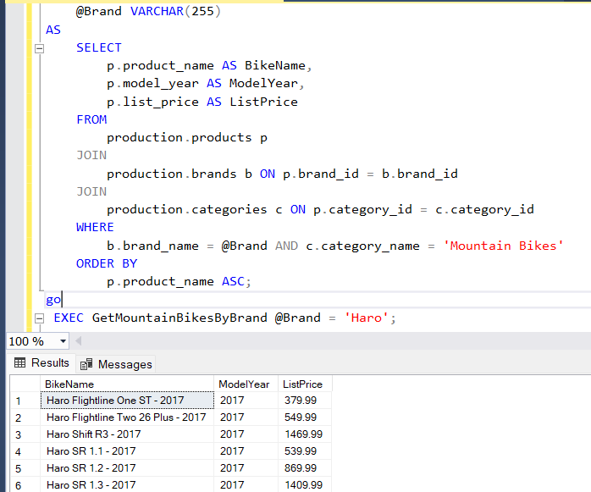 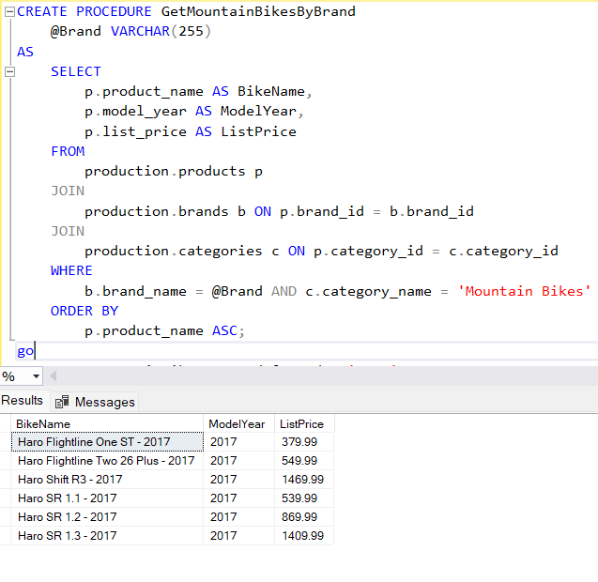

Problem 4: Create a stored procedure that lists bikes within a specified price range. The output must show the bike name, model year, and list price. The results need to be presented in alphabetical order based on the bike name. The skeleton of the stored procedure is provided below.
CREATE PROCEDURE GetBikesByPriceRange
@MinPrice Decimal(10,2), @MaxPrice Decimal(10,2)
AS
<REPLACE WITH YOUR SQL CODE>used perplexity 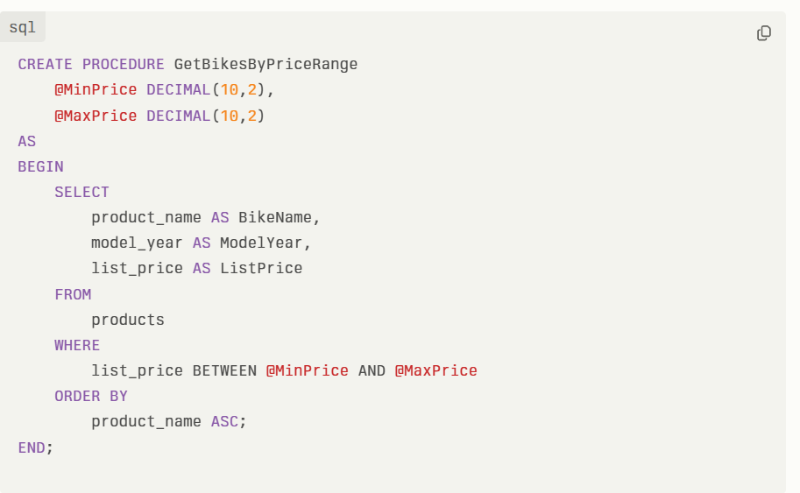 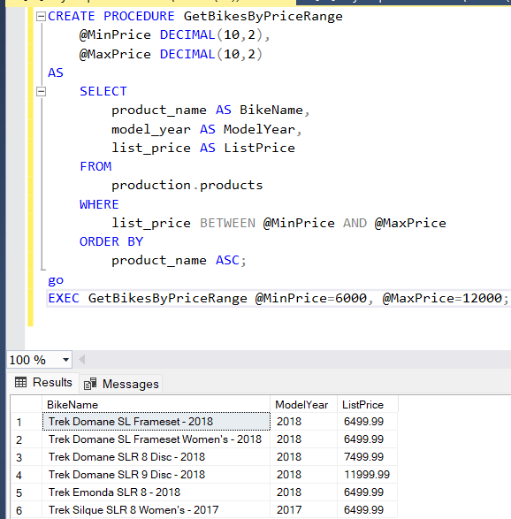

Problem 5: Create a stored procedure that lists the top five priced bikes at a specified store. The output must show the bike name, model year, and list price. The results need to be presented in descending price order. The skeleton of the stored procedure is provided below.
CREATE PROCEDURE GetTopFivePricedBikesByStoreName
@StoreName VARCHAR(255)
AS
<REPLACE WITH YOUR SQL CODE>
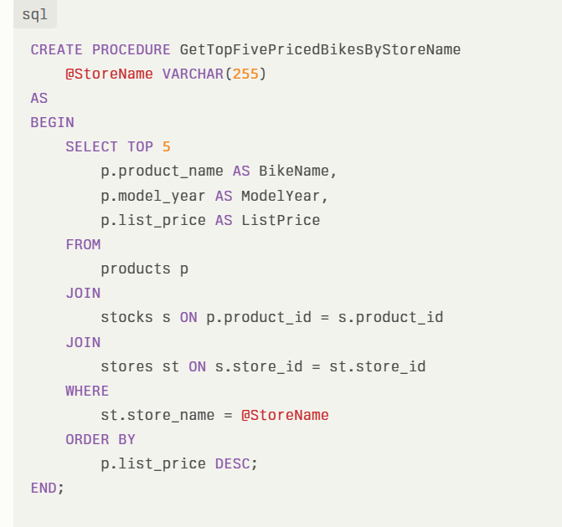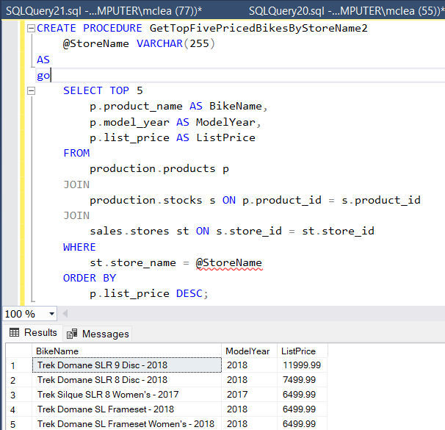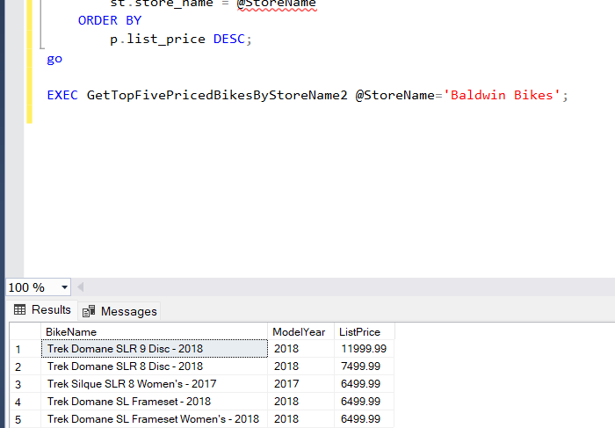
Problem 6: Establish a database view called CompanyStaffListView that lists the last name, first name, and email address of the staff from all the company stores. Then execute a SELECT query to verify the view. Used perplexity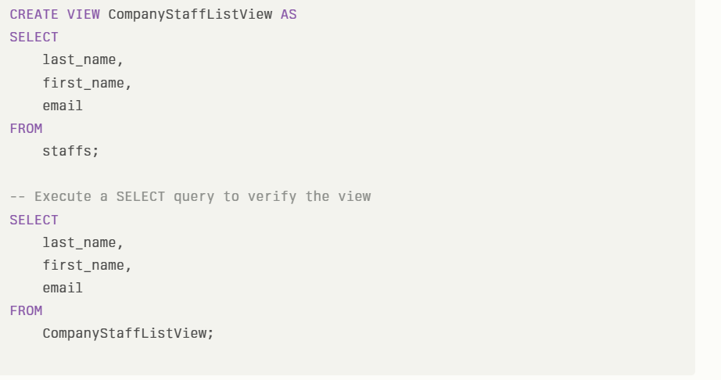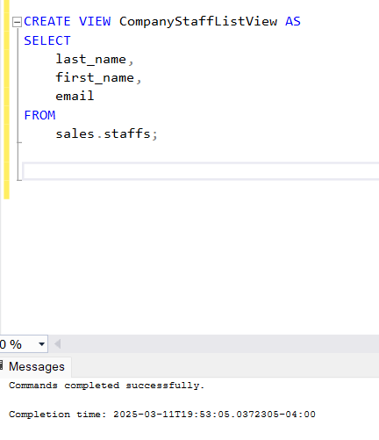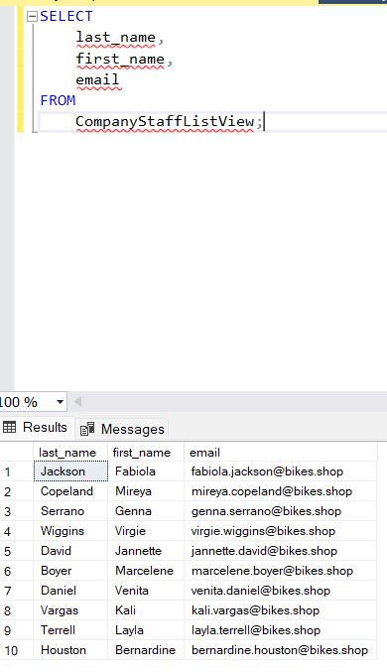

Problem 7: Establish a database view called BuffaloCustomersView that lists the last name, first name, and email address of customers that live in the city of Buffalo, NY. Then execute a SELECT query to verify the view. Used perplexity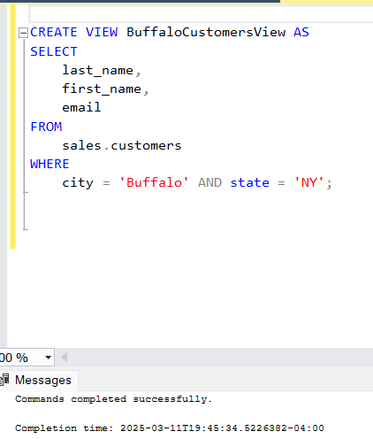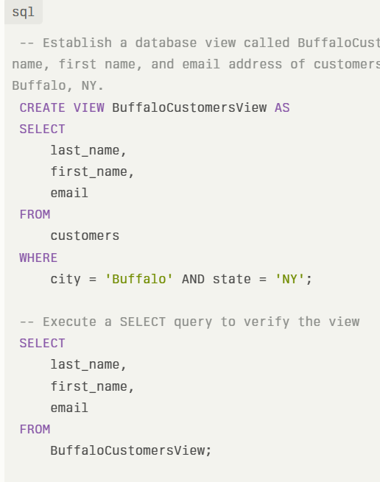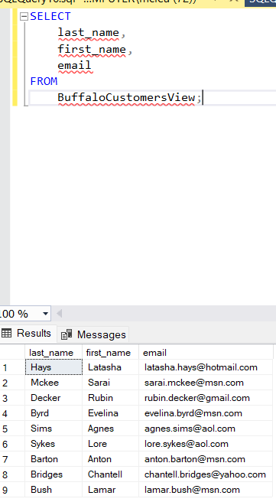
Problem 8: Establish a database view called LowRowlettBikesInventoryView that lists the bikes with stock levels less than 2 at the Rowlett Bikes store. The view needs to contain the bike name, brand name, and stock quantity amount. Then execute a SELECT query to verify the view. Used perplexity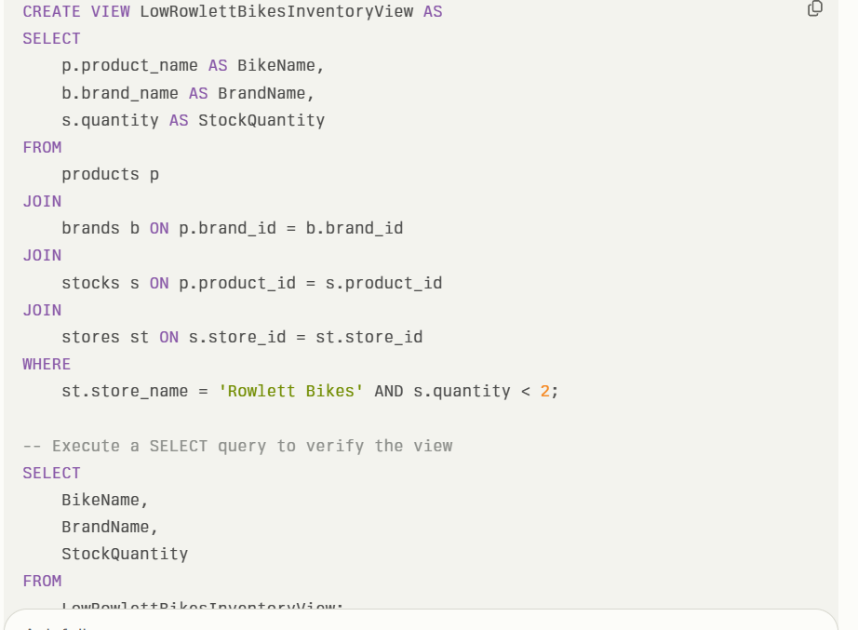 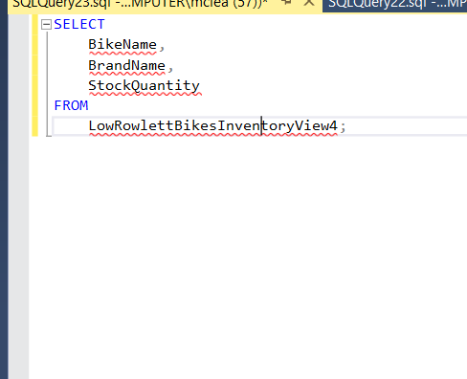 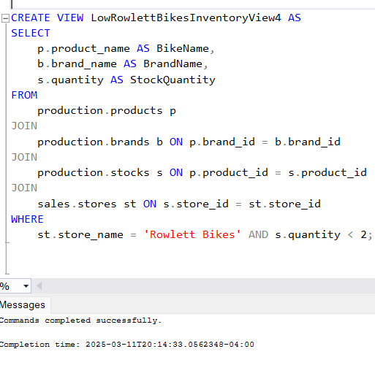 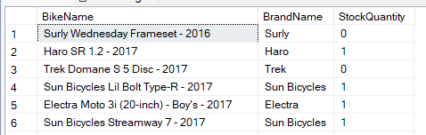 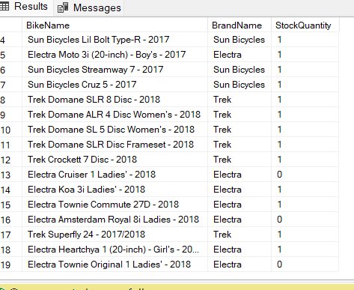

Problem 9: Establish a database view called LowCostBikesView that lists the bikes costing $200 or less. The view needs to contain the bike name, brand name, and list price. Then execute a SELECT query to verify the view. Used GPT
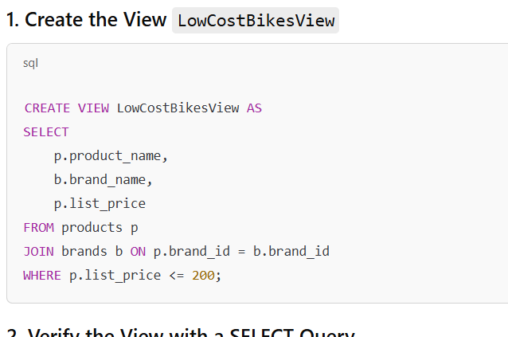
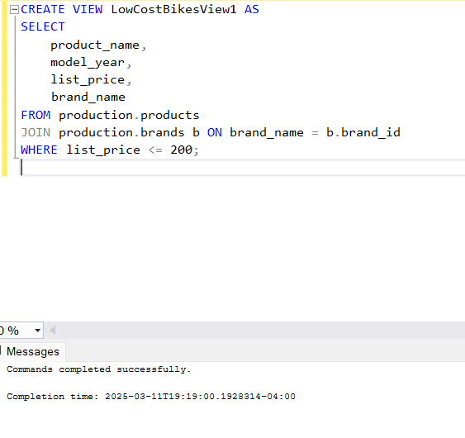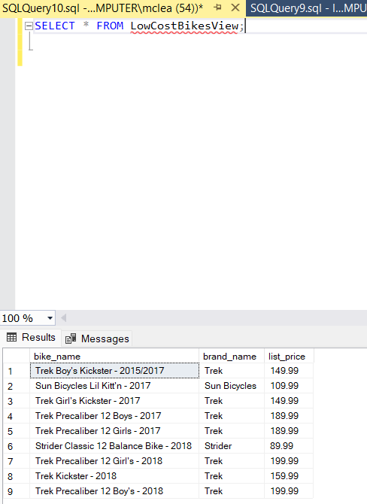

Problem 10: Establish a database view called UnshippedRowlettBikesOrdersView that lists the orders that have not been shipped. The view needs to contain the order ID, customer first name, customer last name, and order date. Unshipped orders are signified by order_status = 1. Then execute a SELECT query to verify the view.
Used Claude 