Christian Mclean
IT 350 Professor Jason Litz March 2, 2025
Assignment 1

- Display the bike names and list prices for bikes costing $5,000 or more. Order the results in descending order based on the list price. 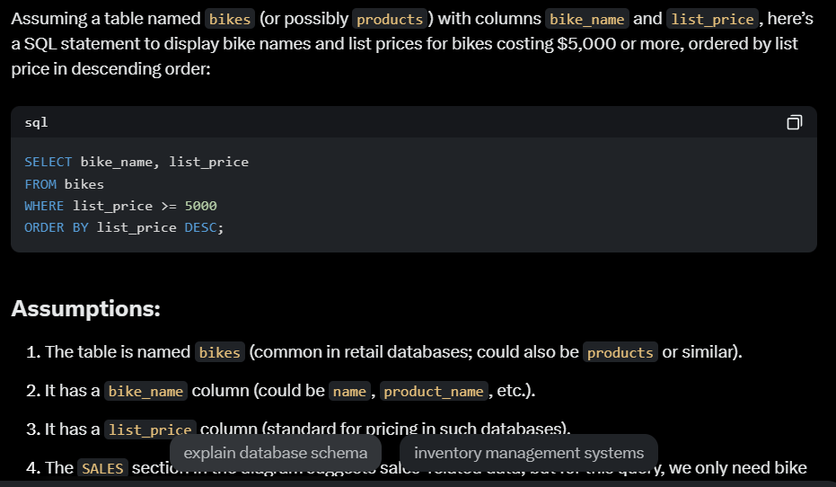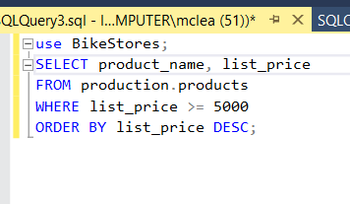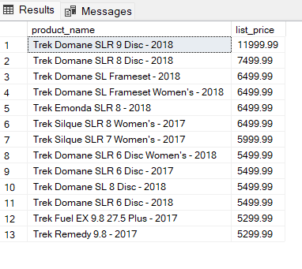
- Present a list of the bikes made by a company called “Haro” in alphabetical order. This one I didn’t surprisingly have to fix. 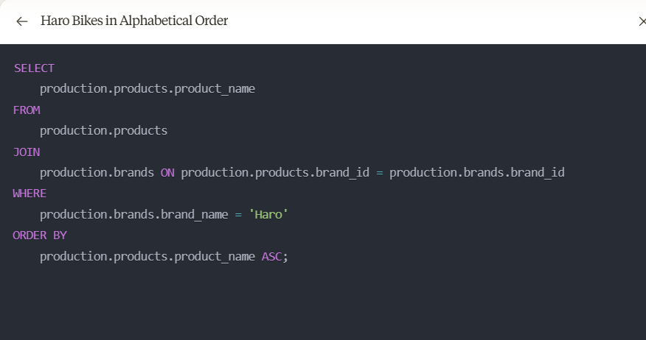 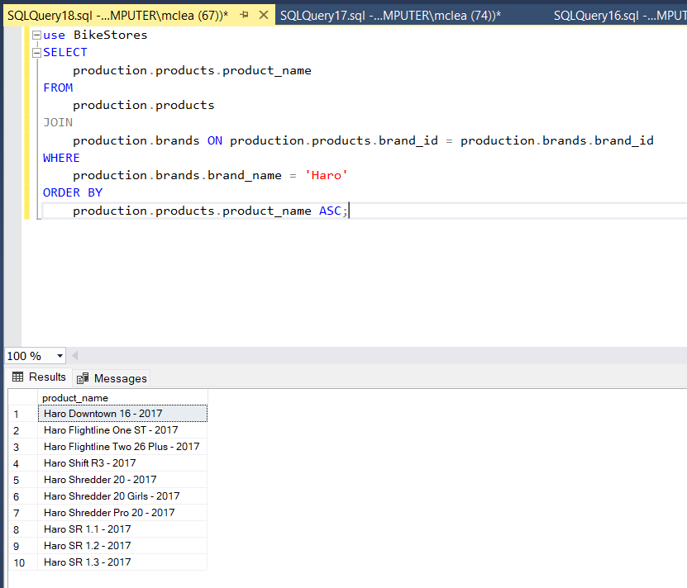
- Select customer records for customers residing in the 14450 zip code. 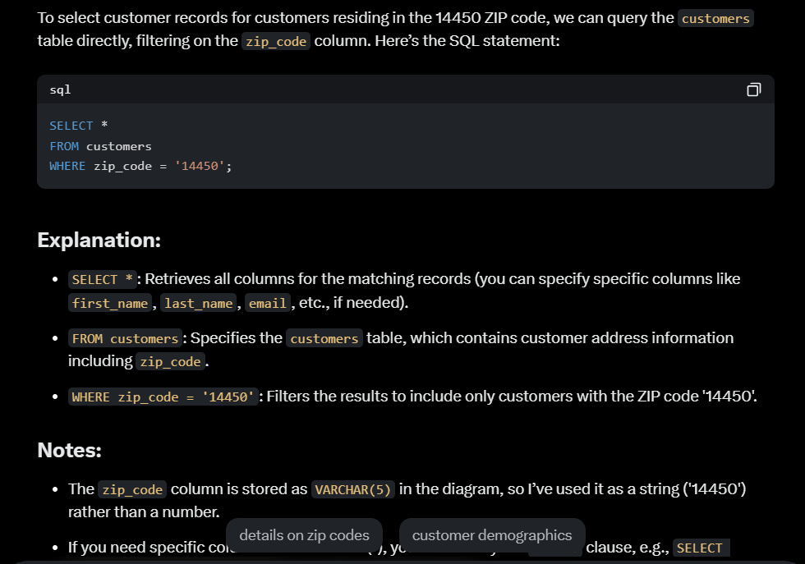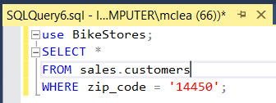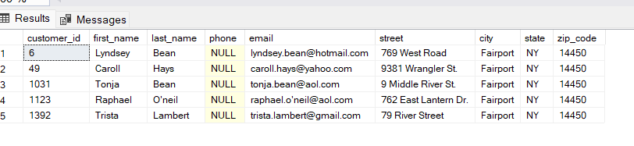
- List the first and last names of staff members whose manager is Mireya Copeland. 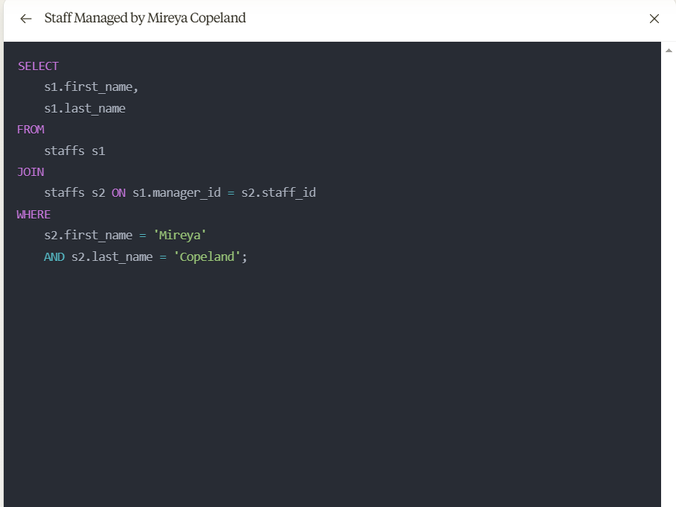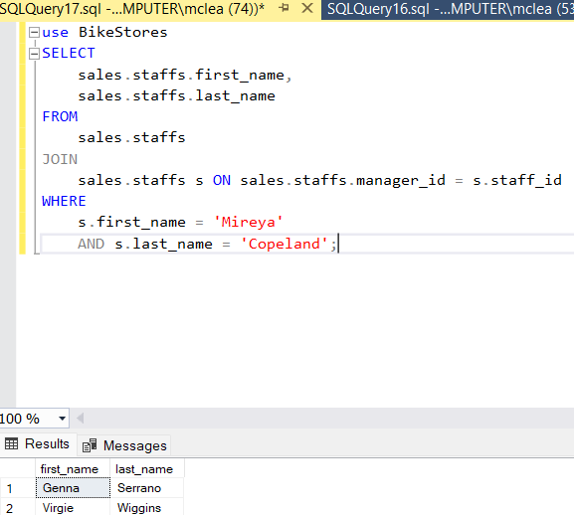
- The company is now selling bikes from a company called GT Bicycles. Enter a new record into the database to reflect this change. 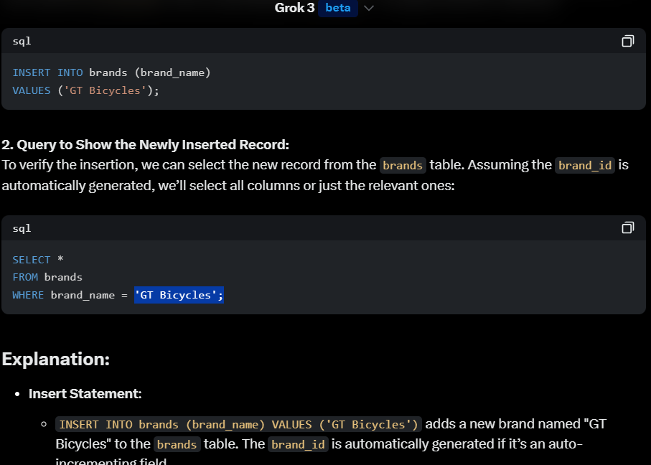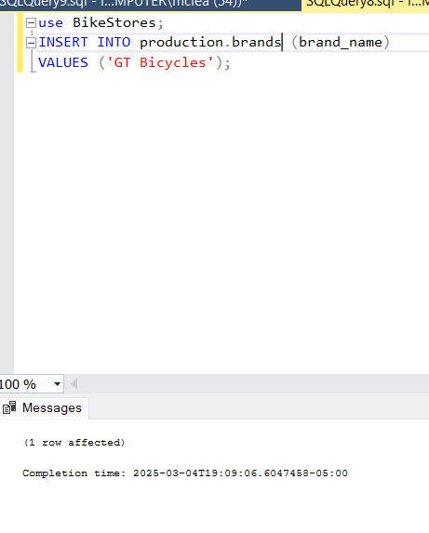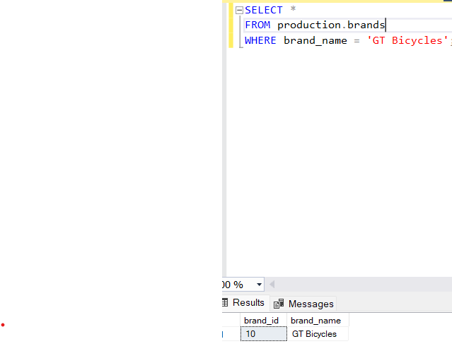
- Update the amount of stock for the bike with product_id = 198 at the store with store_id = 2. The new stock amount should be 20. 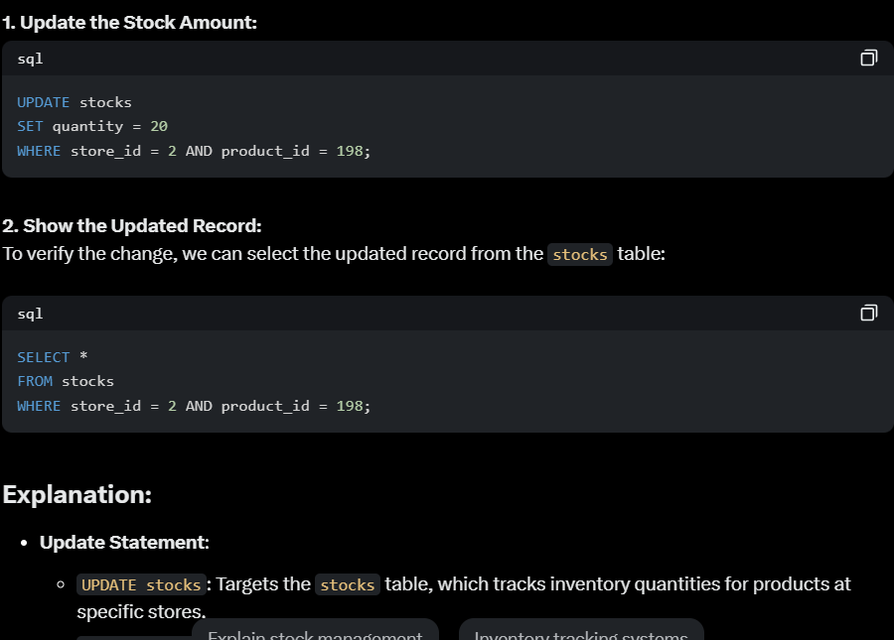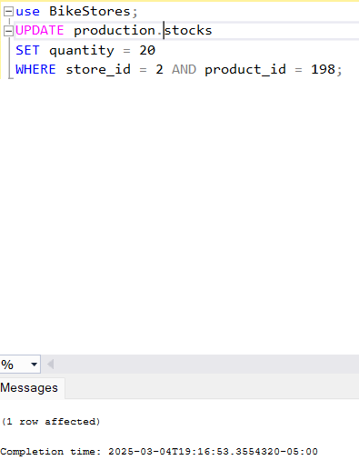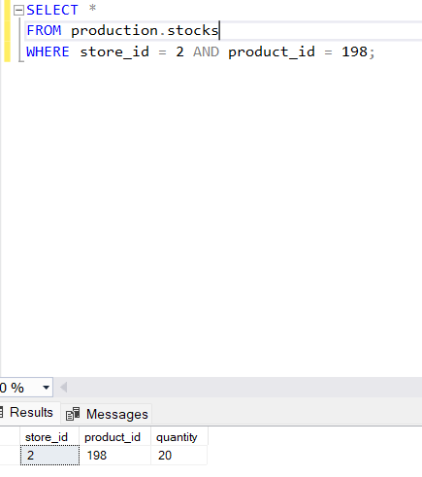
- Show bike names and the total sales amounts for transactions involving bikes costing $10,000 or more. The total sales amount is the product of the bike order item list price, quantity sold, and sale discount. 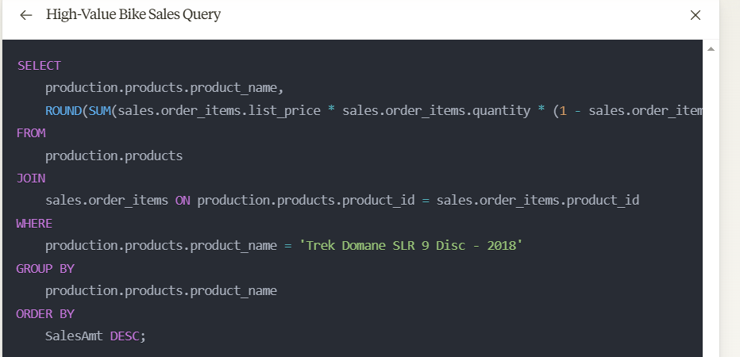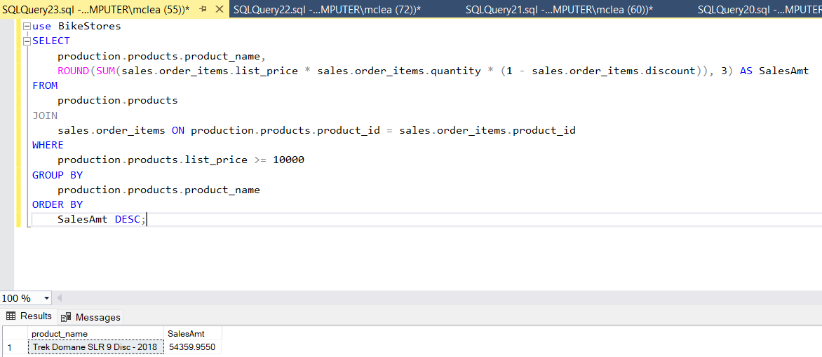
- Provide a distinct list of the states in alphabetical order where the company’s customers reside. I also didn’t have to fix this one to get the output desired 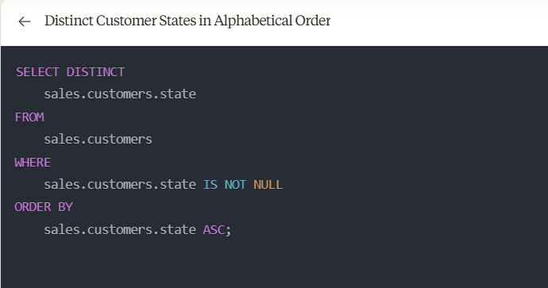 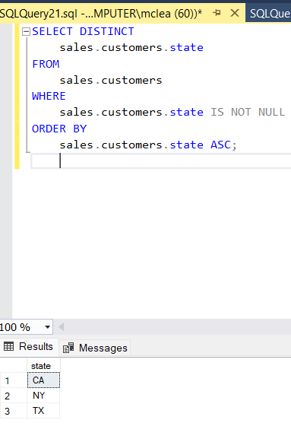
- Display the full names of all staff personnel in First_Name, “ ” , Last_Name format. Use the built-in CONCAT() function for this query. The AI I was using seemed to learning because it was giving me the desired outputs that I was looking for. I was using different Ais jumping but when I started using one it seemed to be learning exactly what I wanted. 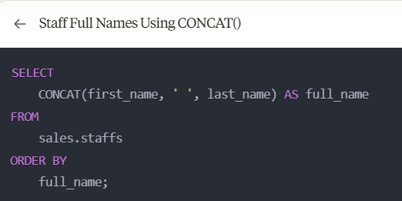 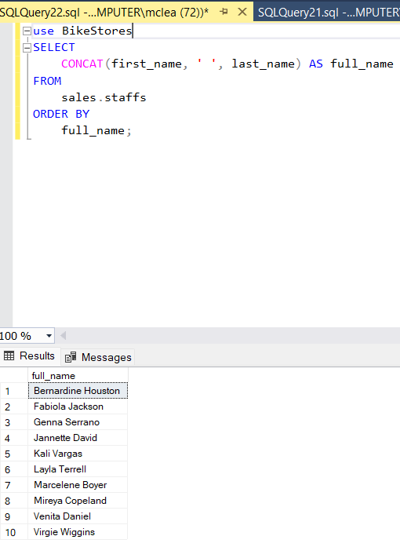
- Show the bikes that have zero stock at the Texas (TX) store. 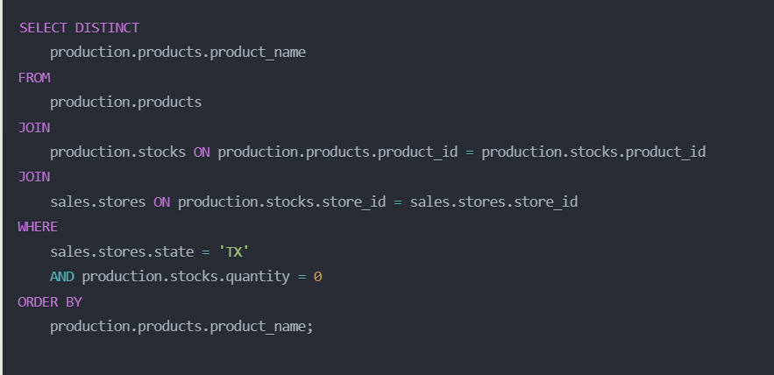 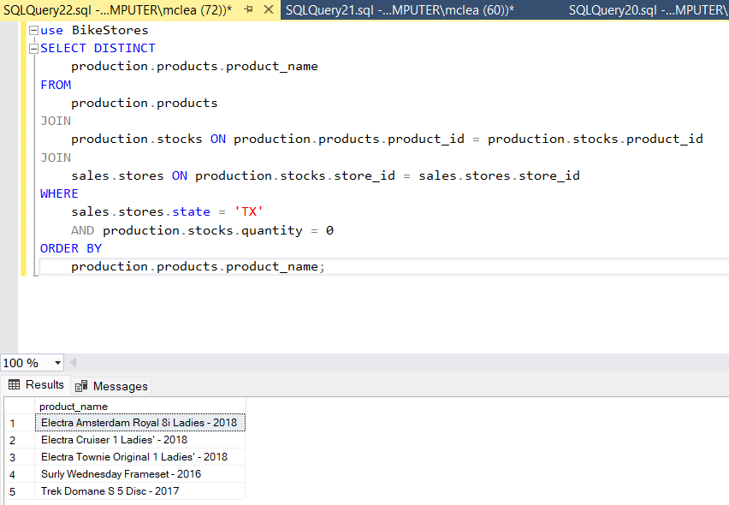
Given the success I had with Claude I believe I will be using that one for this class it seemed more willing able to learn and by the end I had to modify it the least and gave me the cleanest queries. I used Grok, Meta, ChatGPT, and Claude as described in the assignment.

