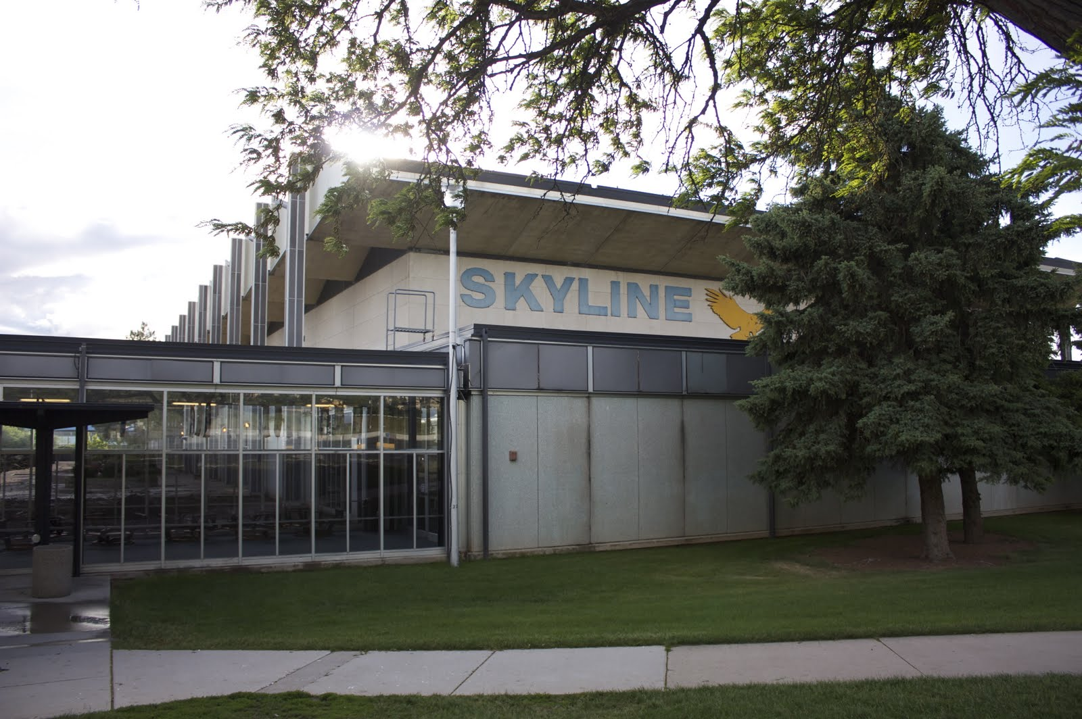

**Career Center**

The Skyline High School Career Center offers a variety of online and in-person opportunities for students to prepare for college and career and technical education. The career center always has capable counselors on staff that are willing to meet with students at any time to work out issues, sign up for classes or to just talk.

**Mission Statement:**

LEAVE HIGH SCHOOL WITH MORE THAN JUST A DIPLOMA…LEAVE WITH A PLAN!

Skyline College & Career Center offers detailed help with upcoming events, 2015-2016 college visits, career pathways, CTE/GTI, SAT/ACT, military enrollment, college planning, scholarships, study skills, Utah colleges, work-base learning, FAFSA and applying to college.

Click Here for More Information

(hyperlink: http://skylinecareercenter.weebly.com/)